

上海交通大学学位论文

海铃光电混合舱的物理信号研究

**姓 名：魏振宇**

**学 号：**519072910021

**导 师：徐东莲**

**学 院**：**物理与天文学院（致远荣誉计划）**

**学科/专业名称：物理学**

**申请学位层次：**  **学士**

**2023年06月**

A Dissertation Submitted to

Shanghai Jiao Tong University for Bachelor Degree

Probing Physics Potential with TRIDENT hDOM

**Author: Zhenyu Wei**

**Supervisor:** **Donglian Xu**

Zhiyuan College

Shanghai Jiao Tong University

Shanghai, P.R.China

June 28th, 2023

**上海交通大学**

**学位论文原创性声明**

本人郑重声明：所呈交的学位论文，是本人在导师的指导下，独立进行研究工作所取得的成果。除文中已经注明引用的内容外，本论文不包含任何其他个人或集体已经发表或撰写过的作品成果。对本文的研究做出重要贡献的个人和集体，均已在文中以明确方式标明。本人完全知晓本声明的法律后果由本人承担。

学位论文作者签名：

日期： 年 月 日

**上海交通大学**

**学位论文使用授权书**

本人同意学校保留并向国家有关部门或机构送交论文的复印件和电子版，允许论文被查阅和借阅。

本学位论文属于 **：**

□**公开论文**

□**内部论文**，保密□1年/□2年/□3年，过保密期后适用本授权书。

□**秘密论文**，保密 年（不超过10年），过保密期后适用本授权书。

□**机密论文**，保密 年（不超过20年），过保密期后适用本授权书。

（请在以上方框内选择打“**√**”）

学位论文作者签名： 指导教师签名：

日期： 年 月 日 日期： 年 月 日

# 摘 要

学位论文是本科生从事科研工作的成果的主要表现，集中表明了作者在研究工作中获得的新的发明、理论或见解，也是科研领域中的重要文献资料和社会的宝贵财富。

为了提高本科生学位论文的质量，做到学位论文在内容和格式上的规范化与统一化，特制作本模板。

**关键词**：学位论文，论文格式，规范化，模板

# ABSTRACT

As a primary means of demonstrating research findings for undergraduate students, dissertation is a systematic and standardized record of the new inventions, theories or insights obtained by the author in the research work. It can not only function as an important reference when students pursue further studies, but also contribute to scientific research and social development.

This template is therefore made to improve the quality of undergraduates’ dissertation and to further standardize it both in content and in format.

**Key words:** dissertation, dissertation format, standardization, template

**CONTENTS**

摘 要 I

ABSTRACT II

Chapter One Introduction 1

1.1 Neutrino 1

1.2 Neutrino Telescopes Overview 3

1.2.1 Detection Principles 6

1.2.2 Trigger Overview 9

1.2.3 Signal and Background for TRIDENT 11

1.3 Purpose of Study 13

Chapter Two Trigger Strategy 15

2.1 Trigger Strategy Design 15

2.2 hDOM internal Trigger 15

2.3 Physics Filter 16

Chapter Three Performance of Trigger 17

3.1 Background Reduction 17

3.2 Signal Events Extraction 18

Chapter Four Future Improvements and Outlook 19

4.1 Physics Filter Optimization 19

4.2 Data Acquisition System 19

4.3 Trigger Design for TRIDENT Phase I 19

References 20

Symbols and Marks Appendix 1 21

Research Projects and Publications during Undergraduate Period 22

Acknowledgements 1

# Chapter One Introduction

## 1.1 Neutrino

Neutrino is firstly proposed by Wolfgang Pauli in 1930 to fix the problem of energy and momentum non-conservation effect in beta decay. In 1942, Ganchang Wang proposed the use of beta capture from 7Be to experimentally detect neutrinos. In 1956, the tiny particle is directly detected for the first time in Cowan-Reines neutrino experiment. In the experiment, antineutrinos created in a nuclear reactor are captured by protons in 200 liters of water, and a pair of neutron and positron is produced, generating a time corelated signals. The neutron is captured by 40 kg of dissolved CdCl2 in water and the positron is annihilated by electron. This great breakthrough won 1995 Nobel prize.

It is a kind of charge-neutral lepton with spin 1/2, which is categorized in three different flavors: electron neutrino 𝜈𝑒, muon neutrino 𝜈𝜇, tau neutrino 𝜈𝜏. Since the mass eigenstates and the flavor eigenstates of neutrino do not overlap, the probability of observing a certain flavor neutrino varies as it propagates(Flavor Oscillation Effect, 2015 Nobel Prize). Neutrino only involves in weak interaction and gravity interaction. Its small cross section induces very scarce reaction events. So neutrinos are sometimes referred as ‘ghost’ particles since they penetrate most substances easily. Until this day, many science problems around neutrino still wait for us to answer. Whether neutrino is a kind of Majorana fermion is still elusive in science frontier up to now. Cosmic neutrinos including Big Band originated cosmic neutrinos and supernova originated neutrinos are also not fully understood.

This kind of nearly massless elementary particle is generated mainly in hadronic process or nuclear reaction(beta+/- decay and election capture), which is enriched in the nuclear power plant, celestial bodies, and earth atmosphere as the high-energy cosmic ray Bombarding atmospheric atoms. The flavor, direction, and energy spectrum of neutrinos are widely different as the sources varies. Generally, high-energy neutrino generation marks occurrence of violent hadronic processes. The processes can be summarized as

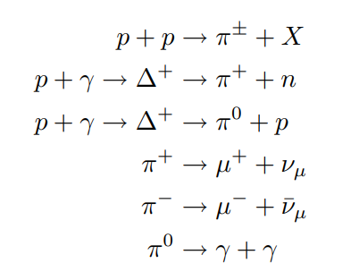

Compared to GeV and above high-energy photons which is deflected by pair-productions, neutrino travel longer with less absorption or deflection in interstellar space. In universe observation, these oscillating high-energy particles can be utilized as a powerful tool to study the astronomical sources since neutrinos’ flavor constituents, direction, and energy of neutrino fets carry very rich physics information. Neutrino sources is widely considered as a smoking gun evidence for ultrahigh energy cosmic ray production, which is a centennial problem for human-being. In 2013, IceCube discovered a diffuse astrophysical neutrino with several potential sources included, such as active galactic nuclei, gamma-ray bursts, and starburst galaxies. In 2017, IceCube linked observed high-energy neutrino with flaring blazar TXS 0506+056 with a 3.5 sigma confidence interval, which indicates an upcoming groundbreaking in multi-messenger astronomy.

These tiny particles are observed using extremely sensitive technologies. The secondary charged particles generated in neutrino-matter interactions induce detectable Cherenkov optical photons. Large areas of photon-sensors continuously monitor a large volume of target optical medium, such as sea water, liquid scintillator, liquid argon or Antarctic ice. The time-resolution of photon-sensors can reach sub-nanosecond level and as for the sensitivity, single photon can be distinguished.

## 1.2 Neutrino Telescopes Overview

In 1998, theoretical calculations suggested that high-energy neutrino flux from AGN(Active Galactic Nuclei) jets or GRB(Gamma Ray Burst) can be observed by a cubic-kilometer detector with sufficiently sensitivity. Numerous interesting topics about cosmic neutrino, along with new physics beyond the Standard Model and quantum gravity, can be studied through the neutrino telescopes. Several neutrino telescopes around the world are under development now. Their geometry design, technical route, noise source and the monitoring sky region are widely different.

1. IceCube

IceCube, located in the deep Antarctic ice, is the largest running Cherenkov neutrino telescope in the world. In the surface, IceTop possesses 81 stations and 324 optical sensors. Below the ice surface, 5160 Digital Optical Modules(referred as DOM, the core component of a neutrino telescope) in total are deployed uniformly in 86 strings, monitoring one cubic kilometer volume. DeepCore, constituted by 8 strings with 480 DOMs, is designed for optimization of lower energies in IceCube experiment. Generally, DOMs form a uniform space lattice with translational symmetry mostly. The neighbor string distance is 125m and the vertical spacing of DOMs in string is 16.7m.

DOM in IceCube utilizes one 10-inch diameter PMT. The dark count, which is around 500Hz per DOM, is the main noise source on the DOM level. For a triggered(called hard local coincidence in IceCube) photon hit, the waveform will be read out in 300MHz sampling rate, while for un-triggered photon hit (isolated photons, called soft local coincidence in IceCube), only the time and amplitude will be read out. After event selections, 100GB/day data stream are transmitted to the north over satellite for further analysis.

1. Km3net

Km3net is a water-based neutrino telescope in the Mediterranean sea mainly driven by EU. Two clusters of strings form ARCA in Italy(Astroparticle Research with Cosmics in the Abyss). And one cluster constitutes ORCA (Oscillation Research with Cosmics in the Abyss) in French.

ARCA will possess instrumented volume of about 1 cubic kilometer with 230 strings comprised of 18 optical modules, slightly larger than that of the IceCube. ORCA will a total densely instrumented volume of about 0.0067 cubic kilometer. The construction of ARCA provides some valuable references for other water-based neutrino telescopes. They developed mDOM(multi-Digital Optical Module) with 31PMTs to detect neutrinos.

Facing the problem of bioluminescence, k-40 and dark noise, they decided to abandon the read-out of waveform. Only the photon hit time and the time-over-threshold are read out. This strategy largely compresses the bandwidth off-shore(still remains 9-12Mb/s output per mDOM, account for 50 Gb/s in total arrays) but also accompanied with the loss of information.

1. P-ONE

P-ONE(Pacific Ocean Neutrino Experiment) is located at a depth of 2660 meters in the Cascadia Basin. The geometry is designed in cluster shape. Each cluster has 10 strings equipped with 20 DOMs. The strings in one cluster form a double-ring structure, and the inner ring has radius 100m with 3 strings and the outer ring possesses 7 strings in the radius of 200m. The large detection array is composed of 7 clusters in total. The average distance between clusters is 1km. Their site is monitored by two pathfinder experiments named STRAW. The optical property of water and the environment parameters such as water velocity are evaluated. Their first prototype line is expected to be deployed in 2023.

1. Baikal-GVD

Baikal Gigaton Volume Detector(Baikal-GVD), with 192 modules successfully operated at a depth of 1.1km, is still under development. The start of Baikal-GVD can date back to 1980, when a laboratory of high-energy neutrino astrophysics was established in Moscow in USSR. They plan to finish the construction in multiple phases. NT-36, NT-72,NT-200 and NT-1000 is performed in sequence. They also implement the cluster-like shape design to adapt to the expenditure. The DOM used in Baikal-GVD only contain one large PMT, and the lake water does not contain any K-40, so its bandwidth is not that large. Since its depth is 1.1km, the rate of atmospheric muons is relatively large.

1. TRIDENT: the next generation neutrino telescope

The tRopIcal DEep-sea Neutrino Telescope, TRIDENT for short, will be deployed on the abyssal plane at South China Sea. Since abyssal water, compared to the glacial ice of IceCube, contains less impurity, Trident will have added advantage in reducing photon scattering. Neutrino pointing in both the track and cascade channels can be benefitted.

The telescope will have an Penrose geometry layout with 1211 strings and 22400 hybrid digital optical modules covering a volume of about 8 cubic-kilometer. Simulation shows that this kind of unsegmented geometry can reduce the clipping edge events(the events which happened in the edge of the detectors, more likely to occur in the clustering geometry). The spiral geometry can also deal with the ‘corridor events’(referred to the events which pass through parallel arrays of strings in the detector)

State-of-the art technologies will be included in hDOM(hybrid digital optical module) design. More than 30 3-inch PMTs and more than 20 1-inch PMTs or SiPMs will be integrated together to achieve high time resolution and excellent light collection ability. This next generation telescope carries more ability to pinpoint the astrophysical neutrino sources, as well as stays sensitive to all flavor neutrinos for multiple critical physics purposes.

### 1.2.1 Detection Principles

The secondary particles from high-energy neutrino-proton or neutrino-neutron collision with are charged and largely boosted. These high-energy particles’ velocity is very close to the speed of light, say c, in vacuum, which the light speed in water, normally 0.75c, is significantly less than. Water is a common dielectric medium that can be polarized electrically. In the case, Cherenkov radiation effect can occur. Secondary charged sparticles carry the information from neutrino due to the conservation of energy and momentum, and emit a large amount of Cherenkov photons. The Cherenkov photons generated along the trajectory follow a fixed emission angle and can be captured by the DOMs in the neutrino telescope. This is the detection principle of neutrino telescopess. The well-known emission angle can be written as $cos(θ) = \frac{1}{nβ}$. This angle property is the foundation of direction reconstruction in neutrino telescope.

The arrival time of a un-scattered Cherenkov photon in the detector can be written as

$$t_{i}=t_{0} + \frac{z_{i}-z_{0}}{c}+tanθ\frac{r_{i}}{c}$$

All quantities are marked in Figure 1. This expressions are applied in the likelihood method in the reconstruction and also the muon event filter algorithm(This will be discussed in later chapter). All photons emitted from the same muon track should obey the law of causality, when scattering effect does not slow down the average velocity too much. This property can be utilized to limit the direction range of muons before reconstruction.

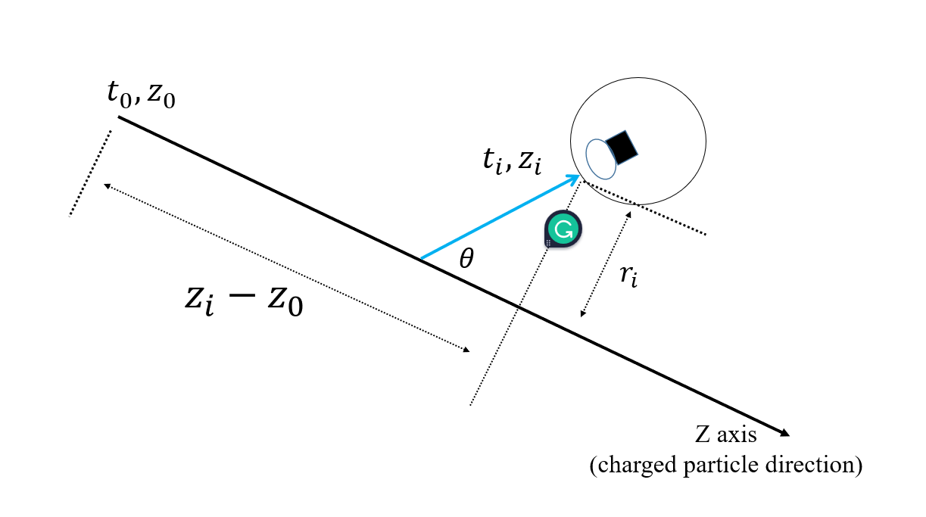

Figure Cherenkov photon arrival time. The blue curve is the track of an emitted Cherenkov photon. $θ$ is the Cherenkov angle.

As for the energy spectrum of Cherenkov photons, the description is given by the Frank-Tamm formula.

$$\frac{d^{2}E}{dxdω}=\frac{q^{2}}{4π}μ(ω)ω(1-\frac{1}{β^{2}n^{2}(ω)})$$

This equation involves $μ(ω)$, the permeability, $n(ω)$, the refractive index and $q$, the electric charge. It calculates the amount of energy emitted per travelling length and per frequency. Since the radiation energy is larger when $β$ factor is closer to 1, more photons can be accepted by DOM for higher energy events. Also, more charged secondary particles can be generated from higher energy events. More photons received generally, more energy the particle carries. This lays the foundation for the energy detection in the neutrino telescope. According to the formula, the energy spectrum of Cherenkov photon is quite flat in optical region. Considering strong absorption effect of water in both large and small wavelength region, only wavelength around 450nm(blue light, 2.76eV) can mostly go through the medium. Since water only opens a window for the light from 2 to 3 eV, our PMTs and SiPMs inside the DOM should be sensitive to this wavelength band.

Intuitively speaking, the signature of muon neutrino events, electron neutrino events and tau neutrino events are distinguishable, since properties of secondary particles are different. Muons, as well as some of tauons, travels longest, electrons bombard out a shower, and tauons both generate a shower and decay. Largely boosted muon neutrinos is viewed as the golden channel to search the astrophysical source in multi-messenger astronomy since muon tracks are usually very long($O(1000m)$) and the reconstruction angular error is the smallest of all flavor. The angle between the induced muon and the neutrino can be approximated as the following expression:

$$∆θ(ν-μ)\sim \frac{1.5°}{\sqrt{E_{ν}[TeV]}}$$

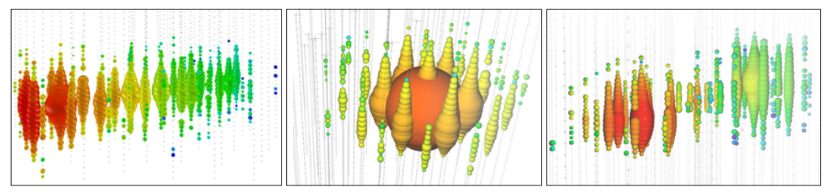

Figure Three examples of event signatures in IceCube. From left to write, a track-like event, a shower-like event, a simulated double-bang event are presented. They are considered as a muon event, electron event, and a tauon event. The DOMs are lightened by Cherenkov photons described above. The signature of events sometimes still degenerate.

The degeneration of signatures can still occur, since tauons can be track-like or shower-like. Clipping edge events only shed light on a few DOMs on the boundary, so it is not that easy to identify. Classification of particles is also a critical process in data analysis, where both machine learning and classical likelihood methods can be involved in.

### 1.2.2 Trigger Overview

It is a trend that the volume of the neutrino telescopes and the number of equipped photoelectric devices are becoming larger. The huge data amount will cause the bandwidth overload and the computation problem. Raw photon hits captured by DOM are almost 100% noise. The signal-to-noise ratio can be up to one in million. Analysis of all data set can be both unnecessary and impracticable without trigger. So a series of trigger strategies are implemented involving both software and hardware before analysis.

The general goal of trigger is the reduction of noise and the extraction of the physics. The second step is sometimes also referred as filter or event selection, since the bandwidth has already been suppressed by the first step, and particle identification are sometimes implemented in this phase.

Since the hardware design emphasizes the simplicity and the reliability more, less steps will be taken below the surface. All filters and particle identifications are more likely to be put on the computation station on the surface.

1. IceCube

The DOMs used in IceCube contain only one PMT and no K-40 issue troubles the device. So inter-DOM triggers are not in need. IceCube defines two adjacent DOMs obtained photons in 1000 ns time window as Hard Local Coincidence(HLC) and isolated DOM hits as Soft Local Coincidence(SLC). All HLCs are digitized and full waveform will be read-out. For those SLCs, only the time stamp and the charge are read-out to save the bandwidth. For those high energy neutrino events, almost all waveform will be read out since most of photons will be HLCs.

All HLCs and SLCs will be transmitted above the ice surface into StringHubs. This computation station will process data with all kinds of filters to extract all kinds of track-like events and cascade-like events. The noise rate will be calculated and be used to monitor the status of the entire arrays. After the filter computing, 100GB/day’s data is transmitted to the satellite.

Filters set in IceCube serve for multiple purposes. SMT(simple multiplicity trigger) simply counts the number of HLCs in a certain time window.(say 8HLCs in 5 $μs$ for in-ice strings) Volume trigger requires 4 HLCs in 1 $μs$. String trigger requites 5 HLCs in 1.5 $μs$. Moreover, SLOP trigger(Slow Particle) are also designed for particles with velocity less than 0.01c. FRT(the fixed-rate trigger) reads out 10ms of hit data from the full detection arrays at a fixed interval for monitoring purposes.

1. Km3Net

Km3Net first applies mDOMs in neutrino telescope. 31 3-incd PMTs are equipped together. Dark count rates are superposed linearly. K-40 decay events surrounded the mDOM can contribute 7kHz hit rate per PMT, and double photon hits even triple photon hits also occurs steadily. This large noise hits force they adopt new read-out strategy. All waveforms are abandoned. Only the hits time and the time-over-threshold are recorded. The bandwidth is suppressed mostly in this phase.

The extraction of physics events is processed on shore in TriDas. Different filters are applied parallelly. For those in-hDOM process, they use the L1 filter. In certain time window, say 10ns, if two different PMTs in the same mDOM is hit, or the same PMT capture 3 photons, then these photons are referred as L1 triggered. If adjacent L1 events occur in 200ns or next-to-adjacent L1 events occur in 300ns, they are T-triggered. Both T-triggered and L1-triggered events are used for latter processing. When no L1 or T trigger happen, the hits are classified as noise and abandoned. If the number of L1 events is larger than a threshold, then more filters are implemented, such as sky-scan filter or causality trigger. They also have external trigger, such as the alert from satellite signals, for some explosive astrophysical events.

1. Baikal-GVD

In lake water, salt such as K-40 is barely contained, so the noise bandwidth is not super high. Simple and fast methods are adopted when designing the data acquisition system. The trigger in the data acquisition system operates in two modes, L trigger and L&H trigger. The previous one demands coincidences of signals in the selected time interval, and the latter one asks for coincidence in any adjacent optical modules.

### 1.2.3 Signal and Background for TRIDENT

In this paper, we generally refer the ambient noise such as K40 decay or bioluminescence and dark count as noise. Atmospheric muons, neutrino events including all flavors, or other slow-moving heavy particles such as magnetic monopoles are called signals in general. Signals can be analyzed with multiple physics purposes, while noise should be reduced as much as possible to save bandwidth.

The element decay events in sea water are dominated by K-40. The activity is around 10Bq/L(10.89Bq/L in the south China sea), in proportion of more than 99.9%. Other elements such as U, Th, Cs, Ra and T are rarely contained in sea water, even though their half-life time are not so long. The information is summarized in following Table 1.

|  |  |  |
| --- | --- | --- |
| Element | Half-life time / year | Activity / Bq /L |
| K-40 | 12.5 * 1e9 | ~10 |
| U | 45.7 * 1e9 | 0.003 |
| Th | 14 * 1e9 | 0.0002 |
| Cs | 30.2 | 0.000001 |
| Ra | 1600 | 0.00001 |
| T | 12.3 | 0.00000005 |

Table Element decay in seawater.

The dark counts of photoelectric instruments are also a source of noise. Dark counts originate from the thermal excitations of the photocathode materials or silicon diode. For every 30-degree drop in environment temperature, the dark count rate drops by an order of magnitude approximately. Low temperature (~2℃ in 3500 depth in the south China sea) can be a beneficial factor for noise reduction for the neutrino telescope. The rate of dark counts for one single PMT or SiPM is in a very wide range, in the order of ${10}^{2}$ to ${10}^{6}$ Hz, which is sill quite sparse for nanoseconds granularity and tens of nanoseconds of trigger time window.

Currently, there are 31 3-inch PMTs and 24 3mm*3mm SiPMs or 1-inch PMTs in one hDOM. The dark count rate of PMT and of 3mm*3mm SiPM is around 300Hz @ 2℃ and 20-30kHz/9mm^2 @ 2 ℃. Calculations show that after trigger, dark noise contributions can be down to *O*(1)Hz , which is negligible.

Atmospheric muons, neutrino events, and other rare events such as proton decays and magnetic monopoles are defined as signals. The atmospheric muons are dominate in this part. Thick water layers has already shielded most of the atmospheric descending muons, while still about 1000 muons per second arrive at the Trident detector. High energy up-going neutrinos are the most critical for future analysis, since it is most likely to be astrophysical since there are no other mechanisms to produce up-going high energy events. For relatively significance sources such as NGC 1068, Trident expects around one hundred observed neutrinos per year. In terms of bandwidth, descending muons occupy the overwhelming majority.

Generally considering the feature of noise and physics signals, the former one, generating single photon hits, distributes uniformly both in time and space, while the latter one produces multiple photon hits in short time range in local hDOMs, which obey the law of causality.

## 1.3 Purpose of Study

Even though noise contributes most in total bandwidth, and atmospheric muons contributes most in signal bandwidth, we should transmit all data to avoid the loss in physics information and be careful when reducing the background. Those relatively low-energy events(sub-TeV) may create only a few Cherenkov photon hits, which is not be significant enough to be distinguished from K-40. Even If the photons’ distribution in time and space are quite dense when the energy of neutrino events is high, those hDOMs far from the event vertex still capture few photon hits, which may cause misjudgment in extracting signals. The more stringent criterion we choose to suppress noise, the less pressure we have to transmit data, and the more physics loss we will face.

The purpose of this work is to explore the possible way to reduce the background as well as to make sure signals are not impaired. hDOMs in TRIDENT are equipped with most number of PMTs and SiPMs, than any other DOMs ever designed. Former neutrino telescopes are generally designed with the ‘all-data-reserved’ philosophy. As much as possible information is reserved when outputting the data to shore from DOMs. This strategy can be helpful to the simplicity and reliability of hardware design inside the DOM. And all information are reserved to the data station on shore, which avoids the potential loss of physics information. While, on the other side, this strategy is a waste of bandwidth. Retaining all noise in the cable is not necessary. The next-generation neutrino telescope, Trident, may not be able to apply the same methods to transmit and digitize data, since the bandwidth is unprecedentedly high and the monitoring volume is incomparably large. New ways of trigger are in need to adapt to the current level of data transmission and computation.

# Chapter Two Trigger Strategy

## 2.1 Trigger Strategy Design

The trigger strategy of Trident should not bear any physics loss, at the same time, suppress the bandwidth to satisfy the workload of data transmission. In one hDOM, 31 PMTs and 24 SiPMs are equipped. Large bandwidth from numerous photon sensors demand relative strict trigger criterion. The framework of trigger constitutes two level. The first level is hDOM-internal trigger. It is the first stage to suppress the bandwidth by considering the number of PMT photon hits. Since the dark count rate of SiPM is in the order of $O({10}^{6})$, the trigger of SiPM will still depend on photon number from PMT. The second one is referred as physics filter. This part considers photon hits in adjacent or next-to-adjacent hDOMs. Data from a local cluster of hDOMs, such as a cylinder or a sphere will be extract for next-stage reconstruction.

## 2.2 hDOM internal Trigger

This part is level-one trigger, sometimes called L1 trigger for short. The waveform of L1-triggered events will be read out for particle identification and reconstruction.

The implementation of L1-trigger is summarized as follows:

1. If at least two different PMTs receive at least two photons in 10ns, the it is a L1-triggered event.
2. The waveform of total 1000ns will be read out. The first 300ns is before the L1-triggered event and the second 700ns is after-L1.
3. The 1000ns read-out time window is for the entire hDOM, including 31 PMTs and 24 SiPMs.

We expect that this part, the foundation of all later data processing, will suppress background, and make no influence on the physics events.

Other neutrino telescopes transmit all data to shore and then use a seires of triggers to process data. However, since the bandwidth of Trident is super high($O(TB/s)$,for all waveforms without trigger) and the workload of optical fiber in the sea cable is limited, we may design a FPGA inside each hDOM to process this L1 trigger. All the signals will be stored in analogue form in a buffer. When the coincidence condition computed by FPGA is satisfied, the triggered signals will be digitized by ADC and transmitted by cable. Otherwise, only the time and the charge of a hit will be obtained by TDC and much less information is transmitted. The physics loss in this phase are unretrievable, the criterion design must be very careful.

It is an obvious drawback that only two or more than two photons can form a L1 trigger. Single-photon condition can never satisfy the L1 trigger. This single photon from physics events can still carry some information that may be helpful for energy and direction reconstruction. Since the dark count and most K-40 decay generate single photon hit, it is quite difficult to distinguish a photon’s origin. A possible solution is that when a higher level trigger is satisfied, all data from the entire detection array or a large cluster of hDOMs are read-out. L1 trigger itself cannot save single photon from physics signals.

## 2.3 Physics Filter

Higher level trigger are generally referred as physics filter. The main purpose of this part is to extract physics signals. This part is the subsequent procedure of L1 trigger and the guiding process before reconstruction. The function will be implemented in the computation infrastructure on the shore. The idea can be generally summarized as convex envelop search. For a series of photon hits distributed in space and time(4 dimensional linear space), we should find a boundary to capsule all points without physics loss, and the boundary should be as small as possible to reduce data amount.

For muon neutrino events, tau neutrino events, electron events, and atmospheric events, the signatures are widely different. Different reaction channels and different energies of the event corresponds to different size of boundary. Normally, for a 100TeV shower event, tens of hDOMs will be lightened. For 100 TeV track event, hundreds of photons will land in tens to hundreds of hDOMs. Time distribution for single PMT ranges from ten to one thousand nanoseconds. This feature requires that the physics filter should be loose and run in parallel to involve all situations.

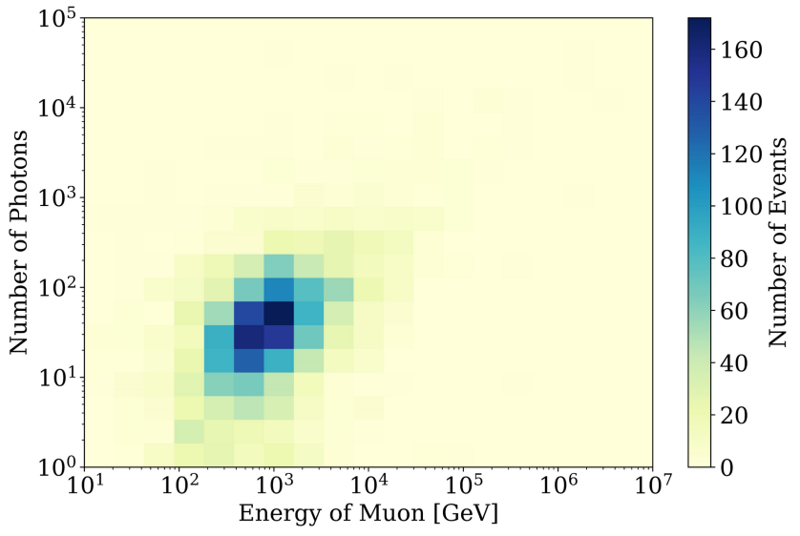

Figure Number of photons received from muon events from simulation. Quantum efficiency of photon sensors is considered. Large white area in the picture is due to a lack of statistics. If enough events are simulated, a linear blue band are expected since the number of photons should be proportional to the energy. But we can conclude that the photon number is distributed in very wide range for the events with the same energy.

We can first use a L2 trigger(level 2, a higher level than L1) to mark those corelated events, which is an indication of physics signals. The L2 trigger’s idea is basically the same as L1 trigger. It only considers the coincidence between 2 adjacent or next-to-adjacent hDOMs.

Cylinder method and sphere method are proposed as preliminary solution for muon events and shower events. Other parallel methods for other physics events such as tau neutrino, Glashow resonance, slow moving particles or Dimuon are still under development.

1. cylinder method

The idea of cylinder method is that photons from track-like events propagates within several times of absorption length of seawater. It is very safe to argue that almost 100 percent of direct photons are constraint in the length of 5 times of attenuation length (around 100m). So for track events, hDOMs in a large cylinder can involve all physics information. In this sense, data from only a proportion of detection arrays is processed. This helps to release the pressure of latter reconstruction computation.

There are several critical points about the method that is in need of evaluation. The threshold of this trigger, the direction, radius, position of the cylinder, and the effectiveness of the trigger should be discussed.

# Chapter Three Performance of Trigger

## 3.1 Background Reduction



**ILLUSTRATION 3-1 XXX**

**Table 3-1 XXX**

|  |  |  |  |
| --- | --- | --- | --- |
| A | B | C | D |
| A1  A2  A3 |  |  |  |

**Table 3-1 (continued)**

|  |  |  |  |
| --- | --- | --- | --- |
| A | B | C | D |
| A4  A5  A6  A7  A8 |  |  |  |

## 3.2 Signal Events Extraction

 （3-1）

# Chapter Four Future Improvements and Outlook

## 4.1 Physics Filter Optimization

……

## 4.2 Data Acquisition System

……

## 4.3 Trigger Design for TRIDENT Phase I

# References

[1] 杨瑞林, 李力军. 新型低合金高强韧性耐磨钢的研究. 钢铁. 1999（7）：41-45.

[2] Schinstock D.E., Cuttino J.F. Real time kinematic solutions of a non-contacting, three dimensional metrology frame[J]. Precision Engineering. 2000, 24(1):70-76.

[3] 温诗铸. 摩擦学原理. 北京：清华大学出版社. 1990：296-300.

[4] 贾名字. 工程硕士论文撰写规范[硕士论文].上海:上海交通大学. 2000.

[5] 姜锡洲．一种温热外敷药制备方案[P]．中国专利：881056078，1983-08-12．

[6] GB／T16159—1996，汉语拼音正词法基本规则[S]．北京：中国标准出版社，1996．

# Symbols and Marks Appendix 1

# Research Projects and Publications during Undergraduate Period

[1] ……

# Acknowledgements

……

**NUMERICAL SIMULATION OF HOMOGENEOUS CHARGE COMPRESSION IGNITION COMBUSTION FUELED WITH DIMETHYL ETHER *(英文大摘要)***

HCCI (Homogenous Charge Compression Ignition) combustion has advantages in terms of efficiency and reduced emission. HCCI combustion can not only ensure both the high economic and dynamic quality of the engine, but also efficiently reduce the NOx and smoke emission. Moreover, one of the remarkable characteristics of HCCI combustion is that the ignition and combustion process are controlled by the chemical kinetics, so the HCCI ignition time can vary significantly with the changes of engine configuration parameters and operating conditions. ……***(英文大摘要正文)***

***英文大摘要单独编页码***