06Mar15

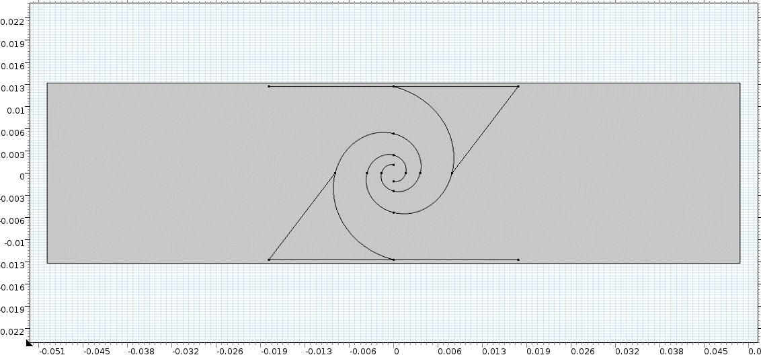

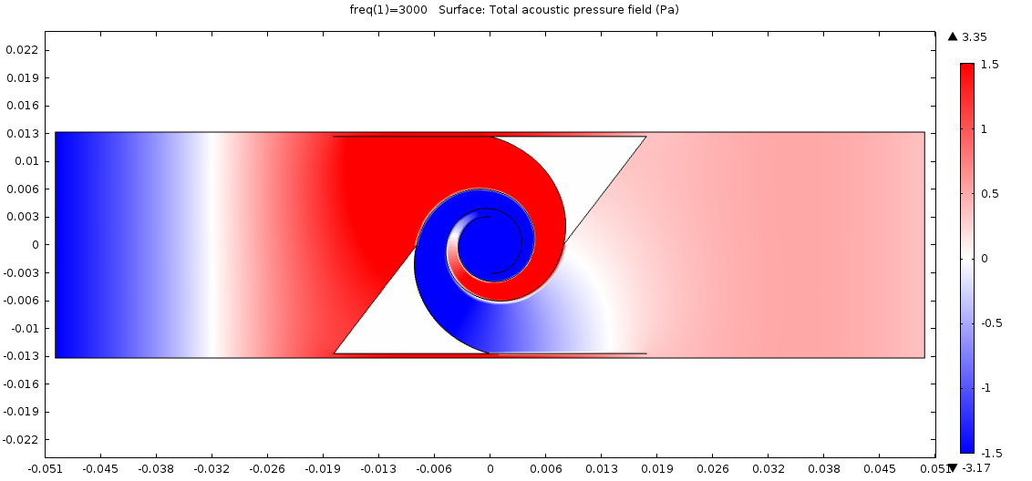

|T| = 0.51, Phase shift = 361

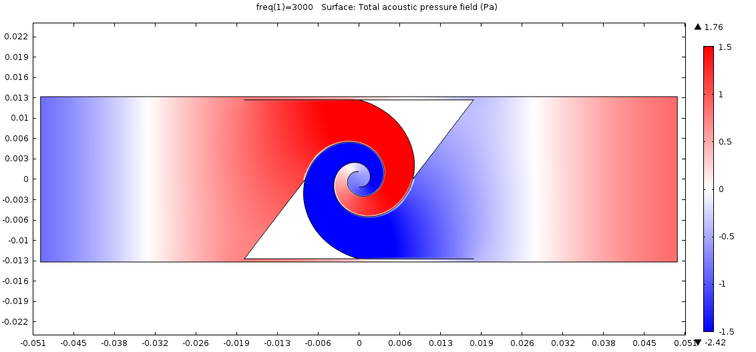

|T| = 0.92, Phase shift = 296

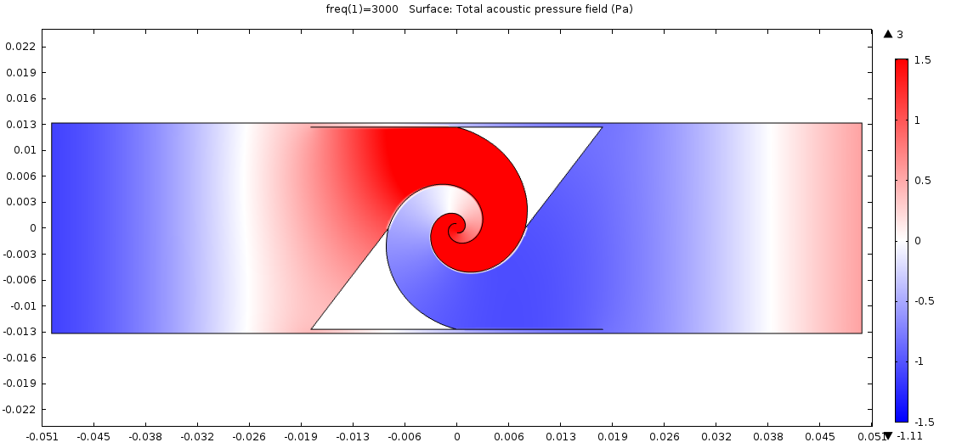

|T| = 0.94, Phase shift = 261

Variables (6 sections)

$$(a_{1}, a_{2}, a_{3}, a_{4}, a_{5}, a_{6}, b_{1}, b_{2}, b_{3},b_{4}, b_{5}, b_{6})$$

$a_{i-1}e^{-b_{i-1}\frac{(i-1)π}{2}}=a_{i}e^{-b_{i}\frac{iπ}{2}}$

$$(a_{1}, a_{2}, a_{3}, a_{4}, a_{5}, a_{6}, b_{1})$$