On the “Atlanta Daily World”: The Corporate Subjugation and Modern Hate on Emory’s Campus

By Connor Kim · Apr 16, 2026

Background

For over a century, Atlanta has been widely regarded as the center for Black excellence, with historical media cementing its role as the cultural epicenter we see today. One such media source, which helped establish Atlanta's civic prominence on the national stage, is the newspaper the “Atlanta Daily World”, the first daily Black newspaper in the United States.
Founded in 1928 by the Morehouse graduate William Alexander Scott II, the Atlanta Daily World (ADW) was created with the intention of empowering Black voices in Atlanta, spotlighting “black educational institutions, businesses, prominent persons, churches, or other news of significance,” (ADW). In addition to drawing attention to the achievements of Black Atlanta, ADW also sought to fight the lack of representation in the media, with the only real news published about Black citizens relating to “crime news and death listings,” (ADW). By providing a voice covering Black Atlanta in a positive light, ADW was seen as the premier source for Black people not only in Atlanta, but on the national stage. This was affirmed through the Atlanta Daily World becoming the first newspaper to have a “White House correspondent: Harry S. Alpin” who held the position beginning in February, 1944 (ADW).
As the first daily newspaper in the United States, the “Atlanta Daily World” was tasked with, and is often praised for, combating the systematic racism which sought to silence and segregate the Black voices in Atlanta. With racist groups such as the KKK and Jim Crow Laws seeking to take power away from Black people in Atlanta, the Atlanta Daily World is often seen as an unyielding force for civil rights.
However, while ADW is largely credited for their role in fighting for Black rights, platforming their voices directly to the nation's capital, when looking at historical media published by the Atlanta Daily World, a different story emerges. Through critical analysis and challenging surface level glorification of Atlanta Daily World, we will explore the price of systematically induced neutrality and its effect on Black Americans during times of racial tension like the Civil Rights movement, and the manifestation of this ‘buried’ racial tension in modern institutions today such as Emory University.

Vested Interest

To understand how Atlanta Daily World pivoted from the uncompromising force for civil rights and black activism to a more palatable news outlet catering to a larger demographic, we must turn to a radical shift in ideology, stemming from the death of the paper's original visionary. On February 4th, 1934, founder William Alexander Scott II was shot and killed with his brother Cornelius Adolphus (C.A.) Scott taking over as “head of the paper,” (ADW).
Unlike his brother, who saw Atlanta Daily World as a platform for Black media in traditionally white dominated spaces, C.A Scott operated from a “more conservative, Republican position”, emphasizing economic pragmatism and institutional stability over grassroots activism (ADW). After the closing of the only other Black Newspaper, the
“Atlanta Independent” in 1933, the Atlanta Daily World became the last remaining voice in Black press in the city. Tasked with the financial and civic burden of operating the sole surviving daily black newspaper in Atlanta ,the paper adopted an editorial mandate that was “mainly neutral in tone” to attract white owned corporate sponsorship (ADW). This deliberate shift to a neutral stance, in spite of their original mission, led to corporations such as Coca Cola, Sears, Roebuck and Company, and, most notably, Rich's, the largest department store in Atlanta to financially support Atlanta Daily World's publication (PBS). While the financial backing of these large White corporations allowed the paper to persist in a time of segregation and Jim Crow, accepting the support of these companies resulted in significant material consequences for subsequent publications which were subjugated to the corporate filter. To fully understand the detrimental effect that resulted from corporate vested interest, we can look at the paper's publication during one of the most tragic periods in Atlanta's History: the Atlanta Child Murders.

Figure 1

“Artifact 1: Victimizing a Killer “
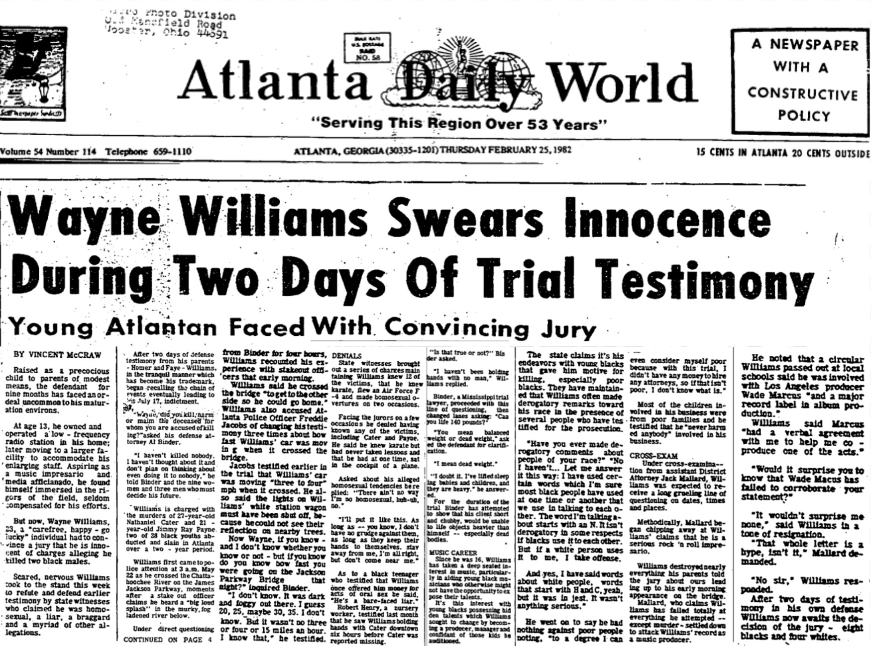
Note. By V. McCraw, 1982, February 25, Wayne Williams Swears Innocence During Two Days Of Trial Testimony, located in the Atlanta Daily World

On February 25, 1982, Vincent McCraw of the Atlanta Daily World, published the article, “Wayne Williams Swears Innocence During Two Days of Trial Testimony”. A visual analysis of this article perfectly illustrates the disconnect between the community’s collective fear of a deadly killer threatening their children, and the publication's editorial stance which has lost touch with the community they were intending to serve.

Figure 2

“Artifact 1: A Visual Analysis”
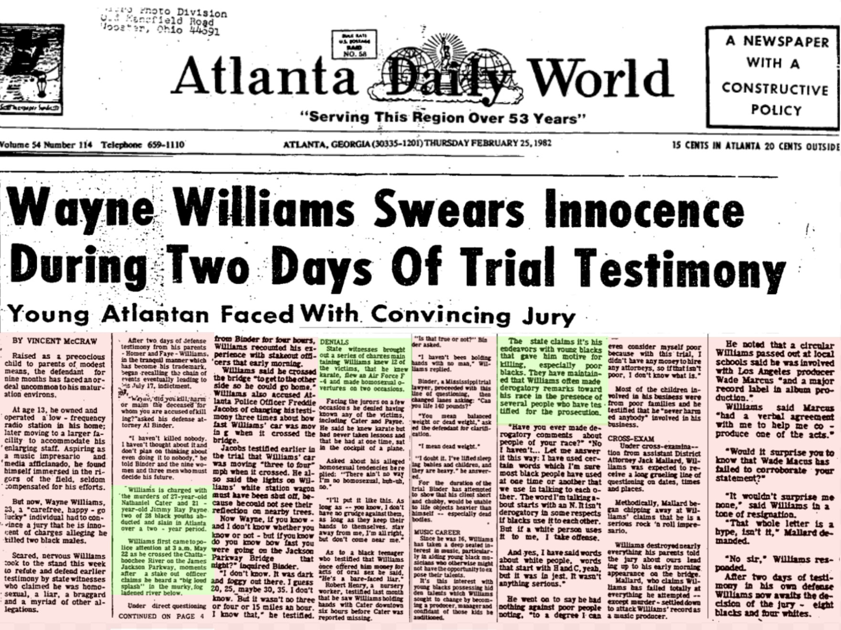
Note. By V. McCraw, 1982, February 25, Wayne Williams Swears Innocence During Two Days Of Trial Testimony, located in the Atlanta Daily World

When examining the article's structural format, we observe that the article sprinkles in details of the actual case and the trial taking place for the murder of 27 year-old Nathaniel Cater and 21 year-old Jimmy Ray Payne (highlighted in green) while spending the majority of the article humanizing Wayne Williams by describing his upbringing and his current life (highlighted in red).
While the paper does not discuss the horrifying reality of children being abducted and killed in Atlanta, it highlights Wayne Williams' childhood, characterising him as a once “precocious child” (McCraw, 1982). The article then goes on to describe his passion for music and his current occupation as an aspiring music impresario (McCraw, 1982). When describing the case itself, they characterize Wiliams as a "'carefree, happy-go-lucky' individual" who now faces the unfortunate burden of having to "convince a jury that he is innocent". Even when the article talks about the perspective motive that Williams had for the killings, given his alleged "derogatory remarks toward his race" and his targeting of “poor blacks", the paper spares no expense in cushioning this narrative, dismissing the possibility that these killings could be motivated by racism and hate (McCraw, 1982).

Figure 3

“Save the Youth”
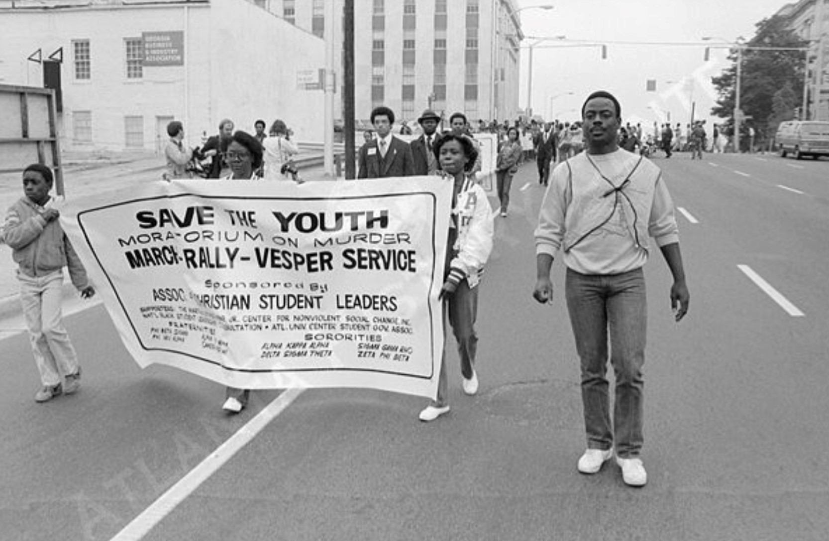
Note. By B. Lewis, 1981, Atlanta Child Murder Cases March, located in the Boyd Lewis Photographs collection.
During the midst of this culturally significant court proceeding, the idea that ADW would rather focus on humanizing the accused murder of dozens of Black children in Atlanta contextualizes how willful ignorance of the community's ongoing distress affected the publications during this time. Pictured is a visual representation of the city’s plea to see actionable results in the case of the Atlanta Child Murders, the photographs captured showing citizens of Atlanta holding signs with the text “"SAVE THE YOUTH" showing the material consequence of the only Black newspaper in Atlanta failing to platform the voices of Black Americans. Rather than being spotlighted by the Atlanta Daily World, these concerned citizens resorted to holding banners pleading for change while the largest Black media platform in Atlanta is publishing articles humanizing the killer responsible for much of this pain.

Figure 4

“Artifact 2: On the wrong side of history”
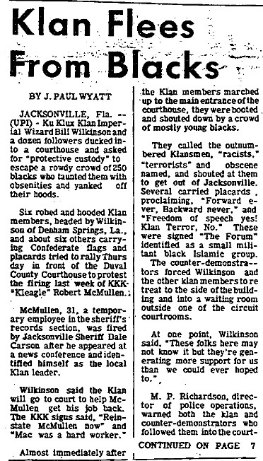
Note. By J. Wyatt, 1982, February 28, Klan Flees From Blacks, located in the Atlanta Daily World (1932-), ProQuest

Sadly, the corporate driven sanitation of articles published by the Atlanta Daily World to maintain the illusion of sociocultural stability through the article covering the Atlanta Child Murders were not an isolated incident, rather they reflected a shift of the publication to defend anti Black rhetoric during moments of racial conflict. One of the most disturbing pieces of historical media illustrating ADW’s forced impartiality is in an article covering Black activists standing up to members of the KKK.
When taking a closer look at the article written by J. Paul Wyatt, published on February 28th 1982, titled “Klan Flees From Blacks”, a darker side of the publication's history is revealed. In this article, the Atlanta Daily World is seen framing a brave group of black rights activists as a threatening group, disrupting the city's public order.
Publication goes out of its way to discredit and tarnish the nobility of the protesting crowd by quoting a bystander’s account of the protest who said a "mob of blacks" pushed them around, taunted them with obscenities, and "stole our hats" (Wyatt, 1982). By not even maintaining neutrality but actively taking an anti-black stance on the accounts of the protest, this historical artifact published by the Atlanta Daily World demonstrates the failure of the publication to support Black Americans and the pro establishment narrative required to keep their corporate sponsors.

Failure to keep their “Promise”
The historical cost of systematically induced neutrality reached a tipping point during the Civil Rights era in Atlanta. The ever-increasing tension between the Black community and the White corporations in Atlanta manifested itself in the form of boycotting and sit-ins at white owned segregated establishments in Atlanta. Rich’s, a notable sponsor of the ADW, was the target of mass boycotting and staged sit-ins organized by the Committee on Appeal for Human Rights (COAHR), an organization made up of HBCU students in Atlanta (Jones, 2010). On October 19 1960, 51 people, including Dr. Martin Luther King Jr., were arrested for participating in a sit-in demonstration at Rich’s Department Store (Jones, 2010).

Figure 5
“We Want to Sit Down”
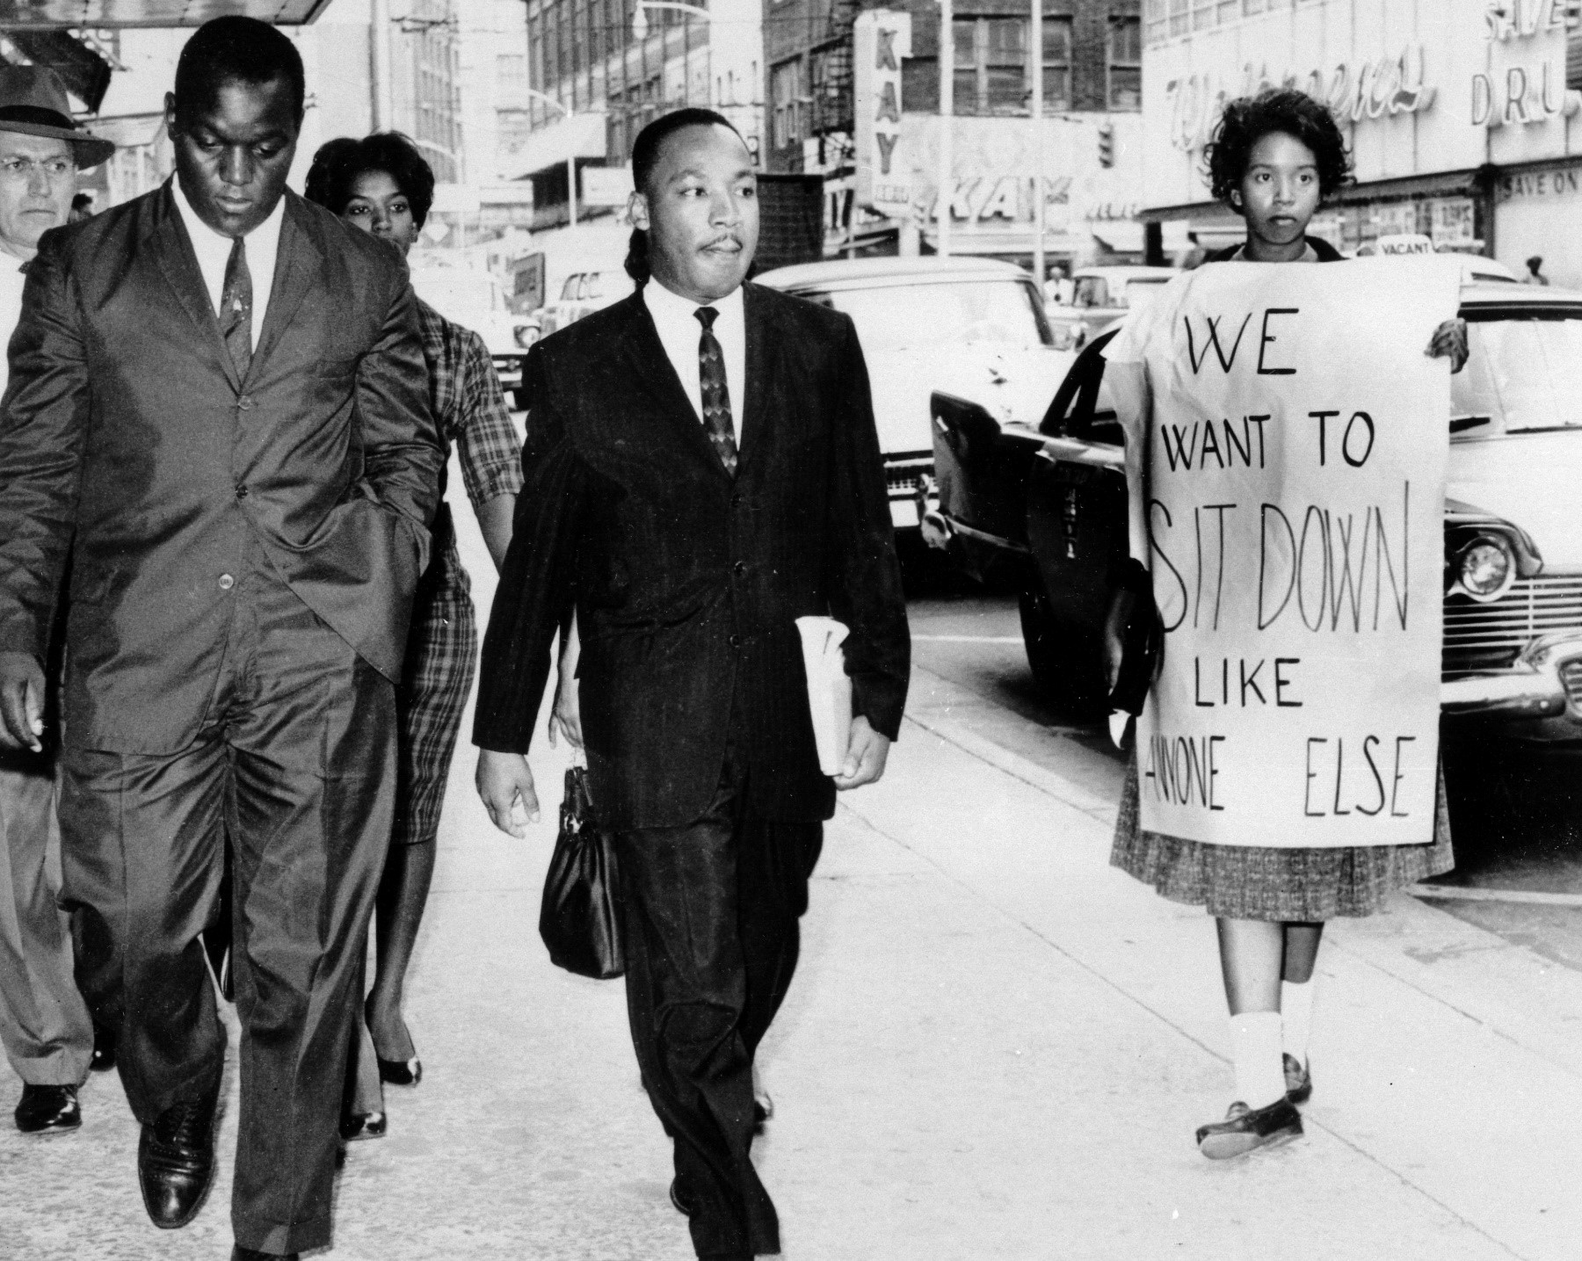
Note. By Associated Press, 1960, October 19, Dr. Martin Luther King Jr. under arrest outside Rich's Department Store, located in the Observer.

As the only black newspaper in Atlanta, the publication was faced with a decision which would have lasting implications in Atlanta's cultural landscape for the decades to come. Rather than to support the mission of Atlanta Daily World founder William Alexander Scott II, C.A. Scott allowed his personal bias and conservative agenda to get between fulfilling the civic duty ADW held as a force for actionable change in civil rights activism. Under threat from“advertisers [who] threatened to pull their business if the demonstrations didn’t stop, C.A. Scott publicly criticized the sit-ins held at Riches and effectively turned his back on student activists trying to create actionable change, choosing financial stability over Black liberation in a historical turning point in US history. Rather than supporting young Atlanta HBCU students in their goal of abolishing segregation, C. A Scott asserted that these demonstrations were " dangerous", hurting Black citizens "looking for jobs"(ADW). He further asserted that Black people in Atlanta should instead elevate their “economic situations” to help combat segregation(ADW). By asserting the necessity of economic gradualism in a system actively designed to marginalize black citizens, the Atlanta Daily World became a part of the problem which William Alexander Scott II aimed to solve. The failure of the Atlanta Daily World to support grassroots activism during one of the largest civil rights movements in the nation's history to maintain the illusion of neutrality and public order has unfortunately created lasting consequences which are felt in the city to this day. By refusing to confront the racial injustice in the city as the only black newspaper in Atlanta, it has left these issues unresolved, leading to modern students to fight the same unresolved racial tension which the COAHR fought over 80 years ago. In contemporary media today, the collision between student advocacy and institutional pacification can be seen throughout Atlanta, even at Emory University.

An Ongoing Struggle

Figure 6
“Racial Tension at Emory: Oxford Campus”
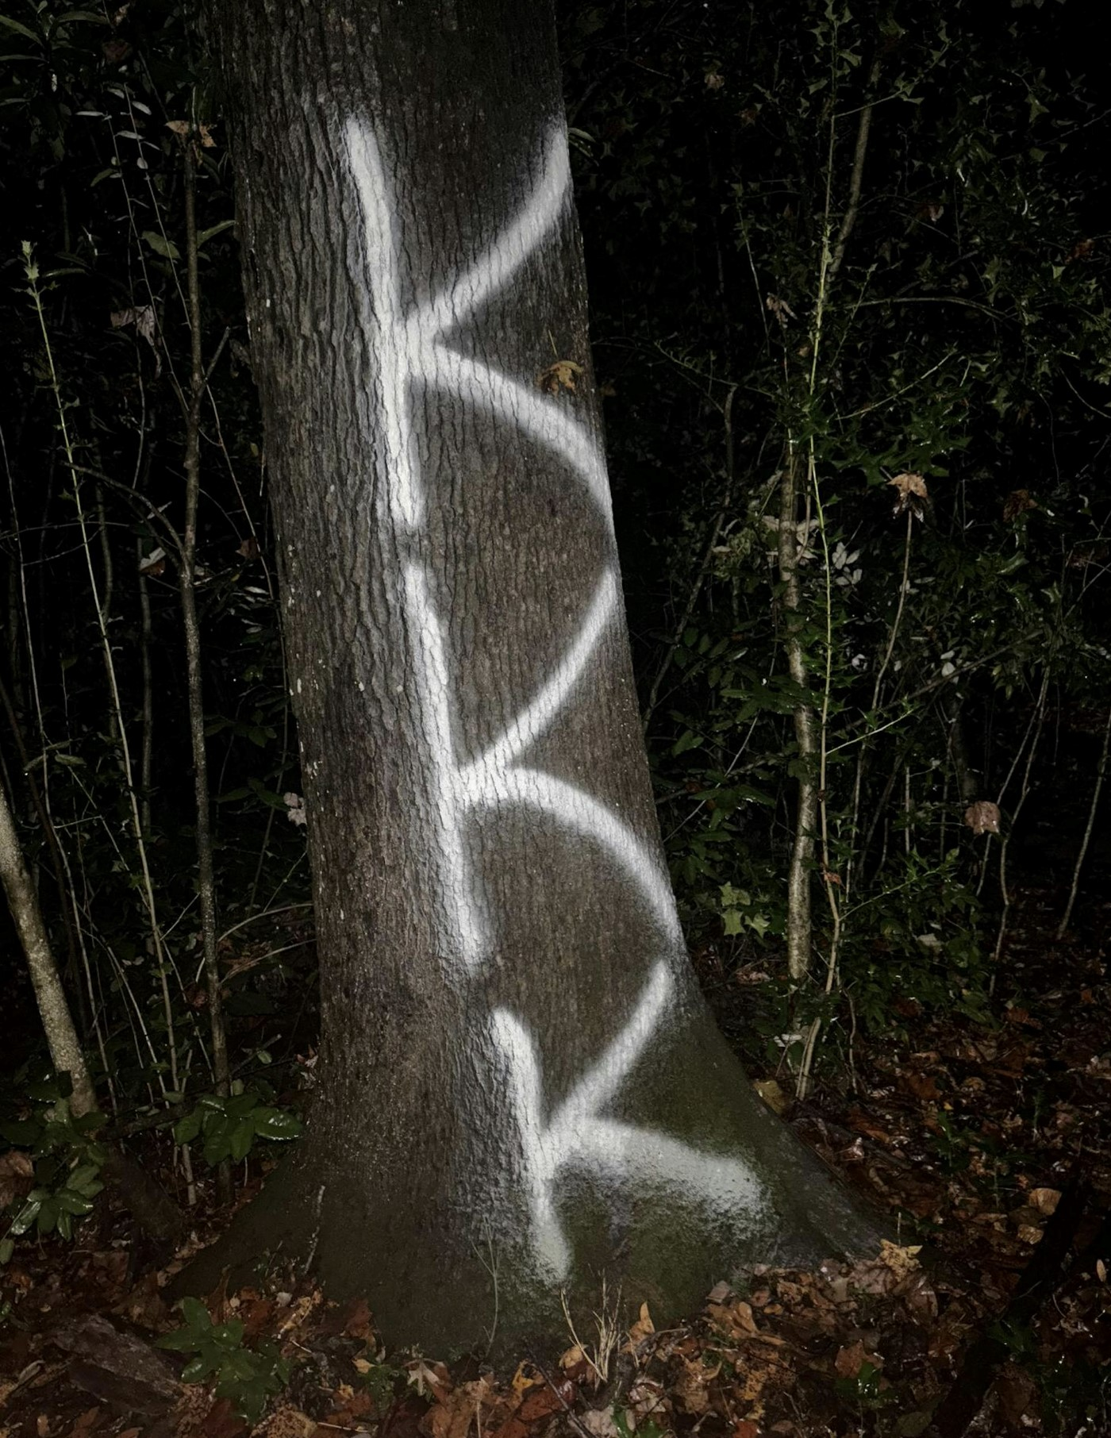
Note. By I. John and K. Schiller, 2025, October 29, Students find 'hateful' graffiti message along Oxford nature trail, located in The Emory Wheel.

As recently as 2025, incidents of racism on both Emory's Oxford Campus and Atlanta
Campus shine light on an uncomfortable reality of persistent racial tension and the consequences of institutional neutrality. The articles published by the student-led Emory publication, reflect the burden placed on students to confront the reality of racism in a city so used to ignoring events such as these.

Figure 7
“Racial Tension at Emory: Atlanta Campus”
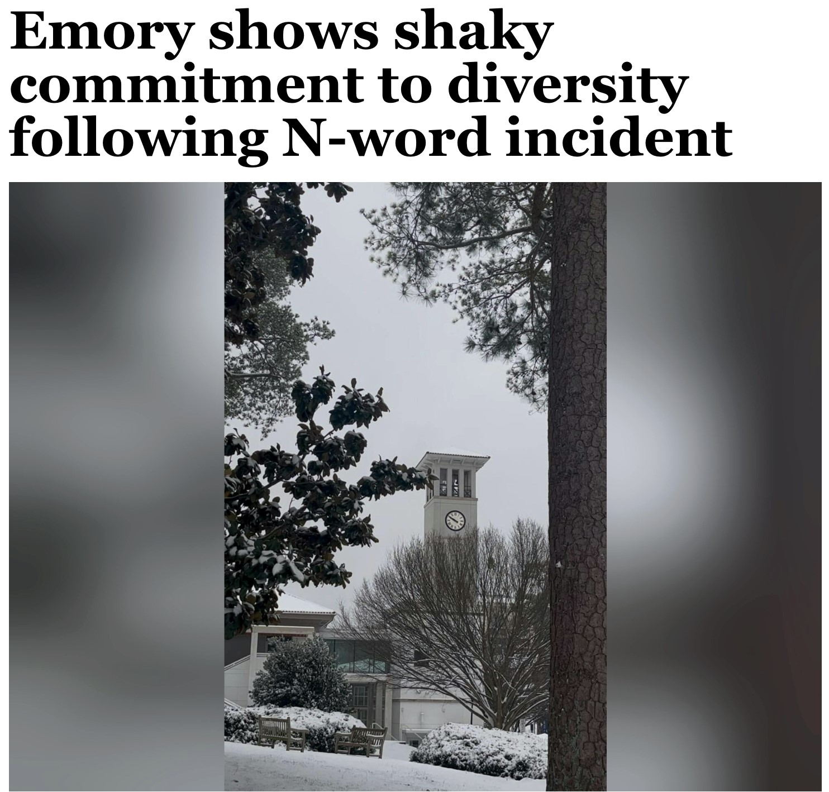
Note. By The Editorial Board, 2025, January 23, Emory shows shaky commitment to diversity following N-word incident, located in The Emory Wheel.

The article published by the Emory Wheel editorial board on Jan. 23, 2025 titled, “Emory shows shaky commitment to diversity following N-word incident”, highlights the shared frustration and lack of accountability and actionable change taken after blatant racism occurs on campus. Emory's response to the N- Word Incident was described as “frustratingly lacklustre in their delayed and limited statements” by the Emory Wheel’s Editorial Board in their 2025 article.
The “lacklustre” response to racism on campus is a modern manifestation of C.A. Scott's "mainly neutral" editorial mandate. By shifting the responsibility for fighting racism away from themselves and towards the student body, it forces students of marginalised groups to carry the heavy burden of grassroots activism. The shift of the burden from platformed news outlets to individuals has been an unfortunate pattern carried on from the ADW to The Emory Wheel.

Figure 8
“Fighting for Change on Emory’s Campus”
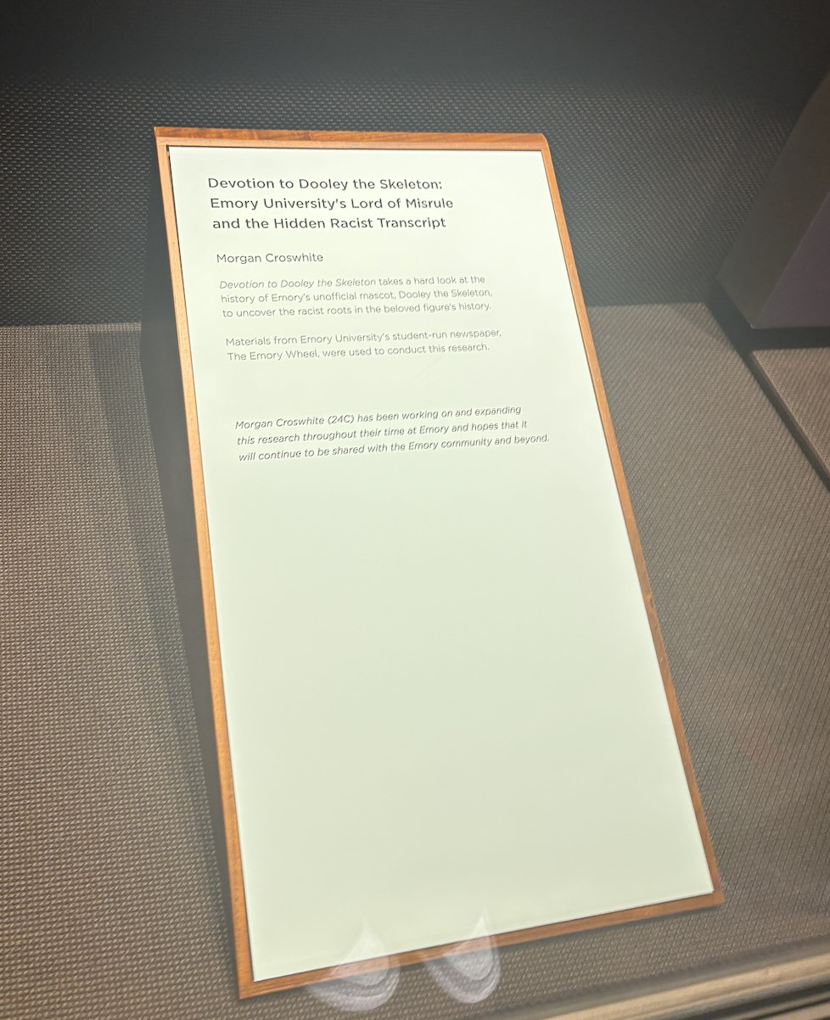
Note. By C. Kim, 2026, Photograph of "Devotion to Dooley the Skeleton" exhibit placard by M. Croswhite, located in the Stuart A. Rose Manuscript, Archives, and Rare Book Library at Emory University.

Although Emory University is not collectively racist, the institution's desire to maintain impartiality through current and historical events of racism represents a broader issue in cultural sanitation. Despite concerted efforts from activists within the Emory community to confront the racist origins of Emory’s culture, most notably surrounding Dooley the Skeleton, the University has largely ignored these efforts by highlighting Dooley across campus and through the Dooley’s week celebrations. The divide on campus between those who know the origin of the mascot and those who are unfamiliar highlights the persistent issue of sanitising and ignoring the uncomfortable truth surrounding racist parts of Emory's past and instead gravitating to willful ignorance. Again, the neutral stance of disregarding the issue is taken, preventing the people who hold deeper issues from being platformed.

Figure 9
“Skeletons in the Closet”
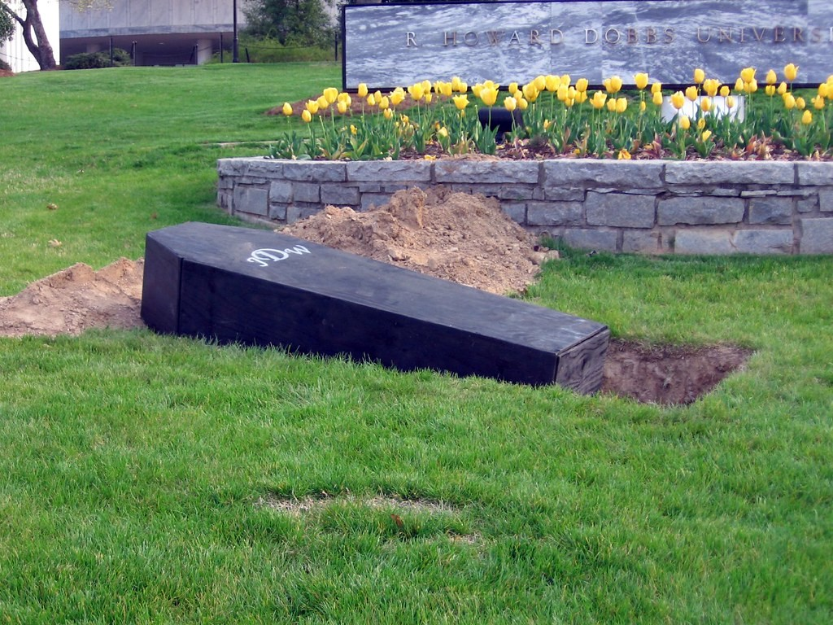
Note. By dolescum, "Dooley rises from the grave," licensed under CC BY-NC-SA 2.0.
The visual representation of Dooley's coffin on campus grounds captures this ongoing tension. While a minority of students are fighting to unearth and confront the skeletons of Emory's past, the wider institution would rather ignore these uncomfortable truths and disregard the past. Ultimately, the decision of the Atlanta Daily World in confronting the ongoing racial tension in Atlanta has developed a culture of unresolved conflict that manifests itself throughout modern-day in Atlanta, even in our own school.

References

"About Us." Atlanta Daily World, atlantadailyworld.com/about-us/. Accessed 24 Apr. 2026.
"Atlanta Daily World." The Black Press: Soldiers Without Swords, PBS, www.pbs.org/blackpress/news_bios/newbios/nwsppr/atlnta/atlnta.html. Accessed 24 Apr. 2026.
"How 60 Years Ago Today Martin Luther King’s Traffic Ticket Changed History’s Course." Chicago Tribune, 4 May 2020, www.chicagotribune.com/2020/05/04/how-60-years-ago-today-martin-luther-kings-traffic-tic ket-changed-historys-course/.
John, Irene, and Kimble Schiller. "Students Find 'Hateful' Graffiti Message Along Oxford Nature Trail." The Emory Wheel, 29 Oct. 2025, emorywheel.com/article/students-find-hateful-graffiti-message-along-oxford-nature-trail-202 51029.
Jones, Hannah. "Atlanta Students Sit-in for U.S. Civil Rights, 1960-1961." Global Nonviolent Action Database, Swarthmore College, 31 Jan. 2010, nvdatabase.swarthmore.edu/content/atlanta-students-sit-us-civil-rights-1960-1961.
Lewis, Boyd. Atlanta Child Murder Cases March. 1981. Digital Library of Georgia, dlg.usg.edu/record/geh_byd_650.
"Martin Luther King Jr. Arrested 1960 Atlanta Sit In." San Antonio Observer, saobserver.com/martin-luther-king-jr-arrested-1960-atlanta-sit-in/. Accessed 24 Apr. 2026.
McCraw, Vincent. "Wayne Williams Swears Innocence During Two Days Of Trial Testimony." Atlanta Daily World, 25 Feb. 1982, p. 1. ProQuest, www.proquest.com/docview/491576305.
The Editorial Board. "Emory Shows Shaky Commitment to Diversity Following N-Word Incident." The Emory Wheel, 23 Jan. 2025, emorywheel.com/article/emory-shows-shaky-commitment-to-diversity-following-n-word-inc ident-20250123.
Wyatt, J. Paul. "Klan Flees From Blacks." Atlanta Daily World, 28 Feb. 1982, p. 1. ProQuest, www.proquest.com/docview/491573148.

