Echoes of the Past in Atlanta’s Public Transit Conversation
By Elaine K. Feller | April 17, 2026
Atlanta’s independence as a defense mechanism against neglect and exploitation impacts major policy areas such as public transit. A 1971 opinion piece from the Atlanta Daily World newspaper archives aims to convert skeptics of the MARTA bus and rail system, which at the time was just a proposal up for vote (Allison). Although Atlanta prides itself on its self-sufficiency, the MARTA piece highlights the dark side of an individualism that impedes collaboration, threatening a public transit proposal that could benefit everybody.
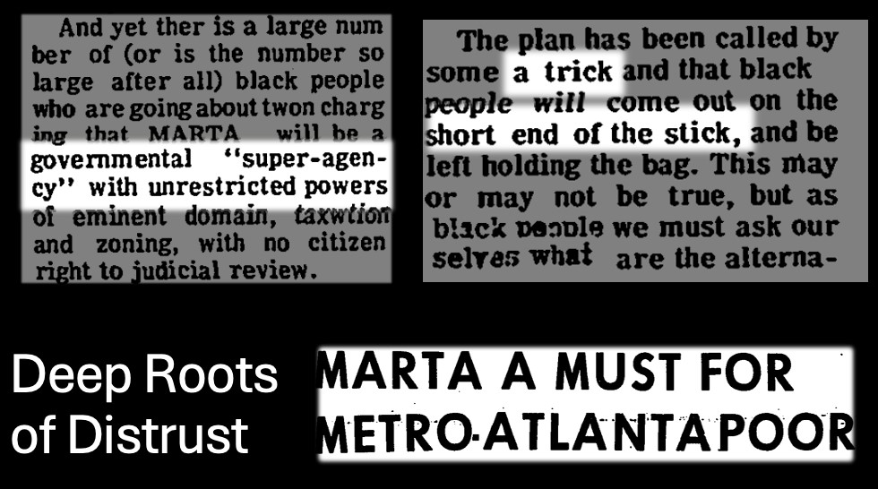
Allison, R. S. A trick/The short end of the stick, 1971, Atlanta Daily World, Atlanta.

The article documents a profound distrust of government present among some Atlanta residents, rebutting the view that “MARTA will be a governmental ‘super-agency’ with unrestricted powers of eminent domain, taxwtion [sic] and zoning…” The author shares that “the [MARTA] plan has been called by some a trick and that black people will come out on the short end of the stick.” Clearly, this view did not arise out of nowhere: throughout history, Black
Southerners have repeatedly been exploited—through events such as the Tuskegee Untreated Syphilis Study in Alabama (CDC)—and neglected—such as during the Atlanta Child Murder cases, sloppily investigated and hastily buried (FBI)— and may have been reluctant to hand more power to a government that did not always have their best interests in mind.
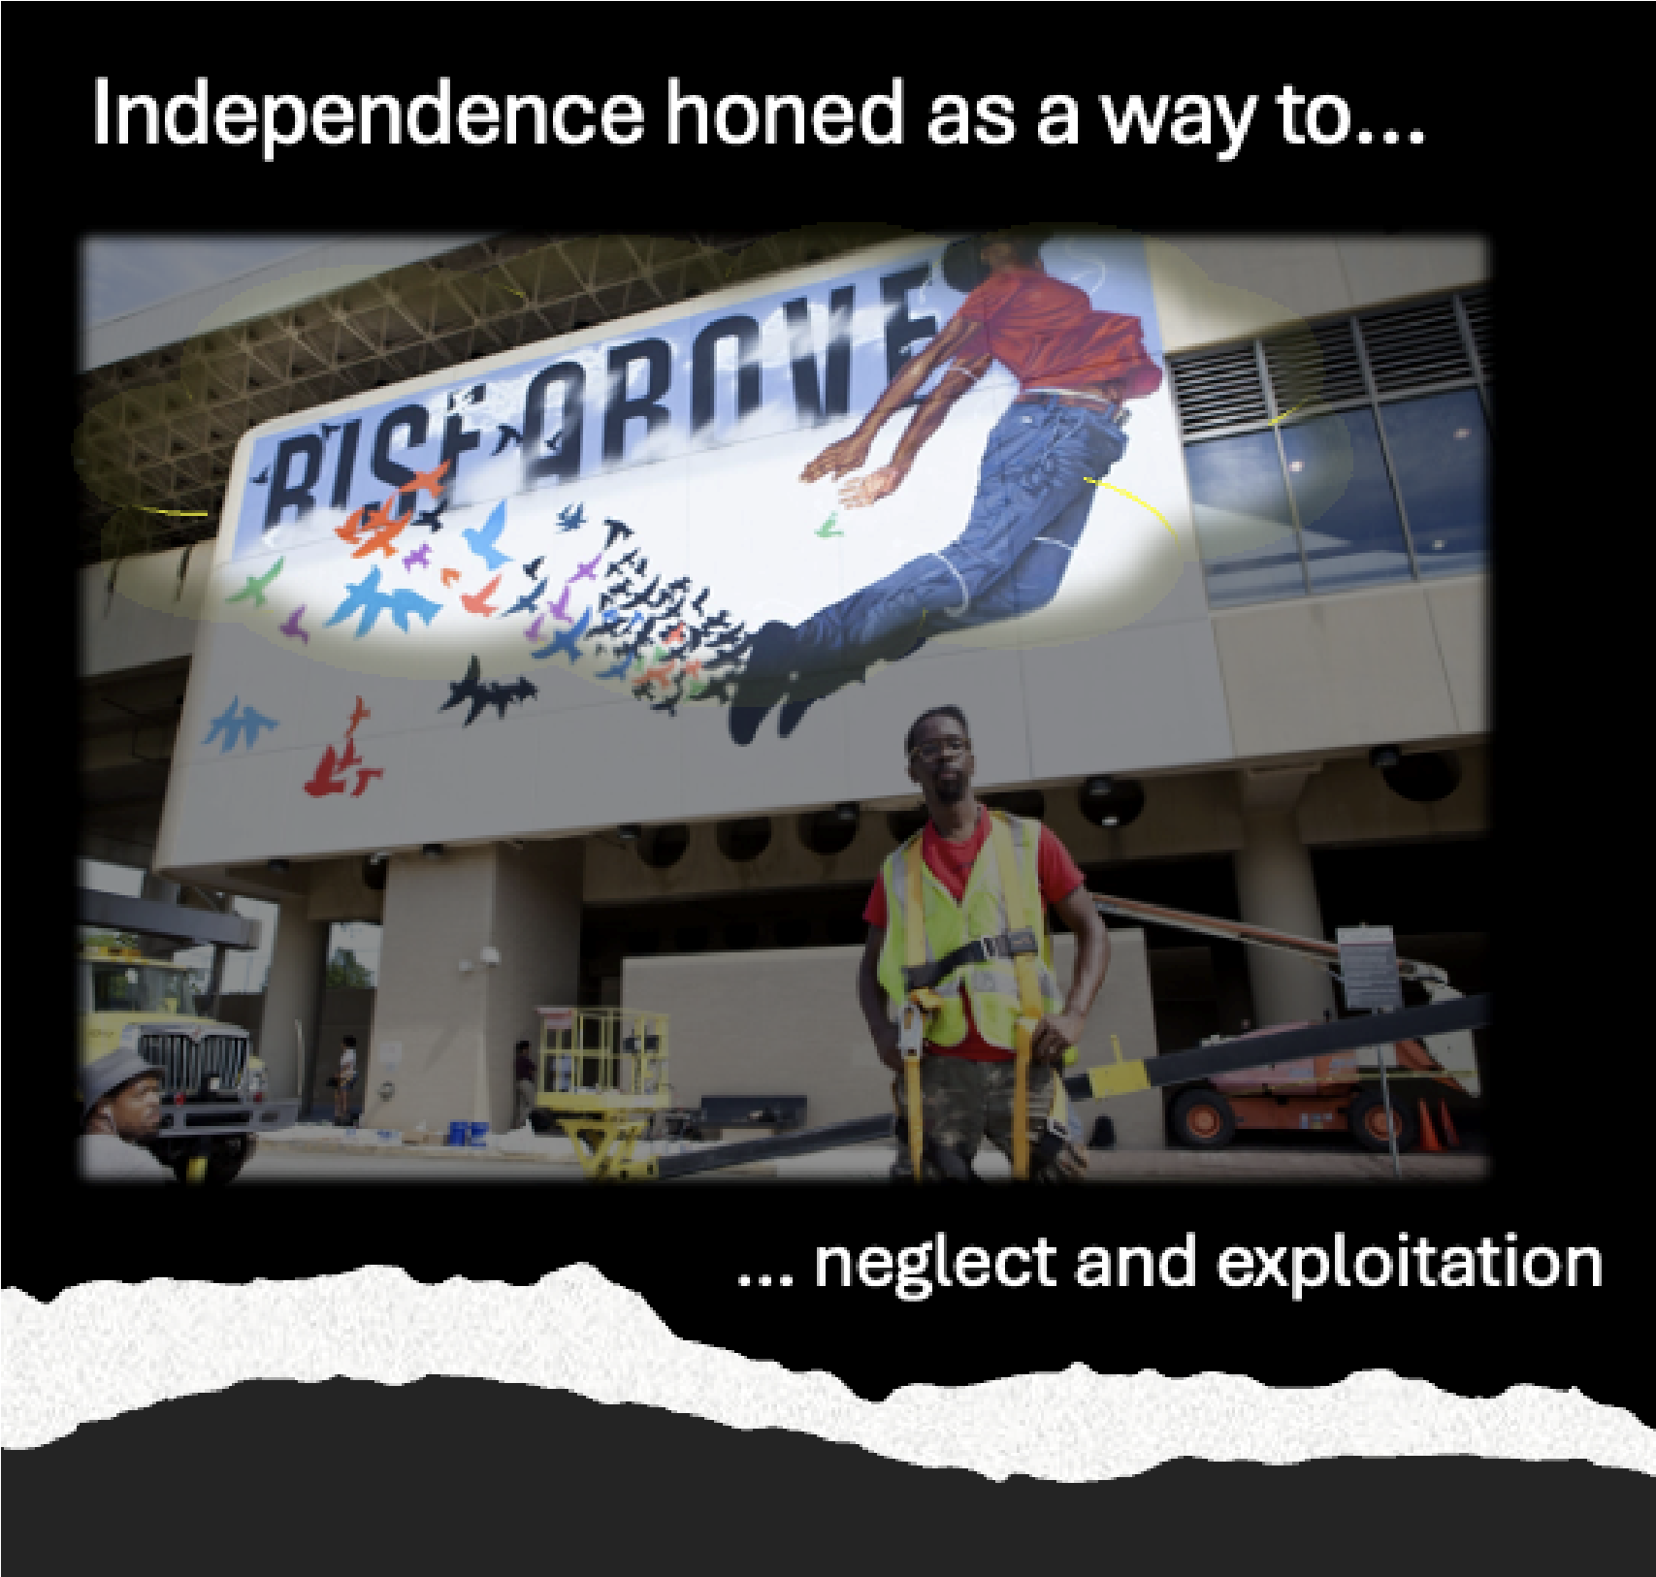
Godfrey, Gavin. Fahamu Pecou, 2016, ArtsATL, Atlanta.
MARTA skeptics may still have been hearing echoes of historical events like the 1906 Atlanta Race Massacre. Atlanta entered the 20th century with acute unease over increasing civil rights for Black men, including voting and owning their own businesses. White political candidates like Clark Howell and Hoke Smith spoke about the need to quote “get rid of black men at the polls.” White newspapers ran unsubstantiated stories about alleged attacks on white women by Black men. The hate boiled over with a four-day rampage on Black businesses in the Five Points area. Rioters killed 25 Black men. None of the murderers were ever meaningfully punished, but over 250 Black Atlantans were arrested (Lohr). The city’s role in inciting the violence, as well as its spectacular failure to deliver justice, was not easily forgotten.
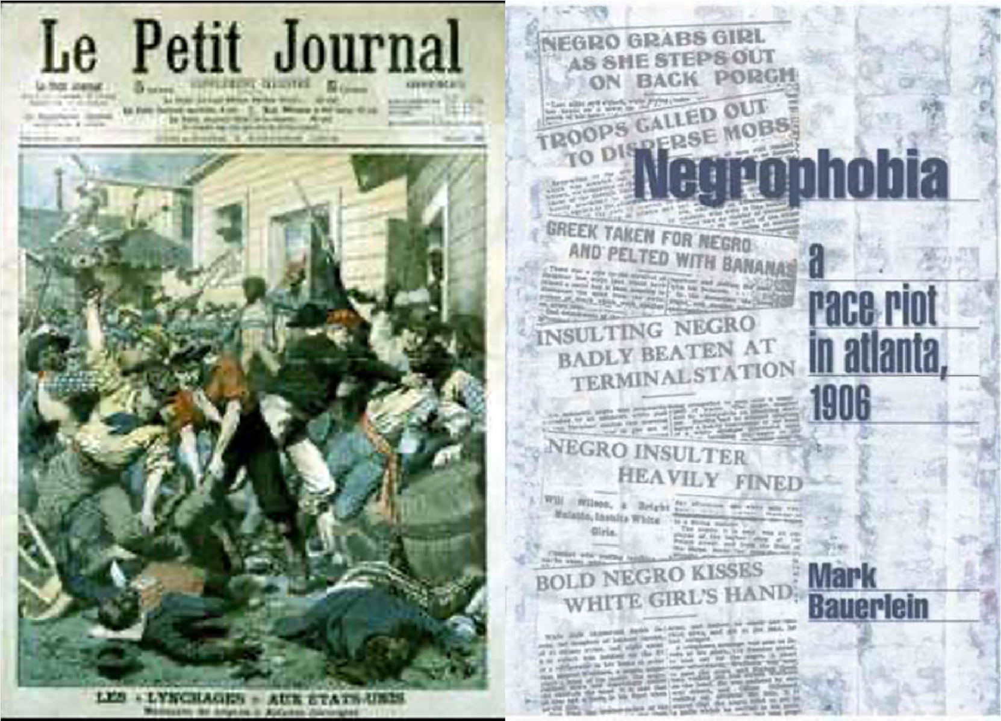
Kenan Research Center, Cover of the French Magazine Le Petit Journal, 7 Oct. 1906, Atlanta History Center, Atlanta & Bauerlein, Mark, Negrophobia, 2001, Encounter Books.

So when the author of this newspaper article presents objections to the MARTA project, they do so with sensitivity: the author clearly disagrees with the sentiment that “MARTA will be a governmental ‘super-agency,’ ” but to the idea that “black people will… be left holding the bag,” they respond not “This is crazy,” or “This is stupid,” but “This may or may not be true.”
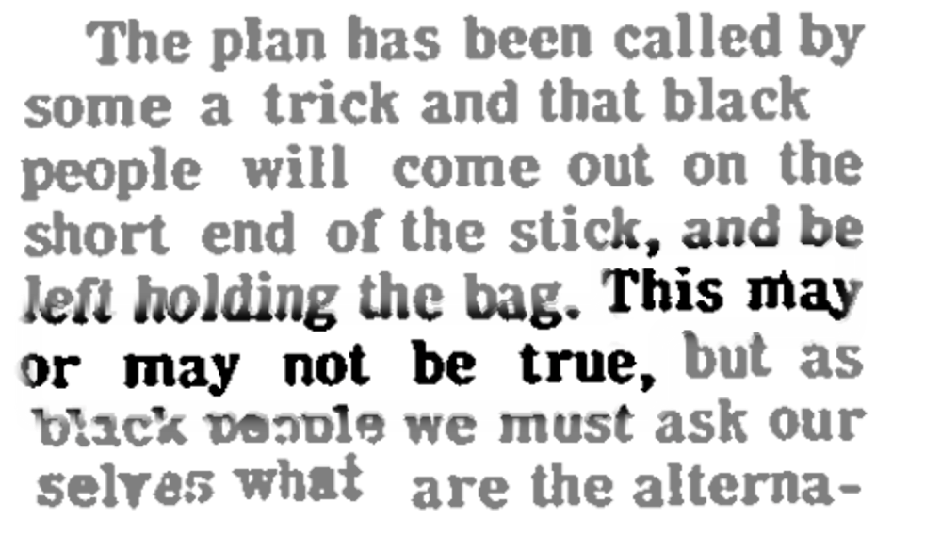

Allison, R. S. A lukewarm endorsement, 1971, Atlanta Daily World, Atlanta.

In spite of the repeated harm and neglect by the government, the author urges readers to consider the potential benefit of MARTA for poor Black residents, who at the time could spend up to $15-20 a month on bus fare. She pleads with readers who have learned that they can’t count on the authorities to look out for them, imploring them to place some trust in the government for the sake of a project that could lift up the entire city, and especially Atlanta’s most vulnerable. All told, the op-ed reflects Atlanta’s scrappy media identity as a city of strivers who have learned to forge their own paths to success in a hostile world. But Atlanta worshipped self-sufficiency at the cost of collaboration.

Works Cited
Allison, R. S. “MARTA a must for Metro Atlanta poor.” Atlanta Daily World (1932-), 31 Oct. 1971, Retrieved from https://login.proxy.library.emory.edu/login?url=https://www.pro quest.com/newspapers/marta-must-metro-atlantapoor/docview/491360997/se-2.
Accessed 7 Apr. 2026.
Bauerlein, Mark. Negrophobia: A Race Riot in Atlanta, 1906. Encounter Books, 2001.
CDC. “About The Untreated Syphilis Study at Tuskegee.” 4 Sept. 2024, https://www.cdc.gov/tuskegee/about/index.html. Accessed 17 Apr. 2026.
FBI. “Atlanta Child Murders.” FBI Vault, https://vault.fbi.gov/Atlanta%20Child%20Murders.
Accessed 17 Apr. 2026.
Godfrey, Gavin. “Fahamu Pecou talks En Route and MARTA’s complex past, present, and future.” ArtsATL, 7 Sept. 2016. https://www.artsatl.org/fahamu- pecou-talks- en-route-martas-complex-past-present-future/. Accessed 12 Apr. 2026.
Kenan Research Center at the Atlanta History Center. “Cover of the French magazine, Le
Petit Journal, October 7, 1906.” Atlanta History Center. https://www.atlantahistorycenter.com/blog/riot-or-massacre-how-one-word-
changes-perspective/. Accessed 11 Apr. 2026.
Lohr, Kathy. “Century-Old Race Riot Still Resonates in Atlanta.” 22 Sept. 2006, https://www.npr.org/2006/09/22/6106285/century-old-race-riot-still-resonates-in- atlanta#:~:text=The%20riot%20continued%20for%20days,than%20the%20official%
20records%20show. Accessed 11 Apr. 2026.

