Atlanta has always told its own story. The question is who gets left out.

By Lily Li | Apr 23, 2026
Today, as much as ever, Atlanta projects a media identity as a city for the people. Atlantans take pride in their scrappiness: their ability to hustle and thrive within a system that was not built for them and is not looking out for their best interests. It is in this spirit that Atlantans speak truth to power through art such as hip-hop and film. And yet, Atlanta’s treasured self-sufficiency comes with a dark side: residents tend to distrust powers such as government and global corporations. This, it may be argued, for good reason. Still, Atlanta at times gets in its own way as a consequence of its fierce individualism. The city’s progress tends to occur unevenly, and during emergencies, cooperation can be critically lacking.
Atlanta in the past
To understand Atlanta's media identity, we first have to understand who was doing the storytelling and why.
The Atlanta Daily World, founded in 1928, was one of the most significant Black newspapers in the American South. It didn't exist because journalism needed another outlet. It existed because the mainstream white press was neglecting the Black population entirely and misrepresenting them. So Black Atlantans built something themselves. The Daily World became Atlanta's own media infrastructure and a platform for the community to document its own life, on its own terms.
This is where our story begins. Because the same instinct that founded the Daily World, which is the refusal to wait for someone else to tell your story and frame it for you, is what gave rise to hip-hop. Hip-hop was born in New York, but by the 1990s Atlanta had built its own lane: producers like Jermaine Dupri and the LaFace Records roster put Southern rap on the map at a time when coastal critics dismissed it entirely. During the 1980s and early 1990s, the "East Coast vs. West Coast" rivalry dominated the industry, rendering the South virtually invisible to mainstream critics and labels. But the South, especially Atlanta, fought for it. The most famous example came at the 1995 Source Awards, when André 3000 delivered his now-legendary declaration: 'The South got something to say' — a rallying cry for the entire region. And it's because of this persistence, hip-hop's "center of gravity" shifted from the coasts to Atlanta, which today is widely considered the genre's global headquarters.
Fast forward to 2006. The Daily World publishes an article announcing that Atlanta's Fox Theatre will host the first-ever BET Hip-Hop Awards. On the surface, this looks like a straightforward entertainment story. But read closely, and it's something bigger: it's Atlanta staking a claim.
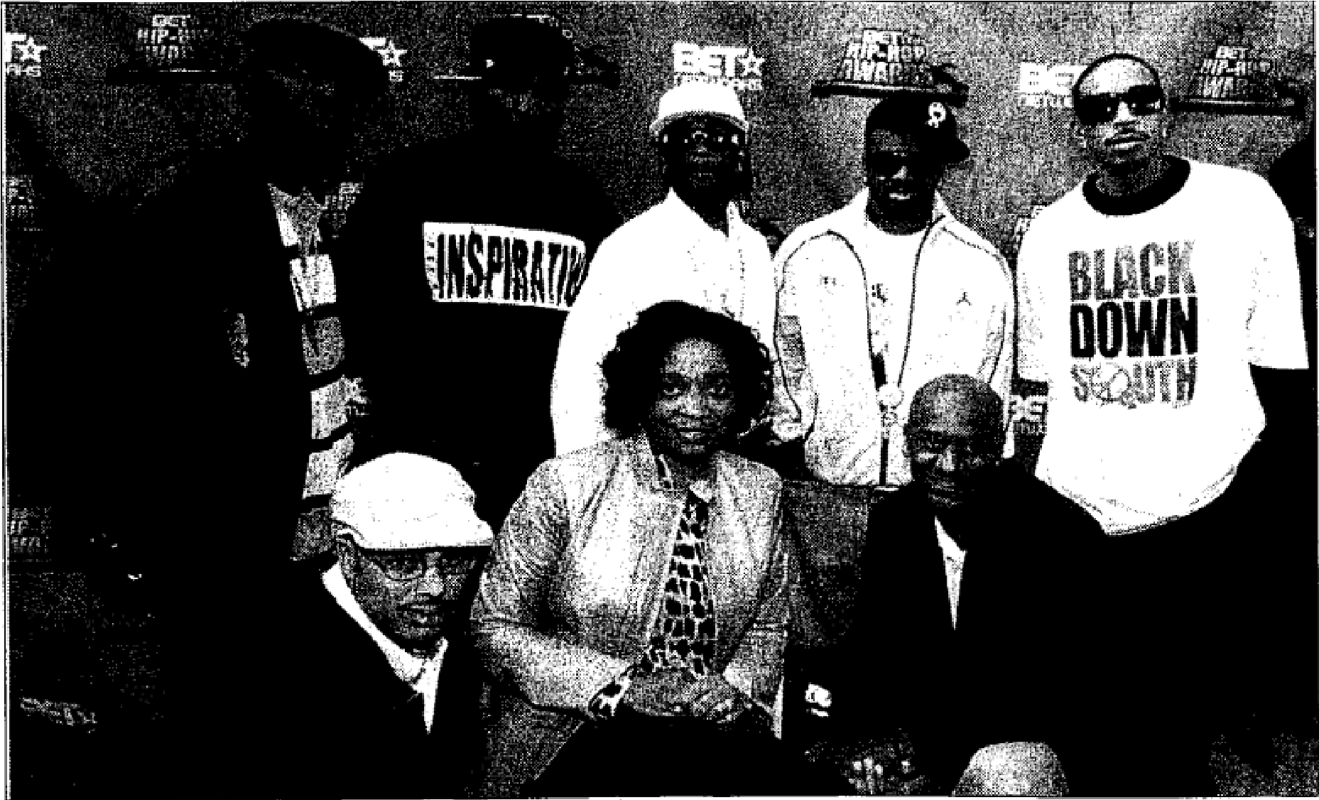
Atlanta put its stamp on hip-hop history as legends and power players gathered to unveil the nominees for BET's first-ever Hip-Hop Awards. (Photo by Rick Diamond, Oct. 19, 2006)
DJ Grandmaster Flash, featured in this article, is one of the founding pioneers of hip-hop who helped shape the art of DJing itself with multiple innovations. He was being honored at the ceremony. He describes hip-hop as "a chance to tell his story," and a way for people to speak about their experiences, especially those ignored by more mainstream media. That framing matters. Hip-hop is more than music.
And Atlanta doesn't just want to host this moment. They have bigger ambitions. Then-City Council President Lisa Borders makes that explicit:

"We don't want to be the host of the first BET Hip-Hop Awards. We want to become the home of the BET Hip-Hop Awards."
That's a declaration of identity. With this, Atlanta cements its image as a city of the people, lifting the voice of the individual. The newspaper itself is nearly 80 years old at this point and still doing the same work of centering Black Atlanta. It is the vehicle that preserves and amplifies this claim.
But here's where it gets complicated. The same ideology driving this triumph of fierce individualism, the celebration of the exceptional hustler who rises above the rest, does carry a cost.
The BET Hip-Hop Awards ceremony is organized around categories like MVP of the Year, Hip-Hop Hustler, and Rookie of the Year. The language is drawn from competition: sports, business, the lone operator clawing to the top. And the reporter notes something telling: "Notably missing from the BET Hip-Hop Award nominees are women." Industry figure Jermaine Dupri acknowledges it plainly with "It has always been the guys promoting one woman here and there."
This isn't incidental. It follows directly from the logic of individualism itself. When recognition is framed as scarce, when the whole framework is built around one MVP, one hustler, one exceptional voice rising above the crowd, that framework doesn't just uplift. It also justifies exclusion. There's only room for one at the top, and historically, that spot defaulted to men. Essentially, some can argue how the very structure that made hip-hop feel liberating for some reproduced the same hierarchies it claimed to challenge. This idea continues to flow into the present day, where resources such as money, fame, and voice were viewed as scarce, especially for minorities and women. To get ahead, it can feel as though one had to elbow everybody else out of the way.
Atlanta's story has always been one of self-determination, and this instinct is genuinely powerful. But self-determination for some can be built on the exclusion of others. Instead of true liberation, some might claim it is just a different arrangement of the same hierarchy. As a result, the city that taught the world the South had something to say still has more work to do in deciding who gets a microphone.

