Atlanta's Media Making: Black
Higher Education and Atlanta's Public Identity
By Nayana Gowda | April 24, 2026

Historical Context: Jim Crow and the Counter-Narrative
To understand Atlanta's role in Black media making, we must first expand what we mean by "media." Media was not simply newspapers or radio broadcasts. Under Jim Crow, segregation laws, public signage, and civic symbols themselves functioned as a media system, constantly communicating who belonged in public life and who did not. Black Americans were excluded from universities, hospitals, and civic spaces, and that exclusion was not subtle. It was displayed, repeated, and reinforced in everyday objects and environments.
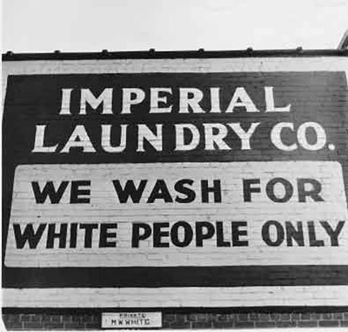
Jim Crow didn't need a megaphone. A laundry sign would do."

Atlanta's HBCUs, including Morehouse, Spelman, and Atlanta University, emerged as a direct counter-response to that system. They were not merely places of learning. They were intentional sites of counter-narrative, spaces where a fundamentally different story about Black life, intellect, and belonging could be created and sustained.

John Hope: Building the Foundation
Before the most well-known chapter of this story begins, the foundation had already been laid by John Hope, one of the first Black presidents of Morehouse College and a principal architect of the 1929 affiliation that formalized the Atlanta University Center. Hope rejected the dominant expectation that Black education should prepare students primarily for labor. He believed in positioning Black students as intellectual leaders and thinkers, which was a radical act in the context of its time.
Though the phrase "media making" would not have been used then, Hope was already engaged in it, deliberately shaping institutional identity to communicate value, ambition, and capability to the outside world. The 1929 affiliation he helped engineer brought together Atlanta's Black colleges into a coordinated consortium, strengthening their collective presence and visibility.
When we look at what came after, we are not watching something new emerge from nothing. We are watching a structure that Hope built be put to use.

Benjamin Mays and the "Morehouse Man"
Benjamin Mays inherited a financially struggling Morehouse College and rebuilt it into one of the premier HBCUs in the country through strategic leadership, fundraising, and identity construction. What Mays created was not just an academic program. He created a public identity: the "Morehouse Man."
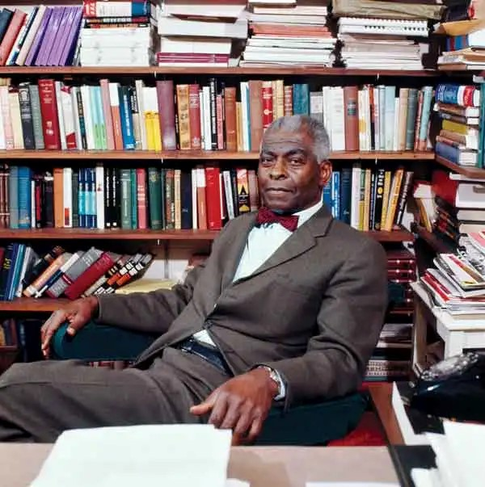
Benjamin Mays: The man who turned a college into a message

This was a deliberately crafted character, intellectually excellent, morally grounded, and civically responsible. In contemporary terms, Mays was building a brand. But what made this brand extraordinary was its medium. It was not spread through advertisements or broadcasts. Every graduate became the message, a living representation of the institution's values. Morehouse functioned as a kind of embodied media platform, where the story was communicated through reputation, behavior, and presence in the world.
As Rovaris (1990) describes it, Mays was a "developer of an institution," and that framing is important. Before Twitter, before television dominance, the narrative was carried by the institution itself and by the people it produced. Mays broadcast his message through every student who graduated, every speech he delivered, and every national platform he occupied in civil rights and religious life.
That identity shaped Martin Luther King, Jr., who graduated from Morehouse in 1948. And through King, what began as an institutional identity in Atlanta became a national and eventually global narrative about Black leadership, moral courage, and the fight for justice.

Media Making Without Traditional Media
What this history ultimately reveals is that media making does not require traditional media channels. It can be built through institutions, sustained through people, and spread through lived experience. Atlanta's HBCUs demonstrate that a counter-narrative can be constructed and maintained even in conditions of deliberate exclusion, not by gaining access to dominant platforms, but by building something powerful enough to speak for itself.
The story Atlanta's Black colleges told was not incidental. It was strategic, sustained, and consequential. It shaped the civil rights movement, produced generations of national leaders, and established Atlanta as a center of Black intellectual and civic life long before the city's contemporary media identity took shape.

Works Cited
Avery, Vida L. A Fateful Hour in Black Higher Education: The Creation of the Atlanta University System. Georgia State University, 2003. ProQuest Dissertations and Theses.
"HBO's The Gilded Age: A Disappointingly One-Sided Depiction of a Complex Era." SHG APE Blog, blog.shgape.org/hbos-the-gilded-age-a-disappointingly-one-sided-depiction-of-a-complex-era/
"Lest We Forget: Benjamin Elijah Mays, Virginia Union." HBCU Story, hbcustory.org/lest-we-forget-benjamin-elijah-mays-virginia-union/
Rovaris, Dereck Joseph. Developer of an Institution: Dr. Benjamin E. Mays, Morehouse College President, 1940–1967. University of Illinois at Urbana-Champaign, 1990. ProQuest Dissertations and Theses.

