**Fabry–Pérot interferometer and simulation**

ZhiDong Ren

Computer Graphics and Multimedia in English

[Xrenzh00@stud.fit.vutbr.cz](mailto:Xrenzh00@stud.fit.vutbr.cz)

contents

Abstract 1

1. Introduction 1

1.1 Interference 1

Between wo plane waves 1

Between two spherical waves 2

Multiple beams 2

Light source requirements 3

Optical arrangements 3

2.Fabry–Pérot interferometer 3

2. Free spectral range 5

3. Recognition accuracy (Finesse) 6

Conclusion 8

References 8

## Abstract

Interference theory, Fabry–Pérot Interferometer theory，The main physical parameters affecting the resolution accuracy of the interferometer and MATLAB simulation, according GUI and user interaction to user can be easily check different parameter influent the result.

Keywords: **Fabry-Pérot interferometer**, **simulation**, **MATLAB**

## Introduction

### Interference

Interference is a phenomenon in which two waves superpose to form a resultant wave of greater, lower, or the same amplitude. Constructive and destructive interference result from the interaction of waves that are correlated or coherent with each other, either because they come from the same source or because they have the same or nearly the same frequency. Interference effects can be observed with all types of waves, for example, light, radio, acoustic, surface water waves, gravity waves, or matter waves. The resulting images or graphs are called interferograms.

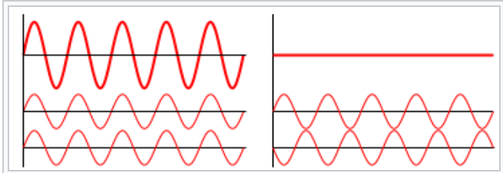

Fig1.  constructive interference(left) and  destructive interference(right)

### Between wo plane waves

A simple form of interference pattern is obtained if two plane waves of the same frequency intersect at an angle. Interference is essentially an energy redistribution process. The energy which is lost at the destructive interference is regained at the constructive interference. One wave is travelling horizontally, and the other is travelling downwards at an angle θ to the first wave. Assuming that the two waves are in phase at the point **B**, then the relative phase changes along the *x*-axis. The phase difference at the point **A** is given by:

It can be seen that the two waves are in phase when

And are half a cycle out of phase when

Constructive interference occurs when the waves are in phase, and destructive interference when they are half a cycle out of phase. Thus, an interference fringe pattern is produced, where the separation of the maxima is

And as know as the fringe spacing. The fringe spacing increases with increase in wavelength, and with decreasing angle θ.

The fringes are observed wherever the two waves overlap and the fringe spacing is uniform throughout.

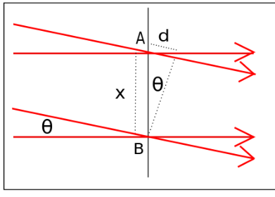

Fig2.Two plane wave interference

### Between two spherical waves

A point source produces a spherical wave. If the light from two point sources overlaps, the interference pattern maps out the way in which the phase difference between the two waves varies in space. This depends on the wavelength and on the separation of the point sources. The figure to the right shows interference between two spherical waves. The wavelength increases from top to bottom, and the distance between the sources increases from left to right.

When the plane of observation is far enough away, the fringe pattern will be a series of almost straight lines, since the waves will then be almost planar.

### Multiple beams

Interference occurs when several waves are added together provided that the phase differences between them remain constant over the observation time.

It is sometimes desirable for several waves of the same frequency and amplitude to sum to zero (that is, interfere destructively, cancel). This is the principle behind, for example, 3-phase power and the diffraction grating. In both of these cases, the result is achieved by uniform spacing of the phases.

The Fabry–Pérot interferometer uses interference between multiple reflections.

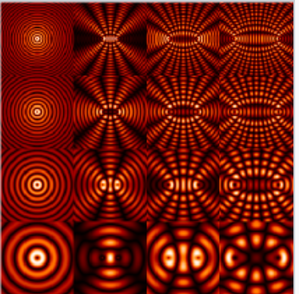

Fig3.Optical interference

### Light source requirements

Conventional light sources emit waves of differing frequencies and at different times from different points in the source. If the light is split into two waves and then re-combined, each individual light wave may generate an interference pattern with its other half, but the individual fringe patterns generated will have different phases and spacings, and normally no overall fringe pattern will be observable. However, single-element light sources, such as sodium- or mercury-vapor lamps have emission lines with quite narrow frequency spectra. When these are spatially and colour filtered, and then split into two waves, they can be superimposed to generate interference fringes.[8] All interferometry prior to the invention of the laser was done using such sources and had a wide range of successful applications.

A laser beam generally approximates much more closely to a monochromatic source, and it is much more straightforward to generate interference fringes using a laser. The ease with which interference fringes can be observed with a laser beam can sometimes cause problems in that stray reflections may give spurious interference fringes which can result in errors.

Normally, a single laser beam is used in interferometry, though interference has been observed using two independent lasers whose frequencies were sufficiently matched to satisfy the phase requirements.[10] This has also been observed for widefield interference between two incoherent laser sources[11].

### Optical arrangements

To generate interference fringes, light from the source has to be divided into two waves which have then to be re-combined. Traditionally, interferometers have been classified as either amplitude-division or wavefront-division systems.

## 2.Fabry–Pérot interferometer

In optics, a Fabry-Pérot interferometer or etalon is an optical cavity made from two parallel reflecting surfaces (i.e.: thin mirrors). Optical waves can pass through the optical cavity only when they are in resonance with it. It is named after Charles Fabry and Alfred Perot, who developed the instrument in 1899.Etalon is from the French étalon, meaning "measuring gauge" or "standard".

The heart of Fabry–Pérot interferometer is a pair of partially reflective glass optical flats spaced micrometers to centimeters apart, with the reflective surfaces facing each other. (Alternatively, a Fabry–Pérot etalon uses a single plate with two parallel reflecting surfaces.) The flats in an interferometer are often made in a wedge shape to prevent the rear surfaces from producing interference fringes; the rear surfaces often also have an anti-reflective coating.

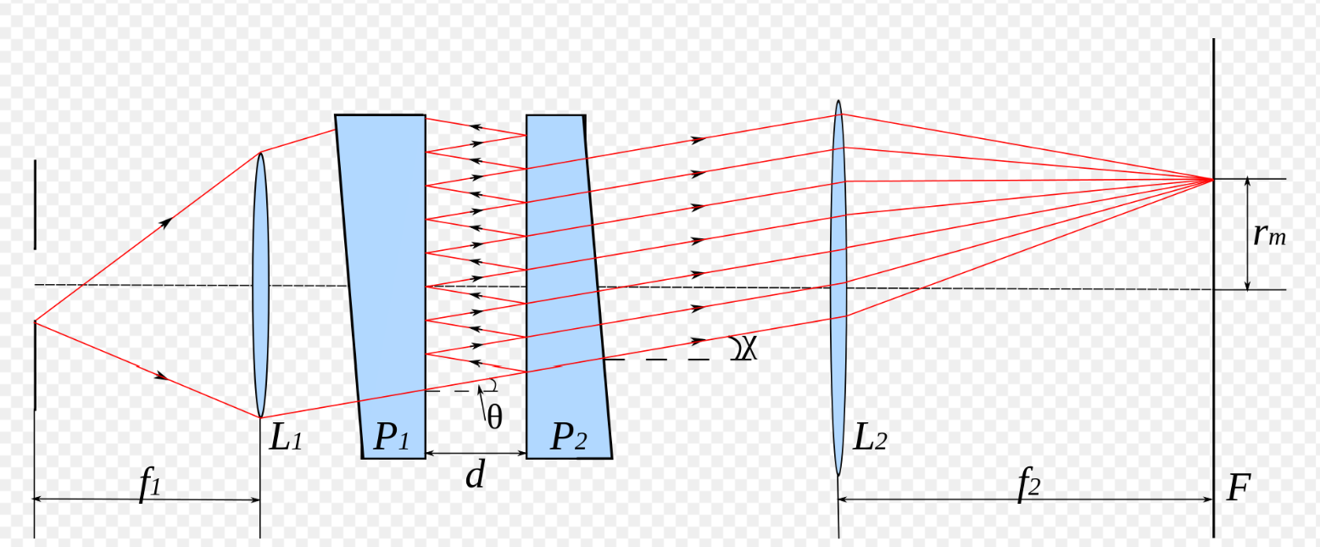

Fig4. Fabry-Pérot interferometer

In a typical system, illumination is provided by a diffuse source set at the focal plane of a collimating lens. A focusing lens after the pair of flats would produce an inverted image of the source if the flats were not present; all light emitted from a point on the source is focused to a single point in the system's image plane. In the accompanying illustration, only one ray emitted from point A on the source is traced. As the ray passes through the paired flats, it is multiply reflected to produce multiple transmitted rays which are collected by the focusing lens and brought to point A' on the screen. The complete interference pattern takes the appearance of a set of concentric rings. The sharpness of the rings depends on the reflectivity of the flats. If the reflectivity is high, resulting in a high Q factor, monochromatic light produces a set of narrow bright rings against a dark background. A Fabry–Pérot interferometer with high Q is said to have high finesse.

The varying transmission function of an etalon is caused by interference between the multiple reflections of light between the two reflecting surfaces. Constructive interference occurs if the transmitted beams are in phase, and this corresponds to a high-transmission peak of the etalon. If the transmitted beams are out-of-phase, destructive interference occurs and this corresponds to a transmission minimum. Whether the multiply reflected beams are in phase or not depends on the wavelength (λ) of the light (in vacuum), the angle the light travels through the etalon (θ), the thickness of the etalon (ℓ) and the refractive index of the material between the reflecting surfaces (n).

The phase difference between each successive transmitted pair (i.e. T2 and T1 in the diagram) is given by[6]:

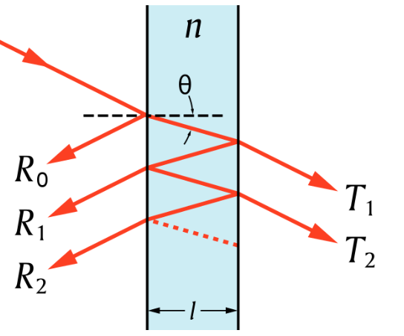

Fig5. Coherent transmitted light

In a transmitted beam, the optical path difference between adjacent beams is given by:

The conditions under which bright streaks are produced is given by:

: Interference series, ：Incident Wavelength

## 2. Free spectral range

Monochromatic light with slight wavelength difference emitted by the same light source and （），After incident, they will form their own rings series.

For same interference series that large interference rings with small wavelength, if increase and make m-th series light rings match to (m-1)-th series light rings.

The wavelength separation between adjacent transmission peaks is called the free spectral range (FSR) of the etalon, , and is given by:

In most of case, ,

We get this formula , is given by:

It means when we have fixed interval d and Incident wavelength as range of to of generate interference do not overlapping

If you want to observe the isobaric interference fringes of the Fabry-Perot interferometer, you should place a lens vertically in the direction of transmitted light transmission. When the lens's optical axis is perpendicular to the screen, the isobaric interference fringes are a set of concentric circles The center of the circle corresponds to the focal point of the normal incident transmitted light., have maximum value :

is not an integer in general, assume integer part as , decimal part is set to , , hence, counter from the center of bright lines ,outer-cycle the p-th bright lines’ corner radius is given by:

The diameter of the circular stripes satisfies:

Where is the focal length of the lens.

The three important characteristic parameters of the Fabry-Perot interferometer are fineness (the ratio of the free spectral range and the FWHM of the transmission peak), peak transmission (the maximum value of the ratio of transmitted light intensity and incident light intensity), Contrast factor (the ratio of the maximum and minimum values of the ratio of transmitted light intensity to incident light intensity), but the higher the reflectance, the higher the fineness, so the peak transmittance and fineness / contrast factor cannot be simultaneously Both are high.

## 3. Recognition accuracy (Finesse)

Define as recognition accuracy for Spectroscope, and for Fabry–Pérot Interferometer, the recognition accuracy is:

: Interference series. : Accuracy

The Physical significance is recognizing largest stripe between two adjust interference series, N depends on reflect ratio(reflectivity) of Parallel plate’s Reflective film.

The higher reflectivity, the higher accuracy (Finesse).

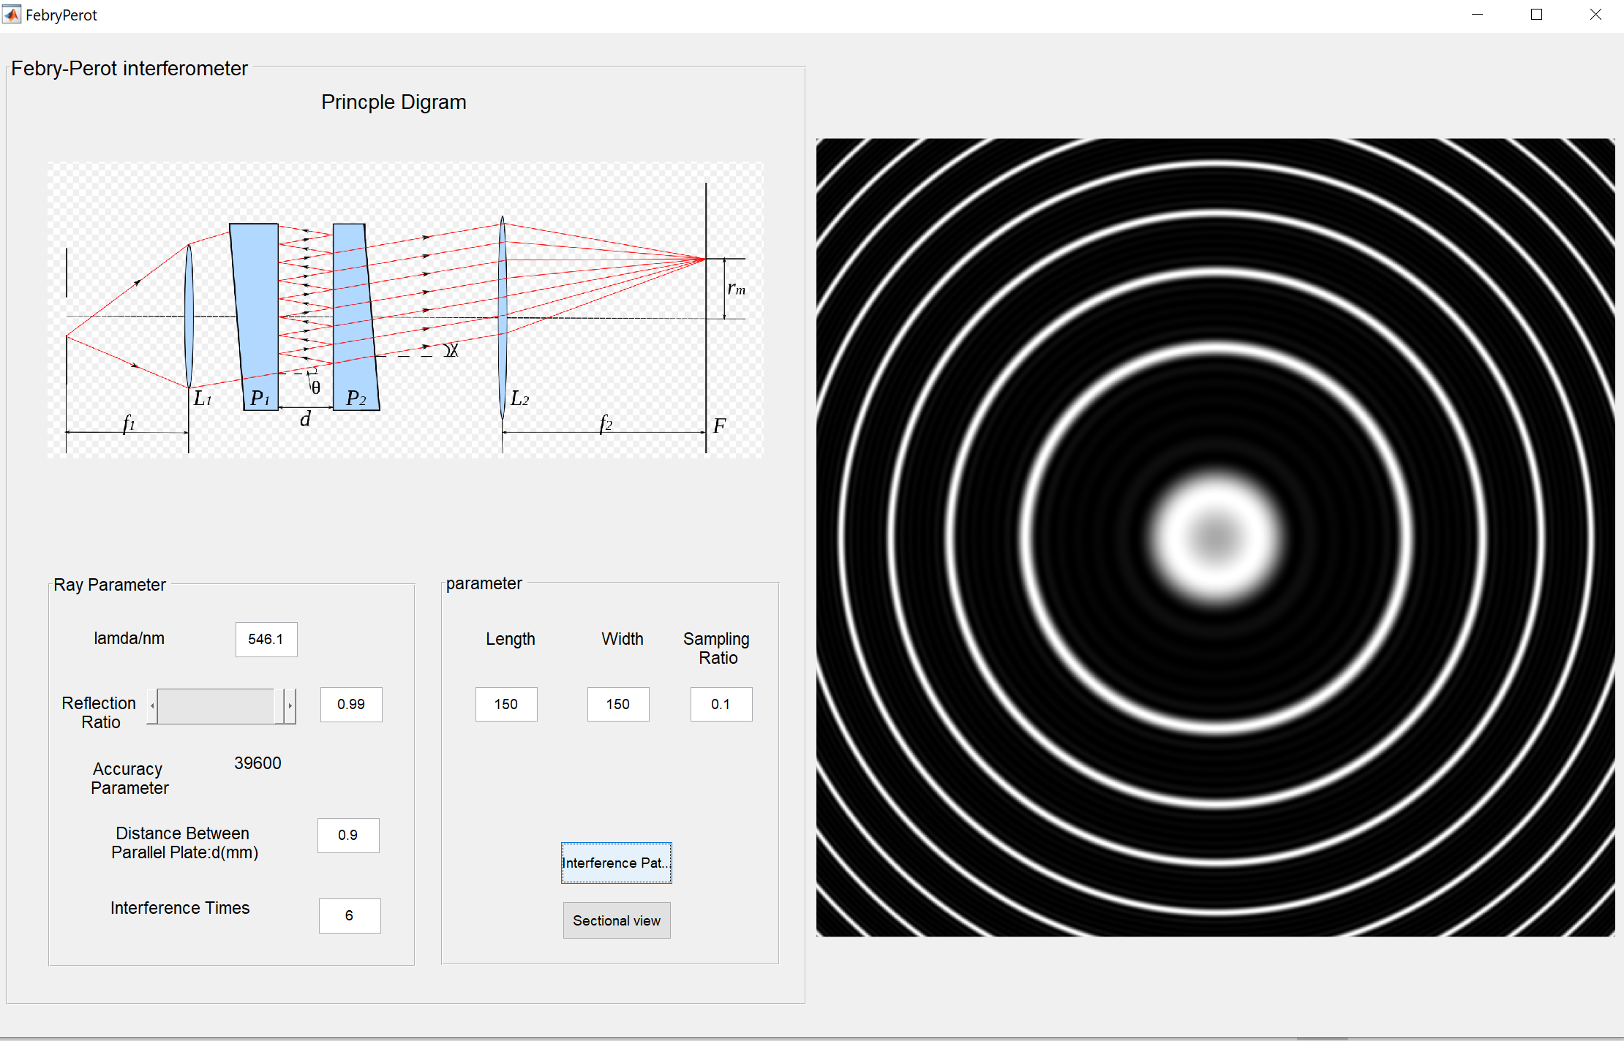

Fig6. Reflectivity as 0.99



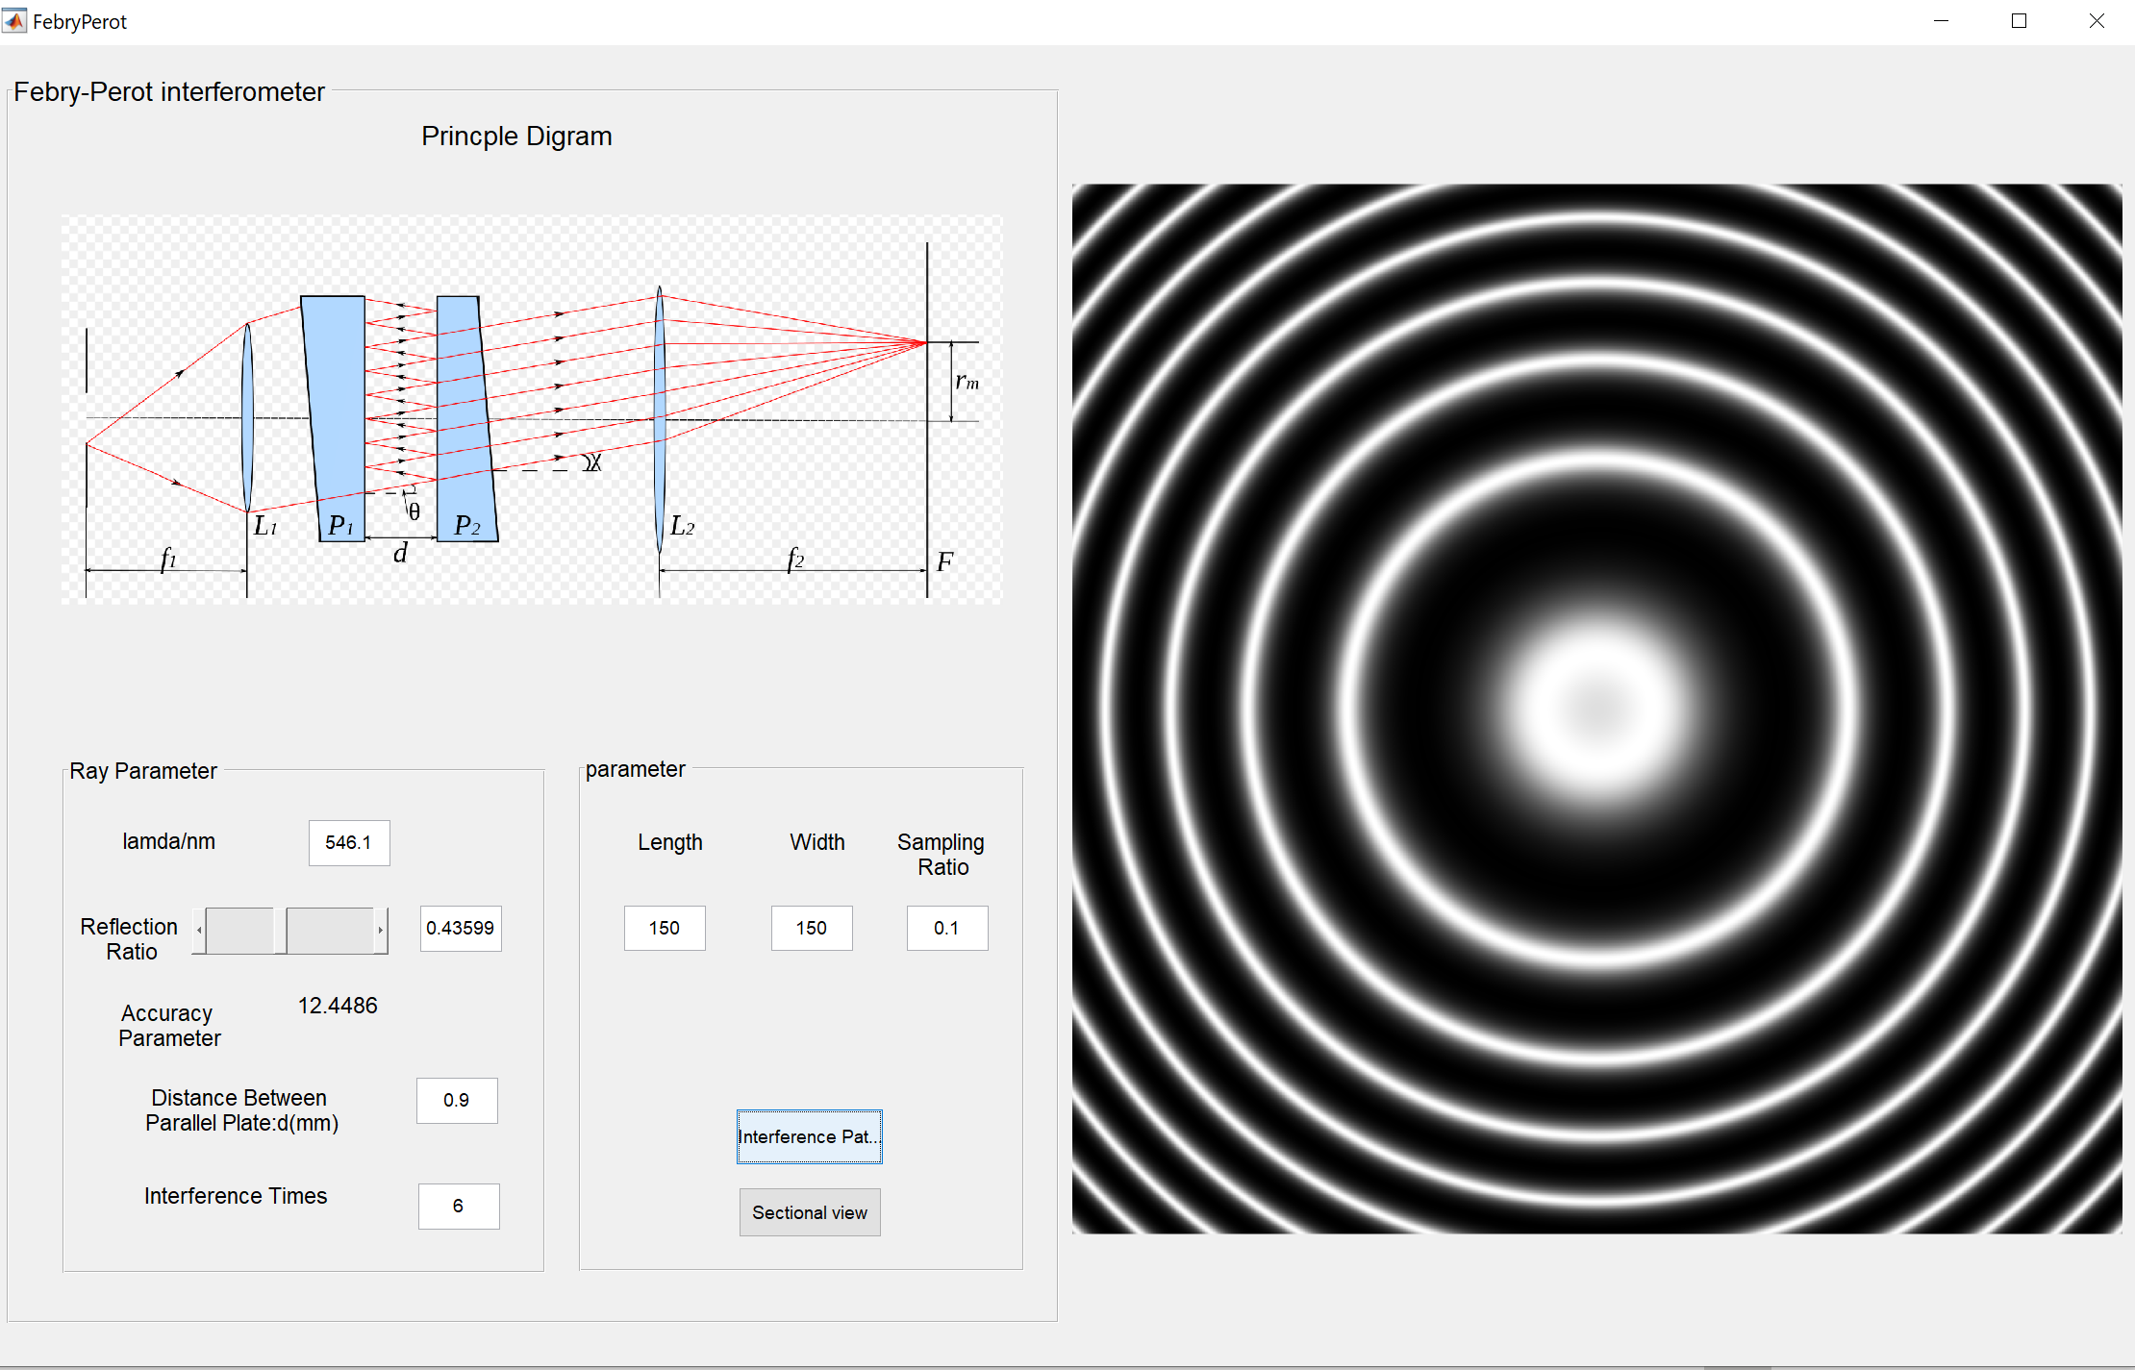

Fig7. Reflectivity as 0.37595

If both surfaces have a reflectance R, the transmittance function of the etalon is given by:

=

Where

is the confident of finesse.

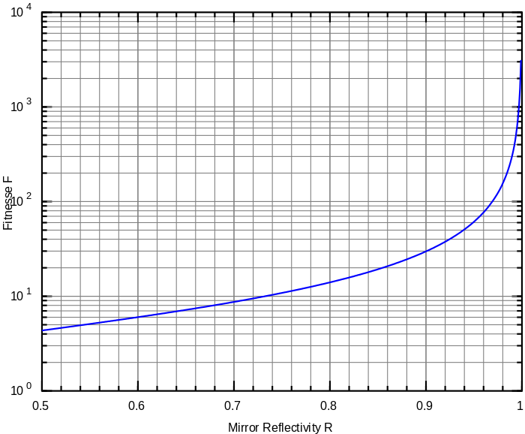

Fig8.Finesse as a function of reflectivity

## Conclusion

In this paper we analyzed Simulink characterization of Fabry-Perot interferometers and different parameter of ray effect on accuracy.

Reflectivity determines the fineness of the interferometer, if the distance between the parallel plates is adjusted, the distance between the interference levels will also increase significantly.

## References

1. Hernández G. Fabry-perot interferometers[M]. Cambridge University Press, 1988.
2. Gibbs H M, McCall S L, Venkatesan T N C. Differential gain and bistability using a sodium-filled Fabry-Perot interferometer[J]. Physical Review Letters, 1976, 36(19): 1135.
3. Vaughan M. The Fabry-Perot interferometer: history, theory, practice and applications[M]. Routledge, 2017.
4. Sánchez-Soto L L, Monzón J J, Leuchs G. The many facets of the Fabry–Perot[J]. European Journal of Physics, 2016, 37(6): 064001.
5. Perot A, Fabry C. On the application of interference phenomena to the solution of various problems of spectroscopy and metrology[J]. The Astrophysical Journal, 1899, 9: 87.
6. Lipson A, Lipson S G, Lipson H. Optical physics[M]. Cambridge University Press, 2010.
7. Born M, Wolf E. Principles of optics: electromagnetic theory of propagation, interference and diffraction of light[M]. Elsevier, 2013.
8. Hora H. WH Steel, Interferometry: Cambridge Studies in Modern Optics 1, Cambridge University Press, 1986, 308 pages. An extensively revised and enlarged edition of Interferometry, which first appeared in 1967. The theory and applications of interferometry are dealt with in some depth; covering the radio region as well as the optical region[J].
9. Longhurst R S. Geometrical and physical optics, Chapter X111[J]. 1968.
10. Pfleegor R L, Mandel L. Interference of independent photon beams[J]. Physical Review, 1967, 159(5): 1084.
11. Patel R, Achamfuo-Yeboah S, Light R, et al. Widefield two laser interferometry[J]. Optics express, 2014, 22(22): 27094-27101.