Analysis-unit dependence and effect-aware calibration in human kidney thick ascending limb single-cell studies
Article type: Research Article
Authors: Peng Zhi, Xiaohe Yan, Chaofan Zhang
Affiliations: Henan Provincial Chest Hospital, Zhengzhou, China
Corresponding author: Peng Zhi, Department of General Practice, Henan Provincial Chest Hospital, Zhengzhou, Henan, China. Email: zhiyoyo0409@163.com. ORCID: 0009-0003-2201-5131
Co-author contacts: Xiaohe Yan. Email: yanxiaohe123456@163.com. ORCID: 0009-0006-2259-9271; Chaofan Zhang. Email: zcf1765081785@163.com. ORCID: 0009-0009-9088-0016
Abstract
Single-cell disease studies often assign a disease association to a cell state without stating whether the contrast is between donors, across tissue neighborhoods, or within a donor. These estimands can disagree, but expression-matched nulls do not separate biological coupling from selection on effect size. We developed a unit-aware framework and applied it to 106,851 KPMP thick ascending limb (TAL) cells from 223 donors. We compared donor pseudobulk, Milo neighborhood abundance, neighborhood-expression association, and within-donor cell-rank association, and evaluated a prespecified 400-gene panel with expression-matched and post hoc effect-aware nulls. In aTAL2, donor and neighborhood-expression directions were positive, whereas the within-donor association was negative in combined disease and AKI (FDR = 0.0086 for each). In the 400-gene panel, donor-within reversal was 19.0% versus 12.7% in expression-matched sets. After preserving effect-size marginals, the conditional null was 20.8% (P = 0.999), showing that the initial excess reflected the selected effect-size distribution rather than broad negative coupling. A smaller neighborhood-versus-within excess (21.0% versus 19.4%) was threshold sensitive. Simulations recovered strong opposing effects while quantifying a screening-threshold null. Two non-KPMP cohorts reproduced the calibration pattern and provided donor-level PAPPA2 support, but not exact subtype replication or a significant within-donor effect. In an independent primary kidney-disease cohort (n = 87), the score was associated with lower eGFR after adjustment. PAPPA2 was a strong tubulointerstitial eGene without glomerular eQTL support. These results define an estimand-level problem and show that effect-aware calibration should accompany matched-set comparisons; they do not establish broad negative coupling.
Keywords: single-cell genomics, analysis unit, kidney disease, thick ascending limb, donor-aware inference, software framework
Introduction
Chronic kidney disease and acute kidney injury are major causes of morbidity and mortality worldwide [1,2]. Kidney injury is not distributed uniformly across the nephron. Proximal tubules, thick ascending limb (TAL) cells, distal tubules, endothelial cells, and immune populations can adopt distinct injury, adaptation, and repair states [3,4]. Single-cell atlases can now catalogue these states, but a disease association is incomplete until its estimand is specified: a contrast between donors, a difference in neighborhood abundance, an association across neighborhoods, or a contrast within a donor.
Four analysis approaches are commonly used in kidney single-cell studies [5]. Donor pseudobulk estimates a between-donor difference in mean expression. Milo neighborhood abundance estimates a difference in neighborhood abundance. Neighborhood-expression association estimates whether neighborhoods with higher gene expression have higher disease logFC. Within-donor cell-rank association estimates whether cells with greater neighborhood exposure have higher expression inside the same donor. These quantities are complementary views of the same cells, not independent measurements. They can disagree because they use different replication units, different exposure variables, and different standardization rules.
An apparent disagreement can therefore reflect biology, but it can also arise from effect-size selection or a null model that does not match the observed effect distribution. Expression-matched random sets preserve gene-level expression and detection but do not necessarily preserve the joint distribution of effects in the two units being compared. A joint evaluation that reports each estimand, separates prespecified and post hoc comparisons, and includes an effect-aware calibration is therefore needed before a unit-dependent result is treated as biological coupling.
TAL cells perform active sodium, potassium, and chloride transport, are metabolically demanding, and are sensitive to ischemic and inflammatory injury [6,7]. Several transcriptionally distinct TAL subtypes have been reported in human kidney atlases, but whether these subtypes share the same disease-related neighborhood states remains unclear. This question is relevant to TAL physiology and translational interpretation because TAL injury and adaptation may affect tubular workload, inflammatory signaling, and repair programs. PAPPA2 is not the central hypothesis; it is a case gene with a less well-defined renal role, used to test whether a gene-state association remains consistent when the analysis unit changes [8,9,10].
In this study, we analyzed the complete KPMP single-nucleus resource, including 106,851 TAL cells, and compared four complementary analysis estimands. The study had three aims: first, to determine whether donor, neighborhood, neighborhood-expression, and within-donor analyses produce concordant subtype-level disease conclusions; second, to test whether the principal directions transfer to non-KPMP kidney cohorts; and third, to determine whether the PAPPA2 case signal has a human kidney regulatory context. The study was designed as a framework-evaluation study, not as a new clustering algorithm, causal test, biomarker validation, or mechanistic experiment.
The central finding is that analysis-unit choice changes subtype-level interpretation, but not all apparent discordance survives calibration. aTAL2 provided the clearest case example, frTAL showed a weaker related pattern, and PAPPA2 provided a disease-associated TAL state without establishing causality. The prespecified expression-matched panel was positive, whereas a post hoc effect-aware null showed that the donor-within excess reflected the selected effect-size distribution. We therefore define the contribution as a framework for reporting analysis-unit-specific estimands and calibrated nulls, not as evidence for broad negative coupling.
Methods
Study design and data sources
We designed a framework-development and empirical validation study using public or controlled-access human kidney data. No new human samples were collected, and no new ethical approval was required for secondary analysis of de-identified data. The study implemented a reusable unit-aware workflow and tested whether disease conclusions remained stable when the unit of inference changed, rather than proposing a new molecular mechanism (Fig. 1).
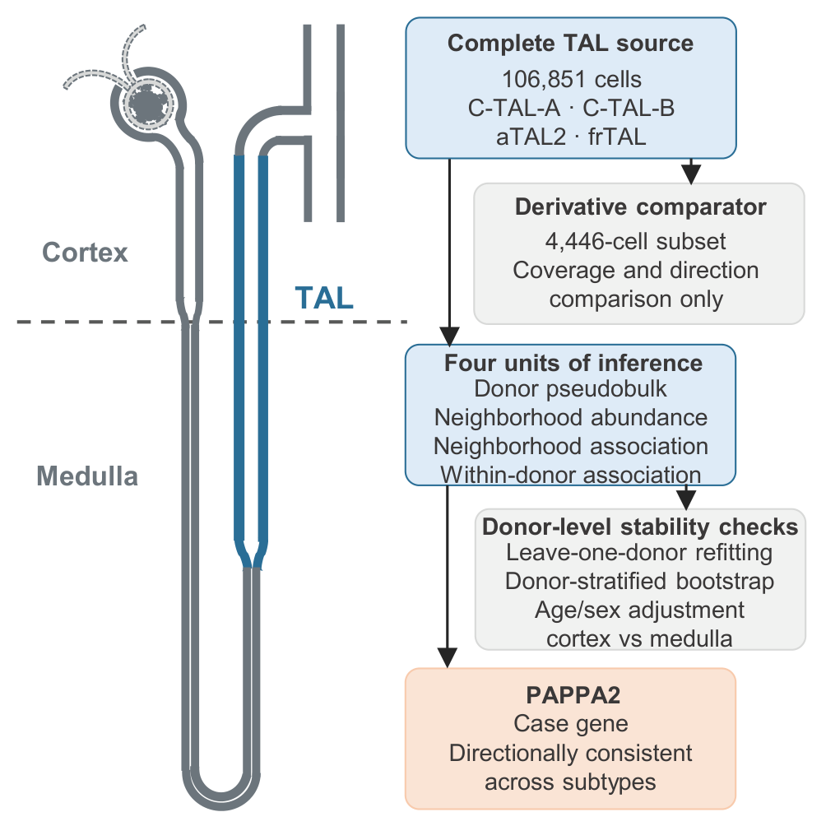
Fig. 1
We selected data sources to provide one discovery resource and separate directional support. The discovery resource was the KPMP human kidney single-nucleus RNA sequencing dataset [5], which contained 1,388,643 cells and 35,455 features. We extracted all cells annotated as C-TAL-A, C-TAL-B, aTAL2, or frTAL, yielding 106,851 TAL cells. A previously generated 4,446-cell derivative matrix was retained only as a coverage and directional comparator. Spatial cross-modality analysis used the KPMP GSE183456 Visium resource, part of the KPMP GEO superseries GSE183279, which contained 23 sections from 22 donors [5,11]. Because GSE183456 shares KPMP consortium provenance with the discovery data, it was treated as same-consortium support rather than an external cohort. Separate directional eGFR testing used GSE137570 [12], and multi-dataset GFR association testing used Nephroseq v5 [13]. Independent validation used the non-KPMP GSE211785 multi-omic kidney atlas and the independent GSE254185 kidney multiome resource.
TAL subtypes and the four analysis units
We restricted the analysis to four TAL subtypes and defined the analysis units before comparing their results. The subtypes were C-TAL-A, C-TAL-B, aTAL2, and frTAL. All primary analyses used the complete 106,851-cell TAL set and the atlas-provided UMAP coordinates.
We compared four primary analysis units because each answers a different question about disease-related TAL state. Donor pseudobulk asks whether mean expression differs between disease and Reference donors. Milo neighborhood abundance asks whether neighborhood abundance differs between disease and Reference. Neighborhood-expression association asks whether neighborhoods with higher expression also have higher disease logFC. Within-donor cell-rank association asks whether cells with greater neighborhood exposure have higher expression inside each donor.
Table 1. Analysis units are complementary estimands, not independent replications.
Analysis unit | Target quantity | Replication unit | Main limitation | Permitted interpretation
Donor pseudobulk | Difference in mean expression between disease and Reference donors | Donor | Donor mix, disease subtype, and treatment confounding | Between-donor association
Milo neighborhood abundance | Difference in abundance of a TAL-associated neighborhood | Donor and neighborhood design | Neighborhoods overlap and are defined from the same atlas embedding | Neighborhood-state association
Neighborhood-expression association | Association between neighborhood mean expression and disease logFC | Neighborhood | Overlapping neighborhoods and reuse of the same cells | Contextual association, not cell-level effect
Within-donor cell rank | Within-donor association between cell neighborhood exposure and gene expression | Cell within donor | Exposure is a neighborhood phenotype, not disease assignment | Within-donor state coupling
Composition-expression decomposition | Separation of a donor-level total difference into subtype composition and subtype expression | Donor | Descriptive decomposition with an interaction and covariance remainder | Source of an aggregate difference, not mechanism
The table defines the inferential target of each analysis. The estimates are derived from the same cells and are not independent validations of one another.
We treated donor-level robustness as a stability check rather than as a fifth analysis unit. This distinction avoids treating resampling stability as an independent biological measurement. The primary Milo threshold was SpatialFDR < 0.05. Milo used logMS normalization and a fixed random seed of 20260927. One AKI donor with zero neighborhood counts was excluded from that comparison. Augur was retained only as a secondary subset-level analysis of disease versus Reference separability [14], using 20 subsamples, 30 cells per subsample, and 3-fold cross-validation.
Donor-level pseudobulk expression
Donor pseudobulk provided the reference analysis unit, because donor-level mean expression is the most common way to relate cell-state genes to disease. Raw counts for PAPPA2, CXCL12, NOTCH3, HES1, and EPHB2 were extracted directly from the sparse source matrix. Counts were normalized using the full per-cell RNA count and transformed with log1p. Expression was averaged within each donor and TAL subtype. Disease groups were compared with Reference donors using two-sided Mann-Whitney tests, and donor-level linear models were adjusted for age midpoint and sex. Benjamini-Hochberg correction was applied across the 60 gene, subtype, and comparison tests. The 4,446-cell subset result was retained only as a comparator, and its original 120-test correction was not mixed with the complete-TAL analysis.
Composition and expression decomposition
We decomposed the overall four-subtype TAL PAPPA2 difference into a subtype composition component and a subtype-expression component. For each donor, the overall TAL mean was the cell-weighted sum of subtype proportions and subtype-specific mean expression. Group differences were separated into composition at reference means, expression at reference proportions, and an exact remainder containing interaction and within-group covariance terms. Missing subtype means were set to zero contribution when the corresponding proportion was zero. Confidence intervals were obtained from 2,000 donor-level bootstrap resamples within disease and Reference groups.
Milo neighborhood abundance
Milo neighborhood abundance tested whether disease was associated with shifts in local TAL neighborhoods rather than only with donor-level average expression. Neighborhoods were rebuilt from the complete TAL set using the atlas UMAP coordinates, k = 30, a neighbor ratio of 0.1, and refined sampling. We tested disease combined, AKI, and CKD against Reference [15]. Results were interpreted as differences in TAL-associated neighborhood state rather than as evidence of direct cell-cell contact.
Neighborhood-expression association
Neighborhood-expression association tested whether neighborhoods with higher gene expression were also those with higher disease logFC. Each Milo neighborhood was represented by its mean PAPPA2 expression and its Milo logFC, and Spearman correlation was calculated across neighborhoods for each comparison and subtype. Stability was assessed with 500 donor-stratified resamples, leave-one-donor-out analysis, and a partial Spearman correlation controlling for neighborhood purity (Additional file 1). These resampling intervals describe donor-level stability and are not independent cell-level p values.
Within-donor cell-rank association
Within-donor cell-rank association tested whether cells with greater neighborhood exposure had higher expression inside the same donor. For each cell, neighborhood exposure was defined as the mean Milo logFC of the neighborhoods assigned to that cell's TAL subtype. Within each donor, Spearman correlation was calculated between PAPPA2 expression and neighborhood exposure, so each donor contributed one estimate. Statistical support was assessed with 1,000 within-donor expression permutations. The primary analysis required at least 5 cells per donor, and sensitivity analyses required at least 3 and 10 cells. BH correction was applied across 60 gene, subtype, and comparison tests. Because neighborhoods overlap, conventional correlation p values were treated as descriptive rather than as independent-sample inference.
Analysis-unit comparison and internal robustness
Analysis-unit comparison tested whether the same gene, subtype, and disease comparison led to the same direction across the four units. For each gene, subtype, and comparison, we recorded the direction in donor pseudobulk, Milo neighborhood abundance, neighborhood-expression association, and within-donor cell-rank association and classified the result as concordant or discordant. A 1,000-replicate donor bootstrap was used for complete-TAL pseudobulk effects. The complete-TAL pseudobulk analysis, the previous subset pseudobulk analysis, the neighborhood-level resampling result, and the within-donor permutation result were joined into a single analysis-unit table. This table was used to evaluate stability across units rather than to treat the most significant unit as definitive.
Internal robustness tested whether the donor-level directions were dependent on individual donors, age or sex, or tissue region. We repeated the pseudobulk analysis after removing one donor at a time, resampling donors within condition strata, adjusting for age and sex, and stratifying by cortex or medulla. These analyses were treated as stability checks and not as additional discovery units.
Prespecified 400-gene analysis-unit panel
A 400-gene panel was frozen before the panel outcome analysis. The panel contained 100 TAL subtype markers, 100 MSigDB Hallmark injury, inflammatory, hypoxic, or metabolic genes, 100 genes coexpressed with PAPPA2 in the 156 training donors, and 100 internal expression-matched negative controls. A separate 2,000-gene pool was matched to the target expression and detection distribution and used to generate 1,000 random 400-gene sets.
Only the three gene-specific units were compared across this panel: donor pseudobulk, neighborhood-expression association, and within-donor cell-rank association. A reversal required opposite signs and absolute standardized effects of at least 0.5 in both units. The primary endpoint was the donor-versus-within reversal fraction. One-sided empirical P values compared the target panel with the random sets. An expression-stratified random-set analysis was performed as a sensitivity check. Because expression matching does not match effect-size distributions, a post hoc conditional pairing permutation was then performed with 10,000 permutations. Within each subtype and comparison, right-unit effects were reassigned across genes without replacement while the left-unit effect and both effect-size marginals were preserved. Valid strata were averaged within each gene before genes were averaged, matching the original panel endpoint. One-sided empirical P values used the 10,000 conditional null values. Threshold sensitivity was evaluated from 0.5 to 2.0. The target-panel hash and frozen definitions are provided in Additional file 21.
The analysis hierarchy was explicit. The expression-matched panel comparison was the prespecified descriptive endpoint. The effect-aware pairing permutation was a post hoc calibration performed after the role of effect-size selection became apparent. It was not used to select genes, thresholds, subtypes, or comparisons, and it did not replace the prespecified result. The two analyses answer different questions: whether the selected genes have more opposite-sign pairs than genes with similar expression, and whether their gene-wise pairing is unusual after preserving the observed effect-size marginals.
Unit-aware software framework
We implemented the analytical workflow as `unitaware` v0.2.0, a platform-independent Python package. The package provides functions for donor pseudobulk, neighborhood-expression association, within-donor cell-rank association, standardized reversal scoring, composition-expression decomposition, and simulation. It also provides a conditional effect-pairing permutation for calibrating reversal estimates against the observed effect-size structure. Analysis-unit definitions and thresholds are explicit inputs rather than hidden defaults. The package includes a command-line interface, six unit tests, API documentation, and an MIT software license, and is distributed with the archived analysis code.
Simulation benchmark
We simulated six prespecified scenarios: null, donor-positive only, within-positive only, concordant positive, donor positive with within negative, and donor negative with within positive. Each scenario used 25 Reference and 25 disease donors, 30-80 cells per donor, gene-specific effects, donor random intercepts, 50 exposure-defined neighborhoods, and 100 replicates. The same reversal threshold used in the empirical panel was applied. The simulation tested whether the framework distinguished genuine opposing effects from null and concordant settings.
KPMP eGFR analysis
The KPMP eGFR analysis tested whether the PAPPA2-associated TAL state was linked to kidney function at the donor level. Donor-level PAPPA2-positive fraction was calculated within TAL cells. Baseline eGFR was treated as an ordinal outcome with four categories: 0-29, 30-59, 60-89, and 90 or more mL/min/1.73 m². The primary ordinal logistic model included PAPPA2-positive fraction per 10 percentage points, age, sex, and disease category. Additional models added C-TAL-A, C-TAL-B, aTAL2, and frTAL fractions, followed by mean detected genes and assay platform. Odds ratios below 1 indicate lower eGFR with higher PAPPA2-positive fraction.
Candidate-gene specificity
Candidate-gene specificity tested whether the PAPPA2 direction was distinctive relative to pre-specified control genes. CXCL12, NOTCH3, HES1, and EPHB2 were analyzed with the same donor-aware and eGFR models used for PAPPA2. The comparison assessed directional consistency, BH-corrected support, and tissue specificity. Because multiple genes can correlate with GFR, the aim was not to identify a unique biomarker but to determine whether PAPPA2 showed a distinct negative direction among the tested candidates.
KPMP GSE183456 spatial cross-modality analysis
Spatial cross-modality analysis tested whether the PAPPA2-associated TAL state co-occurred with a repair-failure spatial program within the same KPMP consortium resource. The frozen spatial analysis used nine main-branch genes: THSD4, TEX41, EGF, CA10, CACNB2, CABP1, CXCL12, PRKG1, and NOS1. The repair-failure signature used TMEM207, KLRD1, RNF144B, JAG1, TMEM52B, DACH1, OSBPL10, LRMDA, and KCNJ10. For each section, genes were normalized by counts per 10,000, transformed with log1p, and converted to within-section z scores. Branch scores were the mean z scores of the signature genes, and high-state thresholds were fixed at the 75th percentile. The primary metric was the odds ratio for co-occurrence of high main-branch and high repair-failure states. The same parameters were applied to all 23 sections without re-tuning.
GSE137570 public eGFR testing
GSE137570 testing provided independent but underpowered directional evidence for the PAPPA2-eGFR relationship. GSE137570 Cohort 1 contained 24 donors with public eGFR, age, sex, and fibrosis. PAPPA2 expression was extracted from the normalized read-count matrix. Spearman correlation was calculated between PAPPA2 and eGFR, and a linear model adjusted for age, sex, and fibrosis. The same model was applied to the four control genes. This analysis was regarded as directional support rather than definitive external validation.
GSE175759 locked clinical-association analysis
GSE175759 provided an independent primary kidney-disease cohort [25] with continuous eGFR. The public series contains 90 manually microdissected tubulointerstitial samples: 46 IgA nephropathy, 22 living-donor controls, nine minimal change disease, four membranous nephropathy, three focal segmental glomerulosclerosis, three diabetic nephropathy, and three lupus nephritis. Three submitter-marked technical outliers were excluded before scoring, leaving 87 samples. Age and sex were not available in the public annotations.
The frozen 11-gene TAL-injury score was computed without outcome-based gene selection or reweighting. The genes were `PAPPA2`, `TMPRSS4`, `LIX1`, `WNT10A`, `KRT7`, `CRIP1`, `S100A14`, `LAMC2`, `LAMB3`, `SOD3`, and `B3GALT5`; all 11 were detected in every original sample. Counts were converted to CPM using the total count per sample, transformed as log2(CPM + 1), and z-scored within the 87-sample analysis cohort. The score was the equal-weight mean of the gene-wise z scores.
The prespecified primary model was `eGFR ~ score` with HC3 heteroskedasticity-robust standard errors. Prespecified secondary and sensitivity models added diagnosis, library size, a PAPPA2-only score, and leave-one-gene-out scores. A post hoc disease-only sensitivity model excluded the 22 control samples. These models tested association, not causality or clinical utility.
Three post hoc score-specificity analyses were locked before execution. First, a fixed TAL-content score based on `UMOD`, `SLC12A1`, `KCNJ1`, `CASR`, and `CLDN16` was added to the clinical model. Second, 10,000 control 11-gene sets were drawn from 14,876 eligible genes after stratification into 20 bins by mean expression; each set was scored identically to the observed signature. Third, a PAPPA2-only model was compared with a model containing PAPPA2 plus the remaining 10 score genes. These analyses tested specificity and incremental information, not causality.
Nephroseq GFR analysis
Nephroseq analysis tested whether the PAPPA2-GFR direction was observed across multiple precomputed kidney datasets. Nephroseq v5 was queried through its public API using the GFR filter and thresholds pValue < 0.05, abs(rValue) ≥ 0.5, and abs(foldChange) ≥ 1.5. PAPPA2 and the four control genes were queried with the same thresholds. Each returned analysis was summarized by dataset, tissue type, GFR method, sample count, correlation coefficient, and p value. Analyses were not treated as independent cohorts because several analyses can originate from the same dataset.
Independent non-KPMP cohort analyses
GSE211785 was generated by the Susztak laboratory and contains control kidney, diabetic kidney disease (DKD), and hypertensive kidney disease samples. We used the non-KPMP merged object and restricted analyses to cells annotated as C_TAL or M_TAL in the SC_RNA and SN_RNA libraries. After requiring at least five TAL cells per donor, 29,847 TAL cells from 35 donors with TAL coverage were available (16 control, 7 DKD, and 12 HKD donors).
GSE254185 contains 46,957 nuclei from 7 normal kidneys and 5 kidneys with obstructive nephropathy. Its public TAL annotations included cTAL1, cTAL2, mTAL, TAL Injured, and TAL Inflammatory states, providing 9,912 annotated TAL cells. For both cohorts, counts were normalized to counts per 10,000 and log1p transformed. Donor pseudobulk values were calculated within TAL state. Donor-label permutations used 20,000 random permutations unless exact enumeration was feasible. Neighborhood features were calculated from the public UMAP coordinates using k = 30 nearest neighbors. These analyses provide independent-cohort validation, not experimental or causal validation.
External application of the frozen analysis-unit panel
To test whether the calibration problem extends beyond KPMP, we applied the same frozen panel to locally processed GSE211785 and GSE254185 cells. Of the 400 target genes, 385 were available in both cohorts; of the 2,000 external control genes, 1,915 were available. The remaining 2,300 genes were analyzed together.
For each cohort, state, and comparison, we estimated donor pseudobulk and within-donor cell-rank associations with the same 0.5 standardized-effect criterion. Donor pseudobulk required at least five cells per donor, and within-donor analysis required at least 20 cells per donor. A state-comparison group required at least three disease and three Reference donors. External neighborhood exposure was defined by a 30-neighbor graph built from the public UMAP coordinates. This is a transparent approximation of the KPMP Milo exposure, not an exact reproduction of Milo.
Two nulls were evaluated. First, 1,000 random sets of 385 genes were drawn from the 1,915 available external control genes. Second, a post hoc effect-aware pairing permutation with 10,000 permutations preserved each target gene's left-unit effect and the marginal distribution of the right-unit effect within each state and comparison.
Donor-stratified TAL signature transfer
To test whether the four KPMP TAL signatures could identify an aTAL2-like state outside the discovery annotations, donors were divided into 156 training and 67 held-out donors. The top 35 markers per subtype were selected only in the training donors. Each cell received the mean within-subtype marker z score, and the difference between the top and second-ranked subtype score was defined as the marker margin. The prespecified high-confidence threshold was a marker margin of at least 0.2.
Held-out KPMP cells were used to estimate coverage, accuracy, macro F1, and aTAL2 precision and recall. The same frozen marker panel was then projected to GSE211785 and GSE254185. In each external cohort, donor pseudobulk and within-donor analyses were repeated in the predicted high-confidence aTAL2-like cells. This analysis tests transfer of a transcriptional signature. It does not reproduce the original KPMP subtype labels and is not described as exact aTAL2 validation.
Kidney eQTL and snATAC context
We used NephQTL2 gene-level eQTL results from 240 glomerular and 311 tubulointerstitial human kidney samples [16]. PAPPA2 and the fixed top-35 aTAL2 markers were evaluated without re-selecting genes. We reported tubulointerstitial and glomerular gene-level FDR values and checked whether PAPPA2 appeared among FDR-significant PTWAS associations for eGFR or urinary albumin-to-creatinine ratio. Absence from the significant PTWAS list was recorded as non-significance, not as a negative association.
GSE211785 snATAC nuclei annotated as C_TAL or M_TAL were analyzed using the gene-activity representation as a chromatin-accessibility proxy. Donor means were calculated after requiring at least five snATAC nuclei per donor and state. Disease and control donors were compared with exact donor-label permutation when feasible. Seven control and four disease donors contributed to both states. Benjamini-Hochberg correction was applied across the fixed gene and state tests. GSE211785 RNA and snATAC are from the same cohort, so the snATAC result is an orthogonal-modality analysis rather than an independent cohort.
Reproducibility and software
Reproducibility was addressed by fixing analysis parameters and linking each reported result to versioned code and summary tables. Analysis scripts, frozen analysis protocols, validation tables, and result hashes were prepared for release in the public repository. The fixed-seed Milo analysis, GSE183456 spatial analysis, and Nephroseq queries were rerun with fixed parameters. Random seeds and versioned outputs are listed in the Availability of data and materials section.
The authors used OpenAI Codex CLI to assist with organization of methodological text, reference checking, and English-language editing. The authors reviewed and edited all content and retain responsibility for the final manuscript.
Results
Complete TAL coverage provided a common substrate for analysis-unit comparison
Complete TAL coverage allowed all four analysis units to be evaluated in the same cells. The complete set contained 106,851 cells from the four target TAL subtypes, whereas the derivative comparator contained 4,446 cells. The coverage difference was largest for subtypes that were sparse in the derivative matrix: aTAL2 contained 6,624 Reference cells from 83 donors in the complete data but only 102 Reference cells from 38 donors in the subset; frTAL contained 6,656 Reference cells from 86 donors in the complete data but only 142 cells from 48 donors in the subset. The complete set therefore provided a different donor and state composition from the derivative matrix and served as the primary substrate for all subsequent comparisons.
TAL subtypes did not share a single disease-related neighborhood state
Complete-data Milo showed that disease-related neighborhood changes were strongly subtype dependent. In the combined disease comparison, C-TAL-A had 1,797 significant neighborhoods among 4,012 annotated neighborhoods, C-TAL-B had 715 among 2,805, aTAL2 had 632 among 1,465, and frTAL had 1,023 among 1,332. The direction also differed: frTAL had 996 positive and 27 negative significant neighborhoods, whereas C-TAL-A had 333 positive and 1,464 negative neighborhoods.
Disease-specific analyses preserved this subtype dependence. In AKI, aTAL2 had 842 significant neighborhoods, 822 positive and 20 negative, with a median logFC of 1.364. In CKD, frTAL had 982 significant neighborhoods, 956 positive and 26 negative, with a median logFC of 1.138. By contrast, CKD aTAL2 had a median logFC of -0.406. These results show that TAL neighborhood remodeling cannot be summarized as one shared disease response (Fig. 2; Additional files 2 and 3).
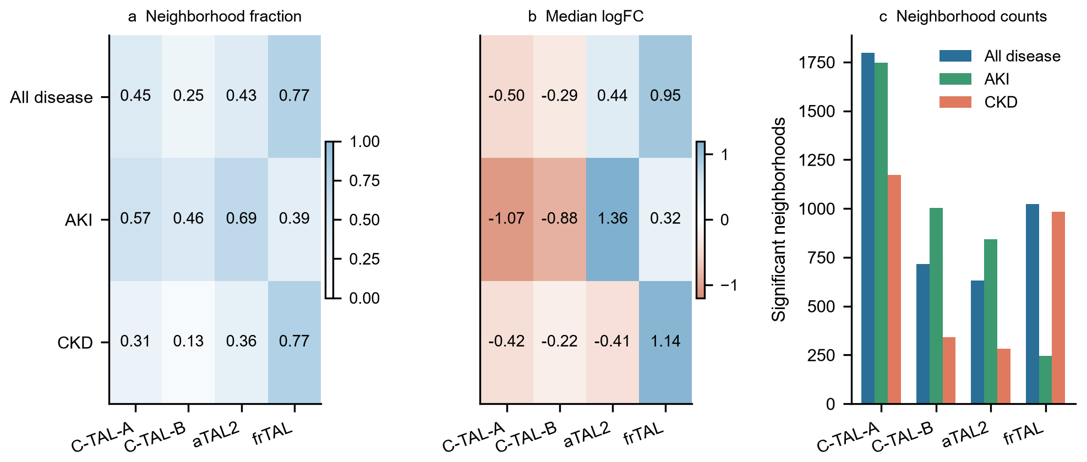
Fig. 2
The secondary subset-level Augur analysis provided complementary evidence that subtype states were not equally separable. AKI C-TAL-A had the highest mean AUC at 0.753, whereas CKD aTAL2 had a mean AUC below 0.5 at 0.479. The moderate AUC values and broad subsample intervals indicate that disease and Reference states were only partially separable. Together with Milo, these results establish subtype-specific neighborhood structure before the analysis units are compared directly (Fig. 3).
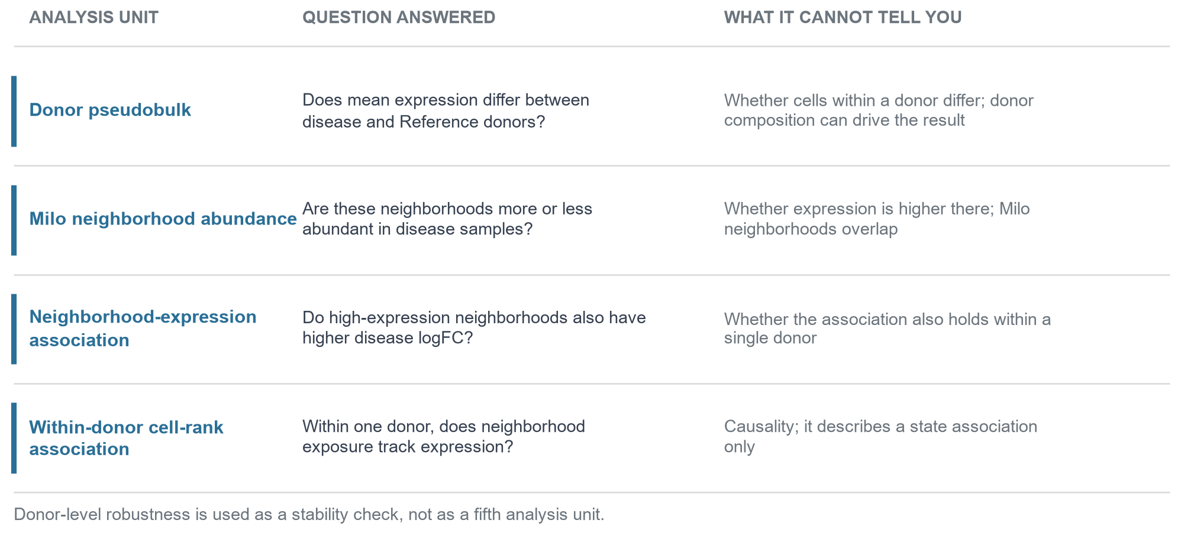
Fig. 3
Subset and complete pseudobulk results changed direction for selected genes
The derivative subset preserved broad pseudobulk trends but changed selected gene and subtype conclusions. In the complete analysis, 20 of 60 gene, subtype, and comparison tests had FDR < 0.05 using unadjusted Mann-Whitney tests, and 25 of 60 remained significant after adjustment for age and sex. Directions agreed between the subset and complete pseudobulk analyses in 48 of 60 comparisons, whereas 12 comparisons changed direction. Those discordant tests were concentrated in CXCL12, HES1, NOTCH3, and EPHB2, and none involved PAPPA2. Thus, the subset result was useful as a comparator but was not sufficient to represent the complete TAL population (Fig. 4; Additional file 4).
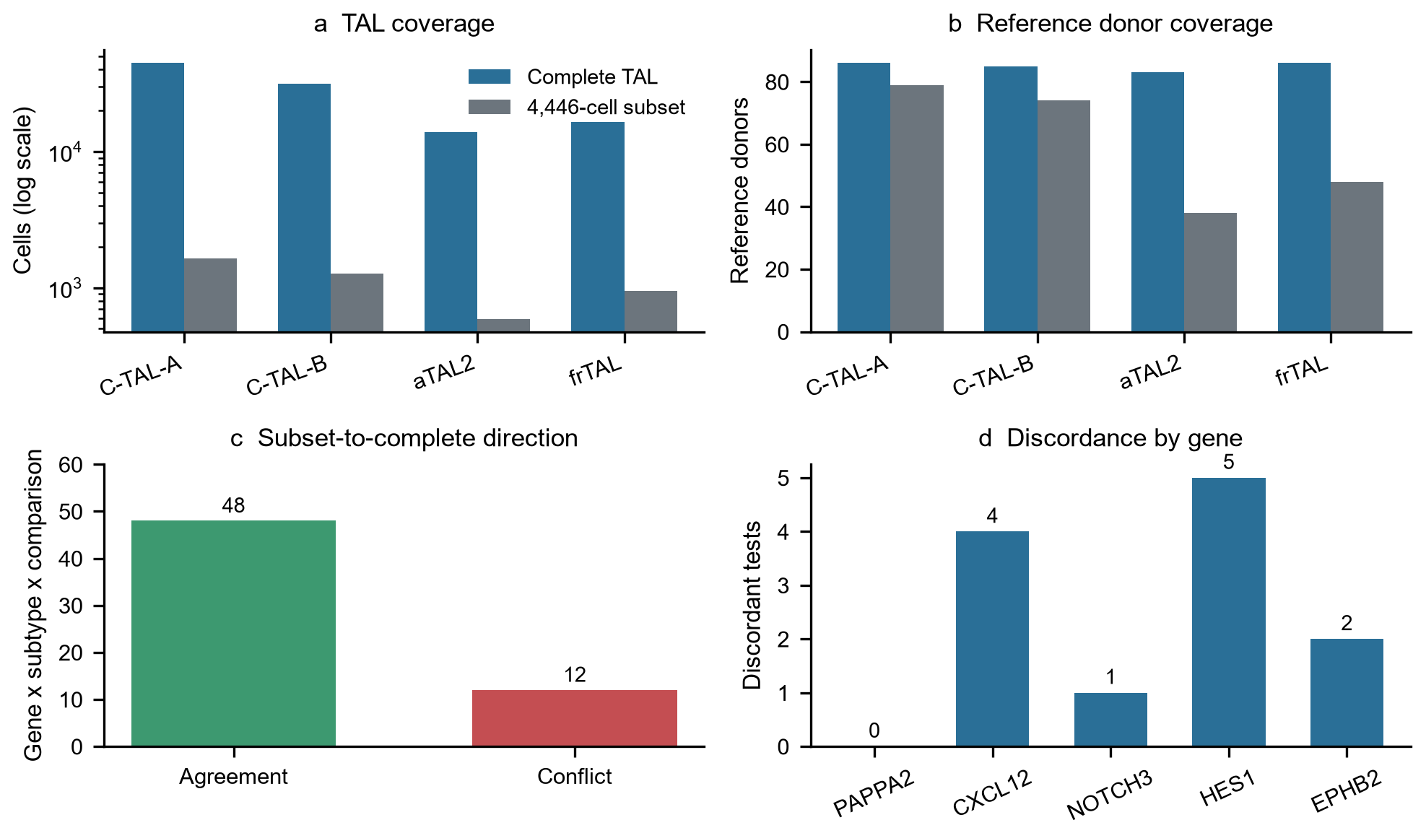
Fig. 4
The four analysis units were not interchangeable
The four analysis units produced related but non-equivalent views of TAL state. Across 12 comparison and subtype groups, neighborhood PAPPA2 expression was positively correlated with Milo logFC in all 12 groups, with Spearman correlations ranging from 0.029 in AKI aTAL2 to 0.729 in combined-disease C-TAL-A. Donor-stratified bootstrap intervals excluded zero in 11 of 12 groups; the exception was AKI aTAL2 (95% interval -0.086 to 0.255). Partial correlations controlling for neighborhood purity were similar to the primary correlations (Fig. 5; Additional files 5 and 6).
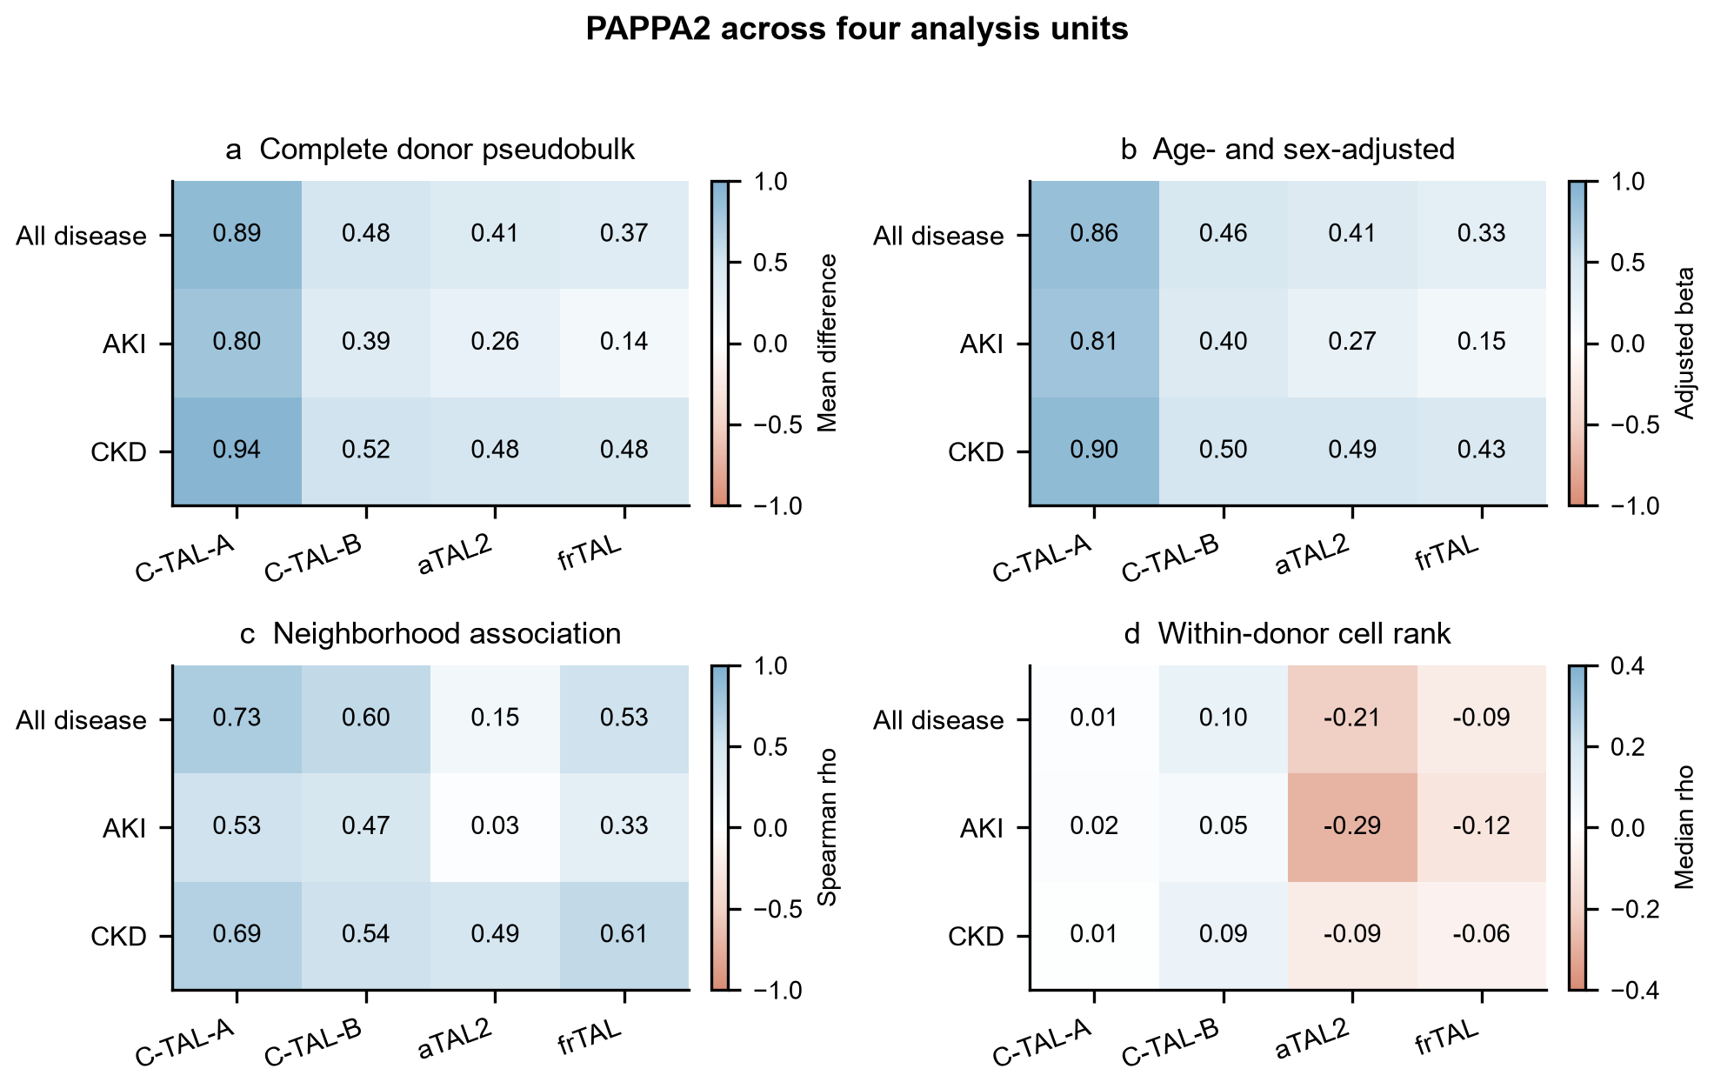
Fig. 5
The units differed in what they measured and did not always support one shared direction (Additional file 7). Donor pseudobulk, neighborhood-expression association, and within-donor cell-rank association were therefore analyzed as distinct units rather than as interchangeable estimates of the same quantity. This difference was clearest in aTAL2 and was also present in a weaker form in frTAL.
Analysis-unit reversal was frequent but depended on effect structure
The donor-versus-within reversal fraction was 19.0% in the 400-gene target panel, compared with 12.7% in expression-matched random sets (empirical P = 0.000999, the minimum attainable value with 1,000 sets). Restricting to the 300 biological genes increased the fraction to 20.8% versus 12.7%. An expression-stratified sensitivity analysis gave the same result (19.0% versus 12.8%; empirical P = 0.000999).
The panel result was not driven by the internal negative controls. Their donor-versus-within reversal fraction was 13.6%, statistically indistinguishable from random 100-gene sets from the external control pool (12.6%; two-sided empirical P = 0.485). Reversal fractions differed across biological groups: 24.0% for PAPPA2 coexpression genes, 21.6% for TAL subtype markers, and 16.8% for injury, inflammatory, and metabolic genes.
Donor-versus-neighborhood reversal was also higher (21.9% versus 14.5%; empirical P = 0.000999). Neighborhood-versus-within reversal showed a smaller full-panel excess (21.0% versus 19.6%; empirical P = 0.005), but the biological 300-gene subset did not (P = 0.189).
The conditional pairing null changed the interpretation. For donor-versus-within reversal, the observed fraction was 19.0% and the effect-aware null was 20.8% (P = 0.999). For donor-versus-neighborhood reversal, the observed fraction was 21.9% and the null was 21.2% (P = 0.111). Thus, the apparent excess over expression-matched genes was explained by selection of gene-state pairs with larger effects in both units. The selected panel demonstrated frequent sign disagreement, but did not establish broad negative coupling beyond the effect-size distribution.
Neighborhood-versus-within reversal retained a small conditional excess (21.0% versus 19.4%; P = 0.0017). This result was threshold sensitive and was not significant above the 0.5 threshold. Individual gene metrics, random-set results, conditional null distributions, and threshold sensitivity are provided in Additional files 22-24 and 26-29. The analysis therefore supports unit dependence as a measurement property, not a claim that selected TAL genes are uniquely prone to reversal.
Simulation benchmark distinguished opposing from concordant unit effects
In the simulation benchmark, donor-versus-within reversal was 95.5% when the true donor effect was positive and the within-donor effect negative, and 97.3% in the reciprocal scenario. Concordant positive effects produced a 2.3% reversal fraction, donor-only and within-only scenarios produced intermediate fractions, and the null scenario produced 20.1%. The null fraction reflects the prespecified effect-size threshold and finite sampling, not a true opposing effect. The value is therefore a screening-threshold calibration rather than a biological false-positive rate. These results show that the framework can recover strong opposing relationships while retaining explicit null calibration (Additional files 24, 25, and 27).
aTAL2 showed the strongest cross-unit discordance
aTAL2 was the clearest example because donor-level and within-donor analyses pointed in opposite directions. Complete donor pseudobulk showed higher PAPPA2 expression in aTAL2 for all three comparisons, with positive mean differences and FDR < 0.05 in each case. The same positive direction was retained in the age- and sex-adjusted models.
Neighborhood-expression association was positive but less stable in aTAL2. The full-data Spearman correlation was 0.145 for combined disease and 0.029 for AKI, and the AKI donor-stratified bootstrap interval included zero. This result indicates that neighborhood expression and donor pseudobulk were aligned in direction but not equally strong.
Within-donor cell-rank association moved in the opposite direction. The disease-minus-Reference rank difference was -0.2857 in AKI and -0.2063 in combined disease, with FDR = 0.0086 for each comparison. In CKD, the difference was also negative (-0.0886) but did not pass FDR (0.224). Therefore the aTAL2 conflict was strongest in aTAL2 and significant in two of three disease comparisons, rather than uniform across all comparisons (Fig. 6; Additional file 8).
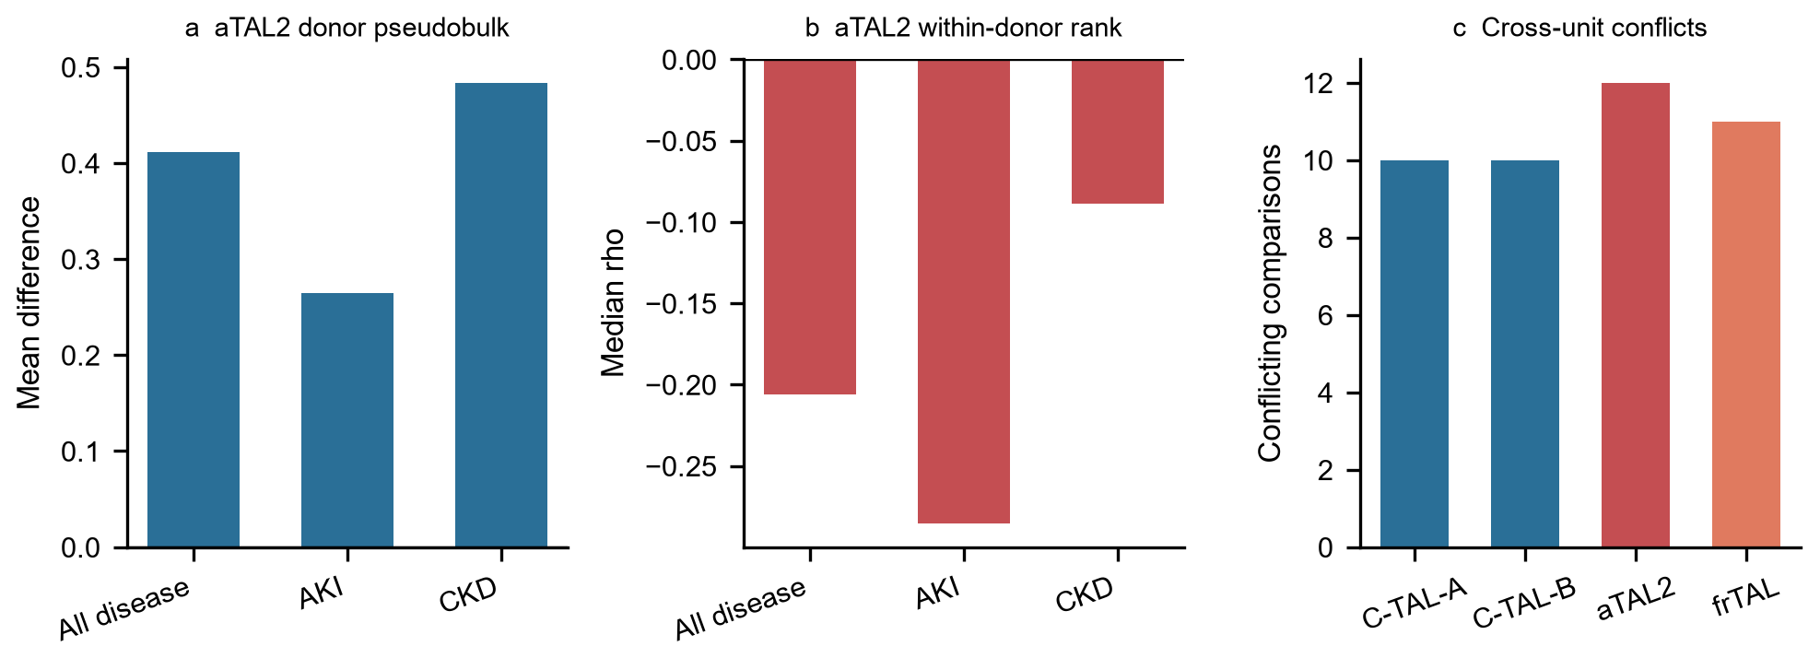
Fig. 6
frTAL showed a weaker related cross-unit pattern
frTAL showed the same qualitative direction conflict as aTAL2, but with weaker statistical support. Donor pseudobulk and neighborhood-expression association were positive for frTAL. In contrast, the within-donor disease-minus-Reference rank difference was negative in all three comparisons: -0.0897 in combined disease (FDR = 0.018), -0.1175 in AKI (FDR = 0.146), and -0.0557 in CKD (FDR = 0.224). Thus, frTAL supports the general analysis-unit sensitivity finding but does not reach the same strength as aTAL2.
PAPPA2 was a directionally consistent case gene across TAL subtypes
Complete donor-level pseudobulk analysis showed higher PAPPA2 expression in all four TAL subtypes for AKI, CKD, and combined disease comparisons. All 12 PAPPA2 gene, subtype, and comparison combinations had positive effect direction, and 11 of 12 passed FDR < 0.05; AKI frTAL was directionally positive but did not pass FDR (0.080). For example, the mean increase in the combined disease comparison was 0.894 for C-TAL-A, 0.477 for C-TAL-B, 0.411 for aTAL2, and 0.370 for frTAL. The same positive pattern was observed in the age- and sex-adjusted models (Additional file 9).
Leave-one-donor analysis preserved the PAPPA2 direction in all 12 groups (Fig. 7; Additional file 10). Bootstrap intervals were used to describe donor-level stability, not independent-cell significance. Cortex and medulla strata agreed in direction in 11 of 12 groups; the only exception was AKI frTAL in medulla, a group that was not significant in the complete pseudobulk analysis. These results identify PAPPA2 as a consistent disease-associated TAL case gene while preserving the distinction between average disease-group elevation and within-donor state association.
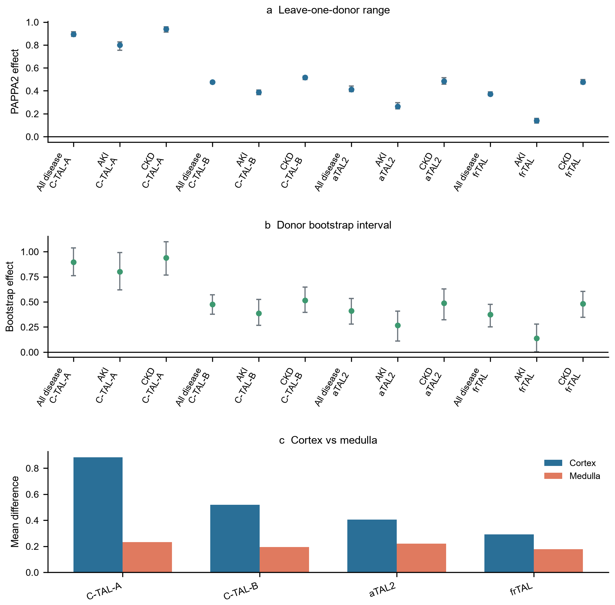
Fig. 7
PAPPA2 enrichment reflected subtype expression rather than composition
The overall four-subtype TAL PAPPA2 difference was not driven by subtype proportion changes. In the combined disease comparison, the observed difference was +0.563 (95% bootstrap interval +0.483 to +0.639), the subtype-expression component was +0.641 (+0.560 to +0.721), the composition component was +0.010 (-0.003 to +0.023), and the interaction/covariance remainder was -0.088 (-0.133 to -0.044). The expression component accounted for 86.7% of the absolute component magnitude, compared with 1.3% for composition.
The same pattern was present in disease-specific comparisons. In AKI, the observed difference was +0.379, expression was +0.522, and composition was -0.009. In CKD, the observed difference was +0.650, expression was +0.698, and composition was +0.019 (Additional file 20). Thus, higher PAPPA2 in disease donors was not explained by a shift toward TAL subtypes with higher baseline PAPPA2. The between-donor expression difference and the negative within-donor neighborhood association therefore describe separable levels of variation. This decomposition does not establish cell-intrinsic induction; donor-level exposures or unmeasured tissue context may still contribute.
PAPPA2-positive fraction was associated with lower eGFR in KPMP
In KPMP donors, higher TAL PAPPA2-positive fraction was associated with lower eGFR in ordinal models. The primary model included 202 donors. For every 10 percentage-point increase in PAPPA2 fraction, the odds ratio was 0.819 (95% CI 0.682-0.985, p = 0.0335) after adjustment for age, sex, and disease category. The direction remained negative after adding TAL subtype fractions (OR 0.696, 95% CI 0.530-0.915) and technical covariates (OR 0.661, 95% CI 0.500-0.875).
The signal was concentrated mainly in CKD. The primary model in disease donors included 130 donors and produced an OR of 0.789 (95% CI 0.648-0.960). CKD included 94 donors and produced an OR of 0.733 (95% CI 0.582-0.924). AKI included 36 donors and did not show a clear association. These results support an internal adjusted association between PAPPA2 and kidney function, but they do not constitute external clinical validation (Additional file 11).
The PAPPA2 signal was directionally distinct among tested genes
In the within-donor analysis, PAPPA2 had seven FDR-supported comparisons at the primary threshold, compared with two for CXCL12 and none for NOTCH3, HES1, and EPHB2. The advantage of PAPPA2 was primarily directional consistency rather than the largest effect size.
The same pattern was observed in Nephroseq. PAPPA2 had seven significant tissue-specific negative GFR analyses, compared with six for HES1, three for EPHB2, two for NOTCH3, and one for CXCL12. HES1 and EPHB2 had multiple significant results, but their directions were mixed or less restricted to tubulointerstitium. CXCL12 did not reproduce the negative PAPPA2 pattern.
PAPPA2-associated spatial signatures showed directional consistency in the KPMP Visium resource
GSE183456 is the KPMP Visium spatial resource and belongs to the same consortium as the discovery snRNA-seq data. We therefore used it for spatial cross-modality analysis, not as an independent external cohort. Across 23 sections, 20 had a co-occurrence odds ratio above 1 for the two PAPPA2-associated branch signatures. All 11 DKD sections had an odds ratio above 1, and all 10 DKD donors remained above 1 after donor-level deduplication. The result was directionally consistent with the discovery analysis.
The spatial result was not disease-specific. The DKD versus Reference comparison had p = 0.078, and 5 of 6 Reference sections also had a co-occurrence odds ratio above 1. The appropriate interpretation is cross-modality directional consistency of a tissue-state relationship within the KPMP resource, not a disease-specific or external spatial validation.
Public external datasets provided directional PAPPA2-GFR support
GSE137570 Cohort 1 provided public eGFR for 24 donors. PAPPA2 was negatively associated with eGFR (Spearman rho = -0.365, p = 0.079), but the adjusted model was not significant (p = 0.351). EPHB2 had a stronger unadjusted correlation (rho = -0.646, p = 0.0006), indicating that this cohort cannot support a claim of PAPPA2-specific significance (Additional file 12).
Nephroseq provided stronger external association support. In 50 GFR analyses, PAPPA2 had 10 significant results, of which 9 were negative. Seven negative analyses came from tubulointerstitial datasets. The strongest results included Sampson Nephrotic Syndrome TubInt (r = -0.558, n = 49), Ju CKD TubInt 2 (r = -0.530, n = 42), ERCB Nephrotic Syndrome TubInt (r = -0.712, n = 17; and r = -0.686, n = 16), and Mariani Nephrotic Syndrome TubInt 2 (r = -0.837, n = 10). One positive analysis came from a cadaveric transplant kidney dataset (r = 0.589, n = 12).
Together, GSE137570 and Nephroseq support the direction of the PAPPA2-GFR relationship. The Nephroseq analyses are precomputed and not independently adjusted in a common model, so they should be reported as multi-dataset external association support rather than as independent cohort counts (Additional file 13).
The frozen TAL-injury score was associated with lower eGFR in an independent primary kidney-disease cohort
In GSE175759, all 11 score genes were detected in all 90 original samples, and 87 samples remained after exclusion of three technical outliers. The primary model showed lower eGFR with higher score: -7.98 eGFR points per one-SD increase (95% CI -12.29 to -3.66; P = 0.00050). Adjustment for diagnosis preserved the association (-8.71; 95% CI -13.79 to -3.63; P = 0.0012), as did additional adjustment for library size (-8.56; 95% CI -13.43 to -3.70; P = 0.00090).
The result was not driven solely by the control samples. Among the 65 disease samples, the unadjusted estimate was -9.27 (95% CI -15.10 to -3.45; P = 0.0027), and the diagnosis-adjusted estimate was -9.67 (95% CI -15.82 to -3.53; P = 0.0031). The IgA nephropathy-only analysis was directionally negative but not significant (-6.07; 95% CI -13.36 to 1.21; P = 0.110). PAPPA2 alone was also associated with lower eGFR (-9.06; 95% CI -14.08 to -4.03; P = 0.00067). All 11 leave-one-gene-out scores retained a negative coefficient with a confidence interval excluding zero. Sample-level scores, model estimates, coverage, and sensitivity results are provided in Additional file 31.
Table 4. Independent clinical association of the frozen TAL-injury score with eGFR in GSE175759.
Analysis | n | eGFR change per 1-SD score | 95% CI | P
Primary, unadjusted | 87 | -7.98 | -12.29 to -3.66 | 0.00050
Diagnosis-adjusted | 87 | -8.71 | -13.79 to -3.63 | 0.0012
Disease samples only | 65 | -9.27 | -15.10 to -3.45 | 0.0027
Disease, diagnosis-adjusted | 65 | -9.67 | -15.82 to -3.53 | 0.0031
IgA nephropathy only | 43 | -6.07 | -13.36 to 1.21 | 0.110
This cohort provides independent external clinical-association support in primary kidney disease. It does not establish stable multicohort validation, and the absence of age and sex limits clinical interpretation.
The clinical score also showed specificity against alternative explanations. After adjustment for the fixed TAL-content score, the injury-score estimate was -8.81 eGFR points per SD (95% CI -13.76 to -3.85; P = 0.00079), and after additional diagnosis adjustment it was -10.13 (95% CI -15.70 to -4.56; P = 0.00062). The injury score and TAL-content score were only moderately correlated (r = 0.287). In 10,000 expression-stratified matched sets from 14,876 eligible genes, the observed coefficient of -7.98 was at the 0.01 percentile of the null distribution (one-sided empirical P = 0.0002; null mean -3.25). Thus, the association was not reproduced by expression-matched random 11-gene sets.
PAPPA2 alone was strongly associated with eGFR. Adding the remaining 10 score genes produced a residual coefficient of -4.10 (95% CI -8.11 to -0.10; P = 0.0478) and increased R-squared from 0.169 to 0.197, but the nested F test was not significant (P = 0.089). The non-PAPPA2 component is therefore a possible but not robustly established source of incremental information; the data do not show that the composite score clearly outperforms PAPPA2 alone.
Non-KPMP cohorts provided directional support for PAPPA2 disease elevation
In GSE211785, donor-level PAPPA2 expression was higher in disease than control donors in both TAL compartments. For C_TAL, the difference was +0.283 (permutation p = 0.0315; FDR = 0.0630 across six TAL-state and comparison tests), with a bootstrap 95% CI of +0.053 to +0.514. For M_TAL, the difference was +0.200 (p = 0.105; FDR = 0.133), with a bootstrap 95% CI of +0.026 to +0.400. DKD-specific contrasts were larger (+0.443 in C_TAL, p = 0.0174; +0.414 in M_TAL, p = 0.0227), whereas HKD-specific contrasts were smaller (+0.189 and +0.083). Leave-one-donor-out estimates remained positive for both states.
Within-donor injury-score associations were negative in C_TAL (-0.033; p = 0.611) and M_TAL (-0.052; p = 0.392), but were not statistically supported. Using neighborhood disease logFC as the exposure also produced a negative C_TAL estimate (-0.074; p = 0.175) and a near-zero M_TAL estimate (+0.014; p = 0.862). Thus, GSE211785 provided directional support for the donor-level PAPPA2 association but did not establish the within-donor negative effect.
Injured TAL states in GSE254185 showed a related analysis-unit pattern
GSE254185 provided a second independent test using cTAL1, cTAL2, mTAL, TAL Injured, and TAL Inflammatory annotations. PAPPA2 donor pseudobulk was higher in mTAL (+0.341; exact p = 0.0121; FDR = 0.0604 across the five TAL states) and in TAL Injured (+0.168; p = 0.711). Neighborhood abundance was also positive in TAL Injured. In contrast, the neighborhood-expression association in TAL Injured was negative (rho = -0.096; FDR = 7.1e-05), and the within-donor rank difference was negative using injury-marker exposure (-0.290; exact p = 0.0702) and neighborhood disease logFC exposure (-0.062; p = 0.825). The same qualitative positive-donor/negative-within-donor pattern was therefore observed in a different TAL state, although the exact aTAL2 and frTAL labels were not available (Additional file 14).
Table 2. External cohorts provide directional support, not exact subtype replication.
Cohort and context | Samples and TAL labels | Donor-level result | Within-donor result | Exact subtype replication
GSE211785: control, diabetic kidney disease, and hypertensive kidney disease | 35 donors with TAL coverage; C_TAL and M_TAL | Positive in both compartments; C_TAL nominal p = 0.0315 and FDR = 0.0630; M_TAL p = 0.105 | Negative in both compartments; neither estimate was statistically supported | No; the discovery aTAL2 and frTAL labels were unavailable
GSE254185: normal kidney and obstructive nephropathy | 12 kidneys; cTAL1, cTAL2, mTAL, TAL Injured, and TAL Inflammatory | Positive in mTAL (p = 0.0121; FDR = 0.0604) and TAL Injured (p = 0.711) | Negative with injury-marker exposure (p = 0.0702) and neighborhood logFC exposure (p = 0.825) | No; the disease context and subtype labels differed
These cohorts support the direction of the donor-level PAPPA2 association and provide qualitative examples of unit dependence. They do not replicate the discovery subtype labels, do not provide a significant external within-donor effect, and are not a substitute for an external clinical outcome cohort.
Frozen-panel calibration recurred in two external cohorts
The frozen panel was available for 2,300 genes in both external cohorts: 385 target genes and 1,915 external control genes. GSE211785 contributed six estimable state-comparison groups, whereas GSE254185 contributed two (`cTAL2` and `TAL Injured`).
In GSE211785, the target panel had a donor-within reversal fraction of 19.5%, compared with 14.3% in expression-matched random sets (empirical P = 0.000999). The effect-aware conditional null was 19.2% (P = 0.347). In GSE254185, the corresponding values were 18.8% versus 16.1% for expression-matched sets (P = 0.012) and 18.7% for the conditional null (P = 0.484).
Table 3. External application reproduces the calibration pattern, not target-panel specificity.
Cohort | Cells and groups | Target | Expression-matched | Conditional null | Conditional P
GSE211785 | 29,847 cells; 6 groups | 19.5% | 14.3% | 19.2% | 0.347
GSE254185 | 9,912 cells; 2 groups | 18.8% | 16.1% | 18.7% | 0.484
The expression-matched controls suggested an external target-panel excess in both cohorts. After preserving effect-size marginals, the excess disappeared. This reproduces the calibration problem across two different disease contexts, but does not establish universal enrichment of the 400-gene panel.
Donor-stratified signature transfer recovered an aTAL2-like state
The frozen four-subtype marker panel assigned 86.66% of held-out KPMP cells at the prespecified margin threshold. Among assigned cells, accuracy was 93.90%, macro F1 was 93.17%, aTAL2 precision was 83.28%, and aTAL2 recall was 93.93% (Additional files 15 and 16). The high held-out performance justified a cautious projection to non-KPMP cohorts; it did not establish cross-cohort label equivalence.
In GSE254185, the transfer identified 1,176 high-confidence aTAL2-like cells, predominantly from TAL Inflammatory and TAL Injured states. Their donor-level PAPPA2 difference was +0.554 (permutation p = 0.0043), whereas the within-donor injury-score direction was negative (-0.581; p = 0.125). In GSE211785, 3,751 high-confidence aTAL2-like cells were mostly derived from M_TAL, with a smaller C_TAL contribution. The donor-level PAPPA2 difference was +0.570 (p = 0.0235), and the within-donor neighborhood-logFC direction was negative but not statistically supported (-0.095; p = 0.405) (Additional file 17).
The external predictions therefore reproduced the donor-level direction and the qualitative donor/within-donor conflict. They did not provide an exact aTAL2 label, and the negative within-donor estimates were underpowered. The transferred cells in GSE254185 were enriched for inflammatory and injured states rather than a clean cortical aTAL2 population.
Kidney eQTL supported a tubulointerstitial context but not disease chromatin
PAPPA2 was a strong tubulointerstitial eGene in NephQTL2 (gene-level FDR = 1.64e-14; model size 1.035), with no glomerular eQTL support (FDR = 0.526) [16] (Additional file 18). This compartment pattern is consistent with a tubule-centered signal. It is a regulatory association and does not establish a disease effect.
PAPPA2 was not among NephQTL2's FDR-significant PTWAS associations for eGFR or urinary albumin-to-creatinine ratio. This absence is reported as non-significance rather than as a negative association, because instrument availability and power can affect PTWAS inclusion. The fixed aTAL2 marker set also showed no overall enrichment for tubulointerstitial eGenes: 11 of 35 markers were eGenes, with an exploratory odds ratio of 0.58 relative to the NephQTL2 gene background. Individual markers had strong eQTLs, but the marker program as a whole should not be described as enriched.
GSE211785 snATAC gene activity did not show higher disease accessibility for PAPPA2. Using seven control and four disease donors, the disease-minus-control difference was -0.029 in C_TAL (exact p = 0.843) and -0.016 in M_TAL (exact p = 0.937; FDR = 1.0 for both) (Additional file 19). The same cohort therefore supports the tubulointerstitial eQTL context but not a disease-associated PAPPA2 chromatin increase. This is an orthogonal-modality boundary result, not an independent-cohort replication.
Candidate pathway results did not establish downstream mechanism
We did not find consistent support for a unified JAG1-NOTCH3-HES1 TAL program. NOTCH3 was significant only in CKD frTAL in the donor pseudobulk analysis, and HES1 showed mixed directions across subtypes. HES1 also had mixed positive and negative GFR associations in Nephroseq.
Similarly, EPHB2 and STAT6 did not form a consistent TAL axis. STAT6 did not show significant donor-level changes, and EPHB2 had subtype-dependent directions. These results are retained as negative or exploratory findings and do not support a causal pathway model.
Discussion
The main contribution is a unit-aware framework with empirical validation
The main contribution is a reusable unit-aware framework that makes the analysis unit an explicit part of single-cell disease inference. The framework does not introduce a new clustering algorithm. It combines donor pseudobulk, neighborhood-expression association, within-donor cell rank, direction standardization, composition-expression decomposition, and matched-null calibration in one workflow. Applying it to the complete TAL resource showed that the units were not interchangeable and that their non-equivalence was observable at both the gene and state level. The result changes how a disease-associated cell state should be interpreted: donor, neighborhood, and within-donor analyses describe different aspects of disease, so agreement between them cannot be assumed.
This interpretation matters because single-cell studies often report a disease-associated state at one level of analysis and then generalize it to a cell type or disease process. Our results show that such generalization is not automatically justified. The central advance is therefore not a new molecular mechanism, but a sharper framework for deciding what a single-cell disease association does and does not represent.
Matched random sets and effect-aware nulls answer different questions
The prespecified 400-gene panel addresses the principal generalizability limitation of a single-gene study. Reversal between donor pseudobulk and within-donor coupling was nearly 50% more frequent in biologically selected TAL genes than in expression-matched controls (19.0% versus 12.7%). The result persisted after expression stratification and was strongest for PAPPA2-coexpressed genes and TAL subtype markers. Internal negative controls were statistically indistinguishable from the external control pool.
That comparison nevertheless does not isolate gene-wise cross-unit coupling. When the same target effects were re-paired under a conditional null, observed donor-versus-within reversal was lower than expected from independent pairing (19.0% versus 20.8%). Donor-versus-neighborhood reversal showed a small, non-significant excess (21.9% versus 21.2%). The initial random-set enrichment therefore demonstrated that selected genes had larger effects across units; it did not demonstrate a panel-specific tendency toward opposite directions.
The neighborhood-versus-within pair retained a small conditional excess (21.0% versus 19.4%), but this finding disappeared at higher effect thresholds and was not significant in the biological 300-gene subset. The defensible conclusion is graded: analysis-unit disagreement is common and can change gene-level interpretation, whereas broad negative coupling between units is not established by this panel.
The same calibration pattern recurred when the frozen panel was applied to GSE211785 and GSE254185. In both cohorts, expression-matched controls suggested a target-panel excess, whereas the effect-aware null did not. This is evidence for portability of the calibration problem, not for universal enrichment of the target panel. It also shows why external validation should include an effect-aware null when the selected genes have unusually large effects.
aTAL2 and frTAL show why analysis units cannot be merged
aTAL2 provides the strongest evidence that average disease elevation and within-donor state coupling are distinct quantities. Donor pseudobulk and neighborhood-expression association were positive, whereas within-donor association was negative in combined disease and AKI and did not reach FDR in CKD. This does not indicate a contradiction that must be forced into one direction. Instead, it shows that the two units answer different questions: one asks whether disease groups have higher average expression, and the other asks whether neighborhood exposure tracks expression within an individual donor.
The decomposition shows that the overall TAL PAPPA2 difference is not a consequence of shifting subtype proportions. Across the four TAL subtypes, the observed disease-reference difference was +0.563, the subtype-expression component was +0.641, the composition component was +0.010, and the interaction/covariance term was -0.088. AKI and CKD showed the same pattern. Thus, higher subtype-specific expression between donors can coexist with a negative within-donor neighborhood relationship. External transfer places predicted aTAL2-like cells mainly in inflammatory and injured states, but this cellular context does not explain the donor-level difference through subtype proportions. The result does not establish cell-intrinsic induction; it shows that a between-donor expression contrast and a within-donor context association are distinct quantities.
frTAL shows that this phenomenon is not unique to aTAL2, although its effect is weaker. The within-donor disease-minus-Reference direction was negative across all three comparisons, but only the combined-disease comparison passed FDR. The appropriate conclusion is therefore graded rather than binary: aTAL2 shows the strongest and most consistent discordance, whereas frTAL provides secondary support for the same general problem.
These findings argue against treating one significant result as definitive. When two defensible units disagree, the disagreement itself is informative about the biological question being asked and about which inference is supported by the data.
Complete data and donor-aware design reduce major artefacts
Complete TAL coverage reduces the risk that the main conclusion is an artefact of the derivative subset that was used in the earlier analysis. The complete resource contained 106,851 TAL cells and differed substantially from the 4,446-cell matrix, especially for aTAL2 and frTAL. The subset and complete pseudobulk analyses agreed in 48/60 directions, but 12 directions changed, which shows that coverage can alter gene-level conclusions even when broad trends remain. This motivates using the complete resource for all primary inference.
The donor-aware design reduces, but does not eliminate, confounding by donor composition and disease mix. Directed comparisons were supported by age- and sex-adjusted models, leave-one-donor analysis, donor bootstrap, cortex/medulla stratification, and neighborhood purity adjustment. These checks support the main directions while preserving the aTAL2 contrast, but they remain internal stability analyses; independent-cohort support is reported separately below.
External cohorts provide donor-level support but not exact subtype replication
The two non-KPMP cohorts add evidence without erasing the boundary of the study. In GSE211785, the donor-level PAPPA2 disease elevation was reproduced in both C_TAL and M_TAL, and leave-one-donor-out estimates retained the positive direction. In GSE254185, TAL Injured showed positive donor-level and neighborhood-abundance directions but negative neighborhood-expression and within-donor directions. This is the same qualitative problem that motivated the discovery analysis: different defensible units answer different questions.
The external data do not provide an exact replication of the aTAL2 and frTAL annotations. GSE211785 contains C_TAL and M_TAL rather than the four discovery subtypes, and GSE254185 contains injured and inflammatory TAL states in an obstructive-nephropathy setting. The external within-donor estimates were also not statistically significant. The correct conclusion is therefore that donor-level PAPPA2 disease elevation and the general analysis-unit problem have directional support, whereas the exact subtype-specific effect remains to be tested in a cohort with matching annotations.
GSE175759 provides clinical-association support but not multicohort validation
GSE175759 adds independent clinical outcome evidence without converting the score into a validated biomarker. The association remained negative after diagnosis and library-size adjustment and after exclusion of healthy controls. This consistency argues against the possibility that the result is explained only by the contrast between controls and disease samples. The IgA-only analysis was not significant, however, so the cohort does not establish a disease-specific effect within IgA nephropathy.
The score-specificity analyses further reduce two alternative explanations. The association remained strong after adjustment for a fixed TAL-content score, and the observed coefficient fell at the extreme negative tail of expression-matched random 11-gene sets. These results support injury-related information beyond bulk TAL content and beyond arbitrary expression-matched gene combinations. In contrast, the incremental value of the non-PAPPA2 score component was borderline: the robust coefficient was nominally significant, but the nested model comparison was not. The composite score should therefore not be presented as clearly superior to PAPPA2 alone.
The interpretation is further limited by the absence of age and sex, the mixed diagnostic composition, and the cross-sectional eGFR measurement. In the final broad audit, no second primary kidney-disease bulk cohort with complete 11-gene coverage and usable sample-level eGFR was found. The appropriate description is therefore one independent external clinical-association cohort, not stable external validation or clinical utility.
Kidney eQTL provides context but does not convert the result into genetic validation
The NephQTL2 result adds an independent human kidney regulatory observation: PAPPA2 is strongly regulated in tubulointerstitial tissue and is not a glomerular eGene. This compartment pattern is concordant with the TAL focus and supports the plausibility of a tubule-compartment signal. The result is nevertheless a regulatory association in kidney tissue, not proof that PAPPA2 causes TAL injury, kidney dysfunction, or disease progression.
The boundary evidence is equally important. PAPPA2 was not among the FDR-significant NephQTL2 PTWAS genes for eGFR or urinary albumin-to-creatinine ratio, and the aTAL2 marker panel was not broadly enriched for tubulointerstitial eGenes. The GSE211785 snATAC analysis also did not show higher disease accessibility for PAPPA2. These findings prevent the manuscript from describing the case gene as genetically validated. They show instead that a strong kidney eQTL context can coexist with uncertainty about the disease direction, cellular source, and causal role, which is itself consistent with the analysis-unit problem.
PAPPA2 is a case gene, not the mechanism
PAPPA2 should be interpreted as a case gene that illustrates the analysis-unit problem, not as the central biological hypothesis. Its expression was directionally positive across TAL subtypes and comparisons, and its positive fraction was associated with lower eGFR in KPMP. This makes PAPPA2 useful for testing whether a gene-state association survives a change in the analysis unit.
The clinical interpretation of PAPPA2 nevertheless remains bounded. The KPMP eGFR association is internal and based on binned eGFR categories. GSE137570 provided only a small and non-significant adjusted estimate. Nephroseq provided multi-dataset directional support but consists of precomputed analyses that may overlap, and GSE183456 belongs to the same KPMP consortium as the discovery data. GSE175759 provided a direction-consistent association for both the composite score and PAPPA2 alone, but it lacked age and sex and did not provide a second complete validation cohort. PAPPA2 is therefore a disease-associated TAL state marker hypothesis, not a validated biomarker, therapeutic target, or causal mediator.
The contribution is methodological, not a clinical biomarker claim
The study does not establish a patient-level biomarker, therapeutic target, or causal mediator. The KPMP eGFR result is internal and based on binned categories. GSE175759 provides one independent directional clinical association, but there is no second complete primary kidney-disease cohort, age and sex were unavailable, and the mixed-diagnosis IgA-only estimate was not significant. PAPPA2 was not among the FDR-significant NephQTL2 PTWAS associations, and the snATAC analysis did not show higher disease accessibility. No perturbation, protein, or functional experiment was performed.
The intended audience is therefore computational biologists, kidney atlas investigators, and translational teams deciding which single-cell association should advance to independent validation. The result should change reporting and validation design, not clinical practice. In particular, it argues for showing donor, neighborhood, and within-donor estimands separately and for reporting an effect-aware null alongside expression-matched comparisons.
Negative pathway findings constrain the mechanistic interpretation
The negative pathway results prevent the analysis-unit finding from being converted into an unsupported mechanism. JAG1-NOTCH3-HES1 and EPHB2-STAT6 did not form consistent TAL programs across subtypes and comparisons. Reporting these results is important because it shows that isolated correlations do not establish an upstream regulator, downstream effector, or direct interacting partner.
Comparison with prior work
Prior human kidney atlases established extensive tubular heterogeneity and disease-associated cell states [5,17]. The contribution of the present study is not to rediscover TAL heterogeneity, but to show that conclusions about that heterogeneity depend on the analysis unit. This extends atlas-based descriptions from a question of which states exist to a question of whether a state association survives a change in inference.
PAPPA2 has been studied mainly in the context of insulin-like growth factor regulation and has not been established as a major determinant of TAL disease [8,9,10]. Our analysis therefore places PAPPA2 within a subtype-resolved analysis-unit framework rather than presenting it as a standalone mechanism.
Data and methodological limitations
The generalizability of the findings is limited by the discovery resource and by the reuse of the atlas-provided embedding and subtype labels. The analysis was based on KPMP, and the UMAP coordinates were reused rather than independently rebuilt. Milo used logMS normalization, and one AKI donor without neighborhood representation was excluded from that comparison. These choices can influence neighborhood boundaries and should be tested in independent datasets, particularly with alternative graph construction, normalization, and subtype annotation strategies.
External validation is now available but remains partial. The discovery data and its spatial component (GEO superseries GSE183279 [18]; Visium GSE183456 [19]) share KPMP consortium provenance, so GSE183456 cannot be treated as an independent spatial cohort. GSE211785 provided directional support for donor-level PAPPA2 disease elevation, but its TAL annotations are C_TAL and M_TAL rather than aTAL2 and frTAL, and its within-donor estimates were not significant. GSE254185 provided an external qualitative cross-unit signal in injured TAL, but its disease context and annotations also differ. Donor-stratified signature transfer supported a donor-level aTAL2-like direction in both cohorts, but the external cells were not exact aTAL2 labels and the within-donor estimates were underpowered. NephQTL2 provided strong tubulointerstitial eQTL support for PAPPA2, but PAPPA2 was not among the FDR-significant PTWAS associations, and the same-cohort snATAC analysis did not show higher disease accessibility. The external panel application used a kNN approximation of neighborhood exposure rather than an exact Milo implementation. Only two state-comparison groups were estimable in GSE254185, so the external result demonstrates portability of the calibration pattern rather than universal panel enrichment. GSE175759 provided an independent clinical association in 87 primary kidney-disease samples, including after diagnosis adjustment and exclusion of controls. However, age and sex were unavailable, disease diagnoses were mixed, the IgA-only analysis was not significant, and no second primary kidney-disease bulk cohort with complete score-gene coverage was identified. The clinical evidence therefore remains single-cohort and cannot be described as stable multicohort validation. The TAL-content and expression-matched sensitivity analyses support score specificity, but the non-PAPPA2 component's incremental value was borderline and the nested model comparison was not significant. Only 24 GSE137570 [20] donors had public eGFR, and the adjusted result was not significant. Nephroseq analyses were precomputed and may contain overlapping datasets. Sample-level GFR annotations for GSE115098 were not publicly available, so that planned validation could not be performed. Mendelian randomization was not feasible because no usable PAPPA2 cis-pQTL was identified; this is an absence of a valid instrument rather than a negative causal test. No perturbation, protein, or functional experiment was performed.
Implications and next steps
The practical implication is that single-cell disease studies should state the analysis unit explicitly and test whether conclusions survive a change in that unit. This recommendation is especially relevant for rare cell subtypes, where small changes in donor or cell coverage can materially alter the result. The next steps are to replicate the exact aTAL2 and frTAL annotations in an independent kidney cohort, use continuous eGFR outcomes, and test the PAPPA2-associated state with protein or functional experiments (Fig. 8).
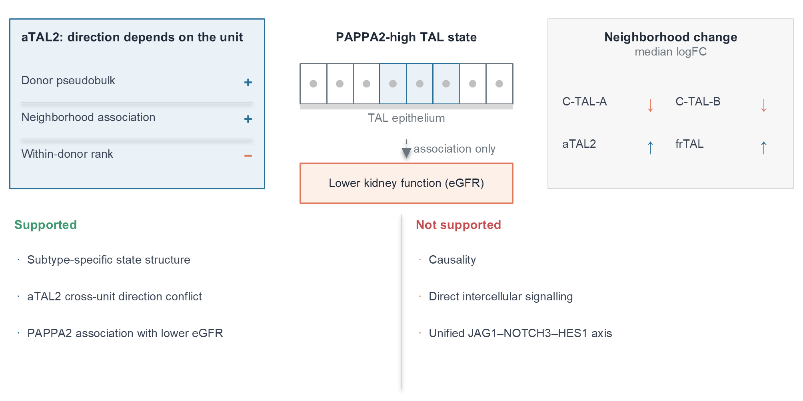
Fig. 8
Conclusions
We developed and empirically evaluated a unit-aware framework showing that the analysis unit is not a neutral choice in human kidney TAL single-cell data. Donor pseudobulk, Milo neighborhood abundance, neighborhood-expression association, and within-donor cell-rank association were not interchangeable: they yielded different subtype-level conclusions, with aTAL2 as the strongest cross-unit discordance example and frTAL as a weaker related pattern. Complete TAL coverage also changed selected gene and subtype conclusions relative to the smaller derivative matrix. A prespecified 400-gene panel showed that donor-versus-within reversal was more frequent in biologically selected TAL genes than in expression-matched controls. A conditional effect-pairing null showed that this excess was explained by the selected effect-size distribution, whereas a smaller neighborhood-versus-within excess remained threshold sensitive. Applying the frozen panel to two external cohorts reproduced the calibration pattern but did not reproduce target-panel specificity. PAPPA2 acts as a case gene with directionally consistent disease association across subtypes. Its donor-level disease elevation received directional support in GSE211785, and an injured-TAL cross-unit signal was observed in GSE254185. Donor-stratified signature transfer reproduced the donor-level direction of an aTAL2-like state but did not provide exact subtype replication or a significant within-donor effect. In GSE175759, the frozen score was associated with lower eGFR after diagnosis adjustment, providing one independent primary kidney-disease clinical association. The absence of age and sex, mixed diagnostic composition, and lack of a second complete cohort preclude stable multicohort clinical validation. The association persisted after TAL-content adjustment and ranked at the extreme negative tail of expression-matched random gene sets, whereas the non-PAPPA2 incremental signal remained borderline. NephQTL2 placed PAPPA2 in a tubulointerstitial regulatory context, without glomerular eQTL support, whereas the same-cohort snATAC analysis did not show a disease-associated accessibility increase. The present evidence does not establish causality, direct intercellular communication, genetic colocalization, or a defined molecular mechanism. These findings support a bounded, human-data-based conclusion: in renal single-cell studies, the analysis unit should be stated explicitly, its influence tested before a disease-state association is interpreted as a general biological property, and effect-aware calibration should be reported alongside expression-matched null sets.
List of abbreviations
AKI: acute kidney injury
AUC: area under the receiver operating characteristic curve
BH: Benjamini-Hochberg
CI: confidence interval
CKD: chronic kidney disease
C-TAL-A, C-TAL-B: KPMP human kidney atlas cortical thick ascending limb subtype labels
C_TAL: cortical thick ascending limb label in GSE211785
DKD: diabetic kidney disease
eGFR: estimated glomerular filtration rate
eQTL: expression quantitative trait locus
FDR: false discovery rate
frTAL: KPMP human kidney atlas thick ascending limb subtype label
GEO: Gene Expression Omnibus
GFR: glomerular filtration rate
HKD: hypertensive kidney disease
KPMP: Kidney Precision Medicine Project
logFC: log2 fold change
LODO: leave-one-donor-out
M_TAL: medullary thick ascending limb label in GSE211785
MR: Mendelian randomization
MSigDB: Molecular Signatures Database
NephQTL2: human kidney eQTL resource
OR: odds ratio
PAPPA2: pappalysin 2
pQTL: protein quantitative trait locus
PTWAS: probabilistic transcriptome-wide association study
snATAC-seq: single-nucleus assay for transposase-accessible chromatin sequencing
snRNA-seq: single-nucleus RNA sequencing
SpatialFDR: spatial false discovery rate
TAL: thick ascending limb
UMAP: uniform manifold approximation and projection
Declarations
Ethics approval and consent to participate
This study used publicly available or controlled-access, de-identified human kidney data. No new human samples were collected, and no participant recruitment or intervention was performed. Ethical approval and informed consent were not required for the present secondary analysis; data access and use were governed by the terms of the original studies and repositories.
No animal experiments were performed in this study.
Consent for publication
Not applicable. No identifiable individual-level data are presented.
Clinical trial number
Clinical trial number: not applicable.
Availability of data and materials
The datasets supporting the conclusions of this article are available in the Gene Expression Omnibus repository, GSE183279 [18] (https://www.ncbi.nlm.nih.gov/geo/query/acc.cgi?acc=GSE183279), which includes single-nucleus RNA sequencing data (GSE183277) and spatial transcriptomics data [19]. GSE137570 is available in the Gene Expression Omnibus repository [20] (https://www.ncbi.nlm.nih.gov/geo/query/acc.cgi?acc=GSE137570). The independent validation datasets are GSE211785 [21,22] (https://www.ncbi.nlm.nih.gov/geo/query/acc.cgi?acc=GSE211785) and GSE254185 [23,24] (https://www.ncbi.nlm.nih.gov/geo/query/acc.cgi?acc=GSE254185). The primary kidney-disease clinical-association cohort is GSE175759 [25] (https://www.ncbi.nlm.nih.gov/geo/query/acc.cgi?acc=GSE175759), including public sample-level eGFR and processed expression matrices. NephQTL2 gene-level and PTWAS summary data were obtained from the supplementary information of [16]. Nephroseq v5 was queried through its public interface [13] (https://www.nephroseq.org).
Access to the Gene Expression Omnibus datasets is unrestricted, including for non-academic users. Nephroseq v5 is accessible through its public web interface, and its use is subject to the terms of use published on the Nephroseq website [13].
Project name: pappa2-tal-analysis-unit-sensitivity
Project home page: https://github.com/ZhiPeng1022/pappa2-tal-analysis-unit-sensitivity
Archived version: https://doi.org/10.5281/zenodo.24042041
Operating system(s): Platform independent
Programming language: Python; R
Other requirements: see requirements.txt in the project repository
License: MIT for the unitaware software; project data follow the repository data license
Any restrictions to use by non-academics: none
Unit-aware software package:
Project name: unitaware v0.2.0
Project home page: https://github.com/ZhiPeng1022/pappa2-tal-analysis-unit-sensitivity/tree/main/unitaware
Archived version: included in the archived analysis release cited above
Operating system(s): Platform independent
Programming language: Python
Other requirements: Python 3.10 or higher; numpy, pandas, scipy
License: MIT
Any restrictions to use by non-academics: none
The processed analysis tables supporting the conclusions of this article are included in Additional files 1-31.
Analysis code is available at https://github.com/ZhiPeng1022/pappa2-tal-analysis-unit-sensitivity. The versioned archive containing the signature-transfer, regulatory-support, composition-expression, and prespecified analysis-unit panel is available at the project repository. The corrected v0.2.0 analysis archive is available at https://doi.org/10.5281/zenodo.24042041.
Competing interests
The authors declare no competing interests.
Funding
This research received no specific grant from any funding agency in the public, commercial, or not-for-profit sectors.
Authors' contributions
P.Z. conceived and designed the study, performed the formal analysis and data curation, and wrote the first draft. X.Y. contributed to validation and data curation, and revised the manuscript. C.Z. contributed to the software and data curation, and revised the manuscript. All authors read and approved the final manuscript.
Additional files
Additional file 1. File format: Comma-separated values (.csv). Title: Permutation null distributions for the within-donor cell-rank analysis. Description: Null distributions from 1,000 within-donor expression permutations for each gene, subtype, and comparison.
Additional file 2. File format: Comma-separated values (.csv). Title: Complete-data Milo neighborhood summary. Description: Neighborhood counts, directions, and median logFC for each subtype and disease comparison in the complete 106,851-cell TAL analysis.
Additional file 3. File format: Comma-separated values (.csv). Title: Subset-level Augur separability summary. Description: Mean AUC values and subsample intervals for disease versus Reference separability in the 4,446-cell derivative subset.
Additional file 4. File format: Comma-separated values (.csv). Title: Complete versus subset pseudobulk direction comparison. Description: Direction of effect for each gene, subtype, and comparison in the complete analysis and in the 4,446-cell subset, including the 12 comparisons with discordant direction.
Additional file 5. File format: Comma-separated values (.csv). Title: Neighborhood-expression association robustness. Description: Spearman correlations between neighborhood expression and Milo logFC, with leave-one-donor and donor-stratified bootstrap stability.
Additional file 6. File format: Comma-separated values (.csv). Title: Donor-stratified bootstrap replicates for neighborhood association. Description: Per-replicate Spearman correlations used to derive the donor-stratified bootstrap intervals.
Additional file 7. File format: Comma-separated values (.csv). Title: Joint analysis-unit concordance table. Description: Donor pseudobulk, neighborhood association, and within-donor cell-rank directions joined for each gene, subtype, and comparison.
Additional file 8. File format: Comma-separated values (.csv). Title: Within-donor cell-rank association results. Description: Donor-level Spearman correlations between gene expression and neighborhood exposure for each gene, subtype, and comparison.
Additional file 9. File format: Comma-separated values (.csv). Title: Complete donor pseudobulk results. Description: Donor pseudobulk effect sizes, age- and sex-adjusted estimates, and false discovery rates for the five analyzed genes.
Additional file 10. File format: Comma-separated values (.csv). Title: Leave-one-donor-out replicates for neighborhood association. Description: Per-replicate Spearman correlations computed with one donor removed at a time.
Additional file 11. File format: Comma-separated values (.csv). Title: KPMP ordinal eGFR models. Description: Ordinal logistic model estimates for the association between PAPPA2-positive TAL fraction and baseline eGFR category.
Additional file 12. File format: Comma-separated values (.csv). Title: GSE137570 directional eGFR association. Description: Unadjusted and adjusted PAPPA2-eGFR association estimates for the 24 donors with public eGFR.
Additional file 13. File format: Comma-separated values (.csv). Title: Nephroseq precomputed GFR associations. Description: Precomputed GFR association results for PAPPA2 and four control genes, summarized by dataset, tissue type, sample count, correlation coefficient, and p value.
Additional file 14. File format: Comma-separated values (.csv). Title: Independent non-KPMP validation of PAPPA2 and analysis-unit direction. Description: TAL state, donor comparison, effect size, permutation p value, false discovery rate, direction, and number of donors for GSE211785 and GSE254185.
Additional file 15. File format: Comma-separated values (.csv). Title: Donor-stratified KPMP TAL marker panel. Description: Top 35 training-donor markers for each of the four TAL subtypes, with mean expression, detection fraction, and specificity.
Additional file 16. File format: Comma-separated values (.csv). Title: Held-out KPMP signature-transfer validation. Description: Held-out prediction coverage, accuracy, macro F1, precision, recall, and confusion matrices at the prespecified marker-margin thresholds.
Additional file 17. File format: Comma-separated values (.csv). Title: External aTAL2-like signature transfer. Description: High-confidence predicted cells, backbone-state composition, and donor-level and within-donor PAPPA2 results for GSE254185 and GSE211785.
Additional file 18. File format: Comma-separated values (.csv). Title: NephQTL2 gene-level eQTL results for PAPPA2 and fixed markers. Description: Tubulointerstitial and glomerular gene-level FDR, eGene status, model size, and prespecified marker annotations from [16].
Additional file 19. File format: Comma-separated values (.csv). Title: GSE211785 snATAC gene-activity analysis. Description: Donor pseudobulk values, exact permutation P values, leave-one-donor ranges, and false discovery rates for PAPPA2 and fixed marker genes in C_TAL and M_TAL.
Additional file 20. File format: Comma-separated values (.csv). Title: Composition and expression decomposition. Description: Overall TAL contribution, subtype-expression component, subtype-composition component, interaction/covariance remainder, donor-bootstrap intervals, and subtype-level contributions for PAPPA2 and control genes.
Additional file 21. File format: Comma-separated values (.csv). Title: Prespecified 400-gene panel and matched control pool. Description: Group assignment, selection rank, expression, and detection statistics for the target panel and the 2,000-gene external negative-control pool.
Additional file 22. File format: Comma-separated values (.csv). Title: Gene-level analysis-unit metrics. Description: Donor pseudobulk, neighborhood-expression, and within-donor effects with validity flags and standardized reversal indicators for all panel and control genes.
Additional file 23. File format: Comma-separated values (.csv). Title: Random-set analysis-unit sensitivity results. Description: Gene-level reversal fractions for 1,000 random 400-gene and 300-gene sets from the expression-matched negative-control pool, including expression-stratified sensitivity sets.
Additional file 24. File format: Comma-separated values (.csv). Title: Unit-aware simulation runs. Description: Per-replicate donor, neighborhood, and within-donor effects and reversal fractions across six simulation scenarios.
Additional file 25. File format: Comma-separated values (.csv). Title: Unit-aware simulation summary. Description: Mean effect sizes and reversal fractions by simulation scenario.
Additional file 26. File format: Tagged Image File Format (.tif). Title: Analysis-unit robustness. Description: a, Expression-matched random-set null for donor-within reversal with the 400-gene target and 300-gene biological panel values. b, Observed reversal fraction and effect-aware conditional null mean with 95% interval for the three gene-specific unit pairs. c, Target and expression-matched reversal fractions across standardized-effect thresholds from 0.5 to 2.0.
Additional file 27. File format: Tagged Image File Format (.tif). Title: Unit-aware simulation benchmark. Description: a, Mean donor and within-donor effects across six simulation scenarios. b, Donor-within reversal fraction by scenario. The opposing scenarios separate from concordant and largely null scenarios.
Additional file 28. File format: Comma-separated values (.csv). Title: Analysis-unit threshold sensitivity. Description: Target-panel and expression-matched random-set reversal fractions for three unit pairs at standardized-effect thresholds from 0.5 to 2.0, including the 300 biological genes and expression-stratified sets.
Additional file 29. File format: Microsoft Excel Worksheet (.xlsx). Title: Effect-aware pairing permutation. Description: Summary and 10,000-run null distributions for donor versus within-donor, donor versus neighborhood-expression, and neighborhood-expression versus within-donor reversal after preserving effect-size marginals and breaking gene-wise unit pairing.
Additional file 30. File format: Microsoft Excel Worksheet (.xlsx). Title: External application of the frozen analysis-unit panel. Description: Two-cohort summary, gene-level reversal fractions, donor and within-donor effect metrics, expression-matched random sets, and 10,000-run conditional null distributions for GSE211785 and GSE254185.
Additional file 31. File format: Microsoft Excel Worksheet (.xlsx). Title: GSE175759 clinical-association analysis. Description: Sample-level 11-gene scores and eGFR, gene coverage, primary and diagnosis-adjusted models, disease-only sensitivity, PAPPA2-only model, and leave-one-gene-out results, together with TAL-content adjustment, 10,000 expression-matched random-set null results, and PAPPA2 incremental models.
References
1. Bikbov B, Purcell CA, Levey AS, Smith M, Abdoli A, Abebe M, et al. Global, regional, and national burden of chronic kidney disease, 1990-2017: a systematic analysis for the Global Burden of Disease Study 2017. Lancet. 2020;395(10225):709-33. doi:10.1016/S0140-6736(20)30045-3.
2. Hoste EAJ, Kellum JA, Selby NM, Zarbock A, Palevsky PM, Bagshaw SM, et al. Global epidemiology and outcomes of acute kidney injury. Nat Rev Nephrol. 2018;14(10):607-25. doi:10.1038/s41581-018-0052-0.
3. Ferenbach DA, Bonventre JV. Mechanisms of maladaptive repair after AKI leading to accelerated kidney ageing and CKD. Nat Rev Nephrol. 2015;11(5):264-76. doi:10.1038/nrneph.2015.3.
4. Bonventre JV, Yang L. Cellular pathophysiology of ischemic acute kidney injury. J Clin Invest. 2011;121(11):4210-21. doi:10.1172/JCI45161.
5. Lake BB, Menon R, Winfree S, Hu Q, Melo Ferreira R, Kalhor K, et al. An atlas of healthy and injured cell states and niches in the human kidney. Nature. 2023;619(7970):585-94. doi:10.1038/s41586-023-05769-3.
6. Knepper MA, Kim GH, Fernández-Llama P, Ecelbarger CA. Regulation of thick ascending limb transport by vasopressin. J Am Soc Nephrol. 1999;10(3):628-34. doi:10.1681/ASN.V103628.
7. Brezis M, Rosen S, Silva P, Epstein FH. Selective vulnerability of the medullary thick ascending limb to anoxia in the isolated perfused rat kidney. J Clin Invest. 1984;73(1):182-90. doi:10.1172/JCI111189.
8. Oxvig C. The role of PAPP-A in the IGF system: location, location, location. J Cell Commun Signal. 2015;9(2):177-87. doi:10.1007/s12079-015-0259-9.
9. Dauber A, Muñoz-Calvo MT, Barrios V, Domené HM, Kloverpris S, Serra-Juhé C, et al. Mutations in pregnancy-associated plasma protein A2 cause short stature due to low IGF-I availability. EMBO Mol Med. 2016;8(4):363-74. doi:10.15252/emmm.201506106.
10. Conover CA, Boldt HB, Bale LK, Clifton KB, Grell JA, Mader JR, et al. Pregnancy-associated plasma protein-A2 (PAPP-A2): tissue expression and biological consequences of gene knockout in mice. Endocrinology. 2011;152(7):2837-44. doi:10.1210/en.2011-0036.
11. Asghari M, Sabo AR, Barwinska D, Melo Ferreira R, Ferkowicz MJ, Bowen WS, et al. Integration of spatial protein imaging and transcriptomics in the human kidney tracks the regenerative potential of proximal tubules. Sci Adv. 2025;11(33):eadv8918. doi:10.1126/sciadv.adv8918.
12. Kennedy C, Doyle R, Gough O, McEvoy C, McAnallen S, Hughes M, et al. A novel role for FERM domain-containing protein 3 in CKD. Kidney360. 2024;5(12):1799-812. doi:10.34067/KID.0000000602.
13. Nephroseq v5. University of Michigan, Ann Arbor, MI, USA. https://www.nephroseq.org. Accessed 29 September 2026.
14. Skinnider MA, Squair JW, Kathe C, Anderson MA, Gautier M, Matson KJE, et al. Cell type prioritization in single-cell data. Nat Biotechnol. 2021;39(1):30-4. doi:10.1038/s41587-020-0605-1.
15. Dann E, Henderson NC, Teichmann SA, Morgan MD, Marioni JC. Differential abundance testing on single-cell data using k-nearest neighbor graphs. Nat Biotechnol. 2022;40(2):245-53. doi:10.1038/s41587-021-01033-z.
16. Han SK, McNulty MT, Benway CJ, Wen P, Greenberg A, Onuchic-Whitford AC, et al. Mapping genomic regulation of kidney disease and traits through high-resolution and interpretable eQTLs. Nat Commun. 2023;14:2229. https://doi.org/10.1038/s41467-023-37691-7.
17. Cippà PE, Sun B, Liu J, Chen L, Naesens M, McMahon AP. Transcriptional trajectories of human kidney injury progression. JCI Insight. 2018;3(22):e123151. doi:10.1172/jci.insight.123151.
18. Kidney Precision Medicine Project. Single-nucleus RNA sequencing resource, GEO superseries GSE183279. https://www.ncbi.nlm.nih.gov/geo/query/acc.cgi?acc=GSE183279. Accessed 29 September 2026.
19. Kidney Precision Medicine Project. Spatial transcriptomics resource, GEO GSE183456. https://www.ncbi.nlm.nih.gov/geo/query/acc.cgi?acc=GSE183456. Accessed 29 September 2026.
20. Human kidney transcriptome cohort, GEO GSE137570. https://www.ncbi.nlm.nih.gov/geo/query/acc.cgi?acc=GSE137570. Accessed 29 September 2026.
21. Abedini A, Kloetzer K, Ma Z, Frederick J, Dhillon P, Balzer M, et al. Single-cell multi-omic and spatial profiling of human kidneys implicates the fibrotic microenvironment in kidney disease progression. Nat Genet. 2024;56(8):1712-24. doi:10.1038/s41588-024-01802-x.
22. Human kidney multi-omic atlas, GEO GSE211785. https://www.ncbi.nlm.nih.gov/geo/query/acc.cgi?acc=GSE211785. Accessed 28 October 2026.
23. Reck M, Baird DP, Veizades S, Sutherland C, Bell RMB, Hur H, et al. Multiomic analysis of human kidney disease identifies a tractable inflammatory and pro-fibrotic tubular cell phenotype. Nat Commun. 2025;16(1):4745. doi:10.1038/s41467-025-59997-4.
24. Human kidney multiome resource with obstructive nephropathy, GEO GSE254185. https://www.ncbi.nlm.nih.gov/geo/query/acc.cgi?acc=GSE254185. Accessed 28 October 2026.
25. Human kidney tubulointerstitial transcriptome cohort, GEO GSE175759. https://www.ncbi.nlm.nih.gov/geo/query/acc.cgi?acc=GSE175759. Accessed 8 November 2026.
Figure legends
Fig. 1. TAL location and analysis-unit study design. The left panel shows a nephron with the thick ascending limb (TAL) highlighted across the cortex and medulla. The right panels summarize the analysis. The discovery resource was the complete KPMP single-nucleus TAL set, comprising 106,851 cells annotated as C-TAL-A, C-TAL-B, aTAL2 or frTAL. A previously generated 4,446-cell derivative matrix was retained only as a coverage and directional comparator. Four complementary analysis estimands were compared: donor pseudobulk, neighborhood abundance, neighborhood-expression association, and within-donor cell-rank association. Donor-level robustness analyses (leave-one-donor refitting, donor-stratified bootstrap, age- and sex-adjusted models, and cortex or medulla stratification) were treated as stability checks rather than as separate estimands. PAPPA2 was analyzed as a pre-specified case gene. The units reuse the same cells and embedding and are not independent validations. No arrow in this schematic implies causality.
Fig. 2. Subtype-resolved disease-related neighborhood remodeling. Complete-data Milo results for the four TAL subtypes across three comparisons (combined disease, AKI, and CKD versus Reference). a Fraction of annotated neighborhoods that were significant. b Median neighborhood logFC. c Number of significant neighborhoods. Neighborhoods were built from atlas-provided UMAP coordinates and tested with Milo using logMS normalization and a fixed seed; the significance threshold was SpatialFDR < 0.05. One AKI donor without neighborhood representation was excluded from the AKI comparison. Numbers of annotated neighborhoods differed between comparisons; in the combined-disease comparison they were 4,012 (C-TAL-A), 2,805 (C-TAL-B), 1,465 (aTAL2), and 1,332 (frTAL). Panels show counts and summary statistics without error bars.
Fig. 3. Analysis-unit comparison design. Schematic definition of the four complementary analysis estimands compared in this study, with the question each estimand addresses and the limitation that applies to it. Donor pseudobulk asks whether mean expression differs between disease and Reference donors and is limited by donor composition and disease mix. Neighborhood-expression association asks whether neighborhoods with higher gene expression also have higher disease logFC and is limited because Milo neighborhoods overlap. Within-donor cell-rank association asks whether cells with greater neighborhood exposure have higher expression inside the same donor and describes a state association rather than causality. Donor robustness analysis resamples donors to test dependence on individual donors or tissue region and provides internal stability only. The schematic illustrates that one gene can be positive in one unit and negative in another; the estimates are not independent validations of one another. No data are plotted.
Fig. 4. Complete TAL coverage and subset discordance. Comparison of the complete 106,851-cell TAL source with the 4,446-cell derivative subset. a Cells per subtype in the complete source and in the subset (log scale). b Number of Reference donors per subtype in both sources. c Gene, subtype, and comparison tests in which the complete and subset pseudobulk analyses agreed or disagreed in direction; 60 tests were evaluated (five genes × four subtypes × three comparisons). d Discordant tests by gene. The coverage difference was largest for the sparse subtypes: aTAL2 contained 6,624 Reference cells from 83 donors in the complete source versus 102 cells from 38 donors in the subset, and frTAL contained 6,656 Reference cells from 86 donors versus 142 cells from 48 donors. Bars show counts; no error bars are shown.
Fig. 5. PAPPA2 case analysis across TAL subtypes. PAPPA2 results across the four analysis units, shown for three comparisons (rows) and four TAL subtypes (columns). a Donor pseudobulk mean expression difference between disease and Reference donors. b Age- and sex-adjusted linear model beta. c Neighborhood-expression association, expressed as the Spearman correlation between neighborhood mean PAPPA2 expression and Milo logFC across neighborhoods. d Within-donor cell-rank association, expressed as the median Spearman correlation between PAPPA2 expression and neighborhood exposure within each donor, using donors with at least five cells. Values are printed in each cell. Panels a and b are donor-level estimates; panels c and d use different units of inference and should not be combined.
Fig. 6. aTAL2 and frTAL cross-unit discordance. Cross-unit comparison for the two subtypes that showed direction conflicts. a aTAL2 donor pseudobulk mean expression difference for the three comparisons. b aTAL2 median within-donor cell-rank correlation for the same comparisons. c Number of comparisons with a direction conflict between the donor pseudobulk and within-donor cell-rank units, by subtype. In aTAL2, donor-level association was positive while the within-donor association was negative in combined disease and AKI (FDR = 0.0086 for each); the CKD difference was also negative but did not pass FDR (0.224). frTAL showed the same qualitative pattern with weaker support (combined disease FDR = 0.018). Bars show point estimates; no error bars are shown.
Fig. 7. Internal robustness of complete TAL pseudobulk effects. Internal stability analysis of the PAPPA2 donor pseudobulk effect across the 12 gene, subtype, and comparison groups (four subtypes × three comparisons). a Full-data effect (points) together with the range obtained when each donor was removed in turn (whiskers span the minimum to the maximum of the leave-one-donor refits). b Donor-stratified bootstrap median with the 95% interval from 1,000 resamples. c Cortex and medulla mean disease-minus-Reference difference for the combined-disease comparison. The PAPPA2 direction was preserved in all 12 leave-one-donor groups, and cortex and medulla agreed in direction in 11 of 12 groups. These intervals describe donor-level stability and are not independent-cell significance tests.
Fig. 8. Subtype-specific TAL state model. Schematic summary of the interpretation supported by this study. The upper part shows subtype-specific TAL neighborhood states (C-TAL-A, C-TAL-B, and frTAL with positive neighborhood association, and aTAL2 as an exploratory decoupling), the donor-aware framework used here (Milo, Augur, donor pseudobulk, and within-donor cell rank), and the PAPPA2-associated TAL state together with lower kidney function. The lower panels state what the data support (subtype-specific state structure, exploratory aTAL2 decoupling, and a PAPPA2 association) and what they do not support (causality, direct intercellular communication, and a unified JAG1-NOTCH3-HES1 or EPHB2-STAT6 mechanism). No arrow implies causal direction.

