Analysis-unit sensitivity distinguishes donor-level expression enrichment from within-donor coupling in human kidney thick ascending limb states
Article type: Research Article
Authors: Peng Zhi, Xiaohe Yan, Chaofan Zhang
Affiliations: Henan Provincial Chest Hospital, Zhengzhou, China
Corresponding author: Peng Zhi, Department of General Practice, Henan Provincial Chest Hospital, Zhengzhou, Henan, China. Email: zhiyoyo0409@163.com. ORCID: 0009-0003-2201-5131
Co-author contacts: Xiaohe Yan. Email: yanxiaohe123456@163.com. ORCID: 0009-0006-2259-9271; Chaofan Zhang. Email: zcf1765081785@163.com. ORCID: 0009-0009-9088-0016
Abstract
Single-cell kidney atlases frequently describe disease-associated states as properties of a cell type, although donor composition, local neighborhood structure, and within-donor coupling measure different quantities. We tested whether these analysis units lead to the same subtype-level conclusion in the human thick ascending limb (TAL). We analyzed 106,851 KPMP single-nucleus TAL cells from 223 donors and compared donor pseudobulk, Milo neighborhood abundance, neighborhood-expression association, and within-donor cell-rank association across C-TAL-A, C-TAL-B, aTAL2, and frTAL. Key directions were tested in GSE211785 and GSE254185, two non-KPMP kidney resources. Donor-stratified signature transfer and kidney tubulointerstitial eQTL and snATAC context were also evaluated. Complete and subset pseudobulk directions agreed in 48/60 comparisons, but 12 changed direction. In aTAL2, donor pseudobulk and neighborhood-expression association were positive, whereas the within-donor association was negative in combined disease and AKI (FDR = 0.0086 for each). In a prespecified 400-gene panel, donor-within reversal exceeded expression-matched random sets (18.6% versus 12.7%; empirical P = 0.000999). Signature transfer achieved 93.9% accuracy among assigned held-out cells and 93.9% aTAL2 recall. Both external cohorts supported donor-level PAPPA2 disease elevation, but within-donor negative estimates were underpowered. PAPPA2 was a strong kidney tubulointerstitial eGene (FDR = 1.64e-14) without glomerular eQTL support, whereas same-cohort snATAC did not show higher disease accessibility. Decomposition attributed the overall PAPPA2 difference mainly to subtype expression effects rather than shifts in TAL subtype proportions. The analysis unit is therefore an effect modifier in kidney single-cell studies. Donor-aware and within-donor results should be reported separately.
Keywords: thick ascending limb, kidney single-cell analysis, analysis unit, donor-aware inference, PAPPA2, kidney eQTL
Introduction
Chronic kidney disease and acute kidney injury are major causes of morbidity and mortality worldwide (Bikbov et al. 2020; Hoste et al. 2018). Kidney injury is not distributed uniformly across the nephron. Proximal tubules, thick ascending limb (TAL) cells, distal tubules, endothelial cells, and immune populations can adopt distinct injury, adaptation, and repair states (Ferenbach and Bonventre 2015; Bonventre and Yang 2011). The biological and clinical meaning of these states depends on both tissue context and the way in which the disease signal is measured. The central question is not only whether a gene is associated with disease, but whether that association survives a change in the unit of inference.
Single-cell and spatial technologies now make it possible to map kidney cell states at high resolution (Lake et al. 2023). However, the conclusions of such studies depend on the unit used for inference. Donor pseudobulk asks whether mean expression differs between disease and Reference donors; Milo neighborhood abundance asks whether neighborhood abundance differs between disease and Reference; neighborhood-expression association asks whether neighborhoods with higher expression also have higher disease logFC; and within-donor analysis asks whether cells with greater neighborhood exposure have higher expression inside each donor. Donor-level robustness is used as a stability check rather than as a separate unit of inference. These approaches answer different questions and may not give the same answer. This ambiguity is important because a disease signal attributed to one cell state could instead reflect donor composition, local neighborhood structure, or a difference between cells within the same donor. Direct comparison of established analysis units within the same disease atlas is therefore needed.
TAL cells perform active sodium, potassium, and chloride transport, are metabolically demanding, and are sensitive to ischemic and inflammatory injury (Knepper et al. 1999; Brezis et al. 1984). Several transcriptionally distinct TAL subtypes have been reported in human kidney atlases, but whether these subtypes share the same disease-related neighborhood states remains unclear. This question is clinically relevant because TAL injury and adaptation may affect tubular workload, inflammatory signaling, and repair programs. PAPPA2 is not the central hypothesis; it is a case gene with a less well-defined renal role, used to test whether a gene-state association remains consistent when the analysis unit changes (Oxvig 2015; Dauber et al. 2016; Conover et al. 2011).
In this study, we analyzed the complete KPMP single-nucleus resource, including 106,851 TAL cells, and compared four established units of inference. The study had three prespecified aims: first, to determine whether donor, neighborhood, neighborhood-expression, and within-donor analyses produce concordant subtype-level disease conclusions; second, to test whether the principal directions transfer to non-KPMP kidney cohorts; and third, to determine whether the PAPPA2 case signal has a human kidney regulatory context. The study was not designed as a new algorithm, causal test, or mechanistic experiment. It was designed to determine which conclusions survive a change in the unit of inference.
The central finding is that changing the analysis unit changes subtype-level conclusions. aTAL2 provided the strongest example of cross-unit discordance, frTAL showed a weaker related pattern, and PAPPA2 marked a disease-associated TAL state without establishing causality. We then tested the key directions in two non-KPMP cohorts and evaluated kidney tubulointerstitial eQTL and snATAC context. These analyses separate a stable disease-level observation from claims that require exact subtype replication, chromatin validation, or causal inference.
Methods
Study design and data sources
We designed an empirical analysis-unit sensitivity study using public or controlled-access human kidney data. No new human samples were collected, and no new ethical approval was required for secondary analysis of de-identified data. The analysis was intended to test whether disease conclusions remained stable when the unit of inference changed, rather than to identify a new molecular mechanism (Fig. 1).
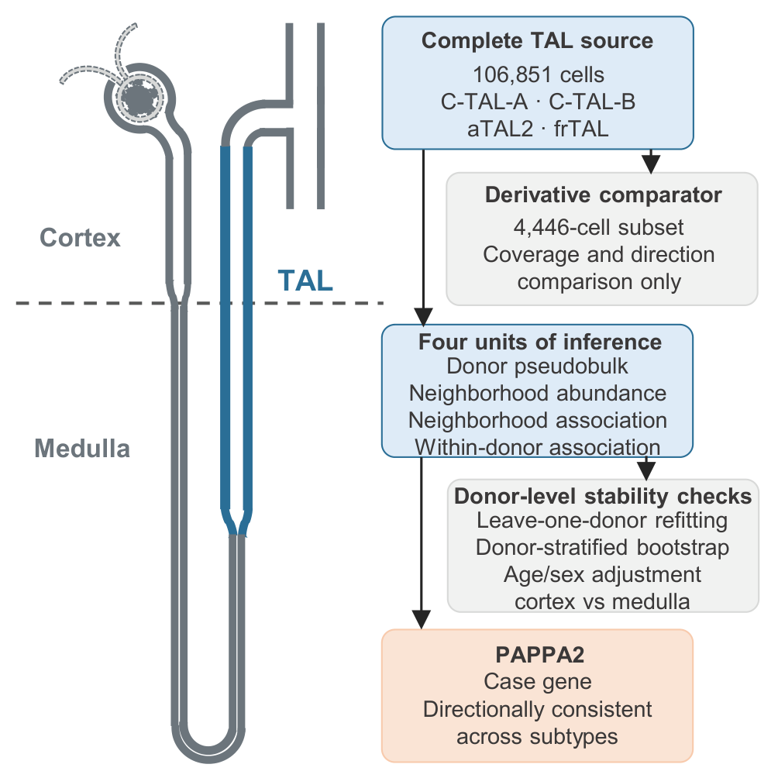
Fig. 1
We selected data sources to provide one discovery resource and separate directional support. The discovery resource was the KPMP human kidney single-nucleus RNA sequencing dataset (Lake et al. 2023), which contained 1,388,643 cells and 35,455 features. We extracted all cells annotated as C-TAL-A, C-TAL-B, aTAL2, or frTAL, yielding 106,851 TAL cells. A previously generated 4,446-cell derivative matrix was retained only as a coverage and directional comparator. Spatial cross-modality analysis used the KPMP GSE183456 Visium resource, part of the KPMP GEO superseries GSE183279, which contained 23 sections from 22 donors (Lake et al. 2023; Asghari et al. 2025). Because GSE183456 shares KPMP consortium provenance with the discovery data, it was treated as same-consortium support rather than an external cohort. Separate directional eGFR testing used GSE137570 (Kennedy et al. 2024), and multi-dataset GFR association testing used Nephroseq v5 (Nephroseq v5 2026). Independent validation used the non-KPMP GSE211785 multi-omic kidney atlas and the independent GSE254185 kidney multiome resource.
TAL subtypes and the four analysis units
We restricted the analysis to four TAL subtypes and defined the analysis units before comparing their results. The subtypes were C-TAL-A, C-TAL-B, aTAL2, and frTAL. All primary analyses used the complete 106,851-cell TAL set and the atlas-provided UMAP coordinates.
We compared four primary analysis units because each answers a different question about disease-related TAL state. Donor pseudobulk asks whether mean expression differs between disease and Reference donors. Milo neighborhood abundance asks whether neighborhood abundance differs between disease and Reference. Neighborhood-expression association asks whether neighborhoods with higher expression also have higher disease logFC. Within-donor cell-rank association asks whether cells with greater neighborhood exposure have higher expression inside each donor.
We treated donor-level robustness as a stability check rather than as a fifth analysis unit. This distinction avoids treating resampling stability as an independent biological measurement. The primary Milo threshold was SpatialFDR < 0.05. Milo used logMS normalization and a fixed random seed of 20260927. One AKI donor with zero neighborhood counts was excluded from that comparison. Augur was retained only as a secondary subset-level analysis of disease versus Reference separability (Skinnider et al. 2021), using 20 subsamples, 30 cells per subsample, and 3-fold cross-validation.
Donor-level pseudobulk expression
Donor pseudobulk provided the reference analysis unit, because donor-level mean expression is the most common way to relate cell-state genes to disease. Raw counts for PAPPA2, CXCL12, NOTCH3, HES1, and EPHB2 were extracted directly from the sparse source matrix. Counts were normalized using the full per-cell RNA count and transformed with log1p. Expression was averaged within each donor and TAL subtype. Disease groups were compared with Reference donors using two-sided Mann-Whitney tests, and donor-level linear models were adjusted for age midpoint and sex. Benjamini-Hochberg correction was applied across the 60 gene, subtype, and comparison tests. The 4,446-cell subset result was retained only as a comparator, and its original 120-test correction was not mixed with the complete-TAL analysis.
Composition and expression decomposition
We decomposed the overall four-subtype TAL PAPPA2 difference into a subtype composition component and a subtype-expression component. For each donor, the overall TAL mean was the cell-weighted sum of subtype proportions and subtype-specific mean expression. Group differences were separated into composition at reference means, expression at reference proportions, and an exact remainder containing interaction and within-group covariance terms. Missing subtype means were set to zero contribution when the corresponding proportion was zero. Confidence intervals were obtained from 2,000 donor-level bootstrap resamples within disease and Reference groups.
Milo neighborhood abundance
Milo neighborhood abundance tested whether disease was associated with shifts in local TAL neighborhoods rather than only with donor-level average expression. Neighborhoods were rebuilt from the complete TAL set using the atlas UMAP coordinates, k = 30, a neighbor ratio of 0.1, and refined sampling. We tested disease combined, AKI, and CKD against Reference (Dann et al. 2022). Results were interpreted as differences in TAL-associated neighborhood state rather than as evidence of direct cell-cell contact.
Neighborhood-expression association
Neighborhood-expression association tested whether neighborhoods with higher gene expression were also those with higher disease logFC. Each Milo neighborhood was represented by its mean PAPPA2 expression and its Milo logFC, and Spearman correlation was calculated across neighborhoods for each comparison and subtype. Stability was assessed with 500 donor-stratified resamples, leave-one-donor-out analysis, and a partial Spearman correlation controlling for neighborhood purity (Supplementary Table S1). These resampling intervals describe donor-level stability and are not independent cell-level p values.
Within-donor cell-rank association
Within-donor cell-rank association tested whether cells with greater neighborhood exposure had higher expression inside the same donor. For each cell, neighborhood exposure was defined as the mean Milo logFC of the neighborhoods assigned to that cell's TAL subtype. Within each donor, Spearman correlation was calculated between PAPPA2 expression and neighborhood exposure, so each donor contributed one estimate. Statistical support was assessed with 1,000 within-donor expression permutations. The primary analysis required at least 5 cells per donor, and sensitivity analyses required at least 3 and 10 cells. BH correction was applied across 60 gene, subtype, and comparison tests. Because neighborhoods overlap, conventional correlation p values were treated as descriptive rather than as independent-sample inference.
Analysis-unit comparison and internal robustness
Analysis-unit comparison tested whether the same gene, subtype, and disease comparison led to the same direction across the four units. For each gene, subtype, and comparison, we recorded the direction in donor pseudobulk, Milo neighborhood abundance, neighborhood-expression association, and within-donor cell-rank association and classified the result as concordant or discordant. A 1,000-replicate donor bootstrap was used for complete-TAL pseudobulk effects. The complete-TAL pseudobulk analysis, the previous subset pseudobulk analysis, the neighborhood-level resampling result, and the within-donor permutation result were joined into a single analysis-unit table. This table was used to evaluate stability across units rather than to treat the most significant unit as definitive.
Internal robustness tested whether the donor-level directions were dependent on individual donors, age or sex, or tissue region. We repeated the pseudobulk analysis after removing one donor at a time, resampling donors within condition strata, adjusting for age and sex, and stratifying by cortex or medulla. These analyses were treated as stability checks and not as additional discovery units.
Prespecified 400-gene analysis-unit panel
A 400-gene panel was frozen before the panel outcome analysis. The panel contained 100 TAL subtype markers, 100 MSigDB Hallmark injury, inflammatory, hypoxic, or metabolic genes, 100 genes coexpressed with PAPPA2 in the 156 training donors, and 100 internal expression-matched negative controls. A separate 2,000-gene pool was matched to the target expression and detection distribution and used to generate 1,000 random 400-gene sets.
Only the three gene-specific units were compared across this panel: donor pseudobulk, neighborhood-expression association, and within-donor cell-rank association. A reversal required opposite signs and absolute standardized effects of at least 0.5 in both units. The primary endpoint was the donor-versus-within reversal fraction. One-sided empirical P values compared the target panel with the random sets. An expression-stratified random-set analysis was performed as a sensitivity check. The target-panel hash and frozen definitions are provided in Supplementary Table S21.
KPMP eGFR analysis
The KPMP eGFR analysis tested whether the PAPPA2-associated TAL state was linked to kidney function at the donor level. Donor-level PAPPA2-positive fraction was calculated within TAL cells. Baseline eGFR was treated as an ordinal outcome with four categories: 0-29, 30-59, 60-89, and 90 or more mL/min/1.73 m². The primary ordinal logistic model included PAPPA2-positive fraction per 10 percentage points, age, sex, and disease category. Additional models added C-TAL-A, C-TAL-B, aTAL2, and frTAL fractions, followed by mean detected genes and assay platform. Odds ratios below 1 indicate lower eGFR with higher PAPPA2-positive fraction.
Candidate-gene specificity
Candidate-gene specificity tested whether the PAPPA2 direction was distinctive relative to pre-specified control genes. CXCL12, NOTCH3, HES1, and EPHB2 were analyzed with the same donor-aware and eGFR models used for PAPPA2. The comparison assessed directional consistency, BH-corrected support, and tissue specificity. Because multiple genes can correlate with GFR, the aim was not to identify a unique biomarker but to determine whether PAPPA2 showed a distinct negative direction among the tested candidates.
KPMP GSE183456 spatial cross-modality analysis
Spatial cross-modality analysis tested whether the PAPPA2-associated TAL state co-occurred with a repair-failure spatial program within the same KPMP consortium resource. The frozen spatial analysis used nine main-branch genes: THSD4, TEX41, EGF, CA10, CACNB2, CABP1, CXCL12, PRKG1, and NOS1. The repair-failure signature used TMEM207, KLRD1, RNF144B, JAG1, TMEM52B, DACH1, OSBPL10, LRMDA, and KCNJ10. For each section, genes were normalized by counts per 10,000, transformed with log1p, and converted to within-section z scores. Branch scores were the mean z scores of the signature genes, and high-state thresholds were fixed at the 75th percentile. The primary metric was the odds ratio for co-occurrence of high main-branch and high repair-failure states. The same parameters were applied to all 23 sections without re-tuning.
GSE137570 public eGFR testing
GSE137570 testing provided independent but underpowered directional evidence for the PAPPA2-eGFR relationship. GSE137570 Cohort 1 contained 24 donors with public eGFR, age, sex, and fibrosis. PAPPA2 expression was extracted from the normalized read-count matrix. Spearman correlation was calculated between PAPPA2 and eGFR, and a linear model adjusted for age, sex, and fibrosis. The same model was applied to the four control genes. This analysis was regarded as directional support rather than definitive external validation.
Nephroseq GFR analysis
Nephroseq analysis tested whether the PAPPA2-GFR direction was observed across multiple precomputed kidney datasets. Nephroseq v5 was queried through its public API using the GFR filter and thresholds pValue < 0.05, abs(rValue) ≥ 0.5, and abs(foldChange) ≥ 1.5. PAPPA2 and the four control genes were queried with the same thresholds. Each returned analysis was summarized by dataset, tissue type, GFR method, sample count, correlation coefficient, and p value. Analyses were not treated as independent cohorts because several analyses can originate from the same dataset.
Independent non-KPMP cohort analyses
GSE211785 was generated by the Susztak laboratory and contains control kidney, diabetic kidney disease (DKD), and hypertensive kidney disease samples. We used the non-KPMP merged object and restricted analyses to cells annotated as C_TAL or M_TAL in the SC_RNA and SN_RNA libraries. After requiring at least five TAL cells per donor, 29,847 TAL cells from 35 donors with TAL coverage were available (16 control, 7 DKD, and 12 HKD donors).
GSE254185 contains 46,957 nuclei from 7 normal kidneys and 5 kidneys with obstructive nephropathy. Its public TAL annotations included cTAL1, cTAL2, mTAL, TAL Injured, and TAL Inflammatory states, providing 9,912 annotated TAL cells. For both cohorts, counts were normalized to counts per 10,000 and log1p transformed. Donor pseudobulk values were calculated within TAL state. Donor-label permutations used 20,000 random permutations unless exact enumeration was feasible. Neighborhood features were calculated from the public UMAP coordinates using k = 30 nearest neighbors. These analyses provide independent-cohort validation, not experimental or causal validation.
Donor-stratified TAL signature transfer
To test whether the four KPMP TAL signatures could identify an aTAL2-like state outside the discovery annotations, donors were divided into 156 training and 67 held-out donors. The top 35 markers per subtype were selected only in the training donors. Each cell received the mean within-subtype marker z score, and the difference between the top and second-ranked subtype score was defined as the marker margin. The prespecified high-confidence threshold was a marker margin of at least 0.2.
Held-out KPMP cells were used to estimate coverage, accuracy, macro F1, and aTAL2 precision and recall. The same frozen marker panel was then projected to GSE211785 and GSE254185. In each external cohort, donor pseudobulk and within-donor analyses were repeated in the predicted high-confidence aTAL2-like cells. This analysis tests transfer of a transcriptional signature. It does not reproduce the original KPMP subtype labels and is not described as exact aTAL2 validation.
Kidney eQTL and snATAC context
We used NephQTL2 gene-level eQTL results from 240 glomerular and 311 tubulointerstitial human kidney samples (Han et al. 2023). PAPPA2 and the fixed top-35 aTAL2 markers were evaluated without re-selecting genes. We reported tubulointerstitial and glomerular gene-level FDR values and checked whether PAPPA2 appeared among FDR-significant PTWAS associations for eGFR or urinary albumin-to-creatinine ratio. Absence from the significant PTWAS list was recorded as non-significance, not as a negative association.
GSE211785 snATAC nuclei annotated as C_TAL or M_TAL were analyzed using the gene-activity representation as a chromatin-accessibility proxy. Donor means were calculated after requiring at least five snATAC nuclei per donor and state. Disease and control donors were compared with exact donor-label permutation when feasible. Seven control and four disease donors contributed to both states. Benjamini-Hochberg correction was applied across the fixed gene and state tests. GSE211785 RNA and snATAC are from the same cohort, so the snATAC result is an orthogonal-modality analysis rather than an independent cohort.
Reproducibility and software
Reproducibility was addressed by fixing analysis parameters and linking each reported result to versioned code and summary tables. Analysis scripts, frozen analysis protocols, validation tables, and result hashes were prepared for release in the public repository. The fixed-seed Milo analysis, GSE183456 spatial analysis, and Nephroseq queries were rerun with fixed parameters. Random seeds and versioned outputs are listed in the Data availability and Code availability sections.
The authors used OpenAI Codex CLI to assist with organization of methodological text, reference checking, and English-language editing. The authors reviewed and edited all content and retain responsibility for the final manuscript.
Results
Complete TAL coverage provided a common substrate for analysis-unit comparison
Complete TAL coverage allowed all four analysis units to be evaluated in the same cells. The complete set contained 106,851 cells from the four target TAL subtypes, whereas the derivative comparator contained 4,446 cells. The coverage difference was largest for subtypes that were sparse in the derivative matrix: aTAL2 contained 6,624 Reference cells from 83 donors in the complete data but only 102 Reference cells from 38 donors in the subset; frTAL contained 6,656 Reference cells from 86 donors in the complete data but only 142 cells from 48 donors in the subset. The complete set therefore provided a different donor and state composition from the derivative matrix and served as the primary substrate for all subsequent comparisons.
TAL subtypes did not share a single disease-related neighborhood state
Complete-data Milo showed that disease-related neighborhood changes were strongly subtype dependent. In the combined disease comparison, C-TAL-A had 1,797 significant neighborhoods among 4,012 annotated neighborhoods, C-TAL-B had 715 among 2,805, aTAL2 had 632 among 1,465, and frTAL had 1,023 among 1,332. The direction also differed: frTAL had 996 positive and 27 negative significant neighborhoods, whereas C-TAL-A had 333 positive and 1,464 negative neighborhoods.
Disease-specific analyses preserved this subtype dependence. In AKI, aTAL2 had 842 significant neighborhoods, 822 positive and 20 negative, with a median logFC of 1.364. In CKD, frTAL had 982 significant neighborhoods, 956 positive and 26 negative, with a median logFC of 1.138. By contrast, CKD aTAL2 had a median logFC of -0.406. These results show that TAL neighborhood remodeling cannot be summarized as one shared disease response (Fig. 2; Supplementary Tables S2 and S3).
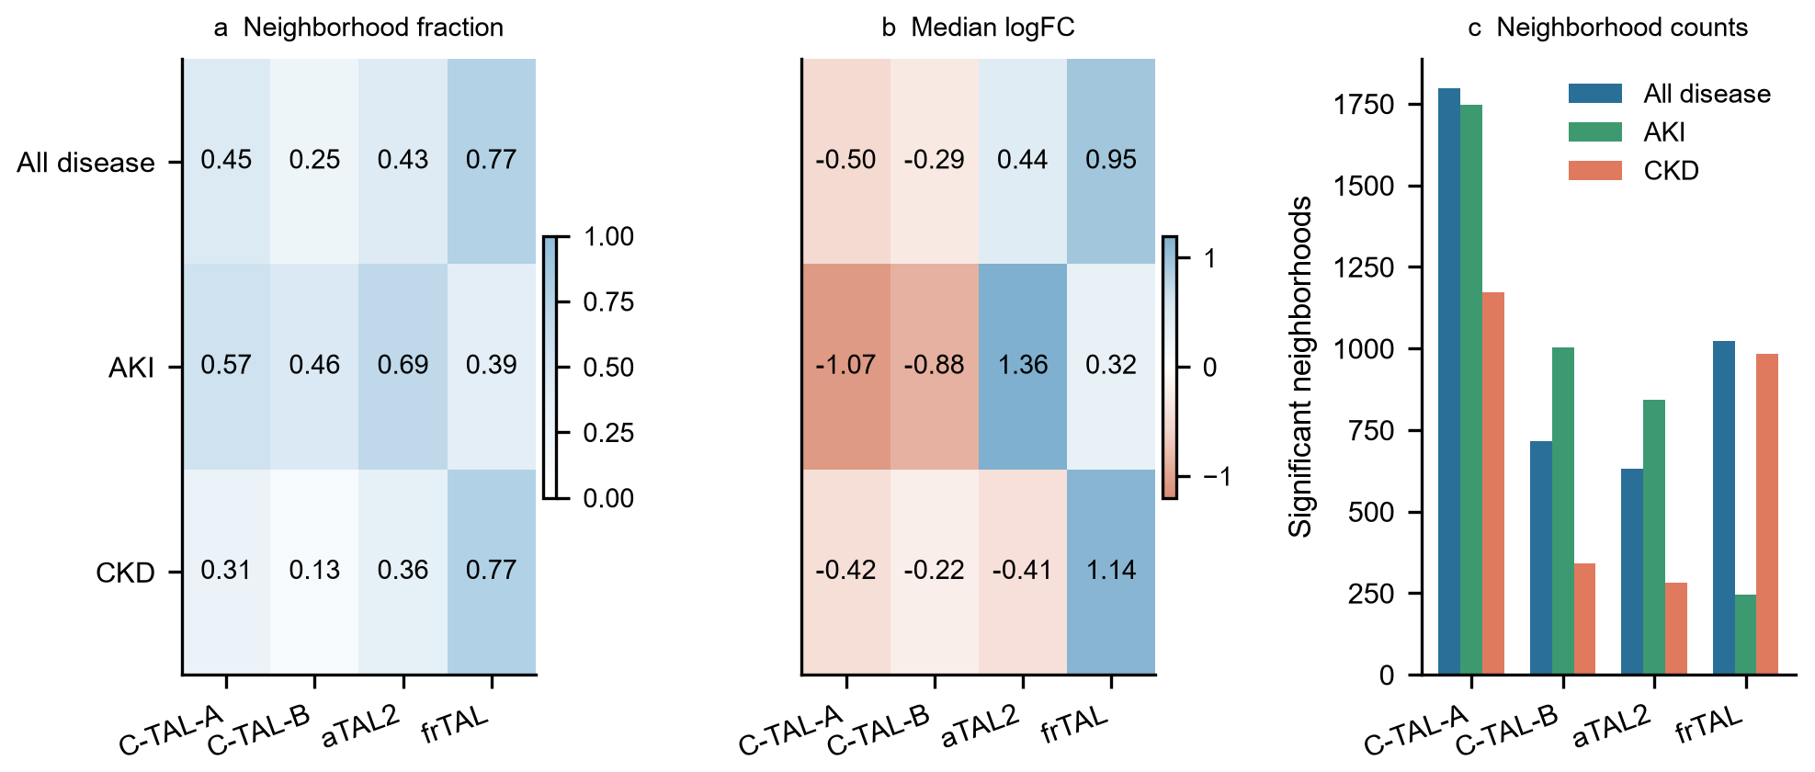
Fig. 2
The secondary subset-level Augur analysis provided complementary evidence that subtype states were not equally separable. AKI C-TAL-A had the highest mean AUC at 0.753, whereas CKD aTAL2 had a mean AUC below 0.5 at 0.479. The moderate AUC values and broad subsample intervals indicate that disease and Reference states were only partially separable. Together with Milo, these results establish subtype-specific neighborhood structure before the analysis units are compared directly (Fig. 3).
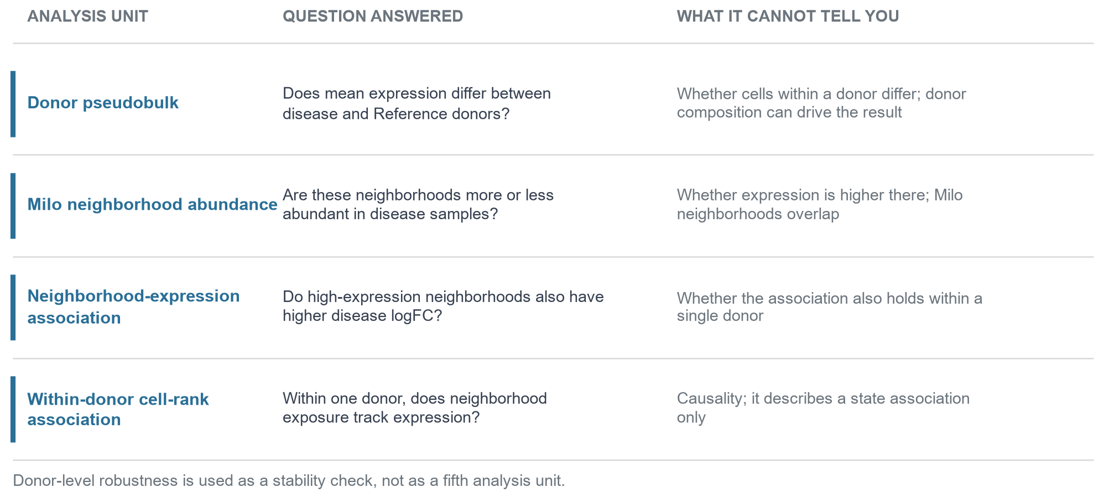
Fig. 3
Subset and complete pseudobulk results changed direction for selected genes
The derivative subset preserved broad pseudobulk trends but changed selected gene and subtype conclusions. In the complete analysis, 20 of 60 gene, subtype, and comparison tests had FDR < 0.05 using unadjusted Mann-Whitney tests, and 25 of 60 remained significant after adjustment for age and sex. Directions agreed between the subset and complete pseudobulk analyses in 48 of 60 comparisons, whereas 12 comparisons changed direction. Those discordant tests were concentrated in CXCL12, HES1, NOTCH3, and EPHB2, and none involved PAPPA2. Thus, the subset result was useful as a comparator but was not sufficient to represent the complete TAL population (Fig. 4; Supplementary Table S4).
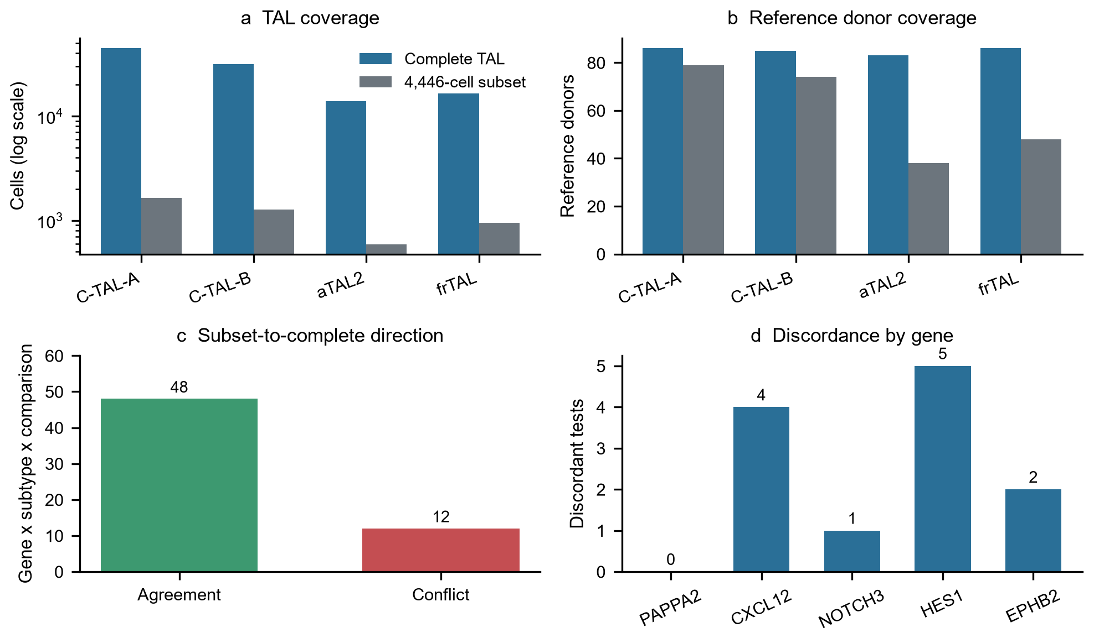
Fig. 4
The four analysis units were not interchangeable
The four analysis units produced related but non-equivalent views of TAL state. Across 12 comparison and subtype groups, neighborhood PAPPA2 expression was positively correlated with Milo logFC in all 12 groups, with Spearman correlations ranging from 0.029 in AKI aTAL2 to 0.729 in combined-disease C-TAL-A. Donor-stratified bootstrap intervals excluded zero in 11 of 12 groups; the exception was AKI aTAL2 (95% interval -0.086 to 0.255). Partial correlations controlling for neighborhood purity were similar to the primary correlations (Fig. 5; Supplementary Tables S5 and S6).
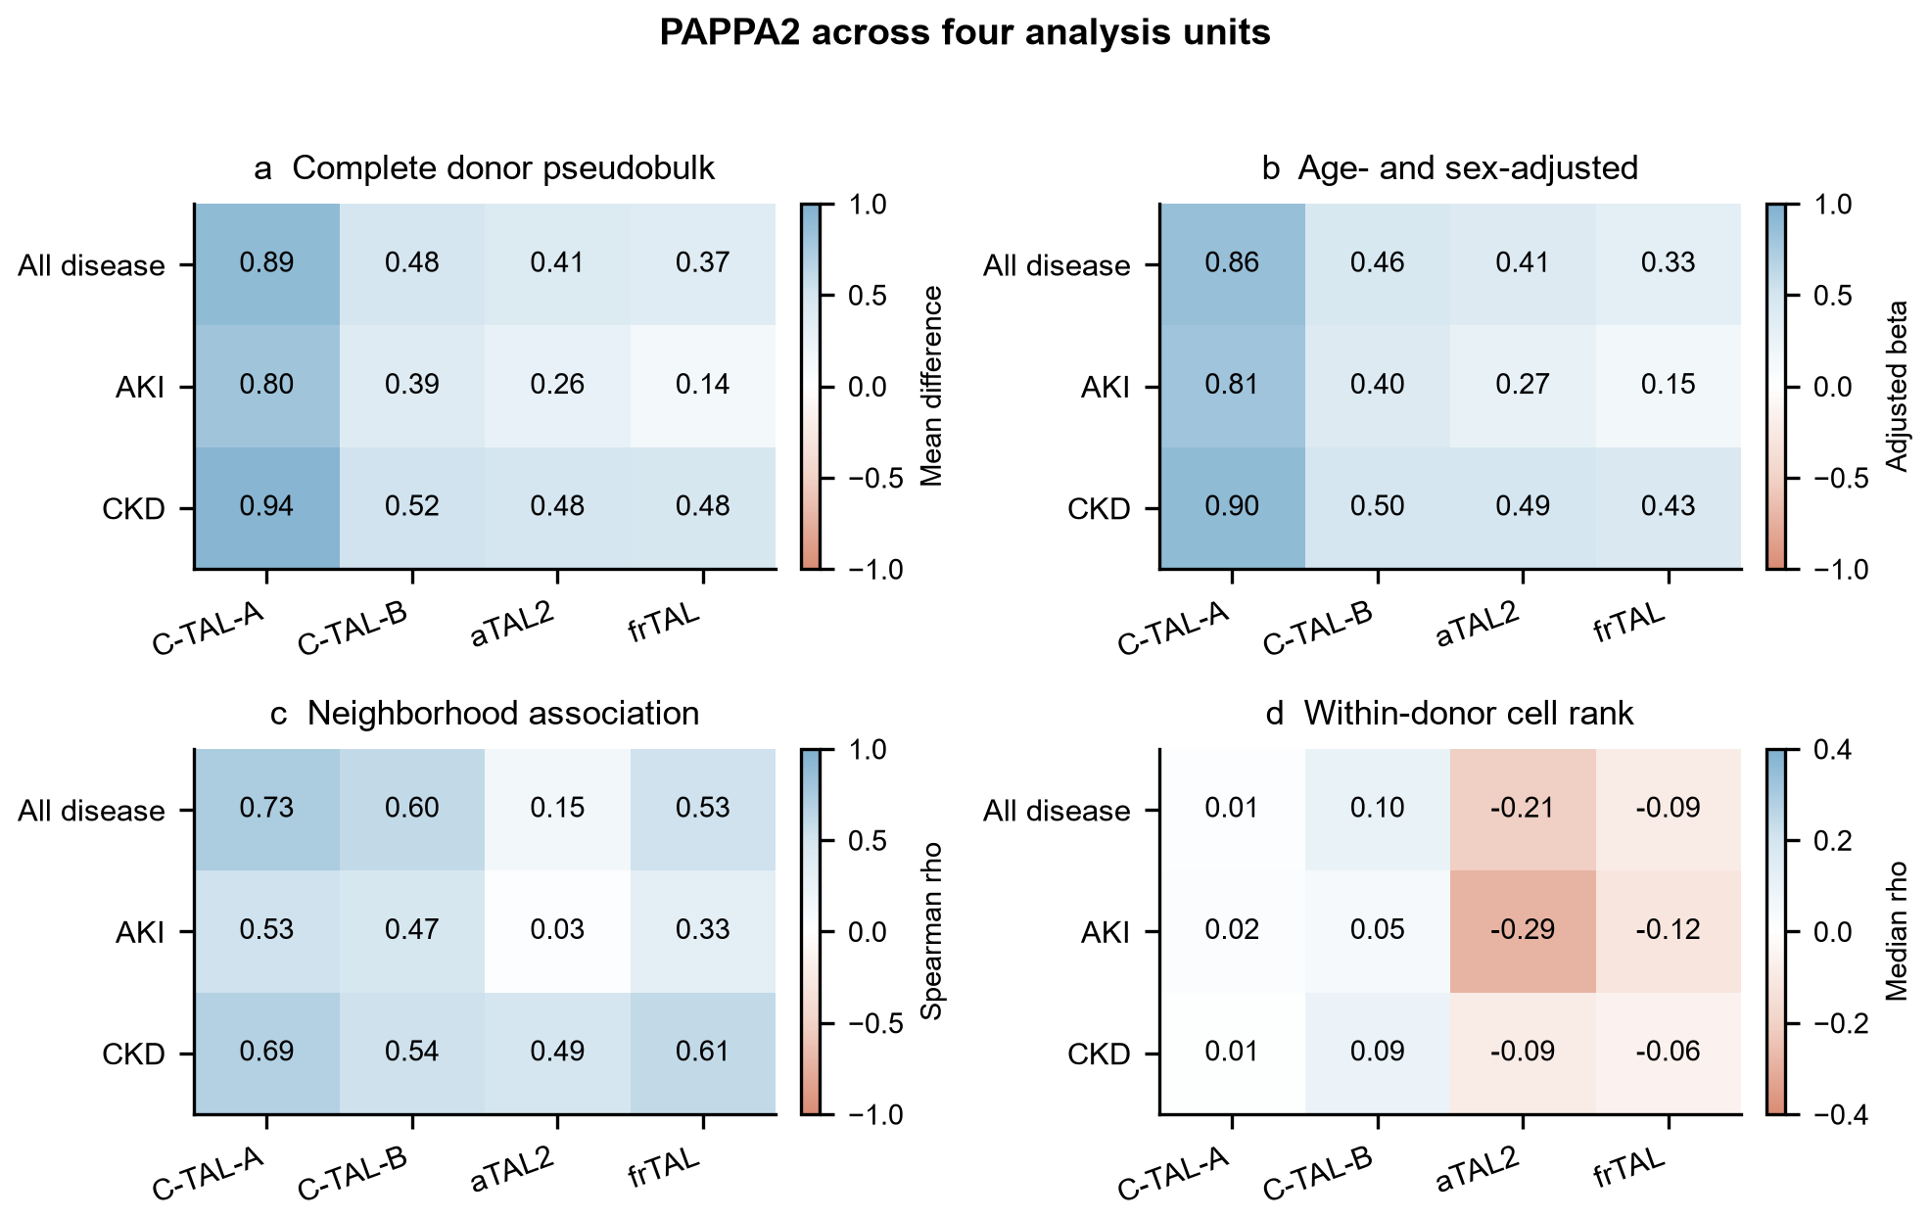
Fig. 5
The units differed in what they measured and did not always support one shared direction (Supplementary Table S7). Donor pseudobulk, neighborhood-expression association, and within-donor cell-rank association were therefore analyzed as distinct units rather than as interchangeable estimates of the same quantity. This difference was clearest in aTAL2 and was also present in a weaker form in frTAL.
Analysis-unit reversal was enriched in the prespecified TAL gene panel
The donor-versus-within reversal fraction was 18.6% in the 400-gene target panel, compared with 12.7% in expression-matched random sets (empirical P = 0.000999, the minimum attainable value with 1,000 sets). Restricting to the 300 biological genes increased the fraction to 20.7% versus 12.7%. An expression-stratified sensitivity analysis gave the same result (18.6% versus 12.8%; empirical P = 0.000999).
The panel result was not driven by the internal negative controls. Their donor-versus-within reversal fraction was 12.3%, statistically indistinguishable from random 100-gene sets from the external control pool (12.6%; two-sided empirical P = 0.825). Reversal fractions differed across biological groups: 25.1% for PAPPA2 coexpression genes, 21.1% for TAL subtype markers, and 15.8% for injury, inflammatory, and metabolic genes.
Donor-versus-neighborhood reversal was also enriched (22.1% versus 14.3%; empirical P = 0.000999). In contrast, neighborhood-versus-within reversal was not significantly enriched (20.1% versus 19.5%; empirical P = 0.0949). Individual gene metrics and random-set results are provided in Supplementary Tables S22 and S23 and Supplementary Fig. S1. The analysis therefore supports a panel-level phenomenon, not a claim that every selected gene is robust.
aTAL2 showed the strongest cross-unit discordance
aTAL2 was the clearest example because donor-level and within-donor analyses pointed in opposite directions. Complete donor pseudobulk showed higher PAPPA2 expression in aTAL2 for all three comparisons, with positive mean differences and FDR < 0.05 in each case. The same positive direction was retained in the age- and sex-adjusted models.
Neighborhood-expression association was positive but less stable in aTAL2. The full-data Spearman correlation was 0.145 for combined disease and 0.029 for AKI, and the AKI donor-stratified bootstrap interval included zero. This result indicates that neighborhood expression and donor pseudobulk were aligned in direction but not equally strong.
Within-donor cell-rank association moved in the opposite direction. The disease-minus-Reference rank difference was -0.2857 in AKI and -0.2063 in combined disease, with FDR = 0.0086 for each comparison. In CKD, the difference was also negative (-0.0886) but did not pass FDR (0.224). Therefore the aTAL2 conflict was strongest in aTAL2 and significant in two of three disease comparisons, rather than uniform across all comparisons (Fig. 6; Supplementary Table S8).
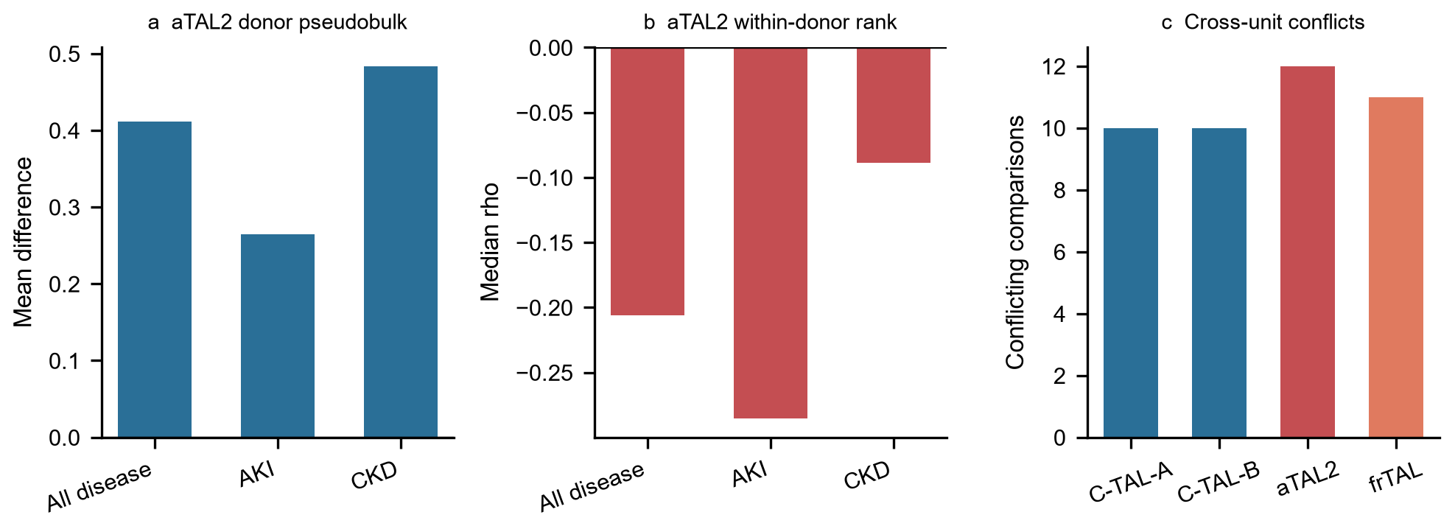
Fig. 6
frTAL showed a weaker related cross-unit pattern
frTAL showed the same qualitative direction conflict as aTAL2, but with weaker statistical support. Donor pseudobulk and neighborhood-expression association were positive for frTAL. In contrast, the within-donor disease-minus-Reference rank difference was negative in all three comparisons: -0.0897 in combined disease (FDR = 0.018), -0.1175 in AKI (FDR = 0.146), and -0.0557 in CKD (FDR = 0.224). Thus, frTAL supports the general analysis-unit sensitivity finding but does not reach the same strength as aTAL2.
PAPPA2 was a directionally consistent case gene across TAL subtypes
Complete donor-level pseudobulk analysis showed higher PAPPA2 expression in all four TAL subtypes for AKI, CKD, and combined disease comparisons. All 12 PAPPA2 gene, subtype, and comparison combinations had positive effect direction, and 11 of 12 passed FDR < 0.05; AKI frTAL was directionally positive but did not pass FDR (0.080). For example, the mean increase in the combined disease comparison was 0.894 for C-TAL-A, 0.477 for C-TAL-B, 0.411 for aTAL2, and 0.370 for frTAL. The same positive pattern was observed in the age- and sex-adjusted models (Supplementary Table S9).
Leave-one-donor analysis preserved the PAPPA2 direction in all 12 groups (Fig. 7; Supplementary Table S10). Bootstrap intervals were used to describe donor-level stability, not independent-cell significance. Cortex and medulla strata agreed in direction in 11 of 12 groups; the only exception was AKI frTAL in medulla, a group that was not significant in the complete pseudobulk analysis. These results identify PAPPA2 as a consistent disease-associated TAL case gene while preserving the distinction between average disease-group elevation and within-donor state association.
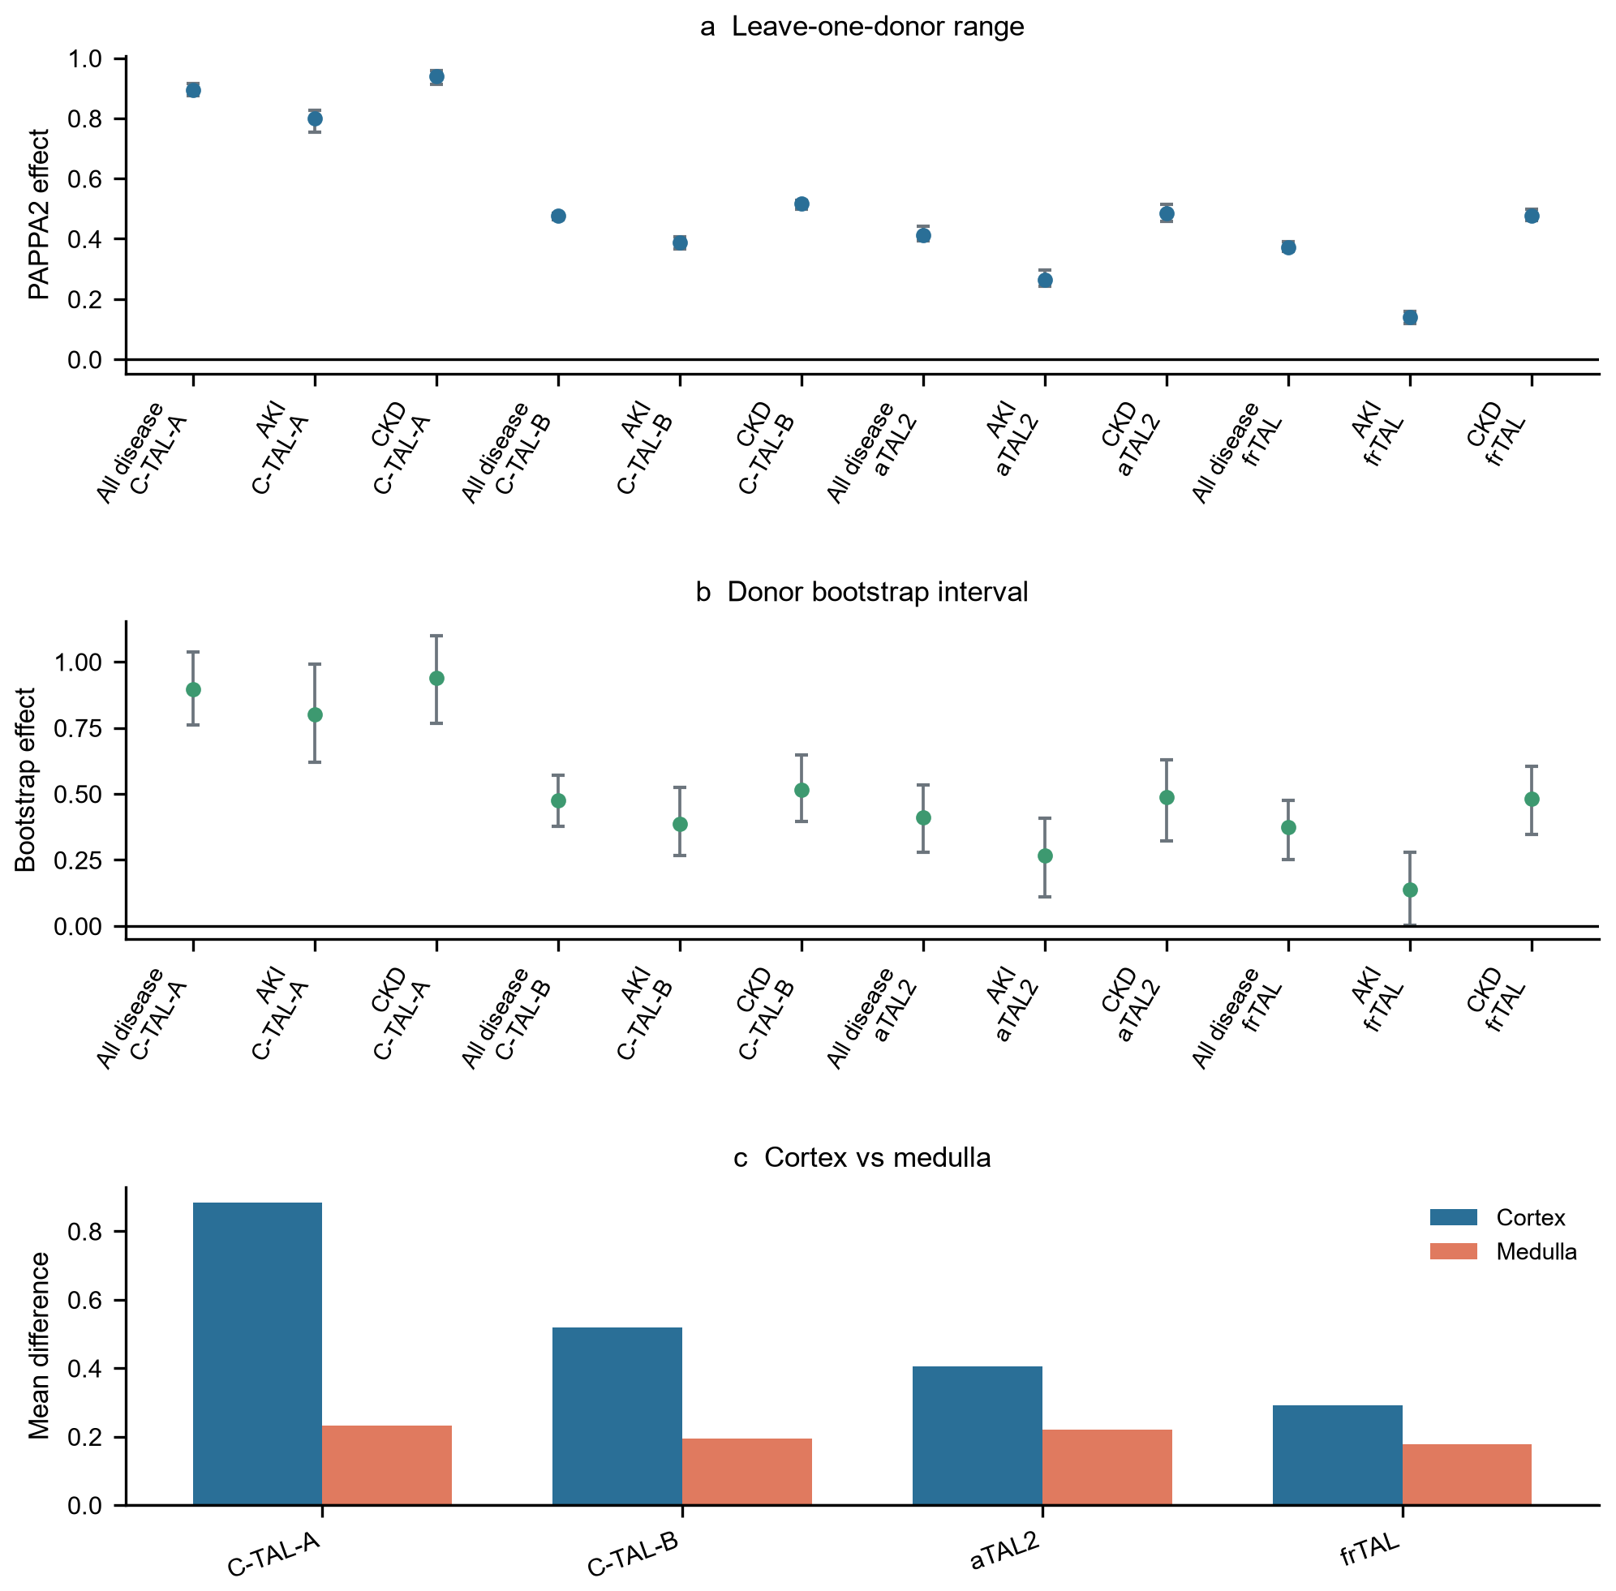
Fig. 7
PAPPA2 enrichment reflected subtype expression rather than composition
The overall four-subtype TAL PAPPA2 difference was not driven by subtype proportion changes. In the combined disease comparison, the observed difference was +0.563 (95% bootstrap interval +0.483 to +0.639), the subtype-expression component was +0.641 (+0.560 to +0.721), the composition component was +0.010 (-0.003 to +0.023), and the interaction/covariance remainder was -0.088 (-0.133 to -0.044). The expression component accounted for 86.7% of the absolute component magnitude, compared with 1.3% for composition.
The same pattern was present in disease-specific comparisons. In AKI, the observed difference was +0.379, expression was +0.522, and composition was -0.009. In CKD, the observed difference was +0.650, expression was +0.698, and composition was +0.019 (Supplementary Table S20). Thus, higher PAPPA2 in disease donors was not explained by a shift toward TAL subtypes with higher baseline PAPPA2. The between-donor expression difference and the negative within-donor neighborhood association therefore describe separable levels of variation. This decomposition does not establish cell-intrinsic induction; donor-level exposures or unmeasured tissue context may still contribute.
PAPPA2-positive fraction was associated with lower eGFR in KPMP
In KPMP donors, higher TAL PAPPA2-positive fraction was associated with lower eGFR in ordinal models. The primary model included 202 donors. For every 10 percentage-point increase in PAPPA2 fraction, the odds ratio was 0.819 (95% CI 0.682-0.985, p = 0.0335) after adjustment for age, sex, and disease category. The direction remained negative after adding TAL subtype fractions (OR 0.696, 95% CI 0.530-0.915) and technical covariates (OR 0.661, 95% CI 0.500-0.875).
The signal was concentrated mainly in CKD. The primary model in disease donors included 130 donors and produced an OR of 0.789 (95% CI 0.648-0.960). CKD included 94 donors and produced an OR of 0.733 (95% CI 0.582-0.924). AKI included 36 donors and did not show a clear association. These results support an internal adjusted association between PAPPA2 and kidney function, but they do not constitute external clinical validation (Supplementary Table S11).
The PAPPA2 signal was directionally distinct among tested genes
In the within-donor analysis, PAPPA2 had seven FDR-supported comparisons at the primary threshold, compared with two for CXCL12 and none for NOTCH3, HES1, and EPHB2. The advantage of PAPPA2 was primarily directional consistency rather than the largest effect size.
The same pattern was observed in Nephroseq. PAPPA2 had seven significant tissue-specific negative GFR analyses, compared with six for HES1, three for EPHB2, two for NOTCH3, and one for CXCL12. HES1 and EPHB2 had multiple significant results, but their directions were mixed or less restricted to tubulointerstitium. CXCL12 did not reproduce the negative PAPPA2 pattern.
PAPPA2-associated spatial signatures showed directional consistency in the KPMP Visium resource
GSE183456 is the KPMP Visium spatial resource and belongs to the same consortium as the discovery snRNA-seq data. We therefore used it for spatial cross-modality analysis, not as an independent external cohort. Across 23 sections, 20 had a co-occurrence odds ratio above 1 for the two PAPPA2-associated branch signatures. All 11 DKD sections had an odds ratio above 1, and all 10 DKD donors remained above 1 after donor-level deduplication. The result was directionally consistent with the discovery analysis.
The spatial result was not disease-specific. The DKD versus Reference comparison had p = 0.078, and 5 of 6 Reference sections also had a co-occurrence odds ratio above 1. The appropriate interpretation is cross-modality directional consistency of a tissue-state relationship within the KPMP resource, not a disease-specific or external spatial validation.
Public external datasets provided directional PAPPA2-GFR support
GSE137570 Cohort 1 provided public eGFR for 24 donors. PAPPA2 was negatively associated with eGFR (Spearman rho = -0.365, p = 0.079), but the adjusted model was not significant (p = 0.351). EPHB2 had a stronger unadjusted correlation (rho = -0.646, p = 0.0006), indicating that this cohort cannot support a claim of PAPPA2-specific significance (Supplementary Table S12).
Nephroseq provided stronger external association support. In 50 GFR analyses, PAPPA2 had 10 significant results, of which 9 were negative. Seven negative analyses came from tubulointerstitial datasets. The strongest results included Sampson Nephrotic Syndrome TubInt (r = -0.558, n = 49), Ju CKD TubInt 2 (r = -0.530, n = 42), ERCB Nephrotic Syndrome TubInt (r = -0.712, n = 17; and r = -0.686, n = 16), and Mariani Nephrotic Syndrome TubInt 2 (r = -0.837, n = 10). One positive analysis came from a cadaveric transplant kidney dataset (r = 0.589, n = 12).
Together, GSE137570 and Nephroseq support the direction of the PAPPA2-GFR relationship. The Nephroseq analyses are precomputed and not independently adjusted in a common model, so they should be reported as multi-dataset external association support rather than as independent cohort counts (Supplementary Table S13).
Non-KPMP cohorts independently supported PAPPA2 disease elevation
In GSE211785, donor-level PAPPA2 expression was higher in disease than control donors in both TAL compartments. For C_TAL, the difference was +0.283 (permutation p = 0.0315; FDR = 0.0630 across six TAL-state and comparison tests), with a bootstrap 95% CI of +0.053 to +0.514. For M_TAL, the difference was +0.200 (p = 0.105; FDR = 0.133), with a bootstrap 95% CI of +0.026 to +0.400. DKD-specific contrasts were larger (+0.443 in C_TAL, p = 0.0174; +0.414 in M_TAL, p = 0.0227), whereas HKD-specific contrasts were smaller (+0.189 and +0.083). Leave-one-donor-out estimates remained positive for both states.
Within-donor injury-score associations were negative in C_TAL (-0.033; p = 0.611) and M_TAL (-0.052; p = 0.392), but were not statistically supported. Using neighborhood disease logFC as the exposure also produced a negative C_TAL estimate (-0.074; p = 0.175) and a near-zero M_TAL estimate (+0.014; p = 0.862). Thus, GSE211785 independently supported the donor-level PAPPA2 association but did not establish the within-donor negative effect.
Injured TAL states in GSE254185 reproduced analysis-unit divergence
GSE254185 provided a second independent test using cTAL1, cTAL2, mTAL, TAL Injured, and TAL Inflammatory annotations. PAPPA2 donor pseudobulk was higher in mTAL (+0.341; exact p = 0.0121; FDR = 0.0604 across the five TAL states) and in TAL Injured (+0.168; p = 0.711). Neighborhood abundance was also positive in TAL Injured. In contrast, the neighborhood-expression association in TAL Injured was negative (rho = -0.096; FDR = 7.1e-05), and the within-donor rank difference was negative using injury-marker exposure (-0.290; exact p = 0.0702) and neighborhood disease logFC exposure (-0.062; p = 0.825). The same qualitative positive-donor/negative-within-donor pattern was therefore observed in a different TAL state, although the exact aTAL2 and frTAL labels were not available (Supplementary Table S14).
Donor-stratified signature transfer recovered an aTAL2-like state
The frozen four-subtype marker panel assigned 86.66% of held-out KPMP cells at the prespecified margin threshold. Among assigned cells, accuracy was 93.90%, macro F1 was 93.17%, aTAL2 precision was 83.28%, and aTAL2 recall was 93.93% (Supplementary Tables S15 and S16). The high held-out performance justified a cautious projection to non-KPMP cohorts; it did not establish cross-cohort label equivalence.
In GSE254185, the transfer identified 1,176 high-confidence aTAL2-like cells, predominantly from TAL Inflammatory and TAL Injured states. Their donor-level PAPPA2 difference was +0.554 (permutation p = 0.0043), whereas the within-donor injury-score direction was negative (-0.581; p = 0.125). In GSE211785, 3,751 high-confidence aTAL2-like cells were mostly derived from M_TAL, with a smaller C_TAL contribution. The donor-level PAPPA2 difference was +0.570 (p = 0.0235), and the within-donor neighborhood-logFC direction was negative but not statistically supported (-0.095; p = 0.405) (Supplementary Table S17).
The external predictions therefore reproduced the donor-level direction and the qualitative donor/within-donor conflict. They did not provide an exact aTAL2 label, and the negative within-donor estimates were underpowered. The transferred cells in GSE254185 were enriched for inflammatory and injured states rather than a clean cortical aTAL2 population.
Kidney eQTL supported a tubulointerstitial context but not disease chromatin
PAPPA2 was a strong tubulointerstitial eGene in NephQTL2 (gene-level FDR = 1.64e-14; model size 1.035), with no glomerular eQTL support (FDR = 0.526) (Han et al. 2023; Supplementary Table S18). This compartment pattern is consistent with a tubule-centered signal. It is a regulatory association and does not establish a disease effect.
PAPPA2 was not among NephQTL2's FDR-significant PTWAS associations for eGFR or urinary albumin-to-creatinine ratio. This absence is reported as non-significance rather than as a negative association, because instrument availability and power can affect PTWAS inclusion. The fixed aTAL2 marker set also showed no overall enrichment for tubulointerstitial eGenes: 11 of 35 markers were eGenes, with an exploratory odds ratio of 0.58 relative to the NephQTL2 gene background. Individual markers had strong eQTLs, but the marker program as a whole should not be described as enriched.
GSE211785 snATAC gene activity did not show higher disease accessibility for PAPPA2. Using seven control and four disease donors, the disease-minus-control difference was -0.029 in C_TAL (exact p = 0.843) and -0.016 in M_TAL (exact p = 0.937; FDR = 1.0 for both) (Supplementary Table S19). The same cohort therefore supports the tubulointerstitial eQTL context but not a disease-associated PAPPA2 chromatin increase. This is an orthogonal-modality boundary result, not an independent-cohort replication.
Candidate pathway results did not establish downstream mechanism
We did not find consistent support for a unified JAG1-NOTCH3-HES1 TAL program. NOTCH3 was significant only in CKD frTAL in the donor pseudobulk analysis, and HES1 showed mixed directions across subtypes. HES1 also had mixed positive and negative GFR associations in Nephroseq.
Similarly, EPHB2 and STAT6 did not form a consistent TAL axis. STAT6 did not show significant donor-level changes, and EPHB2 had subtype-dependent directions. These results are retained as negative or exploratory findings and do not support a causal pathway model.
Discussion
The main contribution is empirical, not algorithmic
The main contribution of this study is an empirical demonstration that the analysis unit is not a neutral choice in human kidney single-cell data. We compared four established analysis units rather than introducing a new algorithm or software method. The units were not interchangeable, and this non-equivalence was reproducible in the complete TAL resource. The result changes how a disease-associated cell state should be interpreted: donor pseudobulk, neighborhood, and within-donor analyses describe different aspects of disease, so agreement between them cannot be assumed.
This interpretation matters because single-cell studies often report a disease-associated state at one level of analysis and then generalize it to a cell type or disease process. Our results show that such generalization is not automatically justified. The central advance is therefore not a new molecular mechanism, but a sharper framework for deciding what a single-cell disease association does and does not represent.
The analysis-unit effect extends beyond the PAPPA2 case
The prespecified 400-gene panel addresses the principal generalizability limitation of a single-gene study. Reversal between donor pseudobulk and within-donor coupling was nearly 50% more frequent in biologically selected TAL genes than in expression-matched controls (18.6% versus 12.7%). The result persisted after expression stratification and was strongest for PAPPA2-coexpressed genes and TAL subtype markers. Internal negative controls were statistically indistinguishable from the external control pool.
The pattern was not universal. Injury, inflammatory, and metabolic genes showed a smaller excess, and neighborhood-versus-within reversal did not differ significantly from matched sets. The appropriate conclusion is therefore a panel-level phenomenon with graded biological groups, not a claim that all TAL genes are unstable or that every individual reversal is biologically meaningful.
aTAL2 and frTAL show why analysis units cannot be merged
aTAL2 provides the strongest evidence that average disease elevation and within-donor state coupling are distinct quantities. Donor pseudobulk and neighborhood-expression association were positive, whereas within-donor association was negative in combined disease and AKI and did not reach FDR in CKD. This does not indicate a contradiction that must be forced into one direction. Instead, it shows that the two units answer different questions: one asks whether disease groups have higher average expression, and the other asks whether neighborhood exposure tracks expression within an individual donor.
The decomposition shows that the overall TAL PAPPA2 difference is not a consequence of shifting subtype proportions. Across the four TAL subtypes, the observed disease-reference difference was +0.563, the subtype-expression component was +0.641, the composition component was +0.010, and the interaction/covariance term was -0.088. AKI and CKD showed the same pattern. Thus, higher subtype-specific expression between donors can coexist with a negative within-donor neighborhood relationship. External transfer places predicted aTAL2-like cells mainly in inflammatory and injured states, but this cellular context does not explain the donor-level difference through subtype proportions. The result does not establish cell-intrinsic induction; it shows that a between-donor expression contrast and a within-donor context association are distinct quantities.
frTAL shows that this phenomenon is not unique to aTAL2, although its effect is weaker. The within-donor disease-minus-Reference direction was negative across all three comparisons, but only the combined-disease comparison passed FDR. The appropriate conclusion is therefore graded rather than binary: aTAL2 shows the strongest and most consistent discordance, whereas frTAL provides secondary support for the same general problem.
These findings argue against treating one significant result as definitive. When two defensible units disagree, the disagreement itself is informative about the biological question being asked and about which inference is supported by the data.
Complete data and donor-aware design reduce major artefacts
Complete TAL coverage reduces the risk that the main conclusion is an artefact of the derivative subset that was used in the earlier analysis. The complete resource contained 106,851 TAL cells and differed substantially from the 4,446-cell matrix, especially for aTAL2 and frTAL. The subset and complete pseudobulk analyses agreed in 48/60 directions, but 12 directions changed, which shows that coverage can alter gene-level conclusions even when broad trends remain. This motivates using the complete resource for all primary inference.
The donor-aware design reduces, but does not eliminate, confounding by donor composition and disease mix. Directed comparisons were supported by age- and sex-adjusted models, leave-one-donor analysis, donor bootstrap, cortex/medulla stratification, and neighborhood purity adjustment. These checks support the main directions while preserving the aTAL2 contrast, but they remain internal stability analyses; independent-cohort support is reported separately below.
Independent cohorts support donor-level association but not exact subtype replication
The two non-KPMP cohorts add evidence without erasing the boundary of the study. In GSE211785, the donor-level PAPPA2 disease elevation was reproduced in both C_TAL and M_TAL, and leave-one-donor-out estimates retained the positive direction. In GSE254185, TAL Injured showed positive donor-level and neighborhood-abundance directions but negative neighborhood-expression and within-donor directions. This is the same qualitative problem that motivated the discovery analysis: different defensible units answer different questions.
The independent data do not provide an exact replication of the aTAL2 and frTAL annotations. GSE211785 contains C_TAL and M_TAL rather than the four discovery subtypes, and GSE254185 contains injured and inflammatory TAL states in an obstructive-nephropathy setting. The independent within-donor estimates were also not statistically significant. The correct conclusion is therefore that donor-level PAPPA2 disease elevation and the general analysis-unit problem are independently supported, whereas the exact subtype-specific effect remains to be tested in a cohort with matching annotations.
Kidney eQTL provides context but does not convert the result into genetic validation
The NephQTL2 result adds an independent human kidney regulatory observation: PAPPA2 is strongly regulated in tubulointerstitial tissue and is not a glomerular eGene. This compartment pattern is concordant with the TAL focus and supports the plausibility of a tubule-compartment signal. The result is nevertheless a regulatory association in kidney tissue, not proof that PAPPA2 causes TAL injury, kidney dysfunction, or disease progression.
The boundary evidence is equally important. PAPPA2 was not among the FDR-significant NephQTL2 PTWAS genes for eGFR or urinary albumin-to-creatinine ratio, and the aTAL2 marker panel was not broadly enriched for tubulointerstitial eGenes. The GSE211785 snATAC analysis also did not show higher disease accessibility for PAPPA2. These findings prevent the manuscript from describing the case gene as genetically validated. They show instead that a strong kidney eQTL context can coexist with uncertainty about the disease direction, cellular source, and causal role, which is itself consistent with the analysis-unit problem.
PAPPA2 is a case gene, not the mechanism
PAPPA2 should be interpreted as a case gene that illustrates the analysis-unit problem, not as the central biological hypothesis. Its expression was directionally positive across TAL subtypes and comparisons, and its positive fraction was associated with lower eGFR in KPMP. This makes PAPPA2 useful for testing whether a gene-state association survives a change in the analysis unit.
The clinical interpretation of PAPPA2 nevertheless remains bounded. The KPMP eGFR association is internal and based on binned eGFR categories. GSE137570 provided only a small and non-significant adjusted estimate. Nephroseq provided multi-dataset directional support but consists of precomputed analyses that may overlap, and GSE183456 belongs to the same KPMP consortium as the discovery data. PAPPA2 is therefore a disease-associated TAL state marker hypothesis, not a validated biomarker, therapeutic target, or causal mediator.
Negative pathway findings constrain the mechanistic interpretation
The negative pathway results prevent the analysis-unit finding from being converted into an unsupported mechanism. JAG1-NOTCH3-HES1 and EPHB2-STAT6 did not form consistent TAL programs across subtypes and comparisons. Reporting these results is important because it shows that isolated correlations do not establish an upstream regulator, downstream effector, or direct interacting partner.
Comparison with prior work
Prior human kidney atlases established extensive tubular heterogeneity and disease-associated cell states (Lake et al. 2023; Cippa et al. 2018). The contribution of the present study is not to rediscover TAL heterogeneity, but to show that conclusions about that heterogeneity depend on the analysis unit. This extends atlas-based descriptions from a question of which states exist to a question of whether a state association survives a change in inference.
PAPPA2 has been studied mainly in the context of insulin-like growth factor regulation and has not been established as a major determinant of TAL disease (Oxvig 2015; Dauber et al. 2016; Conover et al. 2011). Our analysis therefore places PAPPA2 within a subtype-resolved analysis-unit framework rather than presenting it as a standalone mechanism.
Data and methodological limitations
The generalizability of the findings is limited by the discovery resource and by the reuse of the atlas-provided embedding and subtype labels. The analysis was based on KPMP, and the UMAP coordinates were reused rather than independently rebuilt. Milo used logMS normalization, and one AKI donor without neighborhood representation was excluded from that comparison. These choices can influence neighborhood boundaries and should be tested in independent datasets, particularly with alternative graph construction, normalization, and subtype annotation strategies.
External validation is now available but remains partial. The discovery data and its spatial component (GEO superseries GSE183279 (Kidney Precision Medicine Project 2026a); Visium GSE183456 (Kidney Precision Medicine Project 2026b)) share KPMP consortium provenance, so GSE183456 cannot be treated as an independent spatial cohort. GSE211785 independently supported donor-level PAPPA2 disease elevation, but its TAL annotations are C_TAL and M_TAL rather than aTAL2 and frTAL, and its within-donor estimates were not significant. GSE254185 provided an independent qualitative cross-unit signal in injured TAL, but its disease context and annotations also differ. Donor-stratified signature transfer supported a donor-level aTAL2-like direction in both cohorts, but the external cells were not exact aTAL2 labels and the within-donor estimates were underpowered. NephQTL2 provided strong tubulointerstitial eQTL support for PAPPA2, but PAPPA2 was not among the FDR-significant PTWAS associations, and the same-cohort snATAC analysis did not show higher disease accessibility. Only 24 GSE137570 (Human Kidney Transcriptome Cohort 2026) donors had public eGFR, and the adjusted result was not significant. Nephroseq analyses were precomputed and may contain overlapping datasets. Sample-level GFR annotations for GSE115098 were not publicly available, so that planned validation could not be performed. Mendelian randomization was not feasible because no usable PAPPA2 cis-pQTL was identified; this is an absence of a valid instrument rather than a negative causal test. No perturbation, protein, or functional experiment was performed.
Implications and next steps
The practical implication is that single-cell disease studies should state the analysis unit explicitly and test whether conclusions survive a change in that unit. This recommendation is especially relevant for rare cell subtypes, where small changes in donor or cell coverage can materially alter the result. The next steps are to replicate the exact aTAL2 and frTAL annotations in an independent kidney cohort, use continuous eGFR outcomes, and test the PAPPA2-associated state with protein or functional experiments (Fig. 8).
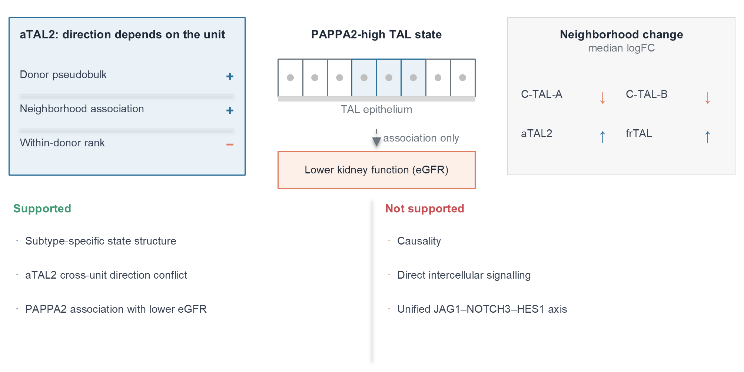
Fig. 8
Conclusions
The central conclusion of this study is that the analysis unit is not a neutral choice in human kidney TAL single-cell data. Donor pseudobulk, Milo neighborhood abundance, neighborhood-expression association, and within-donor cell-rank association were not interchangeable: they yielded different subtype-level conclusions, with aTAL2 as the strongest cross-unit discordance example and frTAL as a weaker related pattern. Complete TAL coverage also changed selected gene and subtype conclusions relative to the smaller derivative matrix. A prespecified 400-gene panel showed that donor-versus-within reversal was more frequent in biologically selected TAL genes than in expression-matched controls, while internal negative controls matched the external control distribution. PAPPA2 acts as a case gene with directionally consistent disease association across subtypes. Its donor-level disease elevation was independently supported in GSE211785, and an injured-TAL cross-unit signal was observed in GSE254185. Donor-stratified signature transfer reproduced the donor-level direction of an aTAL2-like state but did not provide exact subtype replication or a significant within-donor effect. NephQTL2 placed PAPPA2 in a tubulointerstitial regulatory context, without glomerular eQTL support, whereas the same-cohort snATAC analysis did not show a disease-associated accessibility increase. The present evidence does not establish causality, direct intercellular communication, genetic colocalization, or a defined molecular mechanism. These findings support a bounded, human-data-based conclusion: in renal single-cell studies, the analysis unit should be stated explicitly and its influence tested before a disease-state association is interpreted as a general biological property.
List of abbreviations
AKI: acute kidney injury
AUC: area under the receiver operating characteristic curve
BH: Benjamini-Hochberg
CI: confidence interval
CKD: chronic kidney disease
C-TAL-A, C-TAL-B: KPMP human kidney atlas cortical thick ascending limb subtype labels
C_TAL: cortical thick ascending limb label in GSE211785
DKD: diabetic kidney disease
eGFR: estimated glomerular filtration rate
eQTL: expression quantitative trait locus
FDR: false discovery rate
frTAL: KPMP human kidney atlas thick ascending limb subtype label
GEO: Gene Expression Omnibus
GFR: glomerular filtration rate
HKD: hypertensive kidney disease
KPMP: Kidney Precision Medicine Project
logFC: log2 fold change
LODO: leave-one-donor-out
M_TAL: medullary thick ascending limb label in GSE211785
MR: Mendelian randomization
MSigDB: Molecular Signatures Database
NephQTL2: human kidney eQTL resource
OR: odds ratio
PAPPA2: pappalysin 2
pQTL: protein quantitative trait locus
PTWAS: probabilistic transcriptome-wide association study
snATAC-seq: single-nucleus assay for transposase-accessible chromatin sequencing
snRNA-seq: single-nucleus RNA sequencing
SpatialFDR: spatial false discovery rate
TAL: thick ascending limb
UMAP: uniform manifold approximation and projection
Declarations
Ethics approval and consent to participate
This study used publicly available or controlled-access, de-identified human kidney data. No new human samples were collected, and no participant recruitment or intervention was performed. Ethical approval and informed consent were not required for the present secondary analysis; data access and use were governed by the terms of the original studies and repositories.
No animal experiments were performed in this study.
Consent for publication
Not applicable. No identifiable individual-level data are presented.
Clinical trial number
Clinical trial number: not applicable.
Data availability
The datasets supporting the conclusions of this article are available in the Gene Expression Omnibus repository, GSE183279 (Kidney Precision Medicine Project 2026a) (https://www.ncbi.nlm.nih.gov/geo/query/acc.cgi?acc=GSE183279), which includes single-nucleus RNA sequencing data (GSE183277) and spatial transcriptomics data (GSE183456; Kidney Precision Medicine Project 2026b). GSE137570 is available in the Gene Expression Omnibus repository (Human Kidney Transcriptome Cohort 2026) (https://www.ncbi.nlm.nih.gov/geo/query/acc.cgi?acc=GSE137570). The independent validation datasets are GSE211785 (Abedini et al. 2024; Human Kidney Multi-omic Atlas 2026) (https://www.ncbi.nlm.nih.gov/geo/query/acc.cgi?acc=GSE211785) and GSE254185 (Reck et al. 2025; Human Kidney Multiome Resource 2026) (https://www.ncbi.nlm.nih.gov/geo/query/acc.cgi?acc=GSE254185). NephQTL2 gene-level and PTWAS summary data were obtained from the supplementary information of Han et al. (2023). Nephroseq v5 was queried through its public interface (Nephroseq v5 2026) (https://www.nephroseq.org).
Access to the Gene Expression Omnibus datasets is unrestricted, including for non-academic users. Nephroseq v5 is accessible through its public web interface, and its use is subject to the terms of use published on the Nephroseq website (Nephroseq v5 2026).
Project name: pappa2-tal-analysis-unit-sensitivity
Project home page: https://github.com/ZhiPeng1022/pappa2-tal-analysis-unit-sensitivity
Archived version: https://doi.org/10.5281/zenodo.23734944
Operating system(s): Platform independent
Programming language: Python; R
Other requirements: see requirements.txt in the project repository
License: Creative Commons Attribution 4.0 International (CC BY 4.0)
Any restrictions to use by non-academics: none
The processed analysis tables supporting the conclusions of this article are included in Supplementary Tables S1-S23.
Code availability
Analysis code is available at https://github.com/ZhiPeng1022/pappa2-tal-analysis-unit-sensitivity. The versioned archive containing the signature-transfer, regulatory-support, composition-expression, and prespecified analysis-unit panel is available at https://doi.org/10.5281/zenodo.23734944.
Competing interests
The authors declare no competing interests.
Funding
This research received no specific grant from any funding agency in the public, commercial, or not-for-profit sectors.
Authors' contributions
P.Z. conceived and designed the study, performed the formal analysis and data curation, and wrote the first draft. X.Y. contributed to validation and data curation, and revised the manuscript. C.Z. contributed to the software and data curation, and revised the manuscript. All authors read and approved the final manuscript.
Supplementary information
Supplementary Table S1. File format: Comma-separated values (.csv). Title: Permutation null distributions for the within-donor cell-rank analysis. Description: Null distributions from 1,000 within-donor expression permutations for each gene, subtype, and comparison.
Supplementary Table S2. File format: Comma-separated values (.csv). Title: Complete-data Milo neighborhood summary. Description: Neighborhood counts, directions, and median logFC for each subtype and disease comparison in the complete 106,851-cell TAL analysis.
Supplementary Table S3. File format: Comma-separated values (.csv). Title: Subset-level Augur separability summary. Description: Mean AUC values and subsample intervals for disease versus Reference separability in the 4,446-cell derivative subset.
Supplementary Table S4. File format: Comma-separated values (.csv). Title: Complete versus subset pseudobulk direction comparison. Description: Direction of effect for each gene, subtype, and comparison in the complete analysis and in the 4,446-cell subset, including the 12 comparisons with discordant direction.
Supplementary Table S5. File format: Comma-separated values (.csv). Title: Neighborhood-expression association robustness. Description: Spearman correlations between neighborhood expression and Milo logFC, with leave-one-donor and donor-stratified bootstrap stability.
Supplementary Table S6. File format: Comma-separated values (.csv). Title: Donor-stratified bootstrap replicates for neighborhood association. Description: Per-replicate Spearman correlations used to derive the donor-stratified bootstrap intervals.
Supplementary Table S7. File format: Comma-separated values (.csv). Title: Joint analysis-unit concordance table. Description: Donor pseudobulk, neighborhood association, and within-donor cell-rank directions joined for each gene, subtype, and comparison.
Supplementary Table S8. File format: Comma-separated values (.csv). Title: Within-donor cell-rank association results. Description: Donor-level Spearman correlations between gene expression and neighborhood exposure for each gene, subtype, and comparison.
Supplementary Table S9. File format: Comma-separated values (.csv). Title: Complete donor pseudobulk results. Description: Donor pseudobulk effect sizes, age- and sex-adjusted estimates, and false discovery rates for the five analyzed genes.
Supplementary Table S10. File format: Comma-separated values (.csv). Title: Leave-one-donor-out replicates for neighborhood association. Description: Per-replicate Spearman correlations computed with one donor removed at a time.
Supplementary Table S11. File format: Comma-separated values (.csv). Title: KPMP ordinal eGFR models. Description: Ordinal logistic model estimates for the association between PAPPA2-positive TAL fraction and baseline eGFR category.
Supplementary Table S12. File format: Comma-separated values (.csv). Title: GSE137570 directional eGFR association. Description: Unadjusted and adjusted PAPPA2-eGFR association estimates for the 24 donors with public eGFR.
Supplementary Table S13. File format: Comma-separated values (.csv). Title: Nephroseq precomputed GFR associations. Description: Precomputed GFR association results for PAPPA2 and four control genes, summarized by dataset, tissue type, sample count, correlation coefficient, and p value.
Supplementary Table S14. File format: Comma-separated values (.csv). Title: Independent non-KPMP validation of PAPPA2 and analysis-unit direction. Description: TAL state, donor comparison, effect size, permutation p value, false discovery rate, direction, and number of donors for GSE211785 and GSE254185.
Supplementary Table S15. File format: Comma-separated values (.csv). Title: Donor-stratified KPMP TAL marker panel. Description: Top 35 training-donor markers for each of the four TAL subtypes, with mean expression, detection fraction, and specificity.
Supplementary Table S16. File format: Comma-separated values (.csv). Title: Held-out KPMP signature-transfer validation. Description: Held-out prediction coverage, accuracy, macro F1, precision, recall, and confusion matrices at the prespecified marker-margin thresholds.
Supplementary Table S17. File format: Comma-separated values (.csv). Title: External aTAL2-like signature transfer. Description: High-confidence predicted cells, backbone-state composition, and donor-level and within-donor PAPPA2 results for GSE254185 and GSE211785.
Supplementary Table S18. File format: Comma-separated values (.csv). Title: NephQTL2 gene-level eQTL results for PAPPA2 and fixed markers. Description: Tubulointerstitial and glomerular gene-level FDR, eGene status, model size, and prespecified marker annotations from Han et al. (2023).
Supplementary Table S19. File format: Comma-separated values (.csv). Title: GSE211785 snATAC gene-activity analysis. Description: Donor pseudobulk values, exact permutation P values, leave-one-donor ranges, and false discovery rates for PAPPA2 and fixed marker genes in C_TAL and M_TAL.
Supplementary Table S20. File format: Comma-separated values (.csv). Title: Composition and expression decomposition. Description: Overall TAL contribution, subtype-expression component, subtype-composition component, interaction/covariance remainder, donor-bootstrap intervals, and subtype-level contributions for PAPPA2 and control genes.
Supplementary Table S21. File format: Comma-separated values (.csv). Title: Prespecified 400-gene panel and matched control pool. Description: Group assignment, selection rank, expression, and detection statistics for the target panel and the 2,000-gene external negative-control pool.
Supplementary Table S22. File format: Comma-separated values (.csv). Title: Gene-level analysis-unit metrics. Description: Donor pseudobulk, neighborhood-expression, and within-donor effects with validity flags and standardized reversal indicators for all panel and control genes.
Supplementary Table S23. File format: Comma-separated values (.csv). Title: Random-set analysis-unit sensitivity results. Description: Gene-level reversal fractions for 1,000 random 400-gene and 300-gene sets from the expression-matched negative-control pool, including expression-stratified sensitivity sets.
Supplementary Fig. S1. File format: Tagged Image File Format (.tif). Title: Prespecified analysis-unit panel validation. Description: a, Random-set null distribution for donor-within reversal with the 400-gene target and 300-gene biological-panel values. b, Donor-within reversal by panel group. c, Target versus expression-stratified random sets for the three gene-specific unit pairs, with empirical P values.
References
Abedini A, Kloetzer K, Ma Z, Frederick J, Dhillon P, Balzer M, et al (2024) Single-cell multi-omic and spatial profiling of human kidneys implicates the fibrotic microenvironment in kidney disease progression. Nat Genet 56:1712-1724. https://doi.org/10.1038/s41588-024-01802-x
Asghari M, Sabo AR, Barwinska D, Melo Ferreira R, Ferkowicz MJ, Bowen WS, et al (2025) Integration of spatial protein imaging and transcriptomics in the human kidney tracks the regenerative potential of proximal tubules. Sci Adv 11:eadv8918. https://doi.org/10.1126/sciadv.adv8918
Bikbov B, Purcell CA, Levey AS, Smith M, Abdoli A, Abebe M, et al (2020) Global, regional, and national burden of chronic kidney disease, 1990-2017: a systematic analysis for the Global Burden of Disease Study 2017. Lancet 395:709-733. https://doi.org/10.1016/S0140-6736(20)30045-3
Bonventre JV, Yang L (2011) Cellular pathophysiology of ischemic acute kidney injury. J Clin Invest 121:4210-4221. https://doi.org/10.1172/JCI45161
Brezis M, Rosen S, Silva P, Epstein FH (1984) Selective vulnerability of the medullary thick ascending limb to anoxia in the isolated perfused rat kidney. J Clin Invest 73:182-190. https://doi.org/10.1172/JCI111189
Cippa PE, Sun B, Liu J, Chen L, Naesens M, McMahon AP (2018) Transcriptional trajectories of human kidney injury progression. JCI Insight 3:e123151. https://doi.org/10.1172/jci.insight.123151
Conover CA, Boldt HB, Bale LK, Clifton KB, Grell JA, Mader JR, et al (2011) Pregnancy-associated plasma protein-A2 (PAPP-A2): tissue expression and biological consequences of gene knockout in mice. Endocrinology 152:2837-2844. https://doi.org/10.1210/en.2011-0036
Dann E, Henderson NC, Teichmann SA, Morgan MD, Marioni JC (2022) Differential abundance testing on single-cell data using k-nearest neighbor graphs. Nat Biotechnol 40:245-253. https://doi.org/10.1038/s41587-021-01033-z
Dauber A, Munoz-Calvo MT, Barrios V, Domene HM, Kloverpris S, Serra-Juhe C, et al (2016) Mutations in pregnancy-associated plasma protein A2 cause short stature due to low IGF-I availability. EMBO Mol Med 8:363-374. https://doi.org/10.15252/emmm.201506106
Ferenbach DA, Bonventre JV (2015) Mechanisms of maladaptive repair after AKI leading to accelerated kidney ageing and CKD. Nat Rev Nephrol 11:264-276. https://doi.org/10.1038/nrneph.2015.3
Han SK, McNulty MT, Benway CJ, Wen P, Greenberg A, Onuchic-Whitford AC, et al (2023) Mapping genomic regulation of kidney disease and traits through high-resolution and interpretable eQTLs. Nat Commun 14:2229. https://doi.org/10.1038/s41467-023-37691-7
Hoste EAJ, Kellum JA, Selby NM, Zarbock A, Palevsky PM, Bagshaw SM, et al (2018) Global epidemiology and outcomes of acute kidney injury. Nat Rev Nephrol 14:607-625. https://doi.org/10.1038/s41581-018-0052-0
Human Kidney Multiome Resource (2026) Human kidney multiome resource with obstructive nephropathy, GEO GSE254185. https://www.ncbi.nlm.nih.gov/geo/query/acc.cgi?acc=GSE254185. Accessed 28 Oct 2026
Human Kidney Multi-omic Atlas (2026) Human kidney multi-omic atlas, GEO GSE211785. https://www.ncbi.nlm.nih.gov/geo/query/acc.cgi?acc=GSE211785. Accessed 28 Oct 2026
Human Kidney Transcriptome Cohort (2026) Human kidney transcriptome cohort, GEO GSE137570. https://www.ncbi.nlm.nih.gov/geo/query/acc.cgi?acc=GSE137570. Accessed 29 Sep 2026
Kennedy C, Doyle R, Gough O, McEvoy C, McAnallen S, Hughes M, et al (2024) A novel role for FERM domain-containing protein 3 in CKD. Kidney360 5:1799-1812. https://doi.org/10.34067/KID.0000000602
Kidney Precision Medicine Project (2026a) Single-nucleus RNA sequencing resource, GEO superseries GSE183279. https://www.ncbi.nlm.nih.gov/geo/query/acc.cgi?acc=GSE183279. Accessed 29 Sep 2026
Kidney Precision Medicine Project (2026b) Spatial transcriptomics resource, GEO GSE183456. https://www.ncbi.nlm.nih.gov/geo/query/acc.cgi?acc=GSE183456. Accessed 29 Sep 2026
Knepper MA, Kim GH, Fernandez-Llama P, Ecelbarger CA (1999) Regulation of thick ascending limb transport by vasopressin. J Am Soc Nephrol 10:628-634. https://doi.org/10.1681/ASN.V103628
Lake BB, Menon R, Winfree S, Hu Q, Melo Ferreira R, Kalhor K, et al (2023) An atlas of healthy and injured cell states and niches in the human kidney. Nature 619:585-594. https://doi.org/10.1038/s41586-023-05769-3
Nephroseq v5 (2026) University of Michigan, Ann Arbor, MI, USA. https://www.nephroseq.org. Accessed 29 Sep 2026
Oxvig C (2015) The role of PAPP-A in the IGF system: location, location, location. J Cell Commun Signal 9:177-187. https://doi.org/10.1007/s12079-015-0259-9
Reck M, Baird DP, Veizades S, Sutherland C, Bell RMB, Hur H, et al (2025) Multiomic analysis of human kidney disease identifies a tractable inflammatory and pro-fibrotic tubular cell phenotype. Nat Commun 16:4745. https://doi.org/10.1038/s41467-025-59997-4
Skinnider MA, Squair JW, Kathe C, Anderson MA, Gautier M, Matson KJE, et al (2021) Cell type prioritization in single-cell data. Nat Biotechnol 39:30-34. https://doi.org/10.1038/s41587-020-0605-1
Figure legends
Fig. 1. TAL location and analysis-unit study design. The left panel shows a nephron with the thick ascending limb (TAL) highlighted across the cortex and medulla. The right panels summarize the analysis. The discovery resource was the complete KPMP single-nucleus TAL set, comprising 106,851 cells annotated as C-TAL-A, C-TAL-B, aTAL2 or frTAL. A previously generated 4,446-cell derivative matrix was retained only as a coverage and directional comparator. Four established units of inference were compared: donor pseudobulk, neighborhood abundance, neighborhood-expression association, and within-donor cell-rank association. Donor-level robustness analyses (leave-one-donor refitting, donor-stratified bootstrap, age- and sex-adjusted models, and cortex or medulla stratification) were treated as stability checks rather than as separate units of inference. PAPPA2 was analyzed as a pre-specified case gene. No arrow in this schematic implies causality.
Fig. 2. Subtype-resolved disease-related neighborhood remodeling. Complete-data Milo results for the four TAL subtypes across three comparisons (combined disease, AKI, and CKD versus Reference). a Fraction of annotated neighborhoods that were significant. b Median neighborhood logFC. c Number of significant neighborhoods. Neighborhoods were built from atlas-provided UMAP coordinates and tested with Milo using logMS normalization and a fixed seed; the significance threshold was SpatialFDR < 0.05. One AKI donor without neighborhood representation was excluded from the AKI comparison. Numbers of annotated neighborhoods differed between comparisons; in the combined-disease comparison they were 4,012 (C-TAL-A), 2,805 (C-TAL-B), 1,465 (aTAL2), and 1,332 (frTAL). Panels show counts and summary statistics without error bars.
Fig. 3. Analysis-unit comparison design. Schematic definition of the four analysis units compared in this study, with the question each unit addresses and the limitation that applies to it. Donor pseudobulk asks whether mean expression differs between disease and Reference donors and is limited by donor composition and disease mix. Neighborhood-expression association asks whether neighborhoods with higher gene expression also have higher disease logFC and is limited because Milo neighborhoods overlap. Within-donor cell-rank association asks whether cells with greater neighborhood exposure have higher expression inside the same donor and describes a state association rather than causality. Donor robustness analysis resamples donors to test dependence on individual donors or tissue region and provides internal stability only. The schematic illustrates that one gene can be positive in one unit and negative in another; no data are plotted.
Fig. 4. Complete TAL coverage and subset discordance. Comparison of the complete 106,851-cell TAL source with the 4,446-cell derivative subset. a Cells per subtype in the complete source and in the subset (log scale). b Number of Reference donors per subtype in both sources. c Gene, subtype, and comparison tests in which the complete and subset pseudobulk analyses agreed or disagreed in direction; 60 tests were evaluated (five genes × four subtypes × three comparisons). d Discordant tests by gene. The coverage difference was largest for the sparse subtypes: aTAL2 contained 6,624 Reference cells from 83 donors in the complete source versus 102 cells from 38 donors in the subset, and frTAL contained 6,656 Reference cells from 86 donors versus 142 cells from 48 donors. Bars show counts; no error bars are shown.
Fig. 5. PAPPA2 case analysis across TAL subtypes. PAPPA2 results across the four analysis units, shown for three comparisons (rows) and four TAL subtypes (columns). a Donor pseudobulk mean expression difference between disease and Reference donors. b Age- and sex-adjusted linear model beta. c Neighborhood-expression association, expressed as the Spearman correlation between neighborhood mean PAPPA2 expression and Milo logFC across neighborhoods. d Within-donor cell-rank association, expressed as the median Spearman correlation between PAPPA2 expression and neighborhood exposure within each donor, using donors with at least five cells. Values are printed in each cell. Panels a and b are donor-level estimates; panels c and d use different units of inference and should not be combined.
Fig. 6. aTAL2 and frTAL cross-unit discordance. Cross-unit comparison for the two subtypes that showed direction conflicts. a aTAL2 donor pseudobulk mean expression difference for the three comparisons. b aTAL2 median within-donor cell-rank correlation for the same comparisons. c Number of comparisons with a direction conflict between the donor pseudobulk and within-donor cell-rank units, by subtype. In aTAL2, donor-level association was positive while the within-donor association was negative in combined disease and AKI (FDR = 0.0086 for each); the CKD difference was also negative but did not pass FDR (0.224). frTAL showed the same qualitative pattern with weaker support (combined disease FDR = 0.018). Bars show point estimates; no error bars are shown.
Fig. 7. Internal robustness of complete TAL pseudobulk effects. Internal stability analysis of the PAPPA2 donor pseudobulk effect across the 12 gene, subtype, and comparison groups (four subtypes × three comparisons). a Full-data effect (points) together with the range obtained when each donor was removed in turn (whiskers span the minimum to the maximum of the leave-one-donor refits). b Donor-stratified bootstrap median with the 95% interval from 1,000 resamples. c Cortex and medulla mean disease-minus-Reference difference for the combined-disease comparison. The PAPPA2 direction was preserved in all 12 leave-one-donor groups, and cortex and medulla agreed in direction in 11 of 12 groups. These intervals describe donor-level stability and are not independent-cell significance tests.
Fig. 8. Subtype-specific TAL state model. Schematic summary of the interpretation supported by this study. The upper part shows subtype-specific TAL neighborhood states (C-TAL-A, C-TAL-B, and frTAL with positive neighborhood association, and aTAL2 as an exploratory decoupling), the donor-aware framework used here (Milo, Augur, donor pseudobulk, and within-donor cell rank), and the PAPPA2-associated TAL state together with lower kidney function. The lower panels state what the data support (subtype-specific state structure, exploratory aTAL2 decoupling, and a PAPPA2 association) and what they do not support (causality, direct intercellular communication, and a unified JAG1-NOTCH3-HES1 or EPHB2-STAT6 mechanism). No arrow implies causal direction.

