June 20th, 2013

Pointers:

A pointer is declared by putting an asterisk (*) in front of the variable name in the declaration statement:

int thing; /* define a thing */

int *thing_ptr; /* define a pointer to a thing */

将thing_ptr所指向的位置的那个内容替换成5. *加星号表示取出后面这个pointer指向位置的内容。

*thing_ptr = 5;

也就等价于thing = 5;

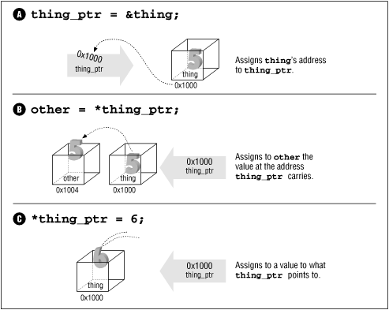

#include <stdio.h>

void inc_count(int *count_ptr)

{

(*count_ptr)++;

}

int main()

{

int count = 0; /* number of times through */

while (count < 10)

inc_count(&count);

return (0);

}

**Const Pointers:**

1. const char *answer_ptr = "Forty-Two";

const放前面说明answer_ptr指向的地方里面存的内容是const

1. char *const name_ptr = "Test";

const放在*的后面说明这个指针的值是固定的，也就是他总是指向同一个地方，这个值不能改变。

char array[5];

char *array_ptr = &array[0];

In this example, *array_ptr is the same as array[0], *(array_ptr+1) is the same as array[1].

**Array:**

Rather than writing:

array_ptr = &array[0];

we can write:

array_ptr = array;

**Command-Line Arguments:**

The procedure main actually takes two arguments.

main(int argc, char *argv[])

The parameter argc is the number of arguments on the command line (including the program name). The array argv contains the actual arguments.

Iterator:

It is an object that pointing to some element in a range of elements, and has the ability to iterate through the elements of the range using a set of operators.就像指针一样，他每一次取到的值都是这个队列里面的一个元素的指针，或者叫做引用。

**Iterator categories:**

1. Input and output iterators: they can perform sequential single-pass input or output operations.
2. Forward iterators: they are limited to one direction in which to iterate through a range forward.
3. Bidirectional iterators: like forward iterators but can also be iterated through backwards.
4. Random-access iterators: have the ability to access ranges non-sequentially; distant elements can be accessed directly by applying an offset value to an iterator without iterating through all the elements.