Usable Security Experiment Report

|  |  |  |  |
| --- | --- | --- | --- |
| **Team Leader** |  | **Student ID** |  |
| **Team Member** |  | **Student ID** |  |
| **Team Member** | _______________________ | **Student ID** | ___________________ |
| **Team Member** | _______________________ | **Student ID** | ___________________ |
| **Experiment Title** | Online Bank Interface design | | |

**Experiment Goal**

The primary goal of this experiment is to design a user-centered interface webpage for an online banking system that incorporates Human-Computer Interaction (HCI) design principles to ensure usability, accessibility, and efficiency. Specifically, the interface should enable users to seamlessly perform the following core banking functions:

* Balance Check: Allow users to view their current account balance in a clear and intuitive manner.
* Deposit: Provide a secure and straightforward way to add funds to their account.
* Withdraw: Enable users to withdraw funds while ensuring accuracy and safety.
* Money Transfer: Facilitate the transfer of money between accounts with minimal effort and error risk.

The experiment also aims to learn from existing online banking systems to identify best practices in HCI design, focusing on creating a user-friendly, accessible, and visually appealing interface.

**Operating System**

For this experiment, the operating system used is **macOS**. The primary browser chosen for testing the interface is **Microsoft Edge**.

Additionally, the programming environment consists of **Vue 3** for building the web interface and **npm** for package management and dependency handling.

**Experiment Procedure Overview**

The experiment consists of five web pages: home page, balance check page, deposit page, withdraw page, and money transfer page.

For the home page, For the home page, it mainly displays the theme of Online Bank and links to other functions.

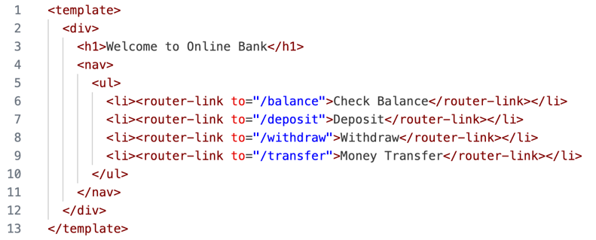

For the balance check page, we set up a query button.

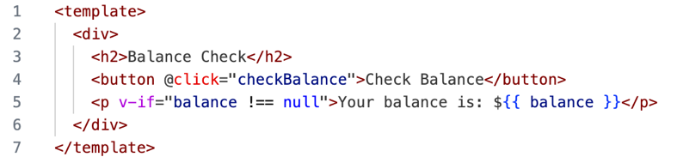

For the deposit page, we set up a deposit input box and a deposit button.

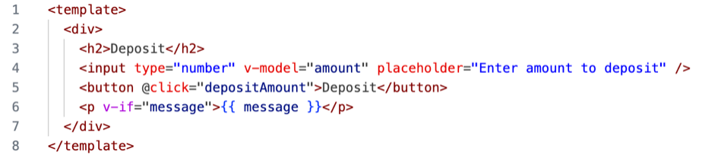

For the withdrawal page, we also set up a withdrawal amount fill box and a confirmation button.

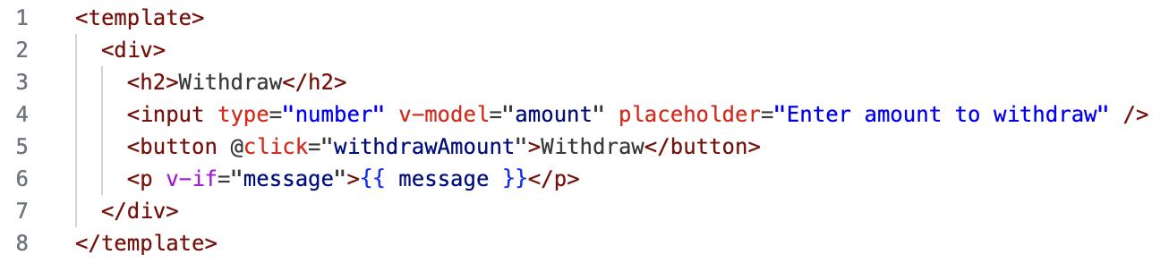

Finally, for the money transfer page, we set up the transfer object box, transfer amount box and confirmation button.

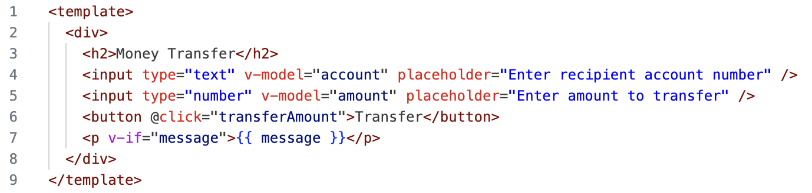

**Analysis**

Here we will present the test results.

**Home page**

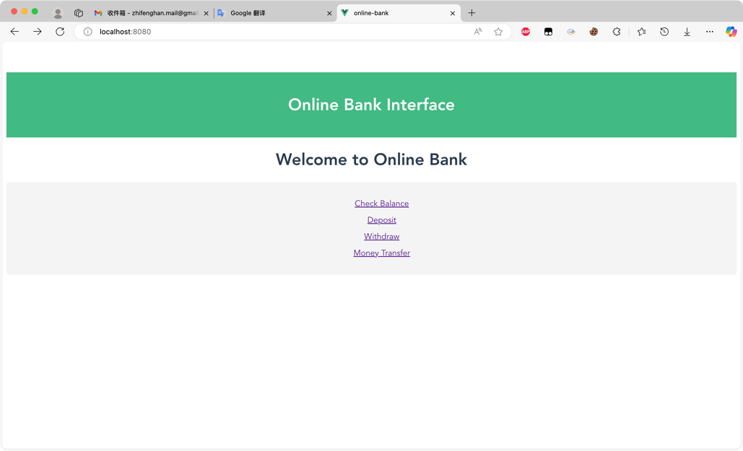

**balance check page**

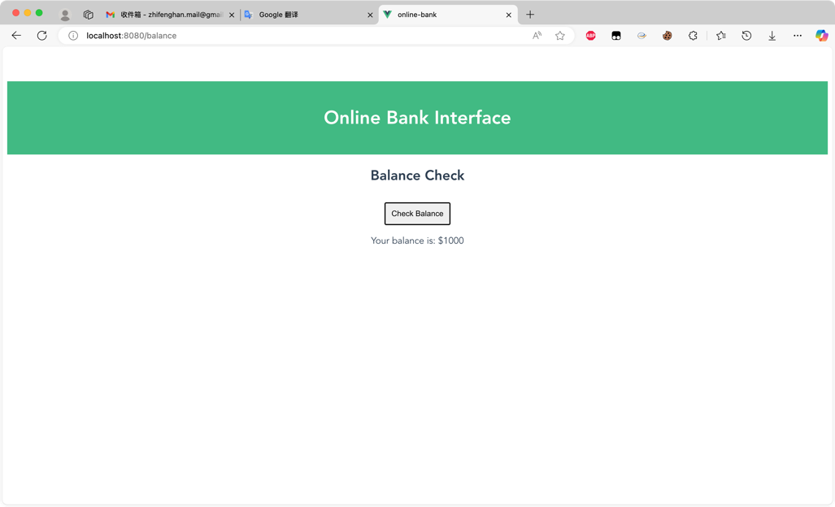

**deposit page**

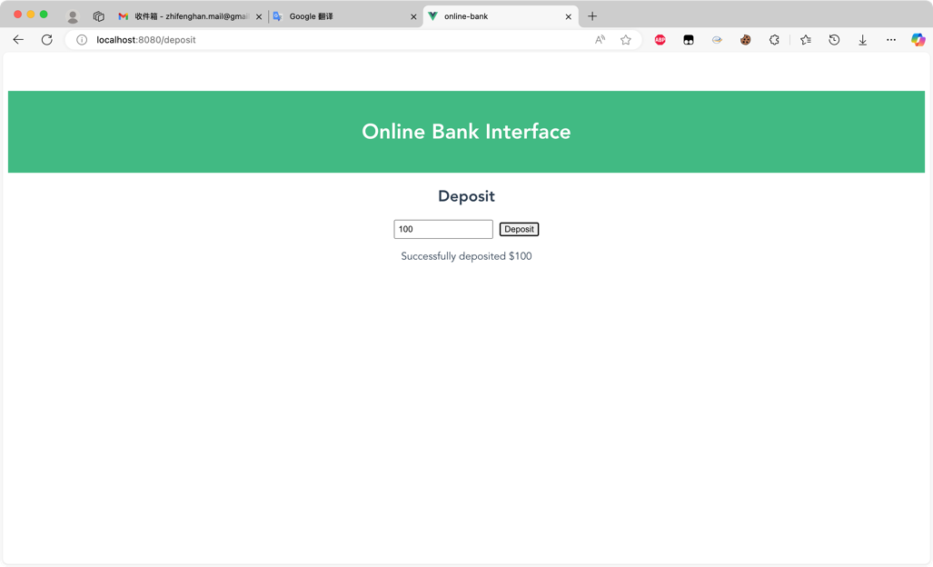

**withdrawal page**

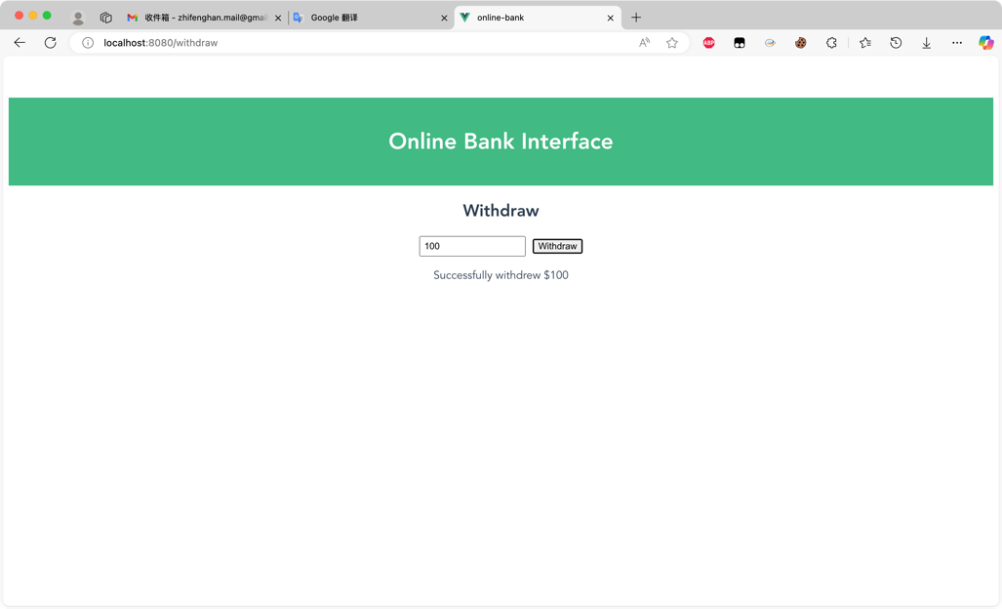

**money transfer page**

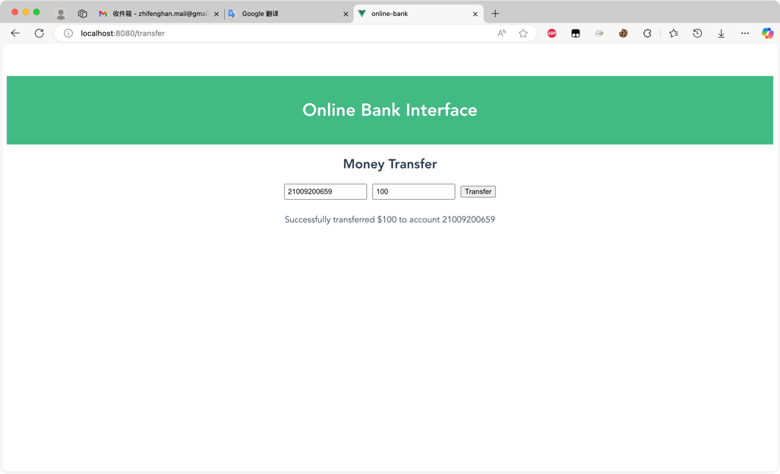

**Conclusion**

In this experiment, an online banking interface was successfully designed and implemented using Vue 3 and npm, tested on macOS with Microsoft Edge as the primary browser. The interface incorporates Human-Computer Interaction (HCI) principles, focusing on usability, accessibility, and user satisfaction. Core functionalities, including balance check, deposit, withdrawal, and money transfer, were designed to be intuitive and efficient.