Documentation of APSIM-Wheat

Bangyou Zheng, Karine Chenu, Scott Chapman, Enli Wang, Fernanda Dreccer

# Introduction

This documentation is based on the current version of [APSIM-Wheat module](https://github.com/APSIMInitiative/ApsimX/tree/d9717df5ef24f6d3f1eb4c301726c213960017bb) with a few modifications in the next generation updated on 17-August-2017.

A simulation is setup to demo the relationship among traits based on the cv. Hartog with high nitrogen and irrigation management under 15TraitMod experiment. The values in the figures below could be variable in other environments.

This is only a documentation for Wheat model in [next generation of APSIM](https://github.com/APSIMInitiative/ApsimX) with our own understanding.

The main contents include

* Detail description of science parts of APSIM-Wheat model
* Figures of default parameters
* Figures of general outputs

## Contributors

* [Bangyou Zheng](https://www.bangyou.me) [bangyou.zheng@csiro.au](mailto:bangyou.zheng@csiro.au)
* [Karine Chenu](https://qaafi.uq.edu.au/profile/18/karine-chenu) [karine.chenu@uq.edu.au](mailto:karine.chenu@uq.edu.au)
* [Scott Chapman](http://people.csiro.au/C/S/Scott-Chapman) [scott.chapman@csiro.au](mailto:scott.chapman@csiro.au)
* [Enli Wang](http://people.csiro.au/W/E/Enli-Wang) [enli.wang@csiro.au](mailto:enli.wang@csiro.au)
* Fernanda Dreccer [Fernanda.Dreccer@csiro.au](mailto:Fernanda.Dreccer@csiro.au)

## Conventions

### Figures

Figures in the documentation are classified into two categories with different backgrounds, i.e. Input and Output. Input figures show default parameter values (not genotypic values) or dynamic parameter values (depending on the other status variables) in the APSIM Next Gen model. Output figures show reportable variables in the in the APSIM Next Gen model. The Input and Output variable names only show the last section (separated by full stop) or specified names to save spaces in the figures.

Most of figures use two time serial variables, i.e. Stage and Accumulated thermal time since sowing. However, only Stage is used if all values are constant (e.g. Fig. 75), or stage based input variables.

The key stages are displayed in all figures (Section 3.2) including G for stage 2 Germination, T for stage 4 Terminal Spikelet, F for stage 6 Flowering, E for stage 8 End of Grain Filling.

## How to contribute?

This documentation is wrote by [RMarkdown](rmarkdown.rstudio.com) and [bookdown](bookdown.org). I suggest you firstly to read the introduction about [RMarkdown](rmarkdown.rstudio.com) and [bookdown](bookdown.org), then fork this repository into your github account. Feel free to submit a pull request and/or an [issue](https://github.com/byzheng/APSIM-Wheat-Doc/issues) if you notice any errors or have any comments.

The new document can be easily generated for any other simulations using following steps.

* Install the required software including [R](https://cran.r-project.org/), [RStudio](https://www.rstudio.com/), [Bookdown](https://bookdown.org/yihui/bookdown) and other depended packages.
* Fork or download all source codes from [git repository](https://github.com/byzheng/APSIM-Wheat-Doc).
* Replace your own simulation.apsimx under simulation subfolder. Your apsimx file should only have ONE simulation and include all report variables used in the report, which can be found in the report replacement of the existing apsimx file.
* Click Build book in the RStudio interface.

### Retrieve fixed value

get_fixed_value function is used to retrieve FixedValue in APSIM Next Gen. The path argument is used to specify the full path to the node with class FixedValue using APSIM format which connects the names of all predecessors started from Wheat. For example, the code below is used to obtain value for GrainsPerGramOfStem with value 22.

get_fixed_value(g_pmf,   
 path = 'Wheat.Grain.NumberFunction.GrainNumber.GrainsPerGramOfStem')

### Add new figure

Figures are classified into Input and Output categories (Section 1.2). div tags in html are used to specify the category.

<div class="fig-input">  
```{r chunk-label, fig.asp=1, fig.cap='A figure caption.'}  
# add you codes here  
```  
</div>  
  
<div class="fig-output">  
```{r chunk-label, fig.asp=1, fig.cap='A figure caption.'}  
# add you codes here  
```  
</div>

Two variables are exposed to global environment (.GlobalEnv in R), i.e. g_pmf for an xml object of the simulation file _simulation/simulation.apsimx, and g_report for a data.frame of the simulation output file. Variables g_pmf and g_report can be used in any places of the documentation.

A few helper functions are designed to plot figures, i.e. plot_xypair and plot_report.

plot_xypair is used to plot the XYPairs function in APSIM Next Gen. The path argument is used to specify the full path of a node with child XYPairs using APSIM format which connects the names of all predecessors started from Wheat (e.g. Wheat.Leaf.CohortParameters.MaxArea.AgeFactor). x_lab and y_lab can be used to specify the X and Y labels.

path <- 'Wheat.Leaf.CohortParameters.MaxArea.AgeFactor'  
plot_xypair(g_pmf, path,  
            x_lab = 'Growthing stage',   
 y_lab = 'Multiplier of maximum leaf area')

plot_report is used to plot outputs of APSIM Next Gen for a single and multiple variables. Two types of X variables are predefined in the global environment (i.e. g_xvar for thermal time and stage; g_xvar2 for stage only). X label is also defined in the global environment. These variables can be overwrote when the plot_report is called, but DO NOT add into global environment as other chunks use the default values.

g_xvar <- c('Wheat.Phenology.Stage',  
 'Wheat.Phenology.AccumulateThermalTime')  
g_xvar2 <- c('Wheat.Phenology.Stage')  
g_xlab <- 'Accumulated thermal time or stage'

The argument y_cols is used to specify one and multiple variables in the APSIM report using plot_report function. Y label y_lab should be specified for each figure.

y_cols <- c('Wheat.Leaf.DMSupply.Fixation',  
 'Wheat.Leaf.DMSupply.Retranslocation',  
 'Wheat.Leaf.DMSupply.Reallocation')  
plot_report(g_report, g_xvar, y_cols, x_lab = g_xlab,   
 y_lab = 'Demand (g/d)', ncol = 3)

## Software information

The R session information when compiling this book is shown below:

## R version 3.4.2 (2017-09-28)  
## Platform: x86_64-w64-mingw32/x64 (64-bit)  
## Running under: Windows 7 x64 (build 7601) Service Pack 1  
##   
## Matrix products: default  
##   
## locale:  
## [1] LC_COLLATE=English_Australia.1252 LC_CTYPE=English_Australia.1252   
## [3] LC_MONETARY=English_Australia.1252 LC_NUMERIC=C   
## [5] LC_TIME=English_Australia.1252   
##   
## attached base packages:  
## [1] stats graphics grDevices utils datasets base   
##   
## other attached packages:  
## [1] bindrcpp_0.2 RSQLite_2.0 DiagrammeR_0.9.2 xml2_1.1.1   
## [5] assertive_0.3-5 dplyr_0.7.4 purrr_0.2.3 readr_1.1.1   
## [9] tidyr_0.7.1 tibble_1.3.4 ggplot2_2.2.1 tidyverse_1.1.1   
## [13] magrittr_1.5 knitr_1.17   
##   
## loaded via a namespace (and not attached):  
## [1] viridis_0.4.0 httr_1.3.1   
## [3] bit64_0.9-7 viridisLite_0.2.0   
## [5] jsonlite_1.5 assertive.sets_0.0-3   
## [7] modelr_0.1.1 assertthat_0.2.0   
## [9] assertive.data_0.0-1 highr_0.6   
## [11] blob_1.1.0 cellranger_1.1.0   
## [13] yaml_2.1.14 backports_1.1.1   
## [15] lattice_0.20-35 glue_1.1.1   
## [17] downloader_0.4 assertive.data.uk_0.0-1   
## [19] assertive.matrices_0.0-1 digest_0.6.12   
## [21] assertive.types_0.0-3 RColorBrewer_1.1-2   
## [23] rvest_0.3.2 colorspace_1.3-2   
## [25] htmltools_0.3.6 plyr_1.8.4   
## [27] psych_1.7.8 XML_3.98-1.9   
## [29] pkgconfig_2.0.1 broom_0.4.2   
## [31] assertive.data.us_0.0-1 assertive.properties_0.0-4  
## [33] assertive.reflection_0.0-4 haven_1.1.0   
## [35] bookdown_0.5 scales_0.5.0   
## [37] brew_1.0-6 influenceR_0.1.0   
## [39] assertive.code_0.0-1 lazyeval_0.2.0   
## [41] mnormt_1.5-5 rgexf_0.15.3   
## [43] readxl_1.0.0 assertive.strings_0.0-3   
## [45] memoise_1.1.0 evaluate_0.10.1   
## [47] methods_3.4.2 assertive.numbers_0.0-2   
## [49] nlme_3.1-131 forcats_0.2.0   
## [51] foreign_0.8-69 Rook_1.1-1   
## [53] tools_3.4.2 hms_0.3   
## [55] assertive.files_0.0-2 stringr_1.2.0   
## [57] munsell_0.4.3 compiler_3.4.2   
## [59] rlang_0.1.2 grid_3.4.2   
## [61] rstudioapi_0.7 visNetwork_2.0.1   
## [63] htmlwidgets_0.9 assertive.models_0.0-1   
## [65] assertive.base_0.0-7 igraph_1.1.2   
## [67] rmarkdown_1.6 gtable_0.2.0   
## [69] codetools_0.2-15 DBI_0.7   
## [71] assertive.datetimes_0.0-2 reshape2_1.4.2   
## [73] R6_2.2.2 gridExtra_2.3   
## [75] lubridate_1.6.0 bit_1.1-12   
## [77] bindr_0.1 rprojroot_1.2   
## [79] stringi_1.1.5 parallel_3.4.2   
## [81] Rcpp_0.12.13

# Overview

The APSIM-Wheat model is based on a framework of the physiological determinants of crop growth and development (Hammer et al. 2016; Charles-Edwards 1982) and is focused at organ scale.

## Organs

In the wheat module, wheat is divided into five components or parts: Grain, Root, Leaf, Spike and Stem. Leaf includes only leaf blades. Stem is defined in a functional rather than amorphological manner and includes plant stems, leaf sheaths. Head is divided into Grain and Spike (which correspond to spike without the grain).

## Terminology

### Phenology

* **Phyllochron** The phyllochron is the thermal time it takes for successive leaves on a shoot to reach the same developmental stage.

### Structure

* **Node (Phytomer)** A phytomer unit is defined as consisting of a leaf, and the associated axillary bud, node and internode.
* **Main stem** The first culm that emerges from the seeds is the main stem.
* **Tiller (Branch)** All remaining culms that emerges from main stem or other tillers (branches), are referred as tillers or branches.
* **Apex** A shoot apex is the terminal bud of plants that grows from 0.1-1.0 mm and consists of the apical meristem, developing leaves and the immediate surrounding leaf primordial. Each tiller has an apex which continuously developes new leaf.

### Leaf

* **Leaf organ** is only included leaf blades excluding section under sheath, i.e. only parts of leaf blades to produce photosynthate.
* **Huan Index** is mainly concerned with the leaf production stage of development (Haun 1973). The length of each emerging leaf is expressed as a fraction of the length of the preceding fully emerged leaf. For example, a 3.2 indicates that three leaves are fully emerged, and a fourth leaf has emerged two-tenths of the length of the third.

# Phenology

## Thermal time

The daily thermal time is calculated using daily records of mean temperature () using a beta function (Wang and Engel 1998).

where, , and are the three cardinal temperatures for wheat development, which are 0, 27.5 and 40 oC, respectively. The parameter is calculated by the following equation. The daily mean temperature is calculated as the average of daily minimum and maximum temperature.

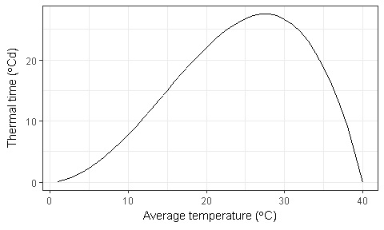

Figure 1 Temperature response of wheat development

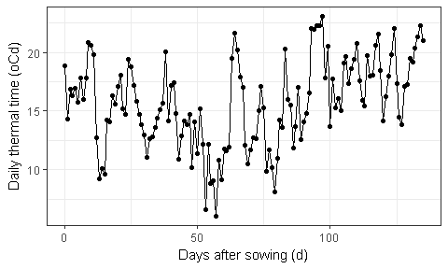

Figure 2 The daily thermal time calculated from the daily mean temperature

## Stages and periods

The growth cycle of wheat is started from sowing and finished at harvest ripe.The whole cycle is separated into 10 stages and 10 phases. Wheat jumps into next stage or phase when certian conditions are statisfied (earliness "per se", vernalization and photoperiod).

|  |  |  |
| --- | --- | --- |
| Stage | Name | Description |
| 1 | Sowing | Sow seeds into field |
| 2 | Germination | Germination begins when the seed imbibes water from the soil and reaches 35 to 45 percent moisture on a dry weight basis |
| 3 | Emergence | The coleoptile extends to the soil surface |
| 4 | TerminalSpikelet | The terminal spikelet initial is formed |
| 5 | FlagLeaf | The appearance of flag leaf tip or ligule (??) |
| 6 | Flowering | The 50% plants are flowering in the field |
| 7 | StartGrainFill | Grain filling follows anthesis and refers to the period during which the kernel matures or ripens |
| 8 | EndGrainFill | Grain filling follows anthesis and refers to the period during which the kernel matures or ripens |
| 9 | Maturity | Grain dry weight reaches its maximum which is correlated to the absence of green color in the chaff or kernels |
| 10 | HarvestRipe | Wheat is ready for harvest |

Each phase has a targer thermal time (earliness *per se*) and several impact factors to extend the growing period including vernalization, photoperiod, water, nitrogen stresses.

|  |  |  |  |  |
| --- | --- | --- | --- | --- |
| Name | Earliness per se | Vernalization | Photoperiod | Description |
| Germinating | NA | NA | NA | Depending on soil water in top layer |
| Emerging |  | NA | NA | Depending on the sowing depth |
| Vegetative | NA | NA | NA | NA |
| StemElongation | NA | NA | NA | NA |
| EarlyReproductive | NA | NA | NA | NA |
| GrainDevelopment | NA | NA | NA | NA |
| GrainFilling | NA | NA | NA | NA |
| Maturing | NA | NA | NA | NA |
| Ripening | NA | NA | NA | NA |
| ReadyForHarvesting | NA | NA | NA | NA |

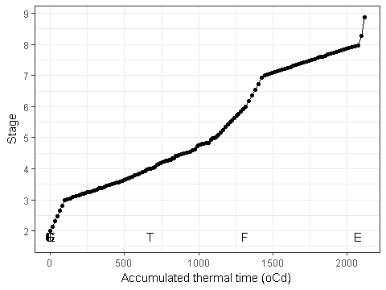

Figure 3 The growthing stage as a function of accumulated thermal time

# Structure

The development of wheat leaves and tillers are simulated with an apex model which is further developed from leaf cohort model (Brown et al. 2014). The basic assumptions include

1. The growth and development of a plant is controlled by apex. Only one apex is existed in a plant at emergence. Branching increases the total apex number of a plant. Apex death decreases the apex number, which are caused by several reasons including the carbon allocation, light intensity, natural death. The apex number is not necessary as an integer to simulate plant development in the population level.
2. The number of apex in a plant determines the number of the new leaves when initialization of a new cohort. The cohort size is fixed after initialization although attributes can be changed in the later stage.
3. The apexes are grouped by age and have the same age if they initialize at the same day. During development of new cohort, new apexes caused by branching develops into new tillers which have the same behaviours during the whole lift span (e.g. size, area, nitrogen, photosynthesis). The apex age equals to 1 when it initialize and increases by 1 when a new leaf cohort initializes. Each apex group has several attributes including size and age.
4. The leaves in a cohort also are distinguished and grouped by apex ages, which determines at the initialization of leaf cohort.
5. Death of branches or tillers only reduces the total number of apexes, not the size of existing cohorts. The apexes with youngest age are going to death first.

## Phyllochron

The phyllochron is the intervening period between the sequential emergence of leaf tips on the main stem of a wheat (McMaster and Hunt 2003).

The non-linear reponse of temperature on phyllchron were observed by Friend et al. (1962) and Cao and Moss (1989). The soil temperature provided more accurately prediction of leaf development than air temperature (Jamieson et al. 1995). However, a simple linear reponse of phyllochron to air temperature works surprusingly well in predicting phyllochron for most field conditions (McMaster and Hunt 2003). If improvements are desired, the use of non-linear reponses and soil temperature shows promise (Jamieson et al. 1995; Yan and Hunt 1999). Consequently, we assume the linear reponse of air temperature on leaf appearance (phyllochorn).

The base phyllochron is a genotypic parameter with default value 120, but is chagned for most of cultivars. Based on (Jamieson et al. 1995), leaf appearance could be described by a base phyllochron determined between leaves 3 and 7 and a phyllochron that was 70% of base phyllochron for leaves < 3 and 140% of base phyllochroen for leaves > 7 (Fig. 4). The phyllochron also is adjusted by photoperiod [reference required] through increasing pholochron in the shorter day length (Fig. 5).

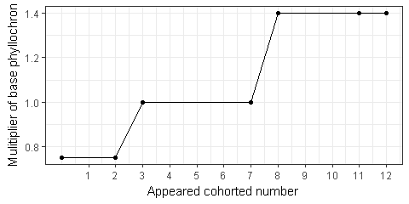

Figure 4 Phyllochron of leaf cohort is depending on the rank on the main stem

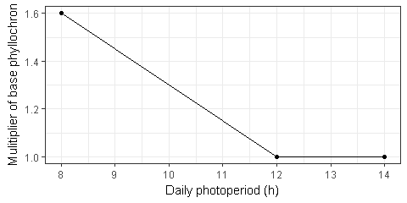

Figure 5 The multiplier of phyllochron which is effected by daily photoperiod length.

Finally, the phyllochron is dynamically adjusted according to appeared cohort number and daily photoperiod (Fig. 6).

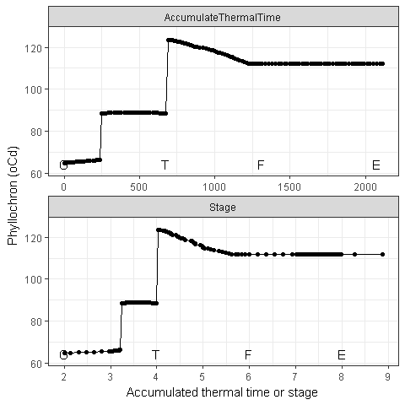

Figure 6 The actual phyllochron in the testing environment

## Final leaf number

Will be documented...

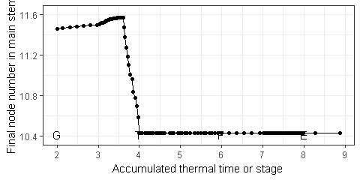

Figure 7 Final leaf number in main stem

## Initialization and appearance of leaf tips on main stem

At Germination stage, 2 new leaf cohorts or tips are initialized at the main stem. At Emergence stage, 1 leaf cohort or tip is appeared at the main stem, and 1 more leaf cohort is initialized. The potential appearance of leaf tip number () is initialized as 1.

After Emergence, the potential appearance of tip number in the main stem () is daily increased according to the daily phyllochron (Fig. 6) and thermal time (Section 3.1) until Maturity (Fig. 8 and 9. should stop increasing when final leaf number is reached).

where, is the daily increase of leaf tip number (Fig. 8), is the daily thermal time, is the phyllochron calculated at today.

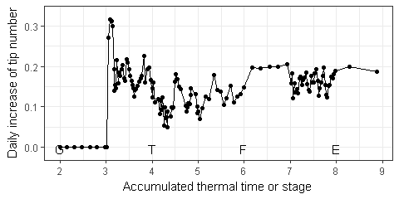

Figure 8 Daily increase of tip number in main stem. There is no point to consider increase of tip number after stage 4 (terminal spikelet), although model exports increase of tip number in the whole growth season

Potential appearance of tip number in main stem () are summarized daily increases since Emergence, plus the appeared leaf tip at Emergence (1 for wheat model) (Fig. 9).

where, is day of Emergence. is today. In the Structure model, the tip numbers are not calculated for branches or tillers, but only for main stem (Figure 9).

Before plant reaches the final leaf number (i.e. all leaves are initialized and appeared), a new leaf cohort is initialized and appeared when increases of are more than 1 (Figure 8). Consequently, the rates of leaf initialization and appearance are same, except initialized tip number is more than 2 of appeared tip number.

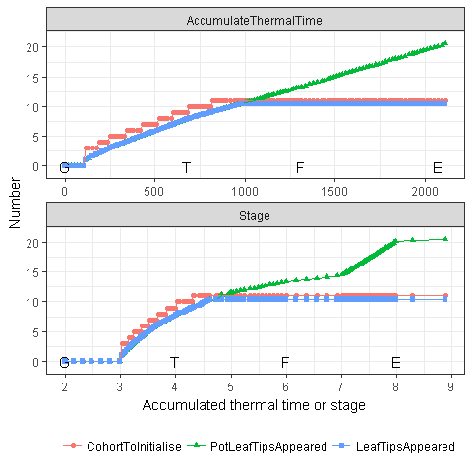

Figure 9 Tips number in main stem. The potential appeared tip number keeps increasing after flag leaf, which is only a model output and need to be fixed.

Huan stage is exported as the output variable LeafTipsAppeared.

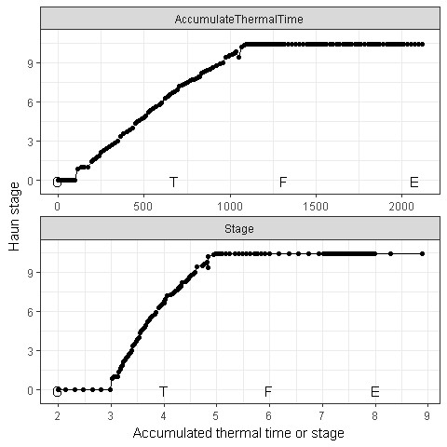

Figure 10 Haun stage in main stem

The fraction of final leaf is used to simulate the variation of final leaf number in a population. The fraction of leaf cohort is set as 1 for all leaf cohort, except the flag leaf which equal to decimal part of final leaf number (Fig. 7).

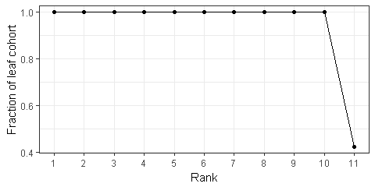

Figure 11 Fraction of leaf cohort

## Tillering

At Emergence, the apex number equals to 1. The apex number in a plant () is increased by branching () and decreased by mortality () in every day.

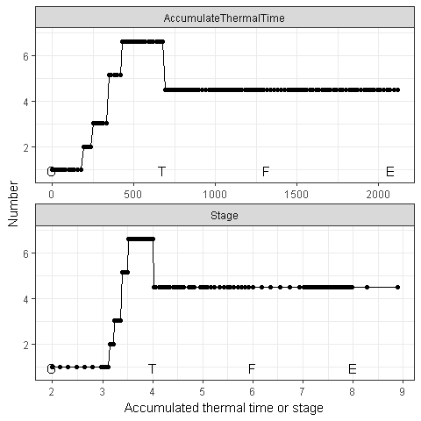

Figure 12 Apex number in the main stem

### Branching rate

The branching rate in a plant is specified by parameter BranchingRate () and is calculated as potential branching rate (Fig. 13) and several stress factors (i.e. nitrogen stress, total coverage, and water stress). From stage Emergence to Terminal Spikelet (Section 3.2), the potential branching rate is defined as a function of number of appeared cohorts in the main stem (Figure 13) which follow the pattern of Fibonacci sequence. Beyond this period, the branching rate is set as zero.

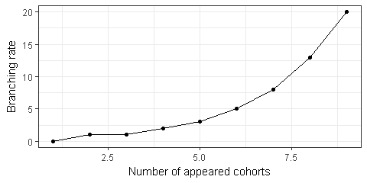

Figure 13 Potential branching rate of APSIM-Wheat as a function of appreared cohort number

Two stresses are defined in the APSIM-Wheat including nitrogen and WSC. A simple sensitivity analysis indicates the branching rate is too sensitive to WSC with default values (x = [0.1, 0.2]; y = [0, 1]). So, this feature is disabled for further analysis.

The nitrogen stress is calculated as a function of fraction of nitrogen supply relative to nitrogen demand which is exported from the Arbitrator module. Wheat module assumes no nitrogen stress when the nitrogen supply is bigger than 1.5 times of nitrogen demand (Figure 14). Nitrogen stress linearly increases when supply/demand ratio less then 1.5 (Reference required.)

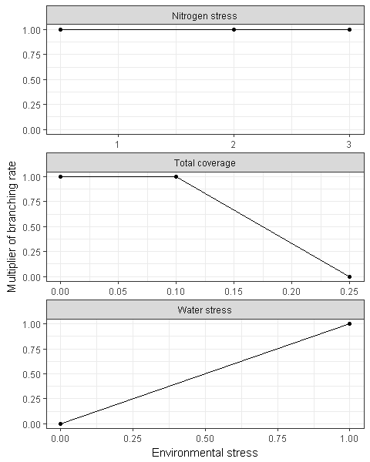

Figure 14 The factors to influence of branching rate (nitrogen stress, total coverage and water stress). The final multiplier of branching rate is the minimum values of the

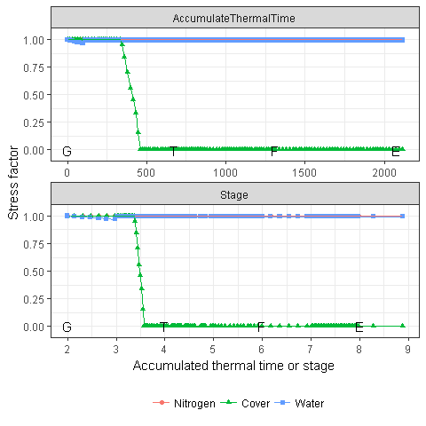

Figure 15 The stress factors for branching rate

Figure 16 shows the branching rate and total branching number in the test simulation without nitrogen stress on branching rate during branching period (from Emergence to Terminal Spikelet.

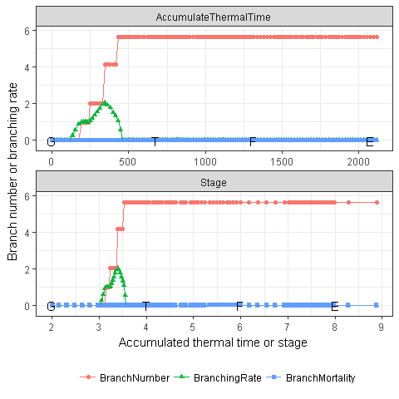

Figure 16 The branching rate and branch number for wheat

### Mortality

Two types of mortality are considered in the apex model, i.e. smaller tiller at terminal spikelet and low growth rate. For any types of tiller mortality, the plant does not reduce the population of existing leaf cohort, but number of apex, then reduce the population size of new leaf cohort.

At the terminal spikelet, all tillers with less than 4 leaves are stopped to growth new leaves.

Branching mortality starts from the Flag leaf until Flowering which defines as a function of moving mean tiller growth rate (Figure 17. The mean tiller growth rate is calculated as the 5 days moving means of tiller growth rate, which is calculated by the daily biomass supply divides thermal time and total stem population. Reference required.

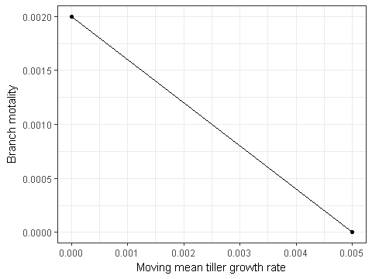

Figure 17 Tiller mortality as a function of moving mean tiller growth rate

Figure 18 shows the mean tiller growth rate and the three factors to calculate it in the test simulation.

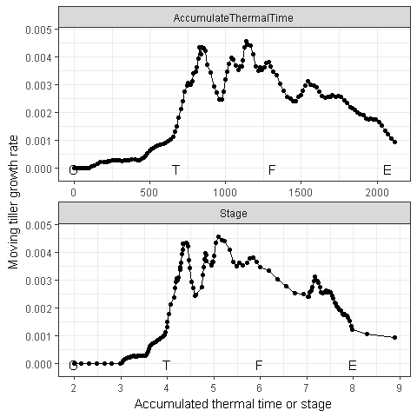

Figure 18 The moving tiller growth rate

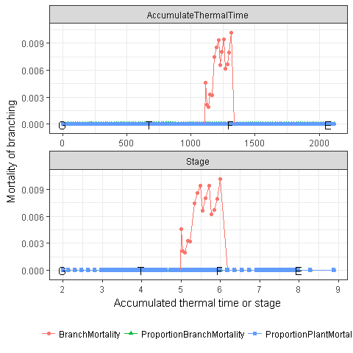

Figure 19 The mortality of tillers

## Plant and Main-Stem Population

No plant mortality is considerred in the wheat model.

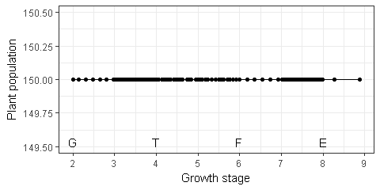

Figure 20 Plant population.

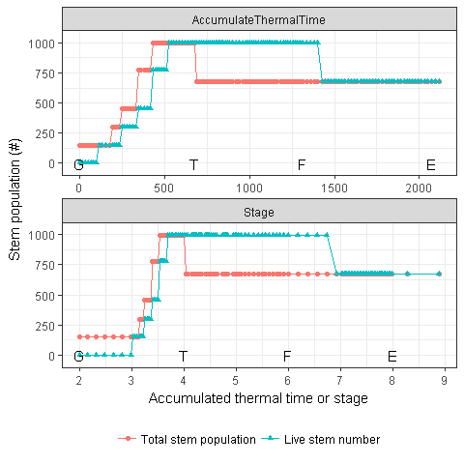

Figure 21 Total stem population and live stem number.

## Canopy height

The canopy height (Fig. 24) is calculated as the potential height (Fig. 22) and adjusted by water stress (Fig. 23).

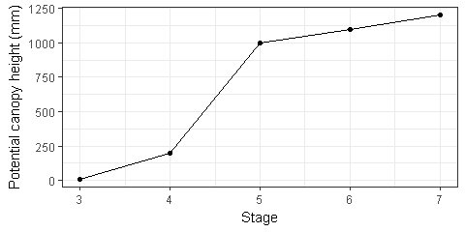

Figure 22 Potential canopy height

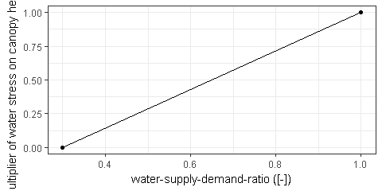

Figure 23 The impact of water stress on canopy height

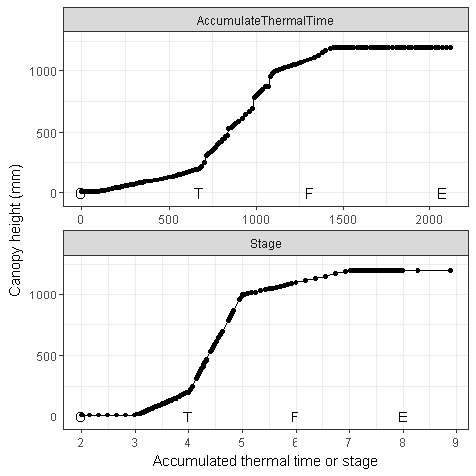

Figure 24 The simulated canopy height

# Biomass

Wheat plants are separated into 5 organs, (i.e. Grain, Root, Leaf, Spike, Stem). Leaf includes only leaf blades (Chapter 10). Stem is defined in a functional rather than a morphological manner and includes nodes, internodes and leaf sheaths (Chapter 12). Spike is the head parts without grain including pedicel and glunes (Chapter 11). Grain is the grain part of heads (Chapter 8). Root is the whole root system below ground (Chapter 9).

The biomass supply comes from three sources (Fixation (Photosynthesis), Retranslocation, Reallocation, Section 5.1). In theory, all organs can provide Fixation through photosynthesis, but only Leaf is considered in the current wheat model.

* **Fixation** The wheat model in the APSIM next generation uses the gross photosynthesis rate, not the net photosynthesis rate in the old APSIM.
* **Retranslocation**
* **Reallocation**

The biomass and nitrogen of each organ is separated into two pools (i.e. Live and Dead, Section 5.5). Each pool is separated into three components (i.e. Structural, Metabolic, Storage, (Section 5.2) ) (Brown et al. 2014).

* **Structural biomass** are essential for the growth of the organ. They remain within the organ once it has been allocated and are passed from Live to Dead pools as the organ senescence.
* **Metabolic biomass** are essential for growth and their concentration can influence the function of organs (e.g. photosynthetic efficiency of the leaf depends on Metabolic nitrogen content). Metabolic biomass may be reallocated (moved to another organ upon senescence of this organ) or retranslocated (moved to another organ at any time when supplies do not meet the structural and metabolic biomass demands of growing organs).
* **Storage biomass** are non-essential to the function of an organ. They will be allocated to an organ only when all other organs have received their Structural and Metabolic allocations and may be reallocated or retranslocated.

Daily biomass supply (Section 5.1) is comsumed by growth respiration (Section 5.3.1) , then partitioned into structural and metabolic components in the Live organs (Fig. 33) according to the relative demand of each organ (Section 5.2). The remaining biomass is partitioned into storage (i.e. Stem (Chapter 12) and Spike (Chapter 11) , Fig. 36). Meanwhile, the metabolic and storage biomass are comsumed by maintenance respiration (Section 5.3.2) .

## Supply

Biomass supplies are divided into three sources, i.e fixation (i.e. photosynthesis), retanslocation, reallocation (Table 1). The only source of fixation is organ Leaf. The sources of retanslocation include organs Spike and Stem. No reallocation is considered in the wheat model. See details in the organs about the dynamic of biomass supply.

Table 1 The source of biomass supply in all organs. X and - indicate the organ has and has not the source, respectively.

|  |  |  |  |
| --- | --- | --- | --- |
| Organ | Fixation | Retranslocation | Reallocation |
| Grain | - | - | - |
| Root | - | - | - |
| Leaf | X | - | - |
| Spike | - | X | - |
| Stem | - | X | - |

Table 2 Figures about biomass supply.

|  |  |
| --- | --- |
| Reference | Caption |
| Fig. 25 | Biomass total supply in three components including total supply. |
| Fig. 26 | Biomass total supply in all organs including total supply. |
| Fig. 27</a | > Biomass supply form fixation in all organs including total fixation. |
| Fig. <a href="#fig:biomass-supply-retranslocation | ">28 Biomass supply from retranslocation in all organs including total retranslocation. |
| Fig. 2 | 9 Biomass supply from reallocation in all organs including total reallocation. |

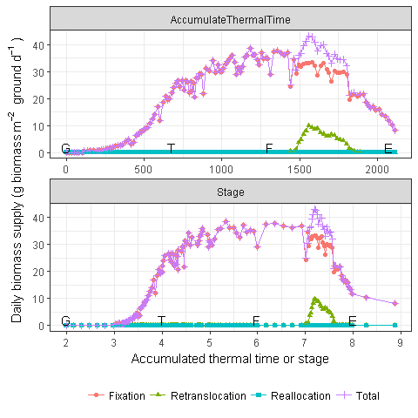

Figure 25 Biomass total supply in three components including total supply.

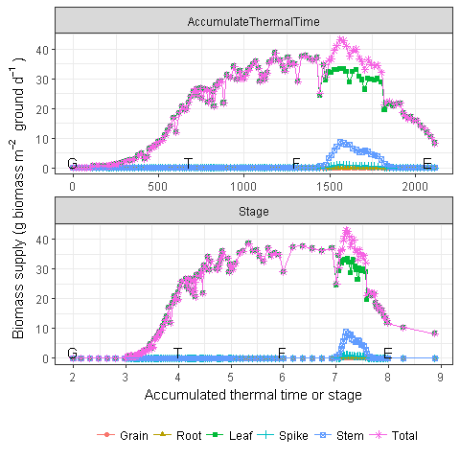

Figure 26 Biomass total supply in all organs including total supply.

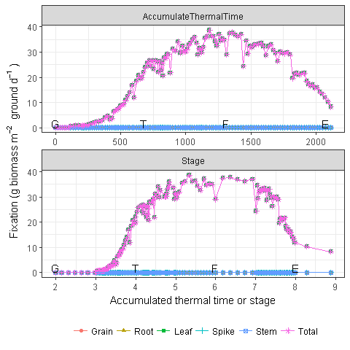

Figure 27 Biomass supply form fixation in all organs including total fixation.

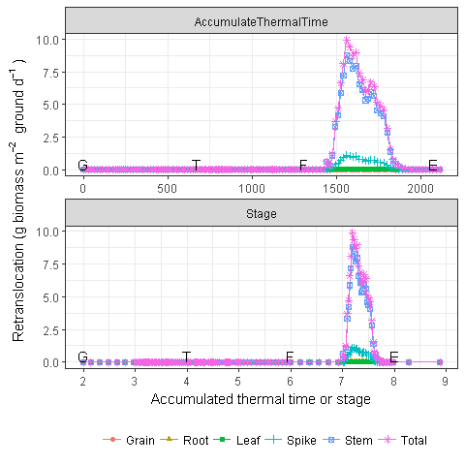

Figure 28 Biomass supply from retranslocation in all organs including total retranslocation.

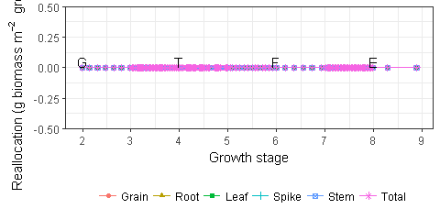

Figure 29 Biomass supply from reallocation in all organs including total reallocation.

## Demand

Depending on the organ, not all components are considered (Table 3). Structural component is considered in all organs. Metabolic component is only considered in Leaf (Chapter 10). Storage component is only considered in Stem (Chapter 12) and Spike (Chapter 11).

Table 3 The three components of biomass in all organs. X and - indicate the organ has and has not the component, respectively.

|  |  |  |  |
| --- | --- | --- | --- |
| Organ | Structural | Metabolic | Storage |
| Grain | X | - | - |
| Root | X | - | - |
| Leaf | X | X | - |
| Spike | X | - | X |
| Stem | X | - | X |

Stem and Root demands determine as the fraction of daily Fixation (Fig. 136, and 76). The Spike demand determines as the head number and growth duration (Fig. 129).

Table 4 Figures about biomass demand

|  |  |
| --- | --- |
| Reference | Caption |
| Fig. <a href="#fig:biomass-demand-totalcomponent | ">30 Biomass demand in all components including the total demand. |
| Fig. 31 | Biomass demand in all organs including the total demand. |
| Fig. 3 | 2 Biomass demand for structural and metabolic components including the total structural and metabolic demands. The structural and metabolic demands are allocated in the first step. |
| Fig. 33</a | > Total biomass demand for structural and metabolic components in all organs including the total structural and metabolic demands. The structural and metabolic demands are allocated in the first step. |
| Fig. 34 | Biomass structural demand in all organs including the total structural demand. |
| Fig. 35< | /a> Biomass metabolic demand in all organs including the total metabolic demand. Only leaf has metabolic demand, so the lines of leaf and total overlap each other. |
| Fig. 36</a | > Biomass storage demand in all organs including total storage demand. |

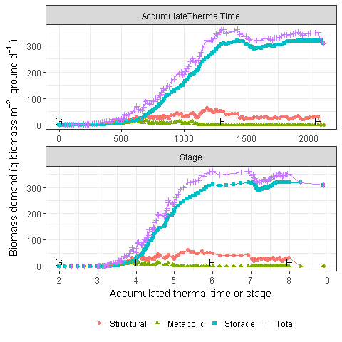

Figure 30 Biomass demand in all components including the total demand.

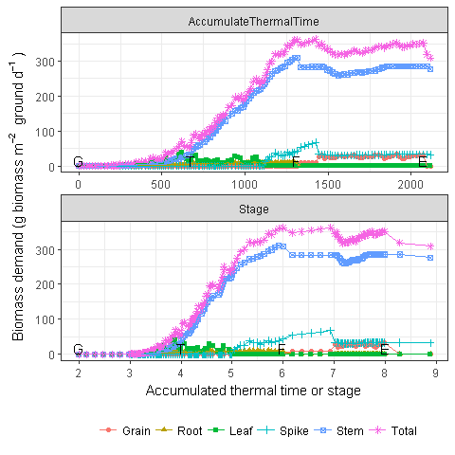

Figure 31 Biomass demand in all organs including the total demand.

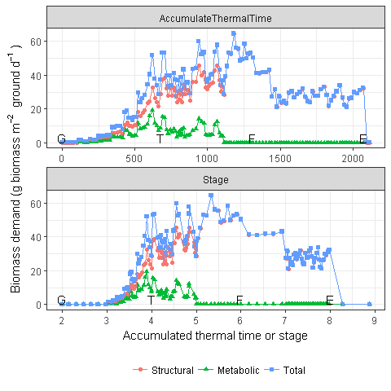

Figure 32 Biomass demand for structural and metabolic components including the total structural and metabolic demands. The structural and metabolic demands are allocated in the first step.

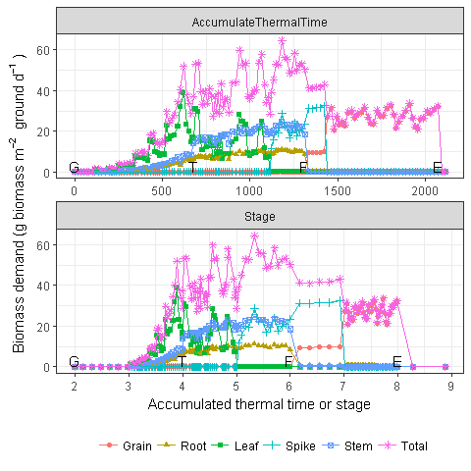

Figure 33 Total biomass demand for structural and metabolic components in all organs including the total structural and metabolic demands. The structural and metabolic demands are allocated in the first step.

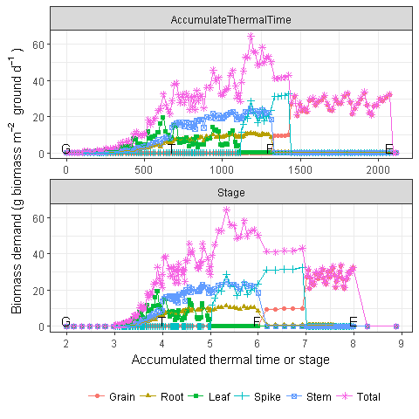

Figure 34 Biomass structural demand in all organs including the total structural demand.

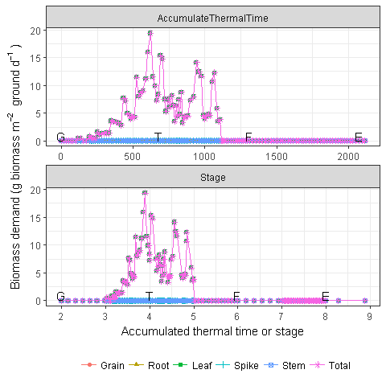

Figure 35 Biomass metabolic demand in all organs including the total metabolic demand. Only leaf has metabolic demand, so the lines of leaf and total overlap each other.

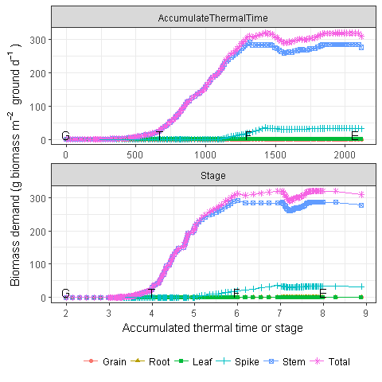

Figure 36 Biomass storage demand in all organs including total storage demand.

## Respiration

As the major roles of carbon balance of crop, respiration is separated into two components, i.e. growth and maintenance respiration (van Iersel and Seymour 2000; Chiariello, Mooney, and Williams 2000). van Iersel and Seymour (2000) described "growth respiration is referred as the amount of carbohydrates respired in a net gain in plant biomass. This includes the production of ATP and reductant for biosynthetic processes, transport processes, and nutrient uptake and reduction. Maintenance respiration is defined as the respiration needed to provide the energy for all plant processes that do not result in a net increase in plant dry matter, such as maintenance of ion gradients across membranes and the resynthesis of degraded organic compounds".

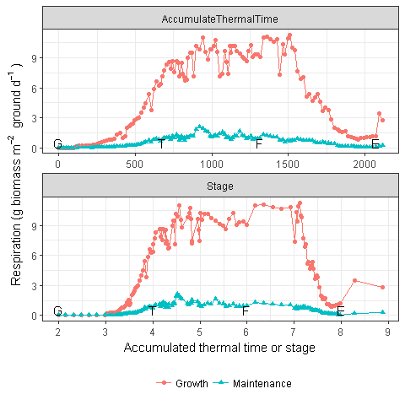

Figure 37 The growth and maintenance respirations.

### Growth respiration (Conversion efficiency))

The allocated biomass of an organ losses through growth respiration (i.e, 1 - Conversion efficiency). The growth respiration is applied to all components of an organ (i.e. structural, metabolic, storage).

Table 5 Biomass conversion efficiency for all organs.

|  |  |
| --- | --- |
| Organ | Conversion efficiency |
| Grain | 0.7067 |
| Root | 0.6925 |
| Leaf | 0.6853 |
| Spike | 0.7067 |
| Stem | 0.6600 |

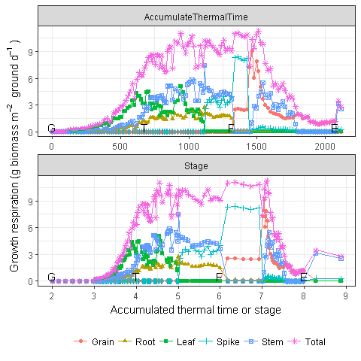

Figure 38 Growth respiration for all organs

### Maintenance respiration

The maintenance respiration is required for metabolic and storage components (Table 3). The metabolic and storage components of Live pool is daily reduced according to a fraction which is used for maintenance respiration (Fig. 40). The maintenance fraction is calculated as reference maintenance fraction at 20 C and a beta function (Wang and Engel 1998) with three cardinal temperatures (i.e. minimum, optimal and maximum temperatures). All organs have the same cardinal temperatures, but different maintenance fraction at 20C (Table 6). Finally, the actual maintenance fraction depends on the daily mean temperature (Fig. 40. Leaf and Stem have the major contributions to maintenance respiration (Fig. 41). Root and Grain don't have maintenance respiration (Fig. 41).

Table 6 The parameter values of maintenance fractions for all organs. , and are the minimum, optimum and maximum temperatures in the Wang and Engle's beta equation. The is the weighting of maximum temperature when calculats daily mean temperature. The and are the reference temperature and fraction of maintenance fractions at reference temperature.

|  |  |  |  |  |  |  |
| --- | --- | --- | --- | --- | --- | --- |
| Organ |  |  |  |  |  |  |
| Grain | -50 | 48 | 60 | 20 | 0.5 | 0.01 |
| Root | -50 | 48 | 60 | 20 | 0.5 | 0.02 |
| Leaf | -50 | 48 | 60 | 20 | 0.5 | 0.03 |
| Spike | -50 | 48 | 60 | 20 | 0.5 | 0.01 |
| Stem | -50 | 48 | 60 | 20 | 0.5 | 0.02 |

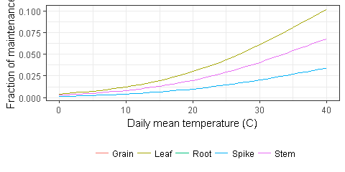

Figure 39 The response of maintenance respiration on daily average temperature with a beta function (Wang and Engel 1998).

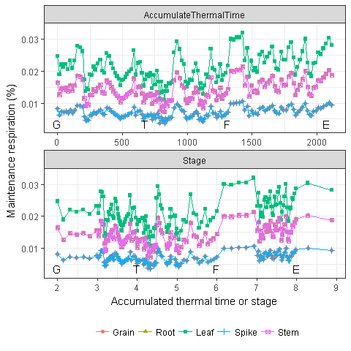

Figure 40 Daily fraction of maintenance respiration for all organs. The maintenance respirations of two groups of organs overlap each other (i.e. stem and root, spike and grain).

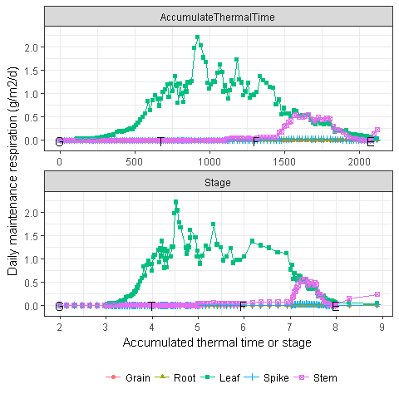

Figure 41 Daily maintenance respiration for all organs.

## Biomass partitioning

The biomass partitions into structural and metabolic components firstly according to the relative demands. The remaining biomass allocates into storage according to the relative demands. The greatest storage demand of stem can store all remaining daily supply.

The daily supply is distributed into Structural and Metabolic components, then Storage component. The daily demand cannot be satisfied if the structural and metabolic demands are more than daily supply, then the allocated biomasses of all organs are proportionally reduced to match daily supply (Fig. 42). The extra daily supply is distributed into storage, i.e. Stem for wheat model, as the extreme higher storage demand for stem (Fig. 43).

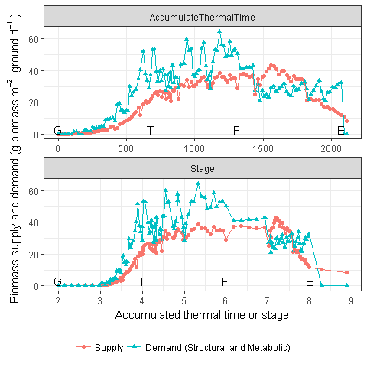

Figure 42 Biomass total supply and demand of structural and metabolic components which are allocated in the first step.

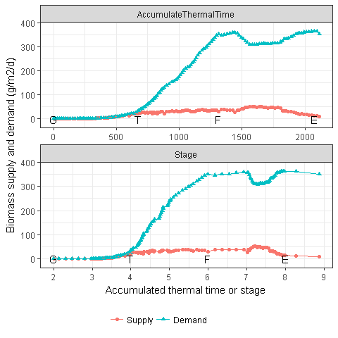

Figure 43 Daily biomass supply and storage demand for all organs

The actual allocated biomass for each organ depends on the daily supply, relative structural and metabolic demand, and storage demands among all organs (Fig. 44, 45 and 46).

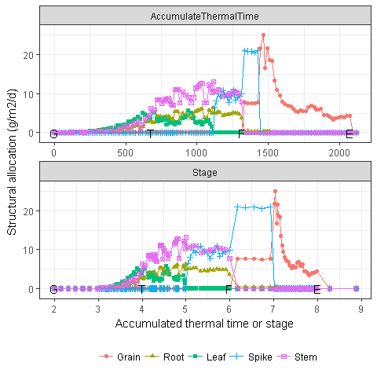

Figure 44 Biomass structural allocation from all organs

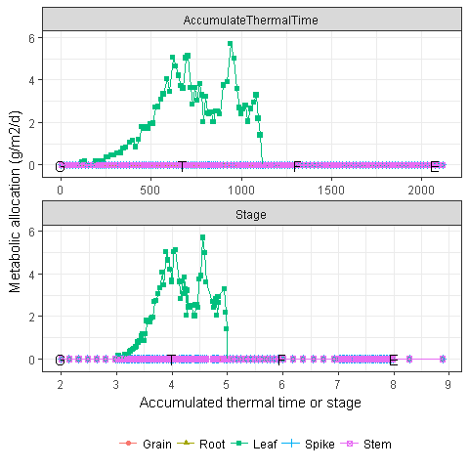

Figure 45 Biomass metabolic allocation from all organs

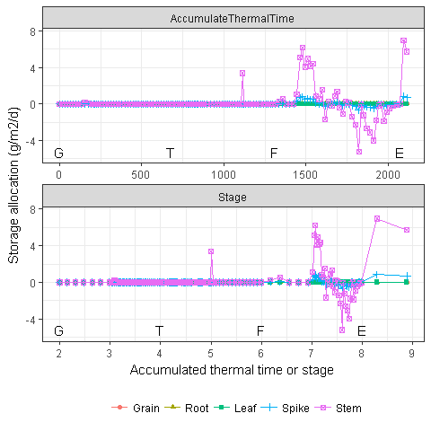

Figure 46 Biomass storage allocation from all organs

The daily biomass supply (Fig. 25) are consumed as growth respiration before partitioning into Live pool in each organ, and consumed as daily maintenance respiration from Live pool in each organ (Fig. 47).

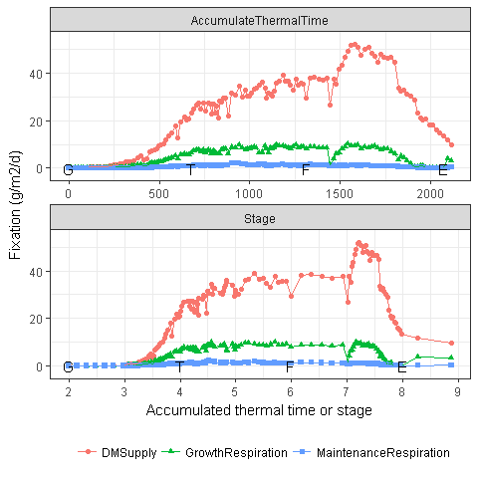

Figure 47 Daily biomass supply and respiration.

## Biomass pool

All organs have the Live pool, but only Leaf has the Dead pool (Table 7).

Table 7 The live and dead groups of biomass in all organs. X and - indicate the organ has and has not the group, respectively.

|  |  |  |
| --- | --- | --- |
| Organ | Live | Dead |
| Grain | X | - |
| Root | X | - |
| Leaf | X | X |
| Spike | X | - |
| Stem | X | - |

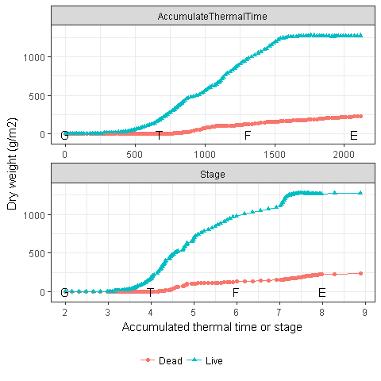

Figure 48 Dry weight of Live and Dead pools

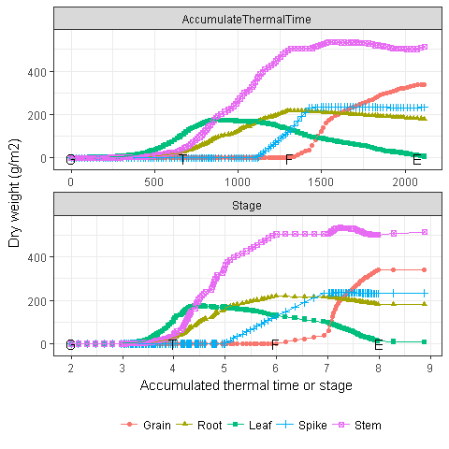

Figure 49 Dry weight of Live pool for all organs

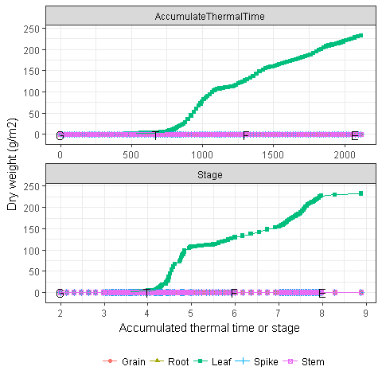

Figure 50 Dry weight of Dead pool for all organs

# Nitrogen

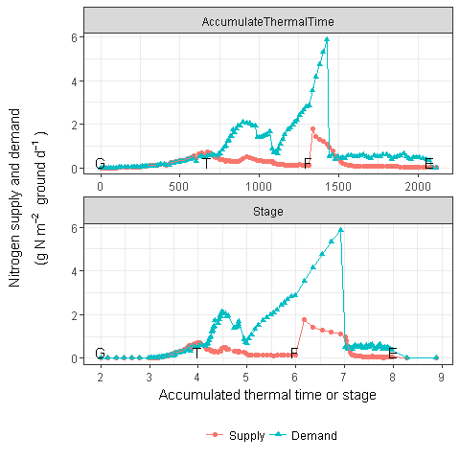

Figure 51 The plant total nitrogen demand and supply

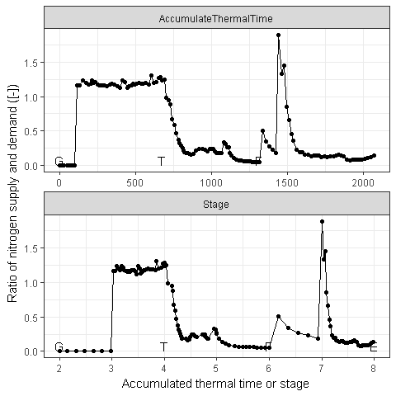

Figure 52 The fraction of nitrogen supply relative to nitrogen demand

## Demand

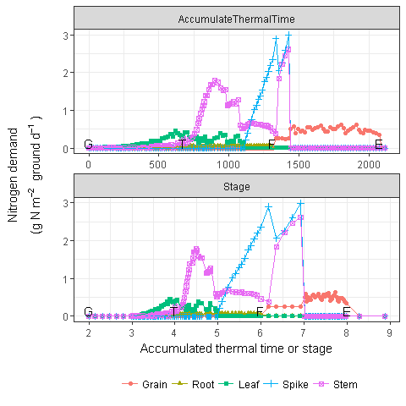

Figure 53 The plant nitrogen demand for all organs

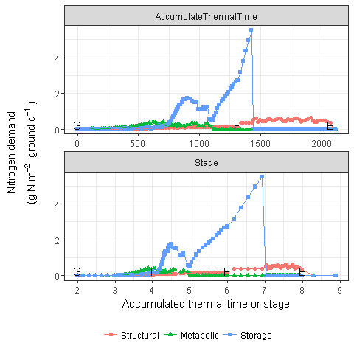

Figure 54 The plant nitrogen demand for all components

## Supply

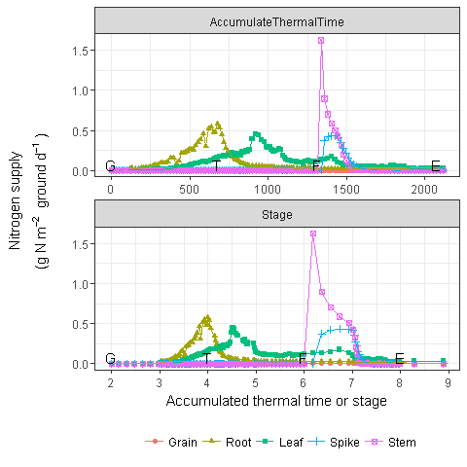

Figure 55 The plant nitrogen supply for all organs

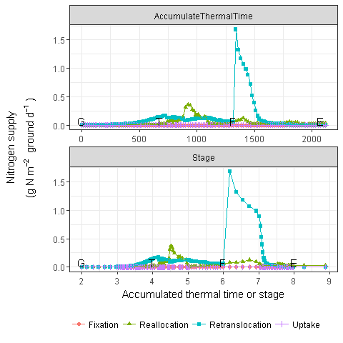

Figure 56 The plant nitrogen supply for all components

## Nitrogen uptake

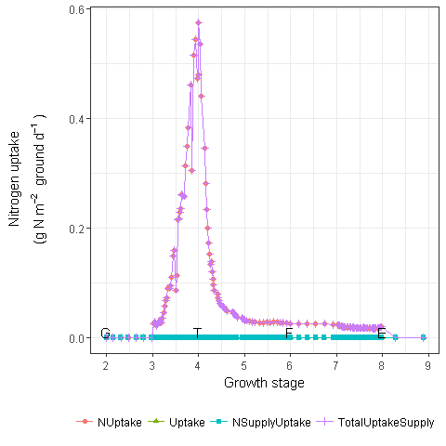

Figure 57 The plant nitrogen uptake

## Nitrogen dynamic

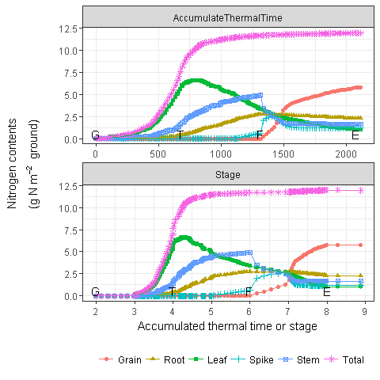

Figure 58 The plant nitrogen uptake

# Water

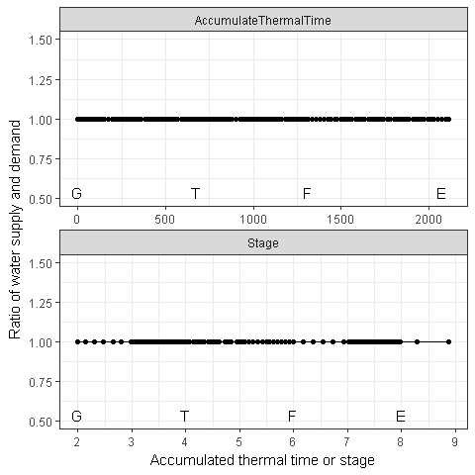

Figure 59 Coverage

## Uptake

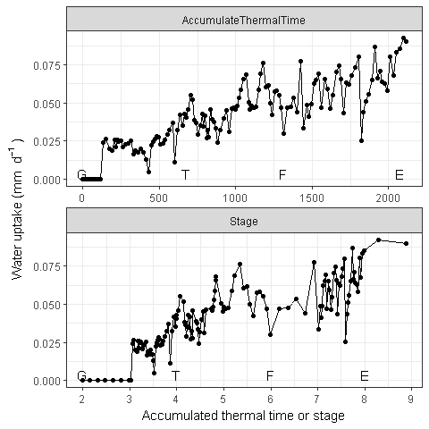

Figure 60 water uptake

# Grain

Grain is only the grain part of head.

## Grain number

Grain number is correlated with stem [ref] and/or spike (Slafer, Andrade, and Satorre 1990; González, Slafer, and Miralles 2005) dry weight at anthesis.

The number of grains per plant () is determined by the Stem and Spike total biomass at Flowering (including Live and Dead).

where and are the stem and spkie total biomass at flowering, respectively. R_{g} is the grain number per gram stem and spike, with default value at 22 grain g-1.

## Supply

No biomass supply is considered in the Grain organ (Fig. 61).

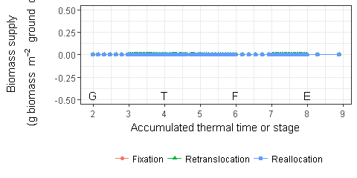

Figure 61 Biomass supply from grain

## Demand

The grain demand is seperated into two periods (i.e. from Flowering to StartGrainFill and from StartGrainFill to EndGrainFill).

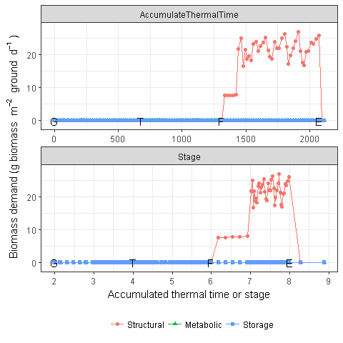

Figure 62 Biomass demand by grain

## Biomass dynamic

Grain only considers the Live conponent, No Dead component.

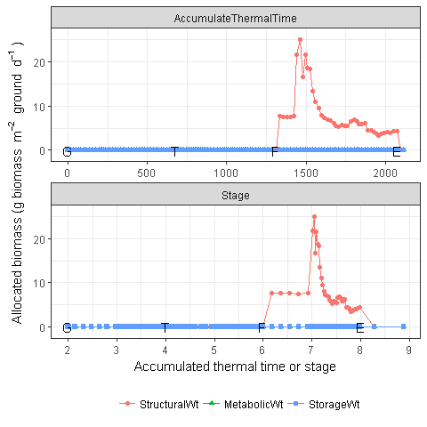

Figure 63 Actual allocated biomass for grain

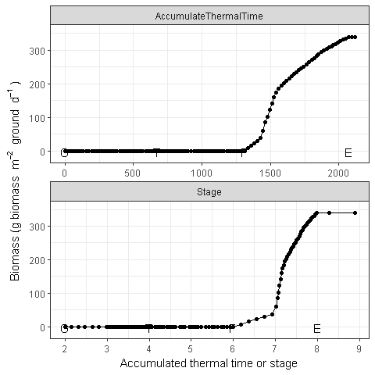

Figure 64 Dynamic of grain biomass (Total)

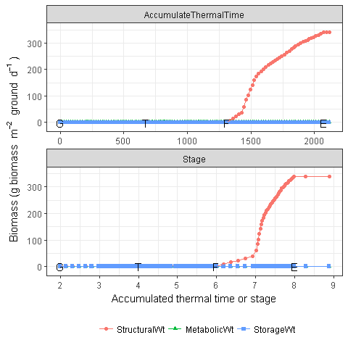

Figure 65 Dynamic of grain biomass (Live component)

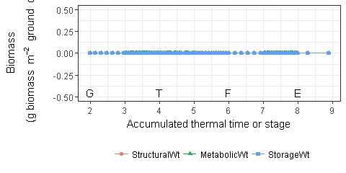

Figure 66 Dynamic of grain biomass (Dead component)

### Yield

The total grain weight at harvest can be considered as the final yield without moisture content in the grain. The normal range of moisture content in the grain is 10-15% with 12% as standard

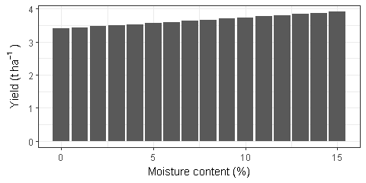

Figure 67 Final yield with different moisture content.

# Root

Only Structural is considered in the three components of biomass for Root. The biomass allocation depending on the fraction of daily fixation (i.e. photosynthesis).

## Root Growth

### Root depth

Roots grow downwards through the soil profile, with initial depth determined by sowing depth and the growth rate determined by RootFrontVelocity, which is determined by potential root front velocity (5 mm/d for pre emergencee, and 20 mm/d for post-emergence, Fig. 68), and mofified (multification) by temperature (Fig. 69) and water stress (Fig. 71).

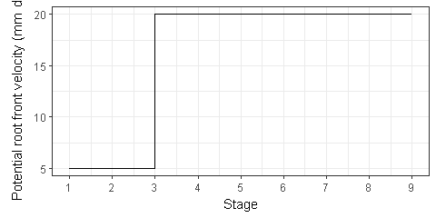

Figure 68 The potential root front velocity.

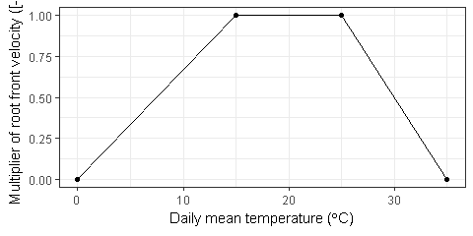

Figure 69 The temperature stress on root front velocity.

Soil water scale is A simple scale to convert soil water content into a value between 0 and 2 (i.e. from 0 to 1 when is between and and from 1 to 2 when is between and , (Fig. 70)).

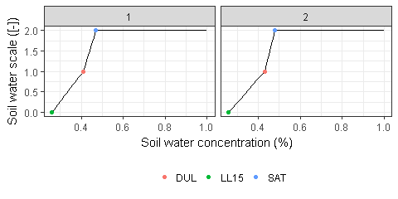

Figure 70 Response of soil water scale on soil water concentration in the top two layers of soil in the tested simulations.

The multiplier of water stress on root front velocity depends on soil water scale which suppresses root growth when water scale is less than 0.25 (Fig. 71).

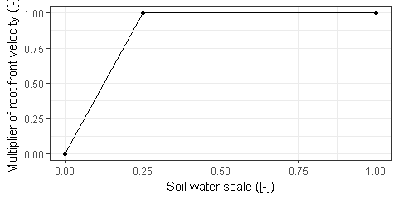

Figure 71 Soil water stress on root front velocity

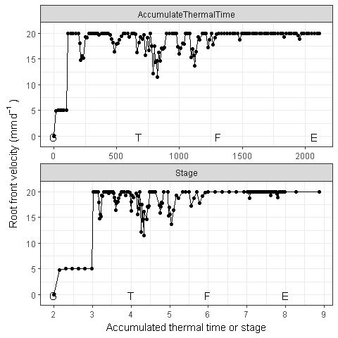

Figure 72 Root front velocity.

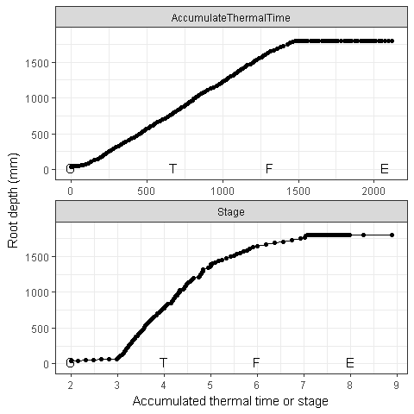

Figure 73 Root depth

### Root length

Root length growth is calculated using the daily dry biomass partitioned to roots and a specific root length (105 m g-1 in default). Root proliferation in layers is calculated using an approach similar to the generalised equimarginal criterion used in economics. The uptake of water and N per unit root length is used to partition new root material into layers of higher 'return on investment'.

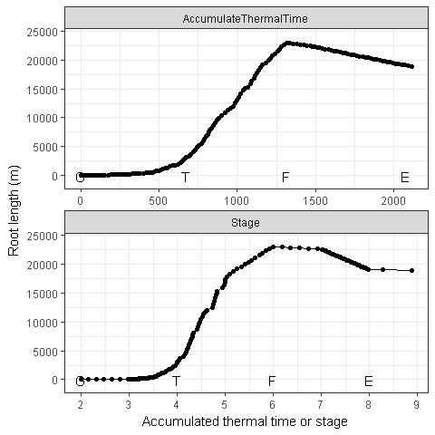

Figure 74 Total root length

## Supply

No biomass supply is considered in the Root organ (Fig. 75).

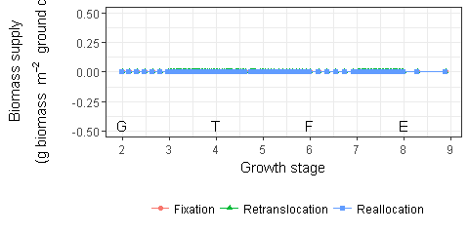

Figure 75 Biomass supply from root

## Demand

The daily biomass demand of Root is calculated as a fraction of daily fixation (i.e. photosynthesis) from Stage 3 (Emergence) to Stage 8 (End of grain filling). The fraction of root demand is 0.2 until Flowering time, then reduces into 0.02 until End of grain filling (Fig. 76). Only structural demand is considered in the Root organ (Fig. 77).

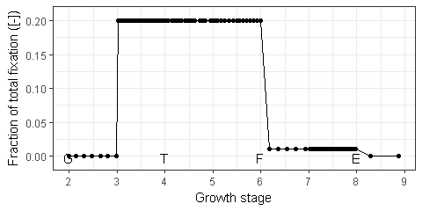

Figure 76 Fraction of root demand in the total fixation.

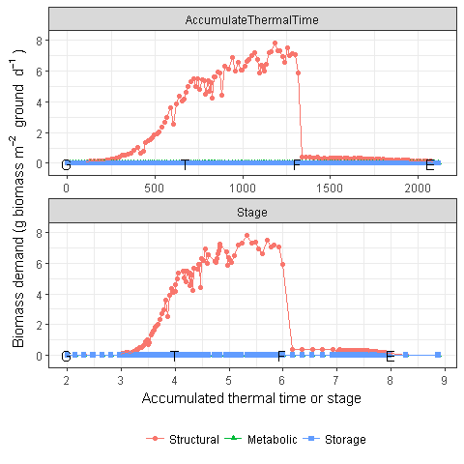

Figure 77 Biomass demand by root

## Biomass dynamic

The actual allocation (Fig. 78) is determined by the actual daily biomass supply (Fig. 25) which may be smaller than than biomass demand (Fig. 77).

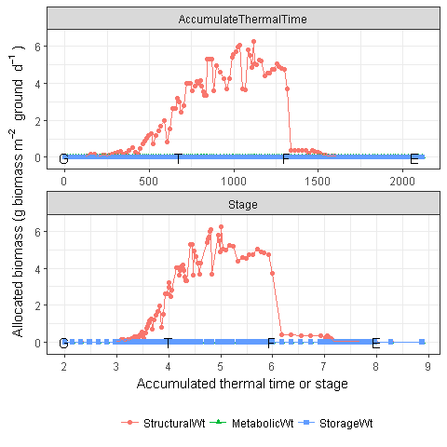

Figure 78 Actual allocated biomass for root

The daily loss of roots is calculated using a SenescenceRate function (0.005 in the default value). All senescence material is automatically detached and added to the soil fresh organic matter (FOM) pool.

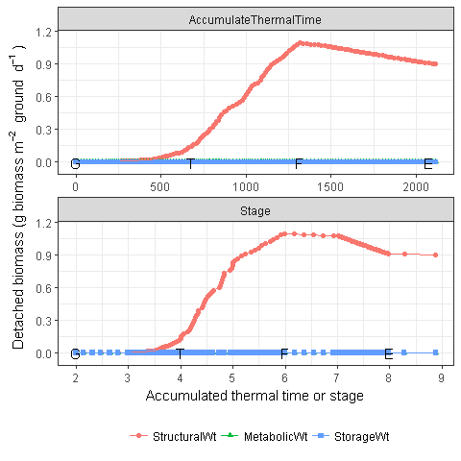

Figure 79 Detached biomass from root into soil organic.

Finally Root biomass increases until flowering time, then gradually decreases as the senescence is more than allocation (Fig. 80). All biomass is allocated into Live component (Fig. 81), as the senescence Root immediately is detached and contributed into soil FOM (Fig. 82).

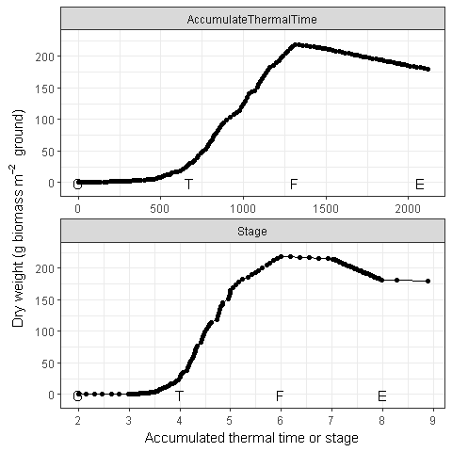

Figure 80 Dynamic of root biomass (Total)

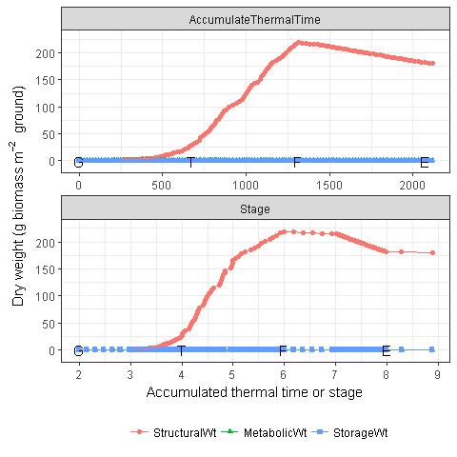

Figure 81 Dynamic of root biomass (Live component)

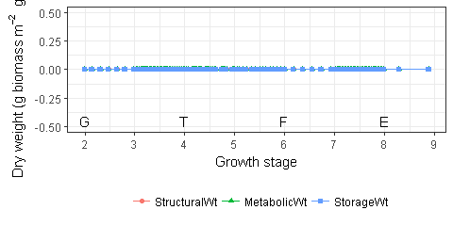

Figure 82 Dynamic of root biomass (Dead component)

# Leaf

The apex model is developed to simulate leaf dynamic based on leaf cohort model.

## Life growth cycle

The growth cycle of leaf cohort is divided into 7 stages and 6 periods from Initialized to Detached. The length of each period depends on the phylochron during Appearance from Initialized to Appeared (fixed by 2 initial leaves at Germination). Other periods are configured by CohortParameters at Appearance, so that parameter values are determined by the values of status variables at the day of leaf cohort Appearance if they depend on other variables.

Several status variables are defined for each leaf cohort, which can be used in other modules to describe the current status of leaf cohort, i.e. IsNotAppeared, IsGrowing, IsAlive, IsGreen, IsNotSenescing, Senescing, isFullyExpanded, ShouldBeDead, IsAppeared and IsInitialised.

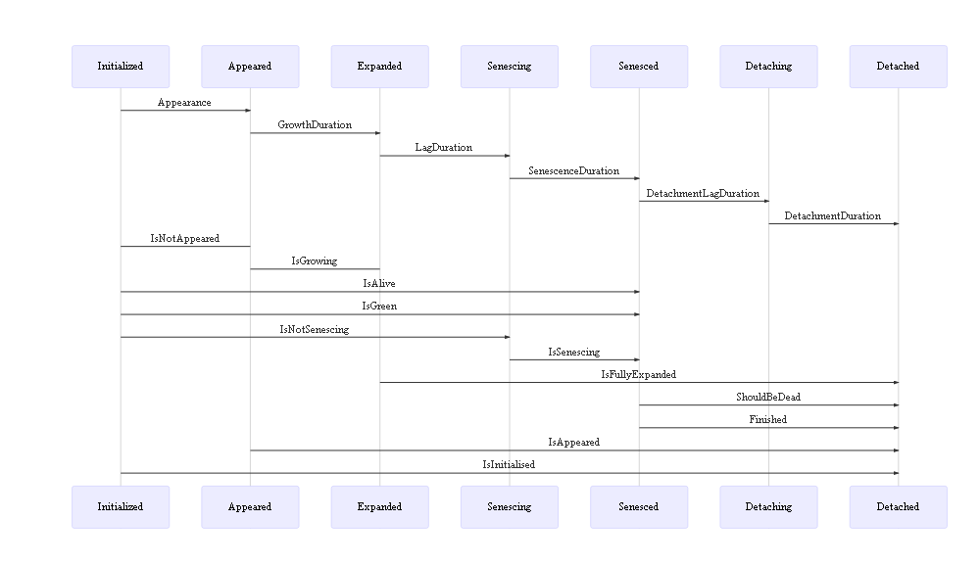

Figure 83 The life cycle of a leaf cohort.

### leaf age

The age of leaf cohort is defined as the thermal time after appearance, (i.e. keep zero after initialization). As the default values of DetachmentLagDuration and DetachmentDuration are set as 1000000 °Cd, the cohort age keeps increasing until growth stage ReadyForHarvesting. The age of first leaf cohort starts from 200 °Cd.

### Leaf initialization and appearance

At Germination, 2 new leaf cohorts are initialized with initial leaf area 200, 0 mm2. The inital leaf area simulates seed biomass or embryo size.

At Emergence stage, 1 leaf cohort is appeared at the main stem, and 1 new leaf cohort is initialized.

After Emergence and before plant reaches the final leaf number (i.e. all leaves are initialized and appeared), a new leaf cohort initialises and an existing leaf cohot appears when increases of potential appearance of tip number are more than 1 (Figure 8). Consequently, the rates of leaf initialization and appearance are same, except initialized tip number is more than 2 of appeared tip number (Fig. 84).

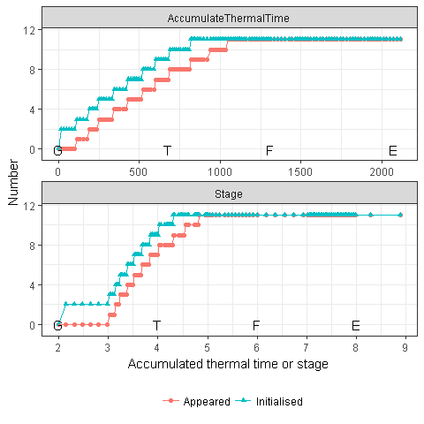

Figure 84 The initialized and appeared leaf cohort number in the main stem

### Leaf growth and senescing

**Growth (expansion) duration**

Leaf expansion of cohort starts from appearance of leaf tip , i.e. the expansion of leaf cohort in the sheath is ignored which does not contribute to green leaf or leaf area index. The growth duration of spring wheat is close to one phylochron as the synchronization of leaf blade and sheath (Skinner and Nelson 1995). The growth duration is set as 1.3 phyllochron in default. The growth duration is adjusted for fraction of flag leaf (Fig. 11) to simulate the variation of final leaf number in a population.

**Lag duration**

Lag duration (full functional duration) is defined as 4 phyllochrons for leaf appeared during vegetative period (from Emergence to TerminalSpikelet) and adjusted by leaf age. For leaf cohort appeared during stem elongation period (from TerminalSpikelet to FlagLeaf), the lag duration equals to total length from stage FlagLeaf to stage EndGrainFill minus 3 phyllochron (senescence duration), i.e. flag leaf is completely death at the stage EndGrainFill.

**Senescene duration**

Senescence duration is defined as 3 phyllochrons in default.

As the variation of phyllochron (Fig. 6), the growth, lag and senescence durations also change by cohort rank (Fig. 85). The growth duration of flag leaf is shorter than secondary leaf as the fraction of flag leaf.

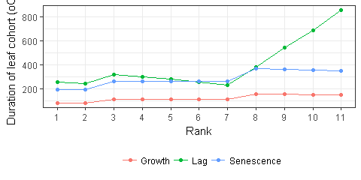

Figure 85 Senescene duration of leaf cohort which is determined at appearance of leaf cohort. The black dots indicate the appearances of leaf cohorts

Figures 86 and 87 shows the number of leaf cohorts changing status including expanding and senescing and at certain status including expanded, green, and dead, respectively.

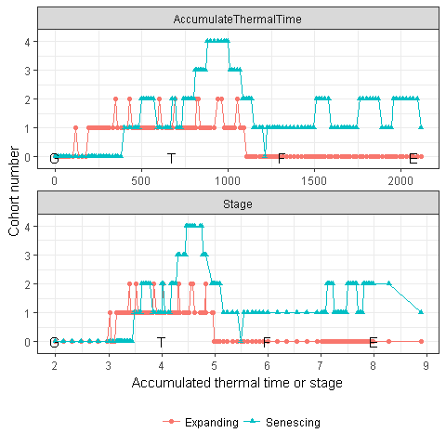

Figure 86 The number of leaf cohort with certain status including expanding and senescing

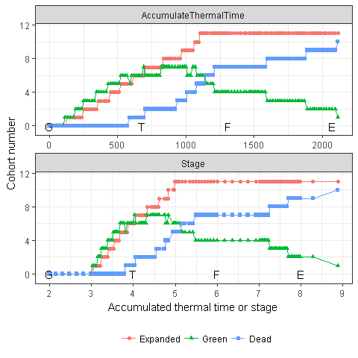

Figure 87 The number of leaf cohort with certain status including expanded, green, dead

### Detachment lag and detachment durations

Detachment lag and detachment durations for leaf cohort are set as a big value 1000000 which assumes no detachment in wheat leaf. Actually all leaves are detached at Harvesting event.

## Leaf area

During the growth (expanding) duration of each cohort (Fig. 86), the daily increase of leaf area is detemined by the minimum increases by water () and carbon () constrained leaf area.

### Maximum (potential) leaf area

The maximum leaf area of each leaf cohort is determined by potential maximum leaf area and reduced by cell division stress from Initialization to Appearance.

The potential maximum leaf areas by rank are specified by two parameters the maximum leaf area in all leaves (AreaLargestLeaves with default value 2600 mm2) and an age factor (Fig. 88). The age factor is assumed leaf areas are linearly increasing from stage Emergence to TerminalSpikelet, and all leaves appeared after stage TerminalSpikelet have the same maximum leaf area (Fig. 89).

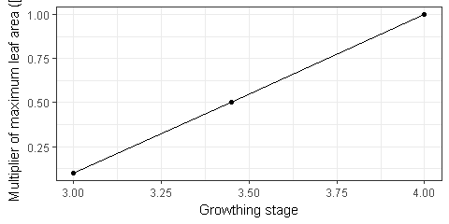

Figure 88 Multiplier of maximum leaf area as a function of growthing stage

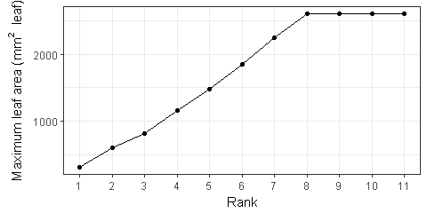

Figure 89 Maximum leaf area by leaf rank

The stress factor of cell division is the minimum multipliers of water stress and nitrogen stresses (Fig. 90). Multipliers of water stress (Fig. 91) is a function of water supply and demand ratio (Fig. 59). Multipliers of nitrogen stress (Fig. 92) is a function of ratio of functional nitrogen (Fig. 116).

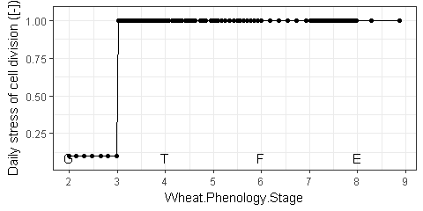

Figure 90 Daily stress of cell division

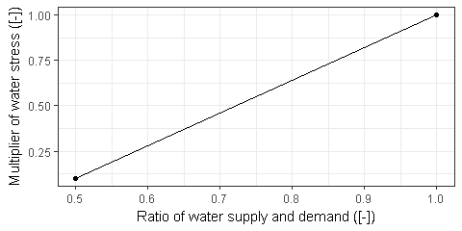

Figure 91 Multiplier of water stress on cell division

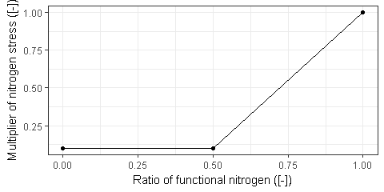

Figure 92 Multiplier of nitrogen stress on cell division

Stress of cell division is averaged by cell division stress factors from Initialization to Appearance, then reduces the potential maximum leaf area (Fig. 93). The actual maximum leaf area of flag leaf can be much smaller than other leaves as the fraction of final leaf to simulate the variation of final leaf number in a population (Fig. 11).

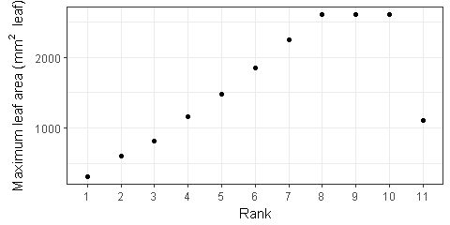

Figure 93 Actual maximum area of leaf cohorts by leaf rank.

### Potential expansion of leaf cohort

The potential leaf area is increased following a logistic equation as a function of thermal time after leaf appearance. The shape of logistic equation is determiend by parameter LeafSizeShapeParameter with default value 0.3 (Fig. 94). The daily potential increase of leaf area is the difference of size function in today and previous (e.g. the height of red area in Fig. 94).

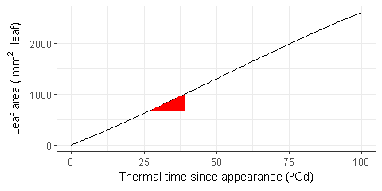

Figure 94 The size function of leaf area development. The maximum leaf area sets as 2600 mm2

### Water constrained leaf area

The water constrained leaf area equals to the daily potential increase of leaf area which reduced by ExpansionStress (Fig. 95) which is a minimum value among temperature, water and nitrogen stresses (Fig. 96). Temperature stress is related with daily mean temperature; water stress is related with water tension factor in root; nitrogen stress related with fraction of functional nitrogen in leaf (Fig. 116).

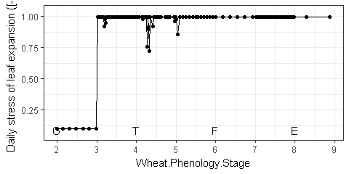

Figure 95 Daily stress of leaf expansion

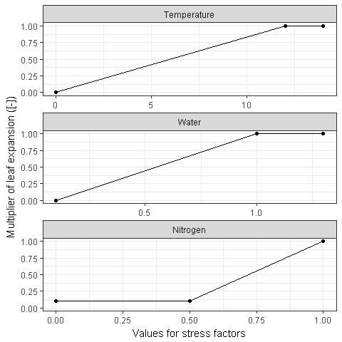

Figure 96 Multiplier of temperature stress on leaf expansion. Temperature stress is related with daily mean temperature. Water stress is related with water tension factor in root. Nitrogen stress is related with ratio of functional nitrogen.

### Carbon constrained leaf area

The leaf area also constrained by the daily allocated cardon (biomass) including structural and metabolic in the leaf cohort [ref], then multiplies maximum specific leaf area for the biggest expansion (Fig. 101).

**The actual daily increase of leaf area is the minimum of water and carbon constrained leaf area.**

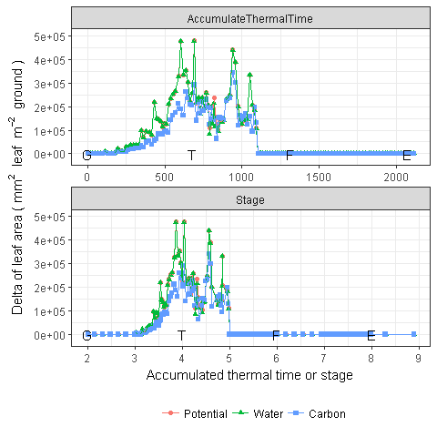

Figure 97 Daily increase of leaf area

### Leaf senescence

During the period of leaf senescene, the daily fraction of leaf senescence is linearly related with thermal time.

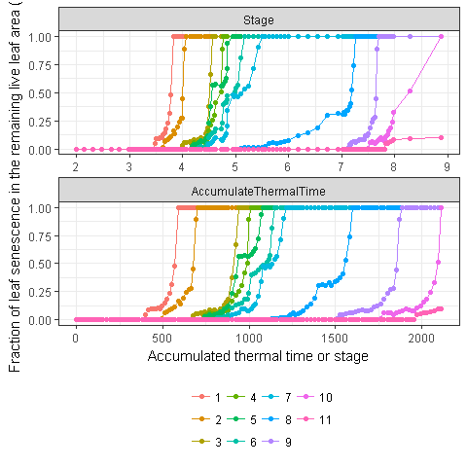

Figure 98 Fraction of leaf senescence by leaf cohort in the remaining live leaf area.

### Leaf area index

Leaf area index (LAI) are calculated for green leaf (), dead leaf (), and total leaf () (Fig. 99).

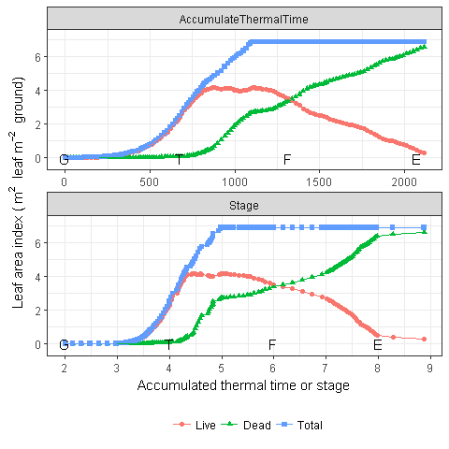

Figure 99 Leaf area index

### Ground coverage

Ground coverage also are calculated for green leaf (), dead leaf (), and total leaf () from LAI and extinction coefficient for green leaf () and dead leaf ().

As the default value of maximum coverage () is 1, the function is reduced to

The similar equation is used for dead coverage.

Total coverage () is calculated from coverage of green and dead leaves.

The extinction coefficient for dead leaf () is defined as 0.3. The extinction coefficient for green leaf () is calculated by parameter ExtinctionCoeff with default value 0.5.

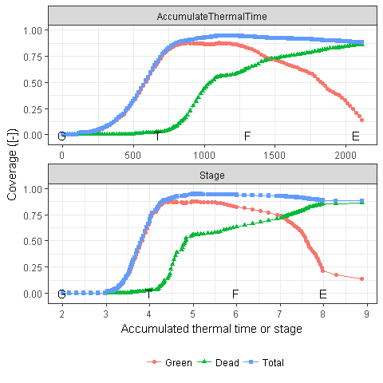

Figure 100 Coverage

### Specific leaf area

The minimum and maximum specific leaf areas are defined in the CohortParameters (Fig. 101), which related with fraction of functional nitrogen (Fig. 116) and stage, respectively.

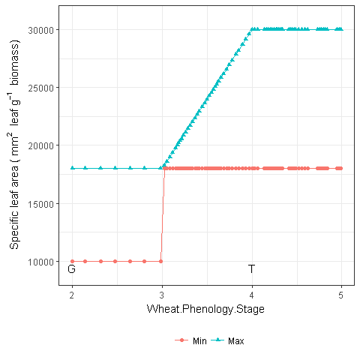

Figure 101 Maximum and minimum specific leaf area.

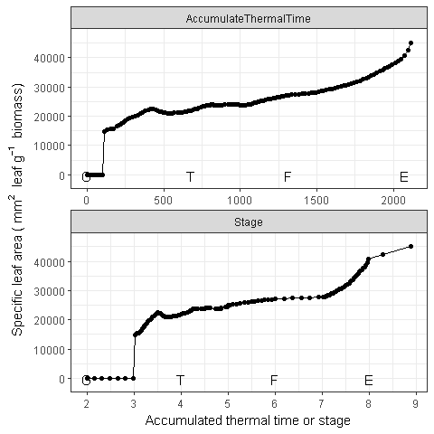

Figure 102 Specific leaf area

## Supply

In Leaf organ, the biomass supply only sources from Fixation (i.e. photosynthesis, Fig. 109). Three photosynthesis models are implemented in the APSIM next generation.

### Radiation use efficiency model

The radiation-limited dry-biomass accumulation () is calculated by the intercepted radiation (), radiation use efficiency ().

#### Radiation interception

Radiation interception is calculated from the leaf area index (LAI, m m) and the extinction coefficient () (Monsi and Saeki 2005).

where is the total radiation at the top of the canopy (MJ) which is directly imported from weather records. Extinction coefficient () set as a constant value 0.5.

#### Actual radiation use efficiency

The actual (g MJ) is calculated as the potential () and several reduction factors, including plant nutrition (), air temperature(), vapour pressure deficit (), water supply () and atmospheric CO2 concentration ().

**The potential RUE ()** has a default value 1.8.

**The temperature factor ()** is calculated as a function of average daily temperature weighted toward maximum temperature according to the specified MaximumTemperatureWeighting factor () with default value 0.75, 0.75.

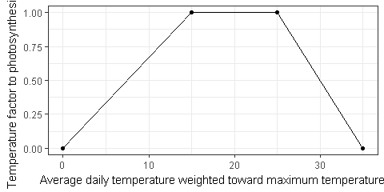

Figure 103 The temperature factor which influences radiation use efficiency

**The plant nutrition factor** is determined by the ratio of functional nitrogen in leaf (Fig. 116) and the multiplier of nitrogen stress (Fig. 104).

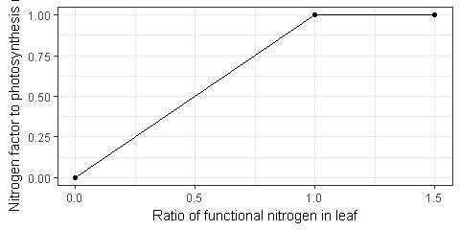

Figure 104 The nitrogen factor which influences radiation use efficiency

**Water stress factor**

quantifies water stress and is calculated as Leaf.Transpiration/Leaf.WaterDemand, where Leaf.Transpiration is the minimum of Leaf.WaterDemand and Root.WaterUptake

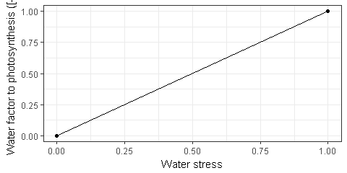

Figure 105 The water factor which influences radiation use efficiency

**CO factor** is calculated by a function of environmental CO concentration (, ppm; > 350 ppm) and daily mean temperature ( < 50°C) as published by Reyenga et al. (1999)

where is the temperature dependent CO compensation point (ppm) and is derived from the following function.

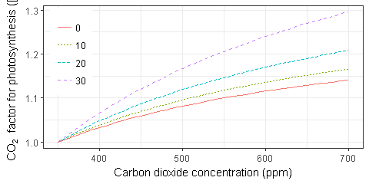

Figure 106 CO factor in response to the CO level for different mean air temperatures.

### SPASS

### Layered Canopy Photosynthesis Model with Transpiration (or DCaPS)

### Comporison of three photosynthesis models

The daily photosynthesis is calculated by SPASS's model, but is exported for all three models to compare model performance. So the input parameters are the same for three models, e.g. leaf area index, temperature and radiation.

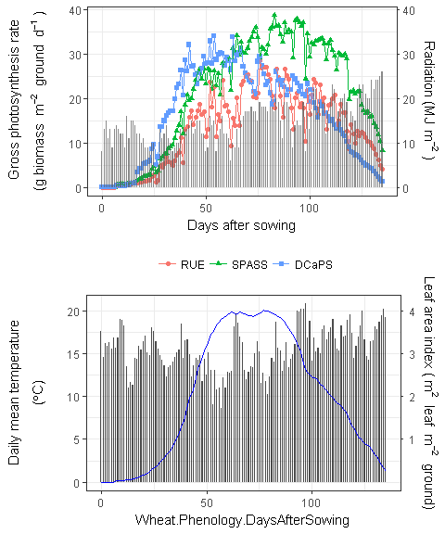

Figure 107 Comparision of biomass supply from leaf using three photosynthesis models. The biomass supplies are directly exported from three models using the same inputs (e.g. leaf area index, radiation, temperature). The actual biomass supply is simuated by SPASS in the model.

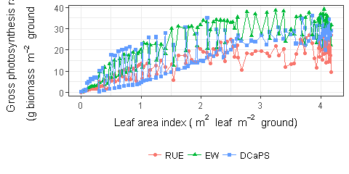

Figure 108 Biomass supply of leaf using three photosynthesis models.

### Actual photosynthesis supply

The actual gross photosynthesis supply is simulated by SPASS model.

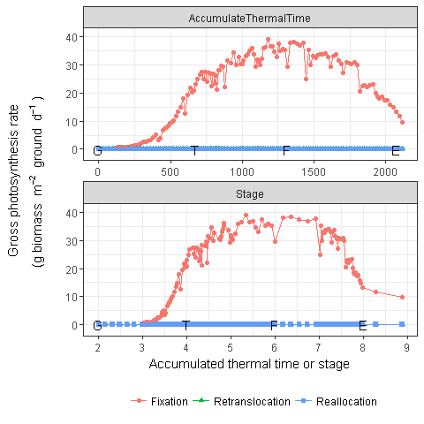

Figure 109 Biomass supply from leaf

## Demand

The leaf demand is summarised for all leaf cohorts in the expanding period (Figs 83 and 86), so that there is no leaf demand after FlagLeaf. No Storage demand is considered in the leaf organ. As the structural fraction is defined as 0.5, the structural and metabolic demands have the same values in the whole life cycle.

The daily demand () is the minimum between potential leaf area (, Section 10.2.2) and water stressed (, Section 10.2.3) leaf area.

where, and are the minimum and maximum specific leaf areas, respectively (Fig. 101).

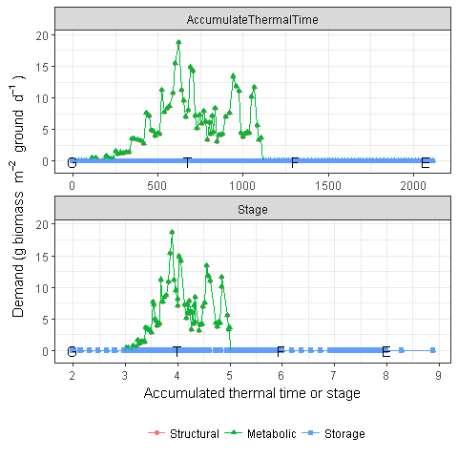

Figure 110 Biomass demand by leaf. The structural and metabolic demands overlap each other as the structural fraction is defined as 0.5.

## Biomass dynamic

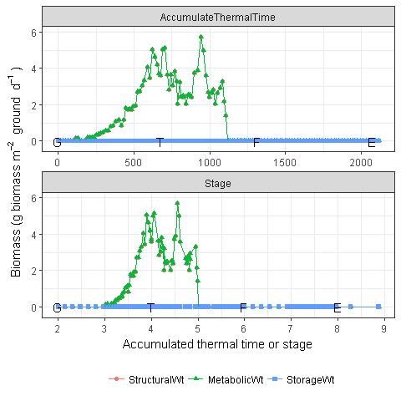

Figure 111 Actual allocated biomass for leaf. The structural and metabolic weights overlap each other as the structural fraction is defined as 0.5.

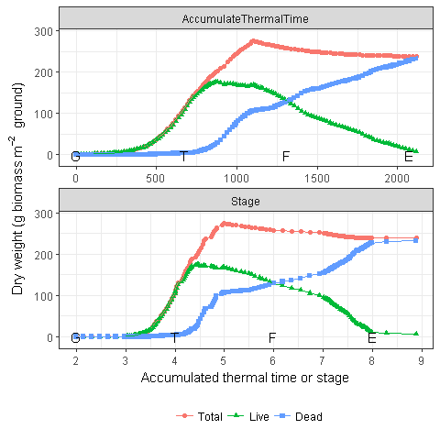

Figure 112 Dynamic of leaf biomass (Total)

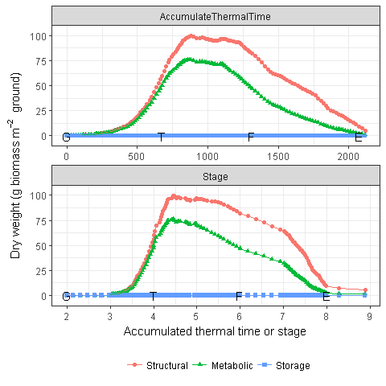

Figure 113 Dynamic of leaf biomass (Live component).

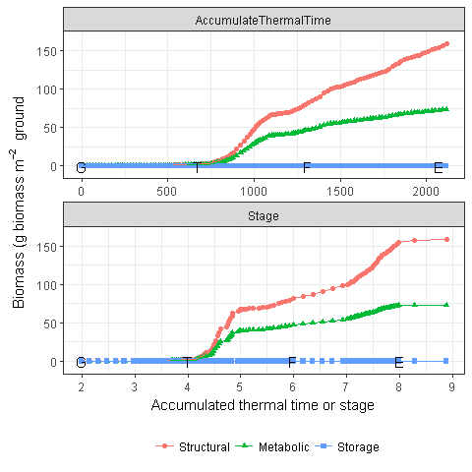

Figure 114 Dynamic of leaf biomass (Dead component).

## Nitrogen

### Functional nitrogen

Ratio of leaf functional nitrogen () quantifys the nitrogen stress status of the plant and represents the concentration of metabolic N relative the maximum potentil metabolic N content of the leaf.

where is the nitrogen concentration of Leaf parts; is multiplier for nitrogen deficit effect on phenology which is specified by N_fact_photo in the wheat.xml and default value is 1.5.

double functionalNConc = (CohortParameters.CriticalNConc.Value() - CohortParameters.MinimumNConc.Value() * CohortParameters.StructuralFraction.Value()) * (1 / (1 - CohortParameters.StructuralFraction.Value()));

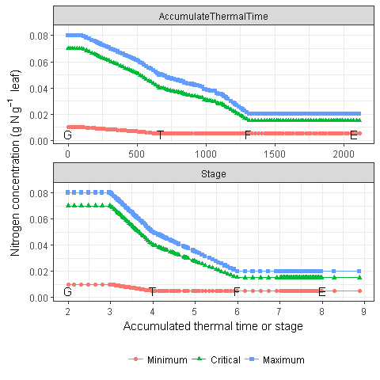

Figure 115 Minimum, critical and maximum nitrogen concentration in leaf.

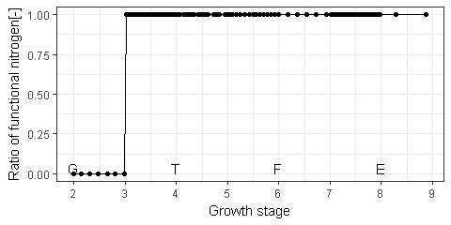

Figure 116 Ratio of functional nitrogen

### Nitrogen demand

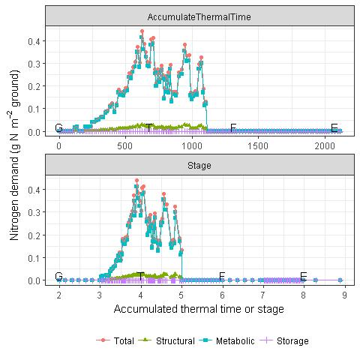

Figure 117 Nitrogen demand of leaf.

### Nitrogen amount

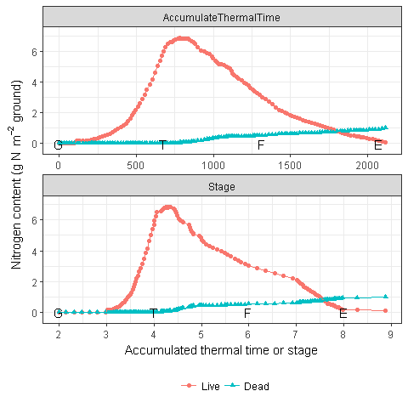

Figure 118 Nitrogen contents in live and dead pools of leaf.

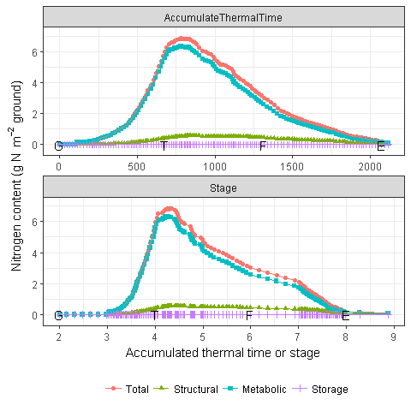

Figure 119 Nitrogen contents of three components in live pool of leaf.

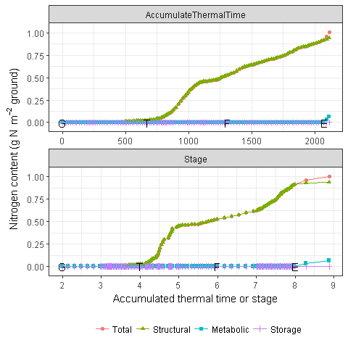

Figure 120 Nitrogen contents of three components in dead pool of leaf.

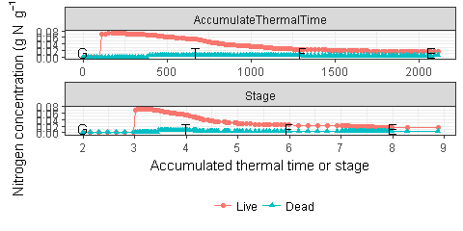

Figure 121 Nitrogen concentration in live and dead pools of leaf.

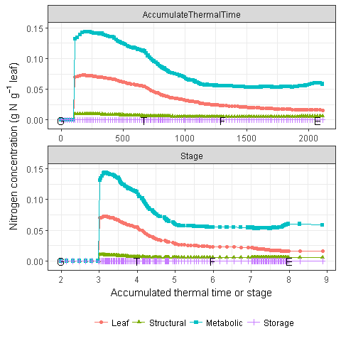

Figure 122 Nitrogen concentration of three components in live pool of leaf.

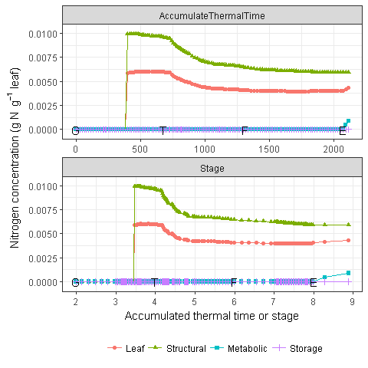

Figure 123 Nitrogen concentration of three components in dead pool of leaf.

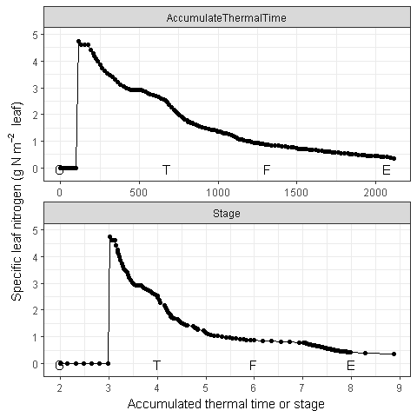

Figure 124 Specific leaf nitrogen

# Spike

Spike provides biomass through retranslocation, requires biomass depending on the population and potential spike weight. The biomass is allocated into two components, i..e Structural and Storage. No Metabolic is considered.

## Supply

In Spike, the biomass supply only sources from retranslocation (Fig. 126). Daily retranslocation is the proportion of current storage (). The default value of proportion is 0.5 since StartGrainFill, i.e. retranslocatable biomsss is 50% during grain filling (Fig. 125).

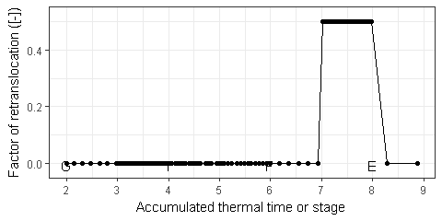

Figure 125 Growth duration of spike development

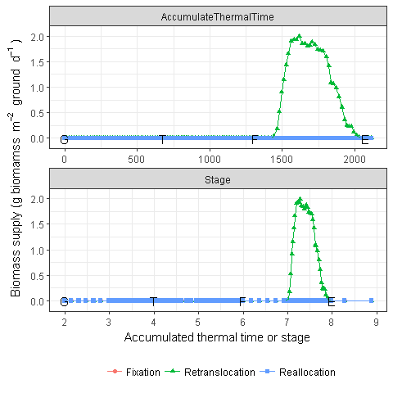

Figure 126 Biomass supply from spike

## Demand

The Structural demand of Spike () is determined by the population based demand function since Stage 5 (FlagLeaf) to Stage 7 (StartGrainFill). The structural demand includes the growth respiration.

where is the daily thermal time in the phenology module (Fig. 2); is the head number per unit area, i.e. total stem population at flowering time (Fig. 21); is the potential weight per spike (g) with default value 0.5; is the growth duration of spike (, the thermal time target from FlagLeaf to StartGrainFill). As the target of EarlyReproductive is sensitive to photoperiod (Section 3.2), the growth duration can be changed during spike development depending on the photoperiod (Fig. 128). The head number, growth duration and potential spike weight are defined as potential spike weight including the structural and storage conponents and the growth respiration.

is the structura fraction of Spike with default value e get_fixed_value(g_pmf, 'Wheat.Spike.StructuralFraction'). is the conversion efficiency of Spike, i.e. the efficiency of alloction biomass converted into carbon (growth respiration). has the default value 0.7067 and is counted befor allocation.

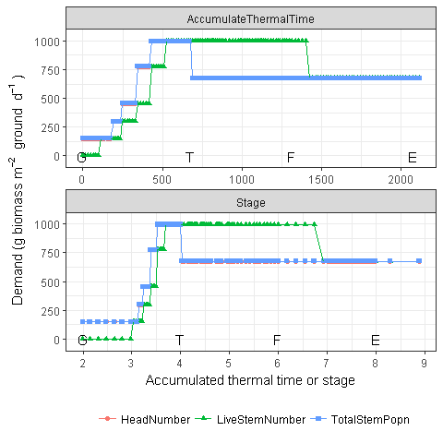

Figure 127 Head number

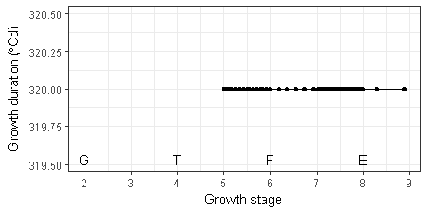

Figure 128 Growth duration of spike development

Storage demand is to fill the non-structural components (i.e. storage for Spike). Current structural biomass and structural demand are used to calculate the potential total biomass of Spike (structural plus storage). The difference of potental total biomas and current biomass are the storage demand. Storage demand also include the growth respiration.

No metabolic demand is calculated for Spike.

The figure below shows the demands of Spike in the test simulation (Fig. @(fig:spike-demand)).

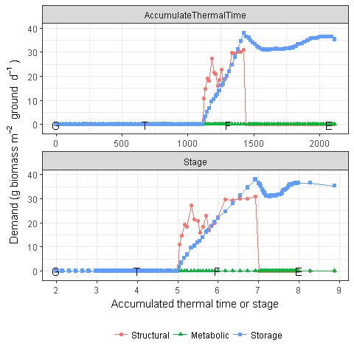

Figure 129 Biomass demand by spike

## Biomass dynamic

The actual allocation reflects the increase of structural component, and retranslocation of storage component (Fig. 130). Spike only considers the Live biomass (Fig. 132, no Dead biomass (Fig. 133).

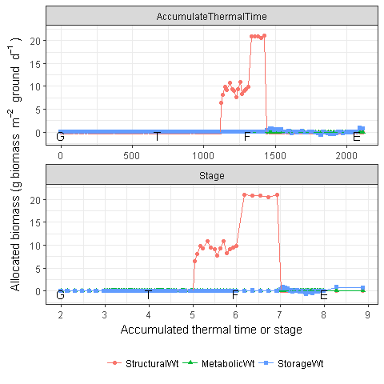

Figure 130 Actual allocated biomass for spike

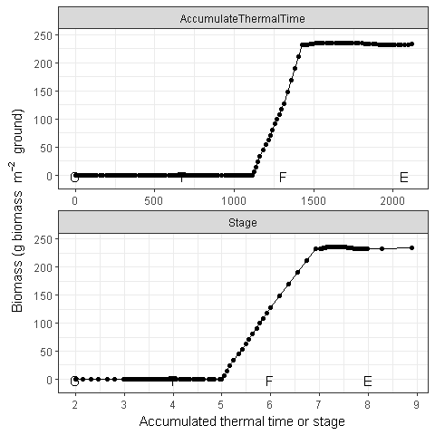

Figure 131 Dynamic of spike biomass (Total)

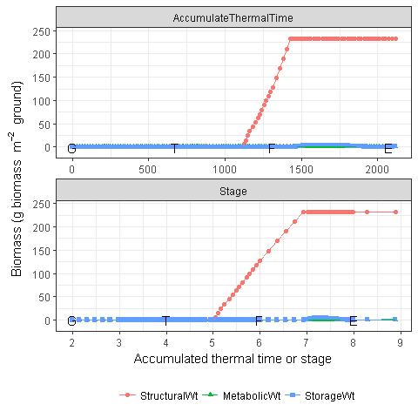

Figure 132 Dynamic of spike biomass (Live component)

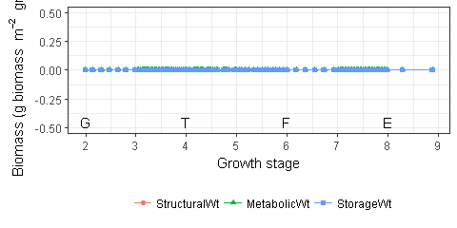

Figure 133 Dynamic of spike biomass (Dead component)

# Stem

Stem provides biomass through retranslocation, requires biomass a proportion of daily fixation (i.e. photosynthesis in Leaf). The biomass is allocated into two components, i..e Structural and Storage. No Metabolic is considered.

## Biomass

### Supply

In Stem, the biomass supply only sources from retranslocation (Fig. 135). Daily retranslocation is the proportion of current storage (). The default value of proportion is 0.5 since StartGrainFill, i.e. retranslocatable biomsss is 50% during grain filling (Fig. 134).

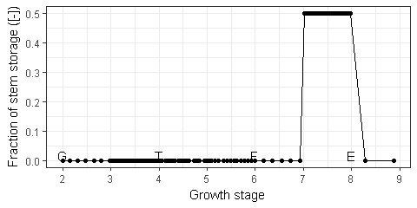

Figure 134 The fraction of stem storage which can be retranslocated in every day.

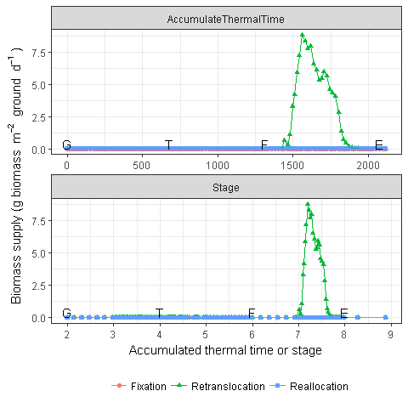

Figure 135 Daily biomass supply of stem.

### Demand

The daily biomass demand of Stem is calculated as a fraction of daily fixation (i.e. photosynthesis) from Stage 3 (Emergence) to Stage 6 (Flowering time) (Fig. 136) and increases at Stage 4 (Terminal spikelet) (Fig. 136). After Flowering time, no biomass allocated into stem (Fig. 137).

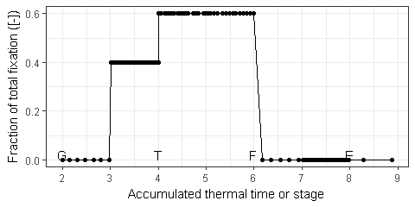

Figure 136 Stem demand as a fraction of daily total fixation (i.e. photosynthesis).

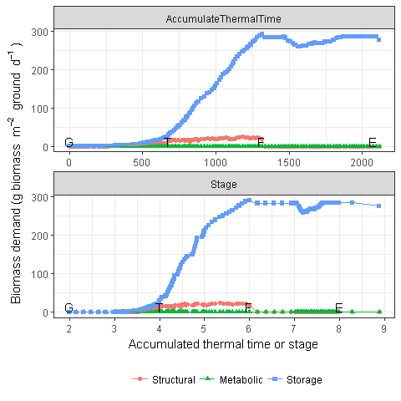

Figure 137 Daily biomass demand of stem for three components.

### Biomass dynamic

The actual allocation reflects the increase of structural component, and retranslocation of storage component (Fig. 138). Stem only considers the Live biomass (Fig. 140, no Dead biomass (Fig. 141).

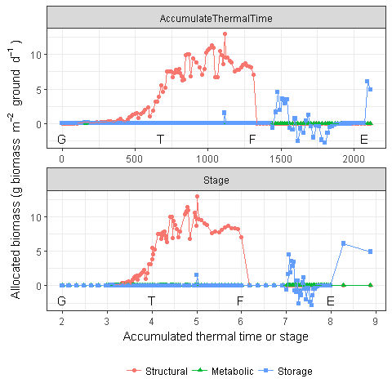

Figure 138 Actual allocated biomass to stem for three components. The negative values of Storage indicate biomass is ratranslocated into other organs.

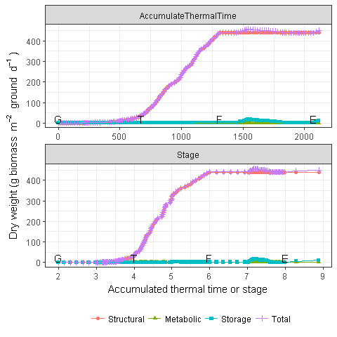

Figure 139 Dynamic of stem dry weights for three components and total.



Figure 140 Dynamic of stem biomass in Live pool for three components and total.

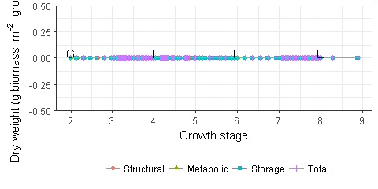

Figure 141 Dynamic of stem biomass in Dead pool for three components and total.

### Water soluble carbohydrate

Water soluble carbohydrates (WSC) are sugars such as fructans, sucrose, glucose and fructose which are accumulated in the stem as reserves.

In APSIM Next Gen, the WSC of stem is defined as the ratio of storage and total weights in the Live pool of stem.

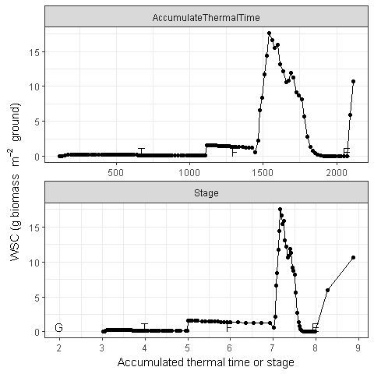

Figure 142 Water soluble carbohydrate in stem.

## Nitrogen

### Demand

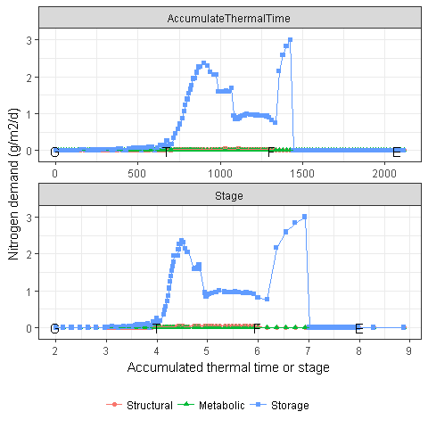

Figure 143 The stem nitrogen demand for all components

### Supply

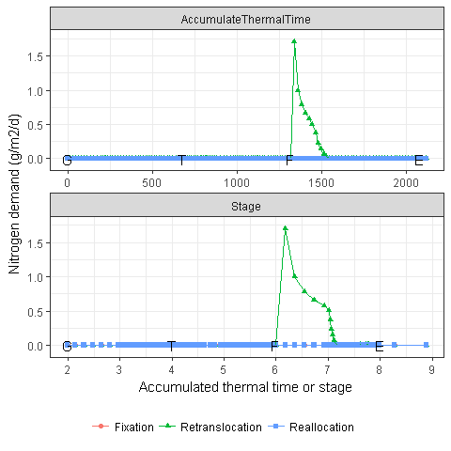

Figure 144 The stem nitrogen supply for all components

# Appendix

# Variable

The input and output variables are listed in this chapter and linked to the figures and tables.

Input

The input variables which are used in this documentation. The prefix of Wheat. is removed from all variables.

|  |  |
| --- | --- |
| Input | Reference |
| Grain.DMConversionEfficiency | Table 5 |
| Grain.MaintenanceRespirationFunction.MaintenanceFractionAt20C | Table 6 |
| Grain.MaintenanceRespirationFunction.WangEngelTempFunction | Table 6 |
| Leaf.CohortParameters.CellDivisionStress | Fig. 90 |
| Leaf.CohortParameters.CellDivisionStress.NitrogenStressEffect | Fig. 92 |
| Leaf.CohortParameters.CellDivisionStress.WaterStressEffect | Fig. 91 |
| Leaf.CohortParameters.ExpansionStress | Fig. 95 |
| Leaf.CohortParameters.ExpansionStress.NitrogenStressEffect | Fig. 96 |
| Leaf.CohortParameters.ExpansionStress.TemperatureEffect | Fig. 96 |
| Leaf.CohortParameters.ExpansionStress.WaterStressEffect | Fig. 96 |
| Leaf.CohortParameters.MaxArea.AgeFactor | Fig. 88 |
| Leaf.CohortParameters.SpecificLeafAreaMax | Fig. 101 |
| Leaf.CohortParameters.SpecificLeafAreaMin | Fig. 101 |
| Leaf.DMConversionEfficiency | Table 5 |
| Leaf.MaintenanceRespirationFunction.MaintenanceFractionAt20C | Table 6 |
| Leaf.MaintenanceRespirationFunction.WangEngelTempFunction | Table 6 |
| Leaf.Photosynthesis_RUE.FN | Fig. 104 |
| Leaf.Photosynthesis_RUE.FT | Fig. 103 |
| Leaf.Photosynthesis_RUE.FW | Fig. 105 |
| Root.DMConversionEfficiency | Table 5 |
| Root.MaintenanceRespirationFunction.MaintenanceFractionAt20C | Table 6 |
| Root.MaintenanceRespirationFunction.WangEngelTempFunction | Table 6 |
| Root.RootFrontVelocity.TemperatureFactor | Fig. 69 |
| Root.RootFrontVelocity.WaterFactor | Fig. 71 |
| Spike.DMConversionEfficiency | Table 5 |
| Spike.MaintenanceRespirationFunction.MaintenanceFractionAt20C | Table 6 |
| Spike.MaintenanceRespirationFunction.WangEngelTempFunction | Table 6 |
| Stem.DMConversionEfficiency | Table 5 |
| Stem.MaintenanceRespirationFunction.MaintenanceFractionAt20C | Table 6 |
| Stem.MaintenanceRespirationFunction.WangEngelTempFunction | Table 6 |
| Structure.BranchingRate.PotentialBranchingRate.Vegetative.PotentialBranchingRate | Fig. 13 |
| Structure.BranchingRate.StressFactors.CoverEffect | Fig. 14 |
| Structure.BranchingRate.StressFactors.NitrogenEffect | Fig. 14 |
| Structure.BranchingRate.StressFactors.WaterStressEffect | Fig. 14 |
| Structure.BranchMortality.MortalityPhase.Mortality.MortalityPerDegDay | Fig. 17 |
| Structure.HeightModel.PotentialHeight | Fig. 22 |
| Structure.HeightModel.WaterStress | Fig. 23 |
| Structure.Phyllochron.LeafStageFactor | Fig. 4 |
| Structure.Phyllochron.PhotoPeriodEffect | Fig. 5 |

Output

The output variables which are used in this documentation. The prefix of Wheat. is removed from all variables.

|  |  |
| --- | --- |
| Output | Reference |
| Arbitrator.FN | Fig. 52 |
| Arbitrator.N.TotalPlantDemand | Fig. 51 |
| Arbitrator.N.TotalPlantSupply | Fig. 51 |
| Arbitrator.N.TotalUptakeSupply | Fig. 57 |
| DMDemand | Fig. 30, 31 |
| DMDemand.Grain | Fig. 31 |
| DMDemand.Leaf | Fig. 31 |
| DMDemand.Metabolic | Fig. 35, 30, 32 |
| DMDemand.Root | Fig. 31 |
| DMDemand.SM.Grain | Fig. 33 |
| DMDemand.SM.Leaf | Fig. 33 |
| DMDemand.SM.Root | Fig. 33 |
| DMDemand.SM.Spike | Fig. 33 |
| DMDemand.SM.Stem | Fig. 33 |
| DMDemand.Spike | Fig. 31 |
| DMDemand.Stem | Fig. 31 |
| DMDemand.Storage | Fig. 43, 36, 30 |
| DMDemand.Structural | Fig. 34, 30, 32 |
| DMDemand.StructuralMetabolic | Fig. 42, 32, 33 |
| DMSupply | Fig. 25, 42, 43, 47, 26 |
| DMSupply.Fixation | Fig. 25, 27 |
| DMSupply.Grain | Fig. 26 |
| DMSupply.Leaf | Fig. 26 |
| DMSupply.Reallocation | Fig. 25, 29 |
| DMSupply.Retranslocation | Fig. 25, 28 |
| DMSupply.Root | Fig. 26 |
| DMSupply.Spike | Fig. 26 |
| DMSupply.Stem | Fig. 26 |
| Grain.Allocated.MetabolicWt | Fig. 45, 63 |
| Grain.Allocated.StorageWt | Fig. 46, 63 |
| Grain.Allocated.StructuralWt | Fig. 44, 63 |
| Grain.Dead.MetabolicWt | Fig. 66 |
| Grain.Dead.StorageWt | Fig. 66 |
| Grain.Dead.StructuralWt | Fig. 66 |
| Grain.DeadWt | Fig. 50 |
| Grain.DMDemand.Metabolic | Fig. 35, 62 |
| Grain.DMDemand.Storage | Fig. 36, 62 |
| Grain.DMDemand.Structural | Fig. 34, 62 |
| Grain.DMSupply.Fixation | Fig. 27, 61 |
| Grain.DMSupply.Reallocation | Fig. 29, 61 |
| Grain.DMSupply.Retranslocation | Fig. 28, 61 |
| Grain.GrowthRespiration | Fig. 38 |
| Grain.Live.MetabolicWt | Fig. 65 |
| Grain.Live.StorageWt | Fig. 65 |
| Grain.Live.StructuralWt | Fig. 65 |
| Grain.LiveWt | Fig. 49 |
| Grain.MaintenanceRespiration | Fig. 41 |
| Grain.MaintenanceRespirationFunction | Fig. 40 |
| Grain.N | Fig. 58 |
| Grain.NDemand.Total | Fig. 53 |
| Grain.NSupply.Total | Fig. 55 |
| GrainWt | Fig. 64 |
| GrowthRespiration | Fig. 47, 37, 38 |
| Leaf.Allocated.MetabolicWt | Fig. 45, 111 |
| Leaf.Allocated.StorageWt | Fig. 46, 111 |
| Leaf.Allocated.StructuralWt | Fig. 44, 111 |
| Leaf.AppearedCohortNo | Fig. 84 |
| Leaf.CohortParameters.CellDivisionStress | Fig. 90 |
| Leaf.CohortParameters.CriticalNConc | Fig. 115 |
| Leaf.CohortParameters.ExpansionStress | Fig. 95 |
| Leaf.CohortParameters.GrowthDuration | Fig. 85 |
| Leaf.CohortParameters.LagDuration | Fig. 85 |
| Leaf.CohortParameters.MaxArea | Fig. 89 |
| Leaf.CohortParameters.MaximumNConc | Fig. 115 |
| Leaf.CohortParameters.MinimumNConc | Fig. 115 |
| Leaf.CohortParameters.SenescenceDuration | Fig. 85 |
| Leaf.CohortParameters.SpecificLeafAreaMax | Fig. 101 |
| Leaf.CohortParameters.SpecificLeafAreaMin | Fig. 101 |
| Leaf.CoverDead | Fig. 100 |
| Leaf.CoverGreen | Fig. 100 |
| Leaf.CoverTotal | Fig. 100 |
| Leaf.Dead.MetabolicN | Fig. 120 |
| Leaf.Dead.MetabolicNConc | Fig. 123 |
| Leaf.Dead.MetabolicWt | Fig. 114 |
| Leaf.Dead.N | Fig. 118, 120 |
| Leaf.Dead.NConc | Fig. 121, 123 |
| Leaf.Dead.StorageN | Fig. 120 |
| Leaf.Dead.StorageNConc | Fig. 123 |
| Leaf.Dead.StorageWt | Fig. 114 |
| Leaf.Dead.StructuralN | Fig. 120 |
| Leaf.Dead.StructuralNConc | Fig. 123 |
| Leaf.Dead.StructuralWt | Fig. 114 |
| Leaf.DeadCohortNo | Fig. 87 |
| Leaf.DeadWeight | Fig. 112 |
| Leaf.DeadWt | Fig. 50 |
| Leaf.DeltaCarbonConstrainedArea | Fig. 97 |
| Leaf.DeltaPotentialArea | Fig. 97 |
| Leaf.DeltaStressConstrainedArea | Fig. 97 |
| Leaf.DMDemand.Metabolic | Fig. 35, 110 |
| Leaf.DMDemand.Storage | Fig. 36, 110 |
| Leaf.DMDemand.Structural | Fig. 34, 110 |
| Leaf.DMSupply.Fixation | Fig. 27, 109 |
| Leaf.DMSupply.Reallocation | Fig. 29, 109 |
| Leaf.DMSupply.Retranslocation | Fig. 28, 109 |
| Leaf.ExpandedCohortNo | Fig. 87 |
| Leaf.ExpandingCohortNo | Fig. 86 |
| Leaf.Fn | Fig. 116 |
| Leaf.GreenCohortNo | Fig. 87 |
| Leaf.GrowthRespiration | Fig. 38 |
| Leaf.InitialisedCohortNo | Fig. 84 |
| Leaf.LAI | Fig. 99 |
| Leaf.LAIDead | Fig. 99 |
| Leaf.LAITotal | Fig. 99 |
| Leaf.Live.MetabolicN | Fig. 119 |
| Leaf.Live.MetabolicNConc | Fig. 122 |
| Leaf.Live.MetabolicWt | Fig. 113 |
| Leaf.Live.N | Fig. 118, 119 |
| Leaf.Live.NConc | Fig. 121, 122 |
| Leaf.Live.StorageN | Fig. 119 |
| Leaf.Live.StorageNConc | Fig. 122 |
| Leaf.Live.StorageWt | Fig. 113 |
| Leaf.Live.StructuralN | Fig. 119 |
| Leaf.Live.StructuralNConc | Fig. 122 |
| Leaf.Live.StructuralWt | Fig. 113 |
| Leaf.LiveStemNumber | Fig. 21, 127 |
| Leaf.LiveWeight | Fig. 112 |
| Leaf.LiveWt | Fig. 49 |
| Leaf.MaintenanceRespiration | Fig. 41 |
| Leaf.MaintenanceRespirationFunction | Fig. 40 |
| Leaf.N | Fig. 58 |
| Leaf.NDemand.Metabolic | Fig. 117 |
| Leaf.NDemand.Storage | Fig. 117 |
| Leaf.NDemand.Structural | Fig. 117 |
| Leaf.NDemand.Total | Fig. 53, 117 |
| Leaf.NSupply.Total | Fig. 55 |
| Leaf.Photosynthesis_DCaPS | Fig. 108, 107 |
| Leaf.Photosynthesis_EW | Fig. 108, 107 |
| Leaf.Photosynthesis_RUE | Fig. 108, 107 |
| Leaf.Photosynthesis_SPASS | Fig. 107, 108 |
| Leaf.SenescingCohortNo | Fig. 86 |
| Leaf.SpecificArea | Fig. 102 |
| Leaf.SpecificAreaMetabolic | Fig. 102 |
| Leaf.SpecificAreaStructural | Fig. 102 |
| Leaf.SpecificLeafNitrogen | Fig. 124 |
| LeafWt | Fig. 112 |
| MaintenanceRespiration | Fig. 47, 37 |
| NDemand.Metabolic | Fig. 54 |
| NDemand.Storage | Fig. 54 |
| NDemand.Structural | Fig. 54 |
| NSupply.Fixation | Fig. 56 |
| NSupply.Reallocation | Fig. 56 |
| NSupply.Retranslocation | Fig. 56 |
| NSupply.Uptake | Fig. 56 |
| Phenology.Stage | Fig. 3 |
| Phenology.ThermalTime | Fig. 2 |
| Root.Allocated.MetabolicWt | Fig. 45, 78 |
| Root.Allocated.StorageWt | Fig. 46, 78 |
| Root.Allocated.StructuralWt | Fig. 44, 78 |
| Root.Dead.MetabolicWt | Fig. 82 |
| Root.Dead.StorageWt | Fig. 82 |
| Root.Dead.StructuralWt | Fig. 82 |
| Root.DeadWt | Fig. 50 |
| Root.Depth | Fig. 73 |
| Root.Detached.MetabolicWt | Fig. 79 |
| Root.Detached.StorageWt | Fig. 79 |
| Root.Detached.StructuralWt | Fig. 79 |
| Root.DMDemand.Metabolic | Fig. 35, 77 |
| Root.DMDemand.Storage | Fig. 36, 77 |
| Root.DMDemand.Structural | Fig. 34, 77 |
| Root.DMDemandFraction | Fig. 76 |
| Root.DMSupply.Fixation | Fig. 27, 75 |
| Root.DMSupply.Reallocation | Fig. 29, 75 |
| Root.DMSupply.Retranslocation | Fig. 28, 75 |
| Root.GrowthRespiration | Fig. 38 |
| Root.Length | Fig. 74 |
| Root.Live.MetabolicWt | Fig. 81 |
| Root.Live.StorageWt | Fig. 81 |
| Root.Live.StructuralWt | Fig. 81 |
| Root.LiveWt | Fig. 49 |
| Root.MaintenanceRespiration | Fig. 41 |
| Root.MaintenanceRespirationFunction | Fig. 40 |
| Root.N | Fig. 58 |
| Root.NDemand.Total | Fig. 53 |
| Root.NSupply.Total | Fig. 55 |
| Root.NSupply.Uptake | Fig. 57 |
| Root.NSupplyUptake | Fig. 57 |
| Root.NUptake | Fig. 57 |
| Root.RootFrontVelocity | Fig. 72 |
| Root.WaterUptake | Fig. 60 |
| RootWt | Fig. 80 |
| Spike.Allocated.MetabolicWt | Fig. 45, 130 |
| Spike.Allocated.StorageWt | Fig. 46, 130 |
| Spike.Allocated.StructuralWt | Fig. 44, 130 |
| Spike.Dead.MetabolicWt | Fig. 133 |
| Spike.Dead.StorageWt | Fig. 133 |
| Spike.Dead.StructuralWt | Fig. 133 |
| Spike.DeadWt | Fig. 50 |
| Spike.DMDemand.Metabolic | Fig. 35, 129 |
| Spike.DMDemand.Storage | Fig. 36, 129 |
| Spike.DMDemand.Structural | Fig. 34, 129 |
| Spike.DMDemandFraction.GrowthDuration | Fig. 128 |
| Spike.DMRetranslocationFactor | Fig. 125 |
| Spike.DMSupply.Fixation | Fig. 27, 126 |
| Spike.DMSupply.Reallocation | Fig. 29, 126 |
| Spike.DMSupply.Retranslocation | Fig. 28, 126 |
| Spike.GrowthRespiration | Fig. 38 |
| Spike.HeadNumber | Fig. 127 |
| Spike.Live.MetabolicWt | Fig. 132 |
| Spike.Live.StorageWt | Fig. 132 |
| Spike.Live.StructuralWt | Fig. 132 |
| Spike.LiveWt | Fig. 49 |
| Spike.MaintenanceRespiration | Fig. 41 |
| Spike.MaintenanceRespirationFunction | Fig. 40 |
| Spike.N | Fig. 58 |
| Spike.NDemand.Total | Fig. 53 |
| Spike.NSupply.Total | Fig. 55 |
| SpikeWt | Fig. 131 |
| Stem.Allocated.MetabolicWt | Fig. 45, 138 |
| Stem.Allocated.StorageWt | Fig. 46, 138 |
| Stem.Allocated.StructuralWt | Fig. 44, 138 |
| Stem.Dead.MetabolicWt | Fig. 141 |
| Stem.Dead.StorageWt | Fig. 141 |
| Stem.Dead.StructuralWt | Fig. 141 |
| Stem.DeadWt | Fig. 50, 141 |
| Stem.DMDemand.Metabolic | Fig. 35, 137 |
| Stem.DMDemand.Storage | Fig. 36, 137 |
| Stem.DMDemand.Structural | Fig. 34, 137 |
| Stem.DMDemandFraction | Fig. 136 |
| Stem.DMRetranslocationFactor | Fig. 134 |
| Stem.DMSupply.Fixation | Fig. 27, 135 |
| Stem.DMSupply.Reallocation | Fig. 29, 135 |
| Stem.DMSupply.Retranslocation | Fig. 28, 135 |
| Stem.GrowthRespiration | Fig. 38 |
| Stem.Live.MetabolicWt | Fig. 140 |
| Stem.Live.StorageWt | Fig. 140, 142 |
| Stem.Live.StructuralWt | Fig. 140 |
| Stem.LiveWt | Fig. 49, 140 |
| Stem.MaintenanceRespiration | Fig. 41 |
| Stem.MaintenanceRespirationFunction | Fig. 40 |
| Stem.MetabolicWt | Fig. 139 |
| Stem.N | Fig. 58 |
| Stem.NDemand.Metabolic | Fig. 143 |
| Stem.NDemand.Storage | Fig. 143 |
| Stem.NDemand.Structural | Fig. 143 |
| Stem.NDemand.Total | Fig. 53 |
| Stem.NSupply.Fixation | Fig. 144 |
| Stem.NSupply.Reallocation | Fig. 144 |
| Stem.NSupply.Retranslocation | Fig. 144 |
| Stem.NSupply.Total | Fig. 55 |
| Stem.StorageWt | Fig. 139 |
| Stem.StructuralWt | Fig. 139 |
| StemWt | Fig. 139 |
| Structure.ApexNum | Fig. 12 |
| Structure.BranchingRate | Fig. 16 |
| Structure.BranchingRate.StressFactors.CoverEffect | Fig. 15 |
| Structure.BranchingRate.StressFactors.NitrogenEffect | Fig. 15 |
| Structure.BranchingRate.StressFactors.WaterStressEffect | Fig. 15 |
| Structure.BranchMortality | Fig. 16, 19 |
| Structure.BranchNumber | Fig. 16 |
| Structure.CohortToInitialise | Fig. 9 |
| Structure.DeltaTipNumber | Fig. 8 |
| Structure.FinalLeafNumber | Fig. 7 |
| Structure.HaunStage | Fig. 10 |
| Structure.Height | Fig. 24 |
| Structure.LeafTipsAppeared | Fig. 9 |
| Structure.MainStemPopn | Fig. 20 |
| Structure.MeanTillerGrowthRate | Fig. 18 |
| Structure.NextLeafProportion | Fig. 11 |
| Structure.Phyllochron | Fig. 6 |
| Structure.PotLeafTipsAppeared | Fig. 9 |
| Structure.ProportionBranchMortality | Fig. 19 |
| Structure.ProportionPlantMortality | Fig. 19 |
| Structure.TotalStemPopn | Fig. 21, 127 |
| Total.N | Fig. 58 |
| TotalDeadWt | Fig. 48 |
| TotalLiveWt | Fig. 48 |
| WaterSupplyDemandRatio | Fig. 59 |

# Figures and Tables

List of tables

|  |  |
| --- | --- |
| Reference | Caption |
| Table 1 | The source of biomass supply in all organs. X and - indicate the organ has and has not the source, respectively. |
| Table 2 | Figures about biomass supply. |
| Table 3 | The three components of biomass in all organs. X and - indicate the organ has and has not the component, respectively. |
| Table 4 | Figures about biomass demand |
| Table <a href="#tab:biomass-respiration-conversion-efficiency | ">5 Biomass conversion efficiency for all organs. |
| Table 6 | The parameter values of maintenance fractions for all organs. , and are the minimum, optimum and maximum temperatures in the Wang and Engle's beta equation. The is the weighting of maximum temperature when calculats daily mean temperature. The and are the reference temperature and fraction of maintenance fractions at reference temperature. |
| Table 7 | The live and dead groups of biomass in all organs. X and - indicate the organ has and has not the group, respectively. |

List of figures

|  |  |
| --- | --- |
| Reference | Caption |
| Fig. 1 | Temperature response of wheat development |
| Fig. 2 | The daily thermal time calculated from the daily mean temperature |
| Fig. 3 | The growthing stage as a function of accumulated thermal time |
| Fig. 4 | Phyllochron of leaf cohort is depending on the rank on the main stem |
| Fig. 5 | The multiplier of phyllochron which is effected by daily photoperiod length. |
| Fig. 6 | The actual phyllochron in the testing environment |
| Fig. 7 | Final leaf number in main stem |
| Fig. 8 | Daily increase of tip number in main stem. There is no point to consider increase of tip number after stage 4 (terminal spikelet), although model exports increase of tip number in the whole growth season |
| Fig. 9 | Tips number in main stem. The potential appeared tip number keeps increasing after flag leaf, which is only a model output and need to be fixed. |
| Fig. 10 | Haun stage in main stem |
| Fig. 11 | Fraction of leaf cohort |
| Fig. 12 | Apex number in the main stem |
| Fig. 13 | Potential branching rate of APSIM-Wheat as a function of appreared cohort number |
| Fig. 14 | The factors to influence of branching rate (nitrogen stress, total coverage and water stress). The final multiplier of branching rate is the minimum values of the |
| Fig. 15 | The stress factors for branching rate |
| Fig. 16 | The branching rate and branch number for wheat |
| Fig. 17 | Tiller mortality as a function of moving mean tiller growth rate |
| Fig. 18 | The moving tiller growth rate |
| Fig. 19 | The mortality of tillers |
| Fig. 20 | Plant population. |
| Fig. 21 | Total stem population and live stem number. |
| Fig. 22 | Potential canopy height |
| Fig. 23 | The impact of water stress on canopy height |
| Fig. 24 | The simulated canopy height |
| Fig. 25 | Biomass total supply in three components including total supply. |
| Fig. 26 | Biomass total supply in all organs including total supply. |
| Fig. 27 | Biomass supply form fixation in all organs including total fixation. |
| Fig. 28 | Biomass supply from retranslocation in all organs including total retranslocation. |
| Fig. 29 | Biomass supply from reallocation in all organs including total reallocation. |
| Fig. 30 | Biomass demand in all components including the total demand. |
| Fig. 31 | Biomass demand in all organs including the total demand. |
| Fig. 32 | Biomass demand for structural and metabolic components including the total structural and metabolic demands. The structural and metabolic demands are allocated in the first step. |
| Fig. 33 | Total biomass demand for structural and metabolic components in all organs including the total structural and metabolic demands. The structural and metabolic demands are allocated in the first step. |
| Fig. 34 | Biomass structural demand in all organs including the total structural demand. |
| Fig. 35 | Biomass metabolic demand in all organs including the total metabolic demand. Only leaf has metabolic demand, so the lines of leaf and total overlap each other. |
| Fig. 36 | Biomass storage demand in all organs including total storage demand. |
| Fig. 37 | The growth and maintenance respirations. |
| Fig. 38 | Growth respiration for all organs |
| Fig. 39</ | a> The response of maintenance respiration on daily average temperature with a beta function (Wang and Engel 1998). |
| Fig. | 40 Daily fraction of maintenance respiration for all organs. The maintenance respirations of two groups of organs overlap each other (i.e. stem and root, spike and grain). |
| Fig. 41 | Daily maintenance respiration for all organs. |
| Fig. 42 | Biomass total supply and demand of structural and metabolic components which are allocated in the first step. |
| Fig. 43 | Daily biomass supply and storage demand for all organs |
| Fig. 44 | Biomass structural allocation from all organs |
| Fig. 45 | Biomass metabolic allocation from all organs |
| Fig. 46 | Biomass storage allocation from all organs |
| Fig. 47 | Daily biomass supply and respiration. |
| Fig. 48 | Dry weight of Live and Dead pools |
| Fig. 49 | Dry weight of Live pool for all organs |
| Fig. 50 | Dry weight of Dead pool for all organs |
| Fig. 51 | The plant total nitrogen demand and supply |
| Fig. 52 | The fraction of nitrogen supply relative to nitrogen demand |
| Fig. 53 | The plant nitrogen demand for all organs |
| Fig. 54 | The plant nitrogen demand for all components |
| Fig. 55 | The plant nitrogen supply for all organs |
| Fig. 56 | The plant nitrogen supply for all components |
| Fig. 57 | The plant nitrogen uptake |
| Fig. 58 | The plant nitrogen uptake |
| Fig. 59 | Coverage |
| Fig. 60 | water uptake |
| Fig. 61 | Biomass supply from grain |
| Fig. 62 | Biomass demand by grain |
| Fig. 63 | Actual allocated biomass for grain |
| Fig. 64 | Dynamic of grain biomass (Total) |
| Fig. 65 | Dynamic of grain biomass (Live component) |
| Fig. 66 | Dynamic of grain biomass (Dead component) |
| Fig. 67 | Final yield with different moisture content. |
| Fig. 68 | The potential root front velocity. |
| Fig. 69 | The temperature stress on root front velocity. |
| Fig. 70 | Response of soil water scale on soil water concentration in the top two layers of soil in the tested simulations. |
| Fig. 71 | Soil water stress on root front velocity |
| Fig. 72 | Root front velocity. |
| Fig. 73 | Root depth |
| Fig. 74 | Total root length |
| Fig. 75 | Biomass supply from root |
| Fig. 76 | Fraction of root demand in the total fixation. |
| Fig. 77 | Biomass demand by root |
| Fig. 78 | Actual allocated biomass for root |
| Fig. 79 | Detached biomass from root into soil organic. |
| Fig. 80 | Dynamic of root biomass (Total) |
| Fig. 81 | Dynamic of root biomass (Live component) |
| Fig. 82 | Dynamic of root biomass (Dead component) |
| Fig. 83 | The life cycle of a leaf cohort. |
| Fig. 84 | The initialized and appeared leaf cohort number in the main stem |
| Fig. 85 | Senescene duration of leaf cohort which is determined at appearance of leaf cohort. The black dots indicate the appearances of leaf cohorts |
| Fig. 86 | The number of leaf cohort with certain status including expanding and senescing |
| Fig. 87 | The number of leaf cohort with certain status including expanded, green, dead |
| Fig. 88 | Multiplier of maximum leaf area as a function of growthing stage |
| Fig. 89 | Maximum leaf area by leaf rank |
| Fig. 90 | Daily stress of cell division |
| Fig. 91 | Multiplier of water stress on cell division |
| Fig. 92 | Multiplier of nitrogen stress on cell division |
| Fig. 93 | Actual maximum area of leaf cohorts by leaf rank. |
| Fig. 94 | The size function of leaf area development. The maximum leaf area sets as 2600 mm2 |
| Fig. 95 | Daily stress of leaf expansion |
| Fig. 96 | Multiplier of temperature stress on leaf expansion. Temperature stress is related with daily mean temperature. Water stress is related with water tension factor in root. Nitrogen stress is related with ratio of functional nitrogen. |
| Fig. 97 | Daily increase of leaf area |
| Fig. 98 | Fraction of leaf senescence by leaf cohort in the remaining live leaf area. |
| Fig. 99 | Leaf area index |
| Fig. 100 | Coverage |
| Fig. 101 | Maximum and minimum specific leaf area. |
| Fig. 102 | Specific leaf area |
| Fig. 103 | The temperature factor which influences radiation use efficiency |
| Fig. 104 | The nitrogen factor which influences radiation use efficiency |
| Fig. 105 | The water factor which influences radiation use efficiency |
| Fig. 106 | CO factor in response to the CO level for different mean air temperatures. |
| Fig. 107 | Comparision of biomass supply from leaf using three photosynthesis models. The biomass supplies are directly exported from three models using the same inputs (e.g. leaf area index, radiation, temperature). The actual biomass supply is simuated by SPASS in the model. |
| Fig. 108 | Biomass supply of leaf using three photosynthesis models. |
| Fig. 109 | Biomass supply from leaf |
| Fig. 110 | Biomass demand by leaf. The structural and metabolic demands overlap each other as the structural fraction is defined as 0.5. |
| Fig. 111 | Actual allocated biomass for leaf. The structural and metabolic weights overlap each other as the structural fraction is defined as 0.5. |
| Fig. 112 | Dynamic of leaf biomass (Total) |
| Fig. 113 | Dynamic of leaf biomass (Live component). |
| Fig. 114 | Dynamic of leaf biomass (Dead component). |
| Fig. 115 | Minimum, critical and maximum nitrogen concentration in leaf. |
| Fig. 116 | Ratio of functional nitrogen |
| Fig. 117 | Nitrogen demand of leaf. |
| Fig. 118 | Nitrogen contents in live and dead pools of leaf. |
| Fig. 119< | /a> Nitrogen contents of three components in live pool of leaf. |
| Fig. 120< | /a> Nitrogen contents of three components in dead pool of leaf. |
| Fig. 121 | Nitrogen concentration in live and dead pools of leaf. |
| Fig. <a href="#fig:leaf-nitrogen-concentration-component-live | ">122 Nitrogen concentration of three components in live pool of leaf. |
| Fig. <a href="#fig:leaf-nitrogen-concentration-component-dead | ">123 Nitrogen concentration of three components in dead pool of leaf. |
| Fig. 124 | Specific leaf nitrogen |
| Fig. 125 | Growth duration of spike development |
| Fig. 126 | Biomass supply from spike |
| Fig. 127 | Head number |
| Fig. 128 | Growth duration of spike development |
| Fig. 129 | Biomass demand by spike |
| Fig. 130 | Actual allocated biomass for spike |
| Fig. 131 | Dynamic of spike biomass (Total) |
| Fig. 132 | Dynamic of spike biomass (Live component) |
| Fig. 133 | Dynamic of spike biomass (Dead component) |
| Fig. 134 | The fraction of stem storage which can be retranslocated in every day. |
| Fig. 135 | Daily biomass supply of stem. |
| Fig. 136 | Stem demand as a fraction of daily total fixation (i.e. photosynthesis). |
| Fig. 137 | Daily biomass demand of stem for three components. |
| Fig. 138 | Actual allocated biomass to stem for three components. The negative values of Storage indicate biomass is ratranslocated into other organs. |
| Fig. 139 | Dynamic of stem dry weights for three components and total. |
| Fig. 140 | Dynamic of stem biomass in Live pool for three components and total. |
| Fig. 141 | Dynamic of stem biomass in Dead pool for three components and total. |
| Fig. 142 | Water soluble carbohydrate in stem. |
| Fig. 143 | The stem nitrogen demand for all components |
| Fig. 144 | The stem nitrogen supply for all components |

# Reference

Brown, Hamish E., Neil I. Huth, Dean P. Holzworth, Edmar I. Teixeira, Rob F. Zyskowski, John N. G. Hargreaves, and Derrick J. Moot. 2014. “Plant Modelling Framework: Software for Building and Running Crop Models on the APSIM Platform.” *Environmental Modelling & Software* 62: 385–98. doi:[10.1016/j.envsoft.2014.09.005](https://doi.org/10.1016/j.envsoft.2014.09.005).

Cao, W. X., and D. N. Moss. 1989. “Temperature Effect on Leaf Emergence and Phyllochron in Wheat and Barley.” *Crop Science* 29 (4): 1018–21. <http://crop.scijournals.org/cgi/content/abstract/cropsci;29/4/1018>.

Charles-Edwards, D. A. 1982. *Physiological Determinants of Crop Growth*. Sydney: Academic.

Chiariello, Nona R., Harold A. Mooney, and Kimberlyn Williams. 2000. “Growth, Carbon Allocation and Cost of Plant Tissues.” In *Plant Physiological Ecology*, 327–65. Springer, Dordrecht. doi:[10.1007/978-94-010-9013-1_15](https://doi.org/10.1007/978-94-010-9013-1_15).

Friend, D. J. C., V. A. Helson, and J. E. Fisher. 1962. “Leaf Growth in Marquis Wheat, as Regulated by Temperature, Light Intensity, and Daylength.” *Canadian Journal of Botany* 40 (10): 1299–1311. doi:[10.1139/b62-123](https://doi.org/10.1139/b62-123).

González, Fernanda G., Gustavo A. Slafer, and Daniel J. Miralles. 2005. “Photoperiod During Stem Elongation in Wheat: Is Its Impact on Fertile Floret and Grain Number Determination Similar to That of Radiation?” *Functional Plant Biology* 32 (3): 181–88. doi:[10.1071/FP04103](https://doi.org/10.1071/FP04103).

Hammer, Graeme, Greg McLean, Al Doherty, Erik van Oosterom, Scott Chapman, I. Ciampitti, and V. Prasad. 2016. “Sorghum Crop Modeling and Its Utility in Agronomy and Breeding.” In *Agronomy Monographs*. American Society of Agronomy and Crop Science Society of America, Inc. <https://dl.sciencesocieties.org/publications/books/abstracts/agronomymonogra/agronmonogr58/agronmonogr58.2014.0064>.

Haun, J. R. 1973. “Visual Quantification of Wheat Development.” *Agronomy Journal* 65: 116. doi:[10.2134/agronj1973.00021962006500010035x](https://doi.org/10.2134/agronj1973.00021962006500010035x).

Jamieson, P. D., I. R. Brooking, J. R. Porter, and D. R. Wilson. 1995. “Prediction of Leaf Appearance in Wheat: A Question of Temperature.” *Field Crops Research* 41 (1): 35–44. doi:[10.1016/0378-4290(94)00102-I](https://doi.org/10.1016/0378-4290(94)00102-I).

McMaster, Gregory S., and L. A. Hunt. 2003. “Re-Examining Current Questions of Wheat Leaf Appearance and Temperature.” In *Modeling Temperature Response in Wheat and Maize*, 18. <http://repository.cimmyt.org/xmlui/bitstream/handle/10883/1043/76760.pdf?sequence=1#page=25>.

Monsi, M., and T. Saeki. 2005. “On the Factor Light in Plant Communities and Its Importance for Matter Production.” *Annals of Botany* 95 (3): 549–67. doi:[10.1093/aob/mci052](https://doi.org/10.1093/aob/mci052).

Reyenga, P. J., S. M. Howden, H. Meinke, and G. M. McKeon. 1999. “Modelling Global Change Impacts on Wheat Cropping in South-East Queensland, Australia.” *Environmental Modelling & Software* 14 (4): 297–306. doi:[10.1016/S1364-8152(98)00081-4](https://doi.org/10.1016/S1364-8152(98)00081-4).

Skinner, R. H., and C. J. Nelson. 1995. “Elongation of the Grass Leaf and Its Relationship to the Phyllochron.” *Crop Science* 35 (1): 4. doi:[10.2135/cropsci1995.0011183X003500010002x](https://doi.org/10.2135/cropsci1995.0011183X003500010002x).

Slafer, Gustavo A., Fernando H. Andrade, and Emilio H. Satorre. 1990. “Genetic-Improvement Effects on Pre-Anthesis Physiological Attributes Related to Wheat Grain-Yield.” *Field Crops Research* 23 (3): 255–63. doi:[10.1016/0378-4290(90)90058-J](https://doi.org/10.1016/0378-4290(90)90058-J).

van Iersel, Marc W., and Lynne Seymour. 2000. “Growth Respiration, Maintenance Respiration, and Carbon Fixation of Vinca: A Time Series Analysis.” *Journal of the American Society for Horticultural Science* 125 (6): 702–6. <http://journal.ashspublications.org/content/125/6/702>.

Wang, E., and T. Engel. 1998. “Simulation of Phenological Development of Wheat Crops.” *Agricultural Systems* 58 (1): 1–24. doi:[10.1016/S0308-521X(98)00028-6](https://doi.org/10.1016/S0308-521X(98)00028-6).

Yan, Weikai, and L. A. Hunt. 1999. “An Equation for Modelling the Temperature Response of Plants Using Only the Cardinal Temperatures.” *Annals of Botany* 84 (5): 607–14. doi:[10.1006/anbo.1999.0955](https://doi.org/10.1006/anbo.1999.0955).