Genetic Algorithm: Water depth measurement

Zhihan Xue, Guozhi Tang

Final Draft: December 04, 2018

**Problem**

We created a genetic algorithm to measure the depth of a lake. The problem poses the situation: There is a lake which is too deep and the depth of it cannot be measured by the limited tools with us. However, we have a kind of fish which has greater survivability in deeper waters. Therefore, we can estimate the maximum depth of the water through the average of the depth that fish live after breeding this fish for many generations.

**Implementation Design**

*Genetic code:* Because we only need one genetic trait of fish, that is, the depth of water that they like to live, the genetic code need not be so complicated. To make the result accurate to six decimal places, we divide an interval of length 3 into 3x10^6 parts.



We will use 22-bit binary genetic code.

*Gene expression:* Assuming that there are currently only two “0” and “1” bases, we use a chain to chain them together in order, because each unit can display a 1-bit amount of information, a sufficiently long chromosome can outline the features we need.

*Fitness function:* The fitness function is the depth of fish activity. We assume it as f =x * sin(10 * pi * x) + 1, and the interval is [-1,2].

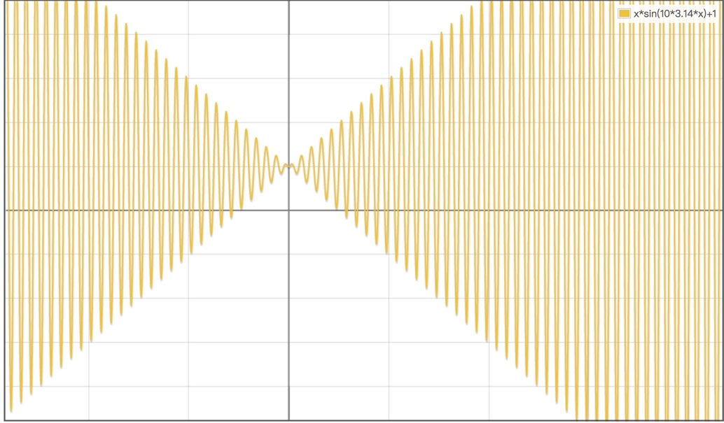

*Mutation:* A gene on one site of a chromosome may change to its allele. For example:

Parent: 1|0|1|1|0|1|0|0|1|0|1|1|0|0|1

The first gene change from “1” to “0”

Child: 0|0|1|1|0|1|0|0|1|0|1|1|0|0|1

*Exchange*: Exchange the position of two genes.

Parent: 1|0|1|1|0|1|0|0|1|0|1|1|0|0|1

Exchange the positions of the first two genes.

Child: 0|1|1|1|0|1|0|0|1|0|1|1|0|0|1

Which version of mutation is performed on a child is selected at random.

*Evolution mechanism:* We use the Roulette Wheel Selection algorithm to make fish living in deep water areas have a higher chance of survival.

For each generation, after the culling is complete the number of survivors is logged along with the highest fitness score. The evolutionary process terminates after 100 generations.

**Results**

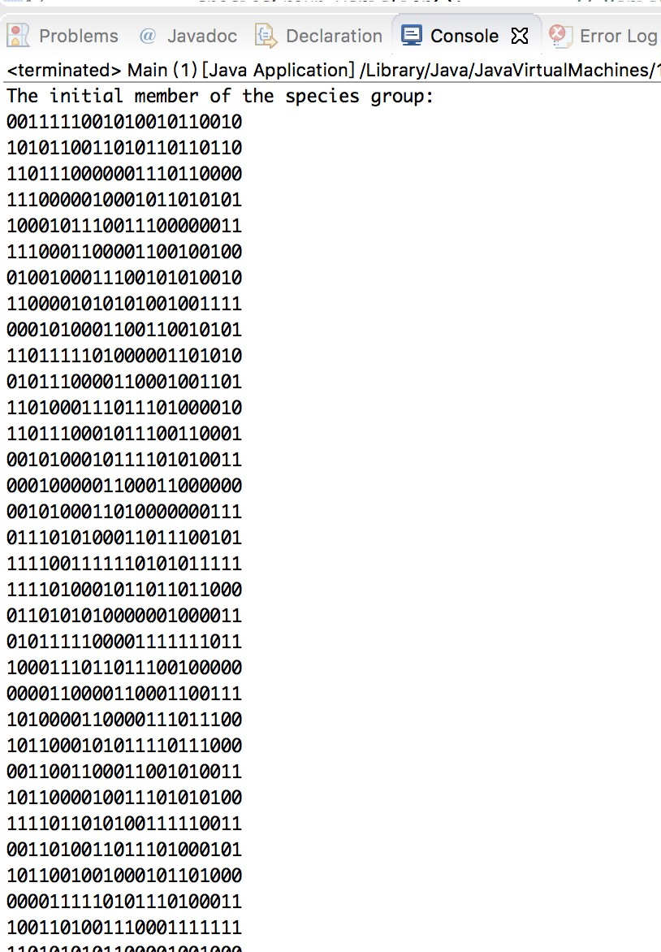

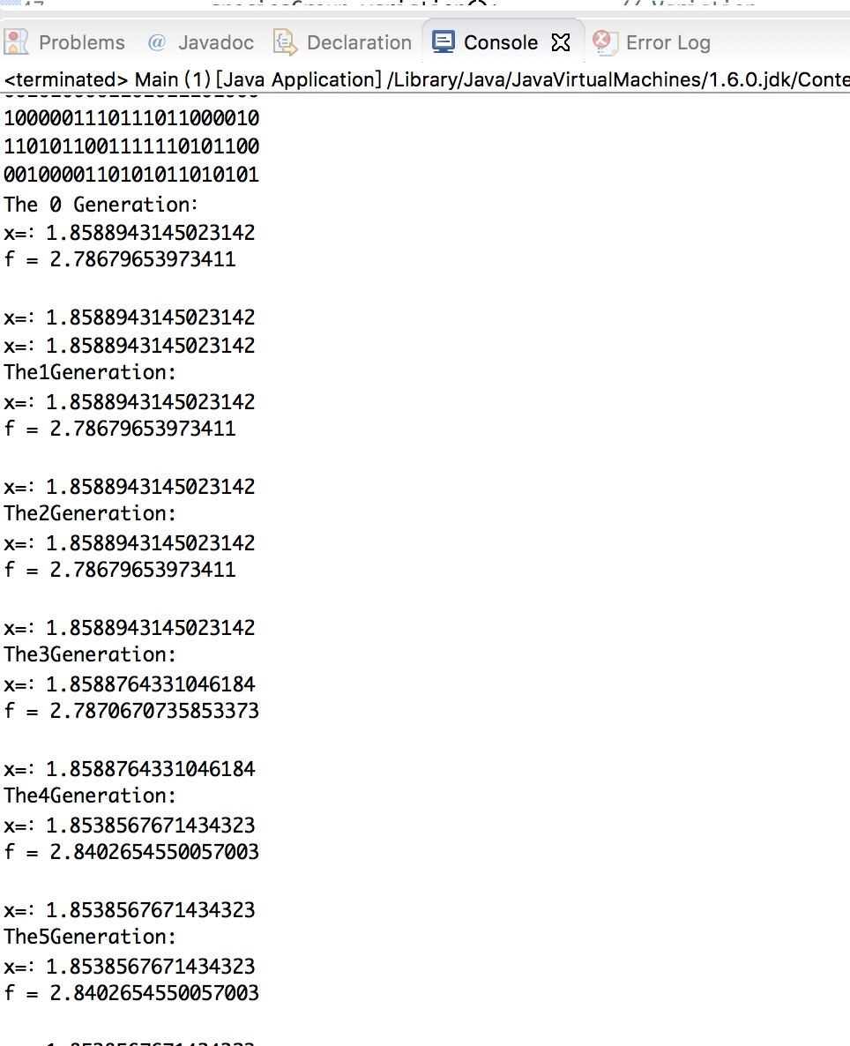 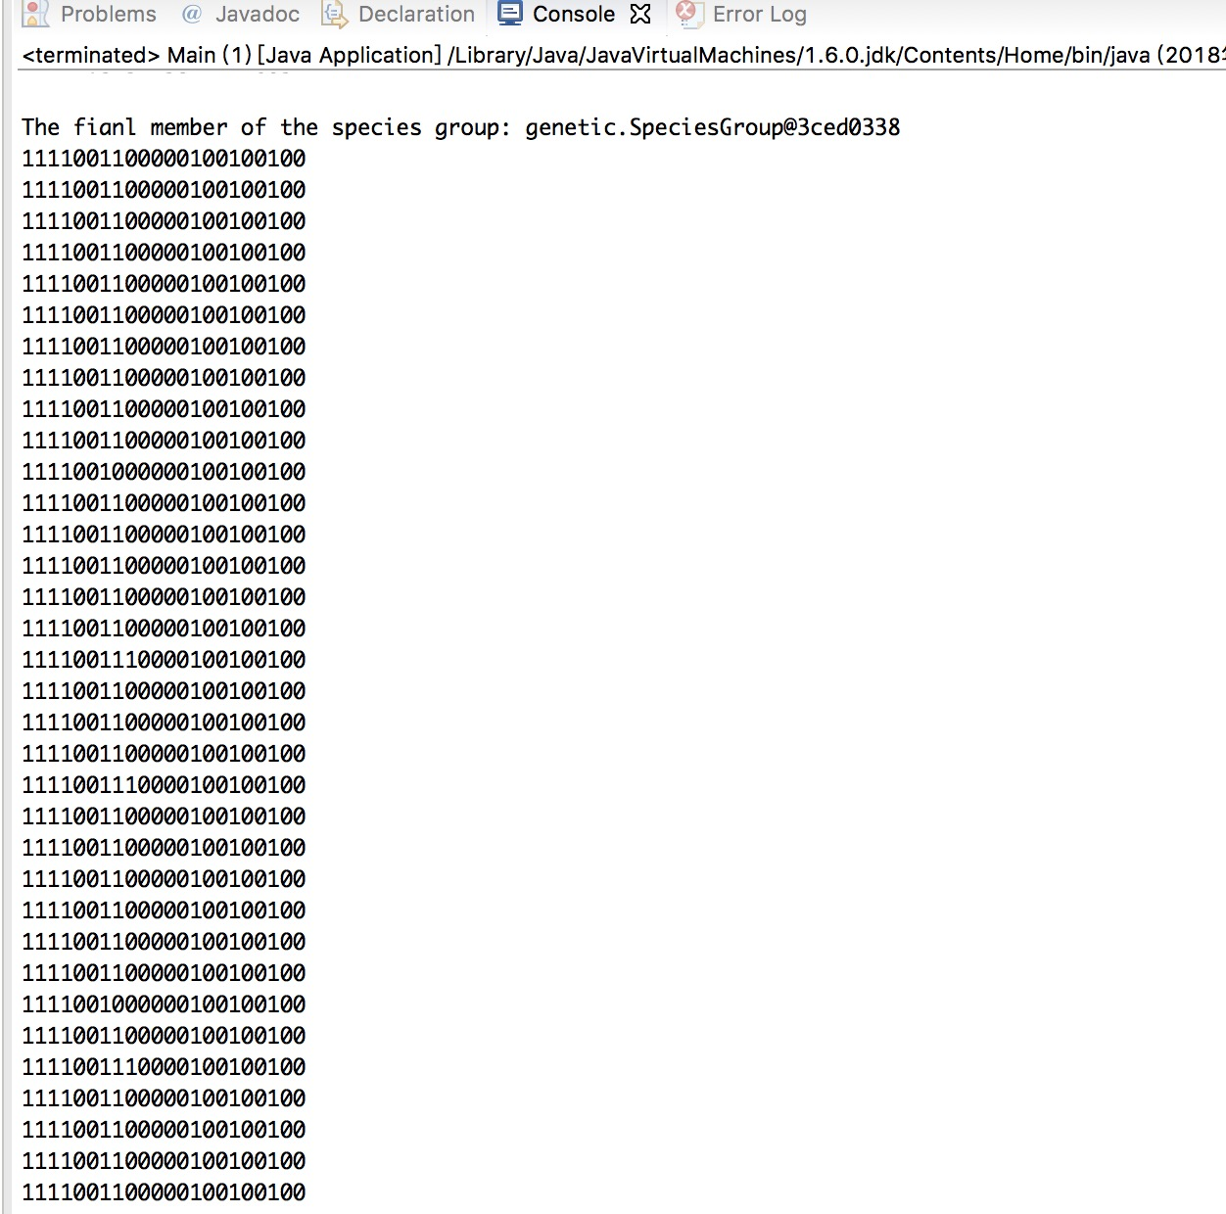

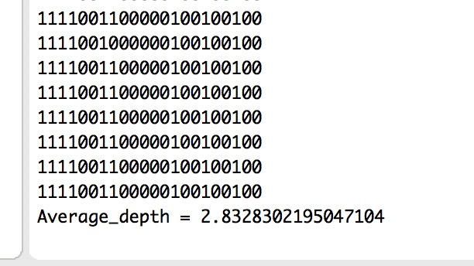

After 100 generations, we get the optimal population and averaged the fitness function of all members as an approximation of the depth of the lake.