3-Level Cache Simulation Using SimpleScalar
CIS 5642 Course Project Final report

Honghao Gan
Computer and Information Science Department
Temple University
Philadelphia, PA 19122
tuj89290@temple.edu
Zhijia Chen
Computer and Information Science Department
Temple University
Philadelphia, PA 19122
tuh17884@temple.edu

Abstract—This is the final report of CIS 5642 course project. It contains two parts. The first part is a team-based report that includes the title of our project, a list of project team members and description of each member's contribution, a detailed description of our design, a discussion of how you test your design, and a discussion of what does not work correctly in our final design. The second part of the final report is an individual report. This individual report includes my contribution on the team project, what I have learned from this project, evaluate my team member's work and some comments on this project.
Keywords—cache design; SimpleScalar

Project Introduction
The goal of the class projects is to give students experience in computer architecture, and specifically, to familiarize students with the design and implementation of a 3-level cache. In this project, we will implement a 3-level cache (L1, L2, L3) using SimpleScalar. L1 cache consists of separate I and D caches, both L2 and L3 are unified caches. They demonstrate inclusion property, i.e, all data in the L1 D-cache are present in L2, and all data in L2 are present in L3 cache.
Our tasks include:
1) Get familiar with Simplescalar. The simulator and its related documents can be downloaded at http://www.simplescalar.com/.
2) Modify the Simplescalar to support inclusion property and 3-level cache.
3) Modify the Simplescalar to support multicore.
4) Perform experiments to evaluate the cache design. You need use at least 2 benchmarks to collect the cache hit/miss information for the following configurations:
Configuration 1: single core processor
L1 D-cache: 16KB, L1 I- Cache: 16KB, 2-way, block size: 64B
L2 cache: 512KB, 4-way, block size: 64B
L3 cache: 8MB, 8-way, block size: 64B
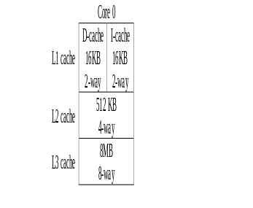
Figure 1. Cache structure for configuration 1
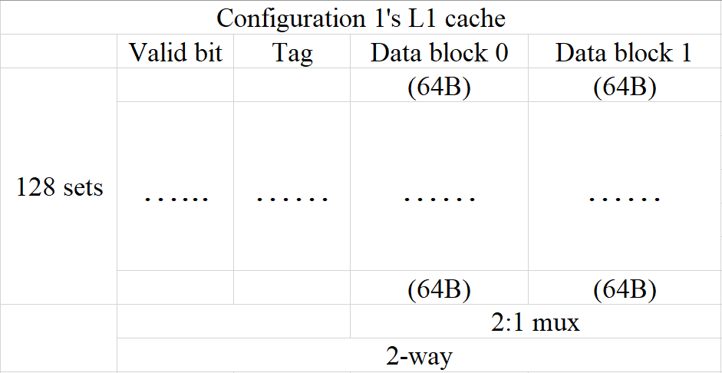
Figure 2. L1 cache design for configuration 1
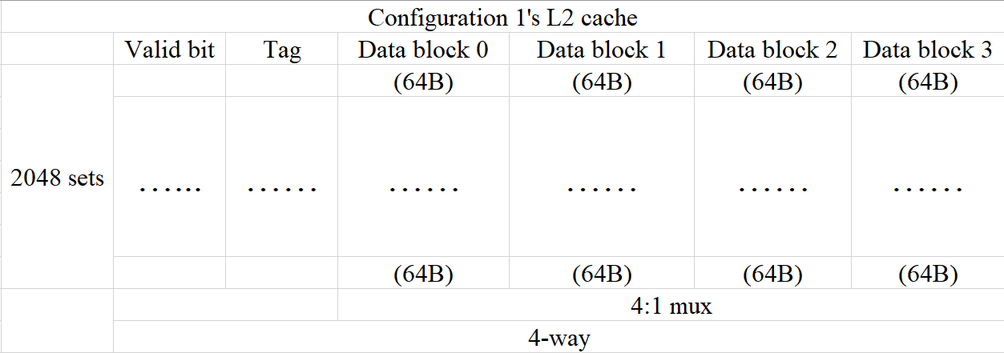
Figure 3. L2 cache design for configuration 1
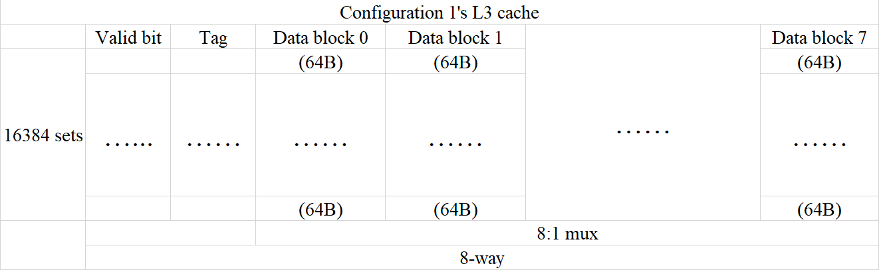
Figure 4. L3 cache design for configuration 1

Configuration 2: Dual core processor, each core has its own L1 and L2 cache and two cores share the L3 cache.
L1 D-cache: 8KB, L1 I- Cache: 8KB, direct mapped, block size: 64B
L2 cache: 128KB, 2-way, block size: 64B,
L3 cache: 16MB, 4-way, block size: 256B
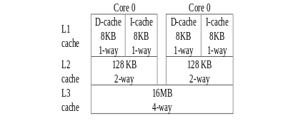
Figure 5. Cache structure for configuration 2
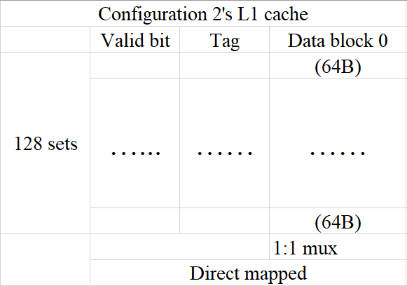
Figure 6. L1 cache design for configuration 2
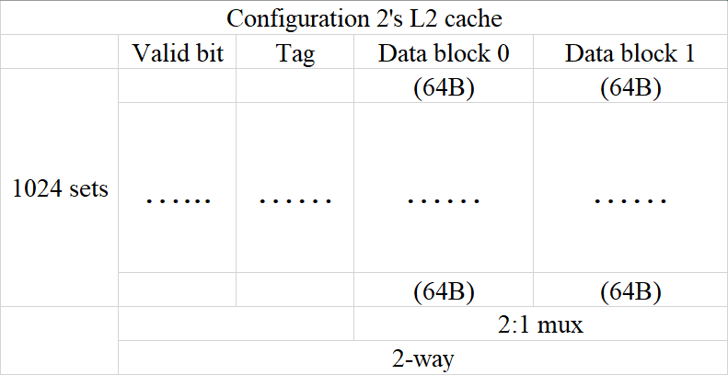
Figure 7. L2 cache design for configuration 2
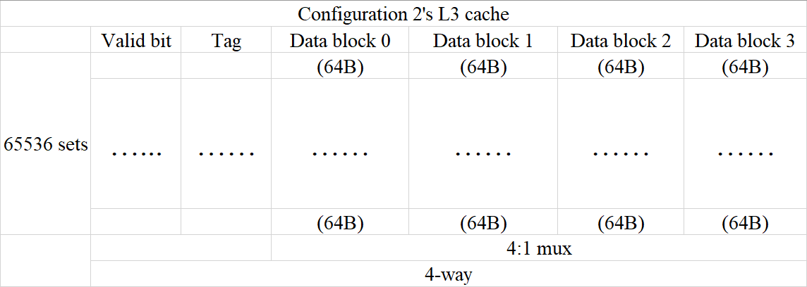
Figure 8. L3 cache design for configuration 2

Team Member & Contribution
Honghao Gan:
- Modify the SimpleScalar to add LFU set replacement policy.
- Write the testing programs.
- Run benchmarks and collect data.
Zhijia Chen:
- Modify the SimpleScalar to support inclusion property and 3-level cache.
- Modify the SimpleScalar to support multicore.

Design Description

SimpleScalar Introduction
SimpleScalar is a toolset that models a virtual computer system with CPU, cache and memory hierarchy. It allows users to build modeling applications that simulate real programs running on a range of modern processors and systems. The toolset includes simulators ranging from a fast functional simulator to a detailed, dynamically scheduled processor model that supports non-blocking caches, speculative execution, and branch prediction. Figure 9 gives an overview of the SimpleScalar toolset.
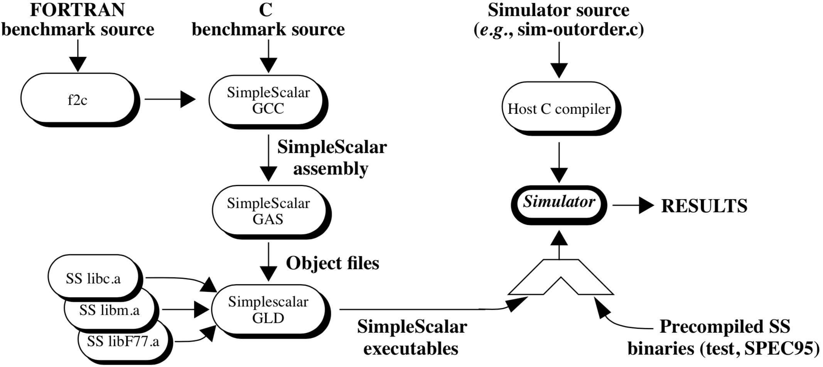
Figure 9. SimpleScalar toolset overview
SimpleScalar can simulate Alpha and PISA (Portable ISA). The PISA instruction set is a simple MIPS-like instruction set maintained primarily for instructional use. The tool set takes binaries compiled for the SimpleScalar architecture and simulates their execution on one of several provided processor simulators. The machine running SimpleScalar is called the Host machine or Host while the ISA that one is targeting such as Alpha or PISA is called Target. Gcc cross-compiler for PISA is available on the internet. We will use gcc cross-compiler in this project.
The toolset provides a collection of microarchitecture simulators that emulate the microprocessor at different levels of details, as listed following.
- sim-fast: fast instruction interpreter, optimized for speed. This simulator does not account for the behavior of pipelines, caches, or any other part of the microarchitecture. It performs only functional simulation using in-order execution of the instructions.
- sim-safe: slightly slower instruction interpreter, as it checks for memory alignment and memory access permission on all memory operations.
- sim-profile: instruction interpreter and profiler. This simulator keeps track of and reports dynamic instruction counts, instruction class counts, usage of address modes, and profiles of the text and data segments.
- sim-cache: memory system simulator. This simulator can emulate a system with multiple levels of instruction and data caches, each of which can be configured for different sizes and organizations. Since we are implementing 3-level cache, we are going to use this simulator as it provides sufficient simulation details for studying the cache but still has relatively fast performance.
- sim-bpred: branch predictor simulator. This tool can simulate difference branch prediction schemes and reports results such as prediction hit and miss rates. Like sim-cache, this does not simulate accurately the effect of branch prediction on execution time.
- sim-outorder: detailed microarchitectural simulator. This tool models in detail and out-of-order microprocessor with all of the bells and whistles, including branch prediction, caches, and external memory. This simulator is highly parameterized and can emulate machines of varying numbers of execution units.

3-Level Inclusive Cache Design
/* cache block (or line) definition */
struct cache_blk_t
{
struct cache_blk_t *way_next; /* next block in the ordered way chain, used to order blocks for replacement */
struct cache_blk_t *way_prev; /* previous block in the order way chain */
……
unsigned int presentCnt;
unsigned int useCnt; /* Used in LFU replacement, increase by 1 if cache block hit, LFU added */
char presentFlag; /* suppose the block size of upper level cache is no less than 1/8 of the block size of current cache, presentFlag tells which part of current block is present in upper level cache. For example, if current block size is 64B and the upper level cache block size is 8B, then binary 00000000 means no data of current block is present in the upper level cache, and binary 00010000 means 8B data of current block is present in the upper level cache which starting at the offset 4*8 = 64. */
};

Cache Block Replacement Policy(LFU & Random)
The cache.h file defines LRU, LFU, Random and FIFO cache replacement policy:
enum cache_policy
{
LRU, /* replace least recently used block (perfect LRU) */
Random, /* replace a random block */
FIFO /* replace the oldest block in the set */
LFU /* replace least frequently used block, LFU added */
};
Those policies are specified in the cache.c file:
/* cache block not found */
/* **MISS** */
cp->misses++;
/* select the appropriate block to replace, and re-link this entry to the appropriate place in the way list */
switch (cp->policy)
{
case LRU:
……
case FIFO:
……
case Random:
{
int bindex = myrand() & (cp->assoc - 1);
repl = CACHE_BINDEX(cp, cp->sets[set].blks, bindex);
while (repl->presentCnt != 0)
{
int bindex = myrand() & (cp->assoc - 1);
repl = CACHE_BINDEX(cp, cp->sets[set].blks, bindex);
}

}
case LFU:// LFU added
{ /* Find the least frequently used block*/
int min;
for (blk = cp->sets[set].way_head; blk; blk = blk->way_next)
{
if (blk->presentCnt == 0)
{
min = blk->useCnt;
break;
}
}
for (blk = cp->sets[set].way_head; blk; blk = blk->way_next)
{
if (blk->useCnt<min && blk->presentCnt==0)
{
min = blk->useCnt;
}
}
for (blk = cp->sets[set].way_head; blk; blk = blk->way_next)
{
if (blk->useCnt==min && blk->presentCnt == 0)
{
repl= blk;
break;
}
}
}
break;
default:
……
}
The random policy’s idea is pretty simple. If there is a cache miss, use the random number generator to specify a “victim” cache block, then replace this block. The function CACHE_BINDEX will specify the cache block based on its parameters, and variable repl will be used later in other cache block replacement functions.
However, since we must use inclusive property, we can only replace the block that only exist in this cache. Thus we use the variable persentCnt to determine whether this block could be replaced or not. If this block’s presentCnt is not equal to 0, then we must choose another victim block to replace using random number generator.
As for LFU, the Least Frequently Used replacement policy, we added the variable useCnt to record each block was hit how many times. If there is a cache hit, then this block’s useCnt would increase by 1. If there is a cache miss, then replace the block with the minimum number of useCnt among all the blocks in the same cache set, and reset the value of useCnt to 0. Once again, we must pay attention to inclusive property of cache. We can only replace the block with both minimum useCnt and presentCnt equals 0.

Multi-Clore Structure Design

Methodology

Test Enviornment
We installed the SimpleScalar on a Ubuntu 14.04.5 LTS virtual machine.
Architecture: i686
CPU op-mode(s): 32-bit, 64-bit
Byte Order: Little Endian
CPU(s): 4
On-line CPU(s) list: 0-3
Thread(s) per core: 1
Core(s) per socket: 2
Socket(s): 2
Vendor ID: GenuineIntel
CPU family: 6
Model: 158
Stepping: 9
CPU MHz: 2808.002
BogoMIPS: 5616.00
Hypervisor vendor: VMware
Virtualization type: full
L1d cache: 32K
L1i cache: 32K
L2 cache: 256K
L3 cache: 6144K
Memory: 4G
Disk: 10G

Benchmarks
We have two benchmarks writen in C language. One is based on matrix multiplication and another is based on RC4 encryption. The idea is to test two cache configurations with sequential access to memory and random access to memory. The matrix multiplication is sequentially access to memory. The randomly scramble the array has a process of using random number generator to access the array, and will scramble the array, so it can be seen as randomly access to memory.
In order to fully test our cache design, for each configuration and replacement policy, we will run each benchmark at least 3 times.
Benchmark 1: Matrix multiplication
#include <stdio.h>
#include <stdlib.h>
#include<time.h>
#define N 300
int a[N][N];
int b[N][N];
int c[N][N];

int MM1(int a[][N], int b[][N], int c[][N])
{
int i = 0, j = 0, k = 0;
for (i = 0; i < N; i++)
for (j = 0; j < N; j++)
for (k = 0; k < N; k++)
c[i][j] = c[i][j] + a[i][k] * b[k][j];

return 0;
}

int init(int a[][N], int b[][N], int c[][N])
{
int i, j;
srand((unsigned)time(NULL));
for (i = 0; i < N; i++)
for (j = 0; j < N; j++)
{
a[i][j] = (rand() % 100);
b[i][j] = (rand() % 100);
c[i][j] = 0;
}
return 0;
}

void display(int a[][N])
{
int i, j;
printf("Matrix:\n");
for (i = 0; i < N; i++)
{
for (j = 0; j < N; j++)
{
printf("%-5d ", a[i][j]);
}
printf("\n");
}
printf("\n");
}

int main()
{
init(a, b, c);
MM1(a, b, c);
display(a);
display(b);
display(c);
getchar();
return 0;
}

Benchmark 2: Randomly scramble the array
#include<stdio.h>
#include<string.h>
#include<stdlib.h>
#include<time.h>
int a[100000];
int main()
{
int i, j,tmp;
srand((unsigned)time(NULL));
for (i = 0; i < 100000; i++)
{
a[i] = rand() % 100000;
}
for(i=0, j=0;i<10000;i++,j++)
{
i = rand() % 100000;
j = rand() % 100000;
tmp = a[i];
a[i] = a[j];
a[j] = tmp;
}
return 0;
}

Evaluation
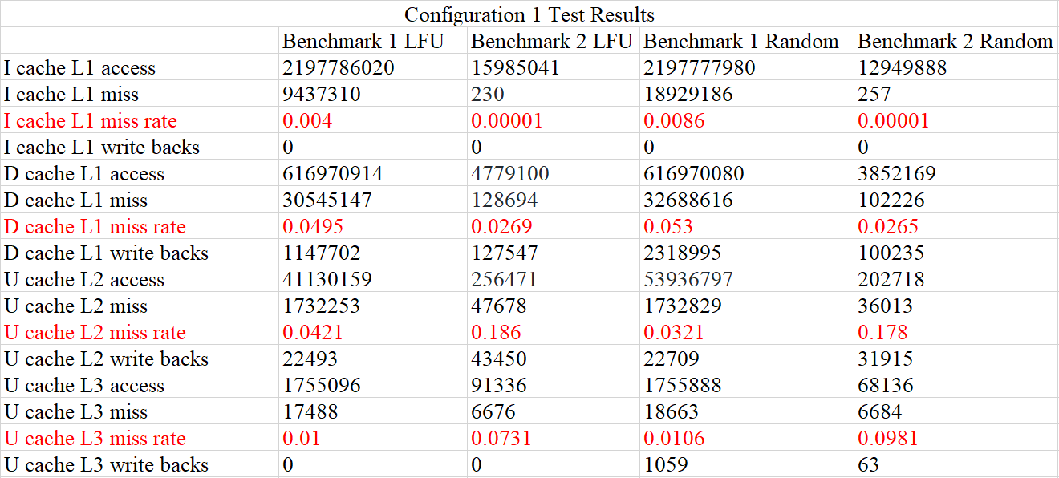
Figure 10. Configuration 1 test results
Above are the test results using configuration 1. For Benchmark 1, all the caches have pretty low miss rate, which give us intuitive impression on the importance of a good cache design. When we look into the results of Benchmark 2, we can see the instruction L1 cache’s miss rate is extremely close to 0. The reason for this is that Benchmark 2 only has a few codes, thus has less instructions need to be executed. The instruction cache can hold almost all the instructions. However, the L2 cache’s miss rate is much higher than the result of Benchmark 1. This is because Benchmark 2 has the idea of randomly access to memory, which means the distances between needed memory addressed could be relatively far, so sometimes the cache was not hold the needed data, causing lots of cache misses. In general, the results between LFU and random replacement policy are not much different, both of them works well.
The results of configuration 2 (multi-core) are pretty similar to the results of configuration 1.
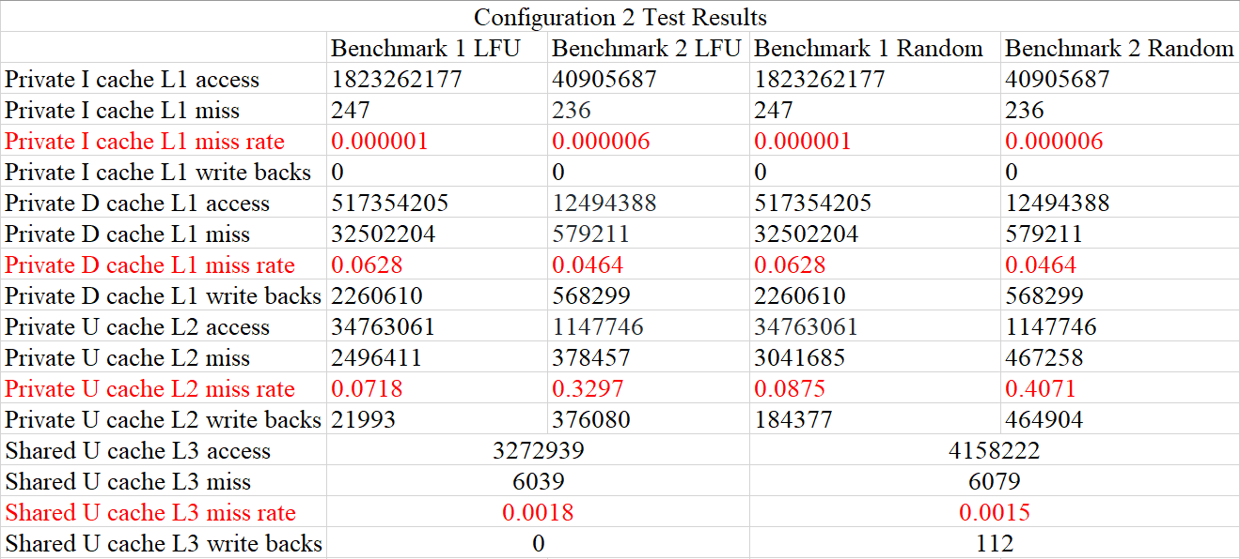
Figure 11. Configuration 2 test results
However, there is one problem: the sum of L1 cache misses is not equal to L2 cache accesses. The sum of the sum of L1 cache miss is not equal to L2 cache misses is not equal to L3 accesses.

Individual Report(Honghao Gan)

Personal Contribution
My contribution in this project is that I have successfully modified the cache.h and cache.c files to let this SimpleScalar support LFU and random cache block replacement policies under inclusive property restriction, wrote the two test program in C language described above, run the test and collect data. Also, I have collected many documents and usage reports of SimpleScalar to help Zhijia Chen’s work.

What I have learned from this project
We have learned some cache knowledge on hardware level, now I have learned the cache design on code level. From the SimpleScalar’s code and examples we studied on previous classes, now I have a clearer understanding of the cache work flow. During the work of modifying the source code of simplescalar, I realize that my ability read someone else’s code is relatively weak, which I need to improve in the future. The test results also show the importance of a good cache design and the cache miss rate is much lower than I thought before.

Evaluate my team member’s work
Zhijia Chen did great job. He has studied lots of documents and usage report in order to have a better understanding about SimpleScalar. He successfully implemented the 3-Level cache structure and inclusive property as well as multi-core. He also actively communicated with me about the progress of this project. I think his tasks are much harder than mine.

My comment on this project
In general, this is a good project. However, the SimpleScalar is too old to use. It was popular maybe 10 years ago, but now there are very few people still use it. Its source code even contain many goto sentence. When I was undergraduate student taking the C language course, the teacher told me that never use goto sentence because this is harmful to program structure. We have to use its own gcc compiler to generate executable files before I can run tests. But its gcc version is so old that it cannot recognize the common syntax we use in C language today. This is the reason that I just wrote two simple test programs in C in order to avoid compile error.

References
- 1
- 2
- 3
- 4
- 5
- 6

