ZHIJIE LI (001563872)

**Program Structures & Algorithms**

**Fall 2021**

**Assignment No. 1**

* **Task**

**Random walk on a 2-dimensional board**:

Imagine a drunken man who, starting out leaning against a lamp post in the middle of an open space, takes a series of steps of the same length: 1 meter. The direction of these steps is randomly chosen from North, South, East or West. **After n steps, how far (*d*), generally speaking, is the man from the lamp post?**

* **Relationship Conclusion: (For ex : z = a * b)**

Close to **d = √n ;**

* **Evidence to support the conclusion:**

1. **Output (Snapshot of Code output in the terminal) **
2. **Graphical Representation(Observations from experiments should be tabulated and analyzed by plotting graphs(usually inexcel) to arrive on the relationship conclusion)**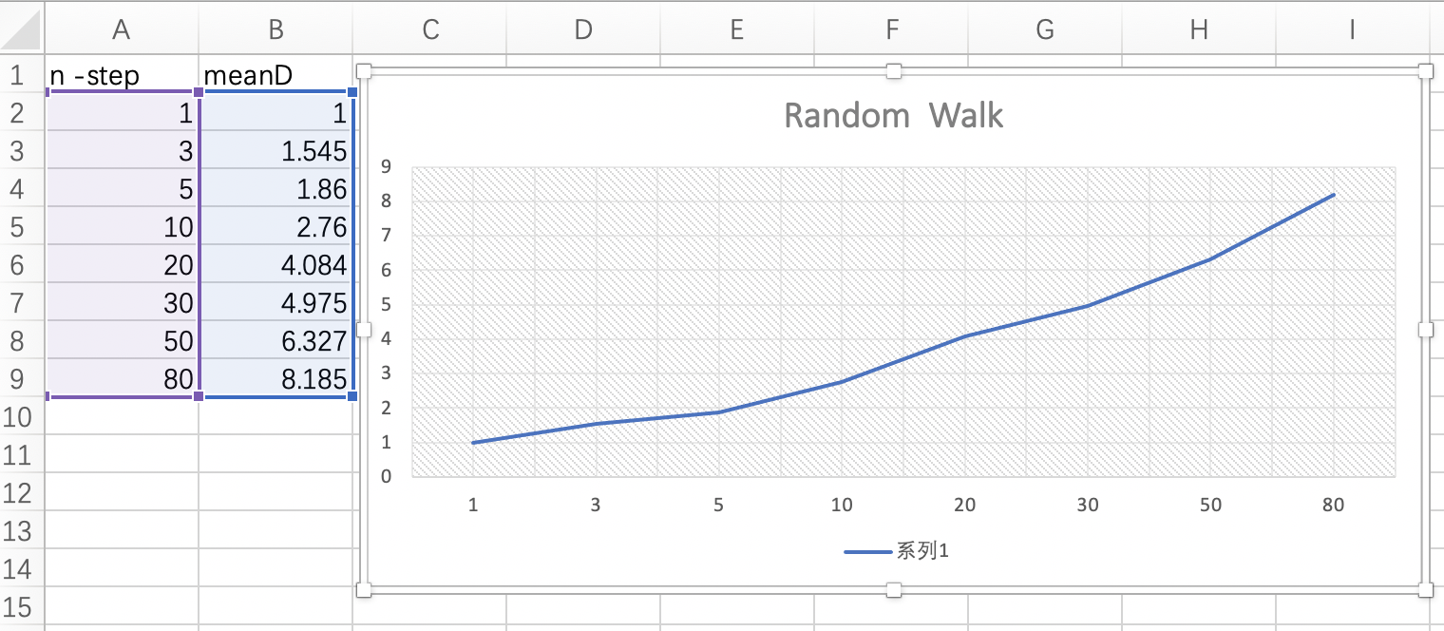

The D-n relationship comes near a square root equation (d = √n ); As n at first increases, d grows fast; n come for nearly double that d only grows less and plain. It seems to be close to d*d = n equation.

* **RandomWalk.java Code:**

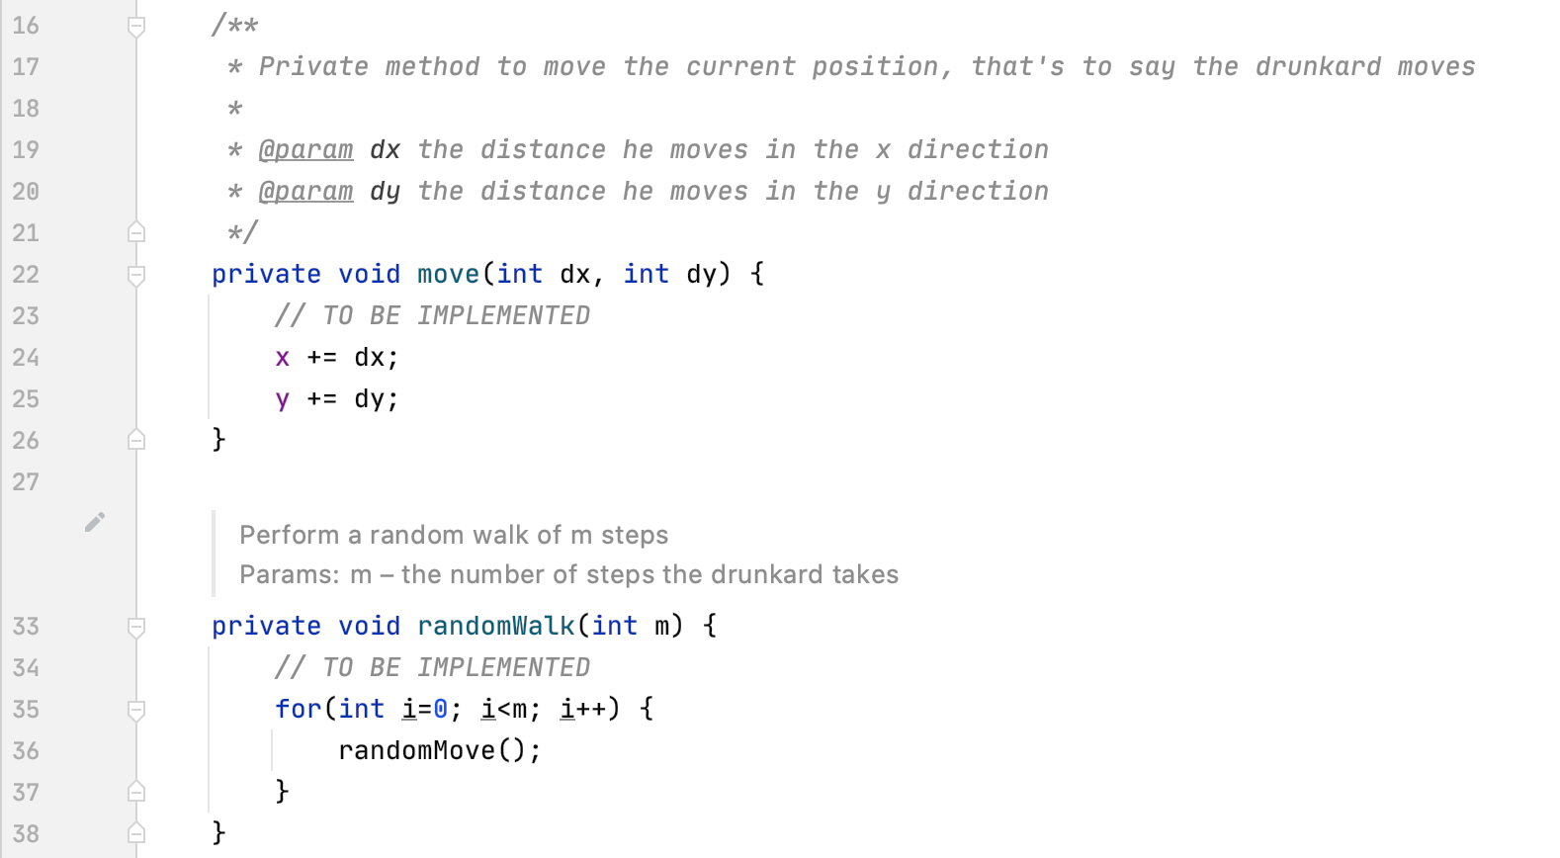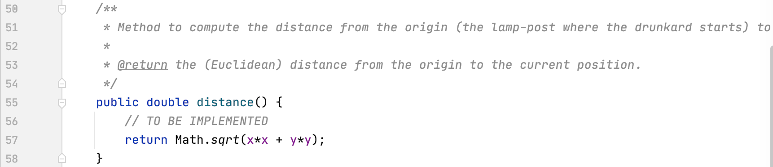

* **Unit tests result:(Snapshot of successful unit test run)**