Zhijie Li (001563872)

**Program Structures & Algorithms**

**Fall 2021**

**Assignment No. 3**

* **Task (List down the tasks performed in the Assignment)**

Step 1:  
(a) Implement height-weighted Quick Union with Path Compression.

(b) Check that the unit tests for this class all work.

Step 2:

Implement the UF_HWQUPC, generates random pairs of integers between 0 and n-1, calling connected() to determine if they are connected and union() if not. Loop until all sites are connected then print the number of connections generated.

Step 3:

Determine the relationship between the number of objects (n) and the number of pairs (m) generated to accomplish this (i.e. to reduce the number of components from n to 1). Justify your conclusion in terms of your observations and what you think might be going on.

* **Relationship Conclusion: (For ex : z = a * b)**

Number of pairs **M = ~** **NlogN**

* **Evidence to support the conclusion:**

1. **Output (Snapshot of Code output in the terminal)**

Step 1 (Unit tests result) 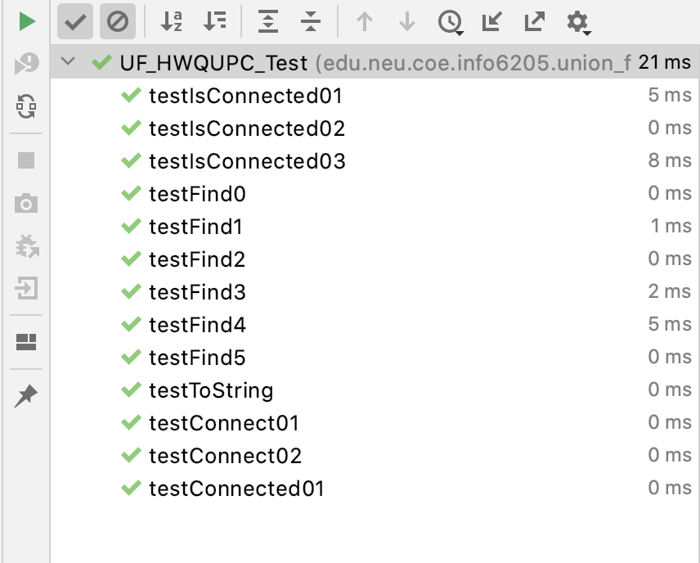

1. **Graphical Representation(Observations from experiments should be tabulated and analyzed by plotting graphs(usually in excel) to arrive on the relationship conclusion)**

|  |  |  |  |  |  |  |  |  |
| --- | --- | --- | --- | --- | --- | --- | --- | --- |
| N | 1 | 2 | 4 | 8 | 16 | 32 | 64 | 128 |
| M | 1 | 1 | 3 | 8 | 24 | 58 | 154 | 345 |

The connections pairs is growing nearly as double as the number of sites doubled and always little bigger than O(N), very close to liner. As a result, the relationship seems like a O(NlogN)

