EMIRATES COLLEGE OF HEALTH SCIENCES AND TECHNOLOGY
OPERATING SYSTEMS
DEPARTMENT: HIM (200 LEVEL)
2. Computer-System Operation
The modern day general-purpose computer system consists of one or more CPUs and a number of device controllers connected through a common bus that provides access to shared memory. Each device controller is in charge of a specific type of device (for example, disk drives, audio devices, or video displays). The CPU and the device controllers can execute in parallel, competing for memory cycles. To ensure orderly access to the shared memory, a memory controller synchronizes access to the memory.
The CPU and memory are directly connected to the bus, while the I/O devices are connected to the bus through device controllers and the DMA. If the CPU and I/O devices try to access the memory at the same time, the bus permits only one of them to proceed. The other accesses are delayed until this access completes.
Modern personal computers have a more complicated structure, involving multiple buses.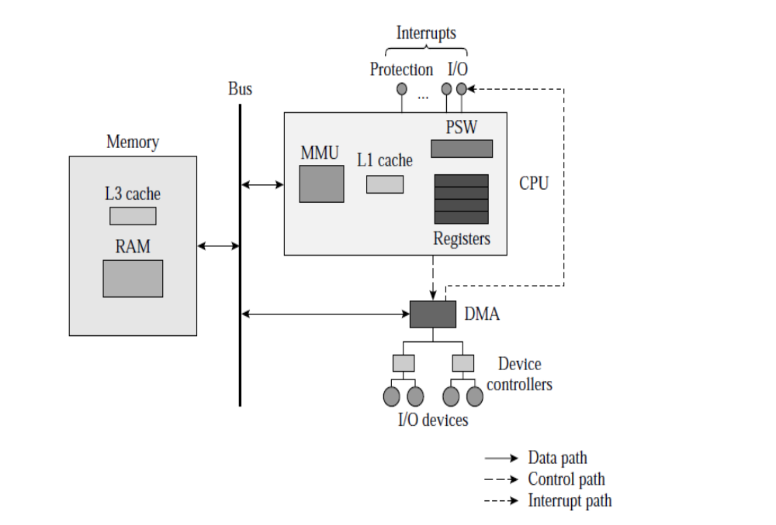
2.1 Processors (C.P.U)
The Processor fetches instructions from memory and executes them. The basic cycle of every CPU is to fetch the first instruction from memory, decode it to determine its type and operands, execute it, check for interrupt and then fetch, decode, and execute subsequent instructions. The cycle is repeated until the program finishes. In this way, programs are carried out.
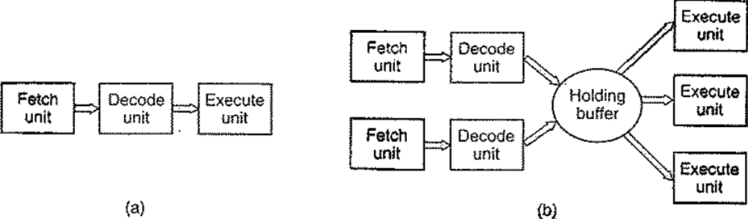
Figure(How processor execute instructions) (a) A three-stage pipeline, (b) A superscalar CPU.
All CPUs contain some registers inside to hold key variables and temporary results. Thus the instruction set generally contains instructions to load a word from memory into a register, and store a word from a register into memory.
2.1.1-Registers
General-Purpose Registers (GPRs) and the Program Status Word (PSW) are two
features of the CPU that are visible to user programs or the operating system.
General-Purpose Registers (GPRs): The GPR are those registers that are used to hold data, addresses, index values, or the stack pointer during execution of a program. These registers are variously called general-purpose registers (GPRs) or program-accessible.
Program Status Word (PSW): They are a set of control registers, which contain information that controls or influences operation of the CPU. For simplicity, the collection of control registers are called the program status word (PSW), and refer to an individual control register as a field of the PSW.
The figure below describes the fields of the PSW. Two fields of the PSW are commonly known to programmers: The program counter (PC) and the condition code.
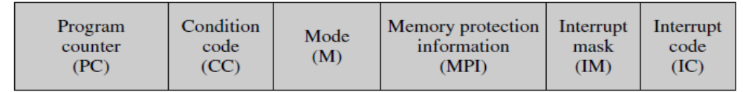
Figure: Important fields of the program status word (PSW).

Field Description
- Program counter: Contains address of the next instruction to be executed.
- Condition code (flags): Indicates some characteristics of the result of the last arithmetic or logical instruction, e.g., whether the result of an arithmetic instruction was > 0, < 0, or = 0. This code is used in execution of a conditional branch instruction.
- Mode: Indicates whether the CPU is executing in kernel mode or user mode. We assume a single-bit field with the value 0 to indicate that the CPU is in kernel mode and 1 to indicate that it is in user mode.
- Memory protection information: Memory protection information for the currently executing program. This field consists of subfields that contain the base register and size register.
- Interrupt mask: Indicates which interrupts are enabled (that is, which interrupts can occur at present) and which ones are masked off.
- Interrupt code: Describes the condition or event that caused the last interrupt. This code is used by an interrupt servicing routine.

The CPU can operate in two modes, called user mode and kernel mode.
- Kernel Mode: The CPU can execute certain instructions only when it is in the kernel mode. These instructions, called privileged instructions, implement special operations whose execution by user programs would interfere with the functioning of the OS or activities of other user programs; e.g., an instruction that changes contents of the memory protection information (MPI) field of the PSW could be used to undermine memory protection in the system.
- User Mode: The user mode is an unprivileged mode because it does not have access to control the systems resources. To have access to the system resources the user mode has to switch to the kernel mode which is a privileged mode.
2.1.2-State of the CPU: The general-purpose registers and the PSW together contain all the information needed to know what the CPU is doing; we say that this information constitutes the state of the CPU. To ensure that the program can resume its execution correctly when scheduled in future, the kernel saves the state of the CPU when it takes away the CPU from the program, and simply reloads the saved CPU state into the GPRs and the PSW when execution of the program is to be resumed. The example below illustrates how saving and restoring the state of the CPU suffices to correctly resume execution of a program.
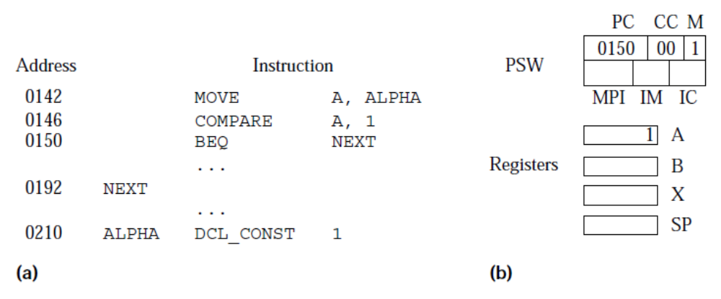
Example 1: (a) Listing of an assembly language program showing address assigned to each instruction or data; (b) state of the CPU after executing the COMPARE instruction.
2.2-Memory
A computer system should ideally contain a large enough and fast enough memory, so that memory accessing will not slow down the CPU. However, fast memory is expensive, so something that can provide the same service as a large and fast memory but at a lower cost is desirable. The solution is a memory hierarchy containing a number of memory units with differing speeds. The fastest memory in the hierarchy is the smallest in size; slower memories are larger in size. The CPU accesses only the fastest memory. If the data (or instruction) needed by it is present in the fastest memory, it is used straightaway; otherwise the required data is copied into the fastest memory from a slower memory, and then used. The data remains in the fastest memory until it is removed to make place for other data. This arrangement helps to speed up accesses to repeatedly used data.
2.2.1-Cache Memory: The cache memory holds some instructions and data values that were recently accessed by the CPU. For every data or instruction required during execution of a program, the CPU performs a cache lookup by comparing addresses of the required bytes with addresses of bytes in memory blocks that are present in the cache. A hit is scored if the required bytes are present in memory, in which case the bytes can be accessed straightaway; otherwise, a miss is scored and the bytes have to be loaded into the cache from memory. The hit ratio (h) of the cache is the fraction of bytes accessed by the CPU that score a hit in the cache.

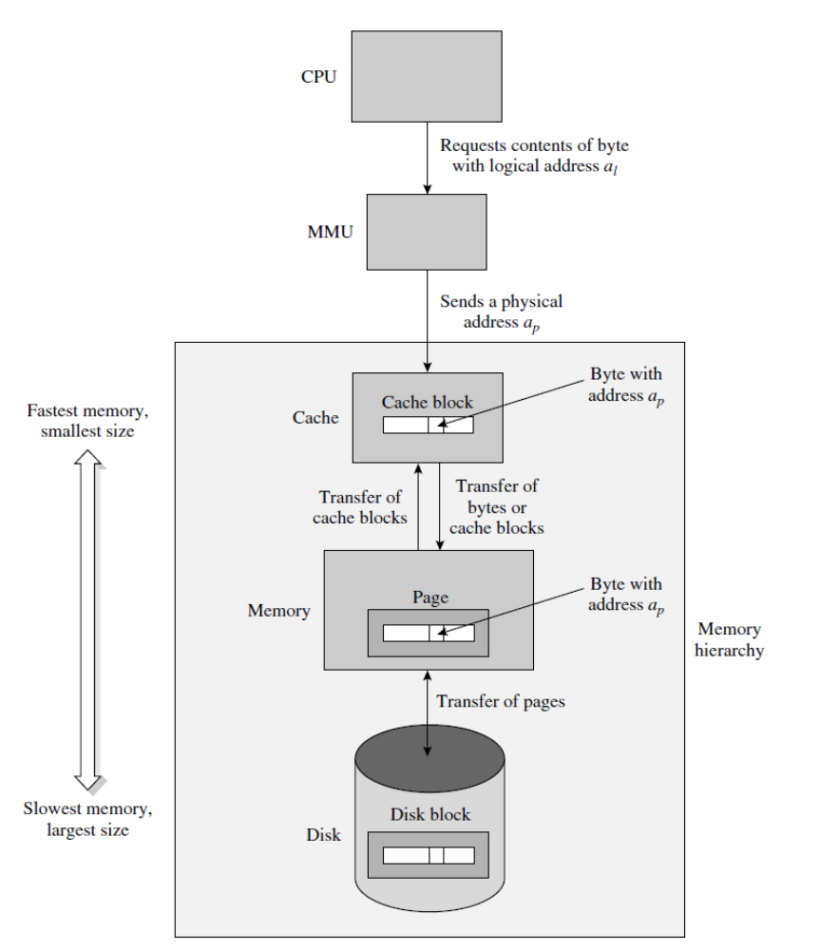

2.2.2-Memory Hierarchy

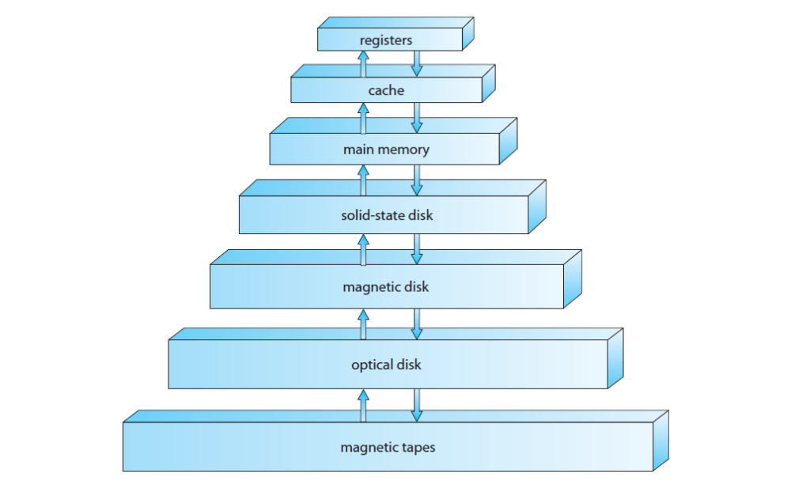

2.3-Input/Output
An I/O operation requires participation of the CPU, memory, and an I/O device. The manner in which the data transfer between memory and the I/O device is implemented determines the data transfer rates and the extent of the CPU’s involvement in the I/O operation. The I/O organization we find in modern computers has evolved through a sequence of steps directed at reducing the involvement of the CPU in an I/O operation. Apart from providing higher data transfer rates, it also frees the CPU to perform other activities while an I/O operation is in progress.

2.3.1-Modes of Performing I/O Operations
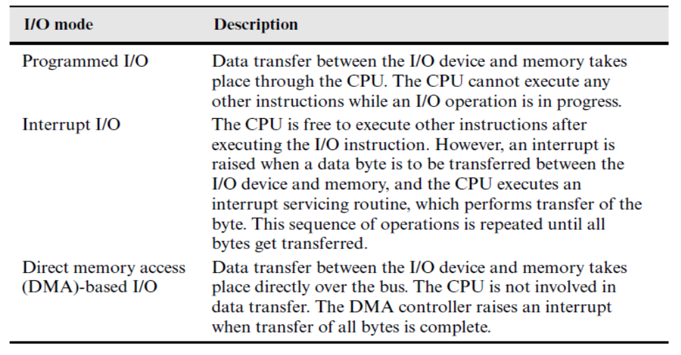

2.4-Interrupts
An event is any situation that requires the operating system’s attention. The computer designer associates an interrupt with each event, whose sole purpose is to report the occurrence of the event to the operating system and enable it to perform appropriate event handling actions. It is implemented using the following arrangement: In the instruction execution cycle of the CPU, it performs four steps repeatedly—fetching the instruction whose address is contained in the program counter (PC), decoding it, executing it, and checking whether an interrupt has occurred during its execution. If an interrupt has occurred, the CPU performs an interrupt action that saves the CPU state, that is, contents of the PSW and the GPRs, and loads new contents into the PSW and the GPRs, so that the CPU starts executing instructions of an interrupt servicing routine, often called ISR, in the kernel. Sometime in the future, the kernel can resume execution of the interrupted program simply by loading back the saved CPU state into the PSW and GPRs.
2.4.1-Classes of Interrupts
The table below describes three classes of interrupts that are important during normal operation of an OS. An I/O interrupt indicates the end of an I/O operation, or occurrence of exceptional conditions during the I/O operation. A timer interrupt is provided to implement a timekeeping arrangement in an operating system.
A program interrupt, also called a trap or an exception, is provided for two purposes. 1) The computer hardware uses the program interrupt to indicate occurrence of an exceptional condition during the execution of an instruction, e.g., an overflow during arithmetic, or a memory protection violation.
2) User programs use the program interrupt to make requests to the kernel for resources or services that they are not allowed to provide for themselves.
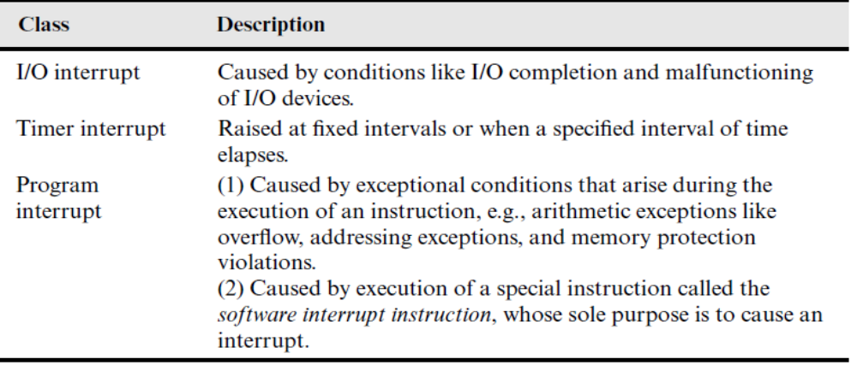

2.4.2-Interrupt Servicing
The interrupt vectors area contains several interrupt vectors; each interrupt vector is used to control interrupt servicing for one class of interrupts. Depending on which class an interrupt belongs to, the interrupt action chooses the correct interrupt vector and loads its contents into PSW fields. An interrupt vector contains the following information:
1. Address of an interrupt servicing routine.
2. An interrupt mask indicating which other interrupts can occur while this interrupt is being processed.
3. A 0 or 1 to indicate whether the CPU should be in kernel or user mode, respectively, while executing the interrupt servicing routine. Typically 0 is chosen so that the interrupt servicing routine, which is a part of the kernel, can use privileged instructions.
For simplicity, we assume that an interrupt vector has the same format as the PSW. The kernel forms the interrupt vectors for various classes of interrupts when the operating system is booted. Each interrupt vector contains the following information: a 0 in the mode (M) field to indicate that the CPU should be put in the kernel mode, the address of the first instruction of the interrupt servicing routine in the program counter (PC) field, a 0 and the size of memory in the memory protection information (MPI) field—so that the interrupt servicing routine would have access to the entire memory—and an interrupt mask in the interrupt mask (IM) field that either disables other interrupts from occurring or enables only higher-priority interrupts to occur, in accordance with the philosophy of nested interrupt servicing employed in the operating system.
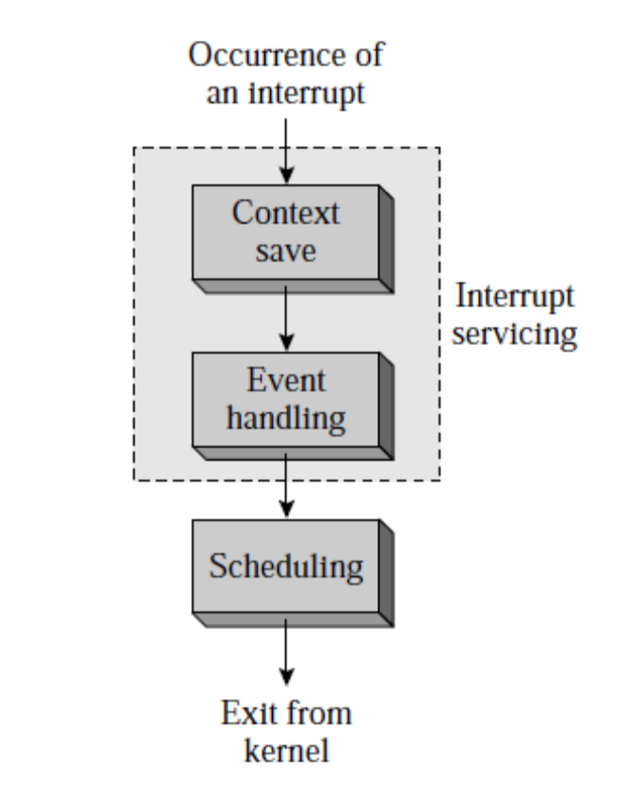

2.4.3-Event Handling Actions of the Kernel
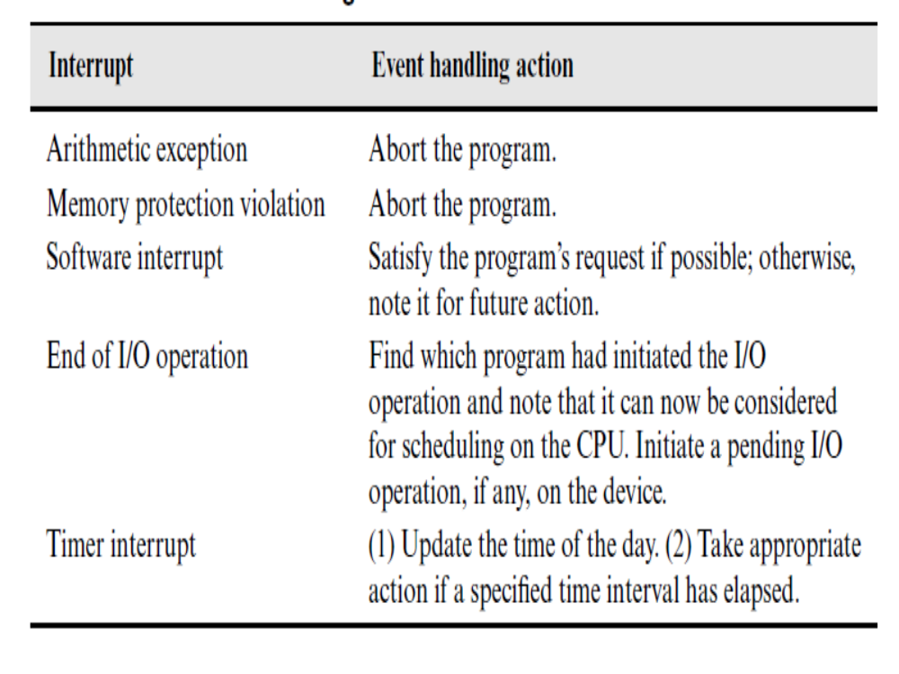

Example 2: Interrupt servicing
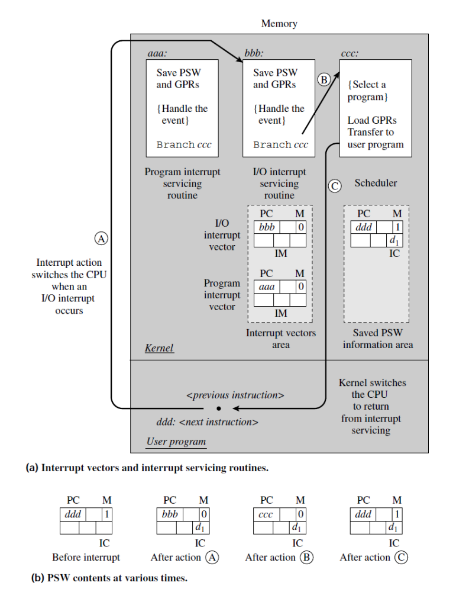

Explanation
In example 2 above figure a) shows the arrangement of interrupt vectors and interrupt servicing routines in memory, while Figure b) shows contents of the PSW at various times during servicing of an I/O interrupt. The interrupt vectors are formed by the OS boot procedure. Each interrupt vector contains the address of an interrupt servicing routine, an interrupt mask and a 0 in the mode field.
A user program is about to execute the instruction that exists at the address ddd in memory when an interrupt occurs signaling the end of an I/O operation on device d1. The leftmost part of Figure b) shows the PSW contents at this time.

2.5-System Calls
A system call is a request that a program makes to the kernel through a software interrupt.
A program needs to use computer resources like I/O devices during its execution. However, resources are shared among user programs, so it is necessary to prevent mutual interference in their use. To facilitate it, the instructions that allocate or access critical resources are made privileged instructions in a computer’s architecture.
Some Linux System Calls
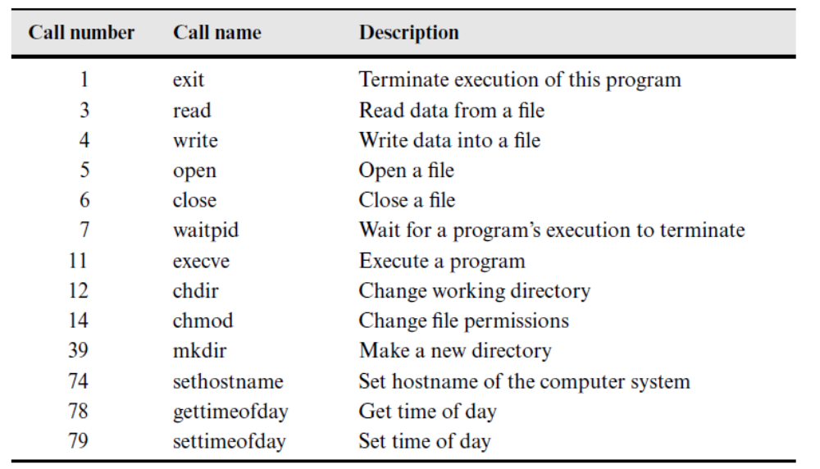

2.6-Booting the Computer
Very briefly, the Pentium boot process is as follows. Every Pentium contains a parentboard (formerly called a motherboard before political correctness hit the computer industry). On the parentboard is a program called the system BIOS (Bask Input Output System). The BIOS contains low-level I/O software, including procedures to read the keyboard, write to the screen, and do disk I/O, among other things. Nowadays, it is held in a flash RAM, which is nonvolatile but which can be updated by the operating system when bugs are found in the BIOS.
When the computer is booted, the BIOS is started. It first checks to see how much RAM is installed and whether the keyboard and other basic devices are installed and responding correctly. It starts out by scanning the ISA and PCI buses to detect all the devices attached to them. Some of these devices are typically legacy (i.e., designed before plug and play was invented) and have fixed interrupt levels and I/O addresses (possibly set by switches or jumpers on the I/O card, but not modifiable by the operating system). These devices are recorded. The plug and play devices are also recorded. If the devices present are different from when the system was last booted, the new devices are configured.
The BIOS then determines the boot device by trying a list of devices stored in the CMOS memory. The user can change this list by entering a BIOS configuration program just after booting. Typically, an attempt is made to boot from the floppy disk, if one is present. If that fails the CD-ROM drive is queried to see if a bootable CD-ROM is present. If neither a floppy nor a CD-ROM is present, the system is booted from the hard disk. The first sector from the boot device is read into memory and executed. This sector contains a program that normally examines the partition table at the end of the boot sector to determine which partition is active. Then a secondary boot loader is read in from that partition. This loader reads in the operating system from the active partition and starts it- this process is known as boot loading.
The operating system then queries the BIOS to get the configuration information. For each device, it checks to see if it has the device driver. If not, it asks the user to insert a CD-ROM containing the driver (supplied by the device's manufacturer). Once it has all the device drivers, the operating system loads them into the kernel. Then it initializes its tables, creates whatever background processes are needed, and starts up a login program or GUI.

