2021级“数据通信与计算机网络”
实验七 虚拟专用网VPN
实验内容：
1、easy VPN配置
2、隧道VPN（IPSec VPN）配置
实验步骤：
一、easy VPN配置
（1）构建如下网络拓扑图。对网络进行配置，实现在内网（LAN1）的计算机访问外网（LAN3）时将内部地址转换为Router0串行端口的地址（参考实验六）。

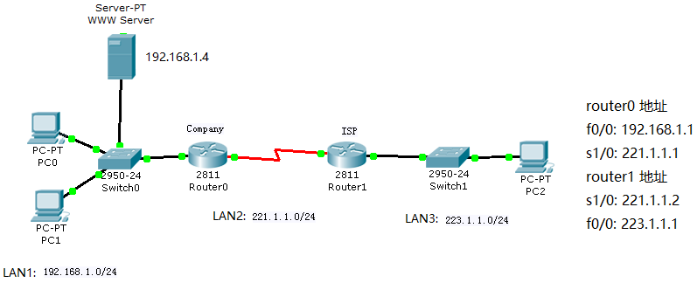
（2）在NAT路由器上配置easy VPN，实现外网(LAN3)内用户通过VPN登录内网(LAN1)和访问内网主机（配置方法见附录1）。

二、隧道VPN（IPSec VPN）配置
（1）构建如下图所示网络，按图中标注的IP地址对计算机和路由器进行配置。
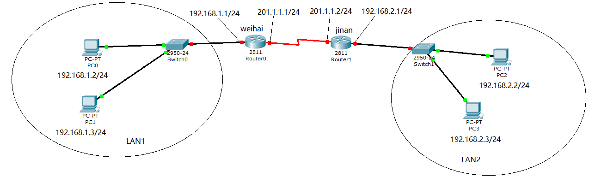
（2）在router0和router1上配置 IPSec VPN，使LAN1与LAN2构成虚拟专用网，主机间采用内部地址通过外部串行链路通信（配置方法见附录2）。
（3）用ping命令、tracert命令测试LAN1内主机与LAN2内主机的连通性能；
（4）用数据包跟踪功能观察IP分组首部地址变化情况，确认VPN配置成功。
实验报告要求：
1、简述easy VPN 配置过程。实验中如何验证easy VPN配置成功？给出实验的结果并进行说明。
2、简述IPSecVPN配置过程。实验中如何验证IPSec VPN配置成功？给出实验的结果并进行说明。
3、完成下面的CCNA测试题：
(1) You have a class C address, and you want to setup five subnets with 18 hosts per subnet. What is your subnet mask?
A. 255.255.255.128 B. 255.255.255.192
C. 255.255.255.224. D. 255.255.255.240
(2) Does every TCP/IP host install the ICMP protocol?
A. TRUE B. FALSE
(3) Which characteristics below are contained in Layer 4 of the OSI model? (choose three)
A. Connection oriented: TCP/IP B. Non acknowledgement UDP
C. Three way handshake TCP/IP D. Route selection: IP
E. sliding window: UDP
(4) Which command can allow you to configure the IP address on one router’s interface?
A. router(config-if)#ip address 163.45.67.89 mask 255.255.224.0
B. router(config-if)#ip 163.45.67.89 255.255.224.0
C. router(config-if)#ip address 163.45.67.89 255.255.224.0
D. router(config-if)#ip 163.45.67.89 mask 0.0.0..255
E. router(config-if)#ip address 163.45.67.89 mask 0.0.0.255
(5) Which prompt will be used in privileged model?
A. Router (config)# B. router> C. Router# D. Router(pri)#
(6) PC A and PC B are on the same Ethernet LAN, you want to ping PC B from PC A, which protocol request will be used to looking for PC B’s MAC address?
A.RIP B. ARP request C. RARP request D. MAC request
(7) What does the ‘base’ mean in the description as “10Base-T”?
A. It means the signaling method for communication.
B. It means the type of media.
C. It means the speed of the signal transmission.
D. It means the lowest way switch can used.
(8) Which of the following form is a valid MAC address?
A. 161.207.2.236 B. 26-43-00-72-66
C. 00.00.12.34.DE.BE D. 0000.12.34.DE.BE
(9) What are true descriptions about layer 2 bridges and switches? (Choose three)
A. Both bridges and switches can increase collision domains.
B. Switches are based on software.
C. Switches have more number of ports than most single bridges.
D. Bridges are faster than switches.
E. Both bridges and switches are layer 2 devices.
F. Bridges are layer 1 devices.
(10) Which of the following shows the correct command to configure RIP as the routing protocol?
A. Router#rip. B. Router>rip.
Network 192.168.1.0 Network 192.168.0.0
C. Router(config-if)#router rip. D. Router(config)#router rip.
Network 192.168.0.0 255.255.255.0 Network 192.168.1.0
(11) Which of the following statements about RIP is true?
A. It has hop counts limitation of 26
B. It uses bandwidth and hops as the metric of their path selection.
C. It is one of the link state routing protocol.
D. It sends broadcasts routing updates every 30 seconds by default.
E. It uses autonomous system numbers.
(12) The network 192.168.1.0/24 was advertised by a neighbor router. It was also added a static route 192.168.1.0/24 manually. Which route would be used to forward traffic?
A. The RIP route. B. The static route. C. The IGRP route. D. Random.
(13) Which of the following VTP mode can create, delete and synchronize of VLANS.
A. server mode B. client mode C. transparent mode D. VTP mode
(14) What is the benefit of VLAN? (Choose two)
A. It increases the number of broadcast domains
B. It increases the number of collision domains
C. To increase network security
D. To reduce switch numbers
(15) What options are true regarding configuration of adding a new VLAN to an existing network? (Choose tree)
A. Must creat the VLAN. B. Naming the VLAN.
C. Must choose VLAN routing path. D. The desired ports should be assigned.
(16) Using a class B address with a mask of 255.255.255.128, how many networks and hosts are allowed?
A. 126 networks and 512 hosts. B. 512 networks and 128 hosts per.
C. 128 networks and 512 hosts per. D. 510 networks and 126 hosts per.
(17) What is a layer two device’s function?
A. It maintains an IP address table.
B. It maintains an MAC to IP address table.
C. It maintains a data link layer and network layer addresses table.
D. It maintains a source MAC to destination MAC’s routing table.
(18) What is the command to configure OSPF as the routing protocol on one router? .
(19) Which protocol is an example of a link state routing protocol?
A. IP B. ICMP C. OSPF D.RIP version 1 E.RIP version 2
(20) What is the benefit of using one router segmenting a network into two segments?
- It increases the number of collisions
- It decreases the number of collisions
- It decreases the number of broadcast domains
- It can prevent broadcasts between the two segments
(21) What is the right order for information packaged during encapsulation among layers?
A. segment data packed frame B. data packet segment frame
C. data segment packet frame D. data frame packet segment
(22) What’s mean of administrative distance? What is the administrative distance for RIP? 。
(23) What is the minimum legal size of an Ethernet frame?
A. 1518bytes B. 48bytes C. 24bytes D.64bytes
(24) Which protocol can be used to translate hardware address into IP address?
(25) You can configure PPP on which physical interfaces listed below?
A. Ethernet B. Synchronous Serial C. Token ring D. ISDN
(26) Create a static route to 172.16.10.0 on Router A through serial interface 10.1.1.1.
A. Router# ip route 172.16.10.0 255.255.255.0 10.1.1.1
B. Router(config)#ip static route 172.16.10.0 255.255.255.0 10.1.1.1
C. Router(config)#ip route 172.16.10.0 10.1.1.1
D. Router(config)#ip route 172.16.10.0 255.255.255.0 10.1.1.1
(27) The value of administrative distance of following routing protocol is:
RIP ; OSPF ; Static routing .
(28）PPP stands for ?
(A) Point –to –Point Protocol (B) Packet-to Packet Protocol
(C) Point-to Packet Protocol (D) None of above
(29) What are the three types of switching modes?
(30) What is the beginning range for a layer three multicast address?
(A) 244.0.0.0 (B) 239.0.0.0 (C) 224.0.0.0 (D) 255.0.0.0
(31) What devices operate at the Network Layer?
A. Switches B. Bridges C. Hubs D. Routers
(32) UDP is a connectionless transport layer protocol in TCP/IP protocol stack. Point out all the possible characteristics of UDP protocol. (Choose two)
A. Less bandwidth-intensive. B. More bandwidth-intensive
C. Non-reliable. D. More reliable.
(33) RIP protocol has a maximum of________ hop counts?
(34) Which of the following commands use ICMP protocol in layer 3? (Choose two)
A. ftp B. telnet C. ping D. pop3 E. traceroute
(35) Identify the seven-layers of the OSI reference model and point out the function of every layer.
附录1 在PAT路由器上配置easy VPN：
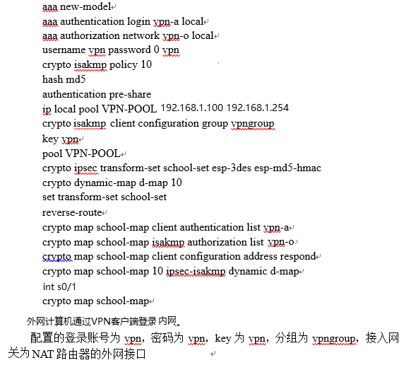
附录2：weihai路由器配置IPSec VPN（jinan路由器可参照配置）
Weihai(config)#crypto isakmp policy 10
Weihai(config-isakmp)#authentication pre-share
Weihai(config-isakmp)#hash md5
Weihai(config-isakmp)#group 2
Weihai(config-isakmp)#encryption 3des
Weihai(config-isakmp)#exit
Weihai(config)#crypto isakmp key aaa address 201.1.1.2
Weihai(config)#crypto ipsec transform-set vpnSet esp-des esp-md5-hmac
Weihai(config)#crypto map vpnMap 10 ipsec-isakmp
Weihai(config-crypto-map)#set peer 201.1.1.2
Weihai(config-crypto-map)#set transform-set vpnSet
Weihai(config-crypto-map)#match address 110
Weihai(config-crypto-map)#exit
Weihai(config)#ip access-list extended 110
Weihai(config-ext-nacl)#permit ip 192.168.1.0 0.0.0.255 192.168.2.0 0.0.255
Weihai(config-ext-nacl)#exit
Weihai(config)#int s1/0
Weihai(config-if)#crypto map vpnMap
Weihai(config-if)#end

