Step2：

Gpc_site: Regional Pumpkin Festival

Origin: city state: Paris

Prov: New York

Country: Mexico

Year: 2547-P

Step5:

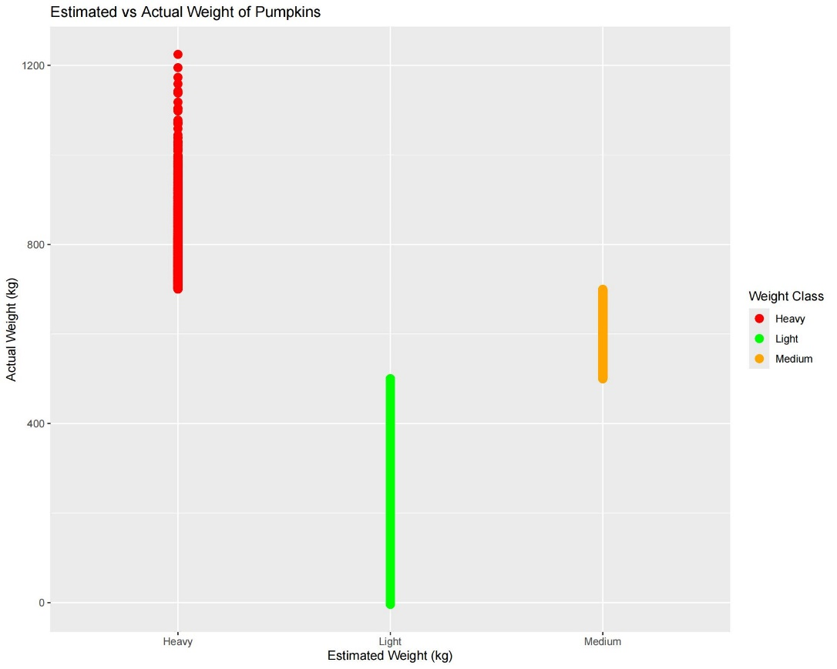

The X-axis represents the estimated weight (in kilograms), divided into three categories: heavy, light and medium.

The Y-axis represents the actual weight in kilograms.

Data point color:

Red: indicates a Heavy pumpkin.

Green: indicates a Light pumpkin.

Orange: Indicates a Medium pumpkin

Step8:

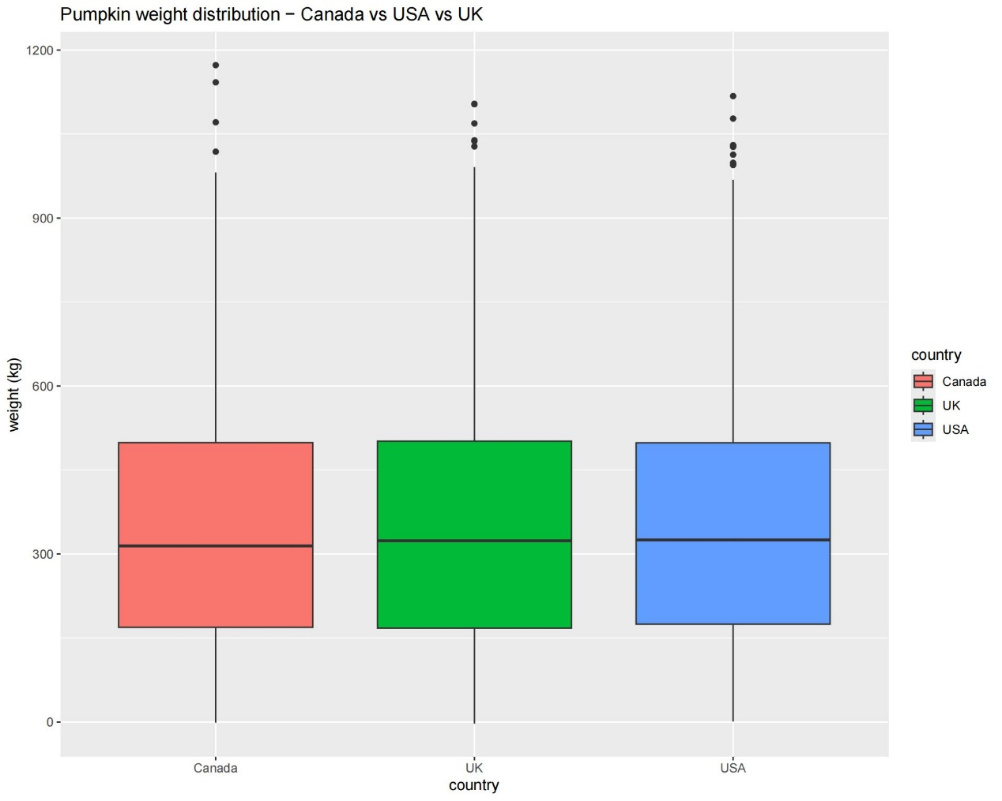

The X-axis shows the countries: Canada, the United States and the United Kingdom

The Y-axis represents the weight of the pumpkin in kilograms.

Data point color

Red: The pumpkin of Canada.

Green: Pumpkin in the United Kingdom.

Blue: The pumpkin of the United States.

Step9:

