Volcano Plot:

The volcano map shows the significance and magnitude of changes in gene expression between A and D or E.

X axis: represents the log2 fold change value of the gene under D or E. Genes up-expressed in positive table D or E relative to condition A; Negative values indicate down-regulated expression.

Y-axis: means that higher points correspond to statistically more significant results. Higher values point to more significant differentially expressed genes.

Data point

Red dots may represent significantly up-regulated genes, blue dots significantly down-regulated genes, and gray dots non-significant genes.

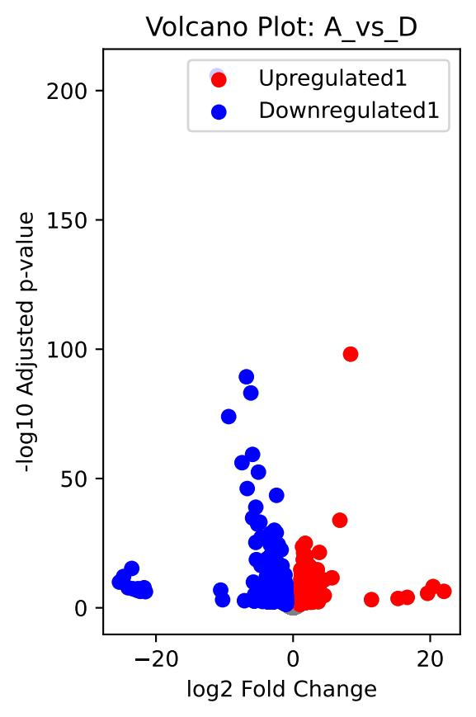 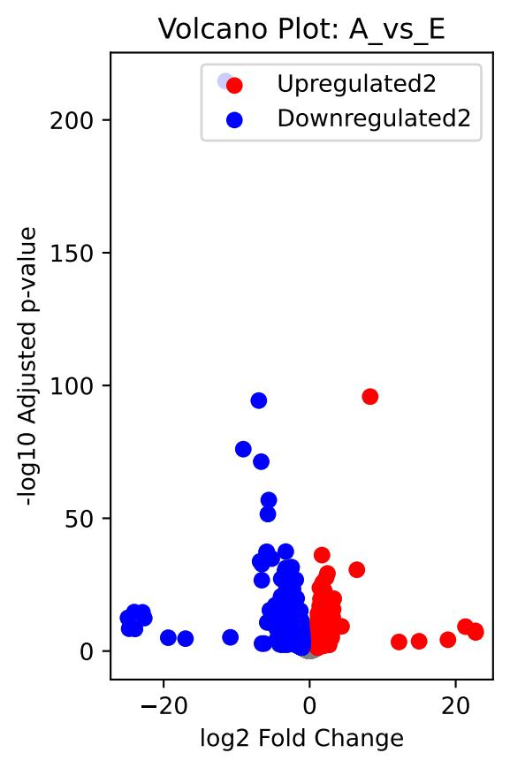

MA Plot::

X axis: represents the average expression of genes under the two conditions, reflecting the average level of gene expression.

Y-axis: represents the log2 fold change value of genes under two conditions. Positive values represent genes that are upregulated in condition D relative to condition A; Negative values indicate down-regulated expression.

Data point color and meaning

Red dots indicate significantly upregulated genes, which are expressed at significantly higher levels in condition D than in condition A.

Blue dots indicate significantly downregulated genes that are expressed at significantly lower levels in condition D than in condition A.

Gray dots: represent not significant genes whose expression differences between the two conditions do not meet the criteria of statistical significance.

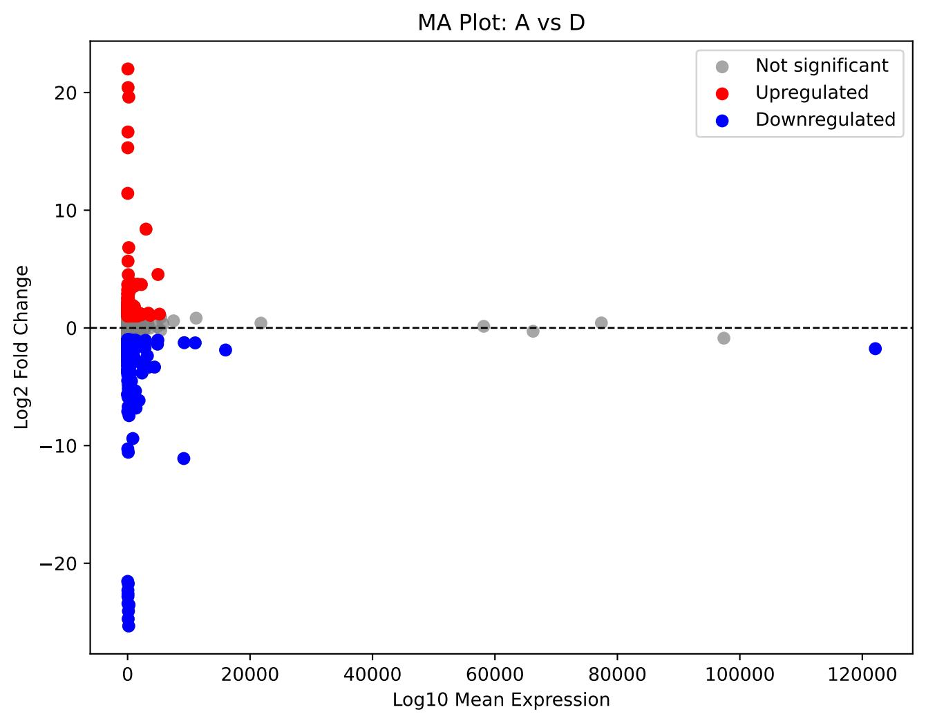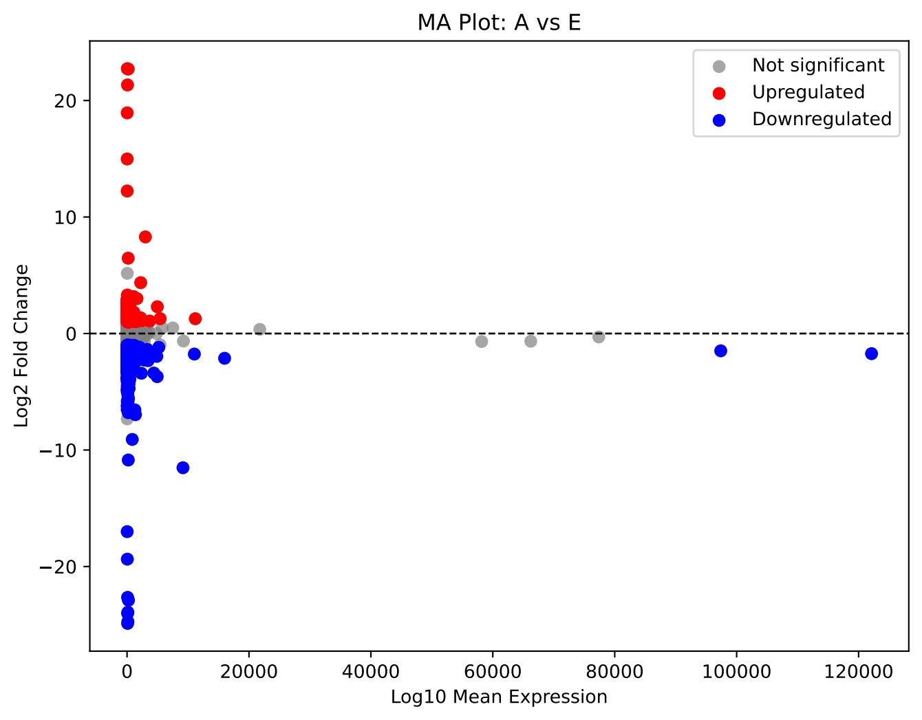

p-value distribution:

Histogram of P-value distribution of gene expression differences between condition A and condition D.

X-axis: Indicates the adjusted p-value, ranging from 0 to 1.

Y-axis: represents frequency, i.e. the number of genes in each P-value interval

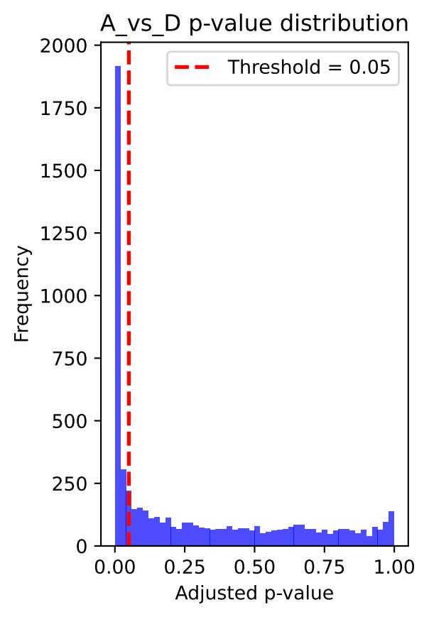\

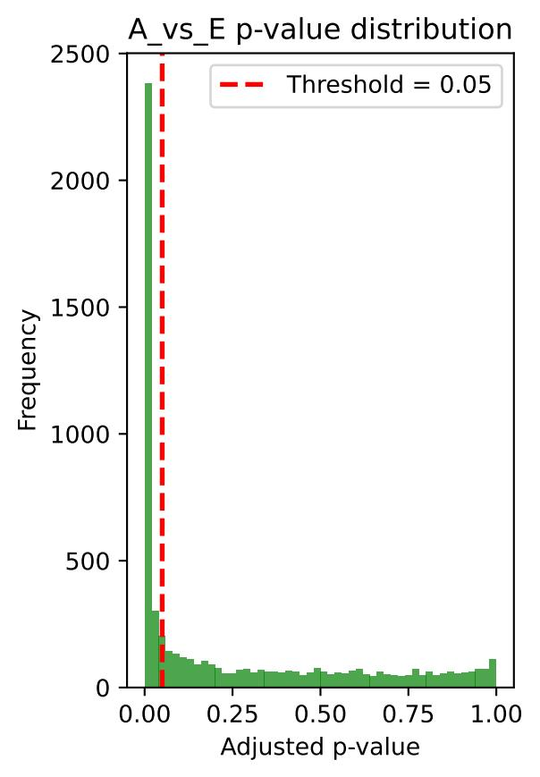

Heatmap:

The heat map shows the expression levels of differentially expressed genes between condition A and condition D

X axis: Represents the average expression of genes (baseMean), ranging from 0 to 120,000.

Y-axis: Represents gene ID, which lists the identifiers of multiple genes.

Color bar: The color bar on the right indicates the expression level, from blue (low expression) to red (high expression).

