Gone With the Wind Model

Zhihan Chen, Zhiqi Ma, Yue Yang, Hung-yu Chen

**Paper Summary:**

The paper constructs a mathematical model for analyzing the love dynamics between Scarlett O'Hara and Rhett Butler in the film "Gone with the Wind." The authors use the following two ODEs respectively to model the fluctuating relationship, which is influenced by each character's ability to attract and respond to the other's affections.

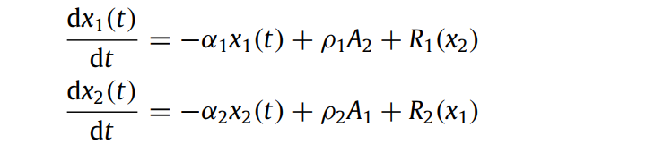

In the above ODEs, −αi*xi(t) represents the oblivion process (αi is the forgetting coefficient), where individuals lose memory of their partners gradually after separation; ρjAi denotes the change of interest generated in individual j by the appeal of the partner i, where Ai is the appeal of individual i and ρj is the sensitivity of individual j to i’s appeal; Rj(xi) signifies the change of interest generated in individual j by the love of the partner i.

By taking different initial values A1 and A2, the authors plot the following three figures.

* In scenario 1 (Figure a), Scarlett and Rhett have equal appeal, and the model predicts a trajectory that tends towards a balanced, though unstable, relationship;
* In scenario 2 (Figure b), Scarlett is slightly more appealing than Rhett, which leads to an equilibrium where Rhett is more involved than Scarlett;
* The final scenario (Figure c) shows the effect of a significant increase in Rhett's appeal post-war, resulting in a stable equilibrium where Scarlett is more involved than Rhett.

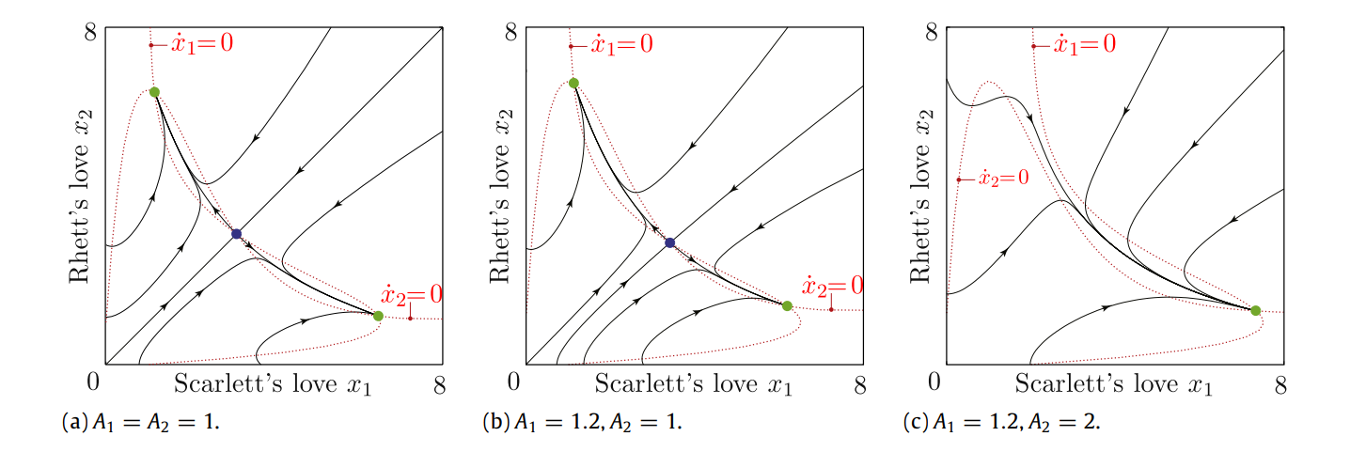

These three figures are constructed intentionally based on the authors’ interpretation of the evolution for Scarlett and Rhett’s love. Specifically, the authors assume that all coefficients in ODEs above are equal for two individuals except for A1 and A2. Then Figure a,b, and c correspond to the initial phase, middle phase, and the final phase of this love story, considering the appeal change between Scarlett and Rhett. Put them together, the authors present the following figure, which shows the overall evolution model, and they conclude that the model accurately predicts the complex evolution of Scarlett and Rhett's relationship in the film.

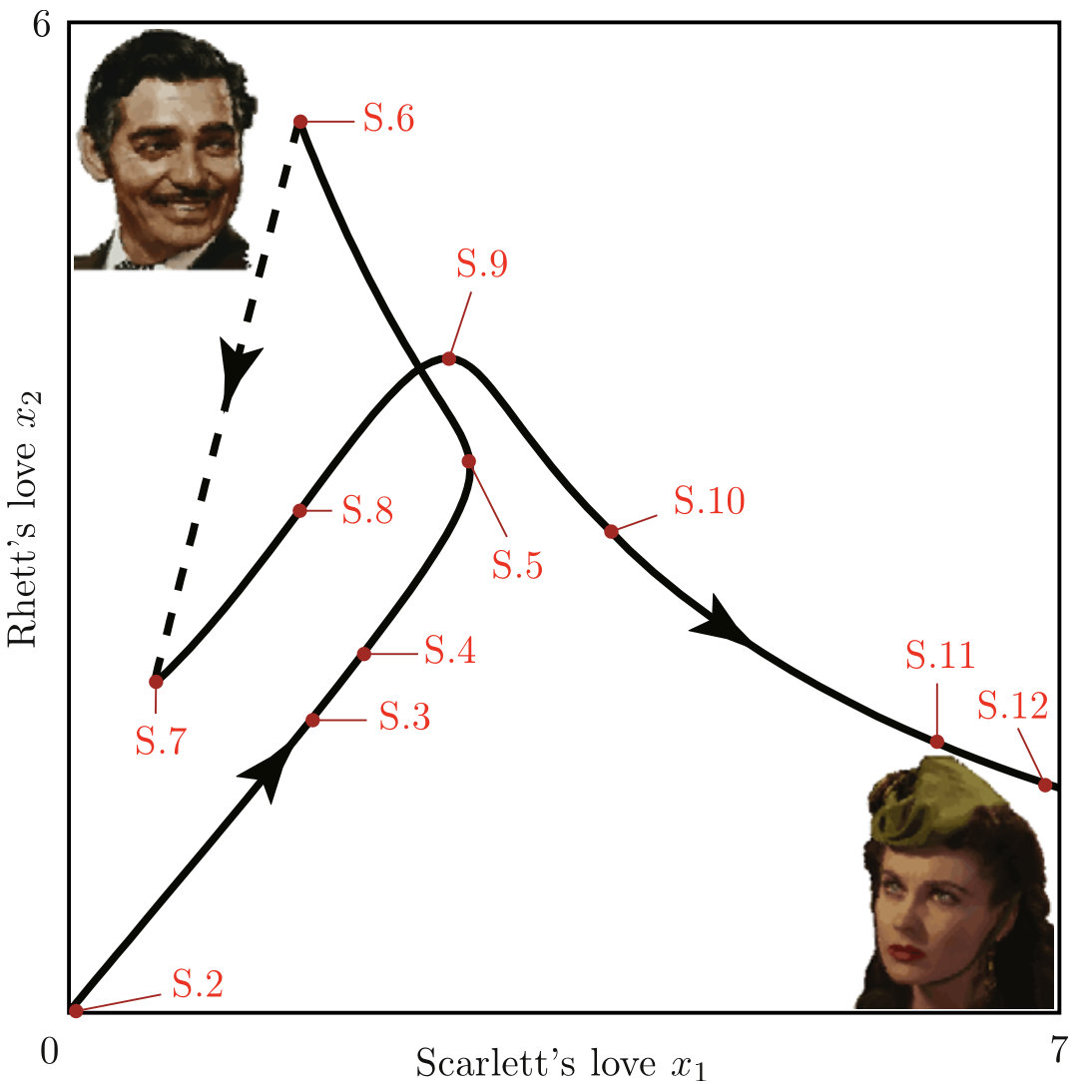

**Possible Modifications:**

1. Assumption verification:
   1. The author assumes that the feelings between Scarlett and Rhett are always positive. We think that Scarlett has a really bad first impression of Rhett and she hates Rhett when Rhett refuses to lend money to her in the second part of the film.
   2. The author used twelve scenes as a reference to describe the change of feelings between Scarlett and Rhett. We want to add other scenes that are also helpful:
      1. Shortly after S2, the first encounter between Scarlett and Rhett, since Rhett overheard Ashley refusing Scarlett and was caught by Scarlett, Scarlett felt ashamed and fell out of favor with Rhett.
      2. S6 is also oversimplified: at first, Scarlett is grateful that Rhett rescued her from the Yankees, especially if we consider the hardship of this escape, which implies that Scarlett’s love for Rhett increased; then it’s the case mentioned in the paper such that Rhett decided to leave Scarlett and join the army, where Scarlett’s love for Rhett decreased.
      3. Between S11 and S12, Scarlett falls down the stairs during an argument with Rhett and has a miscarriage, which leads to Rhett's guilt and Scarlett's resentment.
2. Adding/modifying parameters:
   1. The author thinks that Rhett is only interested in Scarlett’s beauty, but we think that Rhett is also attracted by Scarlett’s other characteristics. At the same time, A1 can decrease due to Scarlett’s love for Ashley all the time. This changes the appeal of Scarlett, A1, in different scenes.
   2. To accommodate the A1, we can also add different weights, which are changed based on external factors like time.
   3. The A2 can also be a linear combination of some components with different weights. For example, the attractiveness of Rhett given by Scarlett not only depends on Rhett’s wealth but also depends on Scarlett’s economic and psychological condition.
3. Variations and Bifurcations analysis:
4. The author assumes the forgetting coefficient (α), the sensitivity coefficient (ρ), and the particular constant β to be 1, and the remaining coefficient k to be 15. We can adjust the value to those parameters to see if the change of variables will affect the trajectories and their global equilibrium.

**Division of Works:**

1. Collect more data from the film: Zhiqi Ma
2. Read and summarize relevant papers: Hung-yu Chen
3. Analyze the model in the paper: Hung-yu Chen
4. Using Matlab/python to replicate the model: Hung-yu Chen
5. Finding limits of the model: Zhihan Chen
6. Using Matlab/python to do experiments to improve the model:
   1. Modify assumptions: Zhiqi Ma
   2. Modify A1(Scarlett’s attractiveness to Rhett): Yue Yang
   3. Modify A2(Rhett’s attractiveness to Scarlett): Yue Yang
   4. Modify R1(The flow of interest generated in Scarlett by Rhett): Zhihan Chen
   5. Modify R2(The flow of interest generated in Rhett by Scarlett): Zhiqi Ma
7. Plot the phase portrait of the new ODE system: Zhihan Chen
8. Solve the new ODE system and plot the trajectories: Yue Yang

Reference

Those references are used because they contain the complete bifurcation analysis [7,12] with respect to all parameters appearing in the model, which will be helpful for constructing our models.

S.H. Strogatz, Nonlinear Dynamics and Chaos, Addison-Wesley, Reading, MA, 1994.

J.-M. Rey, A mathematical model of sentimental dynamics accounting for marital dissolution, PLoS ONE 5 (2010) e9881.

G. Levinger, Toward the analysis of close relationships, Journal of Experimental Social Psychology 16 (1980) 510–544.

S. Rinaldi, F. Della Rossa, F. Dercole, Love and appeal in standard couples, International Journal of Bifurcations and Chaos 20 (2010) 2443–2451.

A. Gragnani, S. Rinaldi, G. Feichtinger, Cyclic dynamics in romantic relationships, International Journal of Bifurcations and Chaos 7 (1997) 2611–2619.

Yu.A. Kuznetsov, Elements of Applied Bifurcation Theory, third ed., Springer-Verlag, Berlin, 2004.

Dercole, Fabio and Sergio Rinaldi. “Love stories can be unpredictable: Jules et Jim in the vortex of life.” Chaos 24 2 (2014): 023134 .

Matsumoto, Akio. “Love Dynamics Between Cautious Romeo and Juliet with Delays in Self and Cross Reactions.” (2016).

Rinaldi, Sergio et al. “Small Discoveries can have Great Consequences in Love Affairs: the Case of Beauty and the Beast.” Int. J. Bifurc. Chaos 23 (2013): n. pag.

Rinaldi, Sergio et al. “A mathematical model of 'Pride and Prejudice'.” Nonlinear dynamics, psychology, and life sciences 18 2 (2014): 199-211.

Scenes: