Small-Signal Impedance Modeling of

Grid-Following Inverter

\\Oled\lea\Forschung\ogP\8316_BMWi_PV_Kraftwerk2025\Intern\Daten\zya\01_Data\01_Figure\01_Circuit\01_Three-Phase Grid-Tied Inverter\System_Single_Inv_LCL_Lg_ACC_PLL_DVC.emf

Established by

RWTH Aachen University

E.ON Energy Research Center

Institute for Power Generation and Storage Systems

Dr.-Ing. Zhiqing Yang

Aachen, on July 2021

Content

[Alternating-Current Control (ACC) 3](#_Toc91247435)

[Proportional-integral (PI) control 3](#_Toc91247436)

[Proportional-resonant (PR) control 5](#_Toc91247437)

[LCL Filter 7](#_Toc91247438)

[Direct-Voltage Control (DVC) 8](#_Toc91247439)

[DC-Link Capacitor 9](#_Toc91247440)

[Phase-Locked Loop (PLL) 10](#_Toc91247441)

[Reference Frame 11](#_Toc91247442)

[System frame 🡪 global frame 11](#_Toc91247443)

[System frame 🡪 control frame 12](#_Toc91247444)

[Control frame 🡪 system frame 13](#_Toc91247445)

[Modulation Delay 14](#_Toc91247446)

[Impedance Model 15](#_Toc91247447)

[Reference 16](#_Toc91247448)

# Alternating-Current Control (ACC)

## Proportional-integral (PI) control

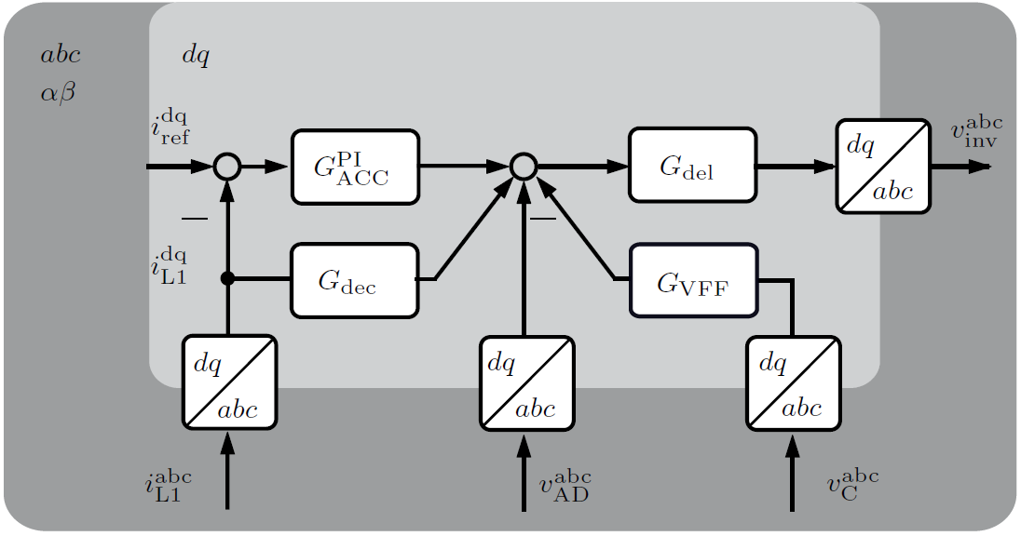

Control transfer function

Control transfer matrix

Decoupling transfer matrix

Voltage feedforward filter (VFF) transfer matrix

Active damping (AD) transfer matrix

Delay matrix in Padé approximation form

Frequency-domain relation

Linearization

## Proportional-resonant (PR) control

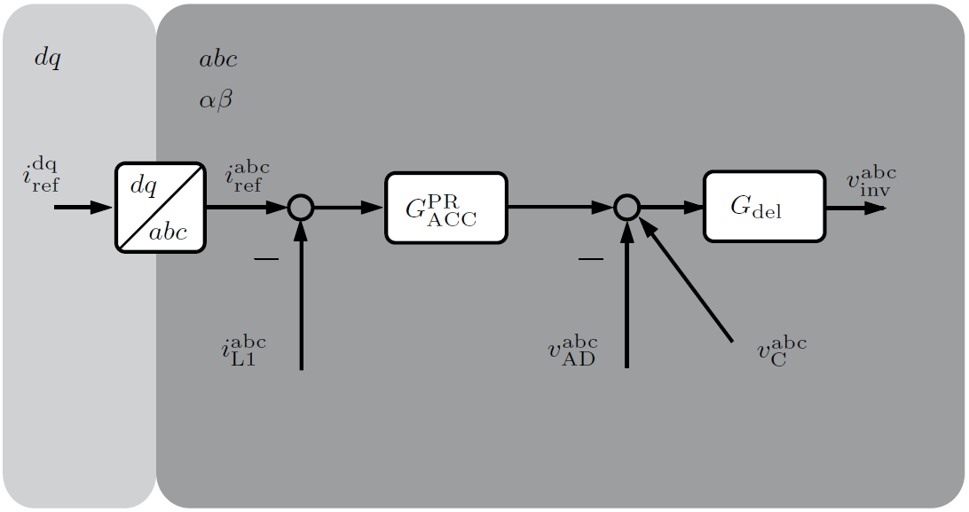

Control transfer function

Control transfer matrix

Active damping (AD) transfer matrix

Delay matrix in Padé approximation form

Frequency-domain relation

Linearization

# LCL Filter

# Direct-Voltage Control (DVC)

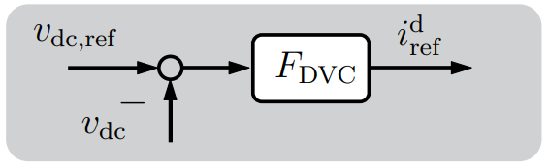

Control transfer function

Frequency-domain relation

Linearization

# DC-Link Capacitor

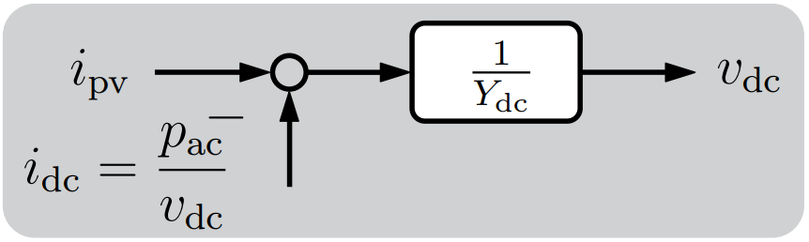

Plant dynamics

Power balance

Linearization

# Phase-Locked Loop (PLL)

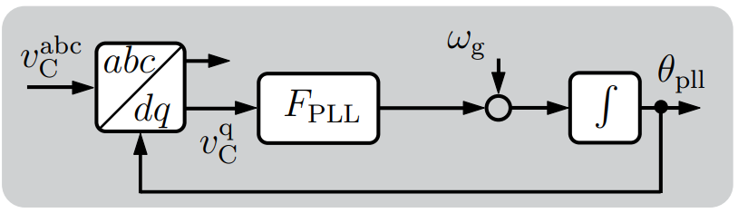

Control transfer function

Linearization according to [1, 2]

Derivation:

According to (E.11) in [2], a variable in the system frame observed in the control frame

According to PLL control diagram

Substitute , acquire

The small-signal transfer function influences the variables through Park and inverse Park transformation, e.g.

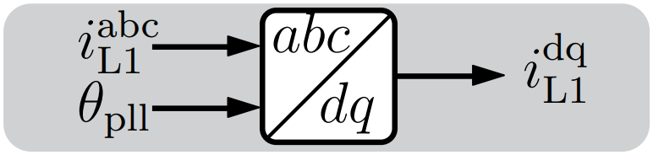 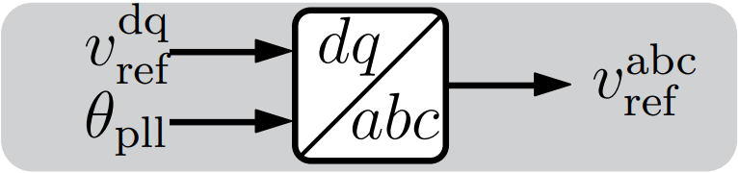

Detailed mathematical impacts are analyzed in the section reference frame

# Reference Frame

Clockwise rotation

Anti-clockwise rotation

**Note:** Usually an anti-clockwise rotation is defined as , however the rotation in the above depicted figure presents the relation of reference frames. A variable in a frame has a reverse rotation reflected in another frame. For convenience, the rotation angle is defined as positive for clockwise rotation, so that a variable observed in different frames can be evaluated according to the rotation direction of frames.

**Example:** a variable in the frame align with the direction of should be with a rotation of when being observed from the .

## System frame 🡪 global frame

To facilitate the integration of multi-inverter system, a common global frame is defined. Each inverter has its own rotation frame. They can be aggregated only after being converted into the same global frame.

According to (E.3) in [2], a variable in the system frame observed in the global frame

Consider inverter

Then

## System frame 🡪 control frame

According to (E.11) in [2], a variable in the system frame observed in the control frame

According to the derivation in the PLL section

Due to the PLL dynamics, variables with Park transformation are converted from the system to control frame.

Inverter-side inductor current

Grid-side capacitor current

Grid-side capacitor voltage

## Control frame 🡪 system frame

Due to the PLL dynamics, variables with inverse Park transformation are converted from the control to system frame.

Modulation index

If PR control is implemented, reference current obtained in the frame should be converted to the frame, which also requires inverse Park transformation, i.e.

# Modulation Delay

The modulation delay in the complex frequency domain can be precisely modeled as:

If the delay is expanded in Euler’s form,

The delay transfer matrix can be described as below.

If the delay is expanded in Padé approximation,

The delay transfer matrix can be described as below.

It should be noticed that, the following format is not very strict, since all the elements in a transfer matrix should be real transfer functions according to [3].

# Impedance Model

|  |  |  |
| --- | --- | --- |
| Control | Without DVC | With DVC |
| PI |  |  |
| PR |  |  |

Where,

# Reference

The model development can refer [4, 5, 6, 7, 2]

|  |  |
| --- | --- |
| [1] | B. Wen, D. Boroyevich, R. Burgos, P. Mattavelli and Z. Shen, "Analysis of D-Q Small-Signal Impedance of Grid-Tied Inverters," *IEEE Transactions on Power Electronics,* vol. 31, no. 1, pp. 675-687, 2016. |
| [2] | Z. Yang, On the Stability of Three-Phase Grid-Tied Photovoltaic Inverter Systems, vol. 90, Aachen: E.ON Energy Research Center, RWTH Aachen University, 2021. |
| [3] | L. Harnefors, "Modeling of Three-Phase Dynamic Systems Using Complex Transfer Functions and Transfer Matrices," *IEEE Transactions on Industrial Electronics,* vol. 54, no. 4, pp. 2239-2248, 2007. |
| [4] | Z. Yang, C. Shah, T. Chen, L. Yu, P. Joebges and R. De Doncker, "Stability Investigation of Three-Phase Grid-Tied PV Inverter Systems Using Impedance Models," *IEEE Journal of Emerging and Selected Topics in Power Electronics,* p. doi: 10.1109/JESTPE.2020.3047964, 2020. |
| [5] | Z. Yang, W. Gou, X. Luo, C. Shah, N. R. Averous and R. W. De Doncker, "Stability Investigation of Three-Phase Grid-Tied PV Inverters with Impedance-Based Method," in *2020 22nd European Conference on Power Electronics and Applications (EPE'20 ECCE Europe)*, Lyon, 2020. |
| [6] | Z. Yang, C. Shah, T. Chen, J. Teichrib and R. W. De Doncker, "Virtual Damping Control Design of Three-Phase Grid-Tied PV Inverters for Passivity Enhancement," *IEEE Transactions on Power Electronics,* p. doi: 10.1109/TPEL.2020.3035417, 2020. |
| [7] | Z. Yang, T. Chen, X. Luo, P. Schülting and R. W. De Doncker, "Margin Balancing Control Design of Three-Phase Grid-Tied PV Inverters for Stability Improvement," *IEEE Transactions on Power Electronics,* vol. 36, no. 9, pp. 10716-10728, 2021. |