Small-Signal State-Space Modeling of Grid-Following Inverter

\\Oled\lea\Forschung\ogP\8316_BMWi_PV_Kraftwerk2025\Intern\Daten\zya\01_Data\01_Figure\01_Circuit\01_Three-Phase Grid-Tied Inverter\System_Single_Inv_LCL_Lg_ACC_PLL_DVC.emf

Established by

RWTH Aachen University

E.ON Energy Research Center

Institute for Power Generation and Storage Systems

Dr.-Ing. Zhiqing Yang

Aachen, on July 2021

Content

[Direct-Voltage Control (DVC) 3](#_Toc77882901)

[State-space model 4](#_Toc77882902)

[Alternating-Current Control (ACC) 5](#_Toc77882903)

[State-space model 6](#_Toc77882904)

[Modulation Delay 7](#_Toc77882905)

[State-space model 8](#_Toc77882906)

[LCL Filter 9](#_Toc77882907)

[State-space model 10](#_Toc77882908)

[Phase-Locked Loop (PLL) 11](#_Toc77882909)

[State-space model 12](#_Toc77882910)

[DC-Link Capacitor 13](#_Toc77882911)

[State-space model 14](#_Toc77882912)

[Grid 15](#_Toc77882913)

[State-space model 16](#_Toc77882914)

[Reference Frame 17](#_Toc77882915)

[Global frame 🡪 system frame 17](#_Toc77882916)

[System frame 🡪 control frame 17](#_Toc77882917)

[Control frame 🡪 system frame 18](#_Toc77882918)

[Derivation of small-signal relationship 18](#_Toc77882919)

[Component Connection Method (CCM) 20](#_Toc77882920)

[State-space model: inverter 20](#_Toc77882921)

[State-space model: inverter + grid 23](#_Toc77882922)

[Padé Approximation 26](#_Toc77882923)

[State-space model 27](#_Toc77882924)

[Reference 28](#_Toc77882925)

# Direct-Voltage Control (DVC)

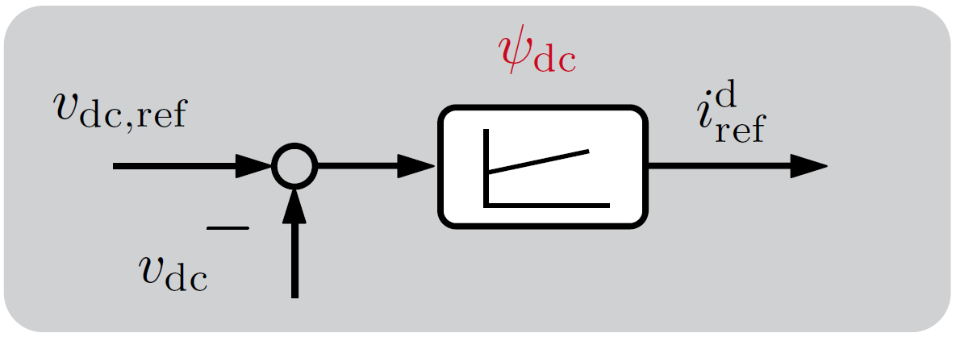

State equation

$$\frac{dψ_{dc}}{dt}=v_{dc,ref}-v_{dc}$$

Output equation

$$i_{ref}^{d}=K_{p}^{DVC}\left(v_{dc,ref}-v_{dc}\right)+K_{i}^{DVC}ψ_{dc}$$

$$i_{ref}^{q}=0$$

Linearization

$$\frac{d{∆ψ}_{dc}}{dt}=∆v_{dc,ref}-{∆v}_{dc}$$

$${∆i}_{ref}^{d}=K_{p}^{DVC}\left(∆v_{dc,ref}-{∆v}_{dc}\right)+K_{i}^{DVC}{∆ψ}_{dc}$$

$${∆i}_{ref}^{q}=0$$

## State-space model

$$\frac{d}{dt}{∆x}_{DVC}{{=A}_{DVC}∆x}_{DVC}+B_{DVC}∆u_{DVC}$$

$${∆y}_{DVC}=C_{DVC}∆x_{DVC}+D_{DVC}∆u_{DVC}$$

$${∆x}_{DVC}^{1x1}={\left[{∆ψ}_{dc}\right]}^{T}$$

$$∆u_{DVC}^{2x1}={\left[\begin{matrix}{∆v}_{dc,ref} & {∆v}_{dc}\end{matrix}\right]}^{T}$$

$${∆y}_{DVC}^{1x1}={\left[{∆i}_{ref}^{d}\right]}^{T}$$

$$A_{DVC}^{1x1}=\left[0\right]$$

$$B_{DVC}^{1x2}=\left[\begin{matrix}1 & -1\end{matrix}\right]$$

$$C_{DVC}^{1x1}=\left[K_{i}^{DVC}\right]$$

$$D_{DVC}^{1x2}=\left[\begin{matrix}K_{p}^{DVC} & -K_{p}^{DVC}\end{matrix}\right]$$

# Alternating-Current Control (ACC)

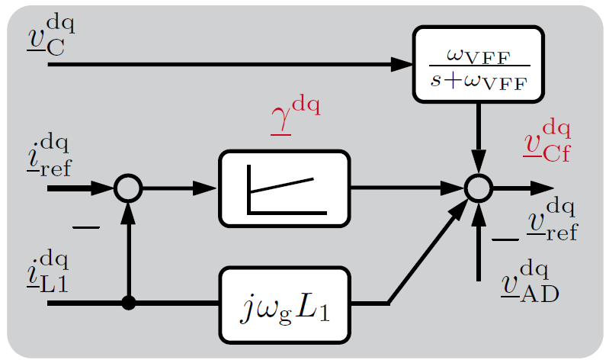

State equation

$$\frac{dγ^{d}}{dt}=i_{ref}^{d}-i_{L1}^{d,c}$$

$$\frac{dγ^{q}}{dt}=i_{ref}^{q}-i_{L1}^{q,c}$$

$$\frac{dv_{Cf}^{d,c}}{dt}={-ω}_{VFF}v_{Cf}^{d,c}+ω_{VFF}v_{C}^{d,c}$$

$$\frac{dv_{Cf}^{q,c}}{dt}={-ω}_{VFF}v_{Cf}^{q,c}+ω_{VFF}v_{C}^{q,c}$$

Output equation

$$v_{ref}^{d}=K_{p}^{ACC}\left(i_{ref}^{d}-i_{L1}^{d,c}\right)+K_{i}^{ACC}γ^{d}-ω_{g}L_{1}i_{L1}^{q,c}+v_{Cf}^{d,c}-K_{AD}\left(i_{L1}^{d,c}-i_{L2}^{d,c}\right)$$

$$v_{ref}^{q}=K_{p}^{ACC}\left(i_{ref}^{q}-i_{L1}^{q,c}\right)+K_{i}^{ACC}γ^{q}+ω_{g}L_{1}i_{L1}^{d,c}+v_{Cf}^{q,c}-K_{AD}\left(i_{L1}^{q,c}-i_{L2}^{q,c}\right)$$

Linearization

$$\frac{d{∆γ}^{d}}{dt}={∆i}_{ref}^{d}-{∆i}_{L1}^{d,c}$$

$$\frac{d{∆γ}^{q}}{dt}={∆i}_{ref}^{q}-{∆i}_{L1}^{q,c}$$

$$\frac{d∆v_{Cf}^{d,c}}{dt}={-ω}_{VFF}{∆v}_{Cf}^{d,c}+ω_{VFF}{∆v}_{C}^{d,c}$$

$$\frac{d{∆v}_{Cf}^{q,c}}{dt}={-ω}_{VFF}{∆v}_{Cf}^{q,c}+ω_{VFF}{∆v}_{C}^{q,c}$$

$${∆v}_{ref}^{d}=K_{p}^{ACC}\left({∆i}_{ref}^{d}-{∆i}_{L1}^{d,c}\right)+K_{i}^{ACC}∆γ^{d}-ω_{g}L_{1}{∆i}_{L1}^{q,c}+{∆v}_{Cf}^{d,c}-K_{AD}\left(∆i_{L1}^{d,c}-{∆i}_{L2}^{d,c}\right)$$

$${∆v}_{ref}^{q}=K_{p}^{ACC}\left({∆i}_{ref}^{q}-{∆i}_{L1}^{q,c}\right)+K_{i}^{ACC}∆γ^{q}+ω_{g}L_{1}∆i_{L1}^{d,c}+{∆v}_{Cf}^{q,c}-K_{AD}\left(∆i_{L1}^{q,c}-{∆i}_{L2}^{q,c}\right)$$

## State-space model

$$\frac{d}{dt}{∆x}_{ACC}{{=A}_{ACC}∆x}_{ACC}+B_{ACC}∆u_{ACC}$$

$${∆y}_{ACC}=C_{ACC}∆x_{ACC}+D_{ACC}∆u_{ACC}$$

$${∆x}_{DVC}^{4x1}={\left[\begin{matrix}{∆γ}^{d} & {∆γ}^{q} & ∆v_{Cf}^{d,c} & {∆v}_{Cf}^{q,c}\end{matrix}\right]}^{T}$$

$$∆u_{DVC}^{8x1}={\left[\begin{matrix}{∆i}_{ref}^{d} & {∆i}_{ref}^{q} & {∆i}_{L1}^{d,c} & {∆i}_{L1}^{q,c} & {∆v}_{C}^{d,c} & {∆v}_{C}^{q,c} & {∆i}_{L2}^{d,c} & {∆i}_{L2}^{q,c}\end{matrix}\right]}^{T}$$

$${∆y}_{DVC}^{2x1}={\left[\begin{matrix}{∆v}_{ref}^{d} & {∆v}_{ref}^{q}\end{matrix}\right]}^{T}$$

$$A_{ACC}^{4x4}=\left[\begin{matrix}0 & 0 & 0 & 0 \\ 0 & 0 & 0 & 0 \\ 0 & 0 & {-ω}_{VFF} & 0 \\ 0 & 0 & 0 & {-ω}_{VFF}\end{matrix}\right]$$

$$B_{ACC}^{4x8}=\left[\begin{matrix}1 & 0 & -1 & 0 & 0 & 0 & 0 & 0 \\ 0 & 1 & 0 & -1 & 0 & 0 & 0 & 0 \\ 0 & 0 & 0 & 0 & ω_{VFF} & 0 & 0 & 0 \\ 0 & 0 & 0 & 0 & 0 & ω_{VFF} & 0 & 0\end{matrix}\right]$$

$$C_{ACC}^{2x4}=\left[\begin{matrix}K_{i}^{ACC} & 0 & 1 & 0 \\ 0 & K_{i}^{ACC} & 0 & 1\end{matrix}\right]$$

$$D_{ACC}^{2x8}=\left[\begin{matrix}K_{p}^{ACC} & 0 & -\left(K_{p}^{ACC}+K_{AD}\right) & -ω_{g}L_{1} & 0 & 0 & K_{AD} & 0 \\ 0 & K_{p}^{ACC} & ω_{g}L_{1} & -\left(K_{p}^{ACC}+K_{AD}\right) & 0 & 0 & 0 & K_{AD}\end{matrix}\right]$$

# Modulation Delay

Refer to Padé approximation

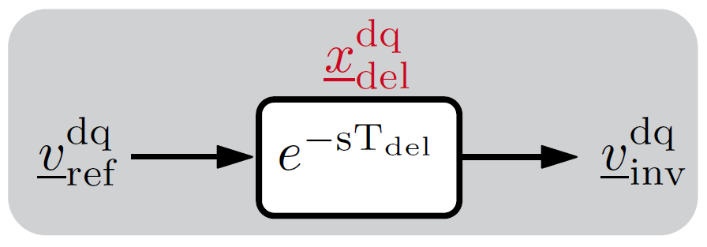

State equation

$$\frac{dx_{del}^{d}}{dt}=A_{d}x_{d}^{d}+B_{d}v_{ref}^{d}$$

$$\frac{dx_{del}^{q}}{dt}=A_{d}x_{d}^{q}+B_{d}v_{ref}^{q}$$

Output equation

$$v_{inv}^{d,c}=C_{d}x_{d}^{d}+D_{d}v_{ref}^{d}$$

$$v_{inv}^{q,c}=C_{d}x_{d}^{q}+D_{d}v_{ref}^{q}$$

Linearization

$$\frac{d{∆x}_{del}^{d}}{dt}=A_{d}∆x_{d}^{d}+B_{d}{∆v}_{ref}^{d}$$

$$\frac{d∆x_{del}^{q}}{dt}=A_{d}{∆x}_{d}^{q}+B_{d}{∆v}_{ref}^{q}$$

$$∆v_{inv}^{d,c}=C_{d}∆x_{d}^{d}+D_{d}{∆v}_{ref}^{d}$$

$$∆v_{inv}^{q,c}=C_{d}{∆x}_{d}^{q}+D_{d}{∆v}_{ref}^{q}$$

## State-space model

$$\frac{d}{dt}{∆x}_{del}{{=A}_{del}∆x}_{del}+B_{del}∆u_{del}$$

$${∆y}_{del}=C_{del}∆x_{del}+D_{del}∆u_{del}$$

$${∆x}_{del}^{2x1}={\left[\begin{matrix}{∆x}_{del}^{d} & {∆x}_{del}^{q}\end{matrix}\right]}^{T}$$

$$∆u_{del}^{2x1}={\left[\begin{matrix}{∆v}_{ref}^{d} & {∆v}_{ref}^{q}\end{matrix}\right]}^{T}$$

$${∆y}_{del}^{2x1}={\left[\begin{matrix}{∆v}_{ref}^{d,c} & {∆v}_{ref}^{q,c}\end{matrix}\right]}^{T}$$

$$A_{del}^{2x2}=\left[\begin{matrix}A_{d} & 0 \\ 0 & A_{d}\end{matrix}\right]$$

$$B_{del}^{2x2}=\left[\begin{matrix}B_{d} & 0 \\ 0 & B_{d}\end{matrix}\right]$$

$$C_{del}^{2x2}=\left[\begin{matrix}C_{d} & 0 \\ 0 & C_{d}\end{matrix}\right]$$

$$D_{del}^{2x2}=\left[\begin{matrix}D_{d} & 0 \\ 0 & D_{d}\end{matrix}\right]$$

# LCL Filter

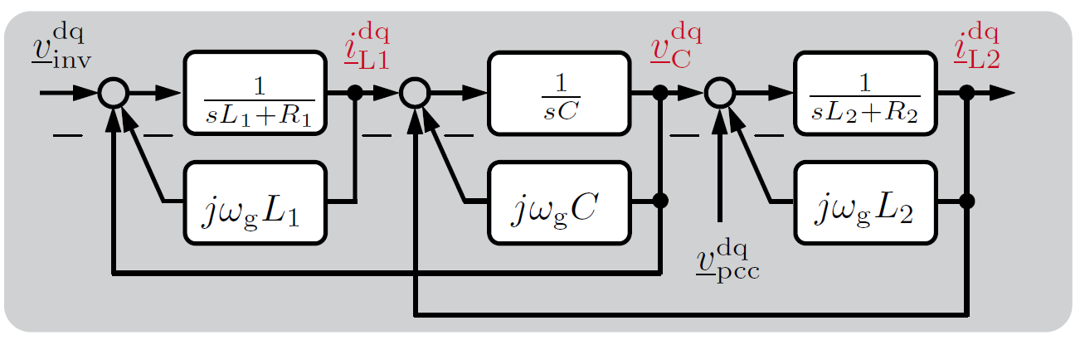

State equation

$$\frac{di_{L1}^{d,s}}{dt}=\frac{1}{L_{1}}v_{inv}^{d,s}-\frac{1}{L_{1}}v_{C}^{d,s}-\frac{R_{1}}{L_{1}}i_{L1}^{d,s}+ω_{g}i_{L1}^{q,s}$$

$$\frac{di_{L1}^{q,s}}{dt}=\frac{1}{L_{1}}v_{inv}^{q,s}-\frac{1}{L_{1}}v_{C}^{q,s}-\frac{R_{1}}{L_{1}}i_{L1}^{q,s}-ω_{g}i_{L1}^{d,s}$$

$$\frac{dv_{C}^{d,s}}{dt}=\frac{1}{C}i_{L1}^{d,s}-\frac{1}{C}i_{L2}^{d,s}+ω_{g}v_{C}^{q,s}$$

$$\frac{dv_{C}^{q,s}}{dt}=\frac{1}{C}i_{L1}^{q,s}-\frac{1}{C}i_{L2}^{q,s}-ω_{g}v_{C}^{d,s}$$

$$\frac{di_{L2}^{d,s}}{dt}=\frac{1}{L_{2}}v_{C}^{d,s}-\frac{1}{L_{2}}v_{pcc}^{d,s}-\frac{R_{2}}{L_{2}}i_{L2}^{d,s}+ω_{g}i_{L2}^{q,s}$$

$$\frac{di_{L2}^{q,s}}{dt}=\frac{1}{L_{2}}v_{C}^{q,s}-\frac{1}{L_{2}}v_{pcc}^{q,s}-\frac{R_{2}}{L_{2}}i_{L2}^{q,s}-ω_{g}i_{L2}^{d,s}$$

Linearization

$$\frac{d{∆i}_{L1}^{d,s}}{dt}=\frac{1}{L_{1}}{∆v}_{inv}^{d,s}-\frac{1}{L_{1}}{∆v}_{C}^{d,s}-\frac{R_{1}}{L_{1}}∆i_{L1}^{d,s}+ω_{g}∆i_{L1}^{q,s}$$

$$\frac{d∆i_{L1}^{q,s}}{dt}=\frac{1}{L_{1}}{∆v}_{inv}^{q,s}-\frac{1}{L_{1}}∆v_{C}^{q,s}-\frac{R_{1}}{L_{1}}∆i_{L1}^{q,s}-ω_{g}∆i_{L1}^{d,s}$$

$$\frac{d∆v_{C}^{d,s}}{dt}=\frac{1}{C}{∆i}_{L1}^{d,s}-\frac{1}{C}{∆i}_{L2}^{d,s}+ω_{g}{∆v}_{C}^{q,s}$$

$$\frac{d{∆v}_{C}^{q,s}}{dt}=\frac{1}{C}{∆i}_{L1}^{q,s}-\frac{1}{C}{∆i}_{L2}^{q,s}-ω_{g}{∆v}_{C}^{d,s}$$

$$\frac{d∆i_{L2}^{d,s}}{dt}=\frac{1}{L_{2}}{∆v}_{C}^{d,s}-\frac{1}{L_{2}}{∆v}_{pcc}^{d,s}-\frac{R_{2}}{L_{2}}∆i_{L2}^{d,s}+ω_{g}∆i_{L2}^{q,s}$$

$$\frac{d∆i_{L2}^{q,s}}{dt}=\frac{1}{L_{2}}{∆v}_{C}^{q,s}-\frac{1}{L_{2}}{∆v}_{pcc}^{q,s}-\frac{R_{2}}{L_{2}}{∆i}_{L2}^{q,s}-ω_{g}{∆i}_{L2}^{d,s}$$

## State-space model

$$\frac{d}{dt}{∆x}_{LCL}{{=A}_{ACC}∆x}_{LCL}+B_{del}∆u_{LCL}$$

$${∆y}_{LCL}=C_{LCL}∆x_{LCL}+D_{LCL}∆u_{LCL}$$

$${∆x}_{LCL}^{6x1}={\left[\begin{matrix}\begin{matrix}i_{L1}^{d,s} & i_{L1}^{q,s} & v_{C}^{d,s}\end{matrix} & \begin{matrix}v_{C}^{q,s} & i_{L2}^{d,s} & i_{L2}^{q,s}\end{matrix}\end{matrix}\right]}^{T}$$

$$∆u_{LCL}^{4x1}={\left[\begin{matrix}\begin{matrix}v_{inv}^{d,s} & v_{inv}^{q,s}\end{matrix} & \begin{matrix}v_{pcc}^{d,s} & v_{pcc}^{q,s}\end{matrix}\end{matrix}\right]}^{T}$$

$${∆y}_{LCL}^{6x1}={\left[\begin{matrix}\begin{matrix}i_{L1}^{d,s} & i_{L1}^{q,s} & v_{C}^{d,s}\end{matrix} & \begin{matrix}v_{C}^{q,s} & i_{L2}^{d,s} & i_{L2}^{q,s}\end{matrix}\end{matrix}\right]}^{T}$$

$$A_{LCL}^{6x6}=\left[\begin{matrix}-\frac{R_{1}}{L_{1}} & ω_{g} & -\frac{1}{L_{1}} & 0 & 0 & 0 \\ -ω_{g} & -\frac{R_{1}}{L_{1}} & 0 & -\frac{1}{L_{1}} & 0 & 0 \\ \frac{1}{C} & 0 & 0 & ω_{g} & -\frac{1}{C} & 0 \\ 0 & \frac{1}{C} & -ω_{g} & 0 & 0 & -\frac{1}{C} \\ 0 & 0 & \frac{1}{L_{2}} & 0 & -\frac{R_{2}}{L_{2}} & ω_{g} \\ 0 & 0 & 0 & \frac{1}{L_{2}} & -ω_{g} & -\frac{R_{2}}{L_{2}}\end{matrix}\right]$$

$$B_{LCL}^{6x4}=\left[\begin{matrix}\frac{1}{L_{1}} & 0 & 0 & 0 \\ 0 & \frac{1}{L_{1}} & 0 & 0 \\ 0 & 0 & 0 & 0 \\ 0 & 0 & 0 & 0 \\ 0 & 0 & -\frac{1}{L_{2}} & 0 \\ 0 & 0 & 0 & -\frac{1}{L_{2}}\end{matrix}\right]$$

$$C_{LCL}^{6x6}=I^{6x6}$$

$$D_{LCL}^{6x4}=0^{6x4}$$

# Phase-Locked Loop (PLL)

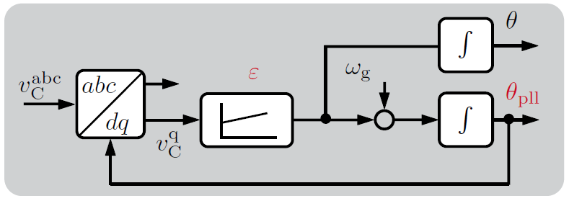

State equation

$$\frac{dε}{dt}=v_{C}^{q,c}$$

$$\frac{dθ}{dt}=K_{p}^{PLL}v_{C}^{q,c}+K_{i}^{PLL}ε+ω_{g}$$

Linearization

$$\frac{d∆ε}{dt}={∆v}_{C}^{q,c}$$

$$\frac{d∆θ}{dt}=K_{p}^{PLL}{∆v}_{C}^{q,c}+K_{i}^{PLL}∆ε+∆ω_{g}$$

$⇓$ If directly convert ${∆v}_{C}^{q,c}$ from the control to system frame

Refer to power angle relationship

$$\frac{d∆ε}{dt}={{∆v}_{C}^{q,c}=∆v}_{C}^{q,s}-V_{C}^{d}∆θ$$

$$\frac{d∆θ}{dt}=K_{p}^{PLL}\left({∆v}_{C}^{q,s}-V_{C}^{d}∆θ\right)+K_{i}^{PLL}∆ε$$

## State-space model

$$\frac{d}{dt}{∆x}_{PLL}{{=A}_{PLL}∆x}_{PLL}+B_{PLL}∆u_{PLL}$$

$${∆y}_{PLL}=C_{PLL}∆x_{PLL}+D_{PLL}∆u_{PLL}$$

$${∆x}_{PLL}^{2x1}={\left[\begin{matrix}∆ε & ∆θ\end{matrix}\right]}^{T}$$

$$∆u_{PLL}^{1x1}={\left[{∆v}_{C}^{q,c}\right]}^{T}$$

$${∆y}_{PLL}^{1x1}={\left[∆θ\right]}^{T}$$

$$A_{PLL}^{2x2}=\left[\begin{matrix}0 & 0 \\ K_{i}^{PLL} & 0\end{matrix}\right]$$

$$B_{PLL}^{2x1}=\left[\begin{matrix}1 \\ K_{p}^{PLL}\end{matrix}\right]$$

$$C_{PLL}^{1x2}=\left[\begin{matrix}\begin{matrix}0 & 1\end{matrix}\end{matrix}\right]$$

$$D_{PLL}^{1x1}=\left[\begin{matrix}0\end{matrix}\right]$$

If consider direct conversion from the control to system frame:

$$∆u_{PLL}^{1x1}={\left[{∆v}_{C}^{q,s}\right]}^{T}$$

$$A_{PLL}^{2x2}=\left[\begin{matrix}0 & -V_{C}^{d} \\ K_{i}^{PLL} & -V_{C}^{d}K_{p}^{PLL}\end{matrix}\right]$$

$$B_{PLL}^{2x2}=\left[\begin{matrix}0 & 1 \\ 0 & K_{p}^{PLL}\end{matrix}\right]$$

$$C_{PLL}^{1x2}=\left[\begin{matrix}\begin{matrix}0 & 1\end{matrix}\end{matrix}\right]$$

$$D_{PLL}^{1x2}=\left[\begin{matrix}\begin{matrix}0 & 0\end{matrix}\end{matrix}\right]$$

# DC-Link Capacitor

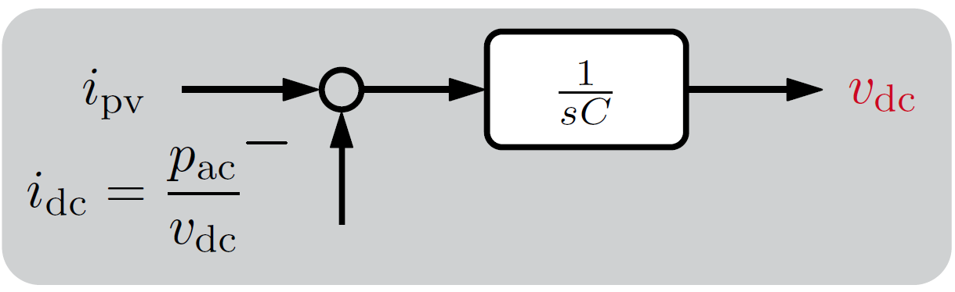

State equation

$$\frac{dv_{dc}}{dt}=\frac{i_{pv}}{C_{dc}}-\frac{3}{2}\frac{\left(v_{inv}^{d,s}i_{L1}^{d,s} +v_{inv}^{q,s}i_{L1}^{q,s} \right)}{{C_{dc}v}_{dc}}$$

Linearization

$$\frac{d{∆v}_{dc}}{dt}=\frac{∆i_{pv}}{C_{dc}}+\frac{3}{2}\frac{\left(V_{inv}^{d}I_{L1}^{d} +V_{inv}^{q}I_{L1}^{q} \right)}{C_{dc}V_{dc}^{2}}{∆v}_{dc}-\frac{3}{2}\frac{I_{L1}^{d}}{{C_{dc}V}_{dc}}∆v_{inv}^{d,s}-\frac{3}{2}\frac{I_{L1}^{q}}{{C_{dc}V}_{dc}}∆v_{inv}^{q,s}-\frac{3}{2}\frac{V_{C}^{d}}{{C_{dc}V}_{dc}}∆i_{L1}^{d,s}-\frac{3}{2}\frac{V_{C}^{q}}{{C_{dc}V}_{dc}}∆i_{L1}^{q,s}$$

## State-space model

$$\frac{d}{dt}{∆x}_{DC}{{=A}_{DC}∆x}_{DC}+B_{DC}∆u_{DC}$$

$${∆y}_{DC}=C_{DC}{∆x}_{DC}+D_{DC}{∆u}_{DC}$$

$${∆x}_{DC}^{1x1}={\left[{∆v}_{dc}\right]}^{T}$$

$$∆u_{DC}^{5x1}={\left[\begin{matrix}{∆v}_{inv}^{d,s} & {∆v}_{inv}^{q,s} & {∆i}_{L1}^{d,s} & {∆i}_{L1}^{q,s} & {∆i}_{pv}\end{matrix}\right]}^{T}$$

$${∆y}_{DC}^{1x1}={\left[{∆v}_{dc}\right]}^{T}$$

$$A_{DC}^{1x1}=\left[\begin{matrix}\frac{3}{2}\frac{\left(V_{inv}^{d}I_{L1}^{d} +V_{inv}^{q}I_{L1}^{q} \right)}{C_{dc}V_{dc}^{2}}\end{matrix}\right]$$

$$B_{DC}^{1x5}=\left[\begin{matrix}-\frac{3}{2}\frac{I_{L1}^{d}}{{C_{dc}V}_{dc}} & -\frac{3}{2}\frac{I_{L1}^{q}}{{C_{dc}V}_{dc}} & -\frac{3}{2}\frac{V_{inv}^{d}}{{C_{dc}V}_{dc}} & -\frac{3}{2}\frac{V_{inv}^{q}}{{C_{dc}V}_{dc}} & \frac{1}{C_{dc}}\end{matrix}\right]$$

$$C_{DC}^{1x1}=I^{1x1}$$

$$D_{DC}^{1x5}=0^{1x5}$$

# Grid

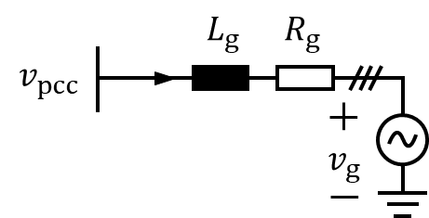

State equation

$$\frac{di_{g}^{D} }{dt}=\frac{1}{L_{g}}v_{pcc}^{D}-\frac{1}{L_{g}}v_{g}^{D}-\frac{R_{g}}{L_{g}}i_{g}^{D}+ω_{g}i_{g}^{Q}$$

$$\frac{di_{g}^{Q} }{dt}=\frac{1}{L_{g}}v_{pcc}^{Q}-\frac{1}{L_{g}}v_{g}^{Q}-\frac{R_{g}}{L_{g}}i_{g}^{Q}-ω_{g}i_{g}^{D}$$

Output equation

(virtual resistor to estimate the voltage at the PCC)

$$v_{pcc}^{D}=R_{v}\left(i_{L2}^{D}-i_{g}^{D}\right)$$

$$v_{pcc}^{Q}=R_{v}\left(i_{L2}^{Q}-i_{g}^{Q}\right)$$

Linearization

$$\frac{d∆i_{g}^{D} }{dt}=\frac{1}{L_{g}}{∆v}_{pcc}^{D}-\frac{1}{L_{g}}{∆v}_{g}^{D}-\frac{R_{g}}{L_{g}}{∆i}_{g}^{D}+ω_{g}{∆i}_{g}^{Q}$$

$$\frac{d{∆i}_{g}^{Q} }{dt}=\frac{1}{L_{g}}{∆v}_{pcc}^{Q}-\frac{1}{L_{g}}{∆v}_{g}^{Q}-\frac{R_{g}}{L_{g}}{∆i}_{g}^{Q}-ω_{g}{∆i}_{g}^{D}$$

$$∆v_{pcc}^{D}=R_{v}\left(∆i_{L2}^{D}-{∆i}_{g}^{D}\right)$$

$${∆v}_{pcc}^{Q}=R_{v}\left({∆i}_{L2}^{Q}-{∆i}_{g}^{Q}\right)$$

## State-space model

$$\frac{d}{dt}{∆x}_{g}{{=A}_{g}∆x}_{g}+B_{g}∆u_{g}$$

$${∆y}_{g}=C_{g}∆x_{g}+D_{g}∆u_{g}$$

$${∆x}_{g}^{2x1}={\left[∆\begin{matrix}i_{g}^{D} & ∆i_{g}^{Q}\end{matrix}\right]}^{T}$$

$${∆u}_{g}^{4x1}={\left[\begin{matrix}{∆i}_{L2}^{D} & ∆i_{L2}^{Q} & {∆v}_{g}^{D} & {∆v}_{g}^{Q}\end{matrix}\right]}^{T}$$

$${∆y}_{g}^{4x1}={\left[\begin{matrix}\begin{matrix}{∆v}_{pcc}^{D} & {∆v}_{pcc}^{Q}\end{matrix} & ∆\begin{matrix}i_{g}^{D} & ∆i_{g}^{Q}\end{matrix}\end{matrix}\right]}^{T}$$

$$A_{g}^{2x2}=\left[\begin{matrix}-\frac{R_{g}+R_{v}}{L_{g}} & ω_{g} \\ -ω_{g} & -\frac{R_{g}+R_{v}}{L_{g}}\end{matrix}\right]$$

$$B_{g}^{2x4}=\left[\begin{matrix}\frac{R_{v}}{L_{g}} & 0 & -\frac{1}{L_{g}} & 0 \\ 0 & \frac{R_{v}}{L_{g}} & 0 & -\frac{1}{L_{g}}\end{matrix}\right]$$

$$C_{g}^{4x2}=\left[\begin{matrix}-R_{v} & 0 \\ 0 & -R_{v} \\ 1 & 0 \\ 0 & 1\end{matrix}\right]$$

$$D_{g}^{4x4}=\left[\begin{matrix}R_{v} & 0 & 0 & 0 \\ 0 & R_{v} & 0 & 0 \\ 0 & 0 & 0 & 0 \\ 0 & 0 & 0 & 0\end{matrix}\right]$$

# Reference Frame

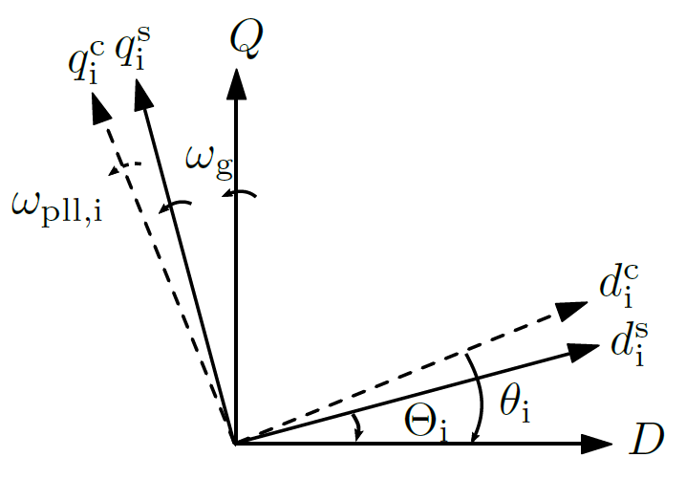

## Global frame 🡪 system frame

To facilitate the integration of multi-inverter system, a common global frame $DQ$ is defined.

Clockwise rotation

$$T_{C}=\left[\begin{matrix}\cos\left(Θ\right) & -\sin\left(Θ\right) \\ \sin\left(Θ\right) & \cos\left(Θ\right)\end{matrix}\right]$$

Anti-clockwise rotation

$$T_{A}=\left[\begin{matrix}\cos\left(Θ\right) & \sin\left(Θ\right) \\ -sin\left(Θ\right) & \cos\left(Θ\right)\end{matrix}\right]$$

Grid-side inductor current of inverter ${Δi}_{L2}^{dq,s}→{Δi}_{L2}^{DQ}$

$$\left[\begin{matrix}{Δi}_{L2}^{D} \\ {Δi}_{L2}^{Q}\end{matrix}\right]=T_{C}\left[\begin{matrix}{Δi}_{L2}^{d,s} \\ {Δi}_{L2}^{q,s}\end{matrix}\right]$$

PCC voltage of the grid ${Δv}_{pcc}^{DQ}→{Δv}_{pcc}^{dq,s}$

$$\left[\begin{matrix}{Δv}_{pcc}^{d,s} \\ Δv_{pcc}^{q,s}\end{matrix}\right]=T_{A}\left[\begin{matrix}{Δv}_{pcc}^{D} \\ {Δv}_{pcc}^{Q}\end{matrix}\right]$$

## System frame 🡪 control frame

Due to the PLL dynamics, variables with Park transformation are converted from the system to control frame.

$$\left[\begin{matrix}{Δx}^{d,c} \\ {Δx}^{q,c}\end{matrix}\right]=\left[\begin{matrix}{Δx}^{d,s} \\ {Δx}^{q,s}\end{matrix}\right]+\left[\begin{matrix}X^{q} \\ -X^{d}\end{matrix}\right]\left[∆θ\right]$$

$$T_{X}^{s2c}=\left[\begin{matrix}X^{q} \\ -X^{d}\end{matrix}\right]$$

Inverter-side inductor current ${Δi}_{L1}^{dq,s}→{Δi}_{L1}^{dq,c}$

$$\left[\begin{matrix}{Δi}_{L1}^{d,c} \\ {Δi}_{L1}^{q,c}\end{matrix}\right]=\left[\begin{matrix}{Δi}_{L1}^{d,s} \\ {Δi}_{L1}^{q,s}\end{matrix}\right]+\left[\begin{matrix}I_{L1}^{q} \\ -I_{L1}^{d}\end{matrix}\right]\left[∆θ\right]$$

Grid-side capacitor current ${Δv}_{C}^{dq,s}→{Δv}_{C}^{dq,c}$

$$\left[\begin{matrix}{Δv}_{C}^{d,c} \\ {Δv}_{C}^{q,c}\end{matrix}\right]=\left[\begin{matrix}{Δv}_{C}^{d,s} \\ {Δv}_{C}^{q,s}\end{matrix}\right]+\left[\begin{matrix}V_{C}^{q} \\ -V_{C}^{d}\end{matrix}\right]\left[∆θ\right]$$

Grid-side inductor current ${Δi}_{L2}^{dq,s}→{Δi}_{L2}^{dq,c}$

$$\left[\begin{matrix}{Δi}_{L2}^{d,c} \\ {Δi}_{L2}^{q,c}\end{matrix}\right]=\left[\begin{matrix}{Δi}_{L2}^{d,s} \\ {Δi}_{L2}^{q,s}\end{matrix}\right]+\left[\begin{matrix}I_{L2}^{q} \\ -I_{L2}^{d}\end{matrix}\right]\left[∆θ\right]$$

## Control frame 🡪 system frame

Due to the PLL dynamics, variables with inverse Park transformation are converted from the control to system frame.

$$\left[\begin{matrix}{Δx}^{d,s} \\ {Δx}^{q,s}\end{matrix}\right]=\left[\begin{matrix}{Δx}^{d,c} \\ {Δx}^{q,c}\end{matrix}\right]+\left[\begin{matrix}{-X}^{q} \\ X^{d}\end{matrix}\right]\left[∆θ\right]$$

$$T_{X}^{c2s}=\left[\begin{matrix}{-X}^{q} \\ X^{d}\end{matrix}\right]$$

Modulation effect ${Δv}_{inv}^{dq,c}→{Δv}_{inv}^{dq,s}$

$$\left[\begin{matrix}{Δv}_{inv}^{d,s} \\ {Δv}_{inv}^{q,s}\end{matrix}\right]=\left[\begin{matrix}{Δv}_{inv}^{d,c} \\ {Δv}_{inv}^{q,c}\end{matrix}\right]+\left[\begin{matrix}-V_{inv}^{q} \\ V_{inv}^{d}\end{matrix}\right]\left[∆θ\right]$$

## Derivation of small-signal relationship

This part provides the derivation of the small-signal relationship between the control and system frame. First consider a variable $x$ that converts from the control to the global frame:

$$x^{DQ}=T_{C}\left(θ\right)x^{dq,c}=T_{C}\left(Θ+∆θ\right)x^{dq,c}$$

The small-signal relationship is derived as:

$${Δx}^{D}={\left[\frac{∂x^{d,c}\cos\left(θ\right)-x^{q,c}\sin\left(θ\right)}{∂x^{d,c}}\right]}_{X^{d},X^{q},Θ}Δx^{d,c}+{\left[\frac{∂x^{d,c}\cos\left(θ\right)-x^{q,c}\sin\left(θ\right)}{∂x^{q,c}}\right]}_{X^{d},X^{q},Θ}Δx^{q,c}$$

$$+{\left[\frac{∂x^{d,c}\cos\left(θ\right)-x^{q,c}\sin\left(θ\right)}{∂θ}\right]}_{X^{d},X^{q},Θ}Δθ$$

$${Δx}^{Q}={\left[\frac{∂x^{d,c}\sin\left(θ\right)+x^{q,c}\cos\left(θ\right)}{∂x^{d,c}}\right]}_{X^{d},X^{q},Θ}Δx^{d,c}+{\left[\frac{∂x^{d,c}\sin\left(θ\right)+x^{q,c}\cos\left(θ\right)}{∂x^{q,c}}\right]}_{X^{d},X^{q},Θ}Δx^{q,c}$$

$$+{\left[\frac{∂x^{d,c}\sin\left(θ\right)-x^{q,c}\cos\left(θ\right)}{∂θ}\right]}_{X^{d},X^{q},Θ}Δθ$$

Which leads to,

$${Δx}^{D}=Δx^{d,c}\cos\left(Θ\right)-Δx^{q,c}\sin\left(Θ\right)+\left(-X^{d}\sin\left(Θ\right)-X^{q}\cos\left(Θ\right)\right)Δθ$$

$${Δx}^{Q}=Δx^{d,c}\sin\left(Θ\right)+Δx^{q,c}\cos\left(Θ\right)+\left(X^{d}\cos\left(Θ\right)-X^{q}\sin\left(Θ\right)\right)Δθ$$

$${Δx}^{DQ}=T_{C}\left(Θ\right){Δx}^{dq,c}+\left[\begin{matrix}-X^{d}\sin\left(Θ\right)-X^{q}\cos\left(Θ\right) \\ X^{d}\cos\left(Θ\right)-X^{q}\sin\left(Θ\right)\end{matrix}\right]Δθ$$

The relationship between ${Δx}^{dq,c}$ and ${Δx}^{dq,s}$

$${Δx}^{dq,s}={T_{A}\left(Θ\right)}^{ }{Δx}^{DQ}={T_{A}\left(Θ\right)}^{ }T_{C}\left(Θ\right){Δx}^{dq,c}+{T_{A}\left(Θ\right)}^{ }\left[\begin{matrix}-X^{d}\sin\left(Θ\right)-X^{q}\cos\left(Θ\right) \\ X^{d}\cos\left(Θ\right)-X^{q}\sin\left(Θ\right)\end{matrix}\right]Δθ$$

$${T_{A}\left(Θ\right)}^{ }\left[\begin{matrix}-X^{d}\sin\left(Θ\right)-X^{q}\cos\left(Θ\right) \\ X^{d}\cos\left(Θ\right)-X^{q}\sin\left(Θ\right)\end{matrix}\right]$$

$$=\left[\begin{matrix}-\cos\left(Θ\right)\left(X^{d}\sin\left(Θ\right)+X^{q}\cos\left(Θ\right)\right)+\sin\left(Θ\right)\left(X^{d}\cos\left(Θ\right)-X^{q}\sin\left(Θ\right)\right) \\ \sin\left(Θ\right)\left(X^{d}\sin\left(Θ\right)+X^{q}\cos\left(Θ\right)\right)+\cos\left(Θ\right)\left(X^{d}\cos\left(Θ\right)-X^{q}\sin\left(Θ\right)\right)\end{matrix}\right]=\left[\begin{matrix}-X^{q} \\ X^{d}\end{matrix}\right]$$

Thus,

$${Δx}^{dq,s}={Δx}^{dq,c}+\left[\begin{matrix}-X^{q} \\ X^{d}\end{matrix}\right]Δθ$$

$${Δx}^{dq,c}={Δx}^{dq,s}+\left[\begin{matrix}X^{q} \\ {-X}^{d}\end{matrix}\right]Δθ$$

# Component Connection Method (CCM)

## State-space model: inverter

State equation

$$\frac{d}{dt}{∆x}_{INV}{{=A}_{INV}∆x}_{INV}+B_{INV}∆a_{INV}$$

$${∆b}_{INV}=C_{INV}∆x_{INV}+D_{INV}∆a_{INV}$$

$∆x$: State variable of all subsystems / the entire system

$${∆x}_{INV}={\left[∆\begin{matrix}x_{DVC}^{T} & ∆x_{ACC}^{T} & {∆x}_{del}^{T} & {∆x}_{LCL}^{T} & {∆x}_{PLL}^{T} & {∆x}_{DC}^{T}\end{matrix}\right]}^{T}$$

$${∆x}_{INV}^{16x1}={\left[\begin{matrix}1x1 & 1x4 & 1x2 & 1x6 & 1x2 & 1x1\end{matrix}\right]}^{T}$$

$∆u$: Input vector of all subsystems

$$∆u_{INV}={\left[∆\begin{matrix}u_{DVC}^{T} & {∆u}_{ACC}^{T} & {∆u}_{del}^{T} & ∆x_{LCL}^{T} & ∆u_{PLL}^{T} & {∆u}_{DC}^{T}\end{matrix}\right]}^{T}$$

$${∆u}_{INV}^{22x1}={\left[\begin{matrix}1x2 & 1x8 & 1x2 & 1x4 & 1x1 & 1x5\end{matrix}\right]}^{T}$$

$∆y$: Output vector of all subsystems

: Input vector of the entire system

$${∆a}_{INV}^{5x1}={\left[\begin{matrix}{∆v}_{dc,ref} & {∆i}_{ref}^{q} & ∆i_{pv} & {∆v}_{pcc}^{D} & {∆v}_{pcc}^{Q}\end{matrix}\right]}^{T}$$

$∆b$: Output vector of the entire system

$${∆b}_{INV}^{2x1}={\left[∆\begin{matrix}i_{L2}^{D} & ∆i_{L2}^{Q}\end{matrix}\right]}^{T}$$

Interconnection equation

$${∆u}_{INV}^{22x1}=L_{INV,1}^{22x13}{∆y}_{INV}^{13x1}+L_{INV,2}^{22x5}{∆a}_{INV}^{5x1}$$

$${∆b}_{INV}^{2x1}=L_{INV,3}^{2x13}{∆y}_{INV}^{13x1}+L_{INV,4}^{2x5}{∆a}_{INV}^{5x1}$$

$$\left[\begin{matrix}{∆v}_{dc,ref} \\ {∆v}_{dc} \\ {∆i}_{ref}^{d} \\ ∆i_{ref}^{q} \\ ∆i_{L1}^{d,c} \\ ∆i_{L1}^{q,c} \\ {∆v}_{C}^{d,c} \\ ∆v_{C}^{q,c} \\ ∆i_{L2}^{d,c} \\ ∆i_{L2}^{q,c} \\ ∆v_{ref}^{d} \\ {∆v}_{ref}^{q} \\ ∆v_{inv}^{d,s} \\ {∆v}_{inv}^{q,s} \\ ∆v_{pcc}^{d,s} \\ {∆v}_{pcc}^{q,s} \\ {∆v}_{C}^{q,c} \\ ∆v_{inv}^{d,s} \\ {∆v}_{inv}^{q,s} \\ ∆i_{L1}^{d,s} \\ ∆i_{L1}^{q,s} \\ {∆i}_{pv}\end{matrix}\right]=\left[\begin{matrix}0 & 0 & 0 & 0 & 0 & 0 & 0 & 0 & 0 & 0 & 0 & 0 & 0 \\ 0 & 0 & 0 & 0 & 0 & 0 & 0 & 0 & 0 & 0 & 0 & 0 & 1 \\ 1 & 0 & 0 & 0 & 0 & 0 & 0 & 0 & 0 & 0 & 0 & 0 & 0 \\ 0 & 0 & 0 & 0 & 0 & 0 & 0 & 0 & 0 & 0 & 0 & 0 & 0 \\ 0 & 0 & 0 & 0 & 0 & 1 & 0 & 0 & 0 & 0 & 0 & I_{L1}^{q} & 0 \\ 0 & 0 & 0 & 0 & 0 & 0 & 1 & 0 & 0 & 0 & 0 & -I_{L1}^{d} & 0 \\ 0 & 0 & 0 & 0 & 0 & 0 & 0 & 1 & 0 & 0 & 0 & V_{C}^{q} & 0 \\ 0 & 0 & 0 & 0 & 0 & 0 & 0 & 0 & 1 & 0 & 0 & -V_{C}^{d} & 0 \\ 0 & 0 & 0 & 0 & 0 & 0 & 0 & 0 & 0 & 1 & 0 & I_{L2}^{q} & 0 \\ 0 & 0 & 0 & 0 & 0 & 0 & 0 & 0 & 0 & 0 & 1 & -I_{L2}^{d} & 0 \\ 0 & 1 & 0 & 0 & 0 & 0 & 0 & 0 & 0 & 0 & 0 & 0 & 0 \\ 0 & 0 & 1 & 0 & 0 & 0 & 0 & 0 & 0 & 0 & 0 & 0 & 0 \\ 0 & 0 & 0 & 1 & 0 & 0 & 0 & 0 & 0 & 0 & 0 & {-V}_{inv}^{q} & 0 \\ 0 & 0 & 0 & 0 & 1 & 0 & 0 & 0 & 0 & 0 & 0 & V_{inv}^{d} & 0 \\ 0 & 0 & 0 & 0 & 0 & 0 & 0 & 0 & 0 & 0 & 0 & 0 & 0 \\ 0 & 0 & 0 & 0 & 0 & 0 & 0 & 0 & 0 & 0 & 0 & 0 & 0 \\ 0 & 0 & 0 & 0 & 0 & 0 & 0 & 0 & 1 & 0 & 0 & -V_{C}^{d} & 0 \\ 0 & 0 & 0 & 1 & 0 & 0 & 0 & 0 & 0 & 0 & 0 & {-V}_{inv}^{q} & 0 \\ 0 & 0 & 0 & 0 & 1 & 0 & 0 & 0 & 0 & 0 & 0 & V_{inv}^{d} & 0 \\ 0 & 0 & 0 & 0 & 0 & 1 & 0 & 0 & 0 & 0 & 0 & 0 & 0 \\ 0 & 0 & 0 & 0 & 0 & 0 & 1 & 0 & 0 & 0 & 0 & 0 & 0 \\ 0 & 0 & 0 & 0 & 0 & 0 & 0 & 0 & 0 & 0 & 0 & 0 & 0\end{matrix}\right]\left[\begin{matrix}{∆i}_{ref}^{d} \\ {∆v}_{ref}^{d} \\ {∆v}_{ref}^{q} \\ ∆v_{inv}^{d,c} \\ {∆v}_{inv}^{q,c} \\ {∆i}_{L1}^{d,s} \\ ∆i_{L1}^{q,s} \\ {∆v}_{C}^{d,s} \\ ∆v_{C}^{q,s} \\ ∆i_{L2}^{d,s} \\ ∆i_{L2}^{q,s} \\ ∆θ \\ ∆v_{dc}\end{matrix}\right]+\left[\begin{matrix}1 & 0 & 0 & 0 & 0 \\ 0 & 0 & 0 & 0 & 0 \\ 0 & 0 & 0 & 0 & 0 \\ 0 & 1 & 0 & 0 & 0 \\ 0 & 0 & 0 & 0 & 0 \\ 0 & 0 & 0 & 0 & 0 \\ 0 & 0 & 0 & 0 & 0 \\ 0 & 0 & 0 & 0 & 0 \\ 0 & 0 & 0 & 0 & 0 \\ 0 & 0 & 0 & 0 & 0 \\ 0 & 0 & 0 & 0 & 0 \\ 0 & 0 & 0 & 0 & 0 \\ 0 & 0 & 0 & 0 & 0 \\ 0 & 0 & 0 & 0 & 0 \\ 0 & 0 & 0 & T_{A}^{1,1} & T_{A}^{1,2} \\ 0 & 0 & 0 & T_{A}^{2,1} & T_{A}^{2,2} \\ 0 & 0 & 0 & 0 & 0 \\ 0 & 0 & 0 & 0 & 0 \\ 0 & 0 & 0 & 0 & 0 \\ 0 & 0 & 0 & 0 & 0 \\ 0 & 0 & 0 & 0 & 0 \\ 0 & 0 & 1 & 0 & 0\end{matrix}\right]\left[\begin{matrix}{∆v}_{dc,ref} \\ {∆i}_{ref}^{q} \\ ∆i_{pv} \\ {∆v}_{pcc}^{D} \\ {∆v}_{pcc}^{Q}\end{matrix}\right]$$

$$\left[\begin{matrix}{∆i}_{L2}^{D} \\ {∆i}_{L2}^{Q}\end{matrix}\right]=\left[\begin{matrix}0 & 0 & 0 & 0 & 0 & 0 & 0 & 0 & 0 & T_{C}^{1,1} & T_{C}^{1,2} & 0 & 0 \\ 0 & 0 & 0 & 0 & 0 & 0 & 0 & 0 & 0 & T_{C}^{2,1} & T_{C}^{2,2} & 0 & 0\end{matrix}\right]\left[\begin{matrix}{∆i}_{ref}^{d} \\ {∆v}_{ref}^{d} \\ {∆v}_{ref}^{q} \\ ∆v_{inv}^{d,c} \\ {∆v}_{inv}^{q,c} \\ {∆i}_{L1}^{d,s} \\ ∆i_{L1}^{q,s} \\ {∆v}_{C}^{d,s} \\ ∆v_{C}^{q,s} \\ ∆i_{L2}^{d,s} \\ ∆i_{L2}^{q,s} \\ ∆θ \\ ∆v_{dc}\end{matrix}\right]+\left[\begin{matrix}0 & 0 & 0 & 0 & 0 \\ 0 & 0 & 0 & 0 & 0\end{matrix}\right]\left[\begin{matrix}{∆v}_{dc,ref} \\ {∆i}_{ref}^{q} \\ ∆i_{pv} \\ {∆v}_{pcc}^{D} \\ {∆v}_{pcc}^{Q}\end{matrix}\right]$$

State-space equation

$$\frac{d}{dt}{∆x}_{INV}^{16x1}=A_{INV}^{16x16}{∆x}_{INV}^{16x1}+B_{INV}^{16x5}{∆a}_{INV}^{5x1}$$

$${∆b}_{INV}^{2x1}=C_{INV}^{2x16}∆x_{INV}+D_{INV}^{2x5}{∆a}_{INV}^{5x1}$$

Where,

$$A_{INV,diag}^{16x16}=diag\left\{\begin{matrix}A_{DVC}^{1x1} & A_{ACC}^{4x4} & A_{del}^{2x2} & A_{LCL}^{6x6} & A_{PLL}^{2x2} & A_{DC}^{1x1}\end{matrix}\right\}$$

$$B_{INV,diag}^{16x22}=diag\left\{\begin{matrix}B_{DVC}^{1x2} & B_{ACC}^{4x8} & B_{del}^{2x2} & A_{LCL}^{6x4} & A_{PLL}^{2x1} & A_{DC}^{1x5}\end{matrix}\right\}$$

$$C_{INV,diag}^{13x16}=diag\left\{\begin{matrix}C_{DVC}^{1x1} & C_{ACC}^{2x4} & C_{del}^{2x2} & A_{LCL}^{6x6} & A_{PLL}^{1x2} & A_{DC}^{1x1}\end{matrix}\right\}$$

$$D_{INV,diag}^{13x22}=diag\left\{\begin{matrix}D_{DVC}^{1x2} & D_{ACC}^{2x8} & D_{del}^{2x2} & A_{LCL}^{6x4} & A_{PLL}^{1x1} & A_{DC}^{1x5}\end{matrix}\right\}$$

$$A_{INV}^{16x16}=A_{INV,diag}^{16x16}+B_{INV,diag}^{16x22}L_{INV,1}^{22x13}{\left(I^{13x13}-D_{INV,diag}^{13x22}L_{INV,1}^{22x13}\right)}^{-1}C_{INV,diag}^{13x16}$$

$$B_{INV}^{16x5}=B_{INV,diag}^{16x22}L_{INV,1}^{22x13}{\left(I^{13x13}-D_{INV,diag}^{13x22}L_{INV,1}^{22x13}\right)}^{-1}D_{INV,diag}^{13x22}L_{INV,2}^{22x5}+B_{INV,diag}^{16x22}L_{INV,2}^{22x5}$$

$$C_{INV}^{2x16}=L_{INV,3}^{2x13}{\left(I^{13x13}-D_{INV,diag}^{13x22}L_{INV,1}^{22x13}\right)}^{-1}C_{INV,diag}^{13x16}$$

$$D_{INV}^{2x5}=L_{INV,3}^{2x13}{\left(I^{13x13}-D_{INV,diag}^{13x22}L_{INV,1}^{22x13}\right)}^{-1}D_{INV,diag}^{13x22}L_{INV,2}^{22x5}+L_{INV,4}^{2x5}$$

## State-space model: inverter + grid

State equation

$$\frac{d}{dt}{∆x}_{SYS}{{=A}_{SYS}∆x}_{SYS}+B_{SYS}∆a_{SYS}$$

$${∆b}_{SYS}=C_{SYS}∆x_{SYS}+D_{SYS}∆a_{SYS}$$

$∆x$: State variable of all subsystems / the entire system

$${∆x}_{SYS}={\left[\begin{matrix}{∆x}_{INV}^{T} & {∆x}_{g}^{T}\end{matrix}\right]}^{T}$$

$${∆x}_{INV}^{18x1}={\left[\begin{matrix}1x16 & 1x2\end{matrix}\right]}^{T}$$

$${∆x}_{SYS}={\left[\begin{matrix}{∆ψ}_{dc} & {∆γ}^{d} & {∆γ}^{q} & {∆v}_{Cf}^{d,c} & {∆v}_{Cf}^{q,c} & {∆x}_{del}^{d} & {∆x}_{del}^{q} & ∆i_{L1}^{d,s} & {∆i}_{L1}^{q,s} & {∆v}_{C}^{d,s} & {∆v}_{C}^{q,s} & ∆i_{L2}^{d,s} & ∆i_{L2}^{q,s} & ∆ε & ∆θ & {∆v}_{dc} & ∆i_{g}^{D} & ∆i_{g}^{Q}\end{matrix}\right]}^{T}$$

$∆u$: Input vector of all subsystems

$$∆u_{SYS}={\left[\begin{matrix}{∆a}_{INV}^{T} & {∆u}_{g}^{T}\end{matrix}\right]}^{T}$$

$${∆u}_{SYS}^{9x1}={\left[\begin{matrix}1x5 & 1x4\end{matrix}\right]}^{T}$$

$∆y$: Output vector of all subsystems

: Input vector of the entire system

$${∆a}_{SYS}^{5x1}={\left[\begin{matrix}{∆v}_{dc,ref} & {∆i}_{ref}^{q} & ∆i_{pv} & {∆v}_{g}^{D} & {∆v}_{g}^{Q}\end{matrix}\right]}^{T}$$

$∆b$: Output vector of the entire system

$${∆b}_{SYS}^{18x1}={∆x}_{SYS}^{18x1}$$

Interconnection equation

$${∆u}_{SYS}^{9x1}=L_{INV,1}^{9x6}{∆y}_{SYS}^{6x1}+L_{SYS,2}^{9x5}{∆a}_{SYS}^{5x1}$$

$$\left[\begin{matrix}{∆v}_{dc,ref} \\ {∆i}_{ref}^{q} \\ ∆i_{pv} \\ {∆v}_{pcc}^{D} \\ {∆v}_{pcc}^{Q} \\ {∆i}_{L2}^{D} \\ ∆i_{L2}^{Q} \\ {∆v}_{g}^{D} \\ {∆v}_{g}^{Q}\end{matrix}\right]=\left[\begin{matrix}0 & 0 & 0 & 0 & 0 & 0 \\ 0 & 0 & 0 & 0 & 0 & 0 \\ 0 & 0 & 0 & 0 & 0 & 0 \\ 0 & 0 & 1 & 0 & 0 & 0 \\ 0 & 0 & 0 & 1 & 0 & 0 \\ 1 & 0 & 0 & 0 & 0 & 0 \\ 0 & 1 & 0 & 0 & 0 & 0 \\ 0 & 0 & 0 & 0 & 0 & 0 \\ 0 & 0 & 0 & 0 & 0 & 0\end{matrix}\right]\left[\begin{matrix}{∆i}_{L2}^{D} \\ {∆i}_{L2}^{Q} \\ {∆v}_{pcc}^{D} \\ {∆v}_{pcc}^{Q} \\ ∆i_{g}^{D} \\ ∆i_{g}^{Q}\end{matrix}\right]+\left[\begin{matrix}1 & 0 & 0 & 0 & 0 \\ 0 & 1 & 0 & 0 & 0 \\ 0 & 0 & 1 & 0 & 0 \\ 0 & 0 & 0 & 0 & 0 \\ 0 & 0 & 0 & 0 & 0 \\ 0 & 0 & 0 & 0 & 0 \\ 0 & 0 & 0 & 0 & 0 \\ 0 & 0 & 0 & 1 & 0 \\ 0 & 0 & 0 & 0 & 1\end{matrix}\right]\left[\begin{matrix}{∆v}_{dc,ref} \\ {∆i}_{ref}^{q} \\ ∆i_{pv} \\ {∆v}_{g}^{D} \\ {∆v}_{g}^{Q}\end{matrix}\right]$$

State-space equation

$$\frac{d}{dt}{∆x}_{SYS}^{16x1}=A_{SYS}^{16x16}{∆x}_{SYS}^{16x1}+B_{SYS}^{16x5}{∆a}_{SYS}^{5x1}$$

$${∆b}_{SYS}^{18x1}=A_{SYS}^{18x18}∆x_{SYS}^{18x1}+D_{SYS}^{18x5}{∆a}_{SYS}^{5x1}$$

Where,

$$A_{SYS,diag}^{18x18}=diag\left\{\begin{matrix}A_{INV}^{16x16} & A_{g}^{2x2}\end{matrix}\right\}$$

$$B_{SYS,diag}^{18x9}=diag\left\{\begin{matrix}B_{INV}^{16x5} & B_{g}^{2x4}\end{matrix}\right\}$$

$$C_{SYS,diag}^{6x18}=diag\left\{\begin{matrix}C_{INV}^{2x16} & C_{g}^{4x2}\end{matrix}\right\}$$

$$D_{SYS,diag}^{6x9}=diag\left\{\begin{matrix}D_{INV}^{2x5} & D_{g}^{4x4}\end{matrix}\right\}$$

$$A_{SYS}^{16x16}=A_{SYS,diag}^{18x18}+B_{SYS,diag}^{18x9}L_{INV,1}^{9x6}{\left(I^{13x13}-D_{SYS,diag}^{6x9}L_{INV,1}^{9x6}\right)}^{-1}C_{SYS,diag}^{6x18}$$

$$B_{SYS}^{16x5}=B_{SYS,diag}^{18x9}L_{INV,1}^{9x6}{\left(I^{13x13}-D_{SYS,diag}^{6x9}L_{INV,1}^{9x6}\right)}^{-1}D_{SYS,diag}^{6x9}L_{SYS,2}^{9x5}+B_{SYS,diag}^{18x9}L_{SYS,2}^{9x5}$$

$$C_{INV}^{2x16}=I^{18x18}$$

$$D_{INV}^{2x5}=0^{18x5}$$

# Padé Approximation

The time delay of the digital control system can be modeled as:

$$v_{inv}^{dq}=e^{-sT_{del}}∙v_{ref}^{dq}$$

Padé approximation is a mathematical tool for analyzing nonlinear plant by using the Taylor series:

$$e^{-sT_{del}}=\frac{b_{0}+⋯+b_{i}{\left(sT_{del}\right)}^{i}+⋯+b_{l}{\left(sT_{del}\right)}^{l}}{a_{0}+⋯a_{j}{\left(sT_{del}\right)}^{j}+⋯+a_{k}{\left(sT_{del}\right)}^{k}}$$

Where,

$$a_{j}=\frac{\left(l+k-j\right)!k!}{j!\left(k-j\right)!},j=0,⋯,k$$

$$b_{i}={\left(-1\right)}^{i}\frac{\left(l+k-i\right)!l!}{i!\left(l-i\right)!},i=0,⋯,l (l=k)$$

Transfer function for time-delay:

$$G\left(s\right)=\frac{Y}{U}=e^{-sT_{del}}=\frac{b_{0}+⋯+b_{i}{\left(sT_{del}\right)}^{i}+⋯+b_{l}{\left(sT_{del}\right)}^{l}}{a_{0}+⋯a_{j}{\left(sT_{del}\right)}^{j}+⋯+a_{k}{\left(sT_{del}\right)}^{k}}$$

Create an intermediate variable $X$:

$$G\left(s\right)=\frac{Y}{X}∙\frac{X}{U}=\frac{\frac{b_{0}}{a_{k}}{T_{del}}^{-k}+⋯+\frac{b_{i}}{a_{k}}{T_{del}}^{-k+i}s^{i}+⋯+\frac{b_{l}}{a_{k}}{T_{del}}^{-k+l}s^{l}}{\frac{a_{0}}{a_{k}}{T_{del}}^{-k}+⋯\frac{a_{j}}{a_{k}}{T_{del}}^{-k+j}s^{j}+⋯+\frac{a_{k-1}}{a_{k}}{T_{del}}^{-1}s^{k-1}+s^{k}}$$

$$\frac{X}{U}=\frac{1}{\frac{a_{0}}{a_{k}}{T_{del}}^{-k}+⋯\frac{a_{j}}{a_{k}}{T_{del}}^{-k+j}s^{j}+⋯+\frac{a_{k-1}}{a_{k}}{T_{del}}^{-1}s^{k-1}+s^{k}}$$

$$\frac{Y}{X}=\frac{b_{0}}{a_{k}}{T_{del}}^{-k}+⋯+\frac{b_{i}}{a_{k}}{T_{del}}^{-k+i}s^{i}+⋯+\frac{b_{l}}{a_{k}}{T_{del}}^{-k+l}s^{l}$$

In time domain,

$${u=\left(\dot{x}\right)}^{k}+\frac{a_{k-1}}{a_{k}}{T_{del}}^{-1}{\left(\dot{x}\right)}^{k-1}+⋯+\frac{a_{j}}{a_{k}}{T_{del}}^{-k+j}{\left(\dot{x}\right)}^{j}+⋯+\frac{a_{1}}{a_{k}}{T_{del}}^{-k+1}\left(\dot{x}\right)+\frac{a_{0}}{a_{k}}{T_{del}}^{-k}\left(x\right)$$

$$y=\frac{b_{l}}{a_{k}}{T_{del}}^{-k+l}{\left(\dot{x}\right)}^{l}+⋯+\frac{b_{i}}{a_{k}}{T_{del}}^{-k+i}{\left(\dot{x}\right)}^{i}+⋯+\frac{b_{1}}{a_{k}}{T_{del}}^{-k+1}\left(\dot{x}\right)+\frac{b_{0}}{a_{k}}{T_{del}}^{-k}\left(x\right)$$

Assume state variables $$x_{1}=\left(x\right),x_{2}=\left(\dot{x}\right),⋯,x_{k}={\left(\dot{x}\right)}^{k-1}{,x}_{k+1}={\left(\dot{x}\right)}^{k}$$

Then,

$${\dot{x}}_{1}=x_{2},$$

$${\dot{x}}_{2}=x_{3},$$

$$⋯$$

$${\dot{x}}_{k}=x_{k+1}={\left(\dot{x}\right)}^{k}=u-\frac{a_{0}}{a_{k}}{T_{del}}^{-k}x_{1}-\frac{a_{1}}{a_{k}}{T_{del}}^{-k+1}x_{2}-⋯-\frac{a_{j}}{a_{k}}{T_{del}}^{-k+j}x_{j+1}-\frac{a_{k-1}}{a_{k}}{T_{del}}^{-1}x_{k}$$

The plant is converted as:

$$\dot{X=\left[\begin{matrix}{\dot{x}}_{1} \\ {\dot{x}}_{2} \\ ⋯ \\ {\dot{x}}_{k-1} \\ {\dot{x}}_{k}\end{matrix}\right]=\left[\begin{matrix}0 & 1 & 0 & ⋯ & 0 \\ 0 & 0 & 1 & ⋯ & 0 \\ ⋮ & ⋮ & ⋮ & ⋱ & ⋮ \\ 0 & 0 & 0 & 0 & 1 \\ -\frac{a_{0}}{a_{k}}{T_{del}}^{-k} & -\frac{a_{1}}{a_{k}}{T_{del}}^{-k+1} & -\frac{a_{2}}{a_{k}}{T_{del}}^{-k+2} & ⋯ & -\frac{a_{k-1}}{a_{k}}{T_{del}}^{-1}\end{matrix}\right]}X+\left[\begin{matrix}0 \\ 0 \\ 0 \\ ⋮ \\ 1\end{matrix}\right]u$$

## State-space model

$$A_{d}=\left[\begin{matrix}0 & 1 & 0 & ⋯ & 0 \\ 0 & 0 & 1 & ⋯ & 0 \\ ⋮ & ⋮ & ⋮ & ⋱ & ⋮ \\ 0 & 0 & 0 & 0 & 1 \\ -\frac{a_{0}}{a_{k}}{T_{del}}^{-k} & -\frac{a_{1}}{a_{k}}{T_{del}}^{-k+1} & -\frac{a_{2}}{a_{k}}{T_{del}}^{-k+2} & ⋯ & -\frac{a_{k-1}}{a_{k}}{T_{del}}^{-1}\end{matrix}\right]$$

$$B_{d}={\left[\begin{matrix}0 & 0 & 0 & ⋯ & 1\end{matrix}\right]}^{T}$$

$$C_{d}=\frac{1}{a_{k}^{2}}[\begin{matrix}\left(a_{k}b_{0}-a_{0}b_{k}\right){T_{del}}^{-k} & \begin{matrix}\left(a_{k}b_{1}-a_{1}b_{k}\right){T_{del}}^{-k+1} & \begin{matrix}⋯ & \left(a_{k}b_{k-1}-a_{k-1}b_{k}\right){T_{del}}^{-1}\end{matrix}\end{matrix}\end{matrix} ]$$

$$D_{d}=\frac{b_{k}}{a_{k}}$$

First-order Padé approximation

$$k=1$$

$$A_{d}=-\frac{a_{0}}{a_{k}}{T_{del}}^{-k}$$

$$B_{d}=1$$

$$C_{d}=\frac{1}{a_{k}^{2}}\left(a_{k}b_{0}-a_{0}b_{k}\right){T_{del}}^{-k}$$

$$D_{d}=\frac{b_{k}}{a_{k}}$$

# Reference

The model development can refer [1, 2, 3]. The component connection method is introduced in [4].

|  |  |
| --- | --- |
| [1] | Z. Yang, Q. Wang, J. Warmuz and R. W. De Doncker, "Stability Assessment of a Three-Phase Grid-Tied PV Inverter with Eigenvalue-Based Method," in *2019 IEEE 10th International Symposium on Power Electronics for Distributed Generation Systems (PEDG)*, Xi'an, 2019. |
| [2] | Z. Yang, C. Bendfeld, J. Qiang, M. Benedict und R. W. De Doncker, „Stability Investigation of Large-Scale PV Parks with Eigenvalue-Based Method,“ in *2020 22nd European Conference on Power Electronics and Applications (EPE'20 ECCE Europe)*, Lyon, 2020. |
| [3] | Z. Yang, On the Stability of Three-Phase Grid-Tied Photovoltaic Inverter Systems, Bd. 90, Aachen: E.ON Energy Research Center, RWTH Aachen University, 2021. |
| [4] | G. Gaba, S. Lefebvre und D. Mukhedkar, „Comparative analysis and study of the dynamic stability of AC/DC systems,“ *IEEE Transactions on Power Systems,* Bd. 3, Nr. 3, pp. 978-985, Aug 1988. |