**Renewable Energy Storage and Sustainable Design of Hybrid Energy Powered Ships: A Case Study**

**Mingyang Huang**

School of Engineering

Ocean University of China

Tsingtao 266001, China

Email: hhhhmyc@stu.ouc.edu.cn

**Wei He**

College of Physics and Electronic Information Engineering

Minjiang University

Fuzhou 350108, China

Email: hewei11@mju.edu.cn

**Atilla Incecik**

[Department of Naval Architecture, Ocean and Marine Engineering](https://aip.scitation.org/action/doSearch?field1=Affiliation&text1=Department%20of%20Naval%20Architecture,%20Ocean%20and%20Marine%20Engineering,%20University%20of%20Strathclyde&field2=AllField&text2=&Ppub=&Ppub=&AfterYear=&BeforeYear=&access=)

[University of Strathclyde](https://aip.scitation.org/action/doSearch?field1=Affiliation&text1=Department%20of%20Naval%20Architecture,%20Ocean%20and%20Marine%20Engineering,%20University%20of%20Strathclyde&field2=AllField&text2=&Ppub=&Ppub=&AfterYear=&BeforeYear=&access=)

Glasgow, Scotland G1 1XQ, United Kingdom;

Email: [atilla.incecik@strath.ac.uk](mailto:atilla.incecik@strath.ac.uk)

**Andrzej Cichon**

Department of Mechanical Engineering

Opole University of Technology

Opole 45758, Poland

Email: [a.cichon@po.opole.pl](mailto:a.cichon@po.opole.pl)

**Grzegorz Królczyk**

Department of Manufacturing Engineering and Automation Products

Opole University of Technology

Opole 45758, Poland

Email: [g.krolczyk@po.opole.pl](mailto:g.krolczyk@po.opole.pl)

**Zhixiong Li**

Yonsei Frontier Lab

Yonsei University

Seoul 03722, Republic of Korea

Email: zhixiong.li@yonsei.ac.kr

**Corresponding Author:** zhixiong.li@yonsei.ac.kr; +61 405-840-751

**Abstract**

With rapidly increasing consumption of energy, shipping industry has imposed a huge burden on the marine environment. It is a general trend to increase the use of renewable energy on ships to improve the ship sustainability. This article summarized the current development and application of solar energy, wind energy and fuel cell in ship power systems. Furthermore, in order to investigate the advantages of sustainable design for the ships, for the first time, a hybrid PV, wind and fuel cell energy system was established for an oil tanker, and the economic and environmental analyses of the hybrid system were performed. The analysis results demonstrate that the optimal hybrid energy system can reduce 151,467kg emission of CO2 and provide 2.92% electricity for the ship gird per year.

**Keywords**: Renewable energy; Energy storage technology; Ship power sustainability; Economic and environmental analysis

1. **Introduction**

In contemporary society, various industries need more and more energy to meet their growing demands; nevertheless, the consumption of non-renewable energy causes great harm to the environment [1]. The large-scale use of non-renewable energy will not only lead to the inevitably shortage of resources in the future, but also gives rise to a series of international conflicts and problems. It is an urgent task to reduce the dependence of fossil fuel by vigorously extending the using of renewable energy, and it is of great importance to the future of all human beings. Countries around the world are gradually aware of this problem, with so many efforts made for the development and utilization of renewable energy [2-5]. According to the date of IRENA, we have more than 584GW of solar installation capacity and 622GW of wind power installation now. Researches and utilizations of renewable energy are getting much more and further. The construction and operation cost of renewable energy is lower on land and therefore most of the renewable energy projects are located on land or offshore. Whereas the oceans make up more than 70 percent of the earth and hold an incredible amount of untapped potential for developing renewable resource such as solar and wind. Even so, the energy of Marine engineering platforms such as ships and offshore platforms mainly supply by non-renewable energy regardless of the advantage from the ocean [6]. Nowadays, renewable energy utilization technologies such as solar energy, offshore wind power and fuel cell are increasing rapidly, the promotion and application of marine renewable energy has become an inevitable trend especially on ships [7-10].

As the main way for global trade transportation, shipping caused inevitably huge pollution, although the MARPOL Convention has strict regulations on pollution from ships [11]. Using the renewable energy to replace the fossil fuel is the most effective method to change this exigent situation from the root.

Solar radiation is the main energy source on the surface of earth with a whopping 1.73× 1017 J of energy per second. It can provide a huge amount of energy for ships with solar installations [12]. Offshore wind turbine has a long history of development and it is very suitable for the power supply to the port which positions are fixed [13-14]. At the same time, using batteries to overcome the intermittent and unstable nature of solar and wind power is an ordinary method. The excess electricity supplies to the electrolyzer to produce hydrogen for fuel cell. All the mentioned renewable energy with addition of diesel generator constitute the ship electricity power and this kind of hybrid renewable energy system is definitely environmentally friendly with so much reduction of emission.

This article summarizes the general development situation of the renewable energy technologies and the applications in the ocean. The feasibility of applying the above renewable energy technologies to ships is illustrated and the economic benefits are discussed. The contributions and innovations of this review include the following points.

(1) For the first time, the practical applications of clean energy for ships are summarized.

(2) Economic analysis of a hybrid PV, wind and fuel cell energy system is performed to illustrate potentials of hybrid power ships.

1. **Renewable energy applications**

According to Renewable Capacity Statistics 2021, in the end of 2020, renewable generation capacity amounted to 2799 GW all around the world [12-17]. Solar and wind accounted for 25.5% (714 GW) and 26.1% (733GW) respectively. Renewable generation capacity increased by 261 GW in 2020 and 10.3% as compared with last year. Solar energy and wind energy increased by 127 GW and 111 GW respectively. Solar and wind led the capacity expansion with 91% of new capacity in 2020. In view of this, solar energy and wind power are mature technologies with great utilization prospects [18-20].

1. (b)

Fig 1 Renewable electricity generation and capacity growth

2.1 Solar energy applications

The manufacturing cost of solar panels has been drastically reduced for the last 10 years. With the support of various policies, solar energy has been widely used and therefore solar photovoltaic (PV) has become one of the fastest developing new energy technologies. According to the dates from IRENA, the capacity of solar PV increased from 72 GW to 714 GW in the decade between 2011 and 2020 [12-17]. The rapid growth of solar PV is closely related to the substantial reduction in its cost. At present, the PV utilization cost in the world is generally lower than 0.2 USD/kWh and it will definitely get much lower with the PV industry developing.

Fig 2 Install capacity and LCOE of PV

The solar radiation absorption efficiency of photovoltaic power generation is only about 15-20%. In comparison, solar thermal utilization has higher efficiency. In recent years, solar thermal utilization is also a hot research topic and photovoltaic–thermal system attracted the attention of many scholars. Relevant concepts and experimental studies about PVT system first appeared in the 1970s. After half a century of development, the system has gradually become mature. PVT collects heat while generating electricity, reducing the temperature of the collector and improving its overall efficiency. Mainstream solar photovoltaic thermal systems fall into two main categories: Flat-plate PV/T and concentrator type PV/T. Normally the working medium of PV/T systems is air or water, but there are also some special systems based on Nano fluid, PCM and refrigerant [21].

The research on the experiment and simulation model of the plate solar collector has been very complete and advanced. Current research is mainly focused on using new materials to improve system efficiency [22], analyzing the main structural factors and performance parameters that affect the efficiency of flat-panel PV/T system, and exploring the possibility of effectively using PV/T system to hybrid energy systems [23]. Fig.3 shows the working principle of the flat-panel solar PV thermal system, which can be divided into liquid-type PV/T system, air-type PV/T system and Bi-fluid type PV/T system according to the different working fluids [24]. The efficiency of air-type PV/T system is lower than other types but its structure is the simplest and it gets a lower installation cost. Liquid PV/T systems have better heat transfer capacity, especially with phase change materials and Nano fluids, but their structure is more complex and the cost is higher. Bi-fluid type PV/T system is a compromise between the two systems. In general, each system has its own advantages and disadvantages, and needs to consider the application environment to choose the suitable system.

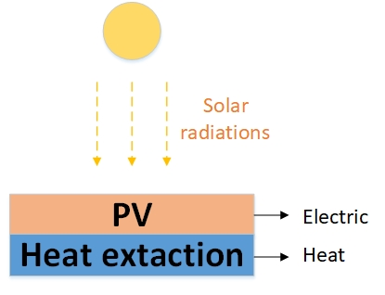

Fig 3 Flat-plate PV/T system

The principle of centralized PV/T system is to enhance the received solar radiation intensity through the reflector while reducing the receiving area. In this way, the efficiency of the system is increased while the cost of the system can be reduced. Fig. 4 shows the working principle of the centralized PV/T system. The power generation efficiency of PV is improved by increasing the radiation intensity, while the collector module absorbs the concentrated light as well as a large amount of heat generated by the PV module due to its high efficiency operation. High temperature has a negative impact on PV and makes the generation efficiency have a certain loss. As a result, the heat collector module is the core-working component of the system. Making the system run efficiently and safely at high temperature is the difficulty of its application. The centralized photovoltaic thermal system can operate stably at 170 ℃ [25], but further researches are still needed.

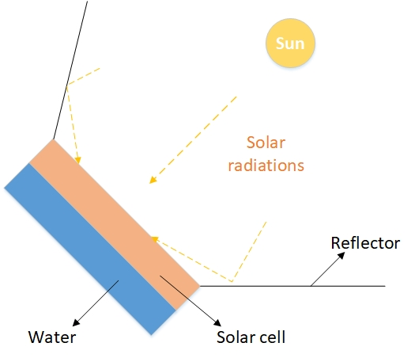

Fig 4 Concentrator type PV/T system

In addition, hydrogen is an expensive fuel due to the high cost of hydrogen production by electrolysis. Solar as one of the most developed renewable energy sources, hydrogen production with solar energy is undoubtedly one of the most promising methods. Hydrogen production by solar mainly includes photoelectric solution, Photovoltaic (PV), photoelectric chemistry, thermal chemistry and artificial photosynthesis [26]. PV hydrogen production is one of the most economical methods. This technology is mature for application after about 50 years’ development [27] and the efficiency can reach 25% [28]. Moreover, different from other solar energy utilization methods, PV hydrogen production takes no account of the disadvantages of fluctuations and intermittences by transforming the solar into a stable resource.

2.2 Wind energy applications

Wind power is one of the more easily available renewable energy sources, with around 20,000 GW available worldwide; nearly eight or nine times the current global total. Wind power is also one of the fastest developing renewable energy sources. Under the development of related research and the promotion of new energy policies in various countries, the cost of wind power is getting much lower, and the scale is getting much larger. Over the past two decades, the installed capacity of wind power has increased more than seventy times. Installed capacity has increased by about 442GW, from 180GW in 2010 to 622GW in 2020.Actual electricity generation increased nearly fourfold from 342,831 GWH in 2010 to 1,262,914 GWH in 2019. Currently, the utilization cost of wind power in various countries is generally lower than 0.1USD /kWh.

Fig 5 Installed capacity and Electricity generation

Wind power generation technology has been widely used, whether in the land or the sea. The offshore turbine has a great potential because of the advantages of continuity, steadiness, high speed, large capacity and far away from living quarters. As the main tool of wind energy utilization, wind turbine has a long history of development. In March 2017, DONG Energy decided to decommission the Vindeby offshore wind farm, which is the world's first offshore wind farm installed in 1991 and worked for about 25 years. In 2009, the first large deep-water floating fan was built at the Hywind wind field in Norway, with a power of 2.3MW and standing at 220 meters deep. Currently, only the United Kingdom, Germany, Denmark, the Netherlands and China have offshore wind farms with a capacity of more than 400MW. Table 1 shows the countries with the largest installed offshore wind power capacity in recent years. The largest offshore wind farm is Hornsea 1 in the UK, which has a capacity of 1,218MW and turbines from 3.6 to 8 MW rated power [29].

|  |  |  |  |  |  |
| --- | --- | --- | --- | --- | --- |
| Table 1 Installed offshore wind power capacity (WM) [6] | | | | | |
| Year | [United Kingdom](https://en.wikipedia.org/wiki/List_of_offshore_wind_farms_in_the_United_Kingdom) | [Germany](https://en.wikipedia.org/wiki/List_of_offshore_wind_farms_in_Germany) | [China](https://en.wikipedia.org/wiki/List_of_offshore_wind_farms_in_China) | [Denmark](https://en.wikipedia.org/wiki/List_of_offshore_wind_farms_in_Denmark) | [Belgium](https://en.wikipedia.org/wiki/List_of_offshore_wind_farms_in_Belgium) |
| 2016 | 5156 | 4108 | 1627 | 1271 | 712 |
| 2017 | 6651 | 5411 | 2788 | 1268 | 877 |
| 2018 | 7963 | 6380 | 4588 | 1329 | 1186 |
| 2019 | 9723 | 7493 | 6838 | 1703 | 1556 |

Fig 6 shows the current three main types of offshore wind turbines, which are divided into horizontal axis and vertical axis according to the type of shaft. The most widely used is the horizontal axis wind turbine (HAWT). The main rotor shaft and generator of the HAWT (Fig 6a) are located at the top of the wind turbine. HAWT has to be angled towards the direction of the wind, so it is always equipped with wind direction sensors to help adjust the direction of the wind turbine. Currently, the largest HAWT in the world is the Haliade-X wind turbine, which is rated at up to 12 MW [30]. The main rotor axis of vertical axis wind turbine (VAWT) (Fig 6b) is perpendicular to the wind direction. This structure makes for the generator and other equipment can be placed in the base of the turbine, reducing the difficulty of installation and maintenance and increasing the safety of the system. The VAWT has no requirements on the wind direction but is less efficient than HAWT and producing much less power at the same wind. The cross-axis wind turbine (CAWT) (Fig 6c) is actually an improvement of VAWT [31]. It combines the strengths of HAWT and VAWT while overcoming their weaknesses. Like VAWT, CAWT occupies much less space than HAWT, and the blade swept area of CAWT is much larger than that of VAWT, so it gets a higher conversion rate of wind energy [32]. CAWT is still in the exploratory stage and has a long way to go before application.

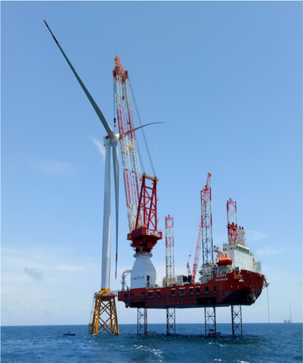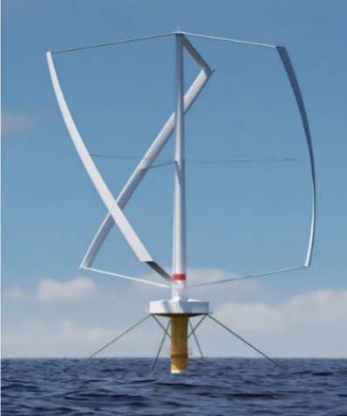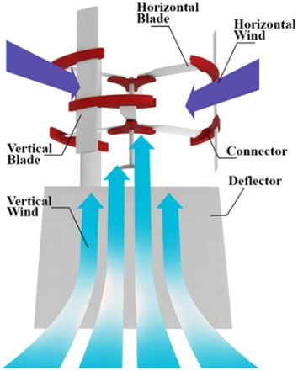

a b c

Fig 6 HAWT (a); VAWT (b) [33]; CAWT (c)

Offshore wind power generation is very important for reducing carbon dioxide emissions and improving the global environment. However, due to the nature of wind resources, wind power generation is not particularly stable, and there will be excess wind power that needs to be discarded in the generation process resulting in the waste of wind resources [34]. Using wind power to produce hydrogen and increasing the on-site consumption of wind power plants is one of the important ways to reduce wind curtailment [35]. This not only ensures the safety and stability of wind power plants and power grids, but also avoids wasting resources. Hydrogen production by wind power generation in ports can also provide a large amount of hydrogen sources for ships, which is conducive to promoting the renewable development of ship energy systems.

People began to explore the possibility of hydrogen production from wind power at the beginning of this century. Kassem [36] analyzed the feasibility of hydrogen production by wind power in 2003, and demonstrated that this method is of great research value and is an effective way for hydrogen production using renewable energy. Bartels [37] made a comprehensive economic analysis of hydrogen production from wind power and analyzed the feasibility from an economic perspective. After the hydrogen production from wind power generation has been gradually recognized, the related specific topics have been widely studied. Takahashi et al. [38] proposed a coordinated control method for hydrogen production from wind power, which effectively reduces the impact of wind fluctuations on the power system. Belmokhtar [39] proposed an optimized control method based on fuzzy logic based on the technical principle of hydrogen production by wind power, which effectively improved the efficiency of the system. At the national level, the United States, the European Union and China all started a series of projects to produce hydrogen from wind power. The United States was the first to carry out wind power generation hydrogen production projects, but it did not receive enough attention at the time. The European Union has also carried out numerous wind power hydrogen production projects and has always been in a leading position in the use of wind power. They plan to achieve sustainable development with full reliance on renewable energy by 2060. China actively promotes cooperation between universities and enterprises in hydrogen production from wind power, and successfully completed the hydrogen production station of the Hebei Guyuan Hydrogen Production Project in 2017. This was China’s first wind power hydrogen production station and the largest hydrogen production station in the world at that time.

2.3 Fuel cell applications

Fuel cell is a device that directly converts chemical energy into electrical energy through the reaction of fuel and oxygen. The products of the reaction are electricity and water. Depending on the fuel used, some produce carbon dioxide and other emissions. The waste heat of fuel cell is much less than that of direct fuel combustion, its energy conversion efficiency is as high as 90%, and the heat recovery rate is as high as 30%-40% [40]. In addition, if hydrogen is used as the fuel of the fuel cell, there will be no carbon dioxide in the reaction product, which is more environmentally friendly. The fuel cell consists of a cathode, an anode and an electrolyte. According to the different electrolytes used, common fuel cells can be divided into three types: alkaline fuel cells (AFC), solid oxide fuel cells (SOFC) and proton exchange membrane fuel cells (PEMFC) [41].

AFC was designed and published by Francis Thomas Bacon in 1959 and in the mid-1960s, NASA began to use AFC to power the Apollo space program. Among these three technologies, AFC has the advantages of low cost, simple and stable structure. It only needs to continuously supply water at room temperature when the system is working. At present, AFC has been developed relatively well [42], so it has been widely used in current commercial applications.

SOFC is highly efficient and it can use different kinds of fuels such as methanol and biogas [43]. However, it usually needs to work in an environment above 500°C, this causes the electrolysis system cannot start quickly and needs to overcome internal problems generated under high temperature conditions. The current researches focus on the development of low temperature, and increase the life of the system while reducing the cost of operation.

PEMFC has the advantages of low running temperature, low noise, high power density and fast start-up [44]. PEMFC usually uses Pt as a reaction catalyst to increase the reaction rate and gain more economic benefits [45]. The materials used in this technology are more easily degradable and more environmentally friendly [46]. PRMFC has been used to replace automobile engines and aero engines [47], but its cost is higher and its durability is poor, so it still needs further research and improvement [48]. A large part of the high cost of PEMFC is due to the high cost of Pt material and hydrogen supply [49]. Exploring how to use Pt alloys to replace pure Pt is an important way to reduce costs. Using renewable energy to produce hydrogen and supply PEMFC is also undoubtedly one of the important ways to reduce costs. Only by gradually reducing the cost of use can the PEMFC technology have greater practical application prospects and create greater commercial value.

As the cleanest energy source, hydrogen plays a vital role in reducing carbon dioxide emissions and improving the current environment. The electrolysis of water to produce hydrogen through electricity generated by solar and wind power is an important form of collecting and storing these renewable energy sources. For ships and offshore platforms, the use of hydrogen-oxygen fuel cells can effectively reduce EEDI and greatly optimize the energy structure of offshore platforms. In addition, the use of hydrogen-oxygen fuel cell devices instead of batteries as the energy storage device of the renewable energy power generation system to solve the problem of intermittent can reduce the cost and make the system more environmentally friendly.

Fuel cells and electrolyzers that use the same electrolyte generally follow the same structure. The common methods for producing hydrogen by electrolysis mainly include Alkaline water electrolysis (AWE), Solid oxide electrolysis (SOE) and Polymer electrolyte membrane electrolysis (PEM). Table 2 shows the specific attributes and parameters.

Table 2 Details of different electrolysis

|  |  |  |  |
| --- | --- | --- | --- |
|  | AWE [50] | SOE [51] | PEM [52] |
| Electrolyte | NAOH/KOH | ZrO2 | Solid polymer |
| Cathode | Ni | LSM-YSZ, | C, Pt |
| Anode | Ni alloys | Ni-YSZ | C, Pt |
| Pressure / (bar) | 2-10 | <30 | 1-2 |
| Temperature /(°C) | 70-90 | 500-900 | 50-100 |
| Capacity / | 5-500 Nm3 /h |  | 20-40 kg/h |

AWE has the longest development time and is the most complete method. Generally, Ni-based metals are used as electrodes for AWE. The two electrodes are placed in an alkaline solution and separated by a diaphragm. The system can operate between 20%-150% of the design capacity. For solar and wind power generation systems with intermittent and large power fluctuations, AWE has the advantages of low cost and system stability. The Utsira wind/hydrogen demonstration plant installed a 600kW wind generator, using the AWE method to produce hydrogen at the rate of 10Nm3/h [53]. However, compared with other methods, the current density of AWE is not high, and the corrosive electrolyte used is not friendly to the environment and is prone to danger.

Solid oxide electrolysis (SOE) generally uses Ni-doped YSZ as the electrode material of the cathode and Lanthanum strontium manganate (LSM) as the electrode material of the anode. The hydrogen production method has the advantages of high efficiency, long life and high stability, but the electrolysis needs to be carried out at extremely high temperatures. At present, it is possible to consider using concentrated solar energy to provide a high-temperature environment for the reaction, and use other new energy technologies to provide electricity, so that renewable energy can be used throughout the reaction, which has better economic benefits.

The structure of the PEM system is simple, and the current density is higher, about four times that of AWE. PEM can accept dynamic energy, so it can be well used in solar and wind energy hydrogen production systems [54]. Table 3 shows some projects of PEM electrolysis hydrogen production around the world.

Table 3 PEM PROJECT

|  |  |  |  |  |
| --- | --- | --- | --- | --- |
| NAME | Time | Parameters | Source | Purpose |
| HYUNDER [55] | 2008 to present | 66 Nm3/h;  300 bar | Wind power; PV | storage of renewable energy |
| Don Quichote [56] | 2012-2018 | 30 Nm3/h;  450 bar | Wind power; PV | Fuel hydrogen supply |
| levenmouth community energy project [57] | 2016 to present | 60 kW;  30bar | Wind power; PV | Store electricity;  Fuel hydrogen supply |
| Pilot plant Falkenhagen [58] | 2014 to present | 2MW | PV | Store electricity |
| Lam Takhong wind hydrogen hybrid project [59] | 2016 to present | 1WM | Wind power | Store electricity |

1. **Renewable energy applications for ships**

3.1 Solar for ship

The application of solar energy on ships firstly appeared in the last century. In 1997, Modular Mouldings manufactured the S B Collinda, which was the first solar ship to cross the English Channel. In October 2006, the Swiss ‘Sun 21’ all-solar powered ship completed the feat of crossing the Atlantic Ocean. In November 2009, the world’s first solar powered large-scale cargo ship "Auriga Leader" Vessel was successfully launched for sea trials with a PV of 40kW on board, including 328 solar panels. The electricity generated can meet 6.9% of the lighting requirements or 0.2% of the power requirements. PlanetSolar was launched on March 31, 2010, at a cost of up to 24 million dollars. It is 31 meters long, equipped with solar cells covering 537m2 with the speed up to 10 knots. In May 2012, it completed the first trip around the world for solar-powered boat. MetaltecNaval's solar-powered commercial passenger ship EcoCat was launched in 2018. It can accommodate 120 passengers and its speed can reach up to 9 knots. The power of Solar boats is growing and their application has spread from small cruise ships to large cargo ship and ro-ro ships in just two decades.

In the past 20 years, the main problem of research has turned from how to simply use solar energy to ship platform to how to efficiently use solar PV system to provide stable power supply for ships. At present, the ship solar PV system is mainly divided into off-grid and grid-connected two types. The off-grid PV system is independent of the ship's power grid and relies on batteries to ensure a continuous supply of power. Its advantages include high security and simple system structure, the disadvantage is that the capacity of the battery needs to be several times the generation capacity of the PV system, in order to stable power output [60, 61]. The grid-connected PV system integrates the electricity generated by the solar system into the main power grid of the ship, therefore it does not have the above problems, and the electricity generated by the PV system can be more fully utilized. Its disadvantage is that the grid-connected system structure and principle is more complex, and for the safety of the power grid, the classification society stipulates that the capacity of the PV system shall not exceed 10% of the diesel generator. By comprehensively considering the actual situations, people still prefer to use the grid-connected system in most cases.

Sun et al. [62] proposed the basic principle of applying solar PV system to ship integrated power grid by analyzing the technical characteristics of off-grid and grid-connected ship PV systems. Combining off-grid and grid-connected PV systems, they designed and installed a hybrid PV system with battery storage for the ‘COSCO TENGFEI’. The system can realize the flexible switching between off-grid and grid-connected operation modes according to the electric load and the state of charge of the battery, and operate stably under various modes. The peak power of this solar PV system is up to 143kW saving 0.46 tons of fuel oil in one day and saving 40,000 dollars in one year [63].

ÇağlarKaratuğ et al. [64] designed a PV array layout for the ro-ro ship. The designed solar system can meet 7.38% of the ship’s fuel demand. It provides 334.06 MWh of electricity to the ship’s power grid within one year, reducing emissions by approximately 232.393 tons of CO2 per year, 0.312 tons of SOx and 3.942 tons of NOx. Yuan et al. [65] designed 135 PV panels in 'Anji204' with a total capacity of 37.12 kW. All the electricity generated is used to supply only the vehicle warehouse lighting system and living area lighting system on board the ship. PV system can generate about 45,000 kWh, reduce fuel consumption by about 16 tons, reduce CO2 emissions by about 28.5 tons, SOx about 0.63 tons, and NOx about 0.05 tons every year.

After more and more solar modules are applied to ships, how to improve PV efficiency has become the focus of research. Zeńczak [66] proposed to increase the efficiency of the ship PV system by adding cooling modules. The PV system of ship ś Winoujście was renovated with the cooling modules, and the results of operation were analyzed. The results show that the method provided 17% more economic benefits for the ship than the PV module without cooling system.

Wen et al. [67] proposed a hybrid integrated method based on the random ship motion model to predict the optimal interval of onboard solar energy to reduce the impact of weather changes and ship position on the solar system and improve the efficiency of the solar system. A hybrid prediction model was formed by combining machine learning technology and particle swarm optimization (PSO), and it was actually tested on the power system on a large oil tanker. The results show that the system is very effective in improving the efficiency of the ship's solar energy system, and can be used as an important reference for the ship's energy management system. Divyajot [68] used variable inertia weight belt (TVIW) of the particle swarm optimization (PSO) method to study the PV, energy storage system on the tanker and diesel generator output between the mutual influence relationship, determining a proposed assembly PV module for the ship.

The application of solar PV technology on ships has matured, and the relevant operating strategies and efficiency improvement methods are the hot topics now. This is one of the most accessible renewable energy sources on ships, and it will also be an important method to improve the energy structure of ships.

3.2 Wind for ship

Equipment of wind power occupies a lot of space, and it is difficult to use it in a ship with a relatively compact space. Therefore, using different types of sails to provide auxiliary power for the ship is one of the best ways for ships to use wind energy. A good wind assisted propulsion device can reduce CO2 emissions by up to 20% for ships [69], and save 1%-30% of fuel consumption [70]. It is a very good improvement to ships for both the environment and the economy.

At present, wind-assisted propulsion methods mainly include Rotors, Towing kites, Suction wings and Rigid sails. Rotors usually refer to Flettner rotors. Fig.7 shows the basic principles of Flettner rotors, which use the Magnus effect to generate thrust by installing rotating cylindrical sails on the ship. Towing kites are mainly driven by the high-altitude sea breeze, which hauls the ship forward. Suction wings are similar to airplane wings and achieve upward lift through boundary layer suction. Current technologies such as Rigid sails, Soft sails, and Hull sails are immature, and their practical applications are very limited. Among these technologies, the most suitable one for large ships is the Flettner rotor in the Rotor sails.

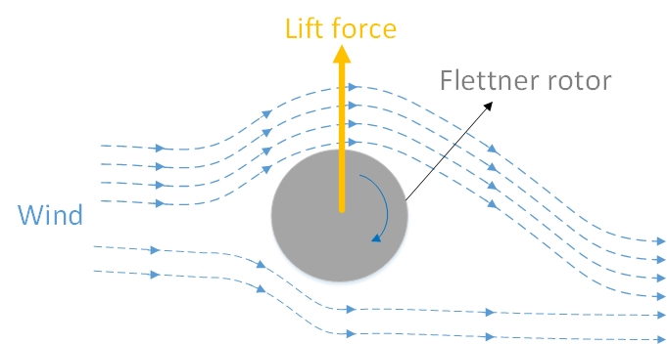

Fig 7 Flettner-rotor

Michael Traut et al. [71] concluded that towing kites can bring about 1%-2% power gains of the main engine, and a single Flettner rotor can bring power benefit about 2-3%. In the comparative analysis of multiple examples, the average power range of Flettner rotors mainly ranges from 193 kW to 373 kW, and the average power range of Towing kites ranges from 127-461kW. Flettner rotors can provide more power and are more stable than Towed kites, but kites take up less deck space and are more economical.

Nader R. Ammar et al. [72] conducted a research on Flettner rotors for a bulk carrier. By adding 4 Flettner rotors to it, they investigated the economic and environmental benefits of three different routes. The results show that the average power of Flettner rotors is between 608 kW and 1,096 kW, which can reduce the fuel consumption by 8.5-16.2%.

Lu et al. [73] conducted a study on Flettner rotor technology for an oil tanker based on its actual sailing data, and analyzed that using Flettner rotors can save 8.9% fuel consumption. After analyzing the efficiency of Flettner rotors in different working conditions, it demonstrated that the use of Flettner rotors is greatly affected by its ship type, speed, sailing route and corresponding weather conditions. These factors must be comprehensively considered to select the best Flettner rotor size and quantity.

Ibrahim et al. [74] took the bulk carrier between Damietta and Dunkirk as an example, and studied the economic benefits with different paths and different sizes of Flettner rotors. The research shows that the average output power of each rotor on the bulk carrier is 384 kW/h under the best condition. The sum of the three rotors is equivalent to saving up to 22.28% fuel consumption for bulk carrier, reducing NOx and CO2 emissions by 270.4 tons and 9272 tons each year, bringing absolute benefits in both economic and environmental aspects.

Tillig et al. [75] proposed a ship performance model called ShipCLEAN to control the Flettner rotor and analyze its impact on ships. The model was applied to an oil tanker and a ro-ro ship, and it was analyzed and verified. The results showed that an oil tanker equipped with 6 Flettner rotors can save up to 30% fuel consumption, and the rolling of 4 Flettner rotors saved 14% fuel consumption.

Marcel et al. [76] developed an intelligent assistance system to enhance the capability of wind-assisted ship propulsion, which can realize the operation of automatic optimization of the energy system. Using a ship equipped with Flettner rotors as the experimental object. The data acquisition, processing and storage modules in the system architecture were studied and analyzed, and the system's human-machine interface (HMI) was used for visualization. It was concluded that the system has the ability to optimize the working ability of the wind-assisted ship propulsion system, which lays the foundation for further improving the fuel-saving ability of wind-assisted ship propulsion.

3.3 Fuel cell for ship

Fuel cells show good energy properties such as low noise, low vibration, high efficiency and environmentally friendly. It can be used as the main energy supply in various occasions. In recent years, the research of fuel cell has gradually matured, and its practical application in residences, ships, power plants and other places has also been further developed, which has greatly stimulated people's research on using fuel cell systems for offshore platforms. At present, most ships are powered by diesel generators. This method will produce a large amount of greenhouse gases, nitrates and sulfides, which is not friendly to the environment. Using fuel cells instead of diesel engines to supply electricity can not only reduce the emission of CO2 and gaseous pollutants, but also reduce the conversion of the primary energy form, thereby greatly improving the efficiency of fuel utilization.

Fig 8 shows the working principle of the PEMFC system. PEMFC has high efficiency, fast start-up, and the working temperature is easier to reach, and it can be used as the main power supply energy for ships. In the 1970s, Germany developed the PEMFC system in military equipment such as submarines [77]. However, because the PEMFC system needs to continuously provide pure hydrogen as fuel, when the sailing time is too long, there will lack of hydrogen supply. Therefore, if PEMFC is to be used on ships, a comprehensive and rigorous design of hydrogen storage and replenishment scheme is required [78]. In the experiment near a hydroelectric power plant, they installed two PEMFC systems with a power of 180kW on a ship that can accommodate 200 people. The electricity produced by nearby hydroelectric power plants is used to produce hydrogen, which solves the problem of the source of hydrogen and also controls the production cost of hydrogen well. On the other hand, PEMFC does have the disadvantages of high cost and low power generation. Further research and improvement on power generation capacity and hydrogen production technology are needed for applying this technology to ships and increasing the economic benefits.

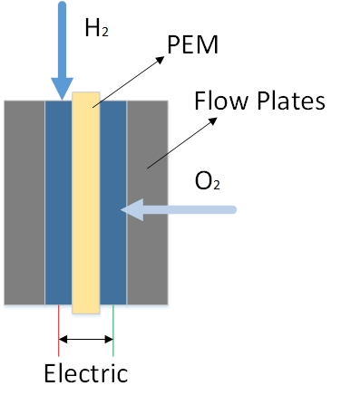

Fig 8. Working principle of PEMFC

Fig. 9 shows the working principle of SOFC. SOFC has relatively loose requirements on fuel. In addition to using hydrogen, methane, biogas as energy supply, SOFC can even run by diesel [79]. Therefore, SOFC is more flexible when it is put into practical application. At present, there are many applications that put SOFC into the ship's power system. Facts have also proved that the ship's power system using SOFC can achieve good economic benefits and is more environmentally friendly.

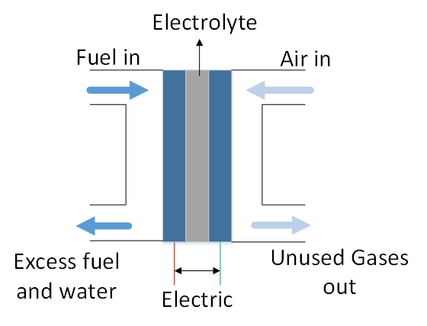

Fig 9. Working principle of SOFC

L.van Biert [80] proposed that the combination of SOFC and the current generator system can achieve lower fuel consumption and has a better development prospect. FrancescoBaldi [81] also proposed that SOFC ships using LNG can reduce greenhouse gas emissions by up to 34%, which is one of the most effective ways to reduce greenhouse gas emissions.

Martinic et al. [82] used three 3700kW SOFC to replace the same power turbine generators on LNG carriers. Analyzed and calculated the energy efficiency after replacement. The research results show that after using the SOFC system, the power generation efficiency has increased from the original 32.9% to 44.8%, and the energy utilization efficiency has been significantly improved. Moreover, since the SOFC system generates a lot of heat, by reusing the waste heat of the system, it is equivalent to saving 2.6% of natural gas consumption.

1. Díaz-de Baldasano [83] designed and installed two 250kW SOFC systems on the platform supply vessel (PSV), using methanol to provide energy for the fuel cell, and integrating the electrical energy generated by the fuel cell into the ship's power grid. The SOFC system can provide up to 20% of the total energy supply for ships, and they also use the waste heat of the SOFC system to produce hot water. The system greatly reduces the fuel consumption of the ship and brings good economic benefits to the ship.

Rafiei [84] proposed to use fuel cells as the main power source for ships, using batteries to cope with the problem of rapid load change, and constructed a zero-emission ferry structure. According to the ship's own power generation and the shore power received when docking, the scholar studied the specifications of the ship and the waterway, evaluated the energy limitations, and optimized the energy management system. According to the ferry's daily route, the energy management problem is implemented in the form of hourly average value, and the improved sine cosine algorithm (ISCA) is used to obtain the best energy management mode for the ferry.

In general, the power generation capacity and volume of PEMFC are very suitable for ship energy structure optimization. However, PEMFC requires pure hydrogen supply and the cost is relatively high. The production of hydrogen through renewable energy will be one of the important methods to reduce the price of hydrogen, which is also a problem that needs to be solved urgently. SOFC can use more types of fuels and has greater power generation, so it is also suitable for large ships such as oil tankers, container ships, or ships with long routes to transform the energy structure. However, SOFC faces the problems of slow start-up and excessively high operating temperature, which also need to be further researched and solved.

3.4 Shore power

There are more than 2,000 ports in the world, and 80% of global trade is carried out through port transportation. The improvement of the energy structure during docking can greatly improve the port environment and reduce the pollution caused by ships. During docking at the port, the power of diesel generator of a container ship, bulk carrier and other ships is between 2000-5000kW [85], while the power of diesel generator of cruise ships is greater, several times that of ordinary ships. If sufficient shore power can be provided to ships during docking, the use of diesel generator can be reduced. The fuel consumption of ships can be greatly reduced. CO2, SOx and NOx emissions can be greatly reduced and the port environment can be improved. Many ports in the world are actively promoting the use of shore power. Many container terminals in the United States and the United Kingdom have brought considerable environmental benefits through the use of shore power, which has promoted the development of shore power in many ports in Europe and North America [86]. Ports in China also use shore power. Since 2010, Lianyungang Port has used shore power to provide energy to cruise ships, and Shanghai Waigaoqiao Port has begun to provide shore power to moored ships. Since 2015, Dalian Port has renovated most of the container ship berths and began to provide shore power to container ships [97]. At present, nearly half of China's ports can provide shore power for docked ships.

For ports, the easiest way to increase shore power is to export it directly from the national grid. Although the operation is simple and the work is stable, it is still not environmentally friendly, which does not fundamentally change the pressure on the environment caused by the ship when it is docked. The use of renewable energy for shore power supply can solve this problem well. Solar PV can be well set up in the open area near the port, or even on the sea [88], to provide a large amount of energy for the shore power of the port. Wind farms near the port could also provide a large amount of energy to the port. Itiki et al. [89] proposed to use renewable energy such as solar energy and wind energy to build an offshore power generation system, and built a system framework that can provide power output to the coast. The power system they proposed can well provide renewable energy for shore power. Gutierrez-Romero [90] installed 163866.6 m2 of solar panels in the port of Cartagena, Spain, and obtained a maximum of 1378.15 MWh of electricity per month, which can reduce a total of 10,000 tons of carbon emissions per year. It can be seen that the use of renewable energy to provide shore power to ships is very valuable.

1. **Hybrid energy system applications**

PV is the most extensive renewable energy sources applied on ships. With the rapid development of technologies such as wind energy and fuel cells, there are more and more applications for assembling hybrid energy on ships. As early as June 2000, the "Solar Sailor" ferry used combined solar and wind energy in the power supply of the propulsion system. Fuel cells were used in military submarines in the early days. In 2003, Siemens created a hybrid power system for the Navy that integrated fuel cells and diesel, and used it in submarines at that time. The abundant solar and wind resources on the ocean are very conducive to the development of renewable energy. Making full use of available resources is of great benefit to the environment and shipowners. The comprehensive use of a variety of renewable energy technologies on ships is conducive to further improving the energy structure of ships and reducing fuel consumption and pollutant emissions. Moreover, a well-designed hybrid renewable energy system can bring considerable economic benefits to the ship. Table 4 shows the summary of research on hybrid renewable energy on ships in recent years.

Table 4 research on hybrid renewable energy on ships

|  |  |  |  |
| --- | --- | --- | --- |
|  | Basic information | Hybrid energy | Research content and results |
| Chen, Xi [91] | Diesel engine | PV system(210kW);  Battery(432kWh); Diesel;  onshore-power | Developed a new offshore HES optimized operation model using evolutionary algorithm, and significantly reduced the electricity cost of ships |
| Rafiei, Mehdi [84] | Ferry；  Length 47m；  Beam 10m;  Average speed 11kn;  electric propulsion | Fuel cell (700kW);  Battery (400kW);  cold-ironing | Transformed a conventional ferry into a zero-emission ship with renewable energy system. The economic benefits and feasibility were analyzed. |
| Guangmiao ZENG [92] | Length 332.95m; width 60.00m；  Diesel engine | PV (210kW);  Wind Turbines (1500kW);  Battery;  Diesel Generator (1900kW) | The IABC algorithm was used to optimize the operation of the hybrid energy system. The influence of three different battery types on the system was compared, and the best configuration scheme was determined. |
| Tang, Ruoli[93] | Diesel engine | PV (210kW); Battery(432kWh); Diesel Generator (250kW);  onshore-power | An optimal energy management model was established, and the dispatch method of model prediction and maximum power control was used to optimize the dispatch of the ship's power flow, and the optimal energy management plan was obtained. |
| Rui Yang[94] | Length 182.8m; width 32.2m;  Speed 20.20kn; Deadweight 14759t;  Diesel engine | PV (265 W);  Battery(3.2V/100Ah);  Diesel Generator (960 kW) | A multi-objective optimization model related to ship fuel economy and diesel generator efficiency is established, and the local group optimization algorithm is used to optimize the operation mode of the ship's power grid. |
| Tang, Ruoli[95] | Diesel engine | PV (210kW); Battery(432kWh); Diesel Generator (250kW);  onshore-power | A power flow dispatching model for a hybrid system based on large-scale global optimization is proposed, which uses swarm intelligence to optimize the use of solar energy to minimize the cost of electricity for ships |
| Vahabzad, Neda[96] | Length 176.9m; width 28.6m;  Diesel engine | Diesel generators (8500 kW);  PV (1 MW);  ESS (432kWh);  cold-ironing | The economic analysis of the hybrid energy system is carried out, and the optimal energy dispatch of the hybrid marine power system is proposed. |
| Xuezhou Wang[97] | Length 19.5m; width 7.5m；  Speed 22kn;  electric propulsion | Diesel generators（2x720 kW）；  Fuel cell(700kW)；Battery(400kW) | The multi-objective double-layer optimization method is used to preliminarily optimize the size and energy management of the hybrid ship propulsion system. |
| Gaber, Mohab[98] | Diesel engine | PV（20kW）；  Fuel cell（10kW）；  Battery（40 Ah） | A hybrid energy system model was established, the corresponding energy management strategy was proposed, and the feasibility of the system was analyzed and studied. |
| ChaoukiGhenai[99] | Cruise ship;  electric propulsion | PV(1200kW)；  PEM fuel Cell (1000kW)；  Diesel Generator(2×2760kW) | A theoretical model of a cruise ship hybrid renewable energy system is established, a simulation study is carried out on it, and an optimal control strategy for the hybrid energy system is proposed. |
| WannengYu[100] | Experimental test rig;  Diesel engine | PV (30kW); Battery(50kWh); Diesel Generator (100 kW); | A solar hybrid energy experiment platform was built, an energy management monitoring system was developed, and the effectiveness and feasibility of the proposed control strategy were verified. |
| Mohsen Banaei[101] | Ferry Ship;  electric propulsion | PV (10kW);  Fuel cell (700kW);  Battery(200kW);  Cold-ironing(100kW) | A hybrid energy model for electric ferry was established, and an energy management strategy was proposed using the mixed integer linear programming method, and the effectiveness of the model was demonstrated through actual case studies. |
| Shuli Wen [102] | Length 332.95m; width 60.00m;  Diesel engine | Wind Generator(30kW);  PV (290kW);  Diesel Generator(2MW); Battery. | A hybrid energy system is proposed, the system configuration is studied and analyzed, and the economic analysis of different configurations is carried out to determine the optimal configuration capacity of the system. |

**5. Modeling and Analysis of HES**

For ships, there are nothing more than two operating states, either sailing at sea or berthing. For these two states, we designed the corresponding comprehensive supply structure of renewable energy, and carried out economic analysis and evaluation based on the parameters in a large oil tanker reported in [102]. Fig. 10 shows the schematic diagram of the ship's integrated energy system designed in this paper. In terms of power system, we design to carry solar PV modules and fuel cell modules for ships. During the ship's voyage, the electricity generated by the PV module is input into the ship's power grid, and together with the diesel generator to supply the ship. In order to ensure the stable operation of the ship, the battery module is equipped to reduce the impact of the power fluctuation of the PV module. Using fuel cell as a backup power source equipped with a hydrogen storage tank, and the excess electricity of the power generation system supply hydrogen electrolysis to produce hydrogen. In terms of propulsion systems, installing Flettner rotors for auxiliary propulsion of ships can reduce a lot of fuel consumption and emissions.

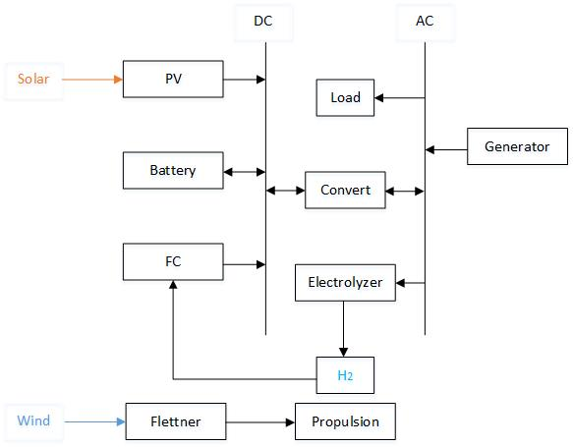

Fig 10 hybrid energy system for ship

In another state, when the ship is in the port, the diesel generator stops working, and the gird is connected to shore power. At this time, the ship uses the shore power as the main source to supply the equipment to operate, and at the same time to charge the batteries. The PV module continues to supply power at the same time as a power supplement. Fig 11 shows the working principle of the hybrid renewable energy system for ports. For the port, in order to optimize its energy structure, wind power plants can be set up nearby, so that the abundant wind resources near the coast can be collected, and at the same time, the port can receive a large amount of power source. According to the construction conditions around the port, the installation of solar PV power plants can also provide a considerable part of the power resources for the port. When wind power and solar power are sufficient, using the electricity to produce hydrogen by electrolysis can provide a large amount of hydrogen supply for marine fuel cells.

The system is relatively complex and huge. This article focuses on the economic analysis of the ship's hybrid energy system equipped with solar PV modules, diesel generator, fuel cell and batteries. The analysis of fuel cell module and the wind-assisted propulsion module are only briefly mentioned.

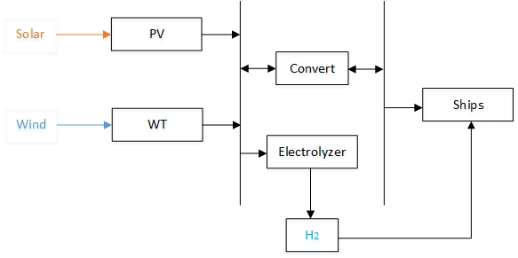

Fig 11 hybrid renewable energy system for ports

5.1 Basic information

The object of the Hybrid system is an oil tanker with the length of 330 m, width of 62 m and weight of 100,000 tons. The load of the tanker under different working conditions is shown in Table 5. The maximum load is 1790kW. Its sailing route is Qingdao, Shanghai, Hong Kong, Singapore, Sri Lanka, Yemen and finally arrives in Egypt. The load is sorted according to its actual working status. The sailing and freight tasks between Qingdao and Egypt are completed in 25 days each month, and the remaining days at the end of the month dock in the port to rest. The obtained operating load of the ship throughout the year is shown in Figure 12.

Table 5 The load of the tanker

|  |  |
| --- | --- |
| Working status | Load power (kW) |
| Cruise | 1580 |
| Dock | 1650 |
| Loading and unloading | 1290 |
| Full speed | 1790 |
| Anchor | 500 |

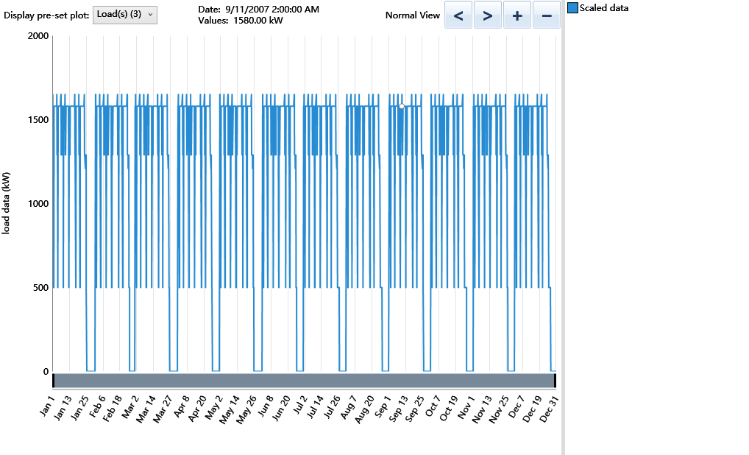

Fig 12 Ship electrical load

Diesel generators must have the ability to independently supply power to the entire ship. Choose 2000kW diesel generator as the main electrical power source considering the need to leave at least 10% of the power generation margin. According to the requirements of China Classification Society, the grid-connected PV capacity of ships should be less than 10% of diesel generator sets [103], as a result, the capacity of selected PV module is 200kW. The power generation status of the PV system is closely related to the solar radiation, so it is necessary to accurately describe the solar radiation status of the ship [104-106]. According to the solar energy data provided by NASA Prediction of worldwide energy resource, the amount of solar radiation passing through the city is shown in Figure 13. The calculation method of the output power of the PV module is as follows:



|  |  |  |
| --- | --- | --- |
| Where: |  |  |
|  |  | = the rated capacity of the PV array, meaning its power output under standard test conditions [kW]; |
|  |  | = the PV derating factor [%]; |
|  |  | = the solar radiation incident on the PV array in the current time step [kW/m2]; |
|  |  | =the incident radiation at standard test conditions [1 kW/m2]; |
|  |  | =the temperature coefficient of power [%/°C]; |
|  |  | =the PV cell temperature in the current time step [°C]; |
|  |  | =the PV cell temperature under standard test conditions [25°C] |

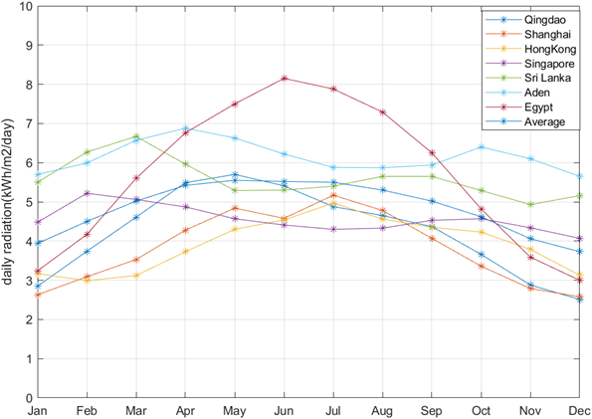

Fig 13 solar radiation passing through the city

Use HOMER software to model and simulate the hybrid renewable energy power system studied in this paper. HOMER software was developed by the National Renewable Energy Laboratory (NREL) of the U.S. Department of Energy. It is used to construct complex hybrid energy power generation, energy storage and load management systems. It can reliably and efficiently analyze and optimize the energy structure of the ship’s integrated system, and carry out economic analysis to provide the best system configuration plan for the ship. Select the main components of the energy system, including diesel generators, PV modules, batteries, and converters according to the ship load. The specific parameters are shown in Table 6. Figure 13 shows the structure of the built hybrid renewable energy power system.

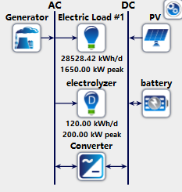

Fig 13 hybrid renewable energy power system

Table 6 parameters of main components

|  |  |  |  |  |
| --- | --- | --- | --- | --- |
|  | Generator | PV | Battery | Converter |
| Type | Generic Large Genset | Generic Flat plate | Li-Ion | System Converter |
| Rated power | 2000 kW | 200 kW | 1kWh | 1kW |
| Capital cost | 300000 $ | 20000$ | 50$ | 300$ |
| O& M cost | 0.25 $/hour | 10$/year | 0 | 0 |
| Life time | 25000 hours | 25 years | 20 years | 15 years |
| Derating factor | 85% | 85% |  |  |
| Fuel type | Diesel |  |  |  |

5.2 Main system Result analysis

Changes in weather conditions have a greater impact on the photovoltaic system. It is necessary to determine the power plan through the forecasted weather given the current weather forecasting technology is well developed. The adjustment of the power system operation strategy is very necessary. By using the Predictive dispatch strategy (PS) strategy, a more reasonable power system operation strategy can be formulated by comprehensively considering the upcoming load and energy supply situation. According to the basic information of the hybrid renewable energy system, several system schemes with different configuration capacities that can be operated reasonably are determined, and their hourly operating data is analyzed and calculated to obtain the most economical system scheme.

After simulation calculations, the comparison results of different configurations are shown in Figure 15. Under the premise that the diesel generator capacity and PV module capacity are determined to be 2,000kW and 200kW respectively, the battery capacity that needs to be installed is 220kWh, and the capacity of the converter is 114kW. In the results, the operating conditions of the diesel engine for power generation are shown in Table 7. A total of 7,296 hours of operation, fuel consumption of 2,687,266L, and power generation of 10,176,139kWh. The PV system generated a total of 306,123 kWh during this operation. Figure 16 shows the specific monthly average power generation of PV system and power generation diesel engines. It can be seen that 97.1% of the power of the ship's power system is provided by diesel generator, and PV modules provide 2.92% of the power.

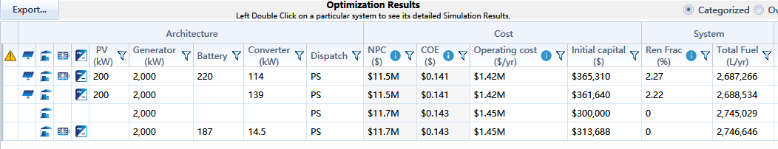

Fig 15 The optimization result of HRE system components.

Table 7 Generator date

|  |  |
| --- | --- |
| Parameters | Value |
| Hours | 7,296 |
| Production (kWh) | 10,176,139 |
| Fuel (L) | 2,687,266 |
| O&M cost ($/year) | 1,824 |
| Fuel cost ($/year) | 1,343,633 |

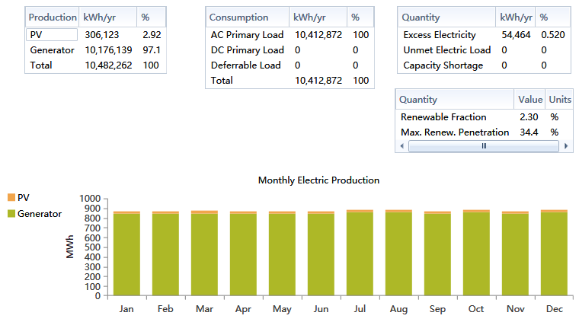

Fig 16 The monthly average power generation

Figure 17 shows the specific operation of the ship's power system, including the total load used for ship operation and the idle load used for hydrogen production by electrolysis, as well as the power supplied by diesel generators, PV modules, and batteries. It can be seen that the electrical load of ships mainly relies on diesel generator, which ensures the safety and stability of the power grid. Solar PV power is greatly affected by the environment, but the addition of batteries effectively reduces the volatility of auxiliary power supply, and overall provides a considerable amount of power input for the ship's power grid. By supplying the electrolysis device with the electricity during idle time, the utilization rate of energy is effectively increased, and the hydrogen produced has high economic value, which can provide a certain supply for the fuel cell part.

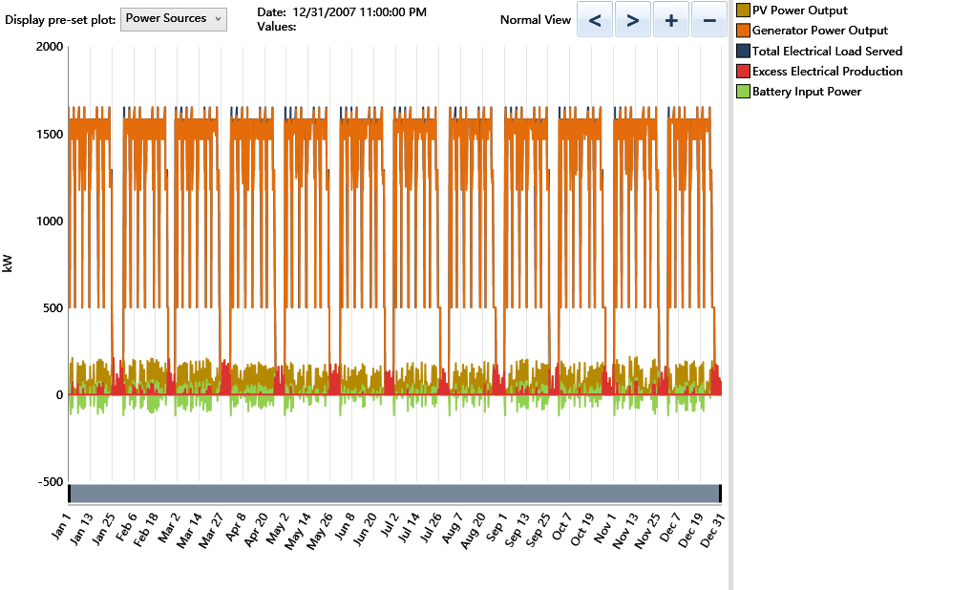

Fig 17 Ship electrical system operation status

Figure 18 shows the economic evaluation results of the system，including The Return on Investment (ROI) and Simple payback. HOMER reflects the economic benefits of the new energy system by comparing with the initial system that only relies on diesel generators to supply electricity. ROI is the annual cost savings relative to the initial investment and is calculated as follows:



|  |  |  |
| --- | --- | --- |
| Where: |  |  |
|  |  | = nominal annual cash flow for base system; |
|  |  | = nominal annual cash flow for current system; |
|  |  | = project lifetime in years; |
|  |  | = capital cost of the current system; |
|  |  | = capital cost of the base system. |

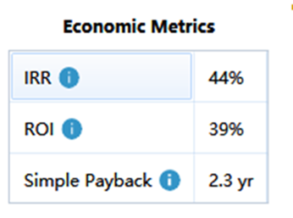

Fig 18 Economic Metrics

The simple payback period refers to the number of years for the cumulative cash flow between the current system and the basic case system to change from negative to positive, that is, how long it takes to recover the investment cost difference between the current system and the basic case system. From the analysis results, it can be concluded that the proposed system can save 39% of the initial investment each year, and achieve the same capital consumption as the initial basic system when the system runs for 2.3 years, filling the additional cost of the proposed system.

Figure 19 shows the comparison of capital consumption between the proposed system and the basic system. Net present costs (NPC) means the total cost of installing and operating the entire life cycle minus all the income it obtains during the project life cycle. The costs in this system mainly include infrastructure costs, replacement costs, operation costs, maintenance costs and fuel cost. After analysis and calculation, the proposed system can save 200k USD. Initial capital is the total cost of the installation of the proposed system, which is USD 365,310. which is 65,310 USD more than the basic system for the construction of renewable energy modules. Among them, 65,310 USD more than the basic system is the construction funds for renewable energy modules. O&M represents the operating and maintenance costs of the system. The addition of a renewable energy system can improve the daily operating status of the ship's power grid and power generation diesel engines. At the same time, the optimization of the operation and maintenance strategy can also reduce the loss of equipment, so the system's operation and maintenance costs tend to reduce.

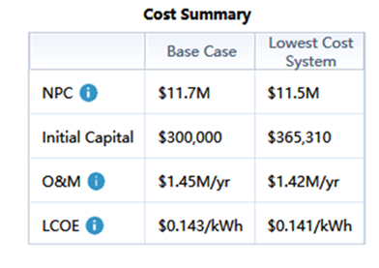

Fig 19 Cost Summary

The levelized cost of energy (LCOE) is the average cost required for the system to generate useful electricity per kWh. The LCOE value of the proposed system is 0.141$/kWh, which less than the LCOE of the basic system by 1.4%. It means proposed system gets good economic benefits and is of great significance for improving the energy structure of ships and protecting the environment. The calculation formula of LCOE is as follows:



|  |  |  |
| --- | --- | --- |
| Where |  |  |
|  |  | = total annualized cost of the system ($/year); |
|  |  | = total electrical load served (kWh/year). |

Table 8 shows the comparison results of ship emissions. After installing the PV module, the new system can reduce emissions of 151,467 kg of CO2, 370 kg of SOX, 150 kg of NOX and a large amount of other harmful gases each year, which greatly improves the environmental performance of the ship and has an important impact on improving the ship exhaust emissions.

Table 8 Emission

|  |  |  |  |
| --- | --- | --- | --- |
| Emission(kg/year) | Based case | Lowest cost system | Reduction |
| CO2 | 7198084 | 7046617 | 151467 |
| SOX | 17595 | 17225 | 370 |
| NOX | 7137 | 6987 | 150 |
| CO1 | 37239 | 36455 | 784 |
| Particulate Matter | 318 | 312 | 6 |
| Unburned Hydrocarbons | 1976 | 1935 | 41 |

The Energy Efficiency Design Index (EEDI) is a measurement tool that characterizes the inherent CO2 emission levels of ships in the design and construction phases. Renewable energy transformation of ship energy systems is beneficial to reduce ships’ performance. Increasing renewable energy is conducive to improving the ship’s energy system and effectively reducing the EEDI. Reference EEDI is a standard and the EEDI calculated according to the actual situation of the ship needs to be less than the Reference EEDI. The calculation formula of Reference EEDI is as follows:



|  |  |  |
| --- | --- | --- |
| For tankers: |  |  |
|  | a | = 1218.8; |
|  | b | = Ship capacity; |
|  | C | = 0.488. |

After calculation, the Reference EEDI of the research object is 4.425 gCO2/tonmile, that is, for the current tanker, it needs to meet the value less than 4.425 to meet the requirements. In order to explore the improvement of the energy structure by the proposed system in this paper, the superiority of the system is reflected by calculating the reduced EEDI value of the ship. The calculation formula of EEDI is as follows:



Analyzing the content of the formula, it is concluded that the numerator of the EEDI calculation formula represents the source of CO2 emitted by the ship and the reason for reducing emissions. It is mainly composed of five parts: main engine propulsion fuel consumption, auxiliary engine daily fuel consumption, shaft generator, and innovative technology reduction. Power consumption and fuel consumption reduced by innovative technology. The denominator represents the shipping capacity of the ship, mainly including loading capacity and speed. This article aims at the impact of increased PV modules on ships, and analyzes the reduced EEDI value. The calculation formula of ΔEEDI is as follows:



|  |  |  |
| --- | --- | --- |
| Where: |  |  |
|  | : | The ratio of average PV power generation in main global shipping routes to the nominal PV power generation specified by the manufacturer. |
|  | : | The required auxiliary engine power to supply normal maximum sea load and includes necessary power for propulsion machinery/systems and accommodation. |
|  | : | The total net electric power (kW) generated by the PV power generation system [107]. |
|  | : | The nondimensional conversion factor between fuel consumption and CO2 emission. |
|  | : | Certified-specific fuel consumption. |
|  | : | The capacity correction factor. |
|  | : | The cubic capacity correction factor. |
|  | : | DWT at maximum summer load draft as certified in the vessel stability booklet approved by the Administration for tankers. |
|  | : | The ship speed measured in knots. |
|  | : | Weather factor, accounts for a decrease in speed in representative sea conditions of wave height, wave frequency. |

The value of each parameter is shown in Table 9 by consulting relevant specifications. After calculation the proposed system can reduce ΔEEDI =0.0888 gCO2/tonmile for the ship. tanker construction generally takes the Reference EEDI as the standard, and a slight reduction will bring a large amount of capital investment. Therefore, the actual EEDI of the tanker is generally very close to Reference EEDI. The calculated value of ΔEEDI is equivalent to 2.0% of the oil tanker construction standard (4.425 g CO2/ton mile), which has achieved a very good improved effect for large ocean-going ships, which can effectively improve the energy structure of the tanker and reduce a large amount of CO2 emissions.

Table 9 Values of EEDI calculation parameters

|  |  |
| --- | --- |
| Parameters | Values |
|  | 200 |
|  | 3.026 |
|  | 220 |
|  | 1 |
|  | 1 |
|  | 1 |

5.3 Other proposals

The proposed system described includes the use of electrolyzers to produce hydrogen supplying fuel cells, Flettner rotor wind assisted propulsion, and the improvement of the shore power structure of renewable energy. The following is only a brief description to provide ideas and initial structure ideas for the next work.

In the proposed system, we used an electrolysis hydrogen production device that runs on idle time. Figure 20 shows the operation of the device within one year. The hydrogen production capacity of the electrolysis device is 40kWh/kg, which can electrolyze 1,000kg of hydrogen in a year. Since it is very uneconomical to supply fuel cells to generate electricity after electrolysis on ships, fuel cells are only used in special circumstances. PEMFC has no requirements for operating temperature and can meet the requirements of fast start-up of the power system, providing 25,000kWh of flexible and efficient power supply for the ship every year. Moreover, for electric propulsion ships, when fuel cells are used as one of the main power sources, the transformation scheme described in this article will have a good redundant electric energy recovery benefit.

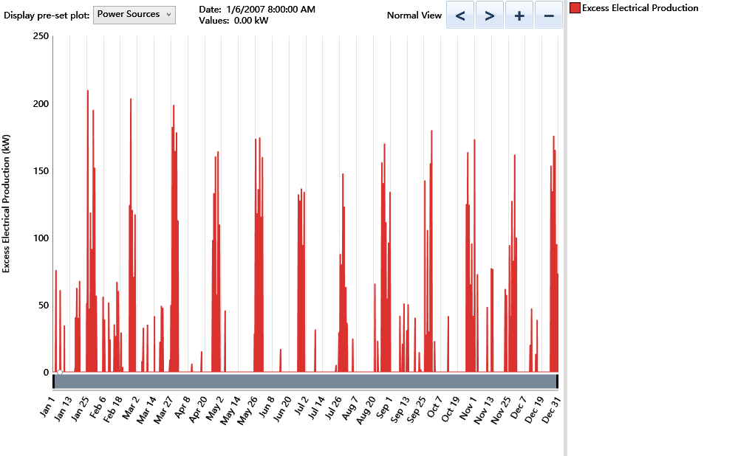

Fig 20 Operation status of electrolysis device

For large ocean-going ships, the installation of Flettner rotors is an important method to reduce the fuel consumption of the main engine. After researching and collating relevant literature, it is found that each Flettner rotor can generally reduce the fuel consumption of ships by 2%-8.9%. Installing four Flettner rotors for the tanker described in this article can theoretically reduce the fuel consumption of the ship by 8%-35.6%. This is of great significance for reducing ship operating costs and reducing pollutant emissions.

The ship described in this article stays in the port nearly 14% of the time throughout the year, and its electrical load during loading and unloading is as high as 1290kW, which is only 290kW less than during normal voyages. If shore power is used to power ships in this state, a lot of fuel consumption can be saved. In addition, if the shore power is consisted of renewable energy, large-scale solar and wind farms are built around the port, and solar power is combined with wind power to build an overall renewable energy system, which can greatly improve the energy structure of the port. It is also possible to construct an electric hydrogen production plant near the port to produce hydrogen from the excess electric energy when the load is small, and to provide hydrogen for ships equipped with hydrogen-oxygen fuel cells, which can make the ship and shore power more environmentally friendly. This proposal has a great impact on improving the energy structure of the shipping industry.

**6. Conclusions**

The shipping industry is currently facing increasingly stringent laws and regulations, and the standards for energy consumption and pollution of ships are getting higher and higher. Coupled with the sluggish development of the shipping industry worldwide, the survival of the traditional shipping industry has become more and more distressed. Under this circumstance, renewable energy technologies have gradually matured, bringing important opportunities to the shipping industry. Using renewable energy technologies such as solar, wind and fuel cells to optimize the energy structure of ships has become one of the main ways for the current ship industry to reduce the emissions and pressure on the natural environment. At the same time, a well-designed new energy system can also reduce a considerable part of long-term operating costs for ships, and has very good economic benefits.

This article summarizes the development and research status of solar energy, wind energy, and fuel cell, focusing on their application and research in the ship industry. A hybrid solar/wind energy/fuel cell ship power system model is constructed for ships, and a hybrid solar/wind energy power supply and hydrogen production model is proposed for port shore power. The simulation analysis is used to optimize the design of the renewable power system, focusing on the emission reduction and economic benefits brought by solar photovoltaic to the ship. The results show that the proposed hybrid renewable energy system can reduce emissions of 151,467 kg of CO2, 370 kg of SOX, 150 kg of NOX and a large amount of other harmful gases for 10W-ton tankers every year. Through calculation, the proposed system can also reduce the EEDI value by 2.0%, and has achieved good performance in environmental protection. In addition, the system can provide 2.92% of the electricity for 10W-ton tankers every year, with a payback period of only 2.3 years, which brings good economic benefits to ships.

The future plan will continue modifying the proposed hybrid power model and determine best balance between different energy sources. The operation mode calculation under shore power state will be performed to investigate the whole process economics of the ship sailing and landing. Experimental validation on the modified calculation model will also be carried out.

**ACKNOWLEDGEMENT**

This work is supported by Fundamental Research Funds for the Central Universities (No. 201941008 & 201912036), Taishan Scholar of Shandong, China (No. tsqn201812025) and Narodowego Centrum Nauki, Poland (No. 2020/37/K/ST8/02748).

**Reference**

1. Harari, P. A., et al. "Experimental investigation on compression ignition engine powered with pentanol and thevetia peruviana methyl ester under reactivity controlled compression ignition mode of operation." Case Studies in Thermal Engineering 25 (2021): 100921.
2. Khosravi R, Rabiei S, Khaki M, Safaei MR, Goodarzi M. Entropy generation of graphene–platinum hybrid nanofluid flow through a wavy cylindrical microchannel solar receiver by using neural networks. Journal of Thermal Analysis and Calorimetry. 2021:1-19.
3. Akkoli, K. M., et al. "Effect of injection parameters and producer gas derived from redgram stalk on the performance and emission characteristics of a diesel engine." Alexandria Engineering Journal 60.3 (2021): 3133-3142.
4. Peng Y, Parsian A, Khodadadi H, Akbari M, Ghani K, Goodarzi M et al. Develop optimal network topology of artificial neural network (AONN) to predict the hybrid nanofluids thermal conductivity according to the empirical data of Al2O3–Cu nanoparticles dispersed in ethylene glycol. Physica A: Statistical Mechanics and its Applications. 2020;549:124015.
5. Peng Y, Zahedidastjerdi A, Abdollahi A, Amindoust A, Bahrami M, Karimipour A et al. Investigation of energy performance in a U-shaped evacuated solar tube collector using oxide added nanoparticles through the emitter, absorber and transmittal environments via discrete ordinates radiation method. Journal of Thermal Analysis and Calorimetry. 2020;139(4):2623-31.
6. Hua J, Wu Y H, Jin P F. Prospects for renewable energy for seaborne transportation—Taiwan example. Renewable energy, 2008, 33(5): 1056-1063.
7. Hadžić N, Kozmar H, Tomić M. Feasibility of investment in renewable energy systems for shipyards. Brodogradnja: Teorija i praksa brodogradnje i pomorske tehnike, 2018, 69(2): 1-16.
8. Ghenai C, Bettayeb M, Brdjanin B, et al. Hybrid solar PV/PEM fuel Cell/Diesel Generator power system for cruise ship: A case study in Stockholm, Sweden. Case Studies in Thermal Engineering, 2019, 14: 100497.
9. Hank C, Sternberg A, Köppel N, et al. Energy efficiency and economic assessment of imported energy carriers based on renewable electricity. Sustainable Energy & Fuels, 2020, 4(5): 2256-2273.
10. Atodiresei D, Toma A, Cotorcea A, et al. Opportunities for harnessing wind potential on board ships in the northwest area of the Black Sea. Revue Roumaine Des Sciences Techniques, 2017, 62(3): 265-268.
11. Lee H. Emission factors based estimation of exhaust emissions with biodiesel blended fuel from naval vessel propulsive diesel engine. Journal of the Korean Society of Marine Engineering, 2013, 37(4): 332-337.
12. Zereshkian S, Mansoury D. A study on the feasibility of using solar radiation energy and ocean thermal energy conversion to supply electricity for offshore oil and gas fields in the Caspian Sea. Renewable Energy, 2021, 163: 66-77.
13. Higgins P, Foley A. The evolution of offshore wind power in the United Kingdom. Renewable and sustainable energy reviews, 2014, 37: 599-612.
14. Dong CZ, and Catbas FN. A review of computer vision-based structural health monitoring at local and global level. Structural Health Monitoring, 20(2021), 692-743.
15. Jia, Yuting, Guruprasad Alva, and Guiyin Fang. Development and applications of photovoltaic–thermal systems: A review. Renewable and Sustainable Energy Reviews 102 (2019): 249-265.
16. Akram, N., Sadri, R., Kazi, S. N., Zubir, M. N. M., Ridha, M., Ahmed, W., Soudagar, E. & Arzpeyma, M. A comprehensive review on nanofluid operated solar flat plate collectors. Journal of Thermal Analysis and Calorimetry 2020.139(2), 1309-1343.
17. Akram, N., Sadri, R., Kazi, S. N., Ahmed, S. M., Zubir, M. N. M., Ridha, M., Soudagar, E., Arzpeyma, M., & Tong, G. B. An experimental investigation on the performance of a flat-plate solar collector using eco-friendly treated graphene nanoplatelets–water nanofluids. Journal of Thermal Analysis and Calorimetry 2019, 138(1), 609-621.
18. Khan, T. Y., Soudagar, M. E. M., Kanchan, M., Afzal, A., Banapurmath, N. R., Akram, N., Mane, S., & Shahapurkar, K. Optimum location and influence of tilt angle on performance of solar PV panels. Journal of Thermal Analysis and Calorimetry 2020, 141(1), 511-532.
19. Akram, N., Montazer, E., Kazi, S. N., Soudagar, M. E. M., Ahmed, W., Zubir, M. N. M., Afzal, A., Muhammad, M., Ali, H., Marquez, F., & Sarsam, W. S. Experimental investigations of the performance of a flat-plate solar collector using carbon and metal oxides based nanofluids. Energy 2021, 227, 120452.
20. Jathar, L. D., Ganesan, S., Shahapurkar, K., Soudagar, M. E. M., Mujtaba, M. A., Anqi, A. E., Farooq, M., Khidmatgar, A., Goodarzi, M., & Safaei, M. R. Effect of various factors and diverse approaches to enhance the performance of solar stills: a comprehensive review. Journal of Thermal Analysis and Calorimetry 2021, 1-32.
21. Arshad, Z., Khoja, A. H., Shakir, S., Afzal, A., Mujtaba, M. A., Soudagar, M. E. M., Fayaz, H., Saleel, A., Farukh, S., & Saeed, M. Magnesium doped TiO2 as an efficient electron transport layer in perovskite solar cells. Case Studies in Thermal Engineering 2021, 101101.
22. Modi, Anish, et al. A review of solar energy based heat and power generation systems. Renewable and Sustainable Energy Reviews 67 (2017): 1047-1064.
23. Aste, Niccolò, Claudio del Pero, and Fabrizio Leonforte. Water flat plate PV–thermal collectors: a review. Solar Energy 102 (2014): 98-115.
24. Ibrahim, Adnan, et al. Recent advances in flat plate photovoltaic/thermal (PV/T) solar collectors. Renewable and sustainable energy reviews 15.1 (2011): 352-365.
25. Ju, Xing, et al. A review of concentrated photovoltaic-thermal (CPVT) hybrid solar systems with waste heat recovery (WHR). Science bulletin 62.20 (2017): 1388-1426.
26. Li Z, Khanmohammadi S, Khanmohammadi S, et al. 3-E analysis and optimization of an organic rankine flash cycle integrated with a PEM fuel cell and geothermal energy. International Journal of Hydrogen Energy, 2020, 45(3): 2168-2185.
27. Bilgen E. Solar hydrogen from photovoltaic‐electrolyzer systems. Energ Conver Manage. 2001; 42(9): 1047‐ 1057.
28. Kothari R, Buddhi D, Sawhney RL. Comparison of environmental and economic aspects of various hydrogen production methods. Renew Sustain Energy Rev. 2008; 12(2): 553‐ 563.
29. <https://hornseaprojectone.co.uk/>
30. <https://www.futurewind.nl/tag/haliade-x-12-mw/>
31. Seralathan S, Gupta J S R, Premkumar T M, et al. Experimental and Numerical Studies on a Cross Axis Wind Turbine[C]//2019 2nd International Conference on Power and Embedded Drive Control (ICPEDC). IEEE, 2019: 185-190.
32. Li, J., et al., A review on development of offshore wind energy conversion system. International Journal of Energy Research, 2020. 44(12): p. 9283-9297
33. <https://wileyonlinelibrary.com>
34. Duan, W (2015) Wind power consumption has been a worldwide problem in the interpretation of the national energy administration. (Notice on the relevant work of 2015 wind power grid work in 2015). The Earth 2015(5): 60–63
35. Qolipour, M, Mostafaeipour, A, Tousi, OM (2017) Techno-economic feasibility of a photovoltaic-wind power plant construction for electric and hydrogen production: A case study. Renewable & Sustainable Energy Reviews 78: 113–123.
36. Kassem, N (2003) Offshore wind farms for hydrogen production subject to uncertainties. In: International joint power generation conference collocated with turboexpo, Atlanta, Georgia, USA, 16–19 June 2003, pp.857–864. ASME.
37. Bartels, JR, Pate, MB, Olson, NK (2010) An economic survey of hydrogen production from conventional and alternative energy sources. International Journal of Hydrogen Energy 35(16): 8371–8384.
38. akahashi, R, Kinoshita, H, Murata, T. (2008) A cooperative control method for output power smoothing and hydrogen production by using variable speed wind generator. In: Power electronics and motion control conference. EPE-PEMC 2008, Poznan, Poland, 1–3 September 2008, pp.2337–2342. IEEE.
39. Belmokhtar, K, Doumbia, ML, Agbossou, K (2014) New fuzzy logic based management strategy to improve hydrogen production from hybrid wind power systems. International Journal of Renewable Energy Research 4(3): 731–742.
40. Abdelkareem M A, Elsaid K, Wilberforce T, et al. Environmental aspects of fuel cells: A review. Science of The Total Environment, 2021, 752: 141803.
41. El‐Emam RS, Özcan H. Comprehensive review on the techno‐economics of sustainable large‐scale clean hydrogen production. J Clean Prod. 2019; 220: 593‐ 609.
42. Ghouri Z K, Elsaid K, Al-Meer S, et al. Applicable anode based on Co3O4–SrCO3 heterostructure nanorods-incorporated CNFs with low-onset potential for DUFCs. Appl Nanosci 7 (8): 625–631. 2017.
43. Andersson et al., 2013. M. Andersson, J. Yuan, B. Sundén. SOFC modeling considering hydrogen and carbon monoxide as electrochemical reactants. J. Power Sources, 232 (2013), pp. 42-54, 10.1016/j.jpowsour.2012.12.122
44. Li Z, Khanmohammadi S, Khanmohammadi S, et al. 3-E analysis and optimization of an organic rankine flash cycle integrated with a PEM fuel cell and geothermal energy. International Journal of Hydrogen Energy, 2020, 45(3): 2168-2185.
45. Fathy A, Abdelkareem M A, Olabi A G, et al. A novel strategy based on salp swarm algorithm for extracting the maximum power of proton exchange membrane fuel cell. International Journal of Hydrogen Energy, 2021, 46(8): 6087-6099.
46. L. Dubau, et al. A review of PEM fuel cell durability: materials degradation, local heterogeneities of aging and possible mitigation strategies Wiley Interdiscip Rev: Energy Environ, 3 (6) (2014), pp. 540-560
47. A. Baroutaji, T. Wilberforce, M. Ramadan, A.G. Olabi. Comprehensive investigation on hydrogen and fuel cell technology in the aviation and aerospace sectors. Renew. Sust. Energ. Rev., 106 (2019), pp. 31-40
48. Jiao Y, Zheng Y, Jaroniec M, Qiao SZ. Design of electrocatalysts for oxygen‐ and hydrogen‐involving energy conversion reactions. Chem Soc Rev. 2015; 44(8): 2060‐ 2086.
49. A.B. Stambouli Fuel cells: the expectations for an environmental-friendly and sustainable source of energy Renew. Sust. Energ. Rev., 15 (2011), pp. 4507-4520, 10.1016/j.rser.2011.07.100
50. Chi J, Yu H. Water electrolysis based on renewable energy for hydrogen production. Chinese Journal of Catalysis, 2018, 39(3): 390-394.
51. Khan M S, Xu X, Knibbe R, et al. Air electrodes and related degradation mechanisms in solid oxide electrolysis and reversible solid oxide cells. Renewable and Sustainable Energy Reviews, 2021, 143: 110918.
52. Bessarabov D, Millet P. PEM water electrolysis. Academic Press, 2018.
53. Ulleberg Ø, Nakken T, Eté A. The wind/hydrogen demonstration system at Utsira in Norway: evaluation of system performance using operational data and updated hydrogen energy system modeling tools. Int J Hydrogen Energy. 2010; 35(5): 1841‐ 1852.
54. Arra D, Valverde L, Pino FJ, Patel MK. A review on the role, cost and value of hydrogen energy systems for deep decarbonisation. Renew Sustain Energy Rev. 2019; 101: 279‐ 294.
55. <http://hyunder.eu/>
56. <http://www.don-quichote.eu/>
57. <https://www.brightgreenhydrogen.org.uk/levenmouth-community-energy-project/>
58. <https://www.sandia.gov/ess-ssl/global-energy-storage-database/>
59. <https://www.sandia.gov/ess-ssl/global-energy-storage-database/>
60. Afzal, A., Abidi, A., Samee, A. M., Razak, R. A., Soudagar, M. E. M., & Saleel, A. C. Effect of parameters on thermal and fluid flow behavior of battery thermal management system. Thermal Science 2020, (00), 290-290.
61. Fayaz, H., Afzal, A., Samee, A. M., Soudagar, M. E. M., Akram, N., Mujtaba, M. A., Jilte, R., Islam, M., Agbulut, U., & Saleel, C. A. Optimization of thermal and structural design in lithium-ion batteries to obtain energy efficient battery thermal management system (BTMS): a critical review. Archives of Computational Methods in Engineering 2021, 1-66.
62. Sun, Yuwei, et al. "The application of hybrid photovoltaic system on the ocean-going ship: engineering practice and experimental research." Journal of Marine Engineering & Technology 18.1 (2019): 56-66.
63. Yuan, Yupeng, et al. "A design and ship." Energy 165 (2018): 965-978.
64. Karatuğ Ç, Durmuşoğlu Y. Design of a solar photovoltaic system for a Ro-Ro ship and estimation of performance analysis: a case study. Solar Energy, 2020, 207: 1259-1268.
65. Yuan C, Pan P, Sun Y, et al. The evaluating on EEDI and fuel consumption of an inland river 800PCC integrated with solar photovoltaic system. Journal of Marine Engineering & Technology, 2021, 20(2): 77-92.
66. Zapałowicz Z, Zeńczak W. The possibilities to improve ship's energy efficiency through the application of PV installation including cooled modules. Renewable and Sustainable Energy Reviews, 2021, 143: 110964.
67. Wen S, Zhang C, Lan H, et al. A hybrid ensemble model for interval prediction of solar power output in ship onboard power systems. IEEE Transactions on Sustainable Energy, 2019, 12(1): 14-24.
68. Kumar R, Fozdar M. Optimal sizing of hybrid ship power system using variants of particle swarm optimization[C]//2017 Recent Developments in Control, Automation & Power Engineering (RDCAPE). IEEE, 2017: 527-532.
69. Bouman E A, Lindstad E, Rialland A I, et al. State-of-the-art technologies, measures, and potential for reducing GHG emissions from shipping–A review. Transportation Research Part D: Transport and Environment, 2017, 52: 408-421.
70. Balcombe P, Brierley J, Lewis C, et al. How to decarbonise international shipping: Options for fuels, technologies and policies. Energy conversion and management, 2019, 182: 72-88.
71. Traut M, Gilbert P, Walsh C, et al. Propulsive power contribution of a kite and a Flettner rotor on selected shipping routes. Applied Energy, 2014, 113: 362-372.
72. Ammar N R, Seddiek I S. Wind assisted propulsion system onboard ships: case study Flettner rotors. Ships and Offshore Structures, 2021: 1-12.
73. Lu R, Ringsberg J W. Ship energy performance study of three wind-assisted ship propulsion technologies including a parametric study of the Flettner rotor technology. Ships and Offshore Structures, 2020, 15(3): 249-258.
74. Seddiek I S, Ammar N R. Harnessing wind energy on merchant ships: case study Flettner rotors onboard bulk carriers. Environmental Science and Pollution Research, 2021: 1-13.
75. Tillig F, Ringsberg J W. Design, operation and analysis of wind-assisted cargo ships. Ocean Engineering, 2020, 211: 107603.
76. Müller M, Götting M, Peetz T, et al. An Intelligent Assistance System for Controlling Wind-Assisted Ship Propulsion Systems//2019 IEEE 17th International Conference on Industrial Informatics (INDIN). IEEE, 2019, 1: 795-802.
77. Sattler G. Fuel cells going on-board, J. power sources, 86 (1) (2000), pp. 61-67
78. Rivarolo M, Rattazzi D, Lamberti T, et al. Clean energy production by PEM fuel cells on tourist ships: A time-dependent analysis. International Journal of Hydrogen Energy, 2020, 45(47): 25747-25757.
79. Ezgi C, Turhan Çoban M, Selvi Ö. Design and thermodynamic analysis of an SOFC system for naval surface ship application. Journal of fuel cell science and technology, 2013, 10(3).
80. van Biert L, Godjevac M, Visser K, et al. A review of fuel cell systems for maritime applications. Journal of Power Sources, 2016, 327: 345-364.
81. Baldi F, Moret S, Tammi K, et al. The role of solid oxide fuel cells in future ship energy systems. Energy, 2020, 194: 116811.
82. Martinić F, Radica G, Barbir F. Application and analysis of solid oxide fuel cells in ship energy systems. Brodogradnja: Teorija i praksa brodogradnje i pomorske tehnike, 2018, 69(4): 53-68.
83. Díaz-de-Baldasano M C, Mateos F J, Núñez-Rivas L R, et al. Conceptual design of offshore platform supply vessel based on hybrid diesel generator-fuel cell power plant. Applied energy, 2014, 116: 91-100.
84. Rafiei M, Boudjadar J, Khooban M H. Energy management of a zero-emission ferry boat with a fuel-cell-based hybrid energy system: Feasibility assessment. IEEE Transactions on Industrial Electronics, 2020, 68(2): 1739-1748.
85. Sui, C., et al., Fuel Consumption and Emissions of Ocean-Going Cargo Ship with Hybrid Propulsion and Different Fuels over Voyage. Journal of Marine Science and Engineering, 2020. 8(8)
86. Kotrikla, A.M., T. Lilas, and N. Nikitakos, Abatement of air pollution at an aegean island port utilizing shore side electricity and renewable energy. Marine Policy, 2017. 75: p. 238-248
87. Yu, J.J., S. Voss, and G.L. Tang, Strategy development for retrofitting ships for implementing shore side electricity. Transportation Research Part D-Transport and Environment, 2019. 74: p. 201-213
88. Choi, Y.K. and J.H. Lee, Structural Safety Assessment of Ocean-Floating Photovoltaic Structure Model. Israel Journal of Chemistry, 2015. 55(10): p. 1081-1090.
89. Itiki, R., et al., A comprehensive review and proposed architecture for offshore power system. International Journal of Electrical Power & Energy Systems, 2019. 111: p. 79-92.
90. Gutierrez-Romero, J.E., J. Esteve-Perez, and B. Zamora, Implementing Onshore Power Supply from renewable energy sources for requirements of ships at berth. Applied Energy, 2019. 255: p. 16.
91. Chen X, Wei Q. Optimal-Operation Model and Optimization Method for Hybrid Energy System on Large Ship[C]//International Conference on Bio-Inspired Computing: Theories and Applications. Springer, Singapore, 2019: 233-242.
92. Zeng G, Wang R, Han R. Optimization of Hybrid Energy System Configuration for Marine Diesel Engine. IEICE Transactions on Fundamentals of Electronics, Communications and Computer Sciences, 2020.
93. Tang R, Wu Z, Li X. Optimal power flow dispatching of maritime hybrid energy system using model predictive control. Energy Procedia, 2019, 158: 6183-6188.
94. Yang R, Yuan Y, Ying R, et al. A novel energy management strategy for a ship’s hybrid solar energy generation system using a particle swarm optimization algorithm. Energies, 2020, 13(6): 1380.
95. Tang R, Li X, Lai J. A novel optimal energy-management strategy for a maritime hybrid energy system based on large-scale global optimization. Applied Energy, 2018, 228: 254-264.
96. Vahabzad N, Mohammadi-Ivatloo B, Anvari-Moghaddam A. Optimal energy scheduling of a solar-based hybrid ship considering cold-ironing facilities. IET Renewable Power Generation, 2021, 15(3): 532-547.
97. Wang X, Shipurkar U, Haseltalab A, et al. Sizing and Control of a Hybrid Ship Propulsion System Using Multi-Objective Double-Layer Optimization. IEEE Access, 2021, 9: 72587-72601.
98. Gaber M, El-banna S H, Hamad M S, et al. Performance Enhancement of Ship Hybrid Power System Using Photovoltaic Arrays//2020 IEEE PES/IAS PowerAfrica. IEEE, 2020: 1-5.
99. Ghenai C, Bettayeb M, Brdjanin B, et al. Hybrid solar PV/PEM fuel Cell/Diesel Generator power system for cruise ship: A case study in Stockholm, Sweden. Case Studies in Thermal Engineering, 2019, 14: 100497.
100. Yu W, Zhou P, Wang H. Evaluation on the energy efficiency and emissions reduction of a short-route hybrid sightseeing ship. Ocean Engineering, 2018, 162: 34-42.
101. Banaei M, Boudjadar J, Dragičević T, et al. Cost Effective Operation of a Hybrid Zero-Emission Ferry Ship//2020 IEEE 11th International Symposium on Power Electronics for Distributed Generation Systems (PEDG). IEEE, 2020: 23-28.
102. Wen S, Lan H, Dai J, et al. Economic analysis of hybrid wind/PV/diesel/ESS system on a large oil tanker. Electric Power Components and Systems, 2017, 45(7): 705-714.
103. Guidelines for inspection of solar photovoltaic systems and lithium iron phosphate battery systems. 2014. Guidance notes GD10-2014, China Classification Society.
104. Li Z, Sarafraz M, Mazinani A, Hayat T, Alsulami H, Goodarzi M. Pool boiling heat transfer to CuO-H2O nanofluid on finned surfaces. International Journal of Heat and Mass Transfer. 2020;156:119780.
105. Sarafraz MM, Goodarzi M, Tlili I, Alkanhal TA, Arjomandi M. Thermodynamic potential of a high-concentration hybrid photovoltaic/thermal plant for co-production of steam and electricity. Journal of Thermal Analysis and Calorimetry. 2021;143(2):1389-98.
106. Shahsavar A, Khanmohammadi S, Karimipour A, Goodarzi M. A novel comprehensive experimental study concerned synthesizes and prepare liquid paraffin-Fe3O4 mixture to develop models for both thermal conductivity & viscosity: a new approach of GMDH type of neural network. International Journal of Heat and Mass Transfer. 2019;131:432-41.
107. Polakis, Maria, Panos Zachariadis, and Jan Otto de Kat. "The energy efficiency design index (EEDI)." Sustainable Shipping. Springer, Cham, 2019, 93-135.