iGEM 2026 Experiment Notebook

Experimental Overview
This team is conducting the following work aimed at heterologous synthesis of astaxanthin and safflower acid (carthamic acid) in *Dunaliella*:
1. Vector backbone : pCAMBIA1302 was used as the plant/algal transformation vector, with kanamycin selection.
2. Target gene :
• *GjALDH2C3* (aldehyde dehydrogenase, involved in carotenoid metabolism)
• *GjCCD4a* (carotenoid cleavage dioxygenase)
• *BKT* (β-carotene ketolase, a key enzyme in astaxanthin synthesis)
• *2146* (gene related to safflor acid synthesis)
• *RBCS2* signal peptide (chloroplast targeting signal peptide, used to direct the target protein into the chloroplast of *Dunaliella salina*)
3. Host : Escherichia coli DH5 α / Trelief 5 α for cloning and amplification; Dunaliella salina (FACHB-435) for final transformation.
4. Key reagents : 2× Phanta Ultra Master Mix, 2× MultiF Seamless Assembly Mix (homologous recombination), Tiangen Plasmid Mini Kit (DP103), Omega Gel
Extraction Kit, MfeI-HF / BstEII-HF double digestion.

Daily Experimental Records
Sunday, July 27, 2026
Purpose: To prepare the basic culture medium required for the experiment, in preparation for subsequent plasmid transformation and amplification.
Materials:
• LB liquid medium (25 g/L)
• LB solid medium (2% agar)
• 1000× Kanamycin Solution (50 mg/mL)
Steps:
5. Prepare 1000 mL of LB liquid medium and autoclave it.

6. Prepare 1000 mL of solid LB medium containing kanamycin. After
sterilization, allow the medium to cool to approximately 55 。C, then add
100 μL of 1000× kanamycin solution, mix thoroughly, and pour into plates
—approximately 60 plates in total.
7. After solidification, seal the plate with sealing film, label it properly, and store it in a 4 。C refrigerator.
Result and Notes: Medium preparation completed, awaiting sterility testing.
Monday, July 28, 2026
Objective: To transform and amplify the pCAMBIA1302 plasmid in Escherichia coli DH5 α strain.
Materials:
• Nine pre-prepared LB solid media (2% agar)
• Three tubes of frozen Escherichia coli DH5 α strain
• pCAMBIA1302 plasmid solution
Procedure (heat shock transformation):
8. Thaw competent DH5 α on ice, add 2 μL of plasmid DNA to 100 μL of competent cells, and incubate on ice for 30 minutes.
9. Heat shock at 42 。C for 60 seconds, then cool on ice for 2 minutes.
10. Add 700 μL of antibiotic-free LB medium and incubate with shaking at 180 rpm for 45 minutes.
11. Plate onto LB agar containing kanamycin.
12. Incubate inverted at 37 。C overnight.
Results and Notes: Wait for colony growth.
Tuesday, July 29, 2026
Objective: To confirm successful transformation with pCAMBIA1302 and to scale up the culture of transformants.
Materials:
• LB liquid medium (25 g/L), 76 mL
• 1000× Kanamycin solution, 76 μL
Steps:

13. Observe the kanamycin-containing plate; DH5 α colonies have successfully grown, indicating successful transformation of pCAMBIA1302.
14. Add 1000× kanamycin to LB liquid medium, select plates with good growth,
pick individual colonies for expanded culture, and incubate overnight at 37 °
C and 180 rpm.
Results and Notes: Obtained overnight culture of pCAMBIA1302-DH5 α, to be used for plasmid extraction the following day.
Wednesday, July 30, 2026
Objective: To extract the pCAMBIA1302 plasmid from overnight-cultured DH5 α.
Materials:
• Plasmid Mini Kit (Tiangen DP103)
• pCAMBIA1302-DH5 α culture medium, 76 mL
Procedure: Follow the instructions provided in the Tiangen DP103 kit manual (column method), with main steps including:
15. Take 1 -5 mL of bacterial culture, centrifuge at 12,000 rpm for 1 minute to collect the cells, and discard the supernatant.
16. Add 250 μL of solution P1 (containing RNase A) to suspend the cells.
17. Add 250 μL of solution P2 and gently invert 6 -8 times to mix.
18. Add 350 μL of solution P3, gently invert to mix immediately, and centrifuge at 12,000 rpm for 10 minutes.
19. Transfer the supernatant to the adsorption column CP3, centrifuge at 12,000 rpm for 30 -60 seconds, and discard the waste liquid.
20. Add 600 μL of wash buffer PW (containing anhydrous ethanol), centrifuge at
12,000 rpm for 30 -60 seconds, discard the supernatant, and repeat once.
21. Centrifuge at 12,000 rpm for 2 minutes to remove residual wash buffer.
22. Transfer the adsorption column to a clean centrifuge tube, air-dry at room temperature for 2 minutes, add 50 -100 μL elution buffer TB, incubate at
room temperature for 2 minutes, then centrifuge at 12,000 rpm for 2 minutes to elute the DNA.
Results and Notes: Received one tube of pCAMBIA1302 plasmid; due to
limitations in laboratory equipment, concentration was not measured and the sample was directly stored at -20 °C for future use.
Thursday, July 31, 2026
Purpose: To prepare the DM medium for cultivating Dunaliella salina.

Materials (for stock solution preparation):
• NaCl 87.69 g; NaNO3 21 g; NaHCO3 42.00 g; NaH2PO4 ·2H2O 0.78 g; KCl 3.70 g; CaCl2 1.483 g; MgSO4 ·7H2O 30.75 g; A5 solution 1.00 mL; Fe-EDTA solution 1.00 mL
Steps:
23. Dissolve NaNO3, NaH2PO4 ·2H2O, KCl, and CaCl2 in 50 mL of water, sterilize the solution, and it will serve as a 1000× stock solution.
24. Dissolve NaHCO3 and MgSO4 ·7H2O in 100 mL of water, sterilize the solution, and it will serve as a 500× stock solution.
25. Fe-EDTA solution should be prepared and used immediately.
26. Prepare DM medium (1 L) according to the following recipe:

Additives | Addition amount
NaCl | 87.69 g (dissolved in 1 L of water)
1000× NaNO3 | 1.00 mL
1000× NaH2PO4 ·2H2O | 1.00 mL
1000× KCl | 1.00 mL
1000× CaCl2 | 1.00 mL
500× NaHCO3 | 2.00 mL
500× MgSO4 ·7H2O | 2.00 mL
A5 Solution | 1.00 mL
Fe-EDTA solution | 1.00 mL
Results and Notes: DM medium has been prepared and will be used for subsequent Dunaliella cultivation.
Friday, August 1, 2026
Purpose: Waiting for the arrival of the target gene and primers.
Note: No wet experiments were conducted on that day.
Saturday, August 2, 2026
Purpose: To prepare LB medium.
Note: Repeat the 7.27 medium preparation procedure to prepare for next week's experiment.
Sunday, August 3, 2026
Note: No wet experiments were conducted on that day, awaiting the arrival of genes and primers.

Monday, August 4, 2026
Purpose: PCR amplification of the vector backbone.
Results and Notes: PCR backbone amplification failed; conditions need to be optimized and the experiment repeated.
Tuesday, August 5, 2026
Objective: To amplify the vector backbone by PCR using the pCAMBIA1302 plasmid as a template.
Materials:
• pCAMBIA1302 plasmid
• Primers P1302-F / P1302-R
• 2× Phanta Ultra Master Mix
• ddH2O
PCR reaction mixture (50 μL):

Component | Volume
1302 Plasmid | 2 μL
P1302-F | 2 μL
P1302-R | 2 μL
2× Phanta Ultra Master Mix | 25 μL
ddH2O | 19 μL
PCR protocol:

Steps | Temperature | Time | Cyclic number
Pre-denaturation | 98 。C | 30 s | 1
Gender transition | 98 。C | 10 s | 34
Annealing | 54 ℃ | 5 s | 34
Extension | 72 ℃ | 1 min 45 s | 34
Endless Extension | 72 ℃ | 2 min | 1
Gel electrophoresis:
• Gel preparation: 50 mL TAE + 0.5 g agarose (1.0%) + 2 μL Gel Red
• Loading: DNA Marker 5 μL × 1 well; PCR product 50 μL × 2 tubes
• Condition: 120 V, 30 min
Result: Electrophoresis showed diffuse bands, and the size of the vector backbone PCR product was unsatisfactory.

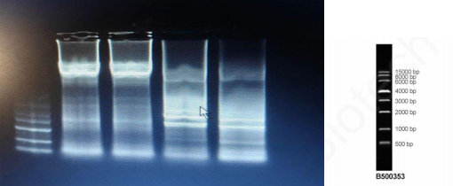
1302 vector PCR electrophoresis results
Wednesday, August 6, 2026
Objective: PCR amplify three target gene fragments—*GjALDH2C3*, *GjCCD4a*, and *RBCS2*—and perform gel purification.
Experiment 1: PCR of the GjALDH2C3 fragment
Reaction mixture (50 μL): 2 μL GjALDH2C3 plasmid + 2 μL GjALDH2C3-F primer
+ 2 μL GjALDH2C3-R primer + 25 μL 2 × Phanta Ultra Master Mix + 19 μL ddH2O.
Program: 98 。C for 30 s → (98 。C for 10 s → 65 。C for 5 s → 72 。C for 15 s) ×34 → 72 。C for 2 min.
Experiment 2: PCR of GjCCD4a Fragment
System: GjCCD4a plasmid 2 μL + GjCCD4a-F 2 μL + GjCCD4a-R 2 μL + 2× Mix 25 μL + ddH2O 19 μL.
Program: 98 。C for 30 s → (98 。C for 10 s → 66 。C for 5 s → 72 。C for 20 s) ×34 → 72 。C for 2 min.
Experiment 3: GjALDH2C3 / GjCCD4a Electrophoresis
• Gel: 50 mL TAE + 0.5 g agarose (1.0%) + 2 μL Gel Red
• Loading: Marker 5 μL × 1; GjALDH2C3 product 50 μL × 2; GjCCD4a product
50 μL × 2
• 120 V, 30 min
• Result: Bright bands appeared in both the left and right lanes, with sizes matching the expected.

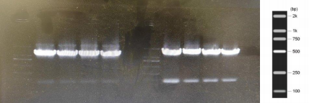
PCR electrophoresis results of GjALDH2C3 (left) and GjCCD4a (right)
Experiment 4: PCR of RBCS2 Fragment
System: RBCS + signal peptide plasmid 2 μL + RBCS2-F 2 μL + RBCS2-R 2 μL + 2× Mix 25 μL + ddH2O 19 μL.
Program: 98 °C for 30 s → (98 °C for 10 s → 61 °C for 5 s → 72 °C for 5 s) × 34 → 72 °C for 2 min.
Experiment 5: RBCS2 Electrophoresis
• Loading: Marker 5 μL × 1; RBCS2 product 50 μL × 4
• 120 V, 30 min
• Result: All 8 RBCS2 samples showed bands.

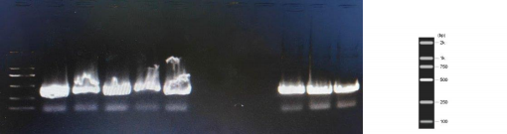
RBCS2 PCR electrophoresis results
Experiment 6: Gel Extraction (Omega Gel Extraction Kit)
Follow the kit instructions for gel extraction: excise the target band → add XP2 Binding Buffer and melt at 50 -60 °C → load onto a Hibind column → wash with SPW → elute with 30 -50 μL.
Concentration of recycled product:

Sample | Concentration  (ng/ μL) | A260/A280 | A260/A230
GjALDH2C3 #1 | 152.20 | 1.882 | 1.268

GjCCD4a | 138.20 | 1.900 | 2.069
RBCS2 #1 | 138.20 | 1.890 | 1.251
RBCS2 #2 | 152.80 | 1.892 | 2.055
Thursday, August 7, 2026
Objective: To ligate the target gene fragment with the 1302 vector backbone
via homologous recombination and transform it into Trelief 5 α competent cells; simultaneously amplify the *2146* and *BKT* fragments by PCR.
Materials: 2× MultiF Seamless Assembly Mix, ddH2O, Trelief 5 α competent cells, LB liquid medium (25 g/L), 1000× kanamycin.
Experiment 1: Homologous Recombination between 1302 and GjALDH2C3

Component | Volume
2× MultiF Seamless Assembly Mix | 10 μL
Linearized vector | 1.3 μL
GjALDH2C3 fragment | 0.5 μL
ddH2O | 8.2 μL
Incubate at 50 °C for 30 minutes, then hold at 4 °C.
Experiment 2: Homologous Recombination between 1302 and GjCCD4a

Component | Volume
2× MultiF Mix | 10 μL
Linearized vector | 1.3 μL
GjCCD4a fragment | 0.6 μL
ddH2O | 8.1 μL
50 °C for 30 minutes.
Experiment 3: Transformation of Recombinant Product into Trelief 5 α
27. Thaw Trelief 5 α on ice, add 10 μL of recombinant product to each, and incubate on ice for 30 minutes.
28. Heat shock at 42 °C for 50 seconds, then cool on ice for 2 minutes.
29. Add 600 μL of antibiotic-free LB and incubate at 37 °C, 200 rpm for 60 minutes.
30. Centrifuge at 5000 rpm for 2 minutes, retain 100 μL of the supernatant, and spread onto LB agar plates containing kanamycin.
31. Incubate inverted at 37 °C overnight.
Experiment 4: PCR of the 2146 Gene Fragment

System: 1 μL of plasmid containing fragment 2146 + 2 μL dsTF2146-F + 2 μL dsTF2146-R + 25 μL 2× Mix + 20 μL ddH2O.
Program: 98 。C for 1 min → (98 。C for 10 s → 63 。C for 5 s → 72 。C for 20 s) ×34 → 72 。C for 2 min.
Experiment 5: PCR of BKT Gene Fragment
System: 1 μL BKT fragment plasmid + 2 μL HpBKT-F + 2 μL HpBKT-R + 25 μL 2 × Mix + 20 μL ddH2O.
Program: 98 。C for 1 min → (98 。C for 10 s → 64 。C for 5 s → 72 。C for 20 s) ×34 → 72 。C for 2 min.
Experiment 6: 2146 / BKT Electrophoresis
• Gel: 50 mL TAE + 0.5 g agarose (1.0%) + 2 μL Gel Red
• 130 V electrophoresis for approximately 25 minutes
• Result: Left side is BKT, right side is 2146, with bright bands.
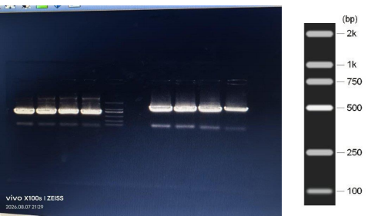
BKT (left) and 2146 (right) PCR electrophoresis results
Experiment 7: Gel Purification of PCR Products from 1302 and 2146
Recover according to the Omega kit.
• 2146 fragment: 152.20 ng/ μL, with A260/A280 and A260/A230 ratios within acceptable ranges.
• BKT fragment: 138.20 ng/ μL, with A260/A280 and A260/A230 ratios within acceptable ranges.

Experiment 8: Homologous Recombination between 1302 and 2146

Component | Volume
2× MultiF Mix | 10 μL
Linearized vector | 1 μL
2146 Fragment | 1 μL
ddH2O | 8 μL
50 °C for 30 minutes.
Experiment 9: Homologous Recombination between 1302 and BKT

Component | Volume
2× MultiF Mix | 10 μL
Linearized vector | 1 μL
BKT fragment | 1 μL
ddH2O | 8 μL
50 °C for 30 minutes.
Experiment 10: Transformation of Trelief 5 α with the recombinant product 1302-2146 / 1302-BKT
32. Add 10 μL of the recombinant product to 100 μL Trelief 5 α and incubate on ice for 15 minutes.
33. Heat shock at 42 °C for 60 seconds, then cool on ice for 10 minutes.
34. Add 700 μL of antibiotic-free LB, and incubate at 37 °C, 200 rpm for 45 minutes.
35. Centrifuge at 12,000 rpm for 1 minute, retain 200 μL of the supernatant, resuspend, and spread onto kanamycin plates.
Friday, August 8, 2026
Purpose: To observe the growth of yesterday's transformed bacterial colonies on the plate.
Result: All four recombinant plasmids (p1302-GjCCD4a, p1302-GjALDH2C3, p1302- 2146, and p1302-BKT) were successfully transformed into Trelief 5 α, yielding sufficient single colonies on the transformation plates.

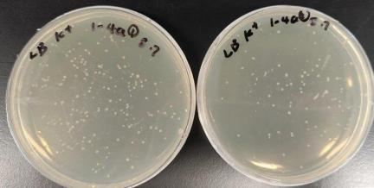
p1302-GjCCD4a transformation plate

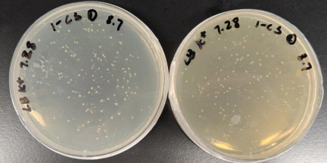

p1302-GjALDH2C3 transformation plate

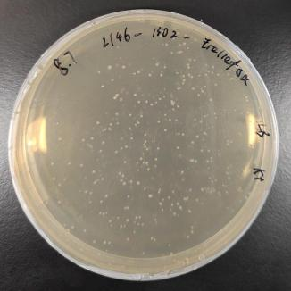

p1302-2146 Conversion Tablet
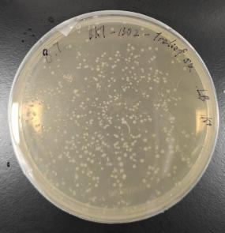
p1302-BKT Conversion Tablet
Experiment: Isolating and Cultivating a Single Colony
• Prepare 8 tubes of 30 mL LB liquid medium (each supplemented with 30 μL kanamycin), and inoculate two tubes each with single colonies from
yesterday's streak plates of 1302-GjCCD4a, 1302-GjALDH2C3, 1302-2146, and 1302-BKT.
• 37 。C, 200 rpm for expanded culture.
Saturday, August 9, 2026
Objective: Perform PCR verification of the bacterial cultures for the first batch of constructed strains 1302-BKT, 1302-2146, 1302-GjALDH2C3, and 1302- GjCCD4a, and extract the plasmids.
Experiment 1: PCR of 1302-GjALDH2C3 bacterial culture
• System: 1 μL bacterial lysate + 1 μL GjALDH2C3-F + 1 μL GjALDH2C3-R + 10 μL 2× Mix + 7 μL ddH2O
• Program: 98 。C for 30 s → (98 。C for 10 s → 65 。C for 5 s → 72 。C for 15 s) ×34 → 72 。C for 2 min
Experiment 2: PCR of 1302-GjCCD4a bacterial culture
• Program: Anneal at 66 。C, extend at 72 。C for 20 seconds.
Experiment 3: PCR of 1302-2146 bacterial culture

• Program: Denature at 98 。C for 1 min, anneal at 63 。C, extend at 72 。C for 20 s.
Experiment 4: PCR of 1302-BKT Bacterial Culture
• Program: Denature at 98 。C for 1 min, anneal at 64 。C, extend at 72 。C for 20 s.
Experiment 5: Electrophoresis of PCR Products from Bacterial Culture
• Gel: 50 mL TAE + 0.5 g agarose (1.0%) + 2 μL Gel Red
• Loading: 20 μL of each plasmid × 2 tubes, Marker 5 μL × 2 wells
• 120 V, 30 min
• Result: All recombinant plasmids amplified the expected bands, and positive clones were preliminarily confirmed.
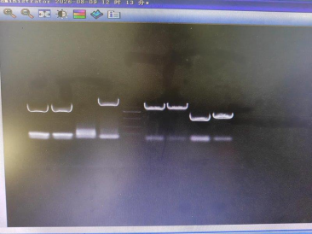
PCR electrophoresis results of 1302-BKT/2146/GjALDH2C3/GjCCD4a bacterial culture
Experiment 6: Plasmid Extraction (Tiangen DP103)
Extract the plasmids 1302-BKT, 1302-2146, 1302-GjALDH2C3, and 1302-GjCCD4a from 30 mL of overnight culture broth.
Plasmid concentration:

plasmid | Sample | Concentration (ng/ μL)
1302-BKT | #1 | 233.70
1302-BKT | #2 | 215.25
1302-BKT | #3 | 271.05
1302-2146 | #1 | 405.95

1302-2146 | #2 | 314.10
1302-2146 | #3 | 352.15
1302-GjALDH2C3 | #1 | 226.20
1302-GjALDH2C3 | #2 | 346.80
1302-GjALDH2C3 | #3 | 170.00
1302-GjCCD4a | #1 | 341.40
1302-GjCCD4a | #2 | 334.70
1302-GjCCD4a | #3 | 261.40
Sunday, August 10, 2026
Purpose: Send the plasmid extracted yesterday for sequencing.
Note: Waiting for sequencing results.
Monday, August 11, 2026
Purpose: Waiting for sequencing results.
Wednesday, August 12, 2026
Objective: Transform the empty pCAMBIA1302 and pCAMBIA1302-2146 plasmids into Trelief 5 α, and culture the bacteria.
Steps:
36. Thaw Trelief 5 α on ice, add 1 μL of plasmid to each, and incubate on ice for 30 minutes.
37. Heat shock at 42 °C for 60 seconds, then cool on ice for 2 minutes.
38. Add 700 μL of antibiotic-free LB and incubate at 37 °C, 200 rpm for 60 minutes.
39. Add the entire 复苏液 to 35 mL of kanamycin-containing LB liquid medium and incubate overnight at 37 °C and 200 rpm.
Thursday, August 13, 2026
Objective: To extract the empty pCAMBIA1302 and pCAMBIA1302-2146 plasmids.
Plasmid concentration:

plasmid | Sample | Concentration  (ng/ μL) | A260/A280 | A260/A230
1302 No Load | #1 | 368.80 | 1.885 | 2.311
1302 No Load | #2 | 85.15 | 1.896 | 2.653
1302-2146 | #1 | 104.50 | 1.898 | 2.555
1302-2146 | #2 | 314.10 | 1.872 | 2.305

Friday, August 14, 2026
Objective: Transform the purified plasmids 1302-BKT, 1302-GjALDH2C3, and 1302- GjCCD4a into Trelief 5 α competent cells.
Steps:
40. Add 4 μL of purified plasmid to each 100 μL Trelief 5 α, and incubate on ice for 30 minutes.
41. Heat shock at 42 °C for 60 seconds, then cool on ice for approximately 30 minutes.
42. Add 700 μL of antibiotic-free LB to each tube and incubate at 37 °C, 200 rpm for 60 minutes.
43. Centrifuge at 5000 rpm for 1 minute, discard the supernatant (500 μL), resuspend the pellet in 100 μL, and spread onto a resistance plate.
44. Incubate overnight at 37 °C.
Saturday, August 15, 2026
Objective: Observe the transformation results from yesterday, perform PCR on the Bar fragment, and carry out retransformation.
Result: Yesterday, the transformation of rc3 (GjALDH2C3), 1-BKT, and 4a
(GjCCD4a) onto antibiotic-resistant plates resulted in confluent growth
(overlapping bacterial lawns). Possible reasons: excessive inoculation
concentration or loss of antibiotic activity on the plates. Decision: reduce the concentration and replate, while also performing a new transformation.

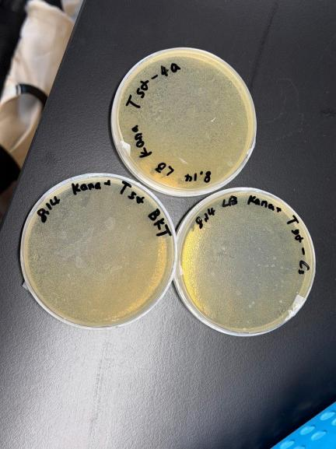
Failed transformation plate (continuous bacterial lawn)
Experiment 1: Bar Fragment PCR
System: Bar plasmid 2 μL + pCAMBIA1302-F 2 μL + pCAMBIA1302-R 2 μL + 2× Mix 25 μL + ddH2O 19 μL.
Program: 98 。C for 30 s → (98 。C for 10 s → 54 。C for 5 s → 72 。C for 7 s) × 34 → 72 。C for 2 min.
Experiment 2: Bar Fragment Electrophoresis
• Gel: 50 mL TAE + 0.5 g agarose (1.0%) + 2 μL Gel Red
• Loading: Marker 5 μL × 1; Bar product 50 μL × 2

• 120 V, 30 min
• Result: The band is incorrect and does not match the expected outcome.

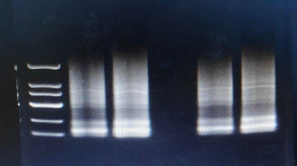
Bar fragment PCR electrophoresis results
Experiment 3: Re-streaking yesterday's transformed competent cells onto plates
• Take 30 μL from each of yesterday's transformed competent cells and spread them onto resistance plates of the same batch used yesterday, then incubate in the incubator.
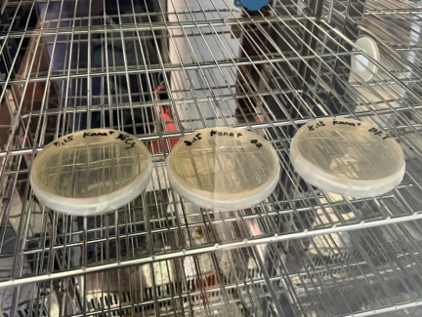
Replate the plate (in incubator)
Experiment 4: Re-transformation of 1302-BKT / 1302-GjALDH2C3 / 1302-GjCCD4a

45. Trelief 5 α, thaw on ice, aliquot into 4 tubes of 50 μL each.
46. Yesterday, 2 μL of plasmid DNA was taken from each of three tubes and added separately; one additional tube without plasmid was set up as a negative control. The samples were incubated on ice for 30 minutes.
47. Heat shock at 42 °C for 50 seconds, then cool on ice for 2 minutes.
48. Add 350 μL of antibiotic-free LB and incubate at 37 °C, 200 rpm for 60 minutes.
49. Centrifuge at 5000 rpm for 2 minutes, retain 200 μL of the supernatant, and spread 50 μL onto a kanamycin plate.
50. Incubate inverted overnight at 37 °C, label as Batch 2.

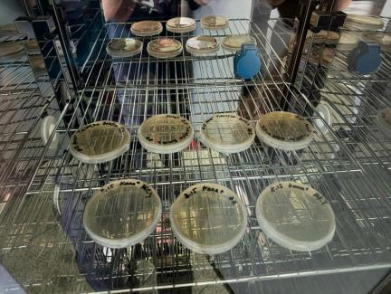
Reconverted tablet (Batch 2)
Sunday, August 16, 2026
Objective: Observe the results of re-plating/re-streaking plates to verify
antibiotic effectiveness; perform PCR on Bar plasmid backbone, gel extraction, and double digestion with 1302.
Result: Yesterday, after re-plating, single colonies were barely observed, confirming that kanamycin had not lost its effectiveness. It was decided to use a 50 μL competent cell transformation system in the future.

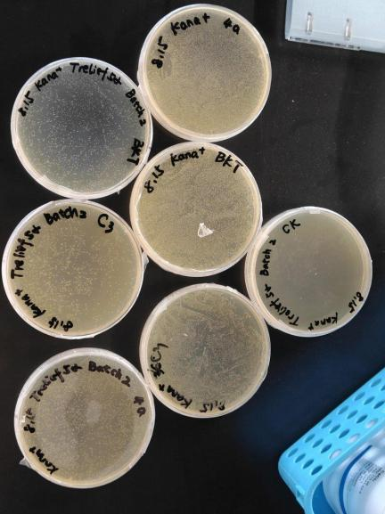
8.16 Plate growth status (left column: 50 μL competent cells, middle column: 100 μL competent
cells, right column: control)
Experiment 1: PCR of the Bar Plasmid Backbone
System: Bar plasmid 2 μL + pCAMBIA1302-F 2 μL + pCAMBIA1302-R 2 μL + 2× Mix 25 μL + ddH2O 19 μL.
Program: 98 。C for 30 s → (98 。C for 10 s → 54 。C for 5 s → 72 。C for 1 min 41 s) × 34 → 72 。C for 2 min.
Experiment 2: Bar Scaffold PCR Electrophoresis
• Gel: 50 mL TAE + 0.5 g agarose (1.0%) + 2 μL Gel Red

• Marker: 250 – 15,000 bp DNA Marker, 10 μL
• Loading: Bar scaffold product 50 μL × 2
• 120 V, 30 min
• Result: The band is located at the expected size of the vector backbone.

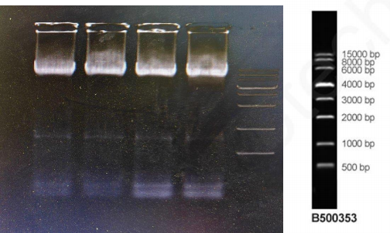
Bar plasmid backbone PCR electrophoresis results
Experiment 3: Bar PCR Product Gel Purification (Omega)
Recovery concentration:

• Sample 1: 53.60 ng/ μL, A260/A280 1.868, A260/A230 1.749
• Sample 2: 45.53 ng/ μL, A260/A280 1.837, A260/A230 1.789 Experiment 4: Double Enzymatic Digestion of pGEM-T 1302

Component | Volume
1302 plasmid (386.8 ng/ μL) | 8.2 μL
MfeI-HF | 1.5 μL
BstEII-HF | 1.5 μL
10× rCutSmart Buffer | 5 μL
ddH2O | 33.2 μL
Digest at 37 °C for 2 hours.
Experiment 5: Isolation and Expansion of Single Colonies

• Prepare 9 tubes of 5 mL LB (each containing 5 μL kanamycin), and pick
three single colonies each from the streak plates of 1302-BKT, 1302-2146, 1302-GjALDH2C3, and 1302-GjCCD4a inoculated yesterday.
• Incubate at 37 。C and 200 rpm.
Monday, August 17, 2026
Objective: To extract the plasmids 1302-BKT, 1302-GjALDH2C3, and 1302-GjCCD4a. Plasmid concentration:
plasmid | Concentration  (ng/ μL) | A260/A280 | A260/A230
1302-BKT | 72.20 | 1.849 | 3.209
1302-GjALDH2C3 | 75.80 | 1.886 | 3.339
1302-GjCCD4a | 74.85 | 1.739 | 4.101
Tuesday, August 18, 2026
Objective: Observe the homologous recombination transformation plates from yesterday, pick single colonies for expansion; initiate the construction of RBCS2 signal peptide fusion.
Result: Yesterday, all plates transformed with the homologous recombination
products (c3, 4a, HpBKT) showed usable single colonies; only a few single
colonies were observed for strain 2146. Today, all single colonies were picked and expanded for culture, and the 2146 colonies were sent to Bioengineering
for sequencing.

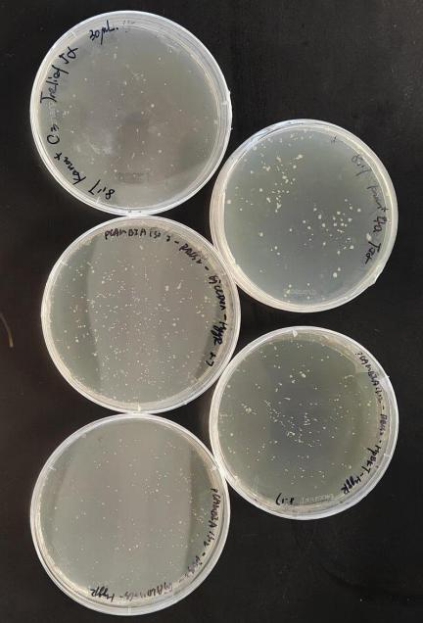

8.18 Transformation plate growth status

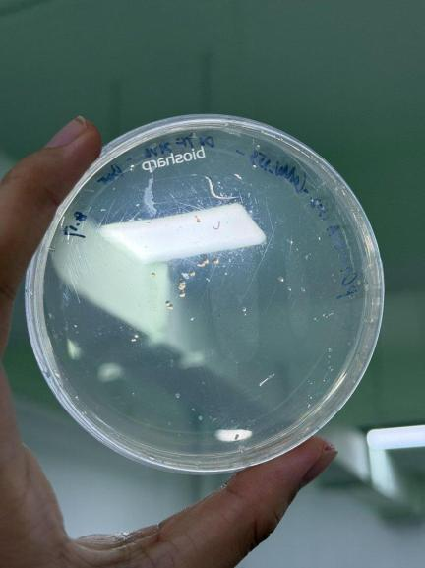

8.18 Plate (2146, few colonies)

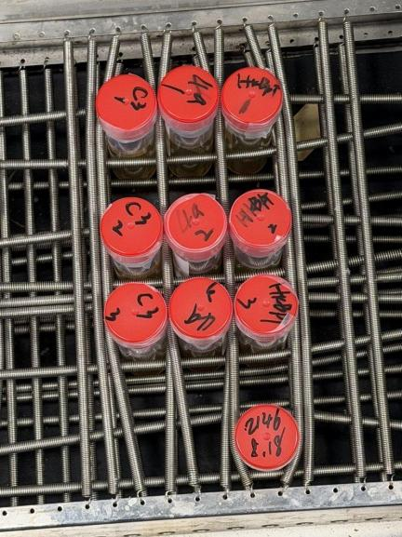
8.18 Shake Flask Inoculation and Expansion
Experiment 1: Extraction of pCAMBIA1302 and pCAMBIA1302-2146 plasmids.
Experiment 2: Pick single colonies of pCAMBIA1302-RBCS2-GjALDH2C3,
pCAMBIA1302-RBCS2-GjCCD4a, pCAMBIA1302-RBCS2-HpBKT, and pCAMBIA1302-RBCS2-2146 for expansion culture.
Wednesday, August 19, 2026
Objective: Extract the RBCS2 fusion construct plasmid and send it for
sequencing; perform PCR amplification of the target gene fragment containing the signal peptide (SP); gel purification; attempt transformation into
Dunaliella salina.

Experiment 1: Plasmid Extraction
Extract plasmids from overnight cultures of pCAMBIA1302-RBCS2-GjALDH2C3,
pCAMBIA1302-RBCS2-GjCCD4a, pCAMBIA1302-RBCS2-HpBKT, and pCAMBIA1302-RBCS2-2146, and send them for sequencing.
Experiment 2: PCR of GjALDH2C3 Fragment (SP Primers)
System: 2 μL GjALDH2C3 plasmid + 2 μL SP-GjALDH2C3-F + 2 μL GjALDH2C3-R + 25 μL 2× Mix + 19 μL ddH2O.
Program: 98 。C for 30 s → (98 。C for 10 s → 65 。C for 5 s → 72 。C for 15 s) ×34 → 72 。C for 2 min.
Experiment 3: PCR of GjCCD4a Fragment (SP Primers)
Anneal at 66 。C, extend at 72 。C for 20 seconds.
Experiment 4: BKT Fragment PCR (SP Primers)
System: 1 μL plasmid containing BKT fragment + 2 μL SP-HpBKT-F + 2 μL HpBKT-F + 25 μL 2× Mix + 20 μL ddH2O.
Program: 98 。C for 1 min → (98 。C for 10 s → 64 。C for 5 s → 72 。C for 20 s) ×34 → 72 。C for 2 min.
Experiment 5: RBCS2 Fragment PCR (Three Reaction Systems)
• System 1: RBCS+signal peptide plasmid 2 μL + HpBKT-sgp-F 2 μL + GjALDH2C3-sgp-R 2 μL + 2× Mix 25 μL + ddH2O 19 μL
• System 2: RBCS+signal peptide plasmid 2 μL + HpBKT-sgp-F 2 μL + HpBKT- sgp-R 2 μL + 2× Mix 25 μL + ddH2O 19 μL
• System 3: RBCS+signal peptide plasmid 2 μL + HpBKT-sgp-F 2 μL + GjCCD4- sgp-R 2 μL + 2× Mix 25 μL + ddH2O 19 μL
• Program: 98 。C for 30 s → (98 。C for 10 s → 65 。C for 5 s → 72 。C for 2
s) ×34 → 72 。C for 2 min.
Experiment 6: Electrophoresis of PCR Products
• Gel: 60 mL TAE + 0.6 g agarose (1.0%) + 2 μL Gel Red
• Loading: Marker 10 μL; GjALDH2C3 50 μL ×1; BKT 50 μL ×1; GjCCD4a 50 μ L × 1; RBCS2 50 μL ×3
• 120 V, 30 min
• Result: Bright bands were observed in all groups.

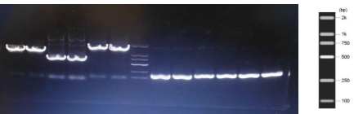
8.19 PCR electrophoresis results (GjALDH2C3, BKT, GjCCD4a, RBCS2) Experiment 7: Gel Purification (Omega)
Recovery concentration:

Sample | Concentration  (ng/ μL) | A260/A280 | A260/A230
SP GjALDH2C3 | 221.10 | reasonable range | Low
SP BKT | 213.35 | reasonable range | Low
SP GjCCD4a | 225.20 | reasonable range | Low
GjALDH2C3 sgp | 227.85 | reasonable range | Low
BKT sgp | 225.90 | reasonable range | Low
GjCCD4a sgp | 170.45 | reasonable range | Low
Experiment 8: 1302-GjALDH2C3 / 1302-GjCCD4a / 1302-BKT Transgenic Dunaliella
Dunaliella salina (FACHB-435) Transformation Protocol (PEG/Triton Method):

51. Dunaliella was cultured in modified PKS liquid/DM medium (containing 1.5 M NaCl) at 26 °C, under a light intensity of 50 μmol photons m-² s-¹ with a 16-hour light/8-hour dark cycle, and grown statically until reaching the
logarithmic growth phase (OD680 ≈ 0.5 -1.0, approximately 105 -106 cells/mL).
52. Centrifuge to collect log-phase cells, discard the supernatant, and
resuspend and wash three times with fresh PKS/DM to completely remove residual metabolites.
53. Resuspend the fresh medium to a concentration of 106 cells/mL.
54. Transfer to fresh medium containing 1 M NaCl and continue culturing for 8 hours (adaptation prior to osmotic shock).
55. Centrifuge 1 mL of the pretreated bacterial suspension to collect the pellet, and discard the supernatant.
56. Resuspend the pellet immediately in 1 mL of fresh PKS/DM containing 0.1 M NaCl.

57. Add in order: 5.46 μg plasmid DNA (pCAMBIA1302 containing the target gene); 15 μL of 0. 1% Triton X-100 stock solution (final concentration for
membrane permeabilization).
58. Vortex oscillation for 60 – 120 seconds (recommended 90 seconds).
59. Transfer immediately to fresh liquid medium.
60. Incubate at 26 °C with 16 hours of light per day for 48 hours; over 90% of surviving transformed cells can resume normal growth.

Dunaliella cell culture and pre-treatment (preparation stage)
Culture Dunaliella FACHB-435 under static conditions in modified PKS liquid/DM medium (containing 1.5 M NaCl) at 26 °C, 50 μmol photons m⁻² s⁻¹ irradiance, and a 16 h light/8 h dark photoperiod. When the cells reach the logarithmic growth phase (density ~10⁵–10⁶ cells/mL), the OD680 is approximately 0.5–1.0.
1. Harvest the log-phase cell culture and collect the pellet by centrifugation.
2. Discard the supernatant, resuspend the pellet in fresh PKS/DM medium, and wash the cells 3 times to thoroughly remove residual metabolites from the old medium.
3. Resuspend the washed Dunaliella cells in fresh medium and adjust the final cell concentration to 10⁶ cells/mL.
4. Transfer the cell suspension to fresh medium containing 1 M NaCl and continue culturing for 8 h. This step serves as “pre-adaptation” for the subsequent osmotic shock.
5. Take 1 mL of the pre-treated cell suspension, collect the cells by centrifugation, and discard the supernatant.
6. Immediately resuspend the pellet in fresh PKS/DM medium containing 0.1 M NaCl (still at a volume of 1 mL).
7. To this 1 mL suspension, precisely add, in order:
- Plasmid DNA: 5.46 μg of pCAMBIA1302 (the vector containing the target gene).
- Surfactant: 15 μL of 0.1% Triton X-100 stock solution (the final concentration assists membrane permeabilization).
8. Place the mixture on a vortex mixer and mix vigorously for 60–120 s (90 s recommended).
9. Immediately after vortexing, transfer the mixture to fresh liquid medium.
10. Recover under static conditions at 26 °C with 16 h light/day for 48 h. At this point, more than 90% of the viable transformed cells resume normal growth.

Dunaliella Transformation Protocol
Thursday, August 20, 2026
Note: No records for the day.
Friday, August 21, 2026
Purpose: Single colonies grew on the plate yesterday; pick single colonies for expansion culture.
Steps:
• Each plate is expanded in one tube, 30 mL system, kanamycin-resistant.
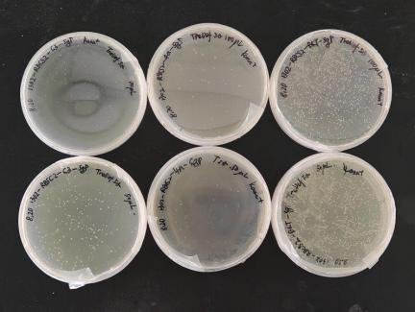
8.21 Plate growth status
Saturday, August 22, 2026
Objective: Perform bacterial PCR verification, purify plasmids, and send for sequencing of the constructed vectors 1302-RBCS2-signal peptide-BKT, 1302-
RBCS2-signal peptide-GjALDH2C3, and 1302-RBCS2-signal peptide-GjCCD4a.
Experiment 1: PCR of 1302-RBCS2-sp-GjALDH2C3 bacterial culture
System: 2 μL bacterial solution + 2 μL RBCS2-F + 2 μL GjALDH2C3-R + 25 μL 2× Mix + 19 μL ddH2O.
Program: 98 。C for 30 s → (98 。C for 10 s → 66 。C for 5 s → 72 。C for 25 s) × 34 → 72 。C for 2 min.

Experiment 2: PCR of 1302-RBCS2-sp-GjCCD4a bacterial culture
Anneal at 66 。C, extend at 72 。C for 30 seconds.
Experiment 3: PCR of 1302-RBCS2-sp-BKT bacterial culture
Anneal at 66 。C, extend at 72 。C for 19 seconds.
Experiment Four: Electrophoresis
• Gel: 60 mL TAE + 0.6 g agarose (1.0%) + 2 μL Gel Red
• Loading: Marker 10 μL; each sample 50 μL ×2
• 120 V, 30 min
• Result: All three RBCS2 fusion constructs amplified the expected bands.
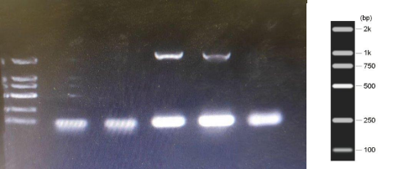
8.22 RBCS2-sp fusion construct bacterial culture PCR electrophoresis results
Experiment 5: Plasmid Extraction (Tiangen DP103)
Plasmid concentration:

plasmid | Sample | Concentration (ng/ μL)
1302-RBCS2-sp-BKT | #1 | 10.80
1302-RBCS2-sp-BKT | #2 | 15.20
1302-RBCS2-sp-GjALDH2C3 | #1 | 13.80
1302-RBCS2-sp-GjALDH2C3 | #2 | 15.05
1302-RBCS2-sp-GjCCD4a | #1 | 14.735
1302-RBCS2-sp-GjCCD4a | #2 | 16.04
Monday, August 24, 2026
Purpose: PCR amplification of the BKT gene fragment.
System: 1 μL plasmid containing BKT fragment + 2 μL HpBKT-F + 2 μL HpBKT-R + 25 μL 2× Phanta Ultra Master Mix + 20 μL ddH2O.

Program: 98 。C for 1 min → (98 。C for 10 s → 64 。C for 5 s → 72 。C for 20 s) ×34 → 72 。C for 2 min.
Tuesday, August 25, 2026
Objective: BKT fragment PCR and gel electrophoresis, gel purification;
homologous recombination between RBCS2 and BKT/GjCCD4a/GjALDH2C3;
transformation of recombinant products; transformation and propagation of 1302-2146 plasmid competent cells.
Experiment 1: BKT Fragment PCR Electrophoresis
• Gel: 60 mL TAE + 0.6 g agarose (1.0%) + 2 μL Gel Red
• Loading: Marker 10 μL; BKT product 50 μL ×4
• 120 V, 30 min
• Result: All four samples showed bands.
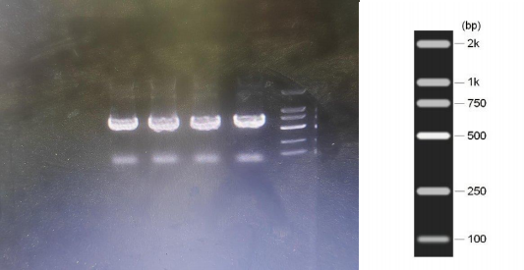
8.25 BKT fragment PCR electrophoresis results
Experiment 2: Gel Purification (Omega)
• Sample concentration: 96.200 ng/ μL.
Experiment 3: Homologous Recombination of RBCS2 with BKT/GjCCD4a/GjALDH2C3
Experiment 4: Transformation of Homologous Recombination Products into Competent Cells
Experiment 5: Plasmid Transformation and Amplification of Competent Cells

Objective: Yesterday, single colonies grew on the plates; pick single colonies for expansion culture and extract the plasmid 1302-2146.
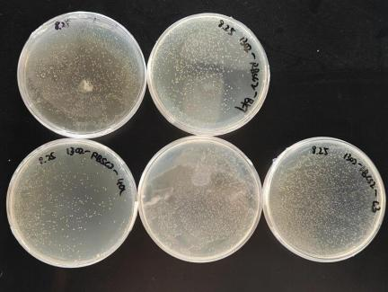
8.26 Plate growth status
Experiment 1: Isolation and Expansion of Single Colonies
Experiment 2: Plasmid Extraction from 1302-2146

Sample | Concentration  (ng/ μL) | A260/A280 | A260/A230
1-1 | 384.65 | Reasonable | Reasonable
1-2 | 431.90 | Reasonable | Reasonable
2-1 | 470.35 | Reasonable | Reasonable
2-2 | 425.45 | Reasonable | Reasonable
3-1 | 549.45 | Reasonable | Reasonable
3-2 | 512.80 | Reasonable | Reasonable
Thursday, August 27, 2026
Objective: To extract the plasmids 1302-RBCS2-BKT, 1302-RBCS2-GjCCD4a, and 1302-RBCS2-GjALDH2C3.

Sample | Concentration (ng/ μL)
1302-RBCS2-BKT-1 | 109.75
1302-RBCS2-BKT-2 | 62.65

1302-RBCS2-GjCCD4a-1 | 94.55
1302-RBCS2-GjCCD4a-2 | 109.05
1302-RBCS2-GjALDH2C3-1 | 119.05
1302-RBCS2-GjALDH2C3-2 | 125.95
A260/A280 and A260/A230 ratios are within acceptable ranges.
Friday, August 28, 2026
Experiment 1: 1302-2146 Dunaliella Transformation
Experiment 2: Transformation and Expansion of Competent Cells 1302
Saturday, August 29, 2026
Experiment 1: Transformation and Expansion of Empty Plasmid Competent Cells in 1302
Sunday, August 30, 2026
Experiment: Inoculate and expand a single colony.
Monday, August 31, 2026
Experiment: Plasmid purification.
Tuesday, September 1, 2026
Experiment: Sequencing sample submission.
Wednesday, September 2, 2026
Experiment: 87373721302 Linearization; RBCS2 PCR.
September 3, 2026 (Thursday)
Experiment: Homologous recombination, competent cell transformation, and plating of 1302-RBCS3-sp-BKT / GjCCD4a / GjALDH2C3.
September 4, 2026 (Friday)
Purpose: Colony PCR verification.
Result:
• DNA Marker: 15000
• First 10 in the front row: 1302-RBCS3-sp-BKT
• First 8 in the second row: 1302-RBCS3-sp-GjCCD4a
• Second row, back 6: 1302-RBCS3-sp-GjALDH2C3
• The band size does not match the expected size and is similar to that of the target gene fragment without promoter and signal peptide.

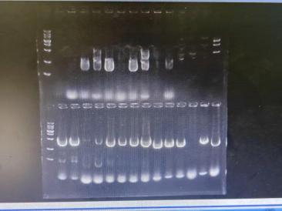
9.4 Colony PCR Electrophoresis Results
Tuesday, September 22, 2026
Purpose: Colony picking and liquid culture expansion.
Reagents and Materials:
61. p1302 empty vector LB solid plate with single colonies grown
62. LB liquid medium
63. Kanamycin stock solution
64. Sterile EP tubes / sterile test tubes, sterile pipette tips, inoculating loops / sterile pipette tips, alcohol lamp, 37 。C constant temperature
shaker
Procedure:
65. In a sterile environment, gently touch the well-formed, isolated single
colony on the plate with a sterile pipette tip, avoiding excessive agar
removal. Then, insert the tip containing the colony into an LB liquid tube and thoroughly resuspend and elute the colony by pipetting.
66. Control: It is recommended to include a negative control (LB medium
containing kanamycin but no bacterial culture) to check for contamination.
67. Shake culture: Loosen the test tube cap by half a turn (to ensure aeration), place in a 37 。C constant-temperature shaker at 200 rpm, and incubate with
shaking overnight for 12 -16 hours.

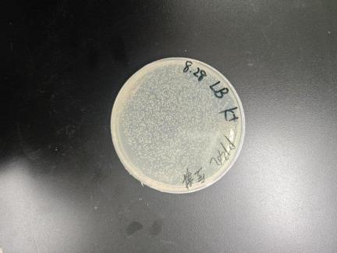
9.22 Pick-up plate (p1302 empty load)

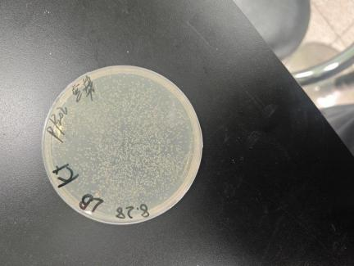
9.22 Bacterial isolation plate

Main Reagents and Instruments
• Host for cloning : Escherichia coli DH5 α, Trelief 5 α competent cells
• Vector : pCAMBIA1302 (kanamycin resistance)
• Polymerase : 2× Phanta Ultra Master Mix (Novegen)

• Connection : 2× MultiF Seamless Assembly Mix (homologous recombination)
• Plasmid extraction : Tiangen DP103 Plasmid Mini Kit
• Gel Recovery : Omega Gel Extraction Kit
• Restriction enzymes : MfeI-HF, BstEII-HF (NEB), 10× rCutSmart Buffer
• Culture conditions : LB medium, kanamycin 50 μg/mL, 37 °C, 180 -200 rpm
• Dunaliella salina strain: FACHB-435
• Dunaliella medium : Modified PKS/DM medium (containing 1.5 M NaCl), 26 °C, 50 μmol photons m-² s-¹, 16 h light per day

