**CSI2120 Project Part 2 Report**

Zhiyu Lin 300255509

Yitao Cui 300345709

**Functions**

**1.**

(define (read-helper p)

; helper function used to read all numbers from the

query histogram and store them in a list

; returns a list that stores the histogram data

**2.**

(define (readQuery queryFilename)

; read query histogram file and store it in a list,

ex: (0.0029 0.0157 ...), already normalized.

; returns a list that stores the normalized histogram

data.

**3.**

(define (readDataset-helper p)

; helper function used to read all numbers from the

dataset histogram, and normalize each histogram data.

; returns a list that stores the histogram data

**4.**

(define (readDatasetHistogram datasetFilename)

; read dataset histogram file and store it in a list.

; returns a list that stores the normalized histogram

data.

**5.**

(define (get-txt-files directory)

; read dataset files names

; returns a list that stores dataset files name

ex: (1001.jpg.txt 1002.jpg.txt 1003.jpg.txt ... )

**6.**

(define (process-files file-list directory)

; processes each file in a list by constructing sublists that contain each dataset image's filename and its histogram.

; returns a list that stores dataset files names and histograms. ex: ((1001.jpg.txt (histogram)) ... )

**7.**

(define (compare-histograms query-hist dataset-hist)

; helper function used to calculate the similarity score between a query histogram and a dataset histogram.

; query-hist (list), dataset-hist (list) -> Output: similarity score (number)

**8.**

(define (process-and-compare-files file-list directory query-histogram)

; helper function used to process and compare each histogram in the dataset with the query histogram.

; returns a list of similarity scores paired with filenames.

; file-list (list), directory (string), query-histogram (list) -> Output: (list)

**9.**

(define (compare-query-with-dataset directory queryFilename)

; compares the query histogram to all histograms in the dataset.

; returns a list of similarity scores and corresponding filenames.

; directory (string), queryFilename (string) -> Output: (list)

**10.**

(define (insert-sorted result item)

; inserts an item into a sorted list based on the item's first element. Sort from biggest to smallest.

; returns the sorted list

**11.**

(define (sort-results results)

; sort the similarity results list (from biggest to

smallest)

; returns the sorted list

**12.**

(define (insert-sorted result item)

; inserts an item into a sorted list based on the item's first element. Sort from biggest to smallest.

; returns the sorted list

**13.**

(define (take-first-5 lst)

; helper function for display the final results.

; returns the first 5 elements from a list.

**15.**

(define (display-results results count)

; helper function for display the final results.

; Output: displays the Top 1 to Top 5 file names and similarity.

**16.**

(define (similaritySearch queryHistogramFilename imageDatasetDirectory)

; main function, get the query histogram file name and the dataset directory.

; Output: displays the final results.

**Results**

**q00**

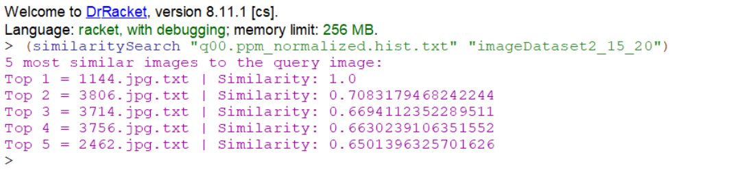

**q01**

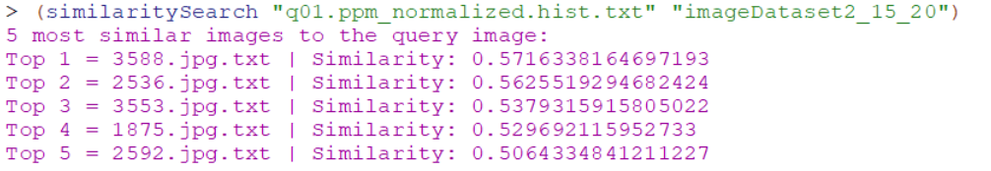

**q02**

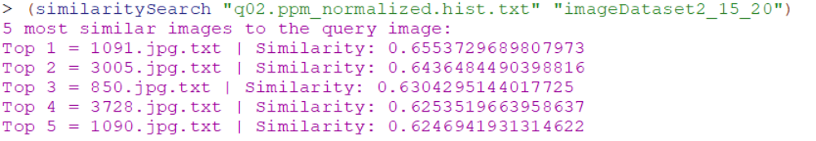

**q03**

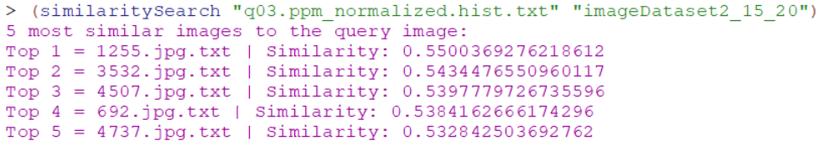

**q04**

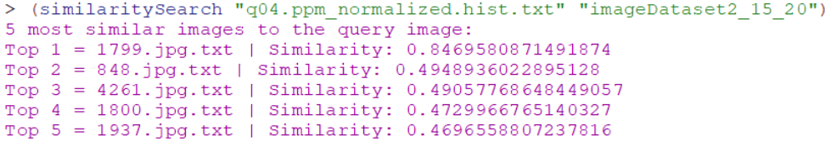

**q05**

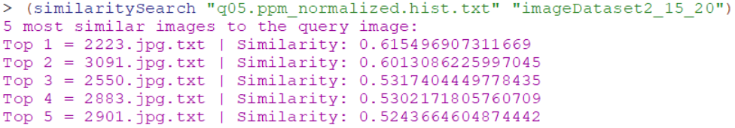

**q06**

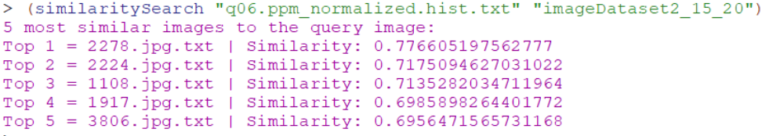

**q07**

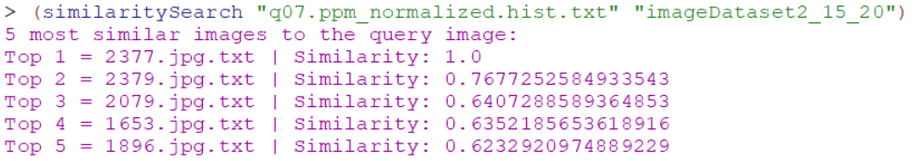

**q08**

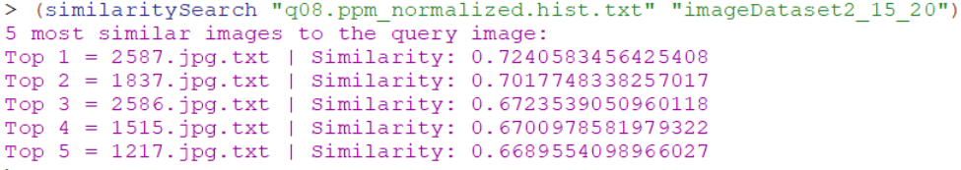

**q09**

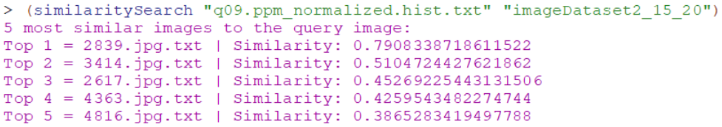

**q10**

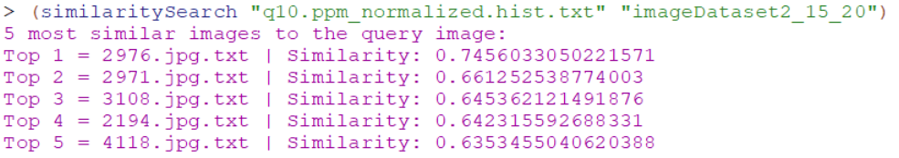

**q11**

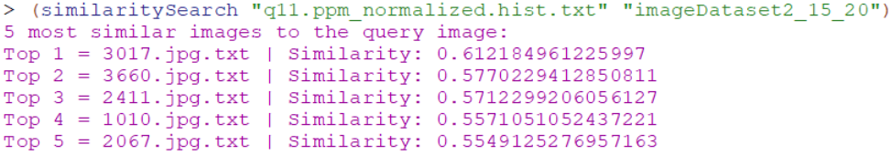

**q12**

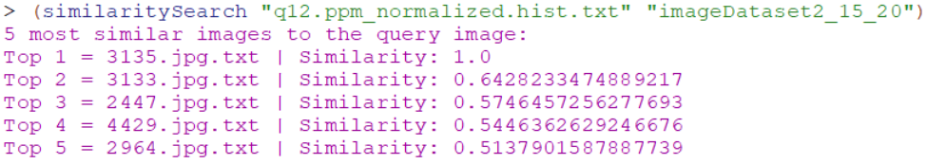

**q13**

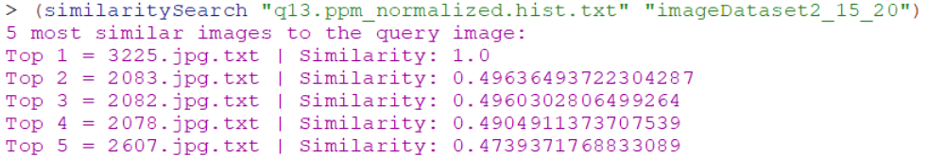

**q14**

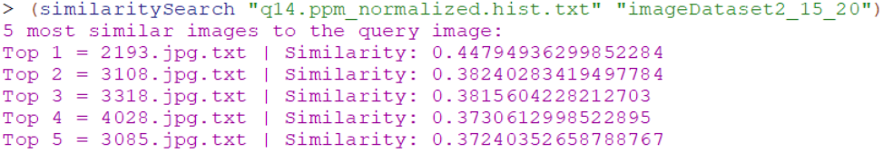

**q15**

