User Manual

1.**Functionalities of PIRs**

**Contacts**: Stores essential contact details such as **names**, **phone numbers**, **emails**, and **addresses**.

**Events**: Manages event-related information, including **descriptions**, **start times**, and customizable **alarm settings**.For events, we have set up a series of alarm mechanisms. In addition to returning through the command line within the program. If the program notices that some of the user's event times meet certain requirements during operation, it will automatically send an **email** prompting the event to the user's registered mailbox.

**Tasks**: Organizes tasks, complete with **descriptive elements** and **deadlines**.

**QuickNotes**: Facilitates the creation of brief, text-based **notes**.

2.**Usage tutorial:**

Users need to start the program from main. The command line will then display an interactive option. **Select** the type of instance to be created according to the type required by the user, or directly **load files**, **search** and **exit** directly.

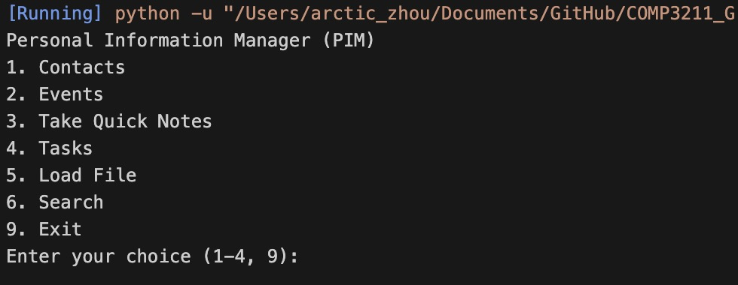

After selecting any instance type (**Enter 1,2,3,4**), the system will prompt the user whether to enter the name of the file to store the instance created this time. If '**y**' is selected, the user will be asked to enter the name of the required file, and then a new file with this name will be created in PIM_dbs; if '**n**' is selected, a file of the corresponding type will be created in a default format. The file name contains the **current date**.

WeChat1dbefe6fa98bd61c75f54fb9c3ed4a1a

After selecting the file to load(‘**y**’), the user will be prompted to enter the name of the file to be loaded. After verifying that the file is correct, the operation interface for the file is also entered.

WeChatc8e94769f9b59254620580f50e5aefc0





图形用户界面, 文本

**Contact, Event, Task**

1. **Choice interface**

After creating an instance storage file or loading a file, the user will be asked to choose what to do with the file. Operations are divided into **add**, **view** and **delete**. The function of **add** is to create the corresponding instance in the file. After selection, the user will be prompted to enter several attributes of the instance; the function of **view** is to return the instance that the user wants to query. After selection, the user will be prompted to enter the name of the instance; **delete** is used to delete An instance also requires the user to enter the corresponding name after selection.

(Contact choice interface)

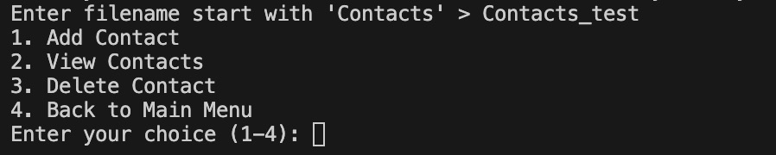

(Event choice interface)

文本

(Task choice interface)

形状

1. **Add function (enter ‘1’)**

(if input contain null, it output **null input try again**)

For **contact** we need to enter: **name, phone number, email, adress**

For **event** we need to enter: **description, start time, alarm**

(note start time must follow format: YYYY-MM-DD HH:MM, and alarm indicate minutes)

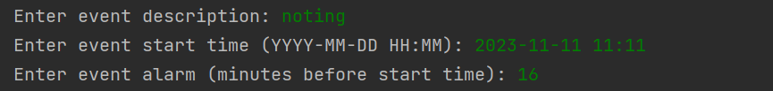

For **event** we need to enter: **description, ddl**



(note start time must follow format: YYYY-MM-DD HH:MM)

1. **View function (enter ‘2’)**

(View of contacts)

形状

(View of events)

形状

(View of tasks)

**形状

**

1. **View delete (enter ‘3’)**

(if delete reference **not found**, it output **file not found**)

For **contact** we need to delete by **name**



For **event** we need to delete by **description**

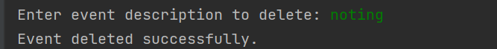

For **task** we need to delete by **description**



1. **Back to main menu (enter ‘4’)**

back to main page

**QuickNote**

Enter ‘3’ to enter note mode, This mode allows for line breaks. Typing '**END**' followed by the Enter key signifies the end of input. At this point, four options will appear: enter '**w**' to rewrite and overwrite the existing file, enter '**a**' to append to the end of the file, enter '**c**' to continue note-taking, and enter '**q**' to exit without saving the file. If any other commands are entered, a message will prompt an incorrect input.

**Search**

For the search function, the system will directly retrieve matching files and instances in the database through the prompt words entered by the user and return them, allowing users to quickly obtain instance information. User need to first enter type of file they want to search (or ‘q’ to quit), then input further information. The output will be the list of the name of matching file. Invalid format of input (such as wrong format of operator with keywords, datetime format)



For **Contacts** and **QuickNotes** we support search by **keywords (also with ‘||’, ‘&&’, ‘!’)**

For **Contacts** and **QuickNotes** we support search by **keywords (enter ‘1’)** and search by **datetime (enter ‘2’) (with ‘>’, ‘<’, ‘=’) (also with ‘||’, ‘&&’, ‘!’)**

**Load**

The load feature allows users to load a specified file into the system by entering the file name. If the file does not exist, it will return '**file not found**'. If the file exists, the system will access the file and provide relevant follow-up operations.

**Alarm**

This is a hidden feature that does not require active usage. It starts a daemon process as soon as the program launches, reads events from the database, matches the current time with the event time and the preset alarm time, and sends notifications to the user via email.

**3.Precautions**

When the user enters the file name, instance name, attribute name of the instance and searches for key words during use, the system presets the corresponding data type or string format. If the user does not follow the appropriate restrictions, the system will reject the user's input.

**4.PIRs Input Restrictions**

Mandatory field compliance is key; contacts require a name and at least one mode of contact, while events and tasks demand properly formatted dates and times.

**5.Input Commands and Structure**

The system operates on numerical input for menu navigation. Detailed prompts guide the entry of PIR-related information.Special commands (e.g., ‘q’ for quitting) are integral for navigation and exiting interfaces.

**6.Invalid Input Handling**

The system is designed to identify and alert users of incorrect inputs, prompting for rectification.Error messages are clear and directive, guiding towards correct data entry.

**7.Output Interpretation**

Upon successful operations, the system affirms actions with clear messages.Outputs, be they search results or viewing requests, are formatted for ease of comprehension.

**8.Advanced Features**

The search utility in the system is robust, supporting keyword-based, date-oriented, and logic-driven queries.Event alarms are automated, adhering to preset parameters for user convenience.