**Team member**

Zhiyan Li([zl7904@rit.edu](mailto:zl7904@rit.edu))

Sahil Gupta([sg5414@rit.edu](mailto:sg5414@rit.edu))

**Problem Definition**

State of the problem is represented in combination of die orientation and it’s location on maze. Three axis up,north and east is used to define orientation. Location is define by (x,y) coordinates. So state is represented as tuple {up,north,east,x,y}. In order to reach goal state orientation and location of die state get changes. Search tree node contain instance of such state. For one up direction there are 4 orientation. There are 5 up directions possible since 6 is excluded in given problem. If l is the length, b is breath and bc are the number of blocks then l*b- bc are the number of positions die can go. So total number of states total number of states are 5*4*(l*b-bc).

**Representation of Problem**

1. Initial State: {1,2,3,xs,ys} is the intial state. So 1 will be at top, 2 at north and 3 at east direction. (xs,ys) is the location of the start block in the maze.

2. State Transition: Rotation of die along the north axis and east axis leads to change in location of die. Single unit of rotation leads to change in 1 square in up,down,right and left direction. Each unit square motion is the state transition of die. Transitions in which 1 is in up direction or square in which it will move is block square is not allowed. Each unit transition add unit transition cost on search problem.

3. Goal State: {1,*,*,xg,yg} is the goal state. So 1 is in up direction,* means any other possible number and (xg,yg) are the goal block location.

**Heuristic Functions**

We have used three heuristic functions. Euclidean, Manhattan and orientation Manhattan. Admissibility property means that metric never over-estimates true cost from start to goal state.

**Euclidean Distance**

It measure the shortest distance of line segment between two blocks.

It is not possible to overestimate it since there is not distance shorter than line distance between two points. So it is admissible. It assumes that die can move in straight line, no orientation is taken into account and there are no obstacle in between.

**Manhattan Distance**

It measure the number of steps or moves/rotations required to reach goal state. It is not possible to overestimate it as there is no path that calculate shorter number moves then this by geometry. Also since banned squares are there in between so real cost should be more than this as it ignore the banned squares. So it is admissible. It assumes that die can rotate either vertically or horizontally, orientation is not taken into account and no obstacles or banned squares are there.

**Orientation Manhattan distance**

It measure the moves /rotations required to reach goal state but with orientation into consideration. There are few rules that consider die at goal state, inline with goal state or away from goal state and not inline. Further through another estimator function goal position is estimated from number of steps/rotation,current orientation and goal orientation. If die is having one upwards than after four rotations in any directions it will return to same state.  
Using this fact along with Manhattan distance these few rules are constructed. In this scheme, either exact distance or just short of the exact distance is generated. So it is not possible to overestimate and is admissible.

It assumes that die can rotate either vertically or horizontally, orientation is taken into account so die must roll not slide,no obstacles or banned squares are there and if die is not in estimated goal orientation at goal state then in least amount of moves it can achieve that.

**Performance Metrics**

|  |  |  |  |  |  |  |
| --- | --- | --- | --- | --- | --- | --- |
|  | Euclidean | | Manhattan | | Orientation Manhattan | |
| States | Generated | Visited | Generated | Visited | Generated | Visited |
| Puzzle 1 | 13 | 9 | 13 | 9 | 29 | 19 |
| Puzzle 2 | 3 | 3 | 3 | 3 | 3 | 3 |
| Puzzle 3 | 37 | 27 | 29 | 21 | 38 | 26 |
| Puzzle 4 | 117 | 94 | 84 | 66 | 125 | 101 |
| Puzzle 5 | 1128 | 990 | 1282 | 881 | 966 | 616 |

**Graphs**

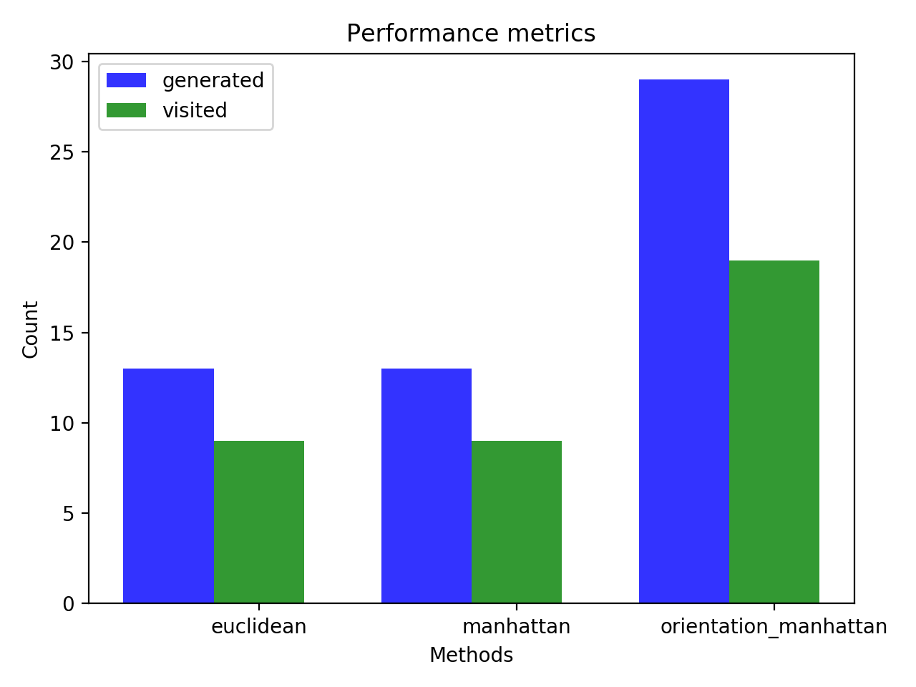

Performance metrics of puzzle 1

**Discussion**

Added to explanation the possibility of creating heuristics with knowledge of blocked squares but simultaneously the danger of overestimation.