Installing VS Code

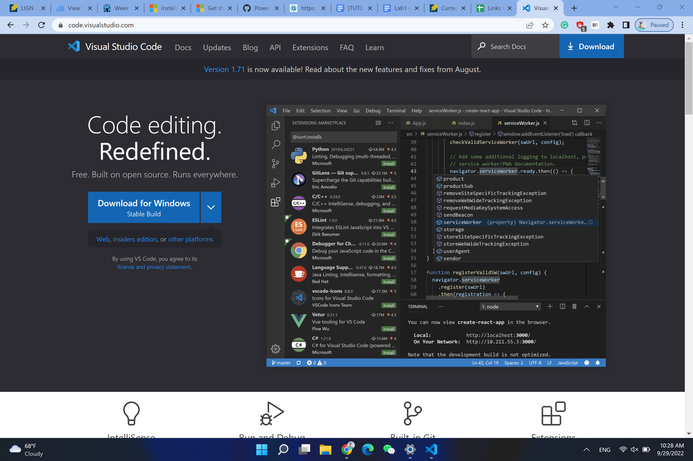

Search for VS Code in Google, and find the download link on the website

Install it to the computer.

Remotely Connecting

Run Some Commands

Local:

On the server:

ls /home/linux/ieng6/cs15lfa22/ can show the name of each members on the CSE15L server



From group member:

Steven suggested that “The whoami command prints out the current username of the active” 

Moving files with scp

I set up the java file and run it locally on my computer

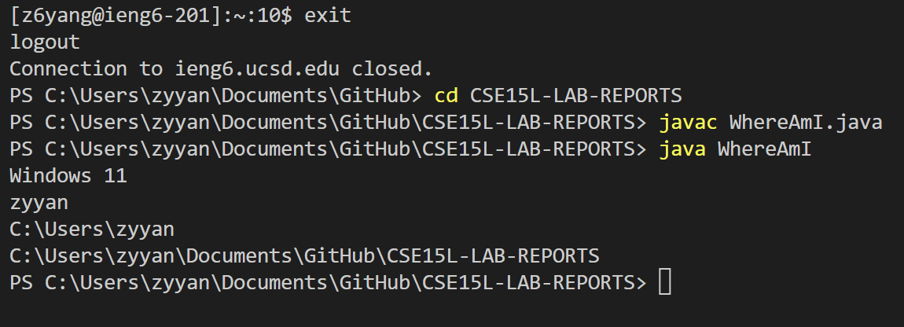

And using the scp to move it to the server and run it on the server.

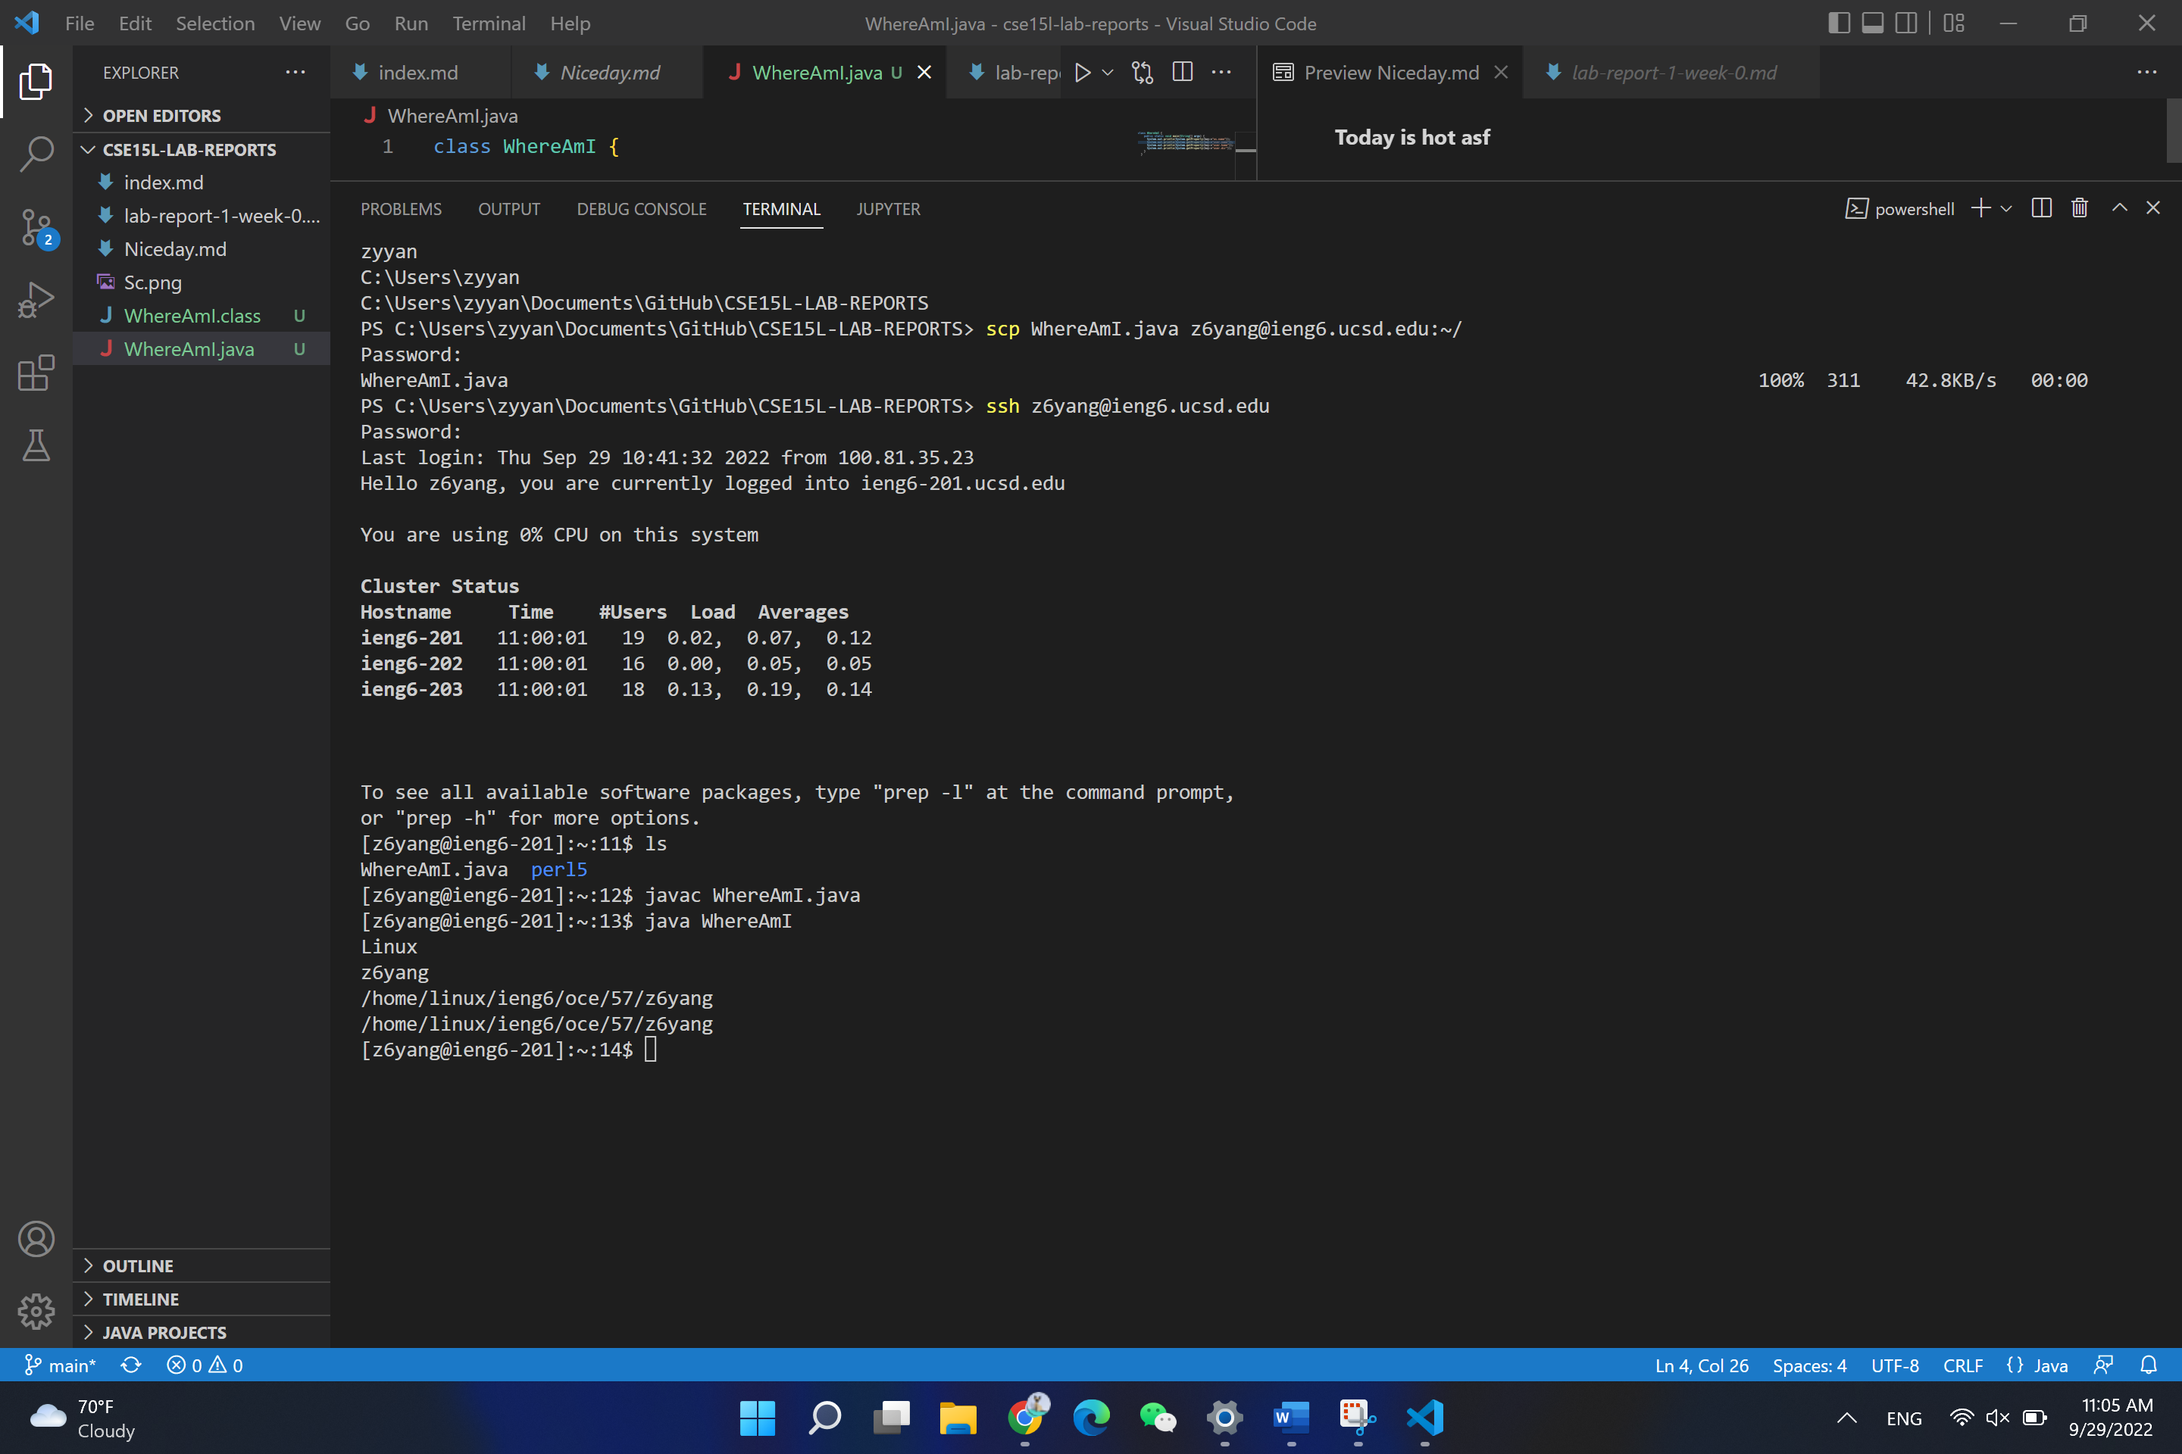

Setting an SHH key:

I set up the SHH key on the computer according to the instructions.

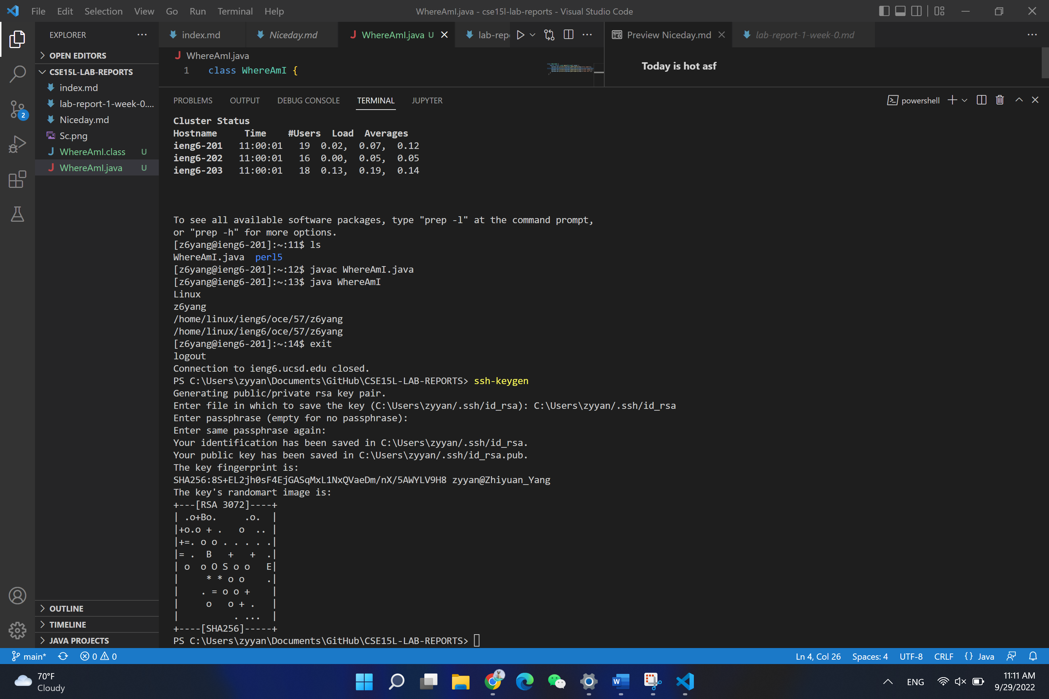

I was a little bit lost during the process, but I solved it after discussing with my group mate.

Optimizing Remote Running

I used ls command to make it show the files in the directory right after logging in, and using javac and java at the same time to make the two steps into one line.

