Nanyang Technological University

Lab 4 Report:

# Visual Mathematics

## CZ 2003 Computer Graphics and Visualization

### Yi Zhiyue

# Experiment 4: Implicit Solids

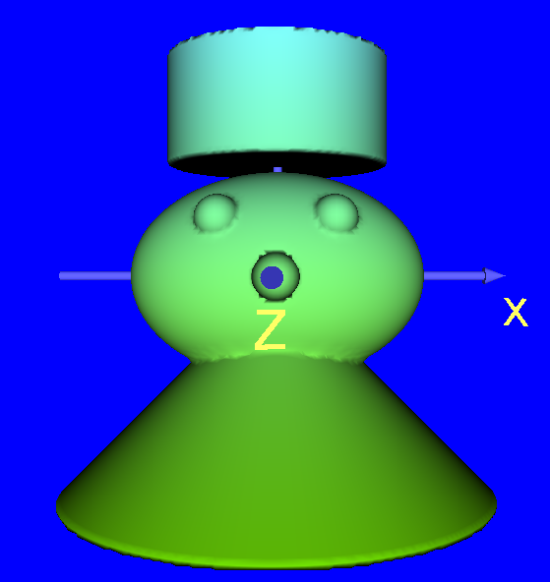 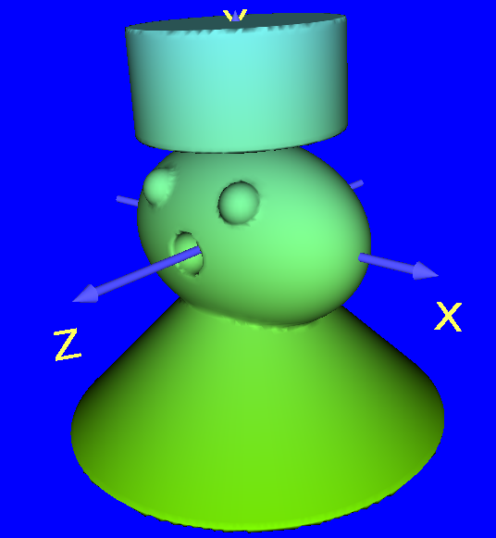

This CSG is an illustration of a princess wearing a dress and a crown.

The dress is a cone with a base. This element is constructed with the plane subtracting the cone.

The head is an ellipsoid union with 2 spheres as eyes and subtracting another sphere as a mouth.

The crown is a cylinder intersecting with 2 planes so that the height is shorten.

At last, all the three main parts union together as a model of princess.

|  |  |
| --- | --- |
|  | diffuseColor "  r=u*0.5*(1-w)*sin(2*pi*v);  g=0.5*w;  b=u*0.5*(1-w)*cos(2*pi*v);" }  Using the expression with variables to create changing diffuse colors. |
|  | diffuseColor "r=u; g=v; b=w;"  r, g and b represent red, green and blue respectively. The value of them represent how deep the base color is.  If variables are assigned to r, g and b, the colors will be varied and gradient on the model. |
|  | diffuseColor "r=u; g=0; b=0;"  It shows that u controls the diffuse color in x axis. |
|  | diffuseColor "r=v; g=0; b=0;"  It shows that v controls the diffuse color in y axis. |
|  | diffuseColor "r=w; g=0; b=0;"  It shows that w controls the diffuse color in z axis. |