**Zhambulkhan DInmukhamed, SE-2419**

**WEB Technologies**

**Assignment 6**

**Part 1: Introduction to JavaScript**

**Task 0 – First Script**

In this task, I created an HTML page and linked it with an external JavaScript file.  
The script prints my name and group in the console and shows an alert message “Hello, JavaScript World!”.  
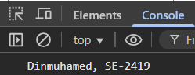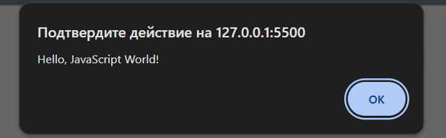

**Task 1 – Variables & Operators**

I declared variables of different types such as string, number, and boolean.  
Then I performed arithmetic operations and string concatenation, printing the results to the console using console.log().  
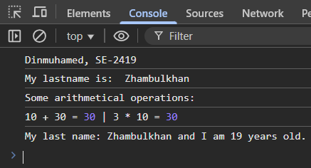

**Part 2: DOM Manipulation**

**Task 2 – Changing Content**

I created a paragraph and a button.  
When the button is clicked, the paragraph text changes to a new message.  
This demonstrates how JavaScript can dynamically change the content of HTML elements.  
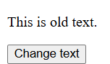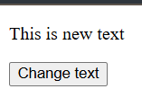

**Task 3 – Changing Styles**

I made a <div> element and two buttons.  
The first button changes the background color of the block, and the second changes the font size of the text inside the block.  
This shows how to use the style property in JavaScript.  
{1AB31807-0D7C-4F8B-8A23-95F2F0BA1077}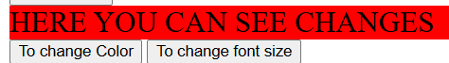

**Task 4 – Creating & Removing Elements**

In this task, I added two buttons — **Add Item** and **Remove Item**.  
The first button adds a new list item (<li>), and the second one removes the last item.  
It demonstrates how to create and delete HTML elements using createElement() and removeChild().  
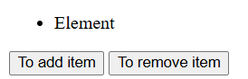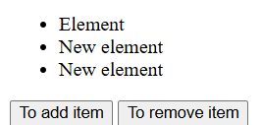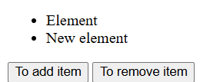

**Part 3: Events**

**Task 5 – Mouse Events**

I created a box that changes its color when the mouse moves over it (mouseover event) and returns to the original color when the mouse leaves (mouseout).  


**Task 6 – Keyboard Events**

I created an input field that displays its current value in real time as the user types.  
This uses the keyup event to update text dynamically.  
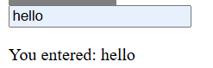

**Task 7 – Form Validation**

A simple form with Name, Email, and Password fields was created.  
If any field is empty, the form submission is prevented and an error message is displayed below the form.  
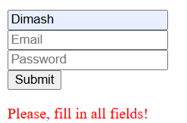

**Part 4: Mini Project — To-Do List**

I developed a simple To-Do List application using JavaScript.  
Users can add new tasks, delete them, and mark them as completed by clicking on them (which applies a strikethrough style).  
Tasks are stored temporarily in an array.  
This project combines event handling, DOM manipulation, and dynamic styling.  
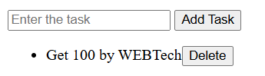

**Conclusion**

Through this practical work, I learned the basics of JavaScript, including:

* Using variables and operators;
* Working with the DOM (Document Object Model);
* Handling user events (mouse, keyboard, and forms);
* Creating dynamic and interactive web pages.

The final To-Do List project helped me understand how JavaScript can make websites more interactive and user-friendly.