Q1: Total revenue in 2024?
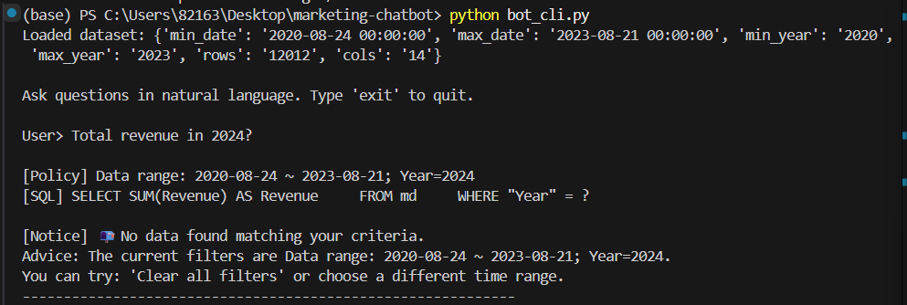

Q2: Top 5 campaign names by revenue last quarter.
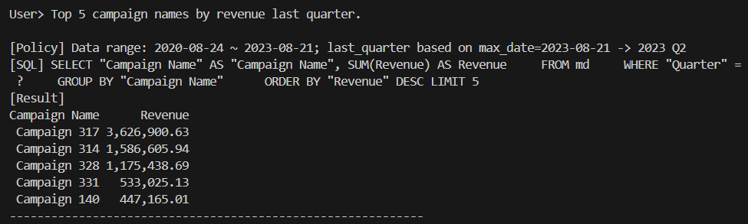

Q3: Revenue and cost trend by month.
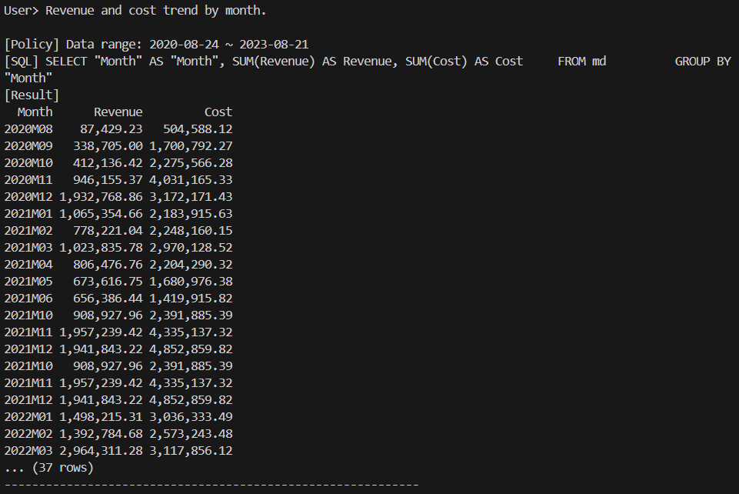
Q4:Which media categories had the highest profit in Q2 2023?
Now only for Product = 2 (Follow-up)
Same but last quarter (Follow-up)
