# Bar(10, 10) STYLE=2

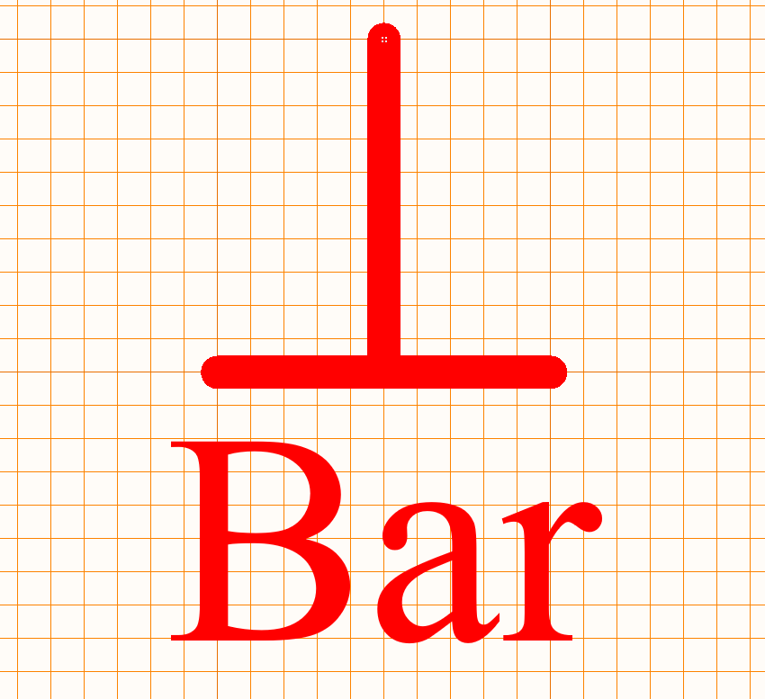

# Arrow(4, 6,6) STYLE=1

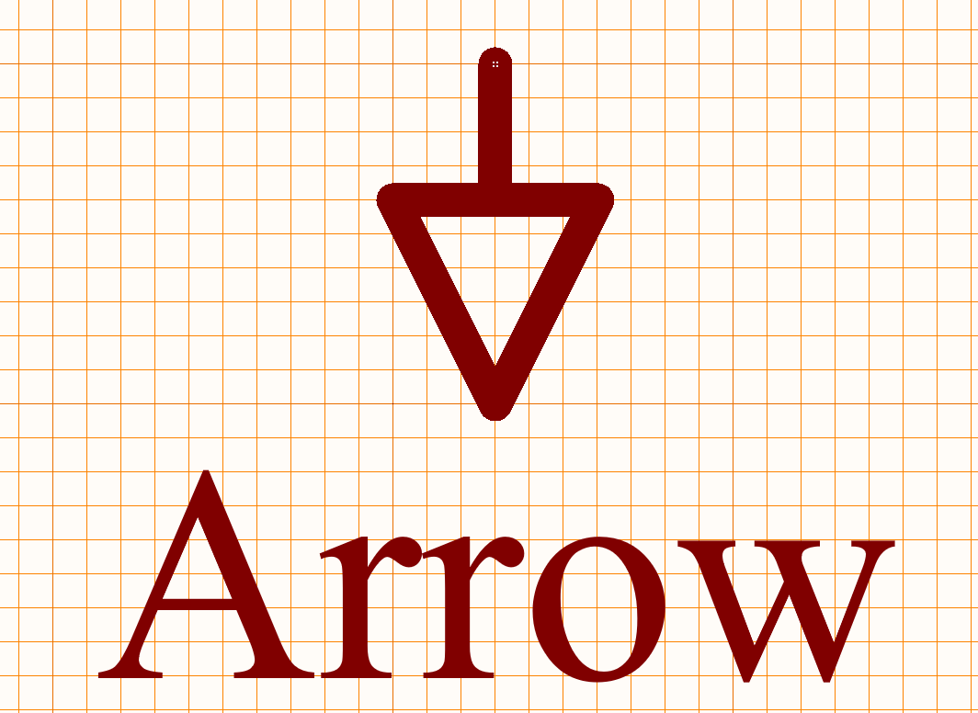

# Circle(4, 3) STYLE=0

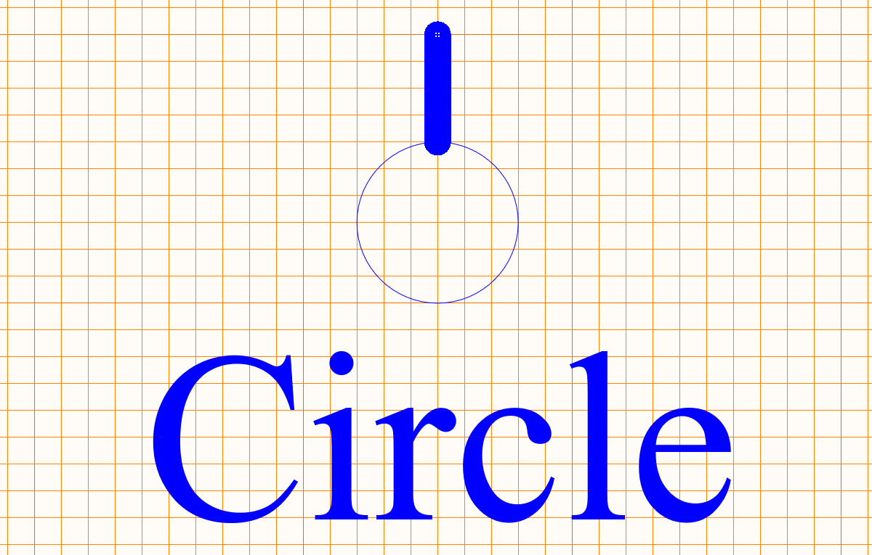

# WAVE (6, 4) STYLE=3

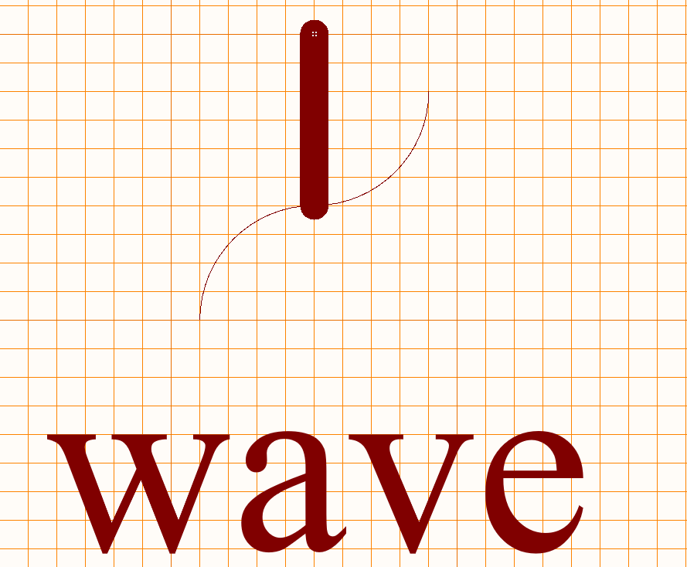

# POWER GROUND (10, 10, 7, 4, 1, 3) STYLE=4

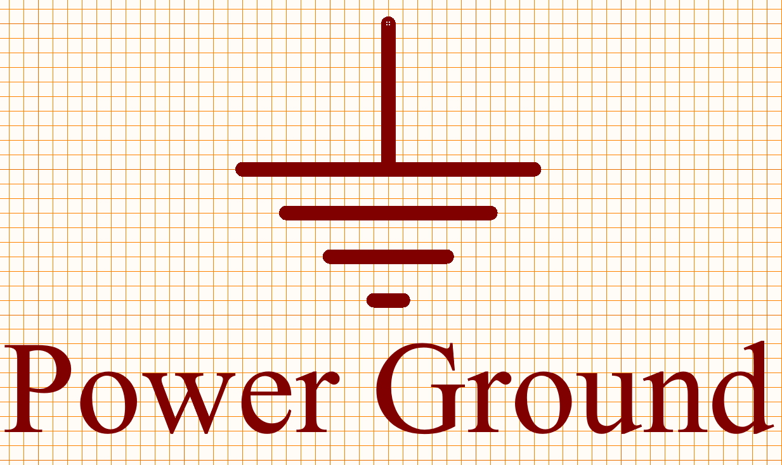

# Signal Ground(10, 10,10) STYLE=5

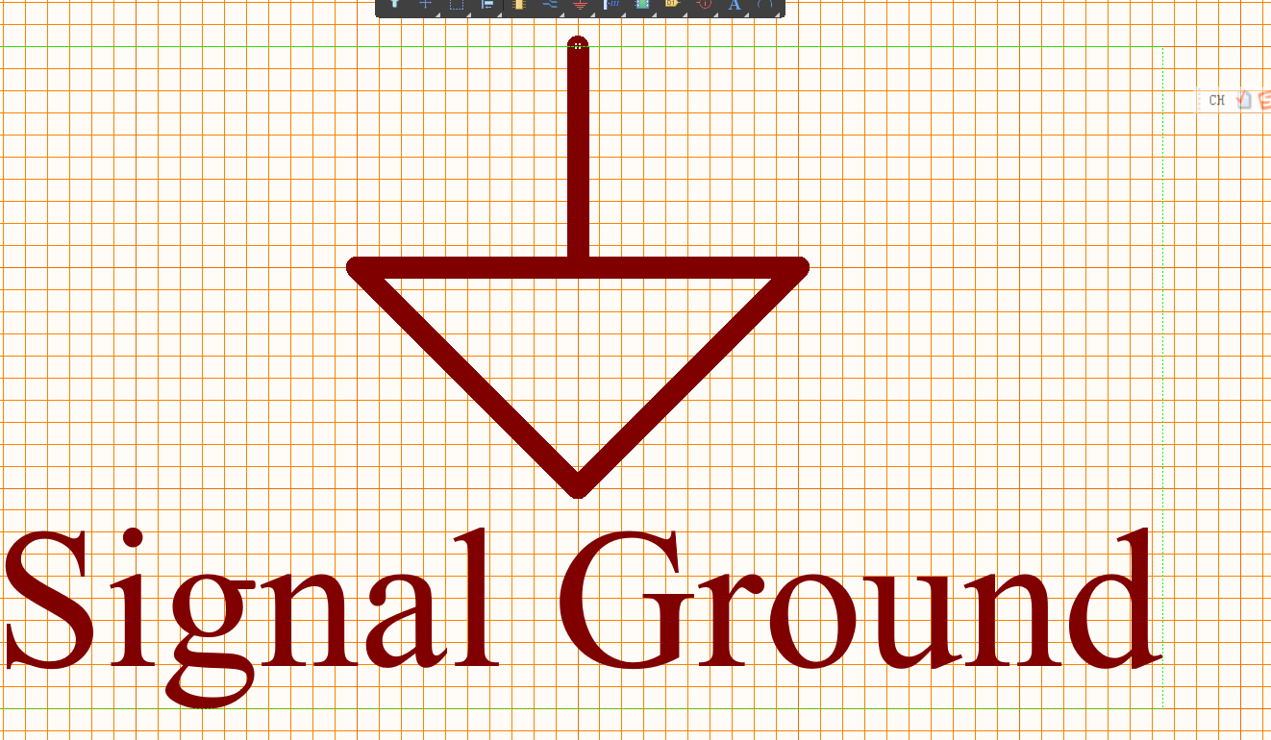

# Earth(10,10,5) STYLE=6

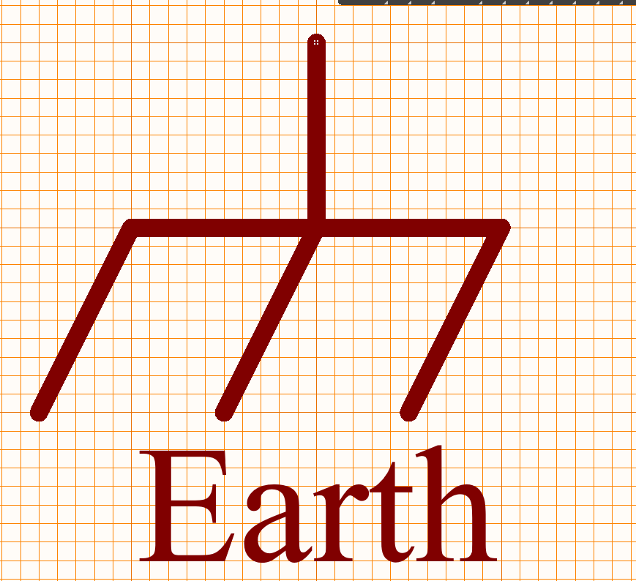

# Gost arrow(4,6,6) STYLE=7

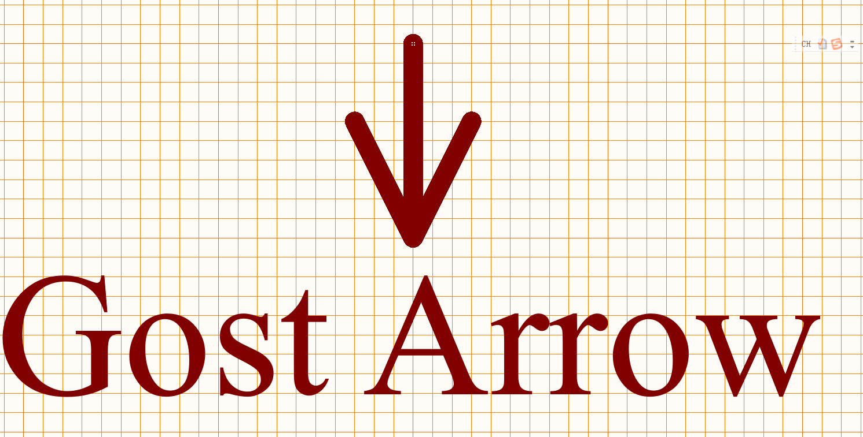

# Gost power ground(16,10,6,2,4) STYLE=8

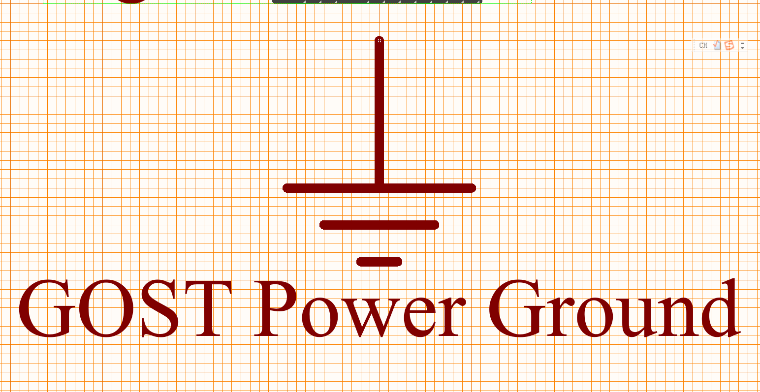

# Gost Earth(10, 6, 2, 4, 12, 16) STYLE=9

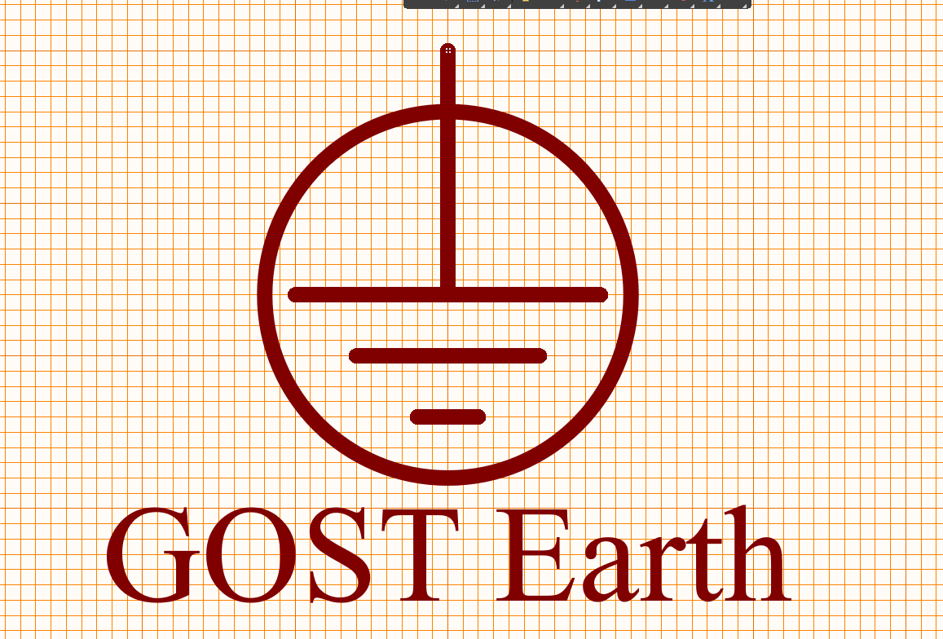

# Gost bar(20,8) STYLE=10

