# Left (STYLE =0)

## 0degree(ORIENTATION=0)



## 90degree(ORIENTATION=1)



## 180degree(ORIENTATION=2)



## 270degree(ORIENTATION=3)



# right(STYLE =1)

## 0degree(ORIENTATION=0)

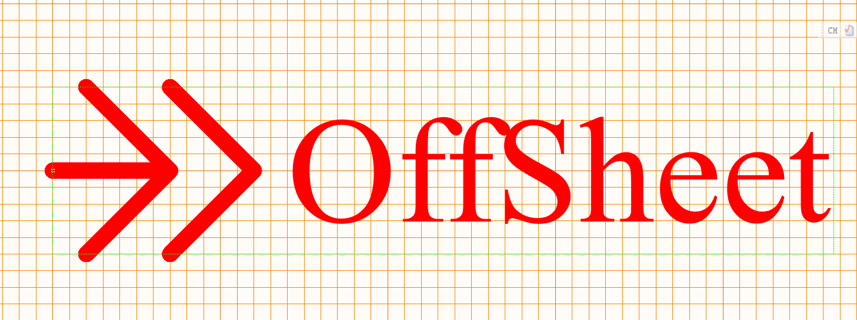

## 90degree(ORIENTATION=1)



## 180degree(ORIENTATION=2)

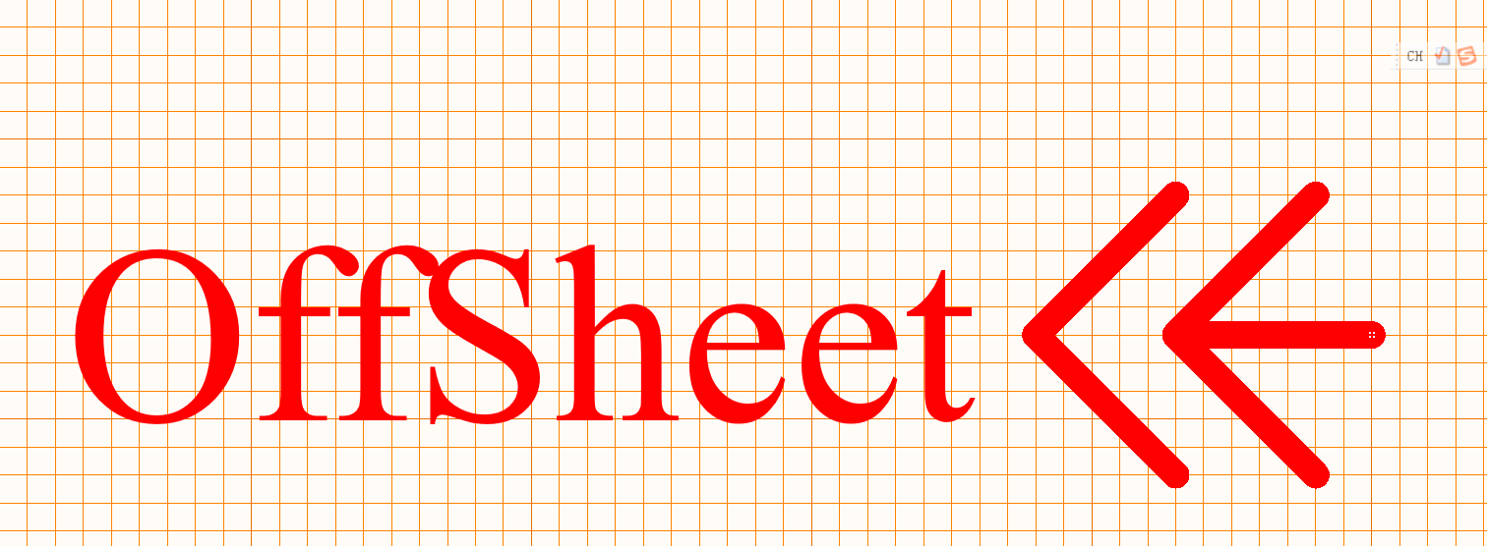

## 270degree(ORIENTATION=3)

