**知了堂_VIP体验营_探探项目_第1次任务**

1. 判断JS变量的数据类型可以用__**使用typeof操作符。**__（拓展任务）
2. JS中把两个字符变量连接起来的运算符_ 用“+=”运算符或者使用数组_（拓展任务）
3. 从GROUP BY分组的结果集中再次用条件表达式进行筛选的子句是_HAVING_（拓展任务）
4. 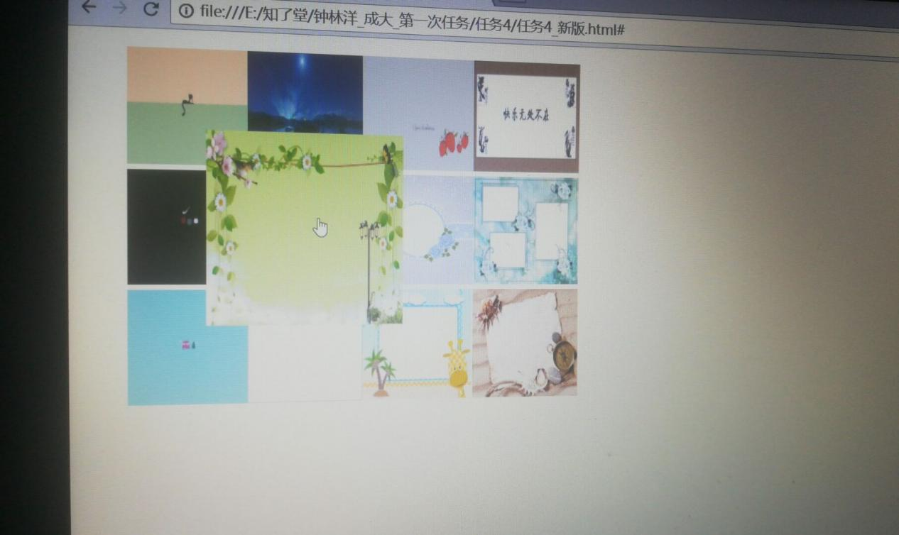

<!DOCTYPE html>

<html lang="en">

<head>

<meta charset="UTF-8">

<meta name="viewport" content="width=device-width, initial-scale=1.0">

<meta http-equiv="X-UA-Compatible" content="ie=edge">

<title>The first task</title>

<style type="text/css">

ul.hoverbox{list-style-type:none;}

</style>

<style>

img:hover{

-webkit-transform: scale(1.7);

}

</style>

</head>

<body>

<ul class="hoverbox">

<li><a href="#"><img src=".\picture\1.jpg" width="100px" height="100px"/><img src=".\picture\g.jpg" width="100px" height="100px"/><img src=".\picture\tg.jpg" width="100px" height="100px"><a href="#"><img src=".\picture\05.png" width="100px" height="100px"></a></li>

<li><a href="#"><img src=".\picture\tig.jpg" width="100px" height="100px"><img src=".\picture\01.png" width="100px" height="100px"><img src=".\picture\02.jpg" width="100px" height="100px"><img src=".\picture\06.jpg" width="100px" height="100px"></a></li>

<li><a href="#"><img src=".\picture\timg.jpg" width="100px" height="100px"><img src=".\picture\03.jpg" width="100px" height="100px"><img src=".\picture\04.jpg" width="100px" height="100px"><img src=".\picture\07.jpg" width="100px" height="100px"></a></li>

</ul>

</body>

</html>

5.<!DOCTYPE html>

<html lang="en">

<head>

<meta charset="UTF-8">

<meta name="viewport" content="width=device-width, initial-scale=1.0">

<meta http-equiv="X-UA-Compatible" content="ie=edge">

<title>The fifth task</title>

</head>

<body>

</body>

<script>

var a=window.prompt("请输入一个四位数整数");

if(a/1000>1)

{

var b,c,d,e,s;

b=parseInt(a/1000);

c=parseInt(parseInt(a%1000)/100);

d=parseInt(parseInt(parseInt(a%1000)%100)/10);

e=parseInt(a%10);

s=b+c+d+e;

alert(s);

}

</script>

</html>

