# Figures

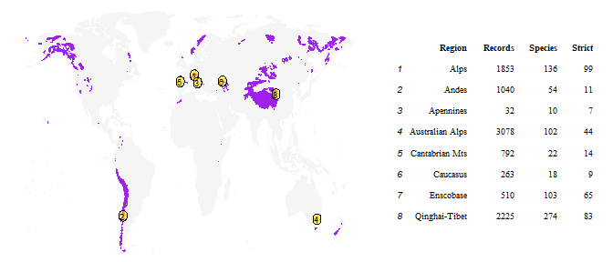

**Table 1**: Geographical origin of the germination data with the number of records, species and strict alpine species per alpine region. Ensconet is not plotted because its records come from alpine regions throughout Europe. The purple areas correspond to the global extension of alpine environments according to Testolin et al. (2020).

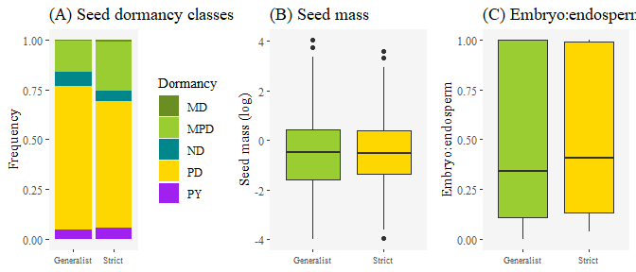

**Figure 1**. Seed dormancy classes, seed mass and embryo to endosperm ratio in the subsets of strict alpine (n =) and generalist species analyzed in this study. Seed dormancy classes are abbreviated as follows: MD (morphological), MPD (morphophysiological), ND (non dormant), PD (physiological), PY (physical).

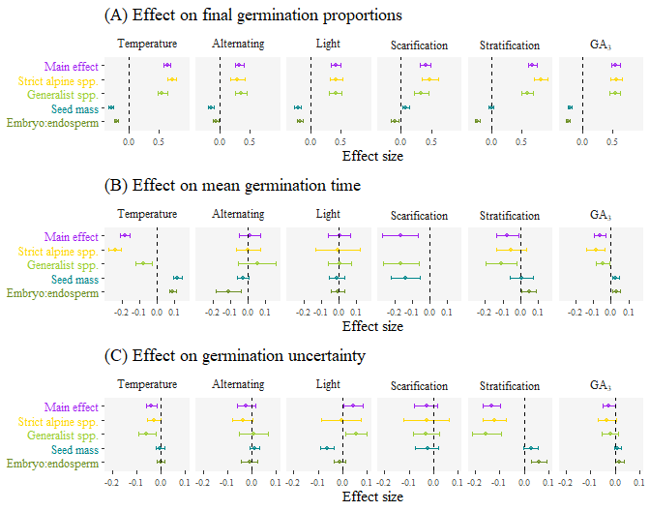

**Figure 2**. Effect of the germination environment on germination, according to the MCMC meta-analysis of the primary data.

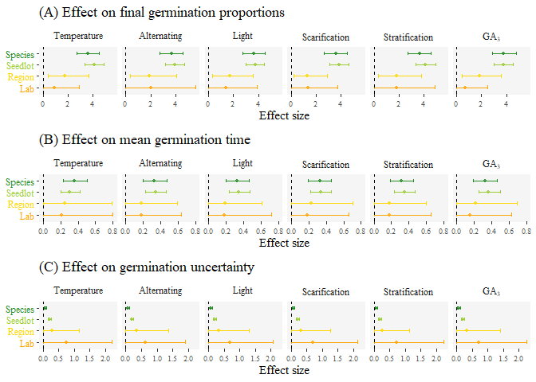

**Figure 3.** Effect of the random factors on germination, according to the MCMC meta-analysis of the primary data.

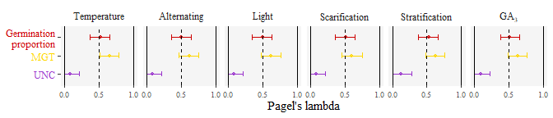

Figure 5X: Phylogenetic signal in the response to the germination environment.

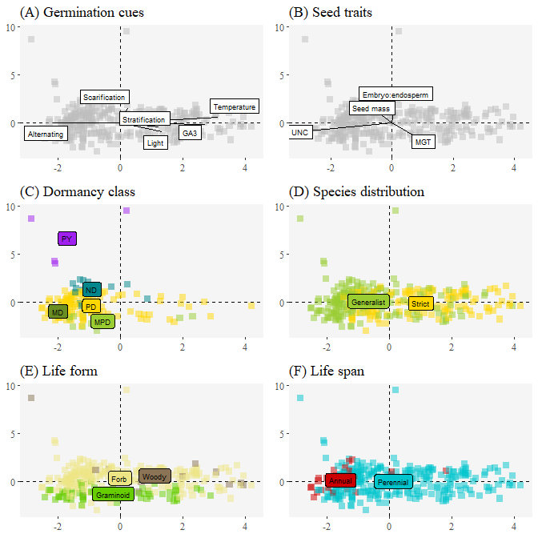

**Figure 4.** FADM ordination of the seed variables and the species distribution, life form and life span.