Downtown Kelowna: SWMM Stormwater Simulation for 1 to 4 November 2023
Generated by aiswmm · swmm-report skill
Table 1: Run identification and generation metadata.
Run ID | 185134_downtown-kelowna-bc_chat
Generated at (UTC) | 2026-09-04T01:57:32+00:00
SWMM version | 5.2.4
Run ID and timestamps are sourced directly from experiment_provenance.json; the SWMM version reflects the binary used during the simulation run.

1 Run Summary
Table 2: Key hydraulic performance metrics for this simulation run.
Metric | Value | Unit
Peak flow at outfall | 0.13 | CMS
Time of peak | 05:03 | hh:mm
Continuity error | routing -1.022 / runoff -0.078 | %
SWMM return code | 0
Values are read from the run manifest and experiment_provenance.json produced by the SWMM runner and audit tool; no metrics are recomputed at report generation time.

2 Model Description
Table 3: Catchment geometry, simulation window, and infiltration parameters.
Parameter | Value
Basin area (ha) | 320.19
Simulation start | 11/01/2023
Simulation end | 11/04/2023
Impervious fraction (%) | 66.33
Saturated hydraulic conductivity (mm/hr) | n/a
Green-Ampt suction head (mm) | n/a
Geometry and simulation-window values are parsed from the run's own SWMM INP (total subcatchment area, area-weighted imperviousness, [OPTIONS] dates); infiltration values are subcatchment averages and are reported only when the model uses Green-Ampt. Values shown as n/a could not be derived from the run directory.

3 QA Gates
Table 4: Automated QA gate results from the audit pipeline.
Gate ID | Status | Detail
runner_return_code_zero | PASS | return_code=0
runner_outputs_exist | PASS | rpt_exists=True out_exists=True
peak_metric_present | PASS | source_section=Node Inflow Summary
Each gate is evaluated by swmm-experiment-audit against thresholds defined in the project configuration; PASS/FAIL status is read from experiment_provenance.json and is not recomputed here.

4 Design Review
No design review recorded for this run.

5 Evidence Boundary
This is an uncalibrated first-pass model. No observed flow data were used, so every value in this report is a simulated result, not a validated prediction. Calibrate against observed flow before design decisions.
No design review was run against this model.

6 Hydraulic Results
Table 5: Node inflow summary, flow in CMS (top 15 of 645 by peak).
Node | Type | Peak total inflow (CMS) | Time of peak | Flow balance error (%)
N179 | JUNCTION | 1.155 | 2 22:41 | 2.281
N175 | JUNCTION | 0.574 | 2 22:42 | -1.851
N59 | JUNCTION | 0.336 | 1 12:38 | 2.107
N181 | JUNCTION | 0.312 | 2 22:42 | 5.349
N459 | JUNCTION | 0.283 | 2 10:06 | 0.783
N661 | JUNCTION | 0.248 | 2 15:42 | 5.388
N670 | JUNCTION | 0.187 | 2 14:11 | 2.122
N287 | JUNCTION | 0.169 | 1 20:19 | 9.355
N296 | JUNCTION | 0.154 | 1 12:55 | 1.868
N288 | JUNCTION | 0.146 | 1 10:30 | 12.454
N456 | JUNCTION | 0.13 | 1 05:00 | 0.0
N457 | JUNCTION | 0.13 | 1 05:00 | -0.264
N461 | JUNCTION | 0.13 | 1 05:00 | 0.09
N462 | JUNCTION | 0.13 | 1 05:00 | 0.047
N467 | JUNCTION | 0.13 | 1 05:00 | 0.028

Table 6: Outfall loading summary, flow in CMS (top 15 of 76 by peak).
Outfall | Flow frequency (%) | Average flow (CMS) | Peak flow (CMS) | Total volume (10^6 L)
OUT_N467 | 71.07 | 0.017 | 0.13 | 1.255
N829 | 76.65 | 0.01 | 0.115 | 0.792
N814 | 57.99 | 0.012 | 0.075 | 0.72
N825 | 51.29 | 0.01 | 0.056 | 0.567
OUT_N619 | 39.1 | 0.011 | 0.045 | 0.456
OUT_N3 | 26.54 | 0.013 | 0.038 | 0.355
N821 | 29.64 | 0.009 | 0.027 | 0.278
N826 | 44.26 | 0.003 | 0.025 | 0.195
OUT_N722 | 68.97 | 0.003 | 0.024 | 0.233
N822 | 24.44 | 0.007 | 0.021 | 0.178
N819 | 47.13 | 0.003 | 0.016 | 0.166
OUT_N756 | 24.73 | 0.005 | 0.013 | 0.134
N820 | 75.57 | 0.002 | 0.012 | 0.137
OUT_N766 | 24.25 | 0.005 | 0.012 | 0.131
OUT_N202 | 22.55 | 0.004 | 0.011 | 0.08

Table 7: Conduit peak flows, flow in CMS (top 15 of 832 by peak).
Link | Type | Peak flow (CMS) | Time of peak | Max/full flow | Max/full depth
115136 | CONDUIT | 1.155 | 2 22:41 | 0.42 | 0.73
115134 | CONDUIT | 0.573 | 2 22:42 | 0.17 | 0.29
191224 | CONDUIT | 0.336 | 1 12:38 | 0.12 | 0.49
116229 | CONDUIT | 0.283 | 2 10:06 | 0.08 | 0.59
191339 | CONDUIT | 0.187 | 2 14:11 | 0.37 | 0.71
115247 | CONDUIT | 0.169 | 1 20:19 | 0.58 | 0.76
115258 | CONDUIT | 0.154 | 1 12:55 | 0.35 | 0.55
115251 | CONDUIT | 0.146 | 1 10:30 | 0.51 | 0.74
116224 | CONDUIT | 0.13 | 1 05:00 | 0.07 | 0.26
116227 | CONDUIT | 0.13 | 1 05:00 | 0.02 | 0.6
212087 | CONDUIT | 0.13 | 1 05:00 | 0.02 | 0.27
212088 | CONDUIT | 0.13 | 1 05:00 | 0.0 | 0.26
218275 | CONDUIT | 0.13 | 1 05:00 | 0.05 | 0.14
C_OUT_N467 | CONDUIT | 0.13 | 1 05:03 | 4.24 | 0.95
165000 | CONDUIT | 0.124 | 1 16:50 | 0.39 | 0.58

Values are read from the run's own SWMM report file. A completed simulation is not a calibrated or validated one: these are model outputs, not measurements.

7 Figures
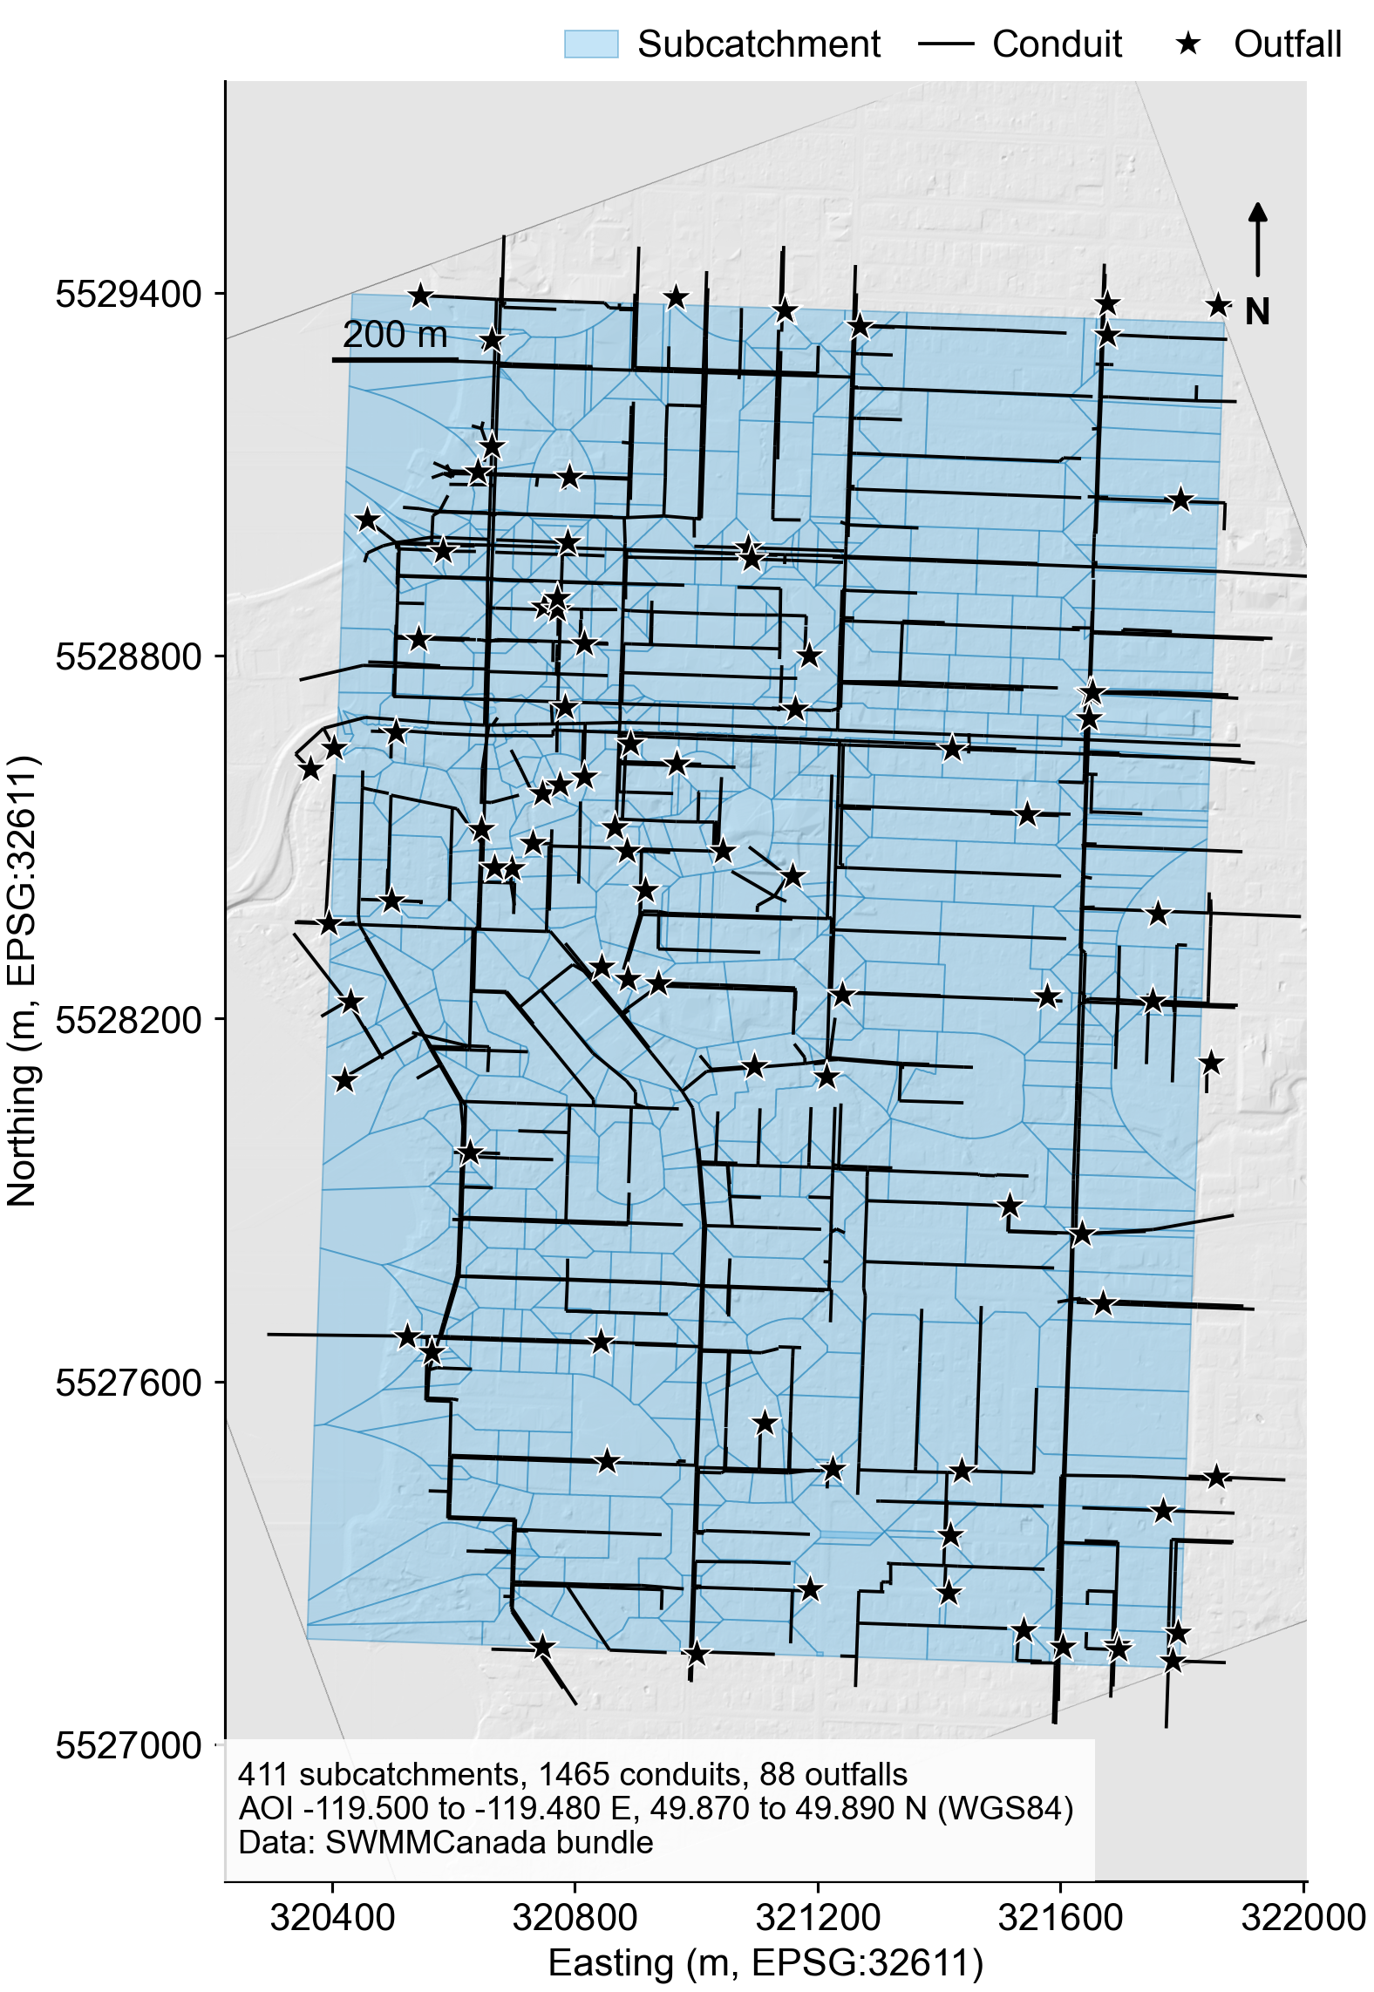
Figure 1: study_area

8 Model Diagnostics
No diagnostics reported. Overall status: UNKNOWN (errors: 0, warnings: 0).

9 Artifact Provenance
Table 8: Cryptographic hashes and roles of artifacts involved in this run.
Artifact ID | Role | SHA-256 (first 16 chars) | Produced by
model_diagnostics | Deterministic SWMM model diagnostics | b1694fe4af97799b | swmm-experiment-audit
model_inp | SWMM input model | bfe2a10665ab7fce | swmm-builder
runner_manifest | SWMM execution provenance | 95bb245033b34d89 | swmm-runner
runner_out | SWMM binary output | 533f9988415c8169 | swmm5 via swmm-runner
runner_rpt | SWMM text report | 035ef8ffbfbd8a37 | swmm5 via swmm-runner
runner_stderr | SWMM stderr log | e3b0c44298fc1c14 | swmm-runner
runner_stdout | SWMM stdout log | 2defae07be9351bf | swmm-runner
SHA-256 digests are computed by swmm-experiment-audit at audit time and stored in experiment_provenance.json; only the first 16 hex characters are shown here for readability. The full digest is available in the provenance JSON.

10 Appendix: Generation Environment
Table 9: Software environment at the time of audit generation.
Item | Value
Git head | 23595d3977fb56768962f6106dd2873ad49f5abc
Git branch | main
SWMM version | 5.2.4
Python version | 3.11.15 (main, Mar 3 2026, 00:52:57) [Clang 17.0.0 (clang-1700.6.4.2)]
Provenance schema version | 1.3
Generated by | swmm-experiment-audit
All environment values are read from experiment_provenance.json; they capture the exact tool versions used to produce and audit the simulation results.

