Run Audit Deliverable
Generated by aiswmm · swmm-report skill
Table 1 — Run identification and generation metadata.
Run ID | 191335_downtown-victoria-bc_run
Generated at (UTC) | 2026-08-10T02:17:21+00:00
SWMM version | 5.2.4
Run ID and timestamps are sourced directly from experiment_provenance.json; the SWMM version reflects the binary used during the simulation run.

1 Run Summary
Table 2 — Key hydraulic performance metrics for this simulation run.
Metric | Value | Unit
Peak flow at outfall | 0.033 | CMS
Time of peak | 05:00 | hh:mm
Continuity error | {'name': 'continuity_error', 'source_artifact': 'runner_rpt', 'source_sections': ['Runoff Quantity Continuity', 'Flow Routing Continuity'], 'unit': 'percent', 'values': {'flow_routing': 0.371, 'runoff_quantity': -0.098}} | %
SWMM return code | 0
Values are read from the run manifest and experiment_provenance.json produced by the SWMM runner and audit tool; no metrics are recomputed at report generation time.

2 Model Description
Table 3 — Catchment geometry, simulation window, and infiltration parameters.
Parameter | Value
Basin area (ha) | 57.27
Simulation start | 11/01/2023
Simulation end | 11/04/2023
Impervious fraction (%) | 75.81
Saturated hydraulic conductivity (mm/hr) | n/a
Green-Ampt suction head (mm) | n/a
Geometry and simulation-window values are parsed from the run's own SWMM INP (total subcatchment area, area-weighted imperviousness, [OPTIONS] dates); infiltration values are subcatchment averages and are reported only when the model uses Green-Ampt. Values shown as n/a could not be derived from the run directory.

3 QA Gates
Table 4 — Automated QA gate results from the audit pipeline.
Gate ID | Status | Detail
runner_return_code_zero | PASS | return_code=0
runner_outputs_exist | PASS | rpt_exists=True out_exists=True
peak_metric_present | PASS | source_section=Node Inflow Summary
Each gate is evaluated by swmm-experiment-audit against thresholds defined in the project configuration; PASS/FAIL status is read from experiment_provenance.json and is not recomputed here.

4 Figures
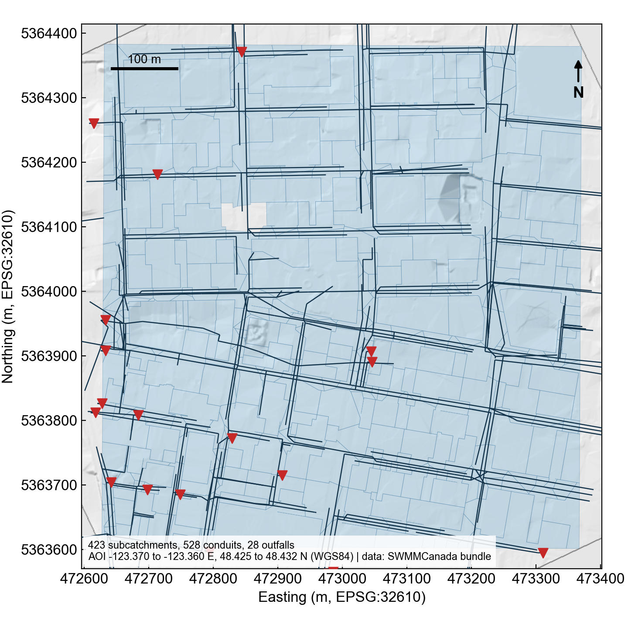
Figure 1 — study_area

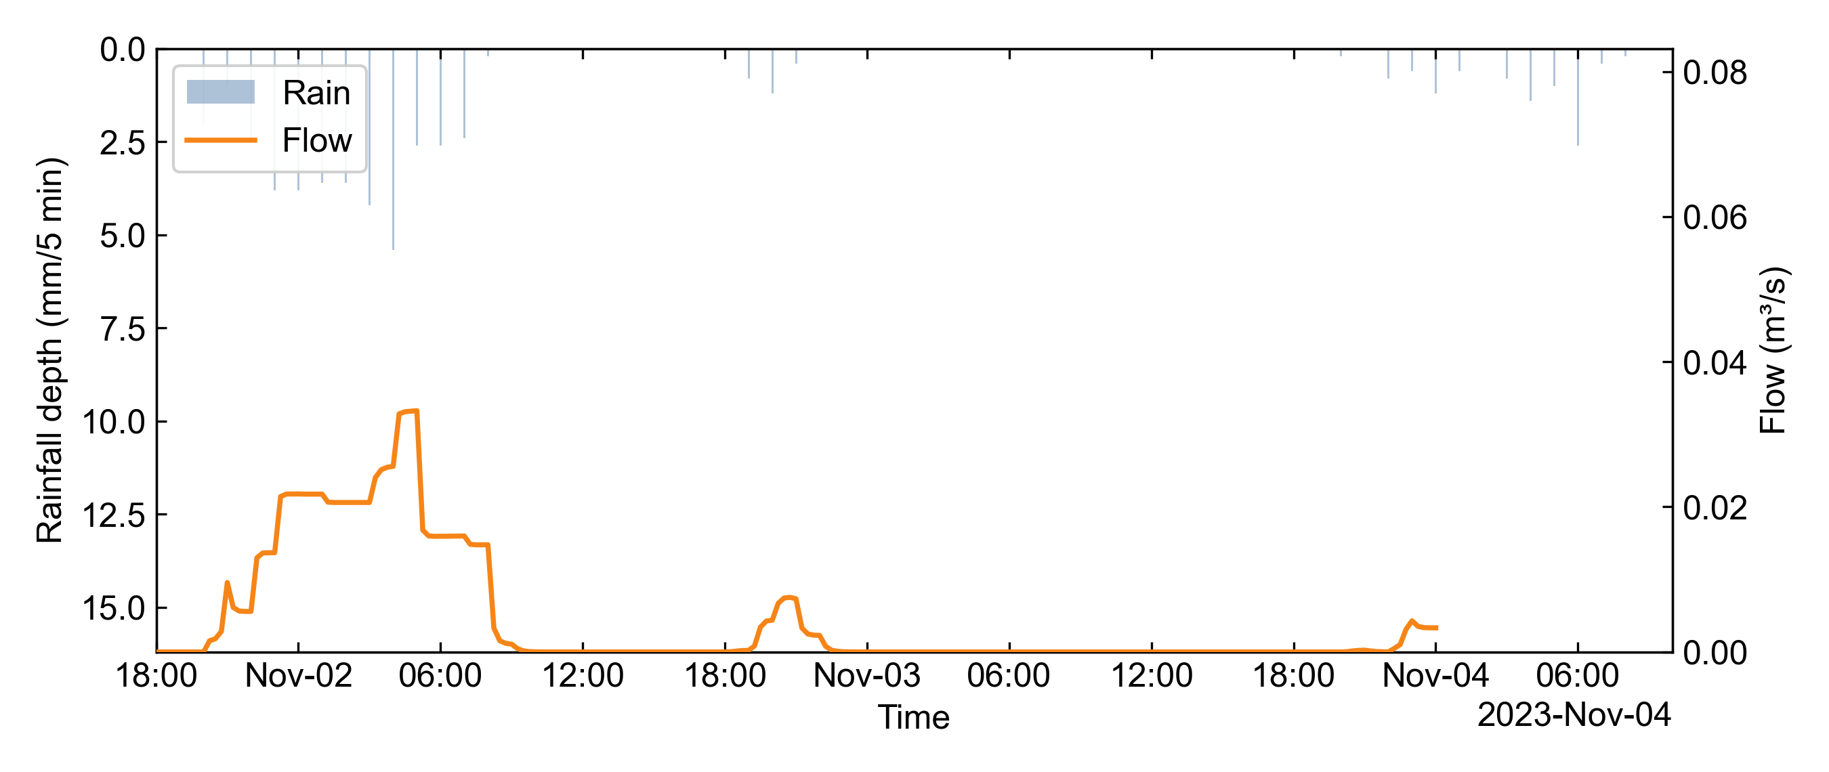
Figure 2 — fig_DOF007021_Total_inflow

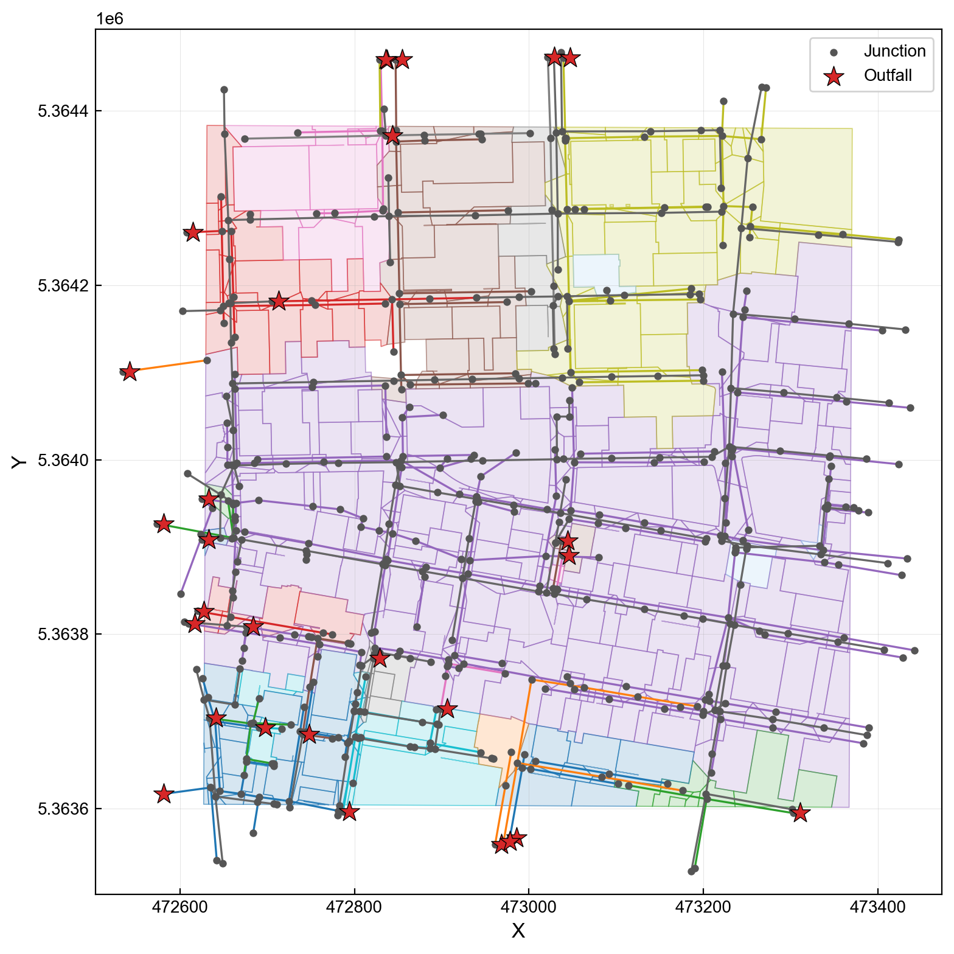
Figure 3 — network_map

5 Model Diagnostics
No diagnostics reported. Overall status: UNKNOWN (errors: 0, warnings: 0).

6 Artifact Provenance
Table 5 — Cryptographic hashes and roles of artifacts involved in this run.
Artifact ID | Role | SHA-256 (first 16 chars) | Produced by
model_diagnostics | Deterministic SWMM model diagnostics | 8e37883441ab58ed | swmm-experiment-audit
runner_manifest | SWMM execution provenance | e8404f2da9666a06 | swmm-runner
runner_out | SWMM binary output | df44090da8ff6413 | swmm5 via swmm-runner
runner_rpt | SWMM text report | 5a566abf3b052398 | swmm5 via swmm-runner
runner_stderr | SWMM stderr log | e3b0c44298fc1c14 | swmm-runner
runner_stdout | SWMM stdout log | e44a90ad1f75d76b | swmm-runner
SHA-256 digests are computed by swmm-experiment-audit at audit time and stored in experiment_provenance.json; only the first 16 hex characters are shown here for readability — the full digest is available in the provenance JSON.

7 Appendix: Generation Environment
Table 6 — Software environment at the time of audit generation.
Item | Value
Git head | fa97d685b67d9a7b3766043d308fbc9040cc7b02
Git branch | main
SWMM version | 5.2.4
Python version | 3.11.15 (main, Mar 3 2026, 00:52:57) [Clang 17.0.0 (clang-1700.6.4.2)]
Provenance schema version | 1.3
Generated by | swmm-experiment-audit
All environment values are read from experiment_provenance.json; they capture the exact tool versions used to produce and audit the simulation results.

