|  |
| --- |
| BCCSS |
| SQL 2014 Functional Specification |
| New and Enhanced Features |
|  |
| **HSSBC Database Services Team** |
| **2/20/2016** |

|  |
| --- |
| This document introduces the new and enhanced features which are supported by HSSBC Database Services Team |
|  |

Contents

1 Purpose 4

2 Audience 4

3 Assumptions 4

4 SQL Server 2014 engine enhancements and editions 4

4.1 SQL Server 2014 overview 4

4.2 HSSBC Standard Supported Features 4

4.2.1 Availability Features 4

4.2.2 AlwaysOn Failover Cluster Instances (FCI) 7

4.3 Backup and restore enhancements 8

4.4 Scalability and performance enhancements 9

4.5 Security enhancements 10

4.6 SQL Server 2014 editions 11

4.6.1 Standard edition 11

4.6.2 Enterprise edition 11

4.6.3 Comparison of Standard and Enterprise Edition 11

4.7 SQL Server Services and High Availability 13

5 Hardware and software requirements 13

6 Migration, upgrade and consolidation strategies 14

6.1 Side-by-side migration 14

6.1.1 Side-by-side migration pros and cons 14

6.1.2 SQL Server 2014 high-level side-by-side strategy 15

6.2 In-place upgrade 15

6.2.1 In-place upgrade pros and cons 16

6.2.2 SQL Server 2014 high-level in-place strategy 16

6.3 Consolidation 17

# Purpose

This document describes the standard offering of SQL 2014 from HSSBC Database Services. In this functional specification, we will explain the SQL Server 2014 features/solutions which are supported as standard offering by HSSBC Database Services Team.

# Audience

This document is for HSSBC internal usage and provides guidance for the HSSBC Architecture Services, Project Service and Operational Teams for implementation and support of SQL Server 2014.

# Assumptions

We assume that you have at least a minimal understanding of SQL Server from both a database and Operating systems perspective

# SQL Server 2014 engine enhancements and editions

## SQL Server 2014 overview

SQL Server can provide the Health Authorities mission-critical performance for the most demanding database applications while delivering the highest forms of security, scalability, high availability, and support.

The following figure shows the Microsoft’s three pillars design that SQL 2014 is built upon.

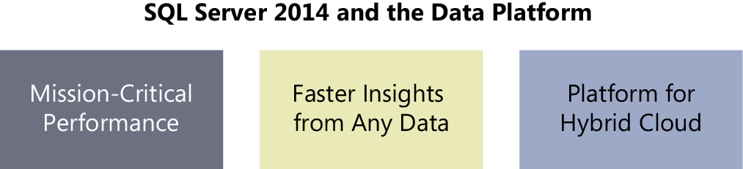

## HSSBC Standard Supported Features

### Availability Features

The high availability features of SQL Server 2014 is called AlwaysOn, which supports two solutions. One is shared nothing, called AlwaysOn Availability groups, and the other is implemented by shared disk volume, called AlwaysOn failover cluster instance.

#### AlwaysOn Availability Groups

This high-availability and disaster-recovery capability provided protection by allowing one or more databases to fail over as a single unit. Shared storage was not needed, and replicas could be leveraged to offload backups and reporting workloads from the primary.

Enhancements in SQL Server 2014 have given databases even better data redundancy, protection, and availability. First, the secondary replicas have been enhanced and can be used for read-only operations even in the case of network failures or loss of quorum between replicas. Second, whether a manual or an automatic failover is performed, the operation no longer needs to fail over databases one at a time. Numerous databases can now fail over simultaneously, which increases availability.

While Alwayson Availability Groups provide high availability and scalability of the databases in the group, it complicates databases administration and implementation at the same time. Every replica of a databases is actually running on different instances. Therefore, all the related login accounts should be synchronized between those instances to make sure the application will still be working properly when a failover happens. Furthermore, the jobs which connect to those databases in the Alwayson Availability Groups must be implemented by taking into the consideration of if the replica is primary or secondary. After comparing the pro and con of Availability group, HSSBC Database Services Team recommend the following two implementations in our organization.

#### Single Data Center Implementation

This implementation is for high availability and scalability. Typically we suggest a two nodes cluster to host AlwaysOn availability group.

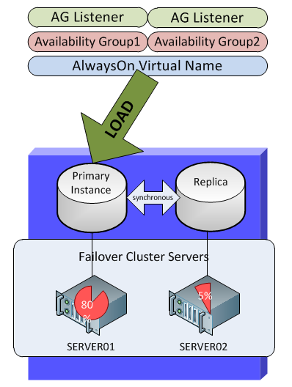

#### Two Data Center implementation

Besides the high availability and scalability, a certain application may need disaster recovery features. Then we recommend the following solution:



In this implementation, the application server should also implement disaster recovery feature and be able to connect to all the replicas of the database in two data centers.

Architecture Decision:

A cluster at most has three nodes no matter they are in one data center or two data centers. Therefore, a database at most has three replicas.

### AlwaysOn Failover Cluster Instances (FCI)

AlwaysOn Failover Cluster Instances (FCIs) is a feature that provides superior instance-level protection by using Windows Server Failover Clustering and shared storage. Traditionally, each SQL Server failover cluster instance required at least one logical unit number (LUN) because the LUN was the unit of failover. This requirement imposed a significant limitation because when a database administrator ran out of drive letters or mount points, the administrator also lost the opportunity to host any more failover cluster instances. This anomaly has been addressed in SQL Server 2014 with the use of the Cluster Shared Volumes (CSVs) feature, which requires fewer LUNs.

The typical configuration of Failover Cluster Instances as follows:

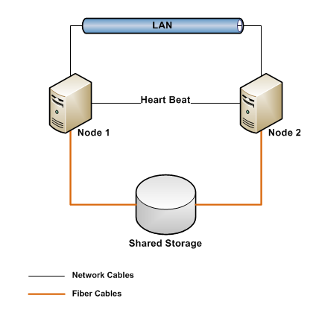

AlwaysOn Failover Cluster Instance (FCI) provides high availability at the instance level. So it is transparent to the application. But you cannot failover a single database from one node to another, the failover has to be done for the whole instance. Furthermore, it cannot be scaled out. At one time, a database can only be hosted in one instance which can only be running on one node. Therefore, we don’t recommend this implementation in HSSBC.

Architecture Decision:

If an application needs AlwaysOn Failover Cluster Instance (FCI), it has to be implemented on a cluster with physical servers.

## Backup and restore enhancements

By default, all the databases have a full backup daily and log backup every 15 minutes. All of the backup files are kept in the local disk for three days. During the three days, Netbackup picks up these backup and store them in the second lay storage. Furthermore, the backup enhancement, encryption for backups, in SQL 2014 is also supported.

Encryption for backupscan now be performed by specifying an encryption algorithm and an encryptor—a certificate or an asymmetric key—to secure the encryption key. The industry standard encryption algorithms that are supported include AES 128, AES 192, AES 256, and Triple DES.

Obviously encryption for backups will take extra resource and time when doing backup and restoration. And much more administrative effort will be required to store and maintain the related certificate and keys.

Architecture Decision:

Encryption for backups can only be implemented when it is absolutely needed by the application and will deal with it case by case.

## Scalability and performance enhancements

The following enhancements will improve SQL Server workloads and performance in certain circumstances. For example, In-Memory OLTP can only be implemented if the server has big RAM; Resource governor is usually used for scalability on a shared server; Colomnstore is used to enhance the performance of certain data warehouse application. Therefore, all of these features will be implemented based on the requirements of application and server configuration.

* **In-Memory OLTP** In-Memory OLTP is considered the most important feature release and investment in SQL Server 2014. This new feature is fully integrated into the Database Engine component. Databases were originally designed to reside on disk because of the high costs associated with procuring memory. This situation has since changed, due mainly to the significant drop in price for memory. It is now possible for most OLTP databases to fit into memory, which reduces I/O expense, and in turn increases transaction speed performance. To date, organizations testing In-Memory OLTP have reported promising numbers: transaction speeds improved up to 30 times that of their past performance. As with any new capability, mileage will vary, and the best performance gains have been achieved when the business logic resides in the database and not in the applications.
* **Resource governor enhancements** In previous versions of SQL Server, it was possible to pool CPU and memory to manage SQL Server workloads and system-resource consumption. In SQL Server 2014, I/O has been added to Resource Governor, which lets I/O be pooled and tiered following an organization’s criteria. This ensures greater scale and performance predictability for your SQL Server workloads.
* **Buffer pool extension** Buffer pool extension enables integration of a nonvolatile random- access-memory extension with the Database Engine buffer pool to significantly improve I/O throughput. Solid-state drives (SSDs) would be considered nonvolatile random access memory, which would be added to the SQL Server system to improve query performance. Benefits that can be achieved when you use buffer pool extension include increased random I/O through- put, reduced I/O latency, increased transaction throughput, improved read performance with a larger buffer pool, and a caching architecture that can take advantage of present and future low-cost memory drives.
* **Columnstore enhancements** Columnstore indexes are used to accelerate query performance for data warehousing that primarily performs bulk loads. In the previous version of SQL Server, tables that had columnstore indexes could not be updated. In the past, you had to drop the index, perform the update, and then rebuild the index, or use partition switching or two tables—one with a columnstore index and another for updating—and then use UNION ALL queries to return data. As you can imagine, this could be challenging from an administrative perspective. With SQL Server 2014, in-memory column store has been modified to support updateable operations such as inserts, updates, and deletes.

## Security enhancements

Data Security is always a priority issue in HSSBC. With SQL Server 2014, the product continues to expand its solid foundation to deliver enhanced security and compliance within the database platform. Here is a list of some of the enhanced enterprise-ready security capabilities and controls that enable us to meet strict compliance policies and regulations in the health industry:

* **Redefined engineering security process**
* **CC certification at high assurance level**
* **Enhanced separation of duty**
* **Transparent data encryption (TDE)**
* **Encryption key management**
* **Support for Windows Server Core** A new set of explicit server-level and database-level permissions for securables have been introduced in SQL Server 2014 to further enhance access and security:
* **CONNECT ANY DATABASE** A server-level permission that grants a login the ability to connect to all databases that currently exist and to any new databases that might be created in the future.
* **IMPERSONATE ANY LOGIN** Another new server-level permission, IMPERSONATE ANY LOGIN allows a middle-tier process to impersonate the account of clients connecting to it as it connects to databases.
* **SELECT ALL USER SECURABLES** When granted, this new server-level permission allows a login to view data in all databases that the user can connect to.
* **ALTER ANY DATABASE EVENT SESSION** Unlike the other permissions listed here, ALTER ANY DATABASE EVENT SESSION is a database-level permission. It is typically used to give a role the ability to read metadata associated with a database for monitoring purposes. A perfect example would be Microsoft System Center Operations Manager agents used to proactively monitor a SQL Server database.

## SQL Server 2014 editions

In HSSBC, we support Standard edition and Enterprise edition of SQL Server 2014.

### Standard edition

The Standard edition is a data-management platform tailored toward departmental databases and limited business-intelligence applications that are typically appropriate for medium-class solutions, or departmental solutions.

### Enterprise edition

The Enterprise edition of SQL Server 2014 is the uppermost SKU and is considered the premium offering. It is designed to meet the highest demands of large-scale data centers and data warehouse solutions by providing mission-critical performance and availability for tier 1 applications and the ability to deploy private-cloud, highly virtualized environments and large, centralized, or external-facing business-intelligence solutions.

### Comparison of Standard and Enterprise Edition

| Features | Enterprise | Standard |
| --- | --- | --- |
| Features  Maximum number of cores | Enterprise  OS Max | Standard  16 cores |
| Features  Maximum memory utilized per instance | Enterprise  OS Max | Standard  128 GB |
| Features  Maximum size | Enterprise  524 PB | Standard  524 PB |
| Features  Programmability (T-SQL, data types, FileTable) | https://www.microsoft.com/en-us/server-cloud/Images/shared/TableIcon.png | https://www.microsoft.com/en-us/server-cloud/Images/shared/TableIcon.png |
| Features  SQL Server Management Studio | https://www.microsoft.com/en-us/server-cloud/Images/shared/TableIcon.png | https://www.microsoft.com/en-us/server-cloud/Images/shared/TableIcon.png |
| Features  Policy-based management | https://www.microsoft.com/en-us/server-cloud/Images/shared/TableIcon.png | https://www.microsoft.com/en-us/server-cloud/Images/shared/TableIcon.png |
| Features  Basic OLTP | https://www.microsoft.com/en-us/server-cloud/Images/shared/TableIcon.png | https://www.microsoft.com/en-us/server-cloud/Images/shared/TableIcon.png |
| Features  Basic security (Separation of duties, basic auditing) | https://www.microsoft.com/en-us/server-cloud/Images/shared/TableIcon.png | https://www.microsoft.com/en-us/server-cloud/Images/shared/TableIcon.png |
| Features  Basic high availability | https://www.microsoft.com/en-us/server-cloud/Images/shared/TableIcon.png | https://www.microsoft.com/en-us/server-cloud/Images/shared/TableIcon.png |
| Features  Built-in data connectors | https://www.microsoft.com/en-us/server-cloud/Images/shared/TableIcon.png | https://www.microsoft.com/en-us/server-cloud/Images/shared/TableIcon.png |
| Features  Basic data integration (SSIS, designer transforms) | https://www.microsoft.com/en-us/server-cloud/Images/shared/TableIcon.png | https://www.microsoft.com/en-us/server-cloud/Images/shared/TableIcon.png |
| Features  Basic reporting | https://www.microsoft.com/en-us/server-cloud/Images/shared/TableIcon.png | https://www.microsoft.com/en-us/server-cloud/Images/shared/TableIcon.png |
| Features  Basic corporate BI (Analytics, multidimensional semantic model, data mining) | https://www.microsoft.com/en-us/server-cloud/Images/shared/TableIcon.png | https://www.microsoft.com/en-us/server-cloud/Images/shared/TableIcon.png |
| Features  Self-service business intelligence (Alerting, Power View, Power Pivot for SharePoint Server) | https://www.microsoft.com/en-us/server-cloud/Images/shared/TableIcon.png |  |
| Features  Advanced corporate BI (Tabular BI semantic model, advanced analytics and reporting, in-memory analytics engine, advanced data mining) | https://www.microsoft.com/en-us/server-cloud/Images/shared/TableIcon.png |  |
| Features  Enterprise data management (Data Quality Services, Master Data Services) | https://www.microsoft.com/en-us/server-cloud/Images/shared/TableIcon.png |  |
| Features  Advanced data integration (Fuzzy grouping and lookup, change data capture) | https://www.microsoft.com/en-us/server-cloud/Images/shared/TableIcon.png |  |
| Features  Advanced security (SQL Server audit, transparent data encryption) | https://www.microsoft.com/en-us/server-cloud/Images/shared/TableIcon.png |  |
| Features  Data warehousing (In-memory columnstore, compression, partitioning) | https://www.microsoft.com/en-us/server-cloud/Images/shared/TableIcon.png |  |
| Features  Advanced high availability (AlwaysOn, multiple, active secondaries; multi-site, geo-clustering) | https://www.microsoft.com/en-us/server-cloud/Images/shared/TableIcon.png |  |
| Features  Advanced transaction processing (In-memory OLTP) | https://www.microsoft.com/en-us/server-cloud/Images/shared/TableIcon.png |  |

Architecture Decision:

For the cost effective reason, Standard edition will be deployed for most of applications unless certain enterprise features are specifically required by the application.

## SQL Server Services and High Availability

There are four SQ Server Services of which high availability options are listed below

|  |  |  |  |
| --- | --- | --- | --- |
|  | Standalone | Windows Failover Clustering | AlwaysOn Availability Group |
| SQL Server Database Engine | ✓ | ✓ | ✓ |
| SQL Server Analysis Service (SSAS) | ✓ | ✓ |  |
| SQL Server Reporting Service (SSRS) | ✓ |  |  |
| SQL Server Integration Service (SSIS) | ✓ |  |  |

# Hardware and software requirements

The least hardware requirements:

* Processor: 2 64-bit CPU
* RAM: 8GB
* Disk: 20GB

Software requirements:

* Operation System: Windows Server 2012 R2 64-bit Datacenter, Enterprise, Standard.
* .NET Framework: Microsoft .NET Framework 3.5 SP1 and Microsoft .NET Framework 4.0
* Windows PowerShell: Windows PowerShell 2.0

# Migration, upgrade and consolidation strategies

## Side-by-side migration

The term *side-by-side migration* describes the deployment of a brand-new SQL Server 2014 instance alongside a legacy SQL Server instance. The new SQL Server 2014 will be installed on a new VM which is running Windows 2012. When the SQL Server 2014 installation is completed, data is migrated from the legacy SQL Server database platform to the new SQL Server 2014 database platform. After the migration, the old version of SQL Server and the corresponding VM will be decommissioned. Side-by-side migration is depicted as follows:

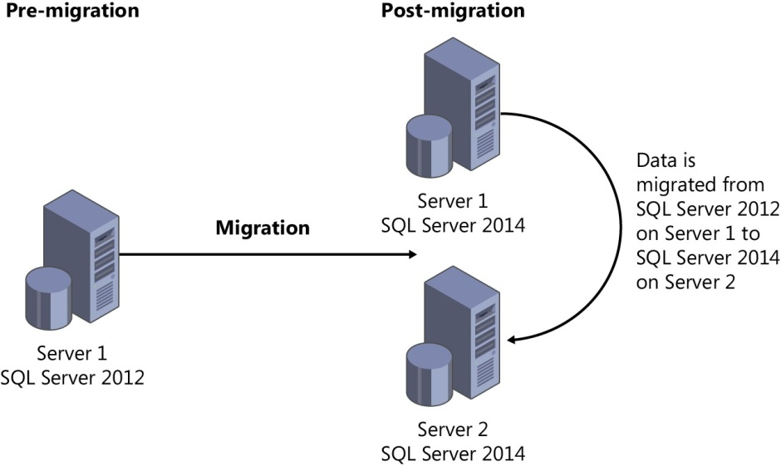

### Side-by-side migration pros and cons

The greatest advantage of a side-by-side migration over an in-place upgrade is the opportunity to build out a new database infrastructure on SQL Server 2014 and avoid potential migration issues that can occur with an in-place upgrade. A side-by-side migration also provides more granular control over the upgrade process because an administrator can migrate databases and components independently of one another. In addition, the legacy instance remains online during the migration process.

All of these advantages result in a more powerful server. Moreover, when two instances are running in parallel, additional testing and verification can be conducted. Performing a rollback is also easy if a problem arises during the migration.

However, there are disadvantages to the side-by-side strategy. An additional virtual machine is required. Applications might also need to be directed to the new SQL Server 2014 instance.

### SQL Server 2014 high-level side-by-side strategy

The high-level side-by-side migration strategy for upgrading to SQL Server 2014 consists of the following steps:

* Ensure that the instance of SQL Server you plan to migrate meets the hardware and software requirements for SQL Server 2014.
* Review the deprecated and discontinued features in SQL Server 2014 by referring to “Deprecated Database Engine Features in SQL Server 2014” at [*http://technet.microsoft.com/en-us/ library/ms143729(v=sql.120).aspx*.](http://technet.microsoft.com/en-us/library/ms143729(v%3Dsql.120).aspx)
* Although a legacy instance that is no longer supported will not be upgraded to SQL Server 2014, it is still beneficial to run the SQL Server 2014 Upgrade Advisor to ensure that the data being migrated to SQL Server 2014 is supported and there is no possibility of a blocker pre- venting the migration.
* If the SQL Server 2014 is installed on a new VM, Windows Server 2012 is recommended.
* Install the SQL Server 2014 prerequisites and desired components.
* Migrate objects from the legacy SQL Server to the new SQL Server 2014 database platform.
* Point applications to the new SQL Server 2014 database platform.
* Decommission legacy servers after the migration is complete.

## In-place upgrade

An in-place upgrade is the upgrade of an existing SQL Server installation to SQL Server 2014. Prior to the upgrade of the existing SQL Server, Windows OS must be upgraded to Windows 2012. When an in-place upgrade is conducted, the SQL Server 2014 setup program replaces the previous SQL Server binaries on the existing machine with the SQL Server 2014 binaries. SQL Server data is automatically converted from the previous version to SQL Server 2014. This means data does not have to be copied or migrated. The figure below depicts a database administrator is conducting an in-place upgrade on a SQL Server 2012 instance running on Server 1. When the upgrade is complete, Server 1 still exists, but the SQL Server 2012 instance and all of its data is upgraded to SQL Server 2014.

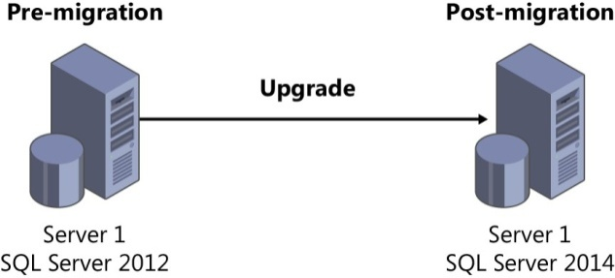

### In-place upgrade pros and cons

The in-place upgrade strategy is usually easier. Upgrading is fairly fast, and additional hardware is not required. Because the names of the server and instances do not change during an upgrade process, applications still point to the old instances. As a result, this strategy is less time-consuming because no changes need to be made to application connection strings.

The disadvantage of an in-place upgrade is that it provides less granular control over the upgrade process. For example, when running multiple databases or components, a database administrator does not have the flexibility to choose individual items for upgrade. Instead, all databases and components are upgraded to SQL Server 2014 at the same time. In addition, the instance remains offline during the in-place upgrade, which means that if a mission-critical database or application or an important line-of-business application is running, a planned outage is required. Furthermore, if a disaster transpires during the upgrade, the rollback strategy can be a complex and time-consuming affair. We have to install the operating system from scratch, install SQL Server, and then restore all the SQL Server data.

### SQL Server 2014 high-level in-place strategy

The high-level in-place upgrade strategy for upgrading to SQL Server 2014 consists of the following steps:

* Ensure that the instance of SQL Server to be upgraded meets the hardware and software requirements for SQL Server 2014.
* Review the deprecated and discontinued features in SQL Server 2014. For more information, refer to “Deprecated Database Engine Features in SQL Server 2014” at [*http://msdn.microsoft. com/en-us/library/ms143729(v=sql.120).aspx.*](http://msdn.microsoft.com/en-us/library/ms143729(v%3Dsql.120).aspx)
* Ensure that the version and edition of SQL Server that will be upgraded is supported. To review all the upgrade scenarios supported for SQL Server 2014, see “Supported Version and Edition Upgrades” at [*http://msdn.microsoft.com/en-us/library/ms143393(v=sql.120).aspx*.](http://msdn.microsoft.com/en-us/library/ms143393(v%3Dsql.120).aspx)
* Run the SQL Server 2014 Upgrade Advisor. The Upgrade Advisor is a tool included with SQL Server 2014, or it can be downloaded directly from the Microsoft website. It analyzes the in- stalled components on the SQL Server instance you plan to upgrade to ensure that the system supports SQL Server 2014. The Upgrade Advisor generates a report identifying anomalies that require fixing or attention before the upgrade can begin. The Upgrade Advisor analyzes any SQL Server 2012, SQL Server 2008 R2, SQL Server 2008, or SQL Server 2005 components that are installed.
* Install the SQL Server 2014 prerequisites.
* Begin the upgrade to SQL Server 2014 by running setup.

## Consolidation

In general, all the dedicated SQL Server with the database size less than 50GB should be consolidated into availability group in a shared SQL Server cluster.

The advantage of consolidating dedicated SQL Servers are:

* Save the cost of license. Every SQL Server license can be used more effectively
* Less administrative effort. Fewer SQL servers are easier to manage and more efficient support
* Shared SQL Server instance is running on cluster and provides high availability to all the database it hosts. Every database on shared SQL Server instance will be in an availability group which provides users with primary replica for regular operation and secondary replica for reporting purpose. Furthermore, the primary replica can be automatically failover to another node in cluster once there is any issue on the current node.
* There is no disk space issue to users. With the growth of user databases, the disk space usage is monitored by Database Services team and will be extended when it is close to the threshold.

The disadvantage to users for using shared SQL Server is that users can only have DBO permission on their databases and all the tasks which need more than DBO will be taken care of by HSSBC Database Services team.

Architecture Decision

When upgrading SQL servers of prior editions to SQL Server 2014, the side-by-side migration strategy is recommended. In-place upgrade is also supported case by case. If the size of a database is less than 50GB, it should be put into a shared SQL Server 2014 availability group.