Acceleration File Name: 021-202506170002-排1右0mm-满载.sup

Trend Plot:
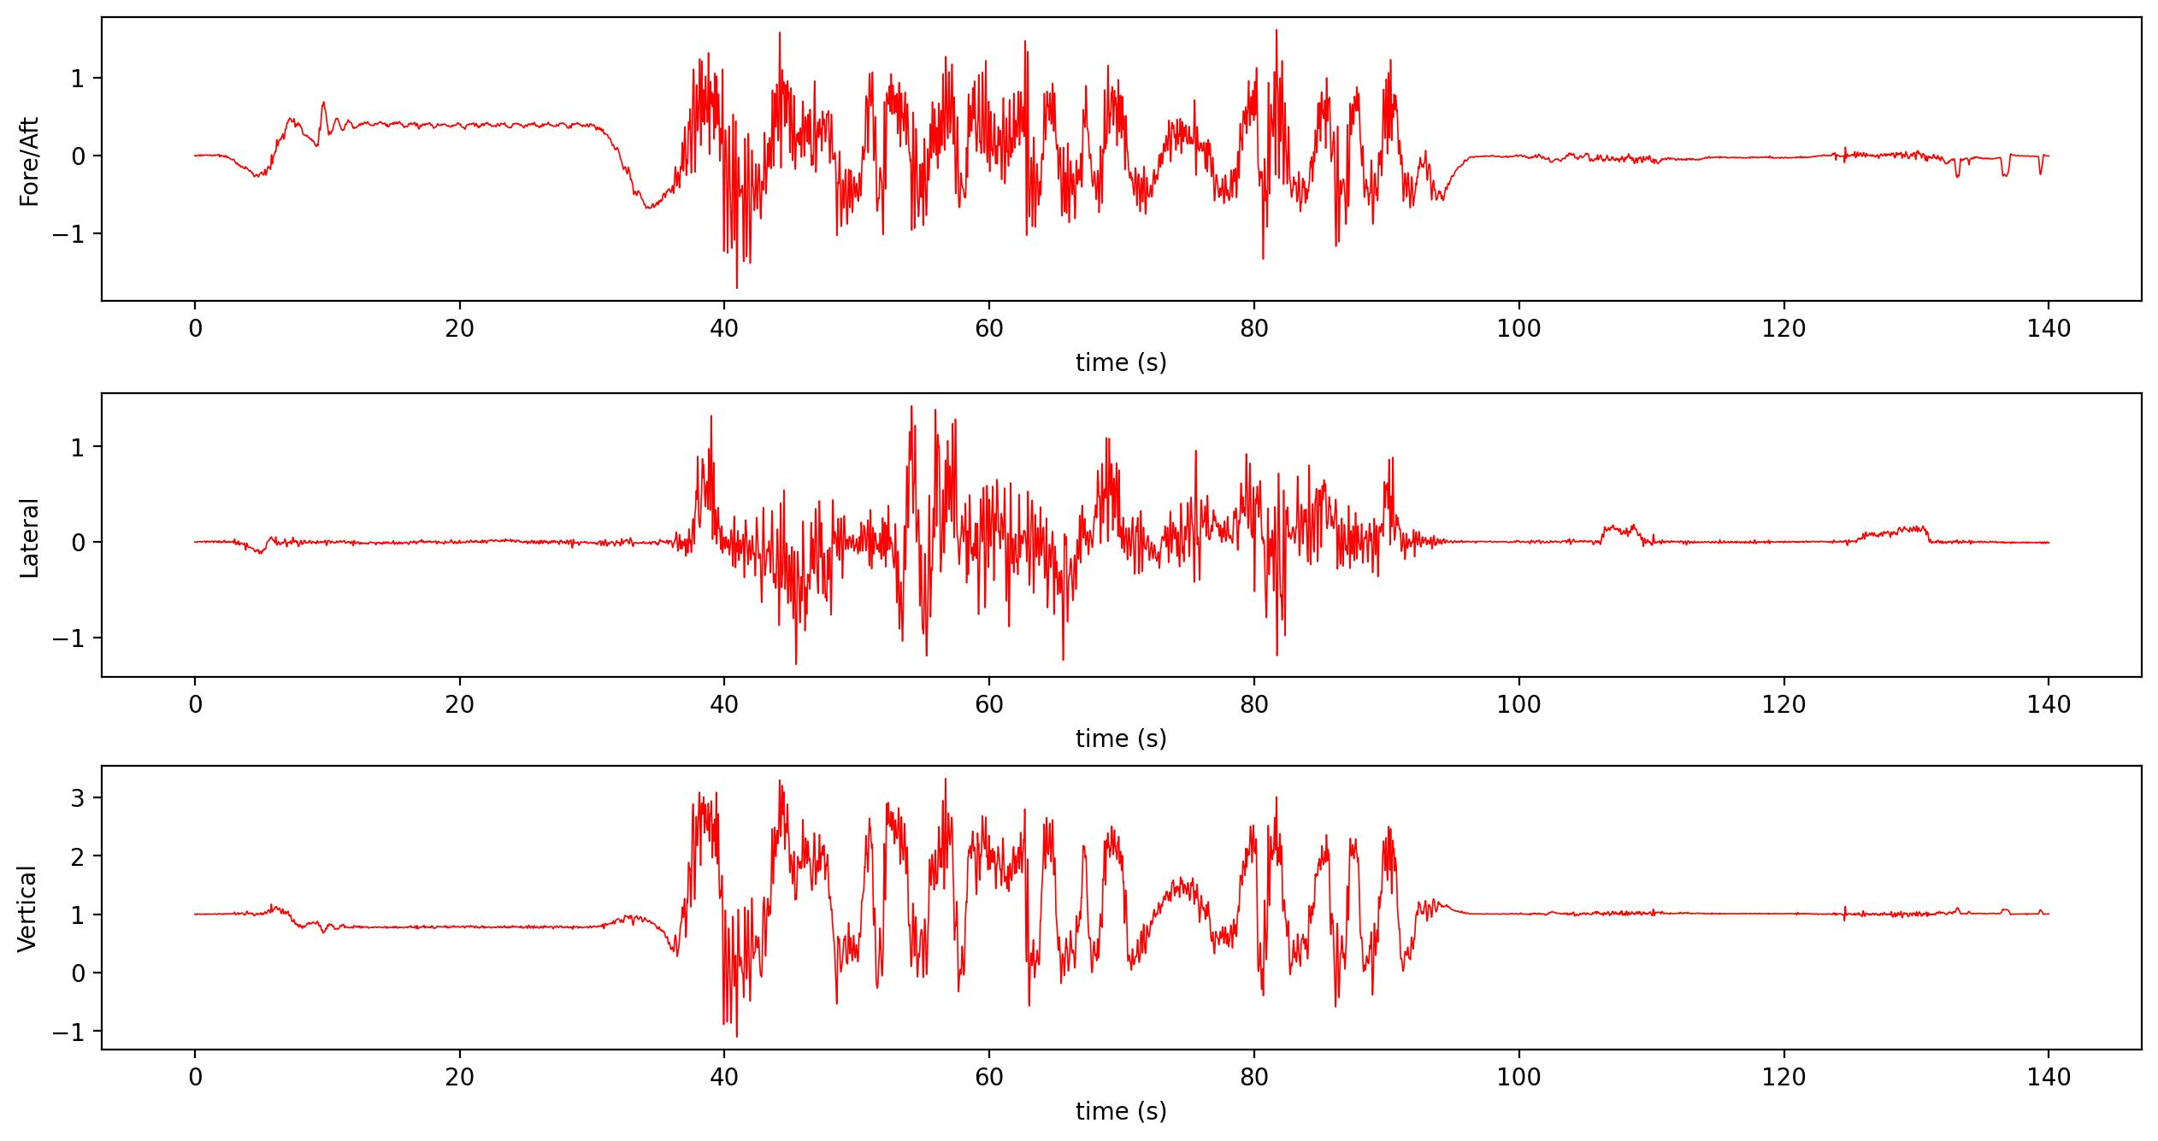
 | t (Max) | t (Min) | Max | Min | Zero Pos
X | 81.69 | 40.94 | 1.619 | -1.7124 | 0.0
Y | 54.135 | 45.415 | 1.4262 | -1.2847 | 0.0
Z | 56.69 | 40.93 | 3.3211 | -1.1006 | 1.0

ASTM F2291 Fitting:
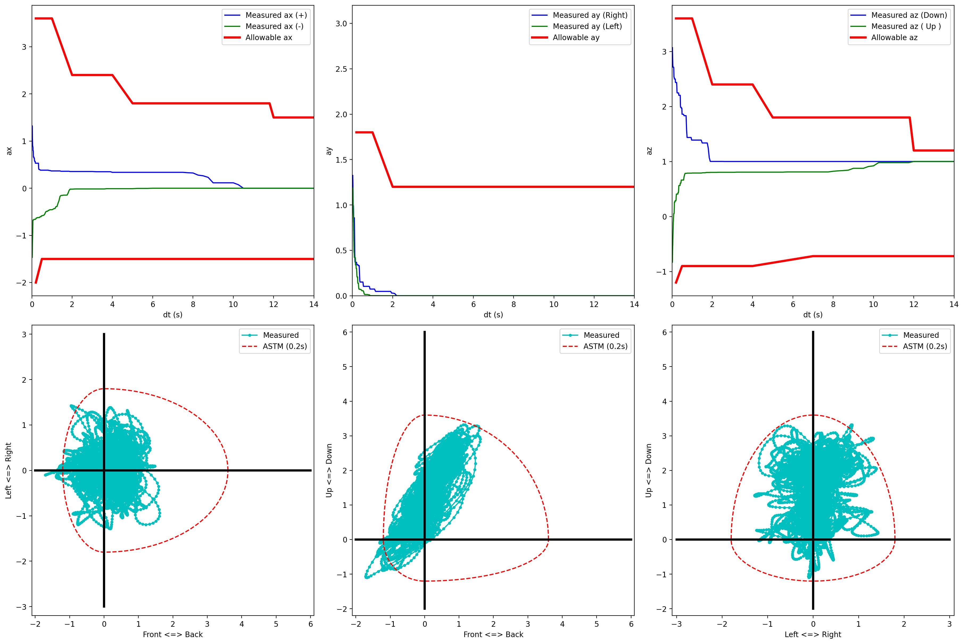

GB 8408 Fitting:
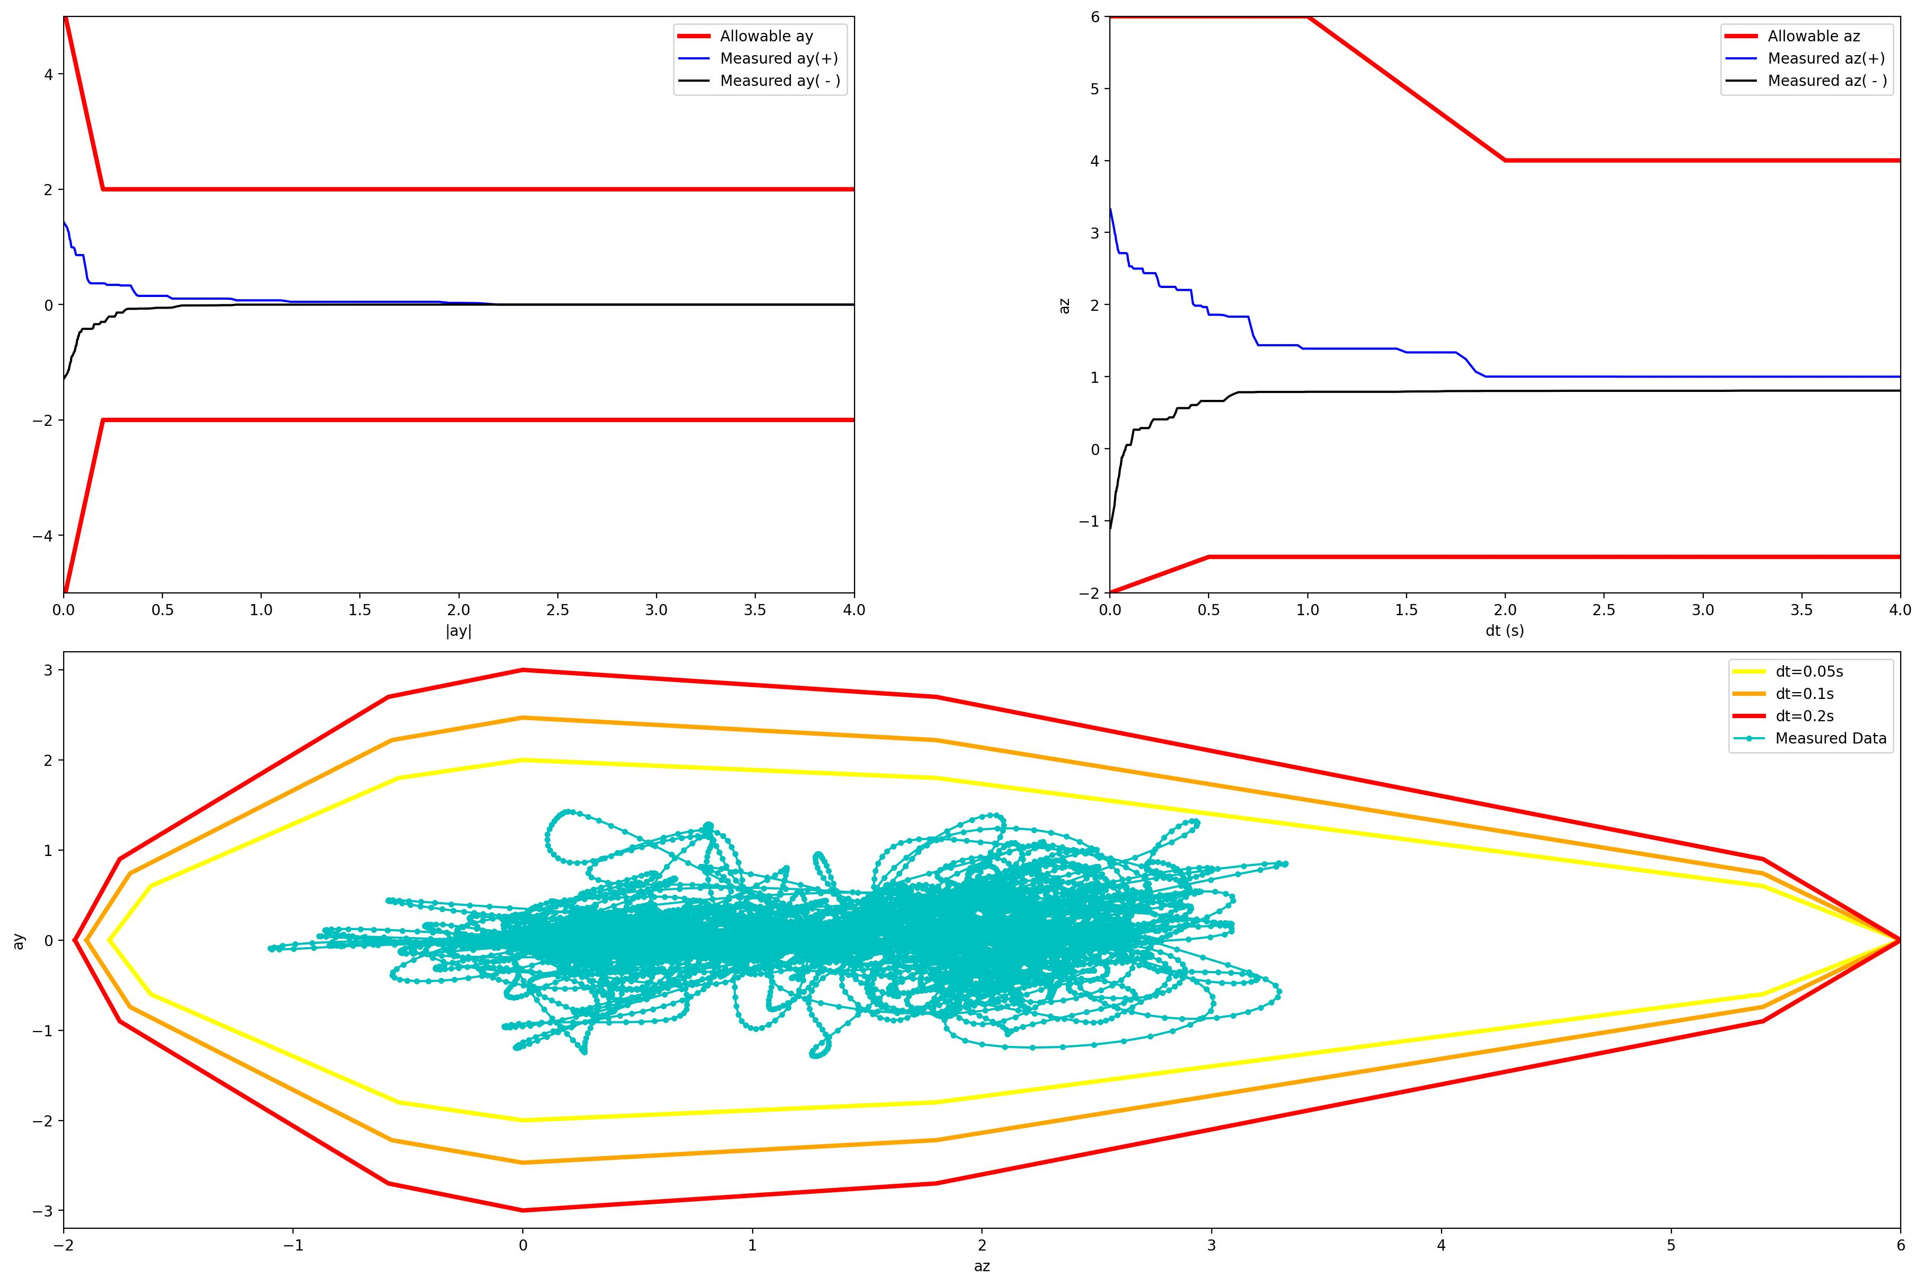

Acceleration Zone Plot:
