- Irrigation Management
- IRRIGATION&WEATHER DATA
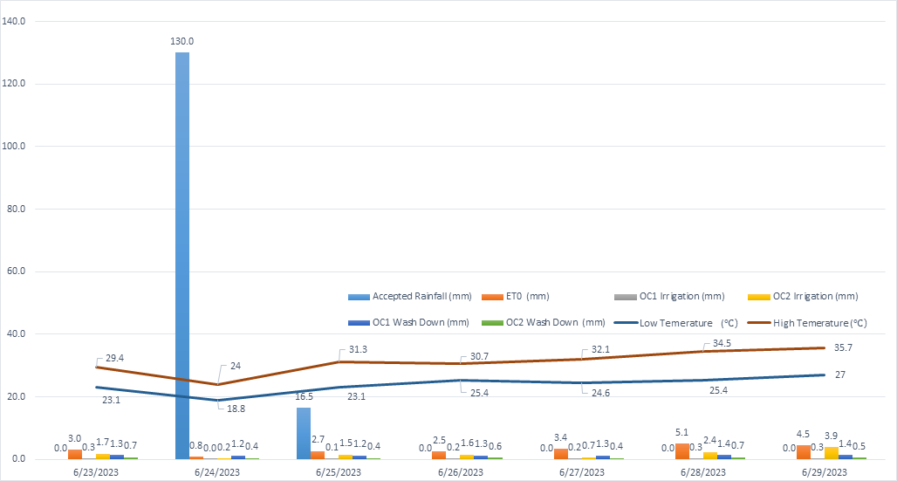
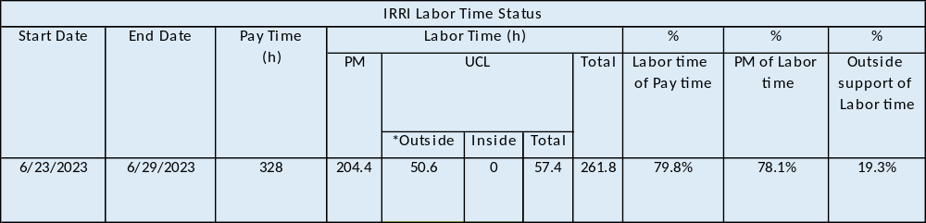
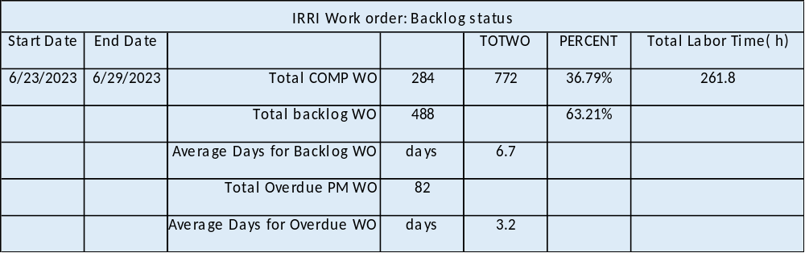
- Non-Plan Maintenance
Gingko Tree Project: Team continues installing the top cooling for new planting Gingko trees at Qimiao Road. Irrigation number 40-2-6. Continue to follow up.
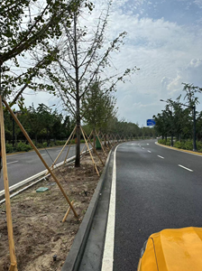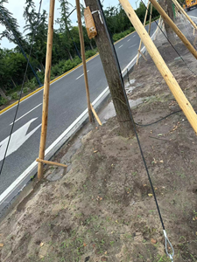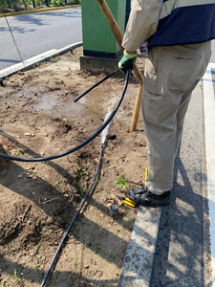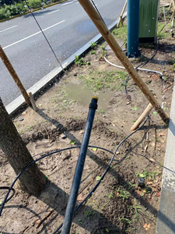
FAM project of FL Road Widen: Team identify existing irrigation later pipe after dismantling, installing new lateral/new irrigation valve boxes/irrigation control wires and commissioning watering. Continue to follow up.
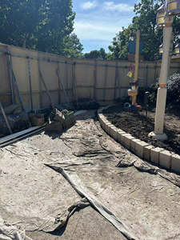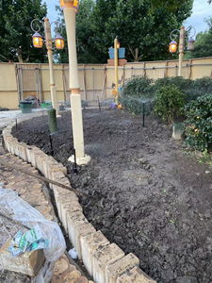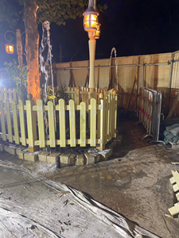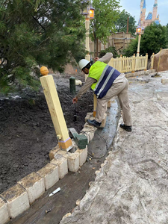
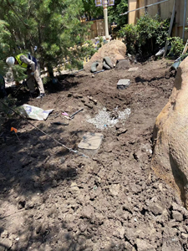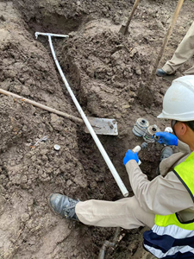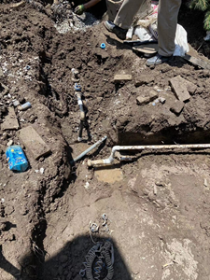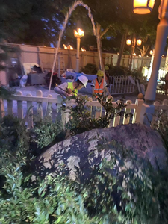
Emergency respond for Wash-down water burst at backstage of Fantasyland: water burst due to pipe broken resulting from incorrect operation of custodial front line. Team repaired and coordinate correct operation on site.
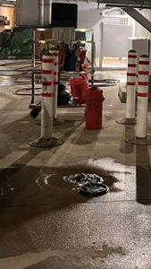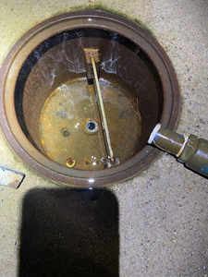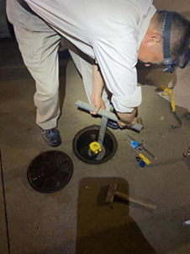
- Plan Maintenance
Filter Screen flushing at POC of Loop Road 39-3/11, Water Treatment Plant 39-12.
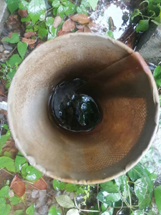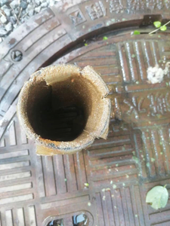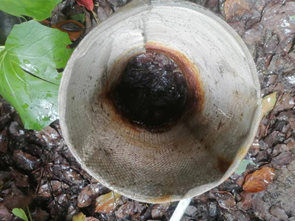
Watering performance check and cleaning the clogged sprinkler nozzle, adjusting the watering Arc to avoid watering out of planting area, adjusting the height of sprinkler to get better view, digging out buried sprinklers when new tree planting, repairing the broken water inlet elbow/ the cracked sprinkler body/internal over 50 locations.
