1. Programming environment

Operating System: subsystem Cygwin 3.0.7-1 in windows 10
Number of Enabled Core: 2
Number of Logical Processors: 4
Compiler: GCC 7.4.0
Compilation standard: ISO C11 + GCC extension

2. Sparse matrix representation

Sparse format: Coordinate Format
Data structure: Orthogonal (Crossing) list

2.1 Analysis of Sparse matrix format

After I did some research of sparse matrix format, I found that comparing other methods (like DIA, ELL, HYB), COO and CSR both are more flexible format to represent sparse matrix. However, the storage efficiency of them is not quite high.[1]

For COO, it can completely disorderly store a matrix, because it recorded both column and row coordinate of non-zero elements. While CSR which only stored the row’s information, just can disorderly represent the row’s elements. Besides, the storage efficiency of CSR is slightly better than COO, which is also because that CSR format only compresses the row index of matrix elements. The other advantage of CSR is the high efficiency of the generation of row slices, which let this format always become the calculation method after reading a matrix. while the COO is not good at operating matrixes. it will be quite hard to do any additions and deletions as long as it been created. Unless it's changed into other formats.[2]

From the actual comparison, in the process of read file, the performance of COO and CSR are basically same. COO might slightly faster than CSR. In the situation reading a 1024 x 1024 matrix with int type, the consuming time of COO is around 0.225 seconds, while for CSR is about 0.238 s. Meanwhile, when I am coding the five operations of these two types of formats, I found that both will be hard to doing addition or deletion of the data if I just use array to store them.

Overall, even though, there are a lot of advantages of CRS, I still choose COO format in the end. The reasons are as follows:

- The consideration of the parallelize computing. Because the vector of CSR is not independent from each other, which might be effect on the performance of parallelization computing and complexity of parallelization algorithm.

- Using the crossing list to store matrix makes up a lot of flaws in COO, which let the operation of matrix become easier. (linked lists increased the connection amount independent elements, and COO format ensured the flexibility of structure)

- COO is more intuitive and logical than CSR, which make the consequent algorithm more explicit, instinct and understandable.

2.2 Implement of Sparse matrix format

I choose the orthogonal list to represent the COO format of spare matrixes. In my code, a spare matrix was recorded by a struct which include the matrix’s row number, col number, non-zero elements number, data type (int or float), and two pointers for series of Nodes (indexing the columns and rows respectively). For each node, there are a row index, a column index, a right and a down pointer to other nodes. Also, in the struct of nodes, it has two types of numerical space to store a different type of non-zero value. The figure of crossing list are as follows:

The structure of crossing list for matrix A: [4]

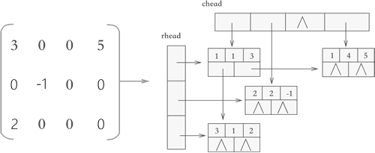

I believe that comparing to using array or Single linked list using crossing list is a better method to store a matrix. The reason is the crossing list enhanced the connection between every element in matrixes, which made the efficiency of searching and updating operations had a significant improvement. It also reduced the consuming of addition or deletion of a matrix. What we need to do is just modifying several nodes, which is not like using array, if we need to add or delete a single element, it might have to modify the whole array (especially for CSR format). Moreover, the crossing list made the algorithm more explicit, because that the structure of crossing list is quite like the actual matrix’s structure. Therefore, the multiplication and addition of matrix in this data structure is more convenient than others.

However, there are still some defects of orthogonal list, and one of them is the increment of the difficulty of parallelization computing. As the same time as the increment of the connection amount elements, the dependency on other elements also was increased. There are three ways to untie these dependencies, which I will show in below. Another flaw in it is the reading file’s speed becomes slower. In fact, the essence of speed of reading a file is the speed of creating a sparse matrix. Creating a crossing list is obviously much slower than creating an array or a single linked list. Also, in same reason, the space consumption is big, that were the sacrifices of decrease the timing consumption, and I believed that this kind of tradeoff is inevitable.

3 Matrix Operation

3.1 Scalar multiplication and Transpose

The result of this homothetic transformation operator is isomorphic to the original matrix. Additionally, during the process of scalar multiplication, new zero elements will not be generated, and original non-zero element also will not be eliminated (except the multiplication’s scalar is 0, which is meaningless). Therefore, basically saying that the shape of orthogonal list would not be changed, which leads that the essence of the scalar multiplication algorithm is just the traversing of every non-empty elements of the original matrix.

Moreover, although the transpose operation changed the matrix’s structure, the changing did not relate to the element’s addition or deletion. In crossing list, the transpose is just exchanging the non-zero element’s column and row’s pointer and index. Therefore, the algorithm of transpose is quite similar with scalar multiplication which also is just traversing lists. That’s why I analyzed them together.

Benefiting from the choice of data structure, the traversing is quite easy. For example, If I make row slices of matrix to traversing it, then due to the independence of elements in COO format, the iteration of rows can be parallelized easily. As for the pointer’s iteration of columns, it also can be solved by using “task” and “untied” clauses directly. However, in the actual computing, I find that using “task” indeed is not good idea. The data onto the actual operation are as follows:

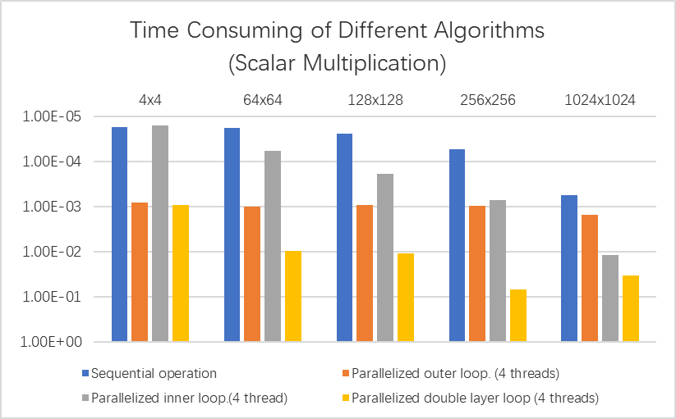
Figure1: Time consuming of different Parallelization Strategies in Scalar Multiplication

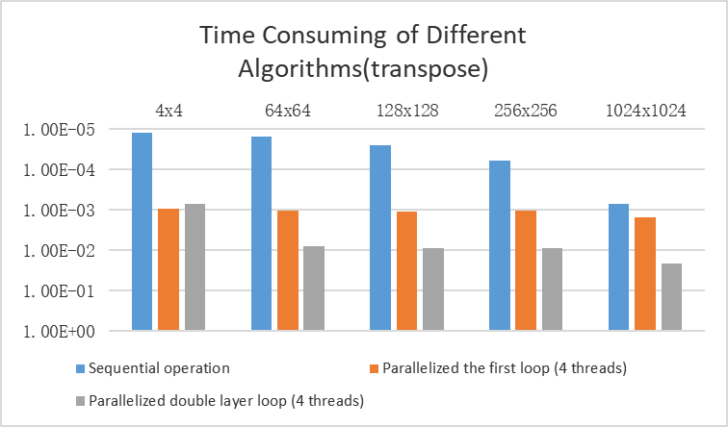
Figure 2: Time consuming of different parallelization strategies in transposing.

(The data onto above graphs are the mean values obtained through ten independent repetitive experiments. Moreover, because of the exponential growth of matrix size, the ordinates (time consumed) of the above graph have been processed in logarithmic inverse order. Simply put, the less time consumed, the higher the corresponding graph.)

From these two figures, we can find 3 important appearances. Firstly, the sequential algorithm is faster than all parallelized algorithms. I believe that it is because the parallel regions are too small, which let the time consumed in creating parallel construct is greater than the saved time which will be consumed in parallel region computing. This phenomenon is quite significant when the parallelization related to the inner loop which was realized by “task” construct. In fact, in each task construct, there are just a few assignment operations or addition operations whose time consuming is much smaller than created task construct itself. This explanation also can be used in the second appearance, with the increase of the matrix dimensional, there are no the decrease trends of the difference between sequential computing and inner loop parallelization computing. Afterall, “task” construct is in inner loop, which means it will not be affected by the size of matrix.

The last appearance is that the performance of parallelized outer loop was stable and indeed getting closer to the sequential one with the growth of matrix size. In fact, from graphs, we can find that the time consuming of these two are quite closed in the 1024x1024 matrix group. That is reasonable, because with the growth of matrix size, the computation in outer “for” construct becomes more and more bigger, which means the time saved by parallel algorithm also would be bigger. Therefore, we can logically anticipate that when the matrix becomes bigger enough, the performance of outer loop parallelization would overwhelm the sequential one. (You might believe the trend is due to the graph’s logarithmic axis, from the difference of other parallelization strategies and the performance of matrix addition, you will find that is not true.)

3.2 Trace

In fact, the trace operation’s algorithm is same as the scalar multiplication operation’s, and the problems encountered with calculating them are also similar. The only difference is that trace needs a “reduction” clause to calculate summary which is trivial (after experiment, reduction indeed is the fastest way, at least, better than data sharing. the space is limited, I omit it here).

However, there is a quite important problem need to be mentioned, which is “is it really a good way for using compressed sparse matrix to calculating trace?” I do not agree with that. Take 1024x1024 matrix as an example, calculating its trace with traditional way, it just needs one loop with 1024 iterations and additions. However, if we use a COO compressed matrix to calculate it, although we can avoid adding non-zero elements in diagonal, the consumption of finding diagonal is quite huge. In most of situations, traversing the whole lower triangular matrix is inevitable. Assuming the density the sparse matrix is 0.1, then the calculation needs about 52428 iterations, which is much more expensive than calculating trace in original matrix.
Moreover, during the process of reading file, the original matrix has been already traversed. Therefore, I added a new member of struct, and calculated the trace during the process of reading file. That’s why I have written the trace function of my code but have never called it.

3.3 Matrixes Addition and Multiplication

The algorithm of addition and multiplication are similar. Both are just adding (creating a matrix is repeatedly adding) or deleting elements based on traversing lists. The only difference is the multiplication must use 3-layer loop. However, after the “collapse (2)” clause was used, the implement of these two is basically same.

To realize the parallelization of matrixes addition and multiplication, we need to untie the dependency on elements in crossing list firstly. During the research of this project, there are three methods I come out.

      - Synchronization mechanism: [5]
Using “critical”, “atomic” clause or lock to ensure that in some special code block there is only one thread can run in same time. Disadvantage: Has great impact on efficiency

      - Matrix partition:
According to the propriety of matrix, the addition and multiplication of large matrices can be replaced by the combination of addition and multiplication of several independent small matrices.

However, the method is not doable in this project. Because in our project both the number of threads and the shape of matrix is not sure. The matrix partition highly depends on these two parameters. If we neglect rationality and use dynamic way to realize it, the time consuming also might be bigger than original, because split a large matrix and merge them are also not easy. Therefore, I believe If we need to use this method, we should specify matrix size or put more information to input files firstly, and then we should use more efficiency format to represent the sparse matrix, but not COO or CSR.

      - Deconstructing the crossing list:
As we all know, the crossing list indeed can greatly simplify computation but also quite hard to established. Besides, this project is not asking for the compound operation of matrix. Therefore, during the addition and multiplication operation we can ignore a half of pointer’s changing and turn the crossing list to an array of list in output. It would not affect the result of output values, but the output matrix cannot be used in further operation. This method not only can decrease the dependency on elements, but also can increase the performance. In 1024x1024 matrix’s addition operation, consumed time reduced 0.0001s(from 0.001717 to 0.001675) by using this method, and for multiplication, the increase in performance is quite impressive. The time consumption reduced from 24.143329 seconds to 7.680934 seconds. However, for the sake of rigor and completeness, the following experimental results have not used this method to simplify the calculation.

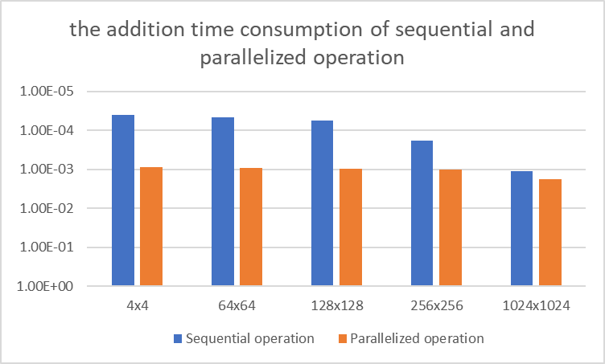
Figure3: the addition time consumption of sequential and parallelized operation

Above figure show the time consumption of various algorithms. From the data onto 1024x1024 matrix, we can find the time consumption of sequential and parallelized operation is quite closed. Especially for matrix additions, it can be found that from 256x256 to 1024x1024, the sequential algorithm’s time consuming was increased 0.000925s while the parallelized one was just increased 0.000746. That is an evidence of the parallelization is working.

Algorithm | Thread | Time consumption
Destructing crossing list | 1 | 7.680934
Sequential operation  collapse (2) + critical | 1  4 | 24.143329  25.340368
collapse (2) +set mutex lock | 4 | 26.830550
collapse (1) + critical | 4 | 27.043150
collapse (2) + critical | 2 | 31.842505
collapse (2) + set two lock | 4 | 35.946327
Table 1: Time consuming of different algorithms for matrix multiplication in 1024x1024 matrix (The data in above tables are the mean values obtained through ten independent repetitive experiments, and more algorithm’s data was showed in appendix)

The table was arranged by order and showed a part of ways I tried to enhance the parallelization performance of matrix multiplication. After experiment, I found that collapse (2) + omp critical clause has the highest performance. What is interesting is that although the application of critical clause and mutex lock is same, however in performance, they have difference. In this case, the critical clause will be faster than mutex lock (about 1s). However, the same phenomena were not such significant in addition’s algorithm. After the research, I learned that this is because that the mutex is more focusing on protecting sharing data, while the semaphore is more care about thread scheduling. Although they can do same things, their performance would be different [6]. In multiplication, we want to manage thread, that is why the critics clause is better. While in addition, the locked block is small, therefore this phenomenon is not significant.

Although there are evidences that can prove the parallelized algorithm is working, the sequential operation still faster. I guess that the lack of cores of my computer might be one of the reasons (Two cores can only run four threads efficiently). Therefore, I used another computer which has 4 cores and 8 thread to run my code. The result is in my anticipation. When I did 1024x1024 matrixes multiplication, the sequential algorithm has spent 28.587857s. 4 threads have spent 29.585758s, and 8 threads have just spent 24.419739s. Meanwhile, In UWA’s Linux lab, this performance was more significant. The sequential algorithm has taken 34.128181s, while the 8 threads parallelized algorithm just have taken 10.589341s, which is indeed much faster
## Reference:

[1] Sparse Matrix Representations & Iterative Solvers, Lesson 1 by Nathan Bell. http ://www.bu.edu/pasi/files/2011/01/NathanBell1-10-1000.pdf
[2] http://yangyiqing.cn/2018/05/01/sparseMatrix/
[3] https://blog.csdn.net/sunhuaqiang1/article/details/51296803
[4] http://data.biancheng.net/view/186.html
[5] https://blog.csdn.net/qihuaheng/article/details/6282060
[6] https://www.zhihu.com/question/47704079

## Appendix

SM:

Matrix | Sequential operation | Parallelized outer loop. (4 threads) | Parallelized inner loop. (4 threads) | Parallelized double loop. (4 threads)
4x4 | 0.000017 | 0.000813 | 0.000016 | 0.000939
64x64 | 0.000018 | 0.001007 | 0.000059 | 0.009769
128x128 | 0.000024 | 0.000903 | 0.000186 | 0.011064
256x256 | 0.000053 | 0.000966 | 0.000706 | 0.068693
1024x1024 | 0.000547 | 0.001505 | 0.011971 | 0.034384
In 8 threads computer: 0.000754 for 8 threads, 0.000827 for sequential operation

TS:

Matrix | Sequential operation | Parallelized the first loop (4 threads) | Parallelized double loop. (4 threads)
4x4 | 0.000012 | 0.000942 | 0.000713
64x64 | 0.000015 | 0.001048 | 0.007754
128x128 | 0.000025 | 0.001067 | 0.008866
256x256 | 0.000059 | 0.001059 | 0.008631
1024x1024 | 0.000691 | 0.001485 | 0.021101

AD:

Matrix | Sequential operation | Parallelized operation
4x4 | 0.000039 | 0.000863
64x64 | 0.000045 | 0.000926
128x128 | 0.000055 | 0.000947
256x256 | 0.000179 | 0.001028
1024x1024 | 0.001104 | 0.001774

1024x1024: destruct crossing list 0.001675 setting lock: 0.001717

MM:

Matrix | Sequential operation | Parallelized operation
4x4 | 0.000112 | 0.001077
64x64 | 0.005939 | 0.022643
128x128 | 0.042713 | 0.150532
256x256 | 0.315833 | 0.881031
1024x1024 | 24.143329 | 25.340368

MM: 1024x1024

Algorithm | Thread | Time consumption
Destructing crossing list | 1 | 7.680934
Destructing crossing list | 4 | 12.546016
Sequential operation  collapse (2) + critical | 1  4 | 24.143329  25.340368
collapse (2) + set lock | 4 | 26.830550
collapse (1) + critical | 4 | 27.043150
collapse (2) + critical | 2 | 31.842505
collapse (2) + critical | 3 | 33.935135
collapse (2) + set two lock | 4 | 35.946327

In 8 threads computer: 28.587857 for 1 thread, 29.585758 for 4 threads, 24.419739 for 8 threads.

