Downloading the VM (includes data sets)
Alternative - download data sets
Virtual machine setup
Using Oracle VirtualBox
Using VMWare

Downloading the VM (includes data sets)
- Download it from http://content.udacity-data.com/courses/ud617/Cloudera-Udacity-Training-VM-4.1.1.c.zip. Warning - the zipped file size is 1.7 GB. If you are on a Windows machine you will likely need to use WinRAR to open this .zip file because other methods fail to open the unzipped file (which exceeds the maximum specified 4GB for a .zip file).
- MD5sum file can be found here http://content.udacity-data.com/courses/ud617/Cloudera-Udacity-Training-VM-4.1.1.c.zip.md5
- Unzip it. Warning - the unzipped size is 4.2GB
- MD5 hashes for files:
  - 8a610c151d4b1ebdce11542d13dd2a53 Cloudera-Training-VM-4.1.1.c.log
  - 6b44c965c1c6062554bf4cc12d11e87e Cloudera-Training-VM-4.1.1.c.plist
  - 46dedeba3e0affd8311431d7e370705e Cloudera-Training-VM-4.1.1.c.vmdk
  - d41d8cd98f00b204e9800998ecf8427e Cloudera-Training-VM-4.1.1.c.vmsd
  - 096956c1cbabeaa652ca63a2d5e14612 Cloudera-Training-VM-4.1.1.c.vmx
  - c9f8a375e82ef1e9d96097850e237df9 Cloudera-Training-VM-4.1.1.c.vmxf
  - 0d7c8becb5a515068e81bb303c794e4f nvram

Alternative - download data sets
Download and unzip data sets from:
- http://content.udacity-data.com/courses/ud617/access_log.gz
- http://content.udacity-data.com/courses/ud617/purchases.txt.gz

Virtual machine setup

Using Oracle VirtualBox
- Download and install VirtualBox from https://www.virtualbox.org/wiki/Downloads
- Create a new Virtual machine:
  - Create a new virtual machine by pressing the ‘New’ button:
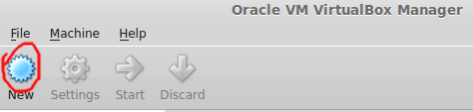
  - Choose a name, use ‘Type’: ‘Linux’: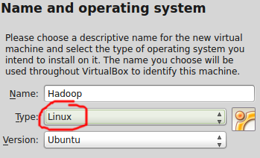
  - Press Next
  - Select memory size for the VM.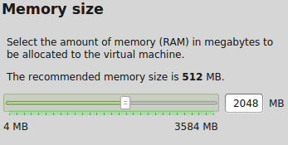
  - Press Next
  - Select ‘Use an existing virtual hard drive file’’, click the button to browse to the directory you unzipped the provided VM image and press ‘Create’.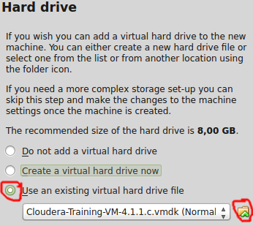
  - Start the VM!
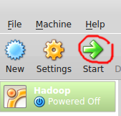

Using VMWare
- Download and install from https://my.vmware.com/web/vmware/free#desktop_end_user_computing/vmware_player/6_0
- Create the Virtual Machine:
  - Click on ‘Open a Virtual Machine’ and, when prompted, navigate to the folder you unzipped the VM, choose the file and click ‘Open’.
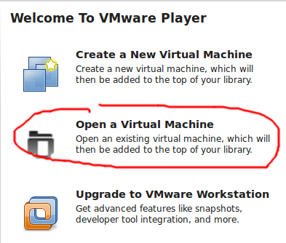
  - Select the machine and click ‘Play virtual machine’