This App will consume Services which registered in Eureka Server.

**Eureka**：service registry and discovery

**Feign**: used for load balance and more clear and easy with annotation. It has reused ribbon internally.

**Ribbon**: used for load balance.

**Hystrix**: used for CircuitBreaker which can prevent destroy expanding.

**Zuul**: used as api gateway, it can remote to dedicate url path.

1. Start up: eureka-server with port 8888
2. Start up: eureka-service-provider with port 9000
3. Start up: eureka-service-provider with port 9001
4. Start up: eureka-service-consumer-ribbon with port 7000
5. 在浏览器上多次访问http://127.0.0.1:7000/request，浏览器交替显示：

hello world from spring cloud, I am from port:9000

hello world from spring cloud, I am from port:9001

这说明当我们通过调用restTemplate.getForObject(“http://SERVICE-HI/hi” ,String.class)方法时，已经做了负载均衡，访问了不同的端口的服务实例。

1. 架构图

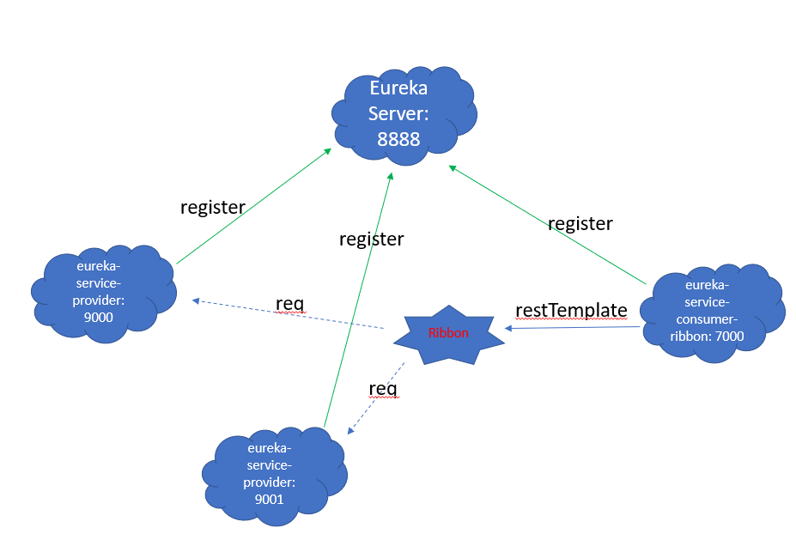

一个服务注册中心，eureka server,端口为8888

eureka-service-provider工程跑了两个实例，端口分别为9000,9001，分别向服务注册中心注册

eureka-service-consumer-ribbon端口为7000,向服务注册中心注册

当eureka-service-consumer-ribbon通过restTemplate调用eureka-service-provider的hi接口时，因为用ribbon进行了负载均衡，会轮流的调用eureka-service-provider：9000和9001 两个端口的hi接口；

Ref: <https://blog.csdn.net/forezp/article/details/70148833>