

《计算机操作实践》课程实验报告

学 院: | 信息学院
专 业: | 计算机科学与技术
姓名 | 周凯君
班级 | 计23-2
学号 | 23101020222
指导教师 | 宋丽华

2025年 11月 27日

目录

实验一 进程调度 3
1. 实验目的： 3
2. 实验内容： 3
3. 设计实现： 3
（1） 目录表 3
（2） 流程图 4
（3） 详细代码 5
4. 实验结果 19
5.实验过程中出现的问题及解决办法 20

实验二 页面置换算法 22
1. 实验目的： 22
2. 实验内容： 22
3. 设计实现： 22
（1） 目录表 22
（2） 流程图 23
（3） 详细代码 24
4. 实验结果 41
5. 实验过程中出现的问题及解决办法 46

实验三 文件系统模拟实现 47
1. 实验目的： 47
2. 实验内容： 47
3. 设计实现： 47
(1) 目录表 47
(2) 流程图 47
(3) 详细代码 47
4. 实验结果 47
5. 实验过程中出现的问题及解决办法 47

实验一 进程调度

实验目的：
通过对进程调度算法的模拟，进一步理解进程的基本概念，加深对进程运行状态和进程调度过程、调度算法的理解。

实验内容：
用C++语言实现对5个进程采用某种进程调度算法（先来先服务调度、短作业优先调度、优先权调度、时间片轮转调度、多级反馈队列调度）的调度。将每个进程的被调度情况显示出来。

设计实现：

目录表
PROCESSSCHEDULER/
│
├─ Algorithms/
│ ├─ FCFS.hpp
│ ├─ MLFQ.hpp
│ ├─ PS.hpp
│ ├─ RR.hpp
│ └─ SJF.hpp
├─ Core/
│ ├─ IProcessScheduler.hpp
│ ├─ Process.hpp
│ └─ Simulator.hpp
├─ Util/
│ └─ RandomDataGenerate.hpp
│
└─ main.cpp

流程图
图一： main.cpp 图五：SJF.hpp
图二： RandomDataGenerate.hpp 图六：PS.hpp
图三： Simulator.hpp 图七：RR.hpp
图四： FCFS.hpp 图八：MLFQ.hpp
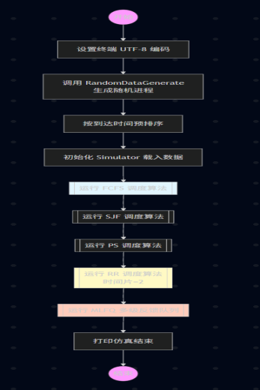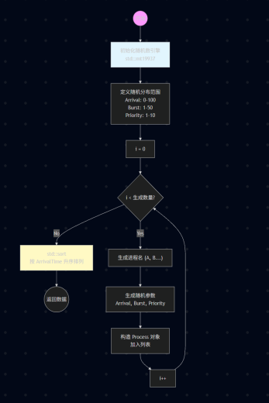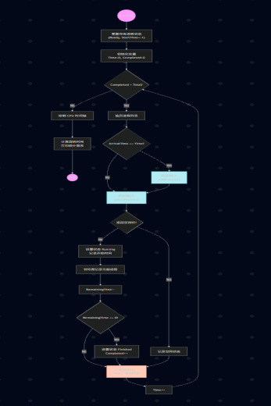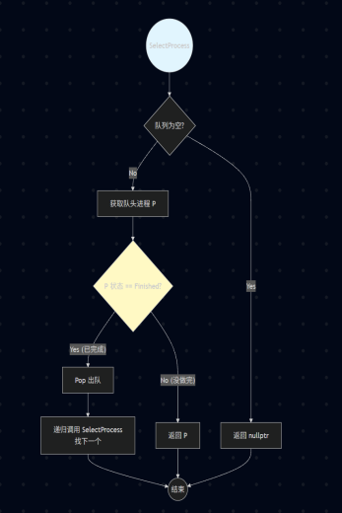
图一 图二 图三 图四

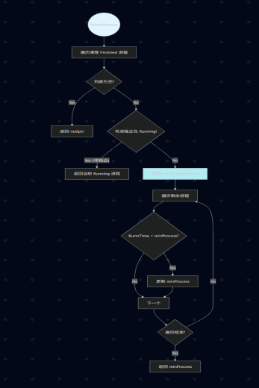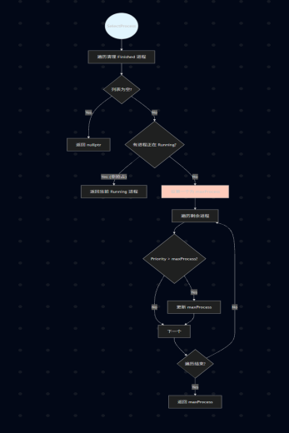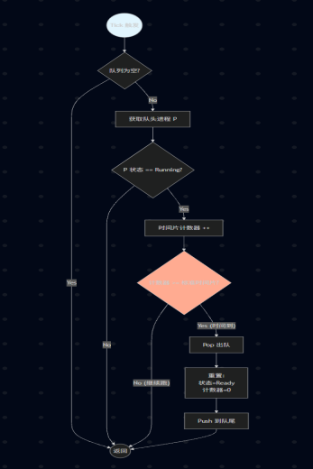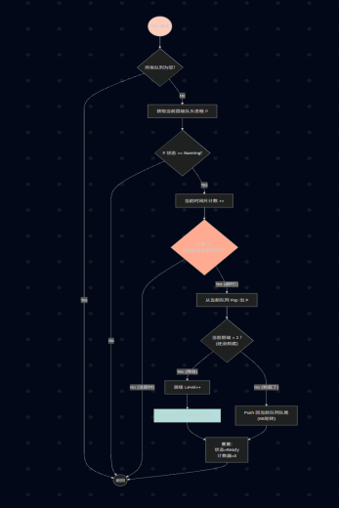
图五 图六 图七 图八

、

详细代码
main.cpp：
#include <iostream>
#include <vector>
#include <windows.h>

#include "Core/Process.hpp"
#include "Core/Simulator.hpp"

#include "Util/RandomDataGenerate.hpp"

#include "Algorithms/FCFS.hpp"
#include "Algorithms/SJF.hpp"
#include "Algorithms/PS.hpp"
#include "Algorithms/RR.hpp"
#include "Algorithms/MLFQ.hpp"

int main()
{
SetConsoleOutputCP(65001);

int processCount = 10;
std::cout << "正在生成" << processCount << "个随机进程" << std::endl;
std::vector<Process> data = RandomDataGenerate::GenerateProcess(processCount);

Simulator simulator(data);
std::cout << "开始进程调度算法仿真" << std::endl;

FCFSScheduler FCFS;
simulator.RunProcessScheduler(&FCFS);

SJFScheduler SJF;
simulator.RunProcessScheduler(&SJF);

PSScheduler PS;
simulator.RunProcessScheduler(&PS);

RRScheduler RR(2);
simulator.RunProcessScheduler(&RR);

MLFQScheduler MLFQ;
simulator.RunProcessScheduler(&MLFQ);

std::cout << "仿真结束" << std::endl;

return 0;
}

Process.hpp：
#pragma once
#include <string>

enum ProcessStatus { Ready, Running, Finished };

struct Process
{
std::string name;
int arrivalTime;
int burstTime;
int priority;
int remainingTime;
int startTime;
int finishTime;
ProcessStatus status = Ready;

Process(std::string n, int arrivetime, int bursttime, int prioity) : name(n), arrivalTime(arrivetime), burstTime(bursttime), priority(prioity) // 显式指认！
{
remainingTime = bursttime;
startTime = -1;
finishTime = 0;
status = Ready;
}
};

IProcessScheduler.hpp：
#pragma once

#include <string>
#include "Process.hpp"

class IProcessScheduler
{
public:
virtual ~IProcessScheduler() = default;

virtual std::string GetAlgorithmName() = 0;

virtual void AddProcess(Process* p) = 0;

virtual Process* SelectProcess(int currentTime) = 0;

virtual void Tick() {};
};
Simulator.hpp：
#pragma once

#include <vector>
#include <iomanip>
#include <iostream>
#include "IProcessScheduler.hpp"

class Simulator
{
private:
std::vector<Process> process;

public:
Simulator(const std::vector<Process>& data) : process(data) {}
void RunProcessScheduler(IProcessScheduler* scheduler)
{
for (auto& p : process)
{
p.remainingTime = p.burstTime;
p.startTime = -1;
p.finishTime = 0;
p.status = Ready;
}

int currentTime = 0;
int totalProcess = process.size();
int completedProcess = 0;

std::string timeLine = "";
Process* lastRun = nullptr;

std::cout << scheduler->GetAlgorithmName() << "：" << std::endl;

while (completedProcess < totalProcess)
{
for (auto& p : process)
{
if (p.arrivalTime == currentTime)
{
scheduler->AddProcess(&p);
}
}

Process* currentProcess = scheduler->SelectProcess(currentTime);

if (currentProcess != nullptr)
{
if (currentProcess->startTime == -1)
{
currentProcess->startTime = currentTime;
}

currentProcess->status = Running;

if (currentProcess != lastRun)
{
timeLine += currentProcess->name;
lastRun = currentProcess;
}
else
{
timeLine += ".";
}

currentProcess->remainingTime--;

if (currentProcess->remainingTime == 0)
{
currentProcess->status = Finished;
currentProcess->finishTime = currentTime + 1;
completedProcess++;
}
}
else
{
timeLine += "_";
lastRun = nullptr;
}

scheduler->Tick();
currentTime++;
}

std::cout << std::endl << "进程执行时间轴: " << timeLine << std::endl;
PrintReport();
}

private:
void PrintReport()
{
std::cout << std::endl;
std::cout << std::left
<< std::setw(6) << "Name"
<< std::setw(8) << "Arrive"
<< std::setw(12) << "Priority"
<< std::setw(12) << "BurstTime"
<< std::setw(12) << "StartTime"
<< std::setw(12) << "FinishTime"
<< std::setw(12) << "TurnTime"
<< std::setw(12) << "WeightedTurnTime";

std::cout << std::endl << std::string(90, '-') << std::endl;

double totalTurnAround = 0;
double totalWeightedTurnAround = 0;

for (const auto& p : process)
{
int turnTime = p.finishTime - p.arrivalTime;

double weightedTurnTime = (double)turnTime / p.burstTime;

totalTurnAround += turnTime;
totalWeightedTurnAround += weightedTurnTime;

std::cout << std::left
<< std::setw(6) << p.name
<< std::setw(8) << p.arrivalTime
<< std::setw(12) << p.priority
<< std::setw(12) << p.burstTime
<< std::setw(12) << p.startTime
<< std::setw(12) << p.finishTime
<< std::setw(12) << turnTime
<< std::fixed << std::setprecision(2) << std::setw(12) << weightedTurnTime
<< std::endl;
}

std::cout << std::string(90, '-') << std::endl;

if (!process.empty())
{
std::cout << "平均周转时间: " << totalTurnAround / process.size() << std::endl;
std::cout << "平均带权周转: " << totalWeightedTurnAround / process.size() << std::endl;
}
std::cout << std::endl;
}
};

RandomDataGenerate.hpp：
#pragma once

#include <vector>
#include <random>
#include <algorithm>
#include "../Core/Process.hpp"

namespace RandomDataGenerate
{
inline std::vector<Process> GenerateProcess(int count)
{
std::vector<Process> data;

std::random_device seed;
std::mt19937 generator(seed());

std::uniform_int_distribution<int> arrivalDistribution(0, 100);
std::uniform_int_distribution<int> burstDistribution(1, 50);
std::uniform_int_distribution<int> priorityDistribution(1, 10);

for (int i = 0; i < count; i++)
{
std::string name(1, 'A' + i);
data.emplace_back(
name,
arrivalDistribution(generator),
burstDistribution(generator),
priorityDistribution(generator)
);
}

// std::sort(data.begin(), data.end(), [](Process& a, Process& b){ return a.arrivalTime < b.arrivalTime ;})
std::ranges::sort(data, {}, &Process::arrivalTime);

return data;
}
}

FCFS.hpp：
#pragma once

#include <queue>
#include "../Core/IProcessScheduler.hpp"

class FCFSScheduler : public IProcessScheduler
{
private:
std::queue<Process*> readyProcess;
public:
std::string GetAlgorithmName() override
{
return "先来先服务调度——FCFS";
}

void AddProcess(Process* p) override
{
readyProcess.push(p);
}

Process* SelectProcess(int currentTime) override
{
if (readyProcess.empty()) return nullptr;

Process* p = readyProcess.front();
if (p->status == Finished)
{
readyProcess.pop();
return SelectProcess(currentTime);
}

return p;
}
};

SJF.hpp：
#pragma once

#include <vector>
#include <algorithm>
#include "../Core/IProcessScheduler.hpp"

class SJFScheduler :public IProcessScheduler
{
private:
std::vector<Process*> readyProcess;
public:
std::string GetAlgorithmName() override
{
return "短作业优先调度——SJF";
}

void AddProcess(Process* p) override
{
readyProcess.push_back(p);
}

Process* SelectProcess(int currentTime) override
{
for (auto it = readyProcess.begin(); it != readyProcess.end();)
{
if ((*it)->status == Finished)
{
it = readyProcess.erase(it);
}
else
{
it++;
}
}

if (readyProcess.empty()) return nullptr;

for (auto* readyprocess : readyProcess)
{
if (readyprocess->status == Running)
{
return readyprocess;
}
}

Process* minProcess = readyProcess[0];
for (auto* readyprocess : readyProcess)
{
if (readyprocess->burstTime < minProcess->burstTime)
{
minProcess = readyprocess;
}
}

// std::sort(readyProcess.begin(), readyProcess.end(), [](Process *a, Process *b)
// {
// return a->burstTime < b->burstTime;
// });

// std::ranges::sort(readyProcess, {}, &Process::burstTime);
// Process* minProcess = readyProcess[0];

return minProcess;
}
};

PS.hpp：
#pragma once

#include <vector>
#include "../Core/IProcessScheduler.hpp"

class PSScheduler : public IProcessScheduler
{
private:
std::vector<Process*> readyProcess;
public:
std::string GetAlgorithmName() override
{
return "优先权调度——PS";
}

void AddProcess(Process* p) override
{
readyProcess.push_back(p);
}

Process* SelectProcess(int currentTime) override
{
for (auto it = readyProcess.begin(); it != readyProcess.end(); )
{
if ((*it)->status == Finished)
{
it = readyProcess.erase(it);
}
else
{
it++;
}
}

if (readyProcess.empty()) return nullptr;

for (auto* readyprocess : readyProcess)
{
if (readyprocess->status == Running)
{
return readyprocess;
}
}

Process* maxPriorityProcess = readyProcess[0];
for (auto* readyprocess : readyProcess)
{
if (readyprocess->priority > maxPriorityProcess->priority)
{
maxPriorityProcess = readyprocess;
}
}

return maxPriorityProcess;
}
};

RR.hpp：
#pragma once

#include <queue>
#include "../Core/IProcessScheduler.hpp"

class RRScheduler : public IProcessScheduler
{
private:
std::queue<Process*> readyProcess;
int standardTimeSlice;
int currentTimeSlice;
public:
RRScheduler(int standardtimeslice) : standardTimeSlice(standardtimeslice), currentTimeSlice(0) {}
std::string GetAlgorithmName() override
{
return "时间片轮转调度——RR(TimeSlice=" + std::to_string(standardTimeSlice) + ")";
}

void AddProcess(Process* p) override
{
readyProcess.push(p);
}

Process* SelectProcess(int currentTime) override
{
if (readyProcess.empty()) return nullptr;

Process* p = readyProcess.front();
if (p->status == Finished)
{
readyProcess.pop();
currentTimeSlice = 0;
return SelectProcess(currentTime);
}

return p;
}

void Tick() override
{
if (readyProcess.empty()) return;

Process* p = readyProcess.front();
if (p->status == Running)
{
currentTimeSlice++;
if (currentTimeSlice >= standardTimeSlice)
{
readyProcess.pop();
p->status = Ready;
readyProcess.push(p);
currentTimeSlice = 0;
}
}
}
};

MLFQ.hpp：
#pragma once

#include <queue>
#include <vector>
#include "../Core/IProcessScheduler.hpp"

class MLFQScheduler : public IProcessScheduler
{
private:
std::vector<std::queue<Process*>> readyProcess;
const std::vector<int> standardTimeSlice = { 1, 4, 16 };
int currentTimeSlice;
int currentLevel;
Process* lastRunningProcess;

public:
MLFQScheduler() : currentTimeSlice(0), currentLevel(0), lastRunningProcess(nullptr)
{
readyProcess.resize(3);
}
std::string GetAlgorithmName() override
{
return "多级反馈队列调度——MLFQ（standardTimeSlice0 = 1, standardTimeSlice1 = 4, standardTimeSlice2 =16）";
}

void AddProcess(Process* p) override
{
readyProcess[0].push(p);
}

Process* SelectProcess(int currentTime) override
{
for (int i = 0; i < 3; i++)
{
if (!readyProcess[i].empty())
{
Process* p = readyProcess[i].front();
if (p->status == Finished)
{
readyProcess[i].pop();
currentTimeSlice = 0;
return SelectProcess(currentTime);
}

currentLevel = i;

if (p != lastRunningProcess)
{
currentTimeSlice = 0;
lastRunningProcess = p;
}

return p;
}
}

return nullptr;
}

void Tick() override
{
if (std::ranges::all_of(readyProcess, [](const auto& q) { return q.empty(); })) { return; }

Process* p = readyProcess[currentLevel].front();
if (p->status == Running)
{
currentTimeSlice++;
if (currentTimeSlice >= standardTimeSlice[currentLevel])
{
readyProcess[currentLevel].pop();
if (currentLevel < 2)
{
int nextLevel = currentLevel + 1;
readyProcess[nextLevel].push(p);
}
else
{
readyProcess[currentLevel].push(p);
}

p->status = Ready;
currentTimeSlice = 0;
lastRunningProcess = nullptr;
}
}
}
};

实验结果
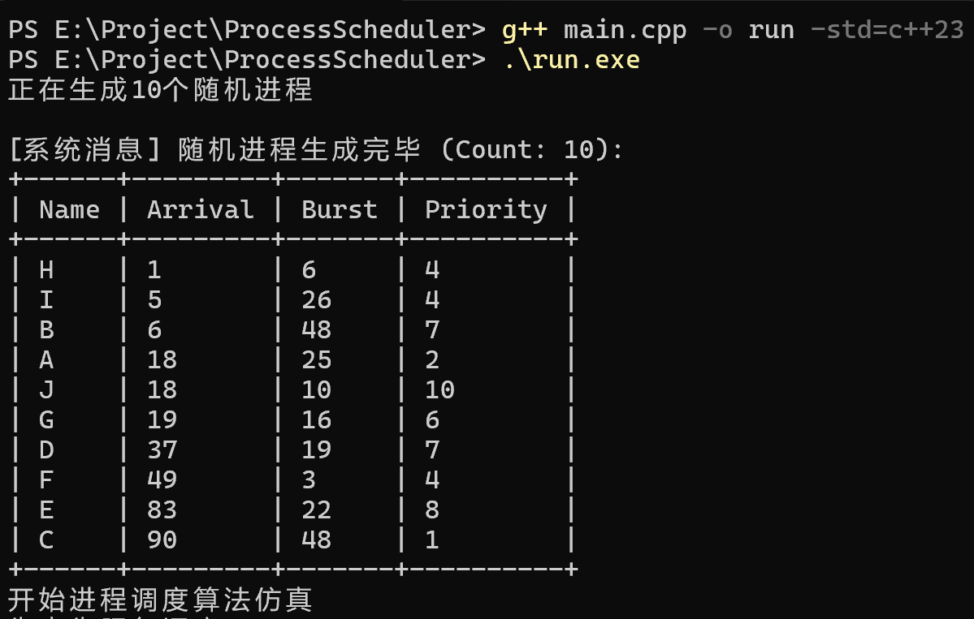
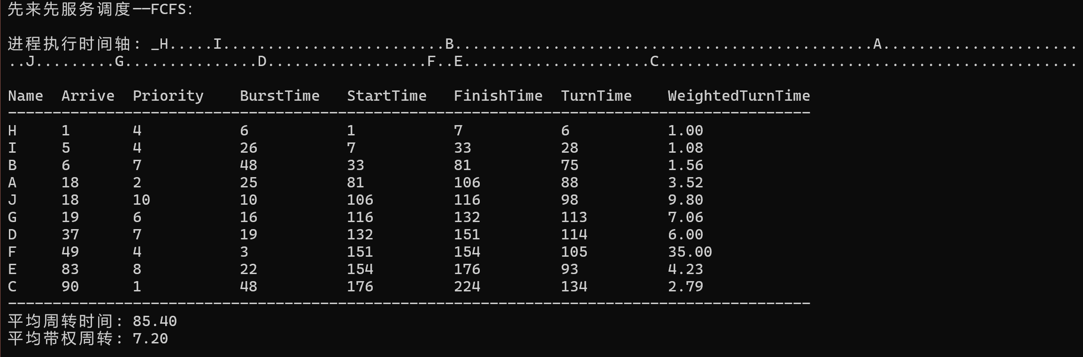
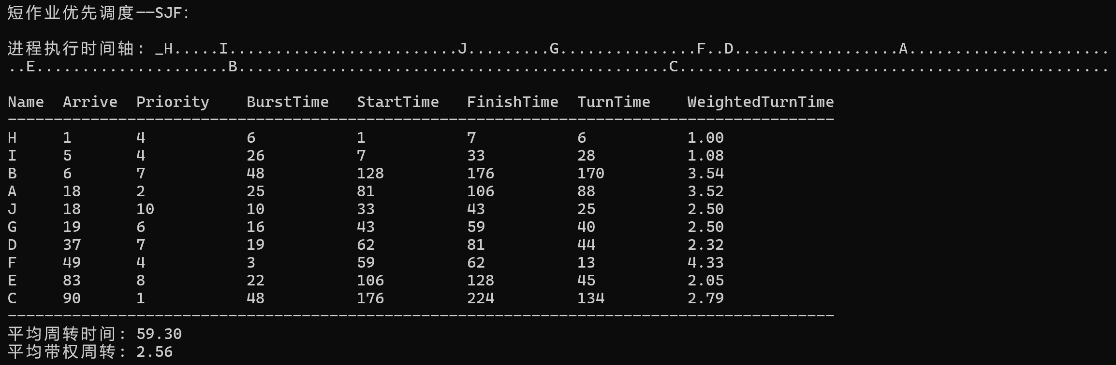
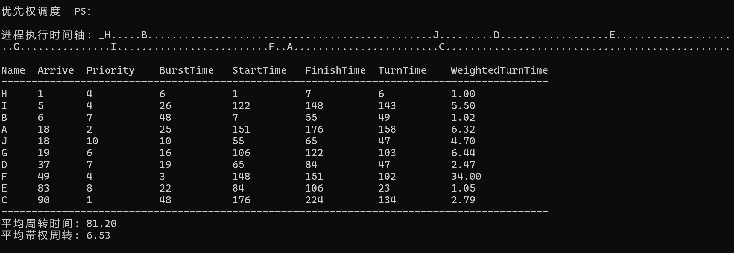
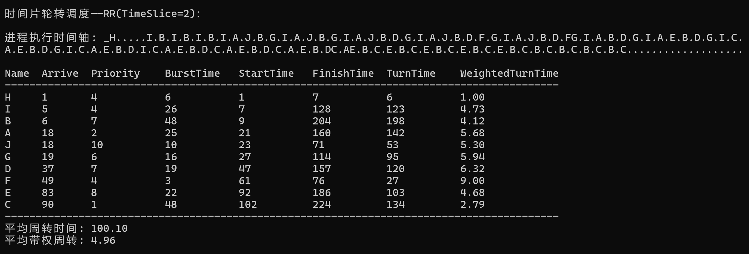
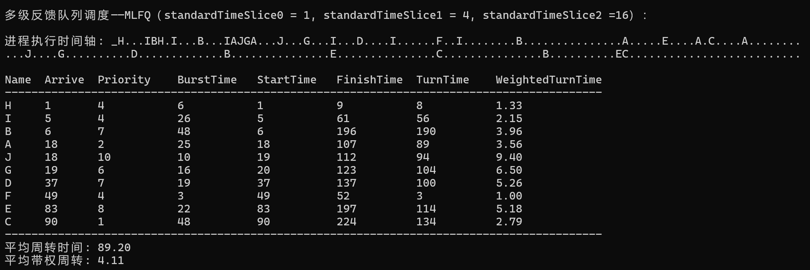

其中进程执行时间轴中’_’（下划线）代表无进程（空闲） ‘.’（点）代表该进程继续进行

5.实验过程中出现的问题及解决办法
本代码还有部分内容可以优化
例如：
利用 constexpr 把计算任务从程序运行的时候挪到代码编译的时候
利用 小根堆大根堆代替Vector容器 可以将复杂度降到log(n)
还有应该用’\n’代替std::endl 可以更快优化
时间轴也可以改变输出格式 变成ganttChart形式
也可以将simulator引擎封装在IProcessScheduler接口内
这些问题都是在在内容实现后才思考优化 但仍未实现

实验二 页面置换算法

实验目的：
1）通过编写程序实现请求分页存储管理的Optimal、FIFO、LRU等页面置换算法中的一种，掌握虚拟存储管理中有关缺页处理方法等内容，巩固有关虚拟存储管理的教学内容。
2）理解内存分配原理，特别是以页面为单位的虚拟内存分配方法。

实验内容：
用C++语言实现页面置换算法（最佳置换算法OPT、FIFO置换算法、最少使用页面置换算法、最近未使用页面置换算法、时钟页面置换算法）。并调入所访问的页面，打印输入结果，在程序中，0代表为空，*代表缺页

设计实现：

目录表
Page Replacement（Optimized） /
│
├─ .vscode
├─ bin
│ └─ run.exe
├─ include
│ ├─ Algorithms/
│ │ ├─ CLOCK.hpp
│ │ ├─ FIFO.hpp
│ │ ├─ LFU.hpp
│ │ ├─ LRU.hpp
│ │ └─ OPT.hpp
│ ├─ Common/
│ │ ├─ GlobalDefine.hpp
│ │ └─ RandomDataGenerator.hpp
│ └─ Core/
│ ├─ BaseAlgorithm.hpp

│ └─ ISimulator.hpp
├─ src
│ └─ main.cpp
└─ run.ps1

流程图
图六： LFU.hpp
图七： LRU.hpp
图八： CLOCK.hpp
图九： OPT.hpp

图一： main.cpp
图二： RandomDataGenerate.hpp
图三： ISimulator.hpp
图四： BaseAlgorithm.hpp
图五： FIFO.hpp

图五：SJF.hpp
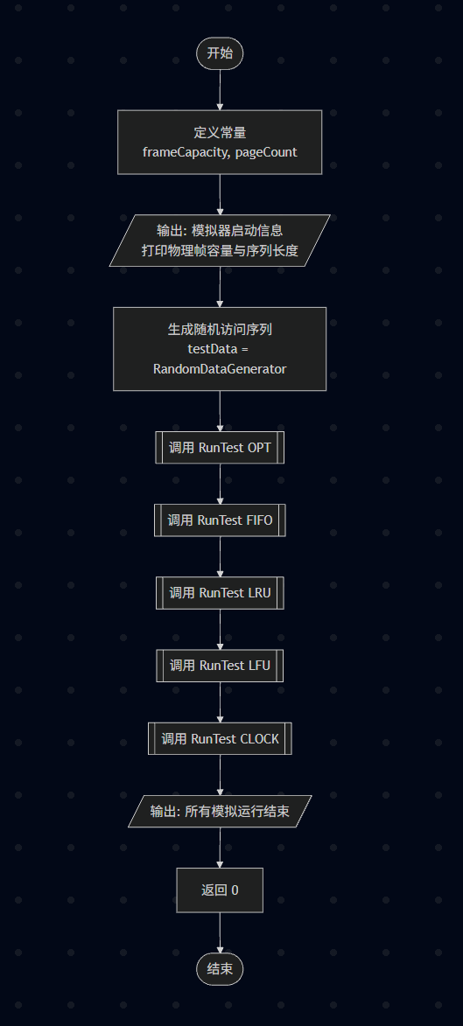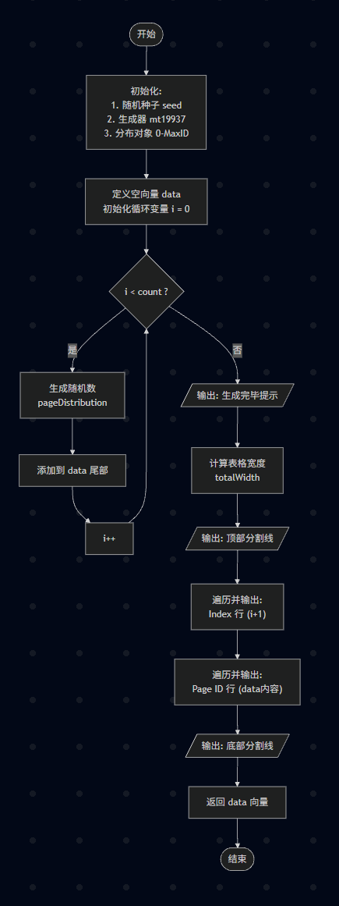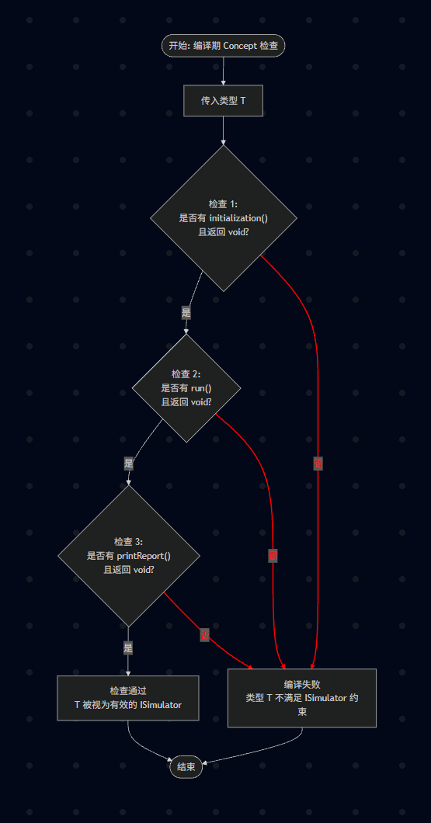
图一 图二 图三 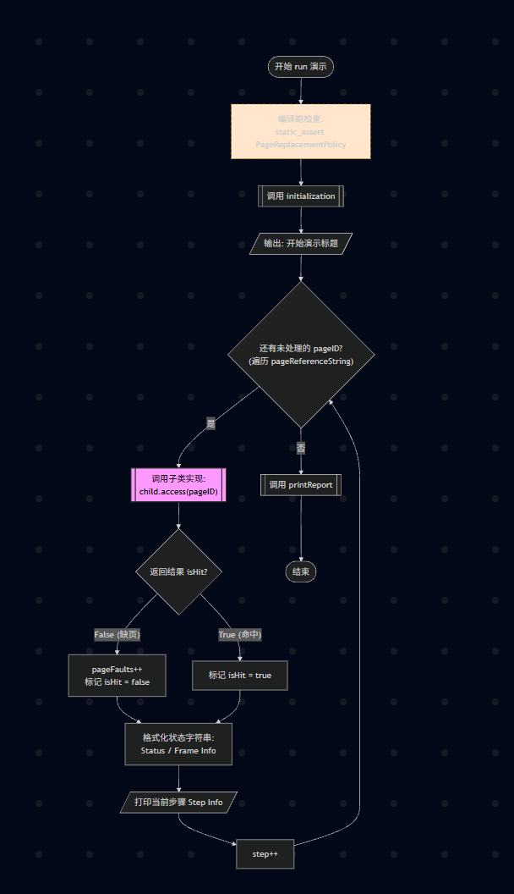 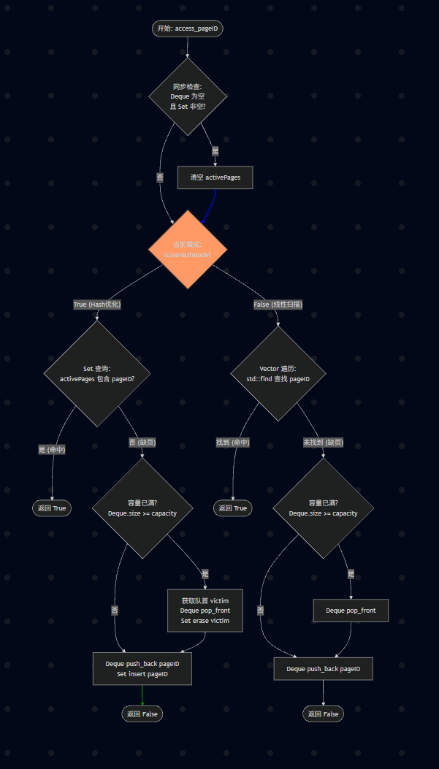 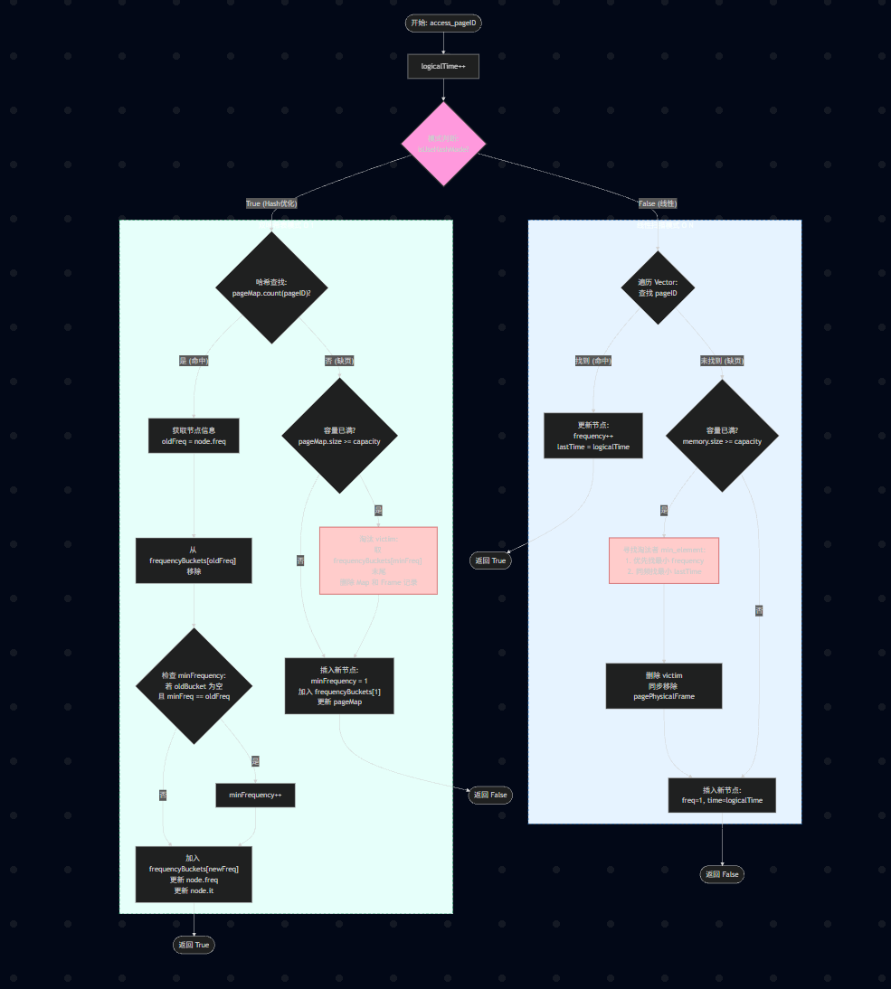 图四 图五 图六

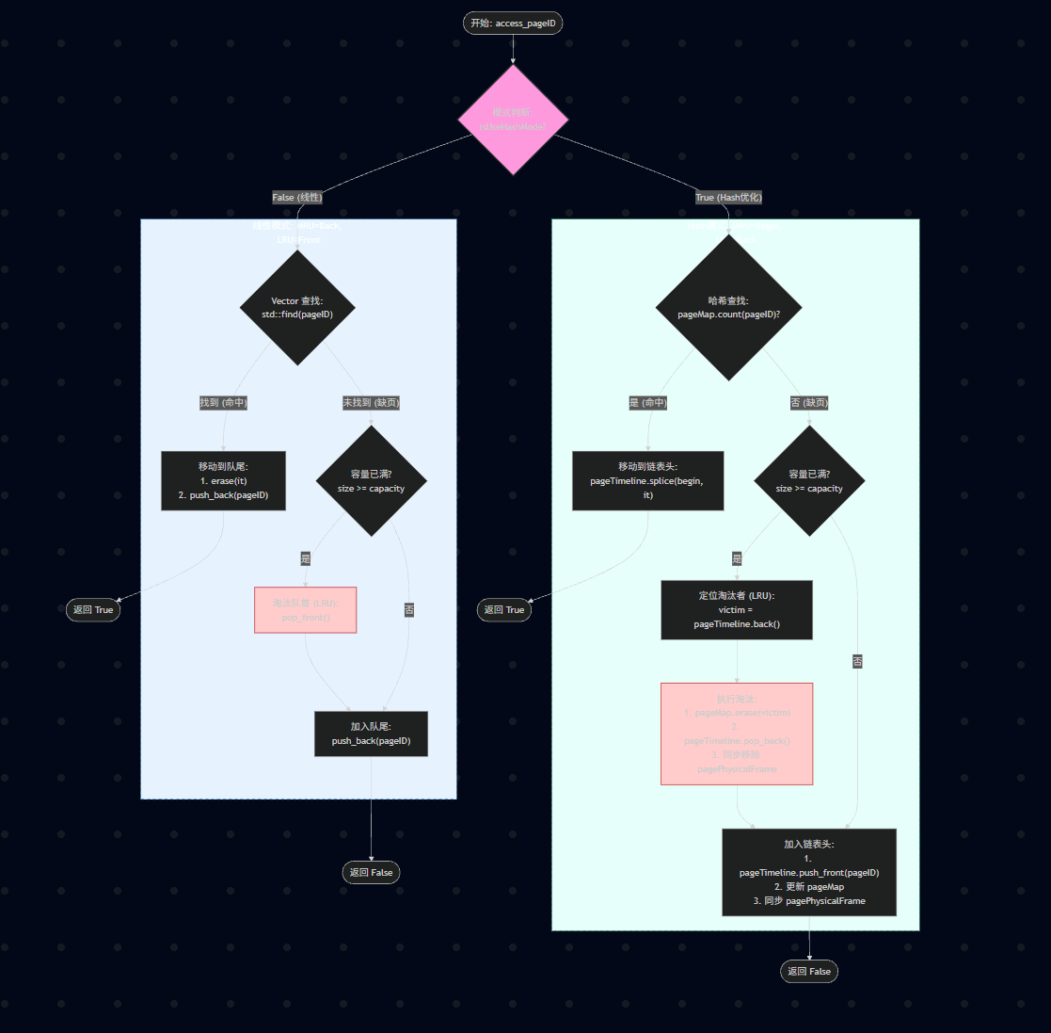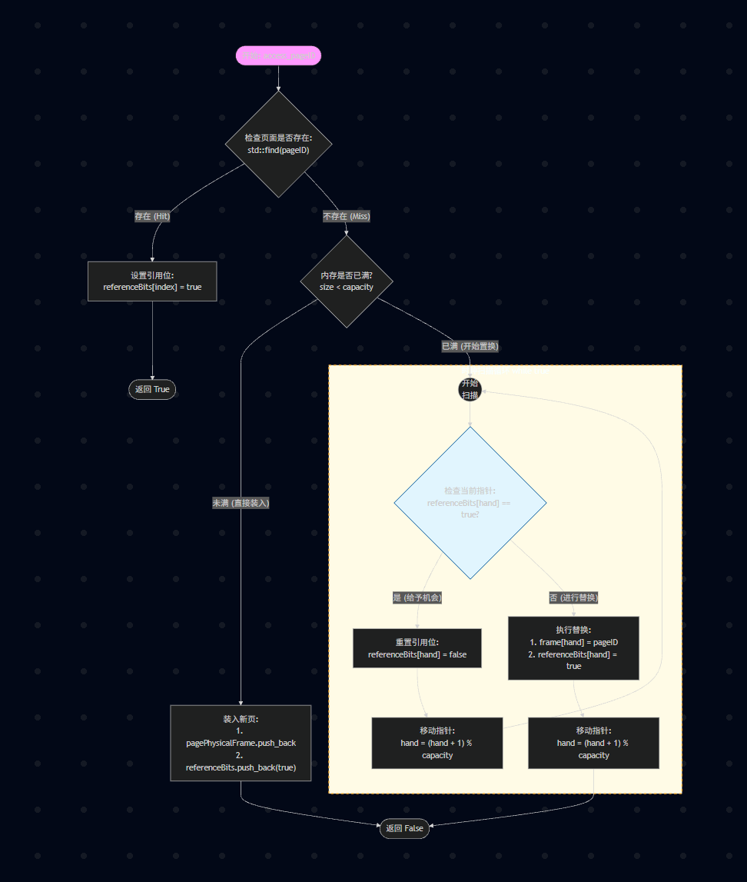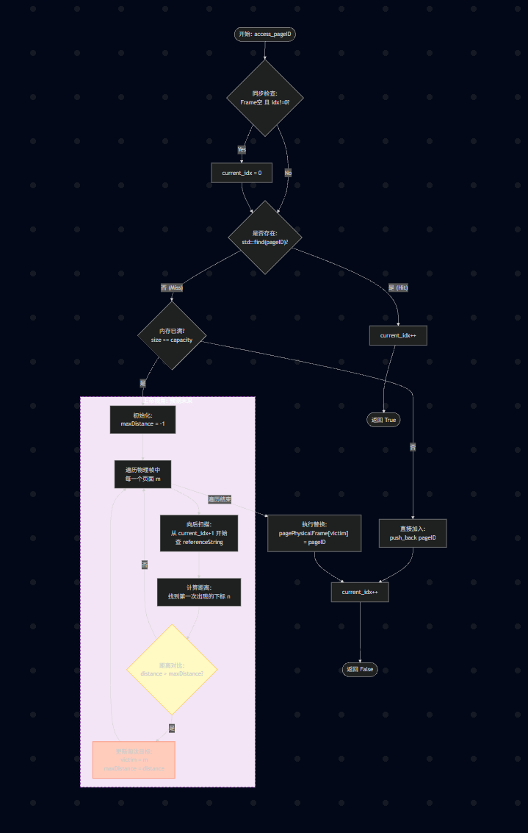

图七 图八 图九

详细代码
main.cpp
#include <iostream>
#include <vector>
#include <memory>

#include "../include/Common/GlobalDefine.hpp"
#include "../include/Common/RandomDataGenerator.hpp"

#include "../include/Core/BaseAlgorithm.hpp"

#include "../include/Algorithms/FIFO.hpp"
#include "../include/Algorithms/OPT.hpp"
#include "../include/Algorithms/LRU.hpp"
#include "../include/Algorithms/LFU.hpp"
#include "../include/Algorithms/CLOCK.hpp"

template <typename AlgorithmType>
void RunTest(const std::vector<int>& data, int capacity)
{
AlgorithmType algorithm(capacity);

algorithm.loadData(data);

algorithm.run();
}

int main()
{
const int frameCapacity = Config::DEFAULT_FRAME_COUNT;
const int pageCount = Config::DEFAULT_REFERENCE_STRING_LENGTH;

std::cout << "页面置换算法模拟器启动" << std::endl;
std::cout << "物理帧容量: " << frameCapacity << std::endl;
std::cout << "访问序列长度: " << pageCount << std::endl;

std::vector<int> testData = RandomDataGenerator::GeneratorPageGenerator(pageCount);

RunTest<OPT>(testData, frameCapacity);
RunTest<FIFO>(testData, frameCapacity);
RunTest<LRU>(testData, frameCapacity);
RunTest<LFU>(testData, frameCapacity);
RunTest<CLOCK>(testData, frameCapacity);

std::cout << std::endl << "所有模拟运行结束" << std::endl;

return 0;
}

RandomDataGenerator.hpp
#pragma once

#include "GlobalDefine.hpp"

#include <random>
#include <vector>
#include <iostream>
#include <iomanip>

namespace RandomDataGenerator
{
inline std::vector<int> GeneratorPageGenerator(int count)
{
std::vector<int> data;

std::random_device seed;
std::mt19937 generator(seed());

std::uniform_int_distribution<int> pageDistribution(0, Config::DEFAULT_MAX_PAGE_ID);

for (int i = 0; i < count; i++)
{
data.emplace_back(pageDistribution(generator));
}

std::cout << std::endl << "随机页面序列生成完毕 (Count: " << count << "):" << std::endl;

int totalWidth = 9 + data.size() * 4;
std::string separatorLine(totalWidth, '-');

std::cout << separatorLine << std::endl;

std::cout << "Index : ";
for (int i = 0; i < data.size(); ++i)
{
std::cout << std::setw(3) << (i + 1) << " ";
}
std::cout << std::endl;

std::cout << "Page ID: ";
for (int i = 0; i < data.size(); ++i)
{
std::cout << std::setw(3) << data[i] << " ";
}
std::cout << std::endl;

std::cout << separatorLine << std::endl;
std::cout << std::endl;

return data;
}
}

ISimulator.hpp
#pragma once
#include <concepts>

// 任何自称是 ISimulator 的类型 T，必须拥有以下成员函数。
// 这种检查发生在编译期，零运行时开销 (Zero Runtime Overhead)。

template<typename T>
concept ISimulator = requires(T t)
{
{ t.initialization() } -> std::same_as<void>;
{ t.run() } -> std::same_as<void>;
{ t.printReport() } -> std::same_as<void>;
};

BaseAlgorithm.hpp:
#pragma once

#include <string>
#include <vector>
#include <deque>
#include <iostream>
#include <iomanip>
#include <algorithm>
#include <concepts>
#include <format>

// CRTP（奇异递归模板模式）

template<typename T>
concept PageReplacementPolicy = requires(T t, int pageID)
{
{ t.access(pageID) } -> std::same_as<bool>;
};

template<typename Child>
class BaseAlgorithm
{
protected:
std::string algorithmName;
std::vector<int> pageReferenceString;
std::deque<int> pagePhysicalFrame;
int pageFaults;

public:
explicit BaseAlgorithm(std::string name) : algorithmName(std::move(name)), pageFaults(0) {}
void loadData(const std::vector<int>& data)
{
pageReferenceString = data;
}
void initialization()
{
pageFaults = 0;
pagePhysicalFrame.clear();
}
void printReport()
{
double faultRate = (double)pageFaults / pageReferenceString.size() * 100.0;
double hitRate = 100.0 - faultRate;

std::cout << std::format(
"\n==========================================\n"
"算法名称: {}\n"
"------------------------------------------\n"
"访问总次数: {}\n"
"缺页次数 : {}\n"
"缺页率 : {:.2f}%\n"
"命中率 : {:.2f}%\n"
"==========================================\n",
algorithmName,
pageReferenceString.size(),
pageFaults,
faultRate,
hitRate
);
}
void run()
{
static_assert(PageReplacementPolicy<Child>, "Fatal Error: Subclass MUST implement 'bool access(int)'!");
initialization();
auto& child = static_cast<Child&>(*this);
int step = 0;
std::cout << std::endl << "开始演示 [" << algorithmName << "]" << std::endl;
for (int pageID : pageReferenceString)
{
bool isHit = true;
if (!child.access(pageID)) [[unlikely]]
{
pageFaults++;
isHit = false;
}

std::string statusStr = isHit ? "\033[32m命中\033[0m" : "\033[31m缺页\033[0m";

std::string frameStr = "[ ";
for (int frame : pagePhysicalFrame) {
frameStr += std::to_string(frame) + " ";
}
frameStr += "]";

std::cout << std::format("Step {:2} | 访问: {} -> {} | 内存: {}\n",
step++, pageID, statusStr, frameStr);

/*
std::string statusStr = isHit ? "\033[32m命中\033[0m" : "\033[31m缺页\033[0m";

// 注意：默认格式通常是 [a, b, c] (带逗号分隔)，这比你之前的 [ a b c ] 更标准
std::cout << std::format("Step {:2} | 访问: {} -> {} | 内存: {}\n",
step++, pageID, statusStr, pagePhysicalFrame);
*/
}

printReport();
}

};

GlobalDefine.hpp
#pragma once

namespace Config
{
constexpr int DEFAULT_FRAME_COUNT = 3; // 物理内存块数
constexpr int DEFAULT_REFERENCE_STRING_LENGTH = 20; // 页面访问序列长度
constexpr int DEFAULT_MAX_PAGE_ID = 9; // 页面ID范围

}

FIFO.hpp
#pragma once

#include "../Core/BaseAlgorithm.hpp"
#include "../Common/GlobalDefine.hpp"

#include <unordered_set>

class FIFO : public BaseAlgorithm<FIFO>
{
private:
static constexpr int HASH_THRESHOLD = 16;

std::unordered_set<int> activePages;
bool isUseHashMode = false;
int frameCapacity;

public:
explicit FIFO(int framecapacity) : BaseAlgorithm("FIFO ——先进先出"), frameCapacity(framecapacity)
{
if (frameCapacity > HASH_THRESHOLD)
{
isUseHashMode = true;
activePages.reserve(frameCapacity);
this->algorithmName += " [Hash Optimized]";
}
else
{
isUseHashMode = false;
this->algorithmName += " [Linear Scan]";
}
}

bool access(int pageID)
{
if (pagePhysicalFrame.empty() && !activePages.empty())
{
activePages.clear();
}

if (isUseHashMode)
{
if (activePages.count(pageID))
{
return true;
}
else
{
if (pagePhysicalFrame.size() >= frameCapacity)
{
int victim = pagePhysicalFrame.front();
pagePhysicalFrame.pop_front();
activePages.erase(victim);
}

pagePhysicalFrame.push_back(pageID);
activePages.insert(pageID);
return false;
}
}
else
{
auto it = std::find(pagePhysicalFrame.begin(), pagePhysicalFrame.end(), pageID);
if (it == pagePhysicalFrame.end())
{
if (pagePhysicalFrame.size() >= frameCapacity)
{
pagePhysicalFrame.pop_front();
}

pagePhysicalFrame.push_back(pageID);
return false;
}
else
{
return true;
}

}
}

};

LFU.hpp
#pragma once

#include "../Core/BaseAlgorithm.hpp"
#include "../Common/GlobalDefine.hpp"

#include <unordered_map>
#include <list>

class LFU : public BaseAlgorithm<LFU>
{
private:
static constexpr int HASH_THRESHOLD = 64;
bool isUseHashMode = false;
int frameCapacity;
int logicalTime = 0;

struct PageNodeLinear
{
int pageID;
int frequency;
int lastTime;
};
std::vector<PageNodeLinear> memory;

struct PageNodeHash
{
int frequency;
std::list<int>::iterator it;
};
int minFrequency;
std::unordered_map<int, std::list<int>> frequencyBuckets;
std::unordered_map<int, PageNodeHash> pageMap;

public:
explicit LFU(int capacity) : BaseAlgorithm("LFU——最少使用算法"), frameCapacity(capacity)
{
if (frameCapacity >= HASH_THRESHOLD)
{
isUseHashMode = true;
this->algorithmName += "[O(1) Optimized]";
}
else
{
isUseHashMode = false;
this->algorithmName += " [Linear Scan]";
}
}

bool access(int pageID)
{
logicalTime++;
if (pagePhysicalFrame.empty())
{
}
if (isUseHashMode)
{
return accessHashMode(pageID);
}
else
{
return accessLinearMode(pageID);
}
}

private:
bool accessLinearMode(int pageID)
{
auto it = std::find_if(memory.begin(), memory.end(), [pageID](const PageNodeLinear& pagenode)
{
return pagenode.pageID == pageID;
});

if (it != memory.end())
{
it->frequency++;
it->lastTime = logicalTime;
return true;
}
else
{
if (memory.size() >= frameCapacity)
{
auto victimIt = std::min_element(memory.begin(), memory.end(), [](const PageNodeLinear& a, const PageNodeLinear& b) {
if (a.frequency != b.frequency)
{
return a.frequency < b.frequency;
}
else
{
return a.lastTime < b.lastTime;
}
});

int victimID = victimIt->pageID;

memory.erase(victimIt);

if (!pagePhysicalFrame.empty())
{
auto it = std::find(pagePhysicalFrame.begin(), pagePhysicalFrame.end(), victimID);
if (it != pagePhysicalFrame.end())
{
pagePhysicalFrame.erase(it);
}
}
}

memory.push_back({ pageID, 1, logicalTime });

pagePhysicalFrame.push_back(pageID);

return false;
}
}

bool accessHashMode(int pageID)
{
if (pageMap.count(pageID))
{
PageNodeHash& node = pageMap[pageID];
int oldFrequency = node.frequency;
int newFrequency = oldFrequency + 1;

frequencyBuckets[oldFrequency].erase(node.it);
if (frequencyBuckets[oldFrequency].empty())
{
frequencyBuckets.erase(oldFrequency);
if (minFrequency == oldFrequency) minFrequency++;
}

frequencyBuckets[newFrequency].push_front(pageID);

node.frequency = newFrequency;
node.it = frequencyBuckets[newFrequency].begin();

return true;
}
else
{
if (pageMap.size() >= frameCapacity)
{
int victimID = frequencyBuckets[minFrequency].back();

frequencyBuckets[minFrequency].pop_back();
if (frequencyBuckets[minFrequency].empty()) frequencyBuckets.erase(minFrequency);

pageMap.erase(victimID);

if (!pagePhysicalFrame.empty())
{
auto it = std::find(pagePhysicalFrame.begin(), pagePhysicalFrame.end(), victimID);
if (it != pagePhysicalFrame.end())
{
pagePhysicalFrame.erase(it);
}
}
}

minFrequency = 1;

frequencyBuckets[1].push_front(pageID);
pageMap[pageID] = { 1, frequencyBuckets[1].begin() };

pagePhysicalFrame.push_back(pageID);

return false;
}
}
};

LRU.hpp
#pragma once

#include "../Core/BaseAlgorithm.hpp"
#include "../Common/GlobalDefine.hpp"

#include <list>
#include <unordered_map>

class LRU : public BaseAlgorithm<LRU>
{
private:
static constexpr int HASH_THRESHOLD = 64;
bool isUseHashMode = false;
int frameCapacity;

std::list<int> pageTimeline;
std::unordered_map<int, std::list<int>::iterator> pageMap;
public:
explicit LRU(int capacity) : BaseAlgorithm("LRU——近期最少使用算法"), frameCapacity(capacity)
{
if (frameCapacity >= HASH_THRESHOLD)
{
isUseHashMode = true;
this->algorithmName += " [O(1) Map+List]";
}
else
{
isUseHashMode = false;
this->algorithmName += " [Linear Vector]";
}
}

bool access(int pageID)
{
if (isUseHashMode)
{
return accessHashMode(pageID);
}
else
{
return accessLinearMode(pageID);
}
}

private:
bool accessLinearMode(int pageID)
{
auto it = std::find(pagePhysicalFrame.begin(), pagePhysicalFrame.end(), pageID);
if (it == pagePhysicalFrame.end())
{
if (pagePhysicalFrame.size() >= frameCapacity)
{
pagePhysicalFrame.pop_front();
}
pagePhysicalFrame.push_back(pageID);

return false;
}
else
{
pagePhysicalFrame.erase(it);
pagePhysicalFrame.push_back(pageID);
return true;
}
}
bool accessHashMode(int pageID)
{
if (pageMap.count(pageID))
{
auto it = pageMap[pageID];
pageTimeline.splice(pageTimeline.begin(), pageTimeline, it);
return true;
}
else
{
if (pageMap.size() >= frameCapacity)
{
int victimID = pageTimeline.back();
pageMap.erase(victimID);
pageTimeline.pop_back();

if (!pagePhysicalFrame.empty())
{
auto it = std::find(pagePhysicalFrame.begin(), pagePhysicalFrame.end(), victimID);
if (it != pagePhysicalFrame.end())
{
pagePhysicalFrame.erase(it);
}
}
}
pageTimeline.push_front(pageID);
pageMap[pageID] = pageTimeline.begin();

pagePhysicalFrame.push_back(pageID);
return false;
}
}
};
CLOCK.hpp
#pragma once

#include "../Core/BaseAlgorithm.hpp"
#include "../Common/GlobalDefine.hpp"
#include <vector>
#include <algorithm>

class CLOCK : public BaseAlgorithm<CLOCK>
{
private:
std::vector<bool> referenceBits; // 引用位 (访问位)
int handPointer; // 时钟指针 (Hand)
int frameCapacity; // 物理帧容量

public:
explicit CLOCK(int capacity) : BaseAlgorithm("CLOCK——时钟置换算法"), handPointer(0), frameCapacity(capacity) {}

bool access(int pageID)
{
auto it = std::find(pagePhysicalFrame.begin(), pagePhysicalFrame.end(), pageID);

if (it != pagePhysicalFrame.end())
{
int index = std::distance(pagePhysicalFrame.begin(), it);

referenceBits[index] = true;

return true;
}
else
{
if (pagePhysicalFrame.size() < frameCapacity)
{
pagePhysicalFrame.push_back(pageID);
referenceBits.push_back(true);
}
else
{
while (true)
{
if (referenceBits[handPointer] == true)
{
referenceBits[handPointer] = false;

handPointer = (handPointer + 1) % frameCapacity;
}
else
{
pagePhysicalFrame[handPointer] = pageID;
referenceBits[handPointer] = true;
handPointer = (handPointer + 1) % frameCapacity;

break;
}
}
}
return false;
}
}
};

OPT.hpp
#pragma once

#include "../Core/BaseAlgorithm.hpp"
#include "../Common/GlobalDefine.hpp"

#include <climits>
#include <cassert>

class OPT : public BaseAlgorithm<OPT>
{
private:
int current_idx = 0;
int frameCapacity;
public:
explicit OPT(int framecapacity) : BaseAlgorithm("OPT——理论算法"), frameCapacity(framecapacity) {}

bool access(int pageID)
{
if (pagePhysicalFrame.empty() && current_idx != 0)
{
current_idx = 0;
}

auto it = std::find(pagePhysicalFrame.begin(), pagePhysicalFrame.end(), pageID);
if (it == pagePhysicalFrame.end())
{
if (pagePhysicalFrame.size() >= frameCapacity)
{
int maxDistance = -1;
int victimIndex = -1;
for (size_t m = 0; m < pagePhysicalFrame.size(); m++)
{
int distance = INT_MAX;
for (size_t n = current_idx + 1; n < pageReferenceString.size(); n++)
{
if (pageReferenceString[n] == pagePhysicalFrame[m])
{
distance = n;
break;
}
}

if (distance > maxDistance)
{
maxDistance = distance;
victimIndex = m;
}
}

assert(victimIndex != -1);
pagePhysicalFrame[victimIndex] = pageID;
}
else
{
pagePhysicalFrame.push_back(pageID);
}

current_idx++;
return false;
}
else
{
current_idx++;
return true;
}
}
};

实验结果
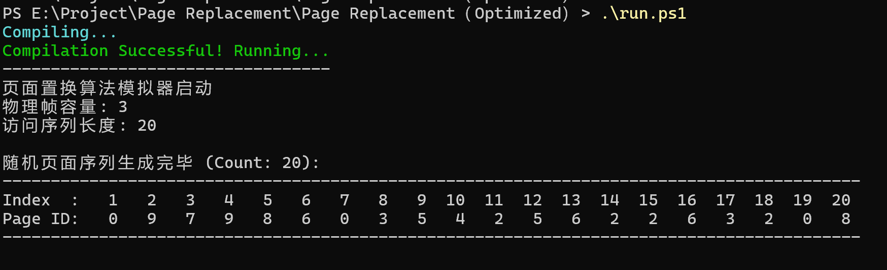

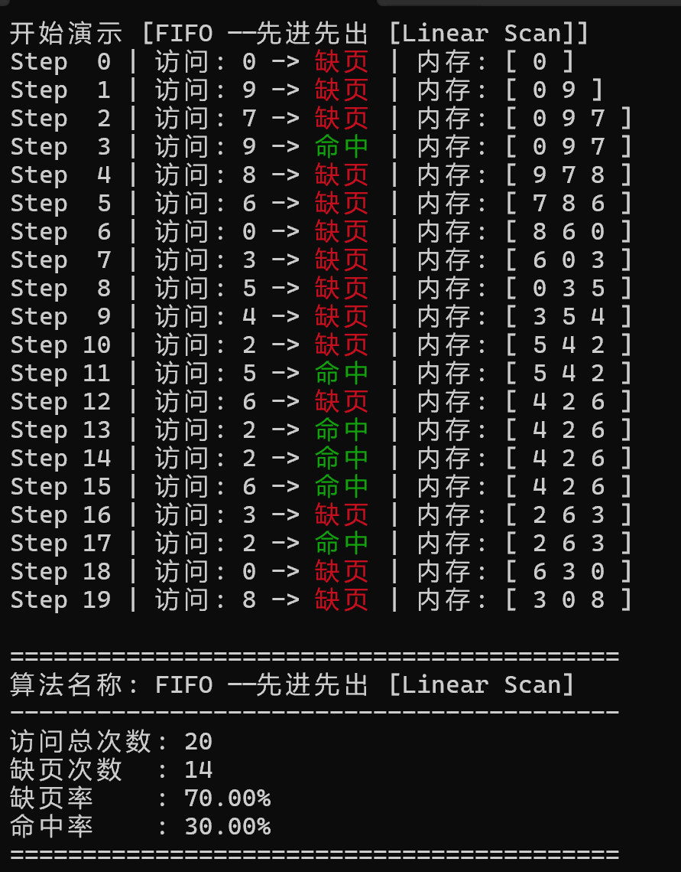
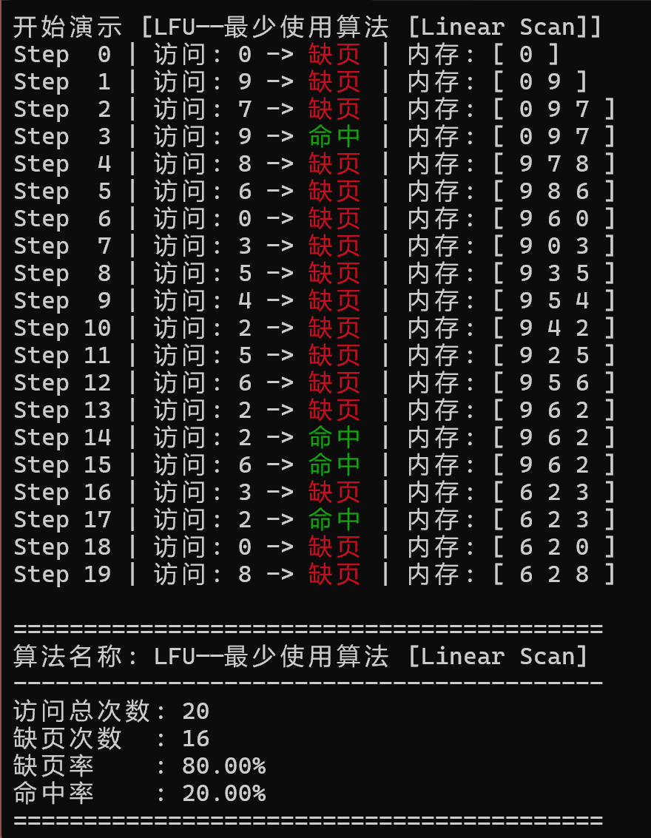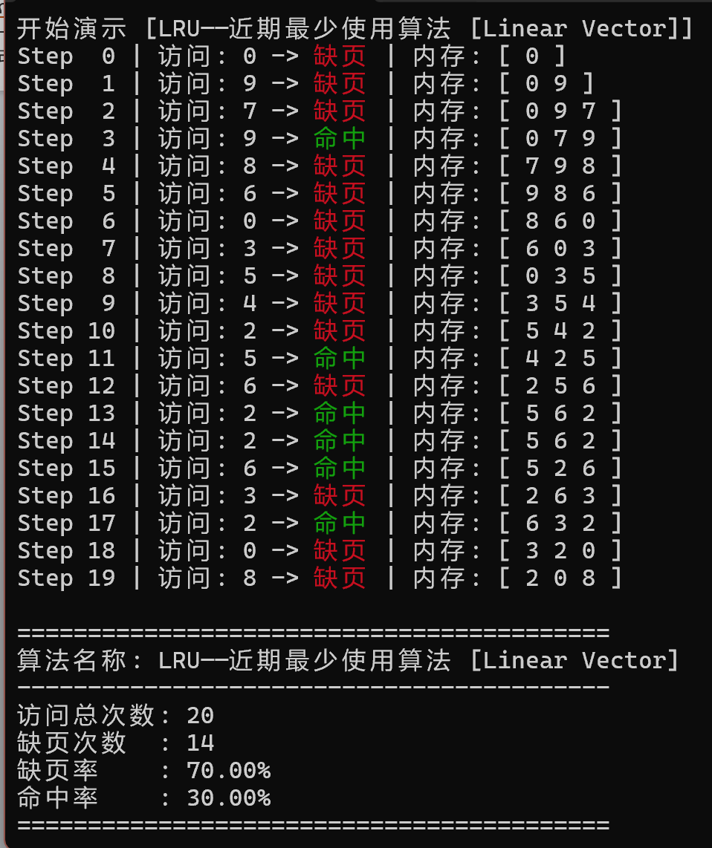
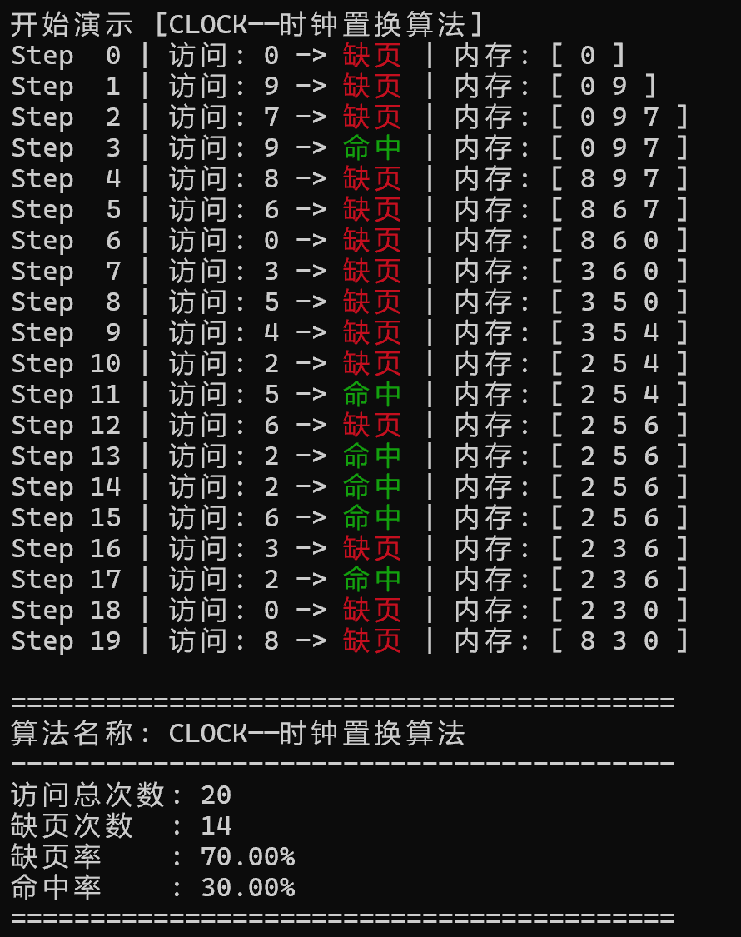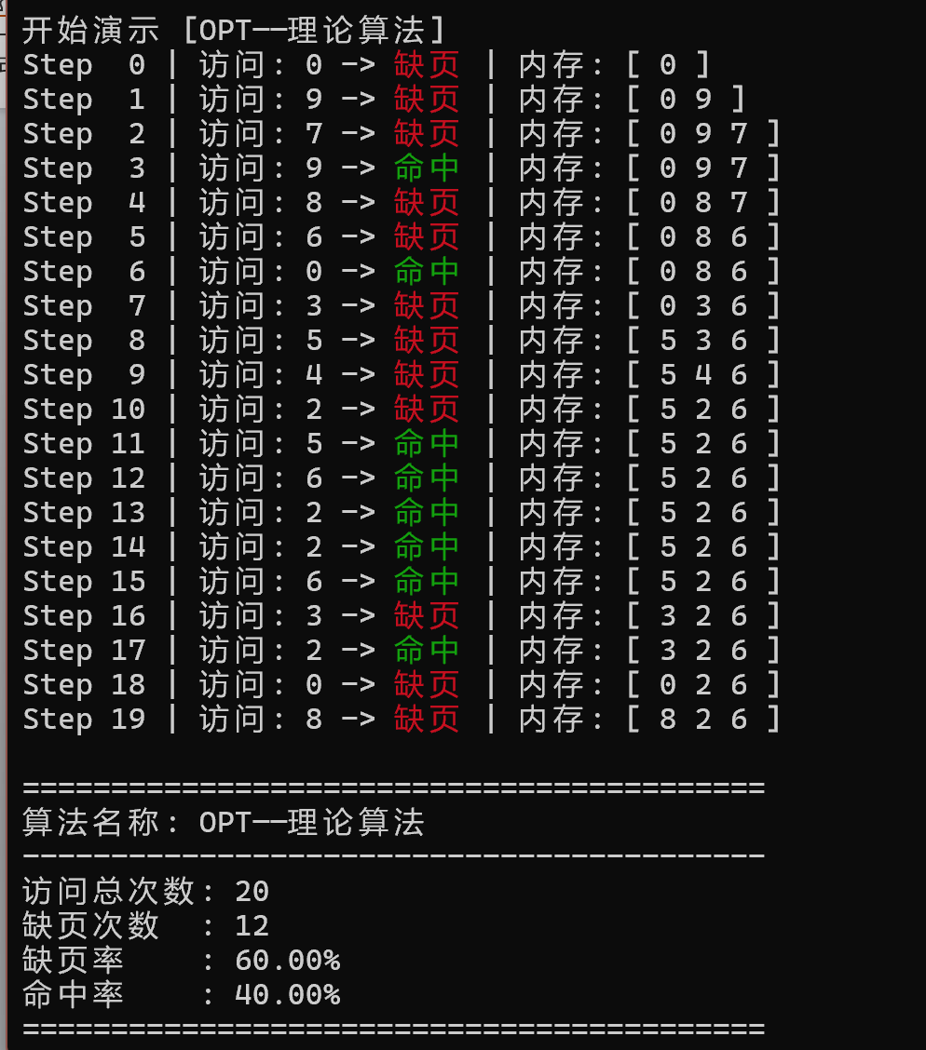

实验过程中出现的问题及解决办法
最开始没有考虑时间复杂度 均用双端队列操作 后续优化时考虑时间和空间复杂度的优化 LRU、LFU和FIFO 均找了相对应的哈希阈值 用于区分是线性扫描还是利用哈希优化 FIFO和LFU和LRU 优化后时复杂度均降至O(1)
并且开始没有考虑编译期的各种优化 后续利用CRTP模式 利用C++20的 concpet 代替抽象类虚函数 运行时0成本开销

实验三 文件系统模拟实现

实验目的：

实验内容：

设计实现：

目录表

流程图

详细代码

实验结果

实验过程中出现的问题及解决办法

