Farm Deploy Guidance
(BBBY Version)

DeepNorth (2018)

Change History
version | content | modify date | owner
1.0 | Initial | 2018-10-19 | Jinming Lv
1.1 | Content | 2018-10-23 | XiChuan Liu
1.2 | Add diagram | 2018-10-24 | Jinming Lv
1.3 | QA bug fix | 2018-10-25 | XiChuan Liu

Catalog
1. Introduction 3
1.1 Background 3
1.2 Hardware requirement 3
1.3 Deploy best practice 4
2. Installation 4
2.1 Drivers 4
2.2 GPUConsole 6
2.3 RabbitMQ 8
2.4 Farm 9
2.5 Mount_NFS 14
2.6 AlgoModules 14
2.7 VideoCapture 16
2.8 AlgoResultProcess 16

Introduction

Background
This document is used to list the steps of how to deploy the end-to-end GPU farm environment.

Architecture diagram:
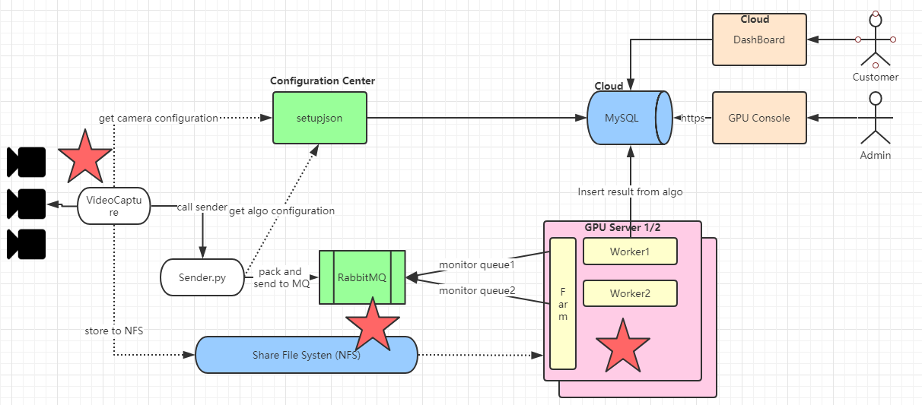
https://www.processon.com/view/link/5b447b7ce4b00c2f18c6a285

Hardware requirement
Hardware | OS | Remark
CPU:  GPU: GTX 1080 TI card (*8)  Mem: 32G | Ubuntu 16.04  Kernel version <= 4.13.0 | GPU Server
DELL 3076 Desktop (for example) | Ubuntu 16.04 | CPU Server

Deploy best practice
Server Type | Service | Number | Remark
GPU Server | Farm  Algo worker  Algo data post-process | >=1
CPU Server | NFS Service  RabbitMQ | 1
CPU Server | VideoCapture  GPU Console | 2 | 1 backup, 1 live

Installation

Drivers
Pre-requirement | First, check with the command nvidia-smi to see if there is a driver installed. If not, then follow the instructions below to install it
Install steps | ###Desktop version of ubuntu installation  #forbbiden nouveau driver  $ sudo gedit /etc/modprobe.d/blacklist-nouveau.conf  # add below contents  blacklist nouveau  options nouveau modset=0  $ sudo update-initramfs -u  # use ctrl+alt+f1 enter tty1 model  $ sudo service lightdm stop  $ wget https://s3-us-west-2.amazonaws.com/vmaxx0/pyEvent_release/NVIDIA-Linux-x86_64-384.98.run  $ sudo chmod 777 NVIDIA-Linux-x86_64-384.98.run  $ sudo ./NVIDIA-Linux-x86_64-384.98.run  ###Server version of ubuntu installation  $ cd /opt/  $ wget https://s3-us-west-2.amazonaws.com/vmaxx0/pyEvent_release/NVIDIA-Linux-x86_64-384.98.run  $ sudo chmod 777 NVIDIA-Linux-x86_64-384.98.run  $ sudo ./NVIDIA-Linux-x86_64-384.98.run
Configuration
Verification | Use command nvidia-smi and the output shows like below indicates the installation was successful.  output:  +-----------------------------------------------------------------------------+  | NVIDIA-SMI 384.130 Driver Version: 384.130 |  |-------------------------------+----------------------+----------------------+  | GPU Name Persistence-M| Bus-Id Disp.A | Volatile Uncorr. ECC |  | Fan Temp Perf Pwr:Usage/Cap| Memory-Usage | GPU-Util Compute M. |  |===============================+======================+======================|  | 0 GeForce GTX 1080 Off | 00000000:01:00.0 On | N/A |  | 33% 37C P8 11W / 200W | 1122MiB / 8105MiB | 6% Default |  +-------------------------------+----------------------+----------------------+  +-----------------------------------------------------------------------------+  | Processes: GPU Memory |  | GPU PID Type Process name Usage |  |=============================================================================|

GPUConsole
Add camera/lines/polygons
Pre-requirement | Login as root
Install steps | $ cd /opt/  $ sudo apt-get update  $ sudo apt-get install -y vim  $ sudo apt-get install -y apache2  $ sudo apt-get install -y php libapache2-mod-php  $ sudo apt-get install -y ffmpeg  $ sudo apt-get install -y php-curl  $ sudo apt-get install -y mysql-client php-mysql  $ sudo sed -i "s@^;extension=php_mysqli.dll.*@extension=php_mysqli.dll@" /etc/php/7.0/apache2/php.ini  $ sudo sed -i "s@^;extension=php_pdo_mysql.dll.*@extension=php_pdo_mysql.dll@" /etc/php/7.0/apache2/php.ini  $ sudo sed -i "s@^;extension=php_curl.dll.*@extension=php_curl.dll@" /etc/php/7.0/apache2/php.ini  $ sudo /etc/init.d/apache2 restart  $ echo "deb [arch=amd64] https://packages.microsoft.com/repos/azure-cli/ wheezy main" | \  $ sudo tee /etc/apt/sources.list.d/azure-cli.list  $ sudo curl -L https://packages.microsoft.com/keys/microsoft.asc | sudo apt-key add -  $ sudo apt-get install -y apt-transport-https  $ sudo apt-get update  $ sudo apt-get install -y azure-cli  $ cd ~  $ sudo cp -R .azure /var/www  $ sudo chmod -R 777 /var/www/.azure  $ sudo apt-get install -y git  $ cd /var/www  $ sudo git clone -b master http://yicun.vmaxx.tech:3000/Chenxiao_Zhao/bbb_local_console.git  $ sudo chmod -R 777 bbb_local_console  $ sudo sed -i "s/html/bbb_local_console/g" /etc/apache2/sites-enabled/000-default.conf  $ sudo sed -i '/bbb_local_console/a\Alias "/event" "/home/ubuntu/pyEvent/results"\n<directory "/home/ubuntu/pyEvent/results">\nRequire all granted\n</directory>' /etc/apache2/sites-enabled/000-default.conf  $ sudo /etc/init.d/apache2 restart
Configuration | configure database:  ##modify bbby_local_console/param/setup.json file  {"dbserver":"xx.xx.xx.xx","dbuser":"xxx","dbpassword":"xxx","dbname":"xxx"}
Verification | Visit the address: http://xx.xx.xx.xx/setup.php  login in using users/password: admin/Xjtu123456

RabbitMQ
Pre-requirement | Login as root
Install steps | $ cd /opt/  $ sudo apt-get update  $ sudo apt-get install libsctp1  ### download from https://packages.erlang-solutions.com/erlang/,version: 20.0-1_ubuntu_xenial  $ sudo dpkg -i esl-erlang_20.0-1_ubuntu_xenial_amd64.deb  ### If the installation fails, then:  $ sudo apt-get install -f -y  $ sudo dpkg -i esl-erlang_20.0-1_ubuntu_xenial_amd64.deb  ### download:sudo wget --content-disposition https://packagecloud.io/rabbitmq/rabbitmq-server/packages/ubuntu/xenial/rabbitmq-server_3.7.6-1_all.deb/download.deb  $ sudo dpkg -i rabbitmq-server_3.7.6-1_all.deb  ### If the installation fails, then:  $ sudo apt-get install -f -y  $ sudo dpkg -i rabbitmq-server_3.7.6-1_all.deb  $ sudo apt-get install -y python-pip  $ export LC_ALL=C  $ sudo pip install pika
Configuration | $ sudo chmod 777 -R /etc/rabbitmq/  $ cd /etc/rabbitmq/  create configuration file:  $ sudo vim rabbitmq.conf  ###open the link address of https://github.com/rabbitmq/rabbitmq-server/blob/master/docs/rabbitmq.conf.example , then copy the content to rabbitmq.conf file: .  $ sudo sed -i "s/# loopback_users.guest = false/loopback_users.guest = false/g" ./rabbitmq.conf  $ sudo chmod 777 ./rabbitmq.conf  $ sudo service rabbitmq-server restart
Verification | ###View message queue:  $ sudo rabbitmqctl list_queues  ###If the installation is successful, using the above command will output the following content in the console, indicating that the installation was successful. The people field is the queue name.  #Timeout: 60.0 seconds ...  #Listing queues for vhost / ...  #people 0  ###Reset the message queue to clear all queues(warning: must stop the farm process and videocapture process and then reset the queue):  $ sudo rabbitmqctl stop_app  $ sudo rabbimqctl reset  $ sudo rabbitmqctl start_app  ###Delete a queue:  $ sudo rabbitmqctl purge_queue queue_name

Farm
Farm is used to monitor and launch algo process.
Pre-requirement | This module does not need to be installed, just download the code from git, put it in the specified directory, modify the configuration file to configure. The following is a detailed description.
Install steps | 1.As shown in Figure 1 below  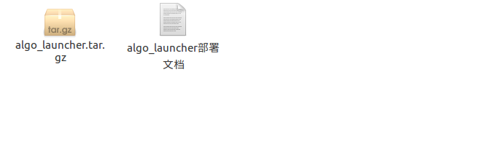  figure 1  2.Decompression the algo_launcher.tar.gz shown in Figure 2 below  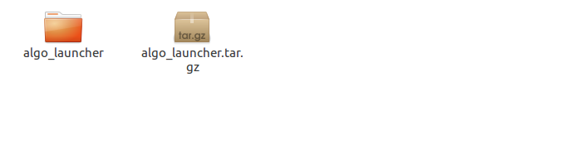  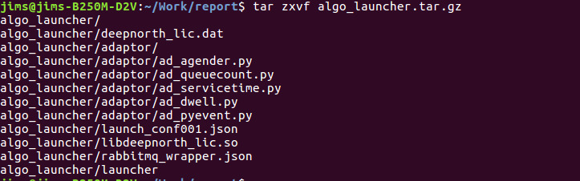  Figure 2  3.Open the algo_launcher folder shown in Figure 3 below  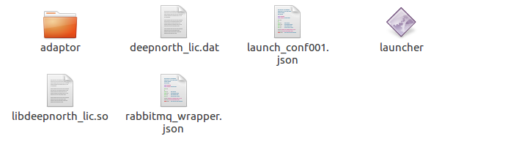  Figure 3  4.Open rabbitmq_wrapper.json and modefy the mq_host paramater.mq_host is mean to rabbitmq server ip .shown in Figure 4 below  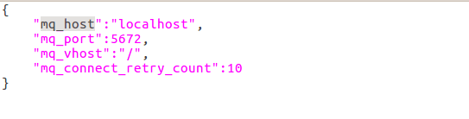  Figure 4  5.Open launch_confxxx.json and set paramaters or add an another launch_confxxx.json for example launch_conf001.json and launch_conf002.json and so on.The format requirements are shown in Figure 5 below  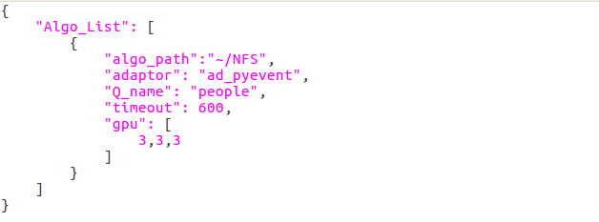  Figure 5  algo_path: is mean to set Local_Farm folder path.  adaptor: is mean to set algorithm name  Q_name: is mean to set rabbitmq queue name  timeout: is mean to set algorithm runing the maximum permissible time  gpu: is mean to set the number of processes on each card  6.run launcher shown in Figure 6 below  (1)./launcher -h  this command is mean to view launcher about methods of use.shown in Figure 7 below  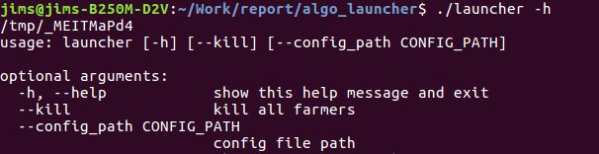  Figure 7  (2)./launcher --config_path launch_confxxx.json  this command is mean to start the project and use the  launch_confxxx.json file .shown in Figure 8 below  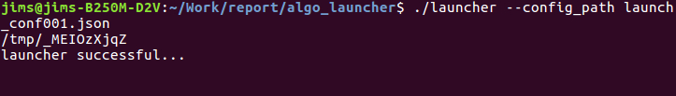  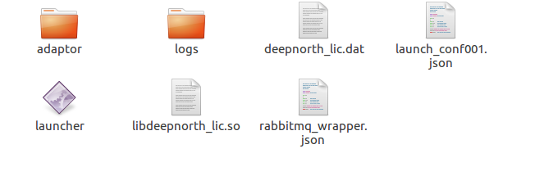  Figure 8  when the project start successful ,the terminal will show “launcher successful” and the local path will generate a new folder and it’s name is “logs”  (3)./launcher –-kill shown in Figure 9 below.  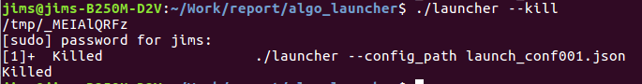  Figure 8  when you start the priject again,you must run “./launcher –kill”command in order to close the process before
Configuration | algo_launch code:  $ git clone  https://github.com/VMaxxInc/common-component.git  in the directory:  common-component/python/algo_launcher
Verification | Move algo_launcher to NFS_folder/, under the same level as Algo_Bucket derectory. (Note: This NFS_folder/ directory is the shared directory you mount in step 2.5.)

Mount_NFS
Pre-requirement | More than two servers, if there is no shared directory between them, follow the instructions below to hang on the shared file directory
Install steps | link address:  https://www.digitalocean.com/community/tutorials/how-to-set-up-an-nfs-mount-on-ubuntu-16-04
Configuration
Verification | The guidance document is very detailed, follow the documentation steps.  Use the command df -h checking if NFS share hangs successfully.

AlgoModules
Pre-requirement | pyEvent module detects pedestrians and counts
pyEvent | $ sudo mkdir -p NFS_folder/Algo_Bucket  $ cd NFS_folder/Algo_Bucket  $ sudo wget https://s3-us-west-2.amazonaws.com/vmaxx0/pyEvent_release/bbb.tar  $ sudo tar xvf bbb.tar  ####move pyEvent folder to NFS_folder/Algo_Bucket
Configuration | Run script install.sh and install system environment  $ sudo sh install.sh
Verification | The code is placed in the /Algo_Bucket/peEvent under the shared directory

Pre-requirement | The agender module detects the age and gender of a person
agender | $ cd NFS_folder/Algo_Bucket  $ sudo git clone https://github.com/VMaxxInc/algorithm-module-age-gender.git  $ sudo mv algorithm-module-age-gender agender
Configuration | Run script setup.sh and install system environment
Verification | The code is placed in the /Algo_Bucket/agender under the shared directory

VideoCapture
Capture video/picture from cameras.
Pre-requirement | file_move and xml_read code: http://yicun.vmaxx.tech:3000/xcliu/fileMove_and_xmlRead.git  video_capture code: http://yicun.vmaxx.tech:3000/xcliu/videocapture_all_project.git
Install steps | $ cd /opt  $ git clone http://yicun.vmaxx.tech:3000/xcliu/videocapture_all_project.git  $ cd /opt/videocapture_all_project  $ sudo python start.py
Configuration | In the params.json file, modify parameters according to project specific requirements.
Verification | In the params.json file, you can configure the path where the video is placed. Usually placed under the shared directory. under NFS_folder/cache_ directory, check if each camera is recording video normally.

AlgoResultProcess
Pyevent will produce algo result with XML files and heatmap/.., this post process will parse result data and insert into DB.
Pre-requirement | file_move and xml_read code: http://yicun.vmaxx.tech:3000/xcliu/fileMove_and_xmlRead.git
Install steps | $ cd /opt  $ git clone http://yicun.vmaxx.tech:3000/xcliu/fileMove_and_xmlRead.git  ### modify path of pyEvent results in file_move.py file,the pyEvent results will be moved to /result/uplinkdata/ directory.  $ cd /opt/fileMove_and_xmlRead/file_move  $ sudo python file_move.py  ### modify database info in xml_read.py file.This script will parse xml file and insert pyEvent result into database.  $ cd /opt/fileMove_and_xmlRead/xml_read  $ sudo python xml_read_farm.py
Configuration
Verification | Check pyEvent results file in /result/uplinkdata/xml directory  When start xml_read process, check if the data is inserted into database. After starting the program for 10 minutes, access the database linecounting table to see if there is any new data insertion at the current time of the system.

