UW-Tsinghua项目申请材料

申请人 | 周建宇
学 号 | 2013011326
班 级 | 计32
目 录
 | - 简历（中、英文）
 | - 个人陈述（中、英文）
 | - 成绩单（中、英文）
 | - 学分绩及排名（中、英文）
 | - 填表信息

2016年3月16日
- 个人简历
周建宇 | 男，1994年10月出生，清华大学计算机科学与技术专业本科生，兼修管理学第二学位，预计2017年6月毕业。 | 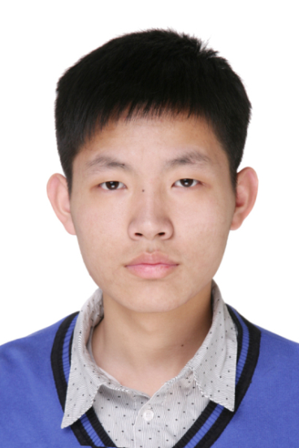
联系方式： | 手机： 188-1091-8292 邮箱：zjythu@163.com
学业成绩： | 平均GPA：80.97/100 总GPA排名：6/130
外语水平： | CET-6：579 IELTS：7.0 TOEFL待考
专业技能： | C++，Python，Matlab，JavaScript，Nodejs，CSS，HTML
科研经历：
2015/3–至今 中文众宝网站开发 清华SRT项目
·搭建一个众包系统，已完成PC端网站和android,ios的移动端APP，负责前端设计与实现。
·网址：www.chinacrowds.com
2015/9–2015/12 中小学生编程学习网站shadowcats开发 软件工程实践
·网站后台开发，管理用户的基本信息，基础界面设计与实现。
·源码：http://stash.secoder.net/projects/SHAD/repos/shadowcats/browse
2016/1–2016/2 基于学生成绩表现的教育投资回报率研究 美国大学生数学建模竞赛
·完成一篇英文论文（Zhou JY, Yuan Z, Gao XY. An Optimal Strategy for Goodgrant Foundation）。
2016/2–至今 大学校园众包平台的系统分析与设计 管理学综合论文
·面向在校大学生的学习、生活和发展需求，提出开发众包平台的创意并进行系统分析与设计。
课外活动：
2013/08–至今 校合唱队：清华大学学生艺术团合唱队 男高音、声部长、副队长
·参加日常排练和寒暑假集中训练，曾参与合唱队组织建设和管理工作，累计参加演出40余场。、
2014/06–至今 系学生会：清华大学计算机系学生会 副主席、生活权益部干事
·开展物品和水果团购等服务，提供反映学生心思的渠道，参与系会主席团及学生节活动等。
2014/12–至今 校课咨委：清华大学首届本科生课程咨询委员会 成员
·参与首届委员会关于GPA分级、选退课、培养方案等改革工作，主导了基础课教学改革等提案。
2014/03–2015/07 摇滚乐队：清华大学计算机系SPLAY乐队 主唱
·参与乐队的创作、排练和演出，主唱了原创歌曲《Bleeding》、《YOUNG》等。
2014/05–2014/07 社会实践：中美支教赴贵州红花岗支队 队长
·招募、组织来自清华、香港和美国大学的10名同学到贵州省遵义市红花岗区开展支教和调研。
兴趣爱好：
文艺：美声、合唱、小提琴、吉它、萨克斯 体育：乒乓球、羽毛球、篮球、游泳、武术
获奖情况：
2014/10：清华大学文艺优秀和社会实践奖学金 2014/09：清华大学中美支教社会实践优秀支队
2015/10：清华大学文艺优秀奖学金 2014/10：清华大学校歌赛最佳原创歌曲奖
自我评价：
敢于追求，具有积极的进取精神和顽强毅力；勤于学习，具有良好的知识结构和专业技能；
善于沟通，具有较强的协作意识和组织能力；乐于助人，具有高雅的生活情趣和品格修养。
我相信：Nothing is impossible！
Resume
Chinese Name | 周建宇  Zhou Jianyu | English Name | David Zhou | 
Gender | Male | Birth-date | Oct.19th,1994
University | Tsinghua University | Major | Computer Science &Technology;  Management( Second Bachelor Degree)
Mobile Phone | (+86) 188-1091-8292 | Email | zjythu@163.com
Education Background | ·Aug, 2013~Mar, 2016: Department of Computer Science &Technology, Tsinghua University.  ·Sep, 2014~Mar, 2016: School of Economics and Management, Tsinghua University.  ·Sep, 2010~July, 2013: No.1 Middle School, Yantai City, Shandong Province, China.
Professional Experience | ·Mar, 2015~present: Developing ChinaCrowds website  ChinaCrowds is an online platform that makes it convenient for users to issue their questions and find people to solve them, or to say, crowdsourcing.  Website: www.chinacrowds.com  ·Sep, 2015~Dec,2015: Developing Shadowcats website  Shadowcats is a website that helps pre-college students to learn programming.  source code: http://stash.secoder.net/projects/SHAD/repos/shadowcats/browse  ·Jan, 2016~Feb, 2016:Taking MCM (The Mathematical Contest in Modeling)  I took the MCM with 2 partners and finally finished a thesis, "Zhou JY, Yuan Z, Gao XY. An Optimal Strategy for Goodgrant Foundation".  ·Mar, 2016~present：Developing crowdsourcing platform for campus  This is a thesis for bachelor's degree in management. The research aims at how to use crowd -sourcing to satisfy the demands of students in campus.
Social Service | ·Vice-Chairman of Student Union of CST,THU.  ·Member of Undergraduate Course Committee of THU.  ·Principal of Tenor voice part of Tsinghua Chorus Team.  ·Member of department of Art in THU Student Council.  ·Volunteer as tour guide in Tsinghua University.  ·Leader of the group of summer service and learning program in Rural China（SSLP）,2014.
Scholarships & Awards | ·The Artistic Excellence Scholarship in THU，2015.  ·The Artistic Excellence Award and Social Practice Award in THU，2014.  ·The Best Original Music Award in the 24th campus singing competition of THU,2014.  ·The member of Top-new-student Camp in THU，2013.
Oversea Experience | ·July, 2015: Participate in the Summer Program of Research in Hong Kong & Macau at Hong Kong Baptist University .  ·July, 2014: Participate in the Future Global Leaders Summer Program held at the University of California, San Diego, U.S.  ·2009-2012: As a tourist to Korea, Singapore, Austria, Belgium, Germany, France etc..
Self-appraisal | ·Key words: Optimistic, Confident, Persistent, Warmhearted, Musiktalent  ·My motto: Nothing is impossible.
2. 个人陈述
计算机已经深刻改变了人们的生产和生活，在未来高度信息化和智能化的世界中，计算机将发挥越来越重要的作用。最近受到全球关注的ALPHAGO与围棋世界冠军李世石的人机大战，更是引发了人们对人工智能未来发展的许多讨论和遐想。如何应用计算机技术使人类生活得更美好，既是我最初选择学习计算机专业的原因，也是一直以来激发我学习兴趣的动力。我非常享受学习计算机技术特别是编程写代码的过程，并且通过课程学习和项目实践具备了必要的理论知识和专业技能，尤其对数据挖掘、数据库、信息管理等方面比较感兴趣。在实际工作中，我发现除了专业技能，团队协作和组织管理也非常重要，高效的管理可以更好地发挥技术的作用，而懂技术反过来可以更好地促进管理。因此我选修管理学作为本科第二学位，希望将计算机技术与管理学更好地融合，使自己成为既懂技术又懂管理的复合型人才，从而更好地实现改变世界的梦想。
按照清华大学注重通识教育和全面发展的理念，我的大学生活非常丰富和忙碌。除了计算机专业和管理kk学的课程之外，我还进一步选修了音乐、文化、艺术等感兴趣的课程，至上学期末我已经完成了89门计189学分的课程，总学分数在全系名列前茅。我乐于参加各种活动，先后参加了合唱队、支教队、文艺部、生权部、课委会等社团组织，通过参加演出、支教、校歌赛、物品团购、本科教学改革调研等活动，既在积极服务中建立了难忘的友谊，也在沟通协调中提升了组织领导力。我还喜欢唱歌以及游泳、篮球、乒乓球、武术等运动，曾经担任SPLAY乐队主唱并获得了清华大学最佳原创歌曲奖，是系乒乓球队、武术队的成员。太多的活动必然要占用大量的课外时间，让我不得不面对GPA成绩不够理想的现实。因此，本学期以来，我大幅减少了社工活动而将更多时间用在专业学习上，相信只要努力了成绩就会有提高。特别是经过今年初美国大学生数学建模竞赛的检验，我擅长数学和英语的优势得到了很好的发挥，这也增强了我学好后续计算机专业课程的信心和动力。
UW-THU项目非常契合我的愿望，仿佛专门为我定制一样。一是到本学期结束后，我将可以修完培养方案规定的除综合论文训练外的全部课程，届时我可以自主地选择大四阶段的学习模式，UW-THU项目提供的大四全年到国外交流的模式是我最期待的选择和难得机遇。二是UW不仅凭其首创的CO-OP教学模式闻名世界，而且其计算机专业如同清华大学一样具有很强的实力，参加该项目不仅可以提前感受和适应海外大学氛围，而且有机会当面接受UW著名教授的指导，从而进一步完善自身的知识结构和专业技能。三是该项目提供了继续在UW读研究生的便利途径，可以大大减少以后申请留学的不确定性和漫长等待，有利于更专心、更深入地学习和研究。四是加拿大是我非常向往的国度，参加该项目可以进一步结交各国朋友、提升英语水平、了解西方文化，有利于拓宽思维和眼界，使自己真正成为国际化人才。
如果我能够参加该项目，我有信心高标准达到清华和UW的培养要求。一是按照项目计划认真修读相关研究方向的计算机专业课程，争取优秀成绩；二是利用UW的教学优势和良好条件，争取选修应用数学、金融管理等方面课程，为申请硕士、博士项目继续深造奠定基础；三是争取在数据挖掘、数据库、信息管理等感兴趣的研究方向上找到契合的指导老师，积极开展学术研究；四是积极参加校园活动，发挥自己在音乐、组织方面的才能，展现清华学子的良好形象，进一步丰富UW-THU的协作成果。
最后，感谢UW-THU项目的组织者和奖学金提供者，期待能够参加该项目并取得良好收获，希望自己好运。
Personal Statement
Computer science has changed the world widely and deeply. Recently, the Go competition between Lee Sedol and AlphaGo has set off a huge concern of Artificial Intelligence around the world. Similarly, the initial motivation for me to choose computer science as my major is that to some extent, CS can be regarded as a revolutionary technology which will greatly accelerate the process of civilization of human beings. During my three-year study of CS, I gradually fall in love with programming and enjoy the sense of success brought by it. Besides coding, the three-year education also brings me with a fundamental theory system and professional skills. More particularly, I gradually raise my academic interests in database and data mining. Besides CS, I also found that except professional skills, how to manage the information of an organization and how to give everyone full scope to his or her talents is of vital importance. As a result, I chose management as my second bachelor's degree. In all, the combination of technique skills in CS and management of information is my academic pursuit, hoping myself to be a compound talent, and finally change the world better.
My campus life can be tense but orderly. Besides CS and management, I also take various courses like music and Chinese culture, hoping to build a wide knowledge system. By the end of last semester, I have finished 89 courses and got 189 credits, which is in the top 5% in CST department of THU. Furthermore, I took part in chorus team, student union and curriculum advisory committee of THU, spent a lot of time to organize the campus singing competition, group-buying, teaching reform and so on. All of these activities cultivate my capability in communicating, organizing and cooperating. As for physical activity, swimming, basketball, table tennis and Chinese KONGFU make up my main exercises. For music, I joined a music band as vocalist. Despite the cultivation of leadership and abundant social work experience, I came to realize that my GPA is not superior enough. Therefore, since this semester, I have quitted extracurricular activities and devoted myself to major study. Considering the wonderful experience of MCM, this is a good chance to give full play to the exertion of my mathematics and programming. This experience greatly raised my confidence in the further study of computer science. I am also confident that better grades can be achieved in my major study with good mathematical ability and high English level.
UW-THU program exactly matches my aspiration. First of all, by the end of this semester, except the bachelor's dissertation, I will finish all the required courses for both CST and management major in THU. At that time, I will have more choices to arrange the last undergraduate year. The opportunity UW-THU program offers to study abroad for a whole year is just my strong expectation. Second of all, widely acknowledged, UW enjoys a good reputation around the world, not only because it’s innovative CO-OP model, but also its world first class computer science across the world. If offered the chance, I will not only experience the preeminent academic atmosphere, but receive the academic guidance and instructions from the best professors. It will have instructive and constructive influence on improving my professional skills. Third of all, it’s a great advantage that it offers a relatively convenient way to my further application for master or PhD programs in UW. Last of all, Canada is a developed country with high level of civilization and modernization. Through this program, I may make a lot of Canadian friends, improve my spoken English and broaden my horizon, which is beneficial to me to be an international talent.
Moreover, if I were admitted, I would be confident to meet the requirements of UW. First, I would make effort to study required courses in CS, and try to do more professional practice. Second, I would strengthen my study in mathematics for the sake of my prospective application for graduate programs. Third, I would do some research in interesting fields like data mining or information management, and attempt to find my supervisor. Last, I would take active part in extracurricular activities in UW, trying to exert my talent in music and leadership and to strengthen the cooperation and communication between UW and THU.
Finally, many thanks to the organizers of UW-THU program, sincerely hope to participate in this program and get expected achievement. Good luck to me.

3.成绩单
清华大学学生成绩单

姓 名 | 周建宇
性 别 | 男 | 学 号 | 2013011326 | 学生类别 | 本科生 | 入学年月 | 2013年08月
院 系 | 计算机科学与技术系 | 专 业 | 计算机科学与技术 | 二学位专业 | 管理学 | 班 级 | 计32

课程号 | 课程名 |  | 学分 | 学时 | 成绩 | 学年学期 |  | 备注
12090043 | 军事理论与技能训练 |  | 3 | 144 | 90 | 2012-2013-3
00750011 | 图书馆概论 |  | 1 | 16 | 通过 | 2013-2014-1
30210041 | 信息科学技术概论 |  | 1 | 16 | 89 | 2013-2014-1
00780431 | 独唱重唱艺术表演(1) |  | 1 | 48 | 93 | 2013-2014-1
00781261 | 合唱艺术(1) |  | 1 | 48 | 90 | 2013-2014-1
00781281 | 室内乐合唱(1) |  | 1 | 48 | 92 | 2013-2014-1
00782131 | 艺术欣赏导论 |  | 1 | 16 | 优秀 | 2013-2014-1
10421055 | 微积分A(1) |  | 5 | 80 | 78 | 2013-2014-1
10421094 | 线性代数(1) |  | 4 | 78 | 77 | 2013-2014-1
10610183 | 思想道德修养与法律基础 |  | 3 | 48 | 93 | 2013-2014-1
10641022 | 学术英语听说（2）－综述 |  | 2 | 32 | 88 | 2013-2014-1
10720011 | 体育(1) |  | 1 | 32 | 83 | 2013-2014-1
20240013 | 离散数学(1) |  | 3 | 48 | 69 | 2013-2014-1
30240233 | 程序设计基础 |  | 3 | 48 | 75 | 2013-2014-1
30240282 | 计算机科学导论 |  | 2 | 32 | 82 | 2013-2014-1
00450012 | 生态学 |  | 2 | 32 | 82 | 2013-2014-2
00640312 | 影视欣赏 |  | 2 | 32 | 88 | 2013-2014-2
00780731 | 独唱重唱艺术表演(2) |  | 1 | 48 | 94 | 2013-2014-2
00781131 | 综合艺术训练(2) |  | 1 | 48 | 94 | 2013-2014-2
00781271 | 合唱艺术(2) |  | 1 | 48 | 96 | 2013-2014-2
00781291 | 室内乐合唱(2) |  | 1 | 32 | 94 | 2013-2014-2
00781872 | 西方古典音乐文化 |  | 2 | 32 | 94 | 2013-2014-2
00781892 | 20世纪中国歌曲发展史 |  | 2 | 32 | 89 | 2013-2014-2
00782162 | 表演初级体验与基础训练 |  | 2 | 48 | 92 | 2013-2014-2
00782281 | 中外名曲赏析 |  | 1 | 32 | 优秀 | 2013-2014-2
10421065 | 微积分A(2) |  | 5 | 80 | 66 | 2013-2014-2
10421102 | 线性代数(2) |  | 2 | 42 | 68 | 2013-2014-2
10430484 | 大学物理B(1) |  | 4 | 64 | 62 | 2013-2014-2
10610193 | 中国近现代史纲要 |  | 3 | 48 | 89 | 2013-2014-2
10641012 | 学术英语听说（1）- 转述 |  | 2 | 32 | 93 | 2013-2014-2
10720021 | 体育(2) |  | 1 | 32 | 98 | 2013-2014-2
20240023 | 离散数学(2) |  | 3 | 48 | 85 | 2013-2014-2
30240532 | 面向对象程序设计基础 |  | 2 | 48 | 79 | 2013-2014-2
10640852 | 大一外语强化训练 |  | 2 | 32 | 免课 | 2013-2014-3 |  | 免修
30240522 | 程序设计训练 |  | 2 | 64 | 77 | 2013-2014-3
00510133 | 会计学原理 |  | 3 | 48 | 73 | 2014-2015-1 |  | 二学位
00510363 | 经济学原理 |  | 3 | 48 | 78 | 2014-2015-1 |  | 二学位
00510392 | 创业管理 |  | 2 | 32 | 通过 | 2014-2015-1 |  | 二学位
00510663 | 管理学（商学导论） |  | 3 | 48 | 89 | 2014-2015-1 |  | 二学位
00510712 | 领导力开发 |  | 2 | 32 | 87 | 2014-2015-1 |  | 二学位
00641302 | 商务英语视听说 |  | 2 | 32 | 83 | 2014-2015-1
00641552 | 音乐中的文化 |  | 2 | 32 | 89 | 2014-2015-1
02070012 | 党的知识概论 |  | 2 | 32 | 通过 | 2014-2015-1
10420252 | 复变函数引论 |  | 2 | 32 | 60 | 2014-2015-1
10430494 | 大学物理B(2) |  | 4 | 64 | 70 | 2014-2015-1
10430801 | 物理实验B(1) |  | 1 | 16 | 82 | 2014-2015-1
10610204 | 马克思主义基本原理 |  | 4 | 64 | 84 | 2014-2015-1
10641032 | 学术英语听说（3）－讨论 |  | 2 | 32 | 88 | 2014-2015-1
10720031 | 体育(3) |  | 1 | 32 | 87 | 2014-2015-1
30260133 | 电子学基础 |  | 3 | 48 | 79 | 2014-2015-1
30510842 | 信息管理导论 |  | 2 | 32 | 通过 | 2014-2015-1
31550011 | 电子学基础实验 |  | 1 | 24 | 86 | 2014-2015-1
60510111 | 创业创新领导力I |  | 1 | 16 | 89 | 2014-2015-1
S1510031 | 实验室科研探究（2） |  | 1 | 16 | 优秀 | 2014-2015-1
40240422 | 计算机图形学基础 |  | 2 |  | 免课 | 2014-2015-2 |  | 免修
00510722 | 组织行为学 |  | 2 | 32 | 86 | 2014-2015-2 |  | 二学位
00510232 | 技术创新管理 |  | 2 | 32 | 86 | 2014-2015-2 |  | 二学位
00510683 | 营销管理 |  | 3 | 48 | 73 | 2014-2015-2 |  | 二学位
00510732 | 推动创新的知识产权战略 |  | 2 | 32 | 77 | 2014-2015-2 |  | 二学位
00510742 | 运作管理 |  | 2 | 32 | 86 | 2014-2015-2 |  | 二学位
00781071 | 独唱重唱艺术表演(4) |  | 1 | 48 | 94 | 2014-2015-2
00781311 | 音乐会合唱(2) |  | 1 | 48 | 95 | 2014-2015-2
00782471 | 中外名歌赏析与比较 |  | 1 | 16 | 通过 | 2014-2015-2
02070071 | 大学生心理训练与潜能开发 |  | 1 | 16 | 96 | 2014-2015-2
10420803 | 概率论与数理统计 |  | 3 | 48 | 87 | 2014-2015-2
10420854 | 数学实验 |  | 4 | 64 | 70 | 2014-2015-2
10430811 | 物理实验B(2) |  | 1 | 16 | 82 | 2014-2015-2
10610224 | 毛泽东思想和中国特色社会主义理论体系概论 |  | 4 | 64 | 91 | 2014-2015-2
10720041 | 体育(4) |  | 1 | 32 | 95 | 2014-2015-2
20240082 | 初等数论 |  | 2 | 32 | 81 | 2014-2015-2
30240042 | 人工智能导论 |  | 2 | 32 | 74 | 2014-2015-2
30240343 | 数字逻辑电路 |  | 3 | 48 | 91 | 2014-2015-2
30240551 | 数字逻辑实验 |  | 1 | 32 | 76 | 2014-2015-2
31510042 | 工业生产概论(1) |  | 2 | 32 | 88 | 2014-2015-2
40240432 | 形式语言与自动机 |  | 2 | 32 | 60 | 2014-2015-2
00690651 | 文化素质教育讲座（1） |  | 1 | 16 | 优秀 | 2014-2015-2
20240103 | 汇编语言程序设计 |  | 3 | 48 | 72 | 2014-2015-3
30240332 | Java程序设计与训练 |  | 2 | 64 | 78 | 2014-2015-3
30240312 | 人工神经网络 |  | 2 |  | 免课 | 2015-2016-1 |  | 免修
40240572 | 计算机网络安全技术 |  | 2 |  | 免课 | 2015-2016-1 |  | 免修
42540371 | 大学生研究训练计划[SRT]暑期社会实践专项（1） |  | 1 | 0 | 95 | 2015-2016-1
00510222 | 质量管理学 |  | 2 | 32 | 83 | 2015-2016-1 |  | 二学位
00510703 | 公司金融 |  | 3 | 48 | 63 | 2015-2016-1 |  | 二学位
00510762 | 国际管理 |  | 2 | 32 | 82 | 2015-2016-1 |  | 二学位
10720110 | 体育专项(1) |  | 0 | 32 | 84 | 2015-2016-1
30240063 | 信号处理原理 |  | 3 | 48 | 72 | 2015-2016-1
30240163 | 软件工程 |  | 3 | 48 | 82 | 2015-2016-1
30240184 | 数据结构 |  | 4 | 64 | 78 | 2015-2016-1
30240262 | 数据库系统概论 |  | 2 | 32 | 89 | 2015-2016-1
30240292 | 人机交互理论与技术 |  | 2 | 32 | 87 | 2015-2016-1
30240382 | 编译原理 |  | 2 | 64 | 60 | 2015-2016-1
40240354 | 计算机组成原理 |  | 4 | 64 | 84 | 2015-2016-1
40240513 | 计算机网络原理 |  | 3 | 48 | 70 | 2015-2016-1
必修课总学分：75 |  | 限选课总学分：67 |  |  |  |  | 任选课总学分：55

TSINGHUA UNIVERSITY ACADEMIC TRANSCRIPT

Student Name | Zhou Jianyu | Gender | Male | Student No. | 2013011326
Student Type | Undergraduate | Date of Admission | August 21, 2013 | Date of Birth | October 19, 1994
School/Department | Department of Computer Science and Technology | Major | Computer Science and Technology | Minor | Management

Course Number | Course Title | Credit | Grade | Year-Semester
12090043 | Military Theory and Skill Training | 3 | 90 | 2013-Summer
00750011 | How to Use The Library | 1 | Pass | 2013-Autumn
30210041 | Introduction to Information Science and Technology | 1 | 89 | 2013-Autumn
00780431 | vocal Music Performance in Solo and Mixed Voices(1) | 1 | 93 | 2013-Autumn
00781261 | Choral Art(1) | 1 | 90 | 2013-Autumn
00781281 | Chamber Choral (1) | 1 | 92 | 2013-Autumn
00782131 | Introduction to Art Appreciation | 1 | Distinction | 2013-Autumn
10421055 | Calculus A(1) | 5 | 78 | 2013-Autumn
10421094 | Linear Algebra(1) | 4 | 77 | 2013-Autumn
10610183 | Ideological Moral and Legal Education | 3 | 93 | 2013-Autumn
10641022 | Listening & Speaking for Academic Purposes (2) | 2 | 88 | 2013-Autumn
10720011 | Physical Education(1) | 1 | 83 | 2013-Autumn
20240013 | Discrete Mathematics(1) | 3 | 69 | 2013-Autumn
30240233 | Fundamentals of Programming | 3 | 75 | 2013-Autumn
30240282 | Computer Science: An Overview | 2 | 82 | 2013-Autumn
00450012 | Ecology | 2 | 82 | 2014-Spring
00640312 | From the Silver Screen: English Films Appreciation | 2 | 88 | 2014-Spring
00780731 | vocal Music Performance in Solo and Mixed Voices(2) | 1 | 94 | 2014-Spring
00781131 | General Arts Training(2) | 1 | 94 | 2014-Spring
00781271 | Choral Art(2) | 1 | 96 | 2014-Spring
00781291 | Chamber Choral (2) | 1 | 94 | 2014-Spring
00781872 | Western Music and Civilization | 2 | 94 | 2014-Spring
00781892 | General History of 20th Century's Chinese Songs | 2 | 89 | 2014-Spring
00782162 | Primary Training and Practice for Performance | 2 | 92 | 2014-Spring
00782281 | Chinese and Foreign Music Appreciation | 1 | Distinction | 2014-Spring
10421065 | Calculus A(2) | 5 | 66 | 2014-Spring
10421102 | Linear Algebra(2) | 2 | 68 | 2014-Spring
10430484 | Physics for Scientists and Engineers B(1) | 4 | 62 | 2014-Spring
10610193 | Outline of Modern Chinese History | 3 | 89 | 2014-Spring
10641012 | Listening & Speaking for Academic Purposes (1) | 2 | 93 | 2014-Spring
10720021 | Physical Education(2) | 1 | 98 | 2014-Spring
20240023 | Discrete Mathematics(2) | 3 | 85 | 2014-Spring
30240532 | Foundation of Object-Oriented Programming | 2 | 79 | 2014-Spring
30240522 | Programing and Training | 2 | 77 | 2014-Summer
00641302 | Business English: An Integrated Approach | 2 | 83 | 2014-Autumn
00641552 | Culture in Music | 2 | 89 | 2014-Autumn
02070012 | Introduction to the Communist Party of China | 2 | Pass | 2014-Autumn
10420252 | Introduction to Complex Analysis | 2 | 60 | 2014-Autumn
10430494 | Physics for Scientists and Engineers B(2) | 4 | 70 | 2014-Autumn
10430801 | Lab. of Physics B(1) | 1 | 82 | 2014-Autumn
10610204 | Principle of Marxist Philosophy | 4 | 84 | 2014-Autumn
10641032 | Listening & Speaking for Academic Purposes (3) | 2 | 88 | 2014-Autumn
10720031 | Physical Education(3) | 1 | 87 | 2014-Autumn
30260133 | Fundamentals of Electronics | 3 | 79 | 2014-Autumn
31550011 | Experiment of Fundamentals electronics | 1 | 86 | 2014-Autumn
60510111 | Leadership for Entrepreneurship and Innovation (I) | 1 | 89 | 2014-Autumn
S1510031 | Exploration to Scientific Research of Lab（2） | 1 | Distinction | 2014-Autumn
00781071 | Vocal Music Performance in Solo and Mixed(4) | 1 | 94 | 2015-Spring
00781311 | Concert Choral(2) | 1 | 95 | 2015-Spring
00782471 | Appreciation & Comparation of Famous Songs | 1 | Pass | 2015-Spring
02070071 | Mental Training and Latent Ability Developing | 1 | 96 | 2015-Spring
10420803 | Probability and Statistics | 3 | 87 | 2015-Spring
10420854 | Experiments in Mathematics | 4 | 70 | 2015-Spring
10430811 | Lab. of Physics B(2) | 1 | 82 | 2015-Spring
10610224 | Introduction to Mao Zedong Thoughts and Theoretical System of Socialism with Chinese Characteristic | 4 | 91 | 2015-Spring
10720041 | Physical Education(4) | 1 | 95 | 2015-Spring
20240082 | Elementary Number Theory | 2 | 81 | 2015-Spring
30240042 | Introduction to Artificial Intelligence | 2 | 74 | 2015-Spring
30240343 | Digital Logic Circuit | 3 | 91 | 2015-Spring
30240551 | Digital Logic Experimentation | 1 | 76 | 2015-Spring
31510042 | An Introduction to Industrial Production(1) | 2 | 88 | 2015-Spring
40240432 | Formal Language and Automation | 2 | 60 | 2015-Spring
00690651 | Liberal Education Lectures(1) | 1 | Distinction | 2015-Spring
20240103 | Assembly Language Programming | 3 | 72 | 2015-Summer
30240332 | Java Program Design and Training | 2 | 78 | 2015-Summer
42540371 | Student Research Training for summer social practice project(1) | 1 | 95 | 2015-Autumn
10720110 | Physical Education(1) | 0 | 84 | 2015-Autumn
30240063 | Principles of Signal Processing | 3 | 72 | 2015-Autumn
30240163 | Software Engineering | 3 | 82 | 2015-Autumn
30240184 | Data Structures | 4 | 78 | 2015-Autumn
30240262 | Introduction to Database Management System | 2 | 89 | 2015-Autumn
30240292 | Human Computer Interaction Theory and Technology | 2 | 87 | 2015-Autumn
30240382 | Principles and Techniques of Compilers | 2 | 60 | 2015-Autumn
40240354 | Computer Organization | 4 | 84 | 2015-Autumn
40240513 | Theory of Computer Network | 3 | 70 | 2015-Autumn
 | Courses For Second Bachelor Degree
00510133 | Accounting Principles | 3 | 73 | 2014-Autumn
00510363 | Principles of Economics | 3 | 78 | 2014-Autumn
00510392 | Entrepreneurial Management | 2 | Pass | 2014-Autumn
00510663 | Business 101 | 3 | 89 | 2014-Autumn
00510712 | Leadership | 2 | 87 | 2014-Autumn
30510842 | Introduction of Information Management | 2 | Pass | 2014-Autumn
00510722 | Organizational Behavior | 2 | 86 | 2015-Spring
00510232 | Management of Technological Innovation | 2 | 86 | 2015-Spring
00510683 | Marketing Management | 3 | 73 | 2015-Spring
00510732 | Driving Innovation: Intellectual Property Strategies | 2 | 77 | 2015-Spring
00510742 | Operations Management | 2 | 86 | 2015-Spring
00510222 | Quality Management | 2 | 83 | 2015-Autumn
00510703 | Corporate Finance | 3 | 63 | 2015-Autumn
00510762 | International Management | 2 | 82 | 2015-Autumn

Total Credits: 189（33credit for second bachelor degree） Date of Graduation: July 1, 2017

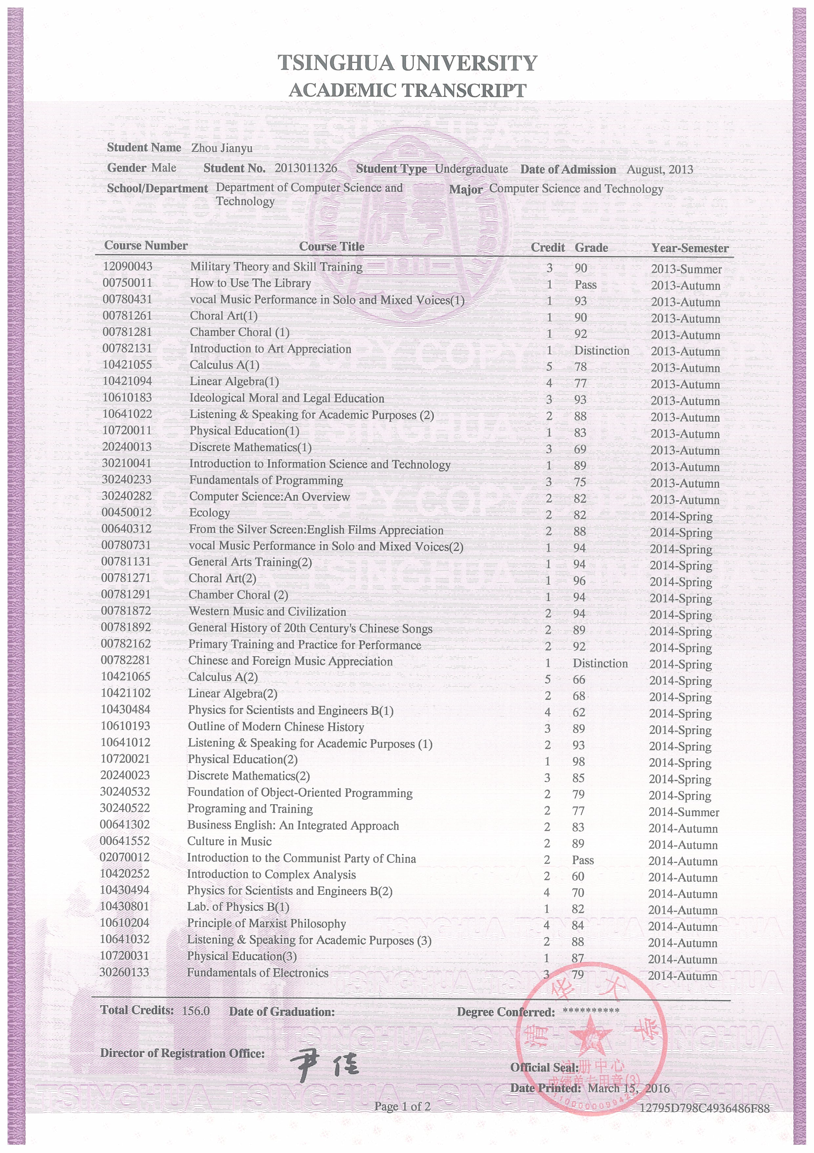
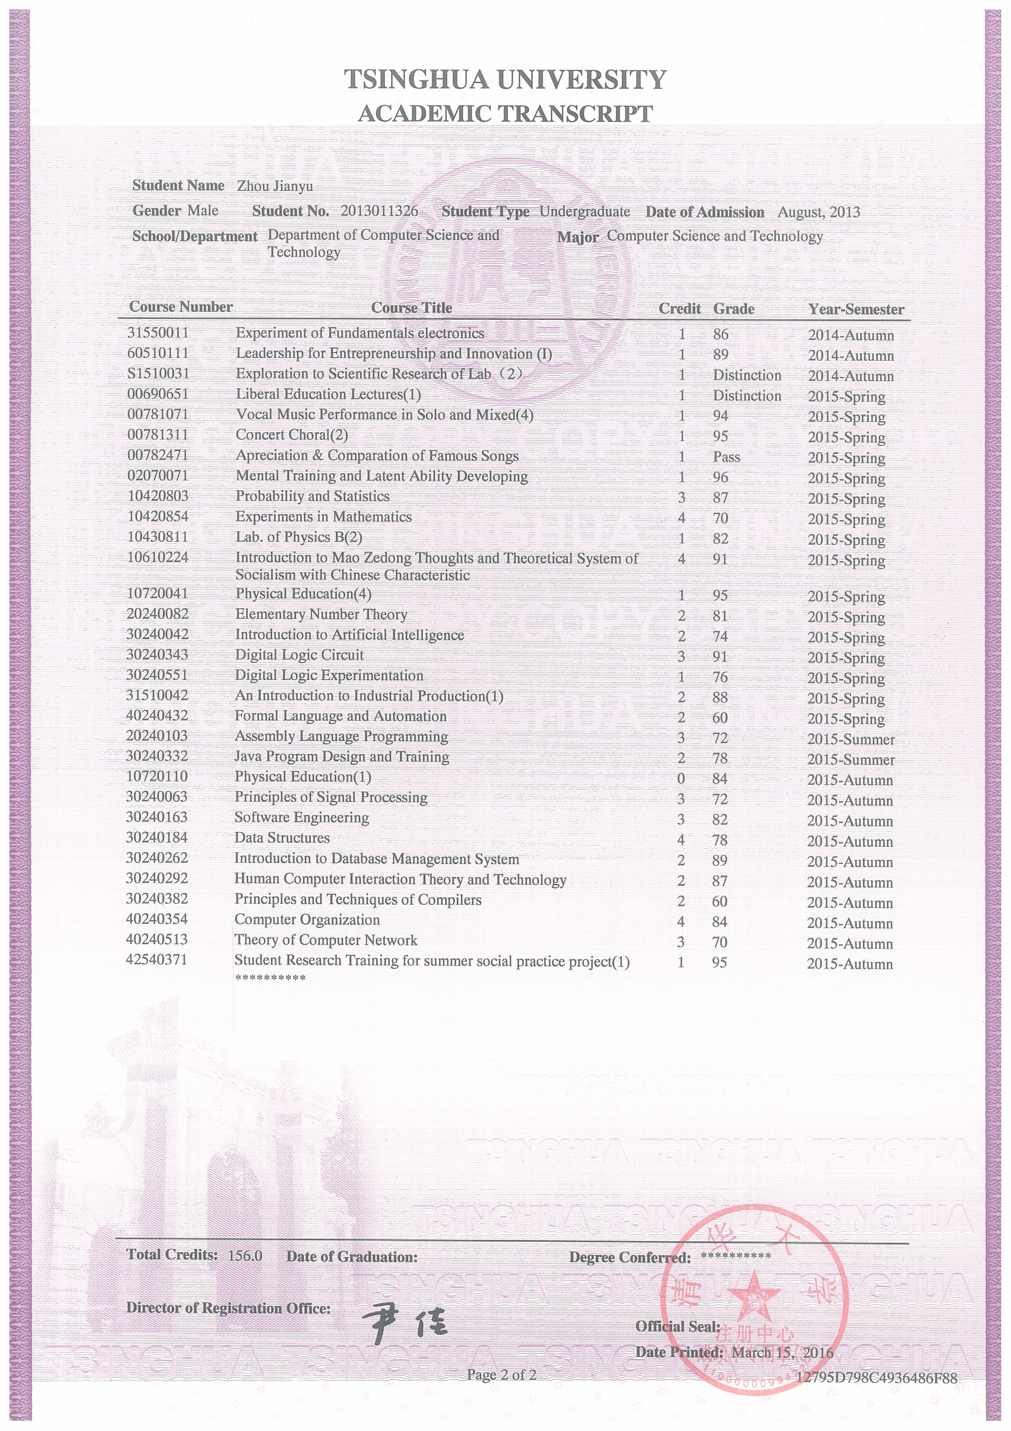
4.学分绩及排名
名 称 | 学分绩 | 学分数 | 总GPA排名/总人数
大一年级 | 82.0 | 69 | 2/114
大二年级 | 81.4 | 84 | 7/132
大三上学期 | 78.6 | 36 | 10/130
截止到大三上学期 | 81.0 | 189 | 6/130

GPA & Ranking
Year-Semester | GPA | Credits | ∑GPA Ranking
2013 Autumn-2014 Spring | 82.0 | 69 | 2/114
2014 Autumn-2015 Spring | 81.4 | 84 | 7/132
2015 Autumn | 78.6 | 36 | 10/130
By the end of 2015 Autumn | 81.0 | 189 | 6/130

5.填表信息
公派出国推荐学生名单
计算机 系推荐名单：
学生姓名 | 姓名拼音 | 学号 | 班级 | 性别 | 校内联系电话及E-mail、家庭联系电话
周建宇 | ZHOU JIANYU | 2013011326 | 计32 | 男 | 校内：18810918292  E-mail：zjythu@163.com  家庭：13305353620 周洪庆
学生所在系联系人： 电话：

