Report for Students’ GPA Alignment between Canvas and Registrar in 2021-2022 Academic Year

Office of Institutional Research

2022-08-18

# Executive Summary

The Grades page on Canvas is one of its most-used features. Up to date grade reporting in Canvas helps students monitor and take responsibility for their progress in a course. In addition, grades entered in Canvas are shared with advisors through Starfish. This report describes the relatively high level of accuracy of final grades recorded in Canvas.

In Summer 2022, the Institutional Research (IR) Office collaborated with the Teaching and Learning Center (TLC) to compare grade consistency between two systems – Canvas [1] and the Registrar’s Office [2].

We examined 15116 final grades which were in the range from 0-110 in Canvas and had a match in Registrar’s GPA systems. [3] We explored the following research questions: 1) How consistent are grades between Canvas and Registrar’s Office for undergraduate and graduate courses? 2) How does grade consistency in undergraduate and graduate courses vary by school, semester and session, and year? The main findings are:

* Many courses’ grades (GPA) are 3.7 and 4.0 in both Registrar and Canvas for undergraduate and graduate courses. However, graduate courses have 20% more 4.0 GPA than undergraduate courses.
* 85% of graduate and 71% of undergraduate courses’ grades matched exactly. Only 4% of graduate and 2% of undergraduate courses’ grades have a significant difference (more than 1.0 GPA difference) between Registrar and Canvas.
* Courses in Lasell Works and the Honors Program had over 90% grade consistency. Courses in multidisciplinary studies have the lowest percentage (55%) exact match.
* In 2021 Summer, session 2 performed the worst (64% for undergraduate courses and 79% for undergraduate courses). However, in 2021 Fall and 2022 Spring, session 2 performed the best (above 90% for both undergraduate and graduate courses). Undergraduate courses have the least grade consistency (around 70%) in main sessions in 2021 Fall and 2022 Spring.
* Graduate courses’ grade consistency in 2021 Fall and 2022 Spring is above 80%, which is almost 10% higher than previous years (data date back to 2018 Spring).

# Patterns of grades distribution

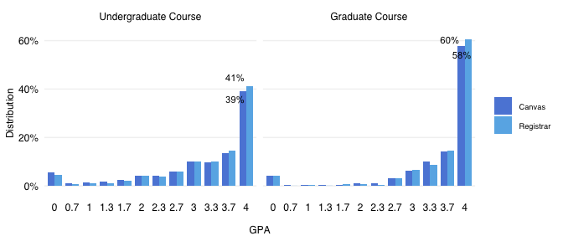

Figure 1: Similar Patterns of Canvas and Registrar Course GPA

As shown in Figure 1, the Registrar and Canvas systems have similar patterns of GPA distribution. In both systems, grades are concentrated towards the higher GPA (i.e., 3.7 and 4.0) and the number of grades decrease towards lower GPA. However, for 4.0 GPA, there are 20% less undergraduate course grades (n=11611) than graduate course grades (n=3505). [4]

# Overall grade consistency

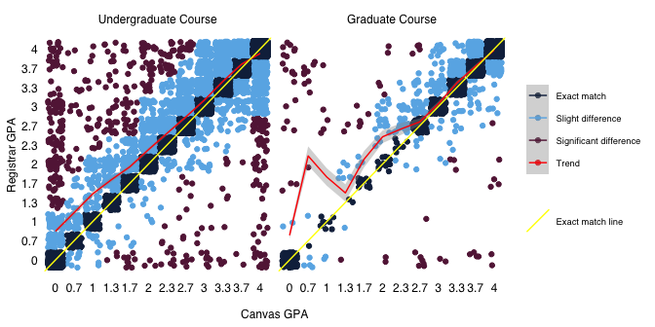

Figure 2: Difference between Canvas and Registrar Course GPA

As shown in Figure 2, more courses have higher grades in Registrar than in Canvas (we have more red dots above the yellow line than below the line). For undergraduate grades (n=11611), grades spread across different GPAs. For graduate grades (n=3505), grades concentrated on 2.7 or higher. The trend line (red line) of undergraduate course grade is closer to the exact match lines (yellow line) towards the 3.7 GPA. The trend line (red line) of graduate course grade almost overlaps with the exact match trend line (yellow line) for 2.7 GPA and higher GPAs.

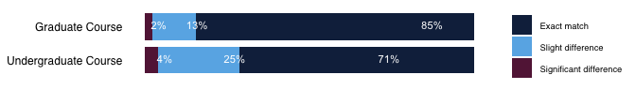

Figure 3: Percentage of Grade Consistency

As shown in Figure 3, 85% graduate grades and 71% undergraduate grades have exact match between Registrar’s Office and Canvas. Only 4% of undergraduate courses and 2% of graduate courses have significant differences (grade difference between the two systems are above 1.0). Graduate course grades had 14% more exact match than undergraduate course grades.

# Grade consistency by School

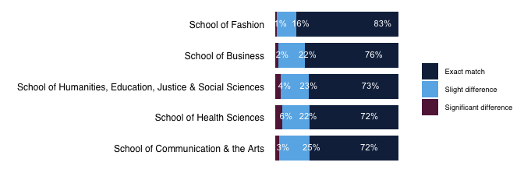

Figure 4: Grade Consistency for Each School

As shown in Figure 4, School of Fashion (n=1101) has the highest grade consistency (i.e., 83% exact match). School of Business (n=4149), School of Health Sciences (n=2210), School of Humanities, Education, Justice and Social Sciences (n=3956), and School of Communication and the Arts (n=2228) are between 72%-76%.

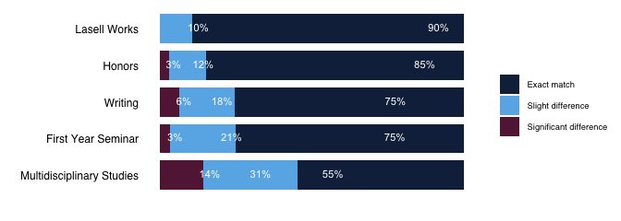

Figure 5: Grade Consistency in Non-School-Affiliated Programs

As shown in Figure 5, Lasell Works (n=134) has the highest grade consistency (i.e., 90%), followed by the Honors Program (n=140), which is 85%. The Writing Program (n=677) and First Year Seminar (n=266) have 75% grades match between the Registrar and Canvas systems. Multidiscplineary Studies (n=239) has the lowest grade consistency, which is 55%.

# Grade consistency by writing program

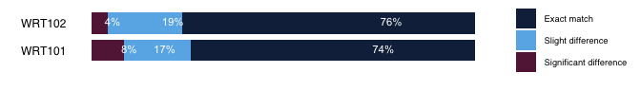

As shown in Figure 6, Writing 101 (n=342) and 102 (n=334) have similar exact match, but Writing 101 has 8% significant difference while Writing 102 has 4%.

# Grade consistency by semester and sessions in 2021-2022

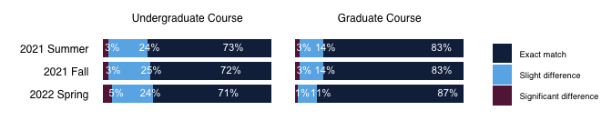

Figure 7: Grade Consistency in Different Terms

As shown in Figure 7, exact match between Canvas and Registrar are between 71%- 87% across different terms (spring, fall, summer) in academic year 2021-2022. There are less than 4% significant difference between Canvas and Registrar grades for both undergraduate and graduate course grades. However, the exact match of graduate course grades are more than 10% higher than undergraduate course grades. In spring, graduate course grades have 18% more exact-matched grades than undergraduate course grades.

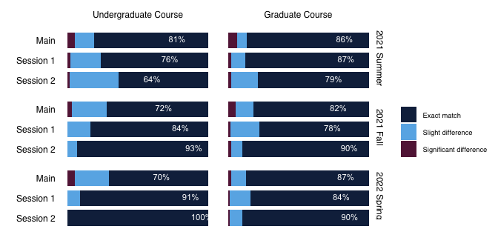

Figure 8: Grade Consistency across Sessions of Different Terms

As shown in Figure 8, for undergraduate courses, the lowest grade consistency appears in the main session of 2021 Fall (n=5869) and 2022 Spring (n=5253), which is only 70%. Then, the grade consistency increases in session 1 of Fall (n=31) and Spring (n=22). The grade consistency is the best for session2 in Fall (n=15) and Spring (n=25), which are above 90%.

For undergraduate courses in 2021 summer, the main session (n=5253) is the highest, which is 81%. It decreases when it moves to session 1 (n=181) and session 2 (n=181) which is only 76% and 64% respectively.

For graduate courses, session 2 has the highest grade consistency of 90% in Fall (n=511) and Spring (n=498). Similar grade consistency were observed for main and session 1 in Fall and Spring. In summer, main session (n=195) and session 1 (n=477) is similar, but session 2 (n=496) has lower grade consistency.

# Grade Consistency by Year

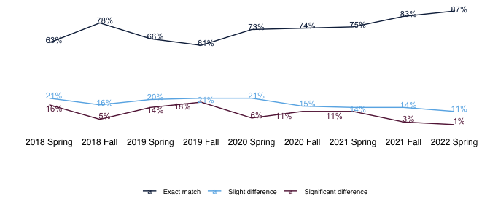

Figure 9: Historical Comparison of Grade Consistency 2018-2022 (Graduate Course Grades)

As shown in Figure 9, the canvas-registrar grade consistency for graduate level courses has been improving since 2019 Fall, and reached the highest percentage (87%) in 2022 Spring. However, there are still 10% of courses with significant differences between Canvas and Registrar.

# Appendix:

## Method: Preparation for Data Analysis

To make the grades comparable, we convert grades in Canvas (i.e., numeric grade in scale of 0-110) and Registrar’s Office (i.e.,letter grade in scale of A-F) to GPA grades (i.e. numeric grade in scale of 0-4.0). Figure 10 shows the distribution of grades in the Canvas and Registrar system before and after conversion.

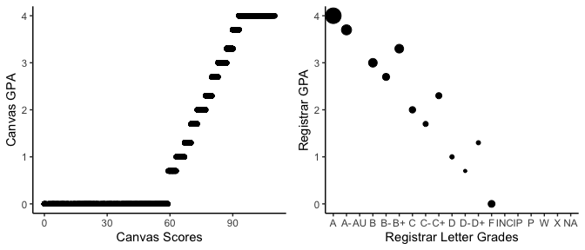

Figure 10: Canvas and Registrar Grades Before and After Conversion

## Grades that included and excluded from the analysis

We used Table 1 to convert scores and grades.

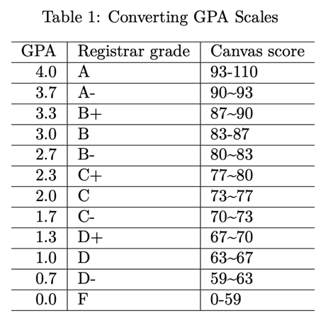

For grades that are excluded from this analysis, Table 2 is a description of the number of scores that are excluded from analysis.

Besides, we did not report programs and courses that has small number of observations. That exclusion help to protect students’ privacy from possibly individual identifiable students data. Specifically, the following programs are omitted from this report: Service Learning (n=5), Individualized Studies (n=2), Academic Achievement Center (n=9), and WRT109 (n=1).

## A few more explanations of Codes

Table 3 shows what’s included in Multidisciplinary Studies:

1. Canvas is a learning management system used for instruction and advising.
2. Registrar’s Office is a data management system used by the Registrar office for generating student transcripts and administrative reports.
3. Appendix details the process of converting grades from the two systems to comparable scales.
4. 40% undergraduate course grades have 4.0 GPA. 60% graduate course grades have 4.0 GPA.