LMSCanvasAccuracy

# Executive Summary

In Summer 2022, the Institutional Research (IR) Office collaborated with the Teaching and Learning Center (TLC) to compare grade consistency between two systems – Canvas [1] and the Registrar’s Office [2]. Comparing students’ grades in Canvas with Registrar is important for providing accurate advising and intervention for students.

We examined 15116 grades which has valid scores range from 0-110 in Canvas and has a match in Registrar’s GPA systems. [3] We explored the following research questions: 1) How consistent are grades between Canvas and Registrar’s Office for undergraduate and graduate courses? 2) How grade consistency in undergraduate and graduate courses vary by school, semester and session, and year? The main findings are:

* Many courses’ grades (GPA) are 3.7 and 4.0 in both Registrar and Canvas for undergraduate and graduate courses. However, graduate courses have 20% more 4.0 GPA than undergraduate courses.
* 85% of graduate and 71% of undergraduate courses grades matched exactly. Only 4% of graduate and 2% of undergraduate courses’ grades have a significant difference (more than 1.0 GPA difference) between Registrar and Canvas.
* Courses in Lasell Works and the Honors Program had over 90% grade consistency. Courses in multidisciplinary studies have the lowest percentage (55%) exact match.
* In 2021 Summer, session 2 perform the worst (64% for undergraduate courses and 79% for undergraduate courses). However, in 2021 Fall and 2022 Spring, session 2 perform the best (above 90% for both undergraduate and graduate courses). Undergraduate courses have the least grade consistency (around 70%) in main sessions in 2021 Fall and 2022 Spring.
* Graduate courses’ grade consistency in 2021 Fall and 2022 Spring is above 80%, which is almost 10% higher than previous years (data date back to 2018 Spring).

# Patterns of grades distribution

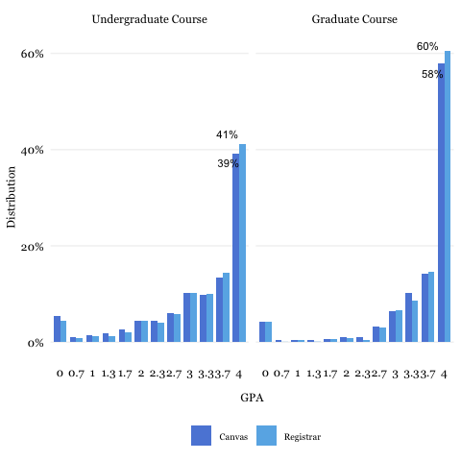

Figure 2.1: Similar Patterns of Canvas and Registrar Course GPA

As shown in Figure 2.1, the Registrar and Canvas systems have similar patterns of GPA distribution. In both systems, grades are concentrated towards the higher GPA (i.e., 3.7 and 4.0) and the number of grades decrease towards lower GPA. However, for 4.0 GPA, there are 20% less undergraduate course grades (n=11611) than graduate course grades(n=3505). [4]

# Overall grade consistency

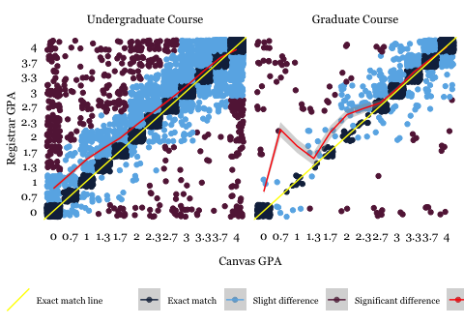

Figure 3.1: Difference between Canvas and Registrar Course GPA

As shown in Figure 3.1, more courses have higher grades in Registrar than in Canvas (we have more red dots above the yellow line than below the line). For undergraduate courses (n=11611), grades spread across different GPAs. For graduate course (n=3505), grades concentrated on 2.7 or higher. The trend line (red line) of undergraduate course grade has is closer to the exact match lines (yellow line) towards the 3.7 GPA. The trend line (red line) of graduate course grade almost overlaps with the exact match trend line (yellow line) since 2.7 GPA and higher GPAs.

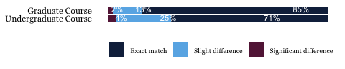

Figure 3.2: Percentage of Grade Consistency

As shown in Figure 3.2, 85% graduate courses and 71% undergraduate courses have exact match of grades between Registrar’s Office and Canvas. Only 4% of undergraduate courses and 2% of graduate courses have significant differences (grade difference between the two systems are above 1.0). Graduate course grades has 14% more exact match than undergraduate course grades.

# Grade consistency by School

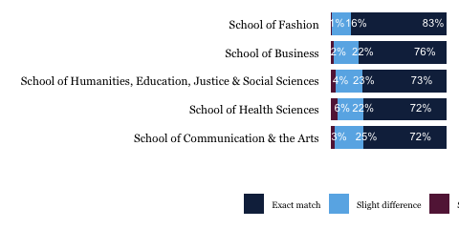

Figure 4.1: Grade Consistency for Each School

As shown in Figure 4.1, School of Fashion (n=1101) has the highest grade consistency (i.e., 83% exact match). School of Business (n=4149), School of Health Sciences (n=2210), School of Humanities, Education, Justice and Social Sciences (n=3956), and School of Communication and the Arts (n=2228) are between 72%-76%.

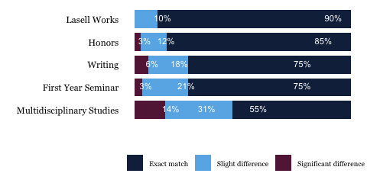

Figure 4.2: Grade Consistency in Non-School-Affiliated Programs

As shown in Figure 4.2, Lasell Works (n=134) has the highest grade consistency (i.e., 90%), followed by the Honors Program (n=140), which is 85%. The Writing Program (n=677) and First Year Seminar (n=266) has 75% grades match between the Registrar and Canvas systems. Multidiscplineary Studies (n=239) has the lowest grade consistency, which is 55%.

# Grade consistency by writing program

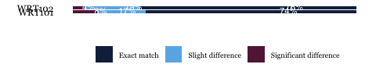 As shown in Figure 5.1, Writing 101 (n=342) and 102 (n=334) has similar exact match, but Writing 101 has 8% significant difference than Writing 102 which is 4%.

# Grade consistency by semester and sessions in 2021-2022

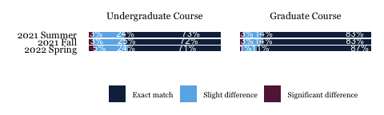

Figure 6.1: Grade Consistency in Different Terms

As shown in Figure 6.1, exact match between Canvas and Registrar are between 71%- 87% across different terms (spring, fall, summer) in academic year 2021-2022. There are less than 4% significant difference between Canvas and Registrar grades for both undergraduate and graduate courses. However, the exact match of graduate course grades are more than 10% higher than undergraduate courses. In spring, graduate course have 18% more exact-matched grades than undergraduate courses.

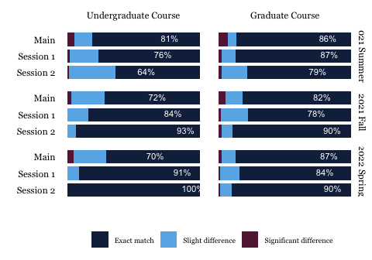

Figure 6.2: Grade Consistency across Sessions of Different Terms

As shown in Figure 6.2, for undergraduate courses, the lowest grade consistency appears in the main session of 2021 Fall (n=5869) and 2022 Spring (n=5253), which is only 70%. Then, the grade consistency increases in session 1 of Fall (n=31) and Spring (n=22). The grade consistency is the best for session2 in Fall (n=15) and Spring (n=25), which are above 90%.

For undergraduate courses in 2021 summer, the main session (n=5253) is the highest, which is 81%. It decreases when it moves to session 1 (n=181) and session 2 (n=181) which is only 76% and 64% respectively.

For graduate courses, session 2 has the highest grade consistency of 90% in Fall (n=511) and Spring (n=498). Similar grade consistency were observed for main and session 1 in Fall and Spring. In summer, main session (n=195) and session 1 (n=477) is similar, but session 2 (n=496) has lower grade consistency.

# Grade Consistency by Year

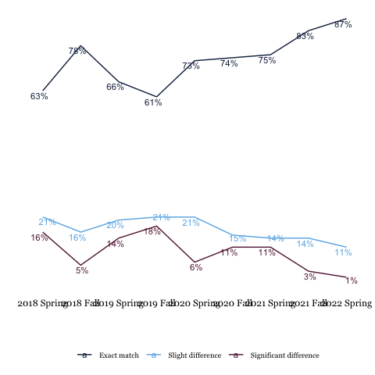

Figure 7.1: Historical Comparison of Grade Consistency 2018-2022 (Graduate Course Grades)

As shown in Figure 7.1, the canvas-registrar grade consistency for graduate level courses has been improving since 2019 Fall, and reached the highest percentage (87%) in 2022 Spring. However, there are still 10% of courses with significant differences between Canvas and Registrar.

# Appendix:

## Method: Preparation for Data Analysis

To make the grades comparable, we convert grades in Canvas (i.e., numeric grade in scale of 0-110) and Registrar’s Office (i.e.,letter grade in scale of A-F) to GPA grades (i.e. numeric grade in scale of 0-4.0). Figure 8.1 shows the distribution of grades in the Canvas and Registrar system before and after conversion.

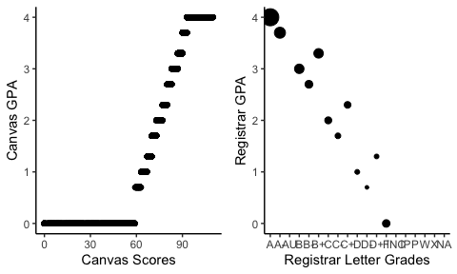

Figure 8.1: Canvas and Registrar Grades Before and After Conversion

## Grades that included and excluded from the analysis

We used Table 8.1 to convert scores and grades.

Table 8.1: Converting GPA Scales

| GPA | Registrar grade | Canvas score |
| --- | --- | --- |
| 4.0 | A | 93-110 |
| 3.7 | A- | 90~93 |
| 3.3 | B+ | 87~90 |
| 3.0 | B | 83-87 |
| 2.7 | B- | 80~83 |
| 2.3 | C+ | 77~80 |
| 2.0 | C | 73~77 |
| 1.7 | C- | 70~73 |
| 1.3 | D+ | 67~70 |
| 1.0 | D | 63~67 |
| 0.7 | D- | 59~63 |
| 0.0 | F | 0-59 |

For grades that are excluded from this analysis, Table 8.2 is a description of the number of scores that are excluded from analysis (table hidden).

Besides, we did not report programs and courses that has small number of observations. That exclusion help to protect students’ privacy from possibly individual identifiable students data. Specifically, the following programs are omitted from this report: Service Learning (n=5), Individualized Studies (n=2), Academic Achievement Center (n=9), and WRT109 (n=1).

Table 8.2: Outlier Grades and Corresponding Courses

| course | Grades>110 |
| --- | --- |
| HIST104.CKP-2021.FAMAIN World Civ II:Science & Medicine | 24 |
| HIST104.EKP-2021.FAMAIN World Civ II:Magic & Religion | 23 |
| BUSS332.A-2021.FAMAIN Cross Cultural Management | 19 |
| POLS101.A-2021.FAMAIN American Government | 17 |
| ED335.A-2022.SPMAIN Teaching Mathematics: PK - 2 | 16 |
| HIST104.CKP-2022.SPMAIN World Civ II: Science & Medicine | 16 |
| BUSS310.A-2022.SPMAIN Advanced Financial Management | 14 |
| HIST124.A-2021.FAMAIN Amer Civ II: Nineteenth Century New York | 14 |
| BUSS101.C-2021.FAMAIN Fund of Bus in a Global Environment | 13 |
| CJ702.A-2021.SUSES1 Critical Legal Issues in Crim Justice | 13 |
| COM105.A-2022.SPMAIN Writing for The Media | 13 |
| GRAP207.A-2022.SPMAIN Web Design & Development | 13 |
| PSYC101.BKP-2021.FAMAIN Psychological Perspectives (KP) | 13 |
| CJ702.B-2021.FASES2 Critical Legal Issues in Crim Justice | 12 |
| COM105.B-2022.SPMAIN Writing for The Media | 11 |
| HIST104.FKP-2022.SPMAIN World Civ II: Magic & Religion | 11 |
| PSYC111.A-2022.SPMAIN Generations in America | 11 |
| GRAP308.A-2022.SPMAIN Interactive & UX Design | 10 |
| BUSS101.D-2021.FAMAIN Fund of Bus in a Global Environment | 9 |
| BUSS497.A-2021.FAMAIN Business Internship & Seminar | 9 |
| HIST104.EKP-2022.SPMAIN World Civ II: The Maritime World | 9 |
| HIST104.FKP-2021.FAMAIN World Civ II:The Maritime World | 9 |
| HIST104.KP-2021FAMAIN: ALL (KP) | 9 |
| ARTS126.FKP-2021.FAMAIN Fund of Visual Art (KP) Grap Majors Only | 7 |
| BIO104.A-2022.SPMAIN Foundations in the Health Professions | 6 |
| MGMT707.B-2022.SPSES1 Operations Strategy | 6 |
| BUSS105.B-2021.FAMAIN Excel for Business | 5 |
| HIST104.BKP-2021.FAMAIN World Civ II:Introduction to East Asia | 5 |
| HIST104.DKP-2021.FAMAIN World Civ II: Intro to the Middle East | 5 |
| HIST104.KP-2022SPMAIN: ALL (KP) | 5 |
| SPED711.A-2021.FASES1 Learners with Special Needs | 5 |
| ARTH107.BKP-2022.SPMAIN SPT:Rennaissance to Modern Art Treasures | 4 |
| BUSS319.A-2021.FAMAIN Cost Accounting | 4 |
| FASH206.A-2021.FAMAIN Sustainability in the Fashion Industry | 4 |
| BIO102L.AKP-2022.SPMAIN Princ of Bio II Lab (KP) | 3 |
| BIO211.A-2021.FAMAIN Microbiology | 3 |
| BUSS224.B-2021.FAMAIN Org Behavior in the Global Workplace | 3 |
| GRAP105.A-2022.SPMAIN Digital Design Essentials | 3 |
| HIST104.AKP-2021.FAMAIN World Civ II: World Wars | 3 |
| MGMT751.A-2022.SPMAIN Business Strategy | 3 |
| ARTS126.CKP-2021.FAMAIN Fundamentals of Visual Art (KP) | 2 |
| BIO102L.B-2022.SPMAIN Princ of Bio II Lab (KP) | 2 |
| BUSS105.A-2022.SPMAIN Excel for Business | 2 |
| FYS103.D-2021.FAMAIN The Three Pillars of Transformation | 2 |
| FYS103.N-2021.FAMAIN The Three Pillars of Transformation | 2 |
| HIST212.A-2022.SPMAIN Mod Japan: Culture & History | 2 |
| MGMT707.A-2021.FASES2 Operations Strategy | 2 |
| PSYC318.A-2022.SPMAIN Abnormal Psychology | 2 |
| WRT101.Q-2021.FAMAIN Writing I | 2 |
| ARTH107.AKP-2022.SPMAIN SPT: Global Art Treasures (KP) | 1 |
| BIO102.AKP-2022.SPMAIN Principles of Biology II (KP) | 1 |
| BUSS105.A-2021.FAMAIN Excel for Business | 1 |
| BUSS332.A-2021.SUSES1 Cross Cultural Management | 1 |
| CHEM204L.A-2022.SPMAIN General Chemistry II Lab | 1 |
| CJ101.AKP-2021.FAMAIN Introduction to Criminal Justice (KP) | 1 |
| COM101.B-2021.FAMAIN Understanding Mass Media | 1 |
| COM219.LWS-2022.SPMAIN Social Media Management | 1 |
| COM315.A-2022.SPMAIN Communication Research | 1 |
| COM742.A-2021.SUSES1 Integrated Marketing Communications | 1 |
| ECON101.A-2022.SPMAIN Principles of Econ-Micro | 1 |
| ED418.A-2022.SPMAIN Integrated Instruction: Elementary: 1-6 | 1 |
| EXSC410.A-2021.FAMAIN Exercise Science Field Experience I | 1 |
| FASH219.A-2022.SPMAIN Fash Industry Professional Development | 1 |
| FYS103.O-2021.FAMAIN Identity and Connecting Across Differenc | 1 |
| GRAP310X.A-2022.SPMAIN UX Explorations | 1 |
| HIST104.AKP-2022.SPMAIN World Civ II: World Wars | 1 |
| HIST104.BKP-2022.SPMAIN World Civ II: Introduction to East Asia | 1 |
| HIST323.A-2021.FAMAIN Special Topics in Global History | 1 |
| LS101.AKP-2021.FAMAIN Foundations of American Legal System(KP) | 1 |
| MATH205.A-2021.FAMAIN Calculus I | 1 |
| MDSC203.E-2021.FAMAIN Entrepreneurship Sport & Entertainment | 1 |
| PSYC101.CKP-2022.SPMAIN Psychological Perspectives (KP) | 1 |
| PSYC318.LWS-2021.FAMAIN Abnormal Psychology | 1 |
| SMGT203X.A-2021.FAMAIN Intro to Parks Recreation & Tourism | 1 |
| SOC104.FKP-2022.SPMAIN Equity & Intersectionality(KP) | 1 |
| SOC221.A-2021.FAMAIN Contemporary Social Problems | 1 |
| SOC301.A-2022.SPMAIN Race & Ethnicity | 1 |
| SOC331.A-2021.FAMAIN Research Methods in the Social Sciences | 1 |
| WRT102.C-2021.FAMAIN Writing II | 1 |
| WRT102.L-2022.SPMAIN WRT II: Sports and Wellness | 1 |

## A few more explanation of Codes

Table 8.3 shows what’s included in Multidisciplinary Studies:

Table 8.3: Multidisciplinary Studies Courses

| Course ID | Course Name | n |
| --- | --- | --- |
| MDSC203 | Democracy | 12 |
| MDSC203 | Digital Society | 43 |
| MDSC203 | Entrepreneurship, Sport & Entertainment | 34 |
| MDSC203 | Fighting Injustice Through Art | 32 |
| MDSC203 | Immigrant Stories | 37 |
| MDSC203 | Immigration Stories | 41 |
| MDSC203 | Persuading People Preserving Planet | 40 |

1. Canvas is a learning management system used for instruction and advising.
2. Registrar’s Office is a data management system used by the Registrar office for generating student transcripts and administrative reports.
3. Appendix details the process of converting grades from the two systems to comparable scales.
4. 40% undergraduate course grades have 4.0 GPA. 60% graduate course grades have 4.0 GPA.