2、**一幅8灰度级图像具有如下所示的直方图，求直方图均衡后的灰度级和对应概率，并画出均衡后的直方图的示意图。（图中的8个不同灰度级对应的归一化直方图为[0.17 0.25 0.21 0.16 0.07 0.08 0.04 0.02]）**

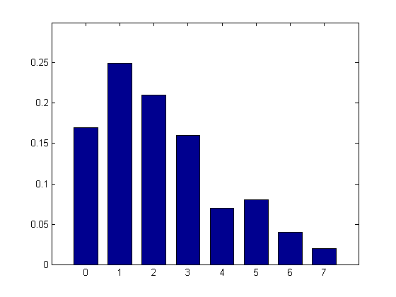

答：直方图均衡的映射函数为

$$T\left(r_{k}\right)=7\sum_{i=0}^{k}{p\left(r_{k}\right)},k=01,2,3,4,5,6,7$$

按照上述计算公式，得到各个灰度的映射表如下 ：

|  |  |  |  |  |  |  |  |  |
| --- | --- | --- | --- | --- | --- | --- | --- | --- |
| $$r$$ | 0 | 1 | 2 | 3 | 4 | 5 | 6 | 7 |
| $$s$$ | 1.19 | 2.94 | 4.41 | 5.53 | 6.02 | 6.58 | 6.86 | 7.00 |
| round(s) | 1 | 3 | 4 | 5 | 6 | 6 | 7 | 7 |

则变换后图像中各个灰度的频率为

|  |  |  |  |  |  |  |  |  |
| --- | --- | --- | --- | --- | --- | --- | --- | --- |
| $$s_{k}$$ | 0 | 1 | 2 | 3 | 4 | 5 | 6 | 7 |
| $$p(s_{k})$$ | 0 | 0.17 | 0 | 0.25 | 0.21 | 0.16 | 0.15 | 0.06 |

则变换后的直方图示意图如下图所示

